Project | IEEE 802.16 Broadband Wireless Access Working Group <http://ieee802.org/16>
Title | Interference scenarios in 5.8GHz UNII band
Date Submitted | 2004-03-23
Source(s) | Marianna Goldhammer  Alvarion  21, HaBarzel Street  Tel Aviv, Israel | Voice: +972 54 22 55 48  Fax: +972 3 6456241  mailto: marianna.goldhammer@alvarion.com
Re: | IEEE 802.16 LE Ad-hoc
Abstract
Purpose | Start of work, to be completed by Ad-Hoc members
Notice | This document has been prepared to assist IEEE 802.16. It is offered as a basis for discussion and is not binding on the contributing individual(s) or organization(s). The material in this document is subject to change in form and content after further study. The contributor(s) reserve(s) the right to add, amend or withdraw material contained herein.
Release | The contributor grants a free, irrevocable license to the IEEE to incorporate material contained in this contribution, and any modifications thereof, in the creation of an IEEE Standards publication; to copyright in the IEEE’s name any IEEE Standards publication even though it may include portions of this contribution; and at the IEEE’s sole discretion to permit others to reproduce in whole or in part the resulting IEEE Standards publication. The contributor also acknowledges and accepts that this contribution may be made public by IEEE 802.16.
Patent Policy and Procedures | The contributor is familiar with the IEEE 802.16 Patent Policy and Procedures <http://ieee802.org/16/ipr/patents/policy.html>, including the statement "IEEE standards may include the known use of patent(s), including patent applications, provided the IEEE receives assurance from the patent holder or applicant with respect to patents essential for compliance with both mandatory and optional portions of the standard." Early disclosure to the Working Group of patent information that might be relevant to the standard is essential to reduce the possibility for delays in the development process and increase the likelihood that the draft publication will be approved for publication. Please notify the Chair <mailto:chair@wirelessman.org> as early as possible, in written or electronic form, if patented technology (or technology under patent application) might be incorporated into a draft standard being developed within the IEEE 802.16 Working Group. The Chair will disclose this notification via the IEEE 802.16 web site <http://ieee802.org/16/ipr/patents/notices>.

Interference scenarios in 5.8GHz UNII band
Author: Marianna Goldhammer (Alvarion), etc.

Introduction
The scope of this work is to define the scenarios in which interference between cells can cause disruption in service. The target frequency is 5.8GHz LE band, according to UNII rules. Will be taken into account un-coordinated deployment cases, to address access providers and private networks.

System parameters
The following parameters are proposed, resulting as an average of product characteristics in 5.8GHz:

BST:
Tx power: Ptb = 20dBm;
Antenna gain: omni: AGo = 10dBi; directional: AGba = 17dBi;
Connector loss: CL =1dB;

SS:
Tx power: Pts = 20dBm;
Antenna gain: omni: AGso = 10dBi; directional: AGsa = 17dBi; AGsb = 23dBi
Connector loss: 1dB.

Antenna isolation for co-located outdoor antennae:
AI = 40dB for directional – to- directional;
AI = 30dB for omni-to-directional or omni-to-omni.

Signal BW for evaluation: 10MHz
Note: for simplification, it is proposed to omit 20MHz here

Fade Margin: 10dB

The Receive Sensitivity Level (RSL), Adjacent Channel Interference (ACI) resistance, Co-channel Interference Resistance (CCI), at minimum rate, as defined in 802.16REVd/D3 (see Annex 1), are summarized below:

 | RSL (dBm) / Modulation | ACI (dB) / Modulation | CCI (dB) / Modulation | Blocking Rx level (dBm)
SCa | -83.2 / BPSK | -12 / BPSK | 9.8 / QPSK | -40
OFDM | -82.6 / QPSK 1/2 | -11 / 16QAM 3/4 | 9.4 / QPSK 1/2 | -30
OFDMA | -82.6 / QPSK 1/2 | -11 / 16QAM 3/4 | 9.4 / QPSK 1/2 | -30

It is proposed to use the following values:

RSL: -83dBm
CCI: 9.8dB
Blocking Level: BL= -40dBm
ACI: -12dB

Note: the value does not reflect OFDM/OFDMA QPSK rate 1/2; however, numbers are not available; please provide numbers!

Interference cases

Base Station to Base Station

Co-located BS
In this case, will be 2 systems: one transmitting and one receiving. If the Tx and Rx intervals are not synchronized, the victim receiver will be interfered by the transmitter.

The interference level will be, in the best case:

I = Ptb – AI = 20dBm – 40dB = -20dB,

I > BL

The interference level is higher than the Blocking Level and as result none of systems will work.

Base Station minimum separation

Adjacent channel

O1

O2

Problem: In the case of not synchronized transmissions, the Base Station located in O1, will create interference to the Base Station located in O2, for the duration of common Tx-Rx periods.
The worst case interference level is for Line-of-Sight (LOS) propagation, sector BS antennae.

The interfering signal at O2 is:

I2 = Ptb1+AGb1-CL1+ AGb2-CLs2 – Path_loss= 20dBm + 17dBi –1dB + 17dBi –1dB – Path_loss

However, this signal comes on the adjacent channel. The channel will affect the victim channel at a power which is lower by ACI dB. For ACI=12dB, results:

Path_loss = 52dBm – I2 – ACI = 40dBm – I2 (1)

Lets suppose that Base Station in O2 works at 10dB above its RSL (fade margin) and can accept 1dB degradation of the RSL. The allowed interference level, I(dB), such that will increase the power level by 1dB, will be:

I(dB) = 10*log(I(W))
I (W)= 10^{(I(dB)/10)}
P(W)+I(W) = 10^{(P(dB)/10)} + 10^{(I(dB)/10)} = P(dB) + 1dB

P(dB) + 1dB =10*log (10^{(P(dB)/10)} + 10^{(I(dB)/10)} )

10 ^{(1+P(dB))/10} = 10^{(P(dB)/10)} + 10^{(I(dB)/10}

10^{(I(dB)/10} = 10 ^{(1+P(dB))/10} - 10^{(P(dB)/10)} = 10 ^{(P(dB)/10} * 10^{1/10} - 10^{(P(dB)/10)}
10^{(I(dB)/10} = 10^{(P(dB)/10)} *(10^{1/10} – 1)

I(dB)/10 = log (10^{1/10} – 1) + P(dB)/10
I(dB) = 10* log(10^{1/10} – 1) + P(dB) = P(dB) - 5.87dB = aprox. P(dB) - 6dB

So, the accepted interference level will be, for RSL = -83dB and FM=10dB:
I = RSL+FM-6= -83+10-6 = -79dB

Replacing in (1) results:

Path_loss = 40 – (-79) = 119dB

In LOS, the path loss at frequency f(GHz) and distance d(m) is given by:

Path_loss = 32.4 + 20 * log (f) + 20 * log (d)

Path_loss - 32.4 - 20*log (f) =20*log (d)

The separation distance d (km) between Base Stations is given at the frequency f (MHz) by:

d = 10(Path_loss - 32.4 - 20 * log(f )) / 20

In our case:

d = 10^{(119-32.4-20*log (5800))/20} = 3.685 km

In conclusion, in order to avoid the interference between 2 Base Stations using sector antennae, and no co-ordination for adjacent channel frequency planning or synchronization,
the separation distance should be higher than 3.7km!

For the case that one antenna is omni and the other one is sectorized, the path-loss became:

Path_loss = 119 – (17-10) = 112dB

And d= 10^{(112-32.4-20*log (5800))/20} = 1.64km

With Base Station synchronization, no separation distance is necessary ☺.

Co-channel

Base Station to/from Subscriber Station

Adjacent channel

Victim BS

Victim SS

Co-channel

Victim BS

Victim SS

Subscriber Station to Subscriber Station

Adjacent channel

Victim SS

Co-channel

Victim SS

ANNEX 1
Radio Characteristics

The data is taken from 802.16REVd/D3.

WirelessMAN Single Carrier (Sca)

8.2.3.9 Receiver sensitivity
Receiver sensitivity shall be better than the values listed below (computed at 10 -3 uncoded BER, and a total of 7 dB in receiver noise figure and 3 dB implementation loss). BW is specified in MHz.
QPSK: -93.2 +10*log(BW)
16-QAM: -86.2 +10*log(BW)
64-QAM: -80 +10*log(BW)

SNRreq assumptions (for uncoded signals at 10 -3 BER) are the following:
QPSK: 9.8 dB
16-QAM: 16.8 dB
64-QAM: 23.0 dB.

8.2.3.10 Receiver maximum input signal
A BS shall be capable of receiving a maximum on-channel operational signal of –40 dBm and should tolerate a maximum input signal of 0 dBm without damage to circuitry. An SS shall be capable of receiving a maximum on-channel operational signal of –20 dBm and should tolerate a maximum input signal of 0 dBm without damage to circuitry.

8.2.3.11 Receiver adjacent channel interference
A system shall achieve the minimum adjacent and alternate adjacent channel interference performance as shown in Table 185. All measurements shall be performed uncoded.

Table 185—Minimum adjacent and alt. adjacent channel interference performance
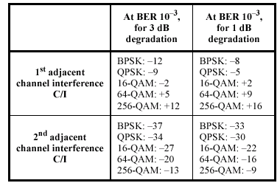

WirelessMAN OFDM

8.3.10.1 Receiver sensitivity
The BER measured after FEC shall be less than 10 –6 at the power levels given by Equation (90) for standard message and test conditions. If the implemented bandwidth is not listed, then the values for the nearest smaller listed bandwidth shall apply. The minimum input levels are measured as follows:
— At the antenna connector or· through a calibrated radiated test environment,
— Using the defined standardized message packet formats, and
— Using an AWGN channel.
The receiver minimum input level sensitivity (R SS ) shall be (assuming 5 dB implementation margin and 7dB Noise Figure):

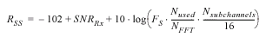
where:
SNR Rx the receiver SNR as per Table 224 in dB
F S sampling frequency in MHz as defined in 8.3.2.2
N sub-channels the number of allocated sub-channels (default 16 if no sub-channelization is used).
.
Table 224—Receiver SNR assumptions

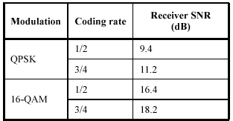

8.3.10.2 Receiver adjacent and alternate channel rejection
The receiver adjacent and alternate channel rejection shall be met over the required dynamic range of the
receiver, from 3dB above the reference sensitivity level specified in 8.3.10.1 to the maximum input signal
level as specified in 8.3.10.3.
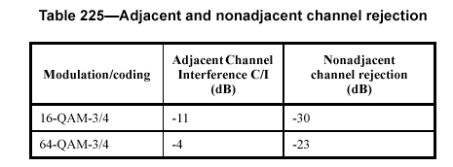

8.3.10.3 Receiver maximum input signal
The receiver shall be capable of receiving a maximum on-channel signal of –30 dBm, and shall tolerate a
maximum signal of 0 dBm without damage.

WirelessMAN OFDMA

8.4.13.1 Receiver sensitivity
The BER shall be less than 10 –6 at the power levels shown in Table 264 for standard message and test condi-tions.
If the implemented bandwidth is not listed, then the values for the nearest smaller listed bandwidth
shall apply. The minimum input levels are measured as follows:
— At the antenna connector or· through a calibrated radiated test environment,
— Using the defined standardized message packet formats, and
Using an AWGN channel.
Table 264 (as well as Table 263) are derived assuming 5 dB implementation loss, a Noise Figure of 7 dB and receiver SNR and Eb /N0 values as listed in Table 265.
Table 265—Receiver SNR and Eb /N0 assumptions
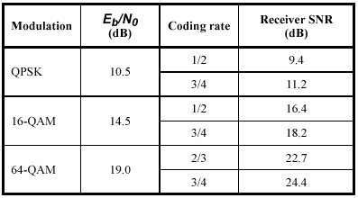

8.4.13.2 Receiver adjacent and alternate channel rejection
The adjacent channel rejection and alternate channel rejection shall be measured by setting the desired sig-nal’s
strength 3 dB above the rate dependent receiver sensitivity (see Table 264) and raising the power level
of the interfering signal until the specified error rate is obtained. The power difference between the interfer-ing
signal and the desired channel is the corresponding adjacent channel rejection. The interfering signal in
the adjacent channel shall be a conforming OFDMA signal, not synchronized with the signal in the channel
under test. For nonadjacent channel testing the test method is identical except the interfering channel shall
be any channel other than the adjacent channel or the co-channel.
For the PHY to be compliant, the minimum rejection shall exceed the following:
Table 266—Adjacent and nonadjacent channel rejection
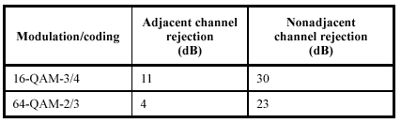

8.4.13.3 Receiver maximum input signal
The receiver shall be capable of receiving a maximum on-channel signal of –30 dBm, and shall tolerate a
maximum signal of 0 dBm without damage.

