Project | IEEE 802.16 Broadband Wireless Access Working Group <http://ieee802.org/16>  C80216-07_030
Title | Further Input for submission to IEEE 802.18 on IMT.EVAL (Edited 8F/1322 Att. 6.7)
Date Submitted | 2007-11-14
Source(s) | Reza Arefi  Acting Chair, IEEE 802.16 ITU-R Liaison Group  Intel Corporation | Reza.arefi@intel.com
Re: | Call for Contributions: Proposed Contribution to IEEE 802.18 on IMT-Advanced [IMT.EVAL], 8/25/2007
Abstract | Further comments on IMT.EVAL based on the work of TGm on evaluation criteria.  This contribution used 802.18 draft document 18-07-0084_IMT-Advanced_Eval_d3 as base document for commenting. Introduced changes in this contribution are limited to Annex 2.
Purpose | To help IEEE 802.16 Working Group to develop a contribution to IEEE 802.18 TAG on IMT-Advanced evaluation criteria.
Notice | This document does not represent the agreed views of the IEEE 802.16 Working Group or any of its subgroups. It represents only the views of the participants listed in the “Source(s)” field above. It is offered as a basis for discussion. It is not binding on the contributor(s), who reserve(s) the right to add, amend or withdraw material contained herein.
Release | The contributor grants a free, irrevocable license to the IEEE to incorporate material contained in this contribution, and any modifications thereof, in the creation of an IEEE Standards publication; to copyright in the IEEE’s name any IEEE Standards publication even though it may include portions of this contribution; and at the IEEE’s sole discretion to permit others to reproduce in whole or in part the resulting IEEE Standards publication. The contributor also acknowledges and accepts that this contribution may be made public by IEEE 802.16.
Patent Policy | The contributor is familiar with the IEEE-SA Patent Policy and Procedures:  <http://standards.ieee.org/guides/bylaws/sect6-7.html#6> and <http://standards.ieee.org/guides/opman/sect6.html#6.3>.  Further information is located at <http://standards.ieee.org/board/pat/pat-material.html> and <http://standards.ieee.org/board/pat>.
attachment 6.7
Source: Document 8F/TEMP/568
Working document towards proposed draft new [Report/Recommendation] [Guidelines for evaluation of radio interface technologies for IMT-Advanced]
(xxxx)

[Editors note: a new section on terminology is necessary for [IMT.EVAL].]
CONTENTS
1 Introduction
2 Scope
3 Structure of the Recommendation/Report
4 Related documents
5 Radio interface technology consideations
6 Technical characteristics chosen for evaluation
7 Selected test environments and deployment models for evaluation
8 Guidelines for evaluating the radio interface technologies by independent evaluation groups
9 Evaluation methodology
10 Detailed evaluation approach
11 Definition of Performance Metrics
Annex 1 – Radio interface technologies description template
Annex 2 – Test environments and deployment models
Annex 3 – Requirements for assessment of candidate technologies
1 Introduction
[Editor notes: NEW common text for IMT-Advanced should be incorporated.]

2 Scope
This [Recommendation/Report] provides guidelines for both the procedure and the criteria (technical, spectrum and service) to be used in evaluating RITs for a number of reference scenarios, test environments and deployment models. These test environments, defined herein, are chosen to simulate closely the more stringent radio operating environments. The evaluation procedure is designed in such a way that the impact of the candidate RITs on the overall performance and economics of IMT-Advanced may be fairly and equally assessed on a technical basis. It ensures that the overall IMT-Advanced objectives are met.
The [Recommendation/Report] provides, for proponents and developers of RITs, the common base for the self and external evaluation of RITs and system aspects impacting the radio performance.
This [Recommendation/Report] allows a degree of freedom so as to encompass new technologies.
The actual selection of the RITs for IMT-Advanced is outside the scope of this [Recommendation/Report].

Structure of the Recommendation/Report
Section 5 outlines the RIT considerations and identifies the transmission dependent part of the radio interface considered in the evaluation procedure. Section 6 defines the criteria for evaluating the RITs and section 7 references the tests environments under which the candidate RITs are evaluated. Section 8 outlines the overall procedure for evaluating the RITs. Section 9 gives details on evaluation methodology. Section 10 describes the detail evaluation approach.
The following Annexes form part of this Recommendation:
Annex 1: Radio interface technologies description template
Annex 2: Test environments and deployment models
Annex 3: Requirements for assessment of candidate technologies

4 Related Documents

5 Radio interface technology considerations
[Editors note Text developed for IMT.TECH and perhaps also annex 4 of circular letter should be referenced here.]

[Editor’s note: WG-SERV provided the following text for this section.]
[Content from Doc. 8F/1287(D)]
Service parameter values for service classes
The following values should be used to represent the service classes in the evaluation of proposals against the requirement to support a wide range of services.
Table 1
Service classification and service parameters
User Experience Class | Service Class | Service Parameters (Numerical Values)
Conversational | Basic conversational service | Throughput: | 20 kbit/s
 | Basic conversational service | Delay: | 50 ms
 | Rich conversational  service | Throughput: | 5 Mbit/s
 | Rich conversational  service | Delay: | 20 ms
 | Conversational  low delay | Throughput: | 150 kbit/s
 | Conversational  low delay | Delay: | 10 ms
Streaming | Streaming Live | Throughput: | 2 – 50 Mbit/s
 | Streaming Live | Delay: | 100 ms
 | Streaming Non-Live | Throughput: | 2 – 50 Mbit/s
 | Streaming Non-Live | Delay: | 1 s
Interactive | Interactive high delay | Throughput: | 500 kbit/s
 | Interactive high delay | Delay: | 200 ms
 | Interactive low delay | Throughput | 500 kbit/s
 | Interactive low delay | Delay | 20 ms
Background | Background | Throughput: | 5 – 50 Mbit/s
 | Background | Delay: | < 2s

6 Characteristics and criteria chosen for evaluation
[Editors note Text developed for annexes 3-5 of circular letter should be referenced here.]
Areas to be evaluated
The evaluations are to cover the following areas:
- Compliance with minimum requirements
This area addresses the check for compliance of the proposal with the minimum criteria.
- Spectrum usage related functionalities
This area addresses the evaluation of spectrum usage related functionalities, such as paired
and unpaired operation, spectrum sharing mechanisms and bandwidth scalability, according
to the relevant requirements of IMT-Advanced

- System performance related to the specified test scenarios
This area addresses the evaluation of the performance of the proposals in the different test environments in terms of specific metrics
- [Complexity of technology]
[This area addresses the impact of a given RIT on complexity of implementation (equipment, infrastructure, installation, etc.) i.e., the less complex the better. In order to achieve the minimum cost and best reliability of equipment, the technologies selected should have a level of complexity consistent with the state of technology, the desired service objectives and the radio environment. Some technologies have several possible methods of implementation which allow a compromise between complexity/cost and performance.]
- Deployment cost
[Editors note: contributions are needed to clarify this issue especially on how the evaluation could be performed and relevant issues.]
Although detailed and quantitative assessment of deployment costs is considered infeasible, it is considered important to understand the capability of an IMT-Advanced system proposal to be in a wide range of economic conditions. The enablers and functionalities supporting flexible roll-out and cost-efficient network deployment shall therefore be included in the evaluation.
The evaluation criteria used to determine the throughput and other performance, general and minimum, of the proposals. Their use is two fold, first of all they are used to verify that the proposal meets the minimum requirements. Secondly they are used to obtain further insight in the performance of the technology proposal.

General characteristics and criteria
Services
[Incorporation of proposals from Service linked document]
[Editors note: Text elements from WG Service for Annex 7]
[Content from 8F/1287(D)]
[Editor’s note: This paragraph and its sub-paragraphs are still under consideration within
SWG IMT.SERV.]
- Throughput-related Satisfied User Criterion
The requirement of a service class on user throughput is defined based on the value of the Cumulative Distribution Function (CDF) of the average user throughput that is exceeded by 95%
of the users.
- Delay-related Satisfied User Criterion
The requirement of a service class on system packet delay is defined based on the 98th percentile
of the CDF of all individual user’s 98th packet delay percentiles (i.e., first for each user the 98th percentile of the packet delay CDF needs to be determined, and then the 98% percentile of the CDF that describes the distribution of the individual user delay percentiles is obtained)
- Service-Class-related Satisfied User Criterion
Satisfactory provision of a service class to the user is assumed in evaluations as long as the service class requirements for user throughput and the service class requirement for user plane packet delay are simultaneously met.

Technical performance
[Incorporation of proposals from IMT.TECH]
[Editors note: source [Doc. 8F/1257, NZ], the characteristics as listed below need further explanation.]
[The technical characteristics chosen for evaluation are explained in detail in [the working document towards a Preliminary Draft New Report on Requirements Related to Technical System Performance for IMT-Advanced Radio Interface(s) [IMT.TECH]] are listed below:
- Peak data rates
- Coverage of data rates over the cell area
- Cell edge data rates
- Area spectrum efficiency
- Spectrum efficiency/ Coverage efficiency
- Technology complexity
- Quality for each required class of service;
- Service Types
- Flexibility of radio interface
- Implication on network interfaces
- Cell Coverage
- Power efficiency
- Spectrum compatibility
- Mobility]
Spectrum related issues
[Incorporation of proposals from Spectrum linked document]
Operation and performance in different carrier frequencies identified for IMT-Advanced should be investigated in different test scenarios in order to further diversify the evaluations. However, it is understood that higher carrier frequencies typically pose more challenges on coverage.

6.2 Minimum characteristics and criteria
Services
[Incorporation of proposals from Service linked document]
Technical performance
[Incorporation of proposals from IMT.TECH]
Spectrum related issues
[Editors note: Text elements from DG Spectrum CL on spectrum matters for Annex 7.]
The following is the list of criteria and attributes to be used in evaluations in candidate RITs.
It is identified which attributes can be described qualitatively (q) and quantitatively (Q).
When more than one candidate RIT is evaluated, it is useful to provide evaluation summaries for each evaluation criteria. A criteria evaluation summary may be difficult to make when both qualitative and quantitative attributes must be considered and when each technical attribute may have different relative importance with the overall evaluation criteria. To facilitate such criteria evaluation summaries, the importance or relative ranking of the various technical attributes within each evaluation criteria is identified by giving a grouping G1 (most important), G2, G3, G4
(least important).
Criteria and attributes for candidate RITs
Index | Criteria and attributes | Q  or  q |  | Gn | Related attributes  in Annex 6
z.z.1 | Spectrum related matters
z.z.1.1 | Flexibility in the use of the frequency band  The proponents should provide the necessary information related to this topic (e.g., possibility to utilize the various bands identified for [IMT-2000/IMT-Advanced/IMT] alone or simultaneously, handling of asymmetric services, usage of non-paired band). |  | Q | G1 | y.y.1  y.y.2  y.y.5
z.z.1.2 | Capability to coexist / share the spectrum with ITU-R primary services [tbd] in the bands [tbd].  [Note: to be specified after the WRC-07.]  The proponent should describe technical solutions to enable sharing when restrictions on the deployment are required from other primary services prospective. These solutions could be geographical/physical or related to advanced spectrum features. The proponent should be able to implement the appropriate mitigation techniques. |  | Q  and  Q | G1 | y.y.3
z.z.1.3 | Spectrum sharing capabilities  The proponent should indicate how global spectrum allocation can be shared between networks and cell types.  The following aspects may be detailed:  - means for spectrum sharing between networks,  - guardbands. |  | Q  and  Q | G4 | y.y.4
z.z.1.4 | Minimum frequency band necessary to operate the system.  Supporting technical information:  - impact of the frequency reuse pattern,  - bandwidth necessary to carry high peak data rate  - solutions provided for operation on the limited bandwidth. |  | Q  and  q | G1 | y.y.2

Selected test environments and deployment models for evaluation
This section describes the reference scenarios (test environments and deployment models)
and channel models necessary to elaborate the performance figures of candidate radio interface
for IMT-Advanced.
These test environments are intended to cover the range of IMT-Advanced operating environments. The necessary parameters to identify the reference models include the test propagation environments, traffic conditions, user information rate for prototype voice and data services, and the objective performance criteria for each test operating environment. The test operating environments are considered as a basic factor in the evaluation process of the radio interface technologies. The reference models are used to estimate the critical aspects, such as the spectrum, coverage and power efficiencies. This estimation will be based on system-level calculations and simulations and link-level software simulations using channel and traffic models.

The test environment
The predefined test environments are used in order to specify the environments of the requirements for the technology proposals. IMT-Advanced is to cover a wide range of performance in a wide range of environments. [A thorough testing and evaluation is prohibitive.] The test environments have therefore be chosen such that typical and different deployment are modelled and critical questions in system design and performance can be investigated. Focus is thus on scenarios testing limits of performance related to capacity and user mobility.
The test environments for IMT-Advanced are the following:
- Base coverage urban: an urban macro-cellular environment targeting to continuous coverage for pedestrian up to fast vehicular users in built-up areas.
- Microcellular: an urban micro-cellular environment with higher user density focusing on pedestrian and slow vehicular users
- Indoor: an indoor environment targeting isolated cells at offices and/or in hotspot based on stationary and pedestrian users.
- High speed: macro cells environment with high speed vehicular and trains.
Three of these test environments are rather similar to the ones that were used for IMT-2000, “Indoor Office, Outdoor to Indoor and pedestrian and finally Vehicular
Differentiation of the test environments is achieved based on BS height (above rooftop in base coverage urban and high-speed, below rooftop in microcellular, and ceiling-mounted for indoor),
as well as based on the user mobility (ranging from stationary in indoor to [very high speed / 350 km/h] in high-speed test environment).
Different environments and the associated propagation effects also offer different opportunities to benefit from spatial processing. The channel models to be used are able to model these effects in a highly realistic manner. Consequently different antenna configurations with respect to sectorisation, number of antenna elements, and antenna element spacing should be used in the test environments to be able to gain insight in the proposals' capabilities to support beamforming, spatial diversity, SDMA, spatial multiplexing, and associated spatial interference mitigation techniques.
The details about the test environments can be found in the Annex 2.
[Editors note: discussion on the issue below is encouraged for future meeting.]
[In the Annex 2 it proposes several scenarios for most of the test environments. To simplify the simulations, only one to two scenarios per test environment is selected for the basic simulations. The scenarios should be:
- Macro-cell for Base coverage urban;
- Micro-cell (including relays) for Microcellular;
- Indoor office and indoor hotspot for Indoor; and
- Moving Network for High speed test environment.]

7.2 Channel model approach for evaluations of proposed IMT-Advanced air interface technologies
Realistic system performance cannot be evaluated by single link simulations. Even single link performance is dependent on other links due to influence of advanced RRM algorithms, interference generated by other links etc. Adequate link level (single link only) channel models exist in both groups described above on sections 3 and 4. Multi-link models for system level evaluations have been developed only in the family of geometry based stochastic channel models. Geometric approach supports multi-link modelling whilst correlation matrix based models are more fixed and applicable on for single link. Thus for evaluations of proposed IMT-Advanced air interface technologies recommend the geometry based stochastic approach.
[Time-spatial propagation models can consists of long-term time-spatial profile, short-term time-spatial profile, and instantaneous time-spatial profile (Figure [A2-1-1]), and can be modeled with limited number of parameters as shown in Appendix 1 in Annex 2.]
The channel model is a geometry-based stochastic model. It can also be called double directional channel model. It does not explicitly specify the locations of the scatters, but rather the directions of the rays, like the well-known SCM model [1]. Geometry-based modeling of the radio channel enables separation of propagation parameters and antennas.
The channel parameters for individual snapshots are determined stochastically, based on statistical distributions extracted from channel measurements. Antenna geometries and radiation patterns can be defined properly by the user of the model. Channel realizations are generated with geometrical principle by summing contributions of rays (plane waves) with specific small scale parameters like delay, power, angle-of-arrival (AoA) and angle-of-departure (AoD). Superposition results to correlation between antenna elements and temporal fading with geometry dependent Doppler spectrum.
A number of rays constitute a cluster. In the terminology of this document we equate the cluster with a propagation path diffused in space, either or both in delay and angle domains. Elements of the MIMO channel, i.e. antenna arrays at both link ends and propagation paths, are illustrated in Figure 1.
Figure 1
The MIMO channel

Transfer matrix of the MIMO channel is
$H\left(t;τ\right)=\sum_{n=1}^{N}{H_{n}\left(t;τ\right)}$ (1)
It is composed of antenna array response matrices F_{tx} for the transmitter, F_{rx} for the receiver and the propagation channel response matrix h_{n} for cluster n as follows
$H_{n}\left(t;τ\right)=\iint{F_{\text{rx}}\left(ϕ\right)h_{n}\left(t;τ,φ,ϕ\right)F_{\text{tx}}^{T}\left(φ\right)dφdϕ}$ (2)
The channel from Tx antenna element s to Rx element u for cluster n is
$\begin{aligned}H_{u,s,n}\left(t;τ\right)=\sum_{m=1}^{M}{}{\left[\begin{matrix}F_{\text{rx},u,V}\left(φ_{n,m}\right) \\ F_{\text{rx},u,H}\left(φ_{n,m}\right)\end{matrix}\right]}^{T}\left[\begin{matrix}α_{n,m,\text{VV}} & α_{n,m,\text{VH}} \\ α_{n,m,\text{HV}} & a_{n,m,\text{VV}}\end{matrix}\right]\left[\begin{matrix}F_{\text{tx},s,V}\left(ϕ_{n,m}\right) \\ F_{\text{tx},s,H}\left(ϕ_{n,m}\right)\end{matrix}\right] \\ ×\text{exp}\left(j2{\text{πλ}}_{0}^{−1}\left({\bar{φ}}_{n,m}⋅{\bar{r}}_{\text{rx},u}\right)\right)\text{exp}\left(j2{\text{πλ}}_{0}^{−1}\left({\bar{ϕ}}_{n,m}⋅{\bar{r}}_{\text{tx},s}\right)\right) \\ ×\text{exp}\left(j2{\text{πυ}}_{n,m}t\right)δ\left(τ−τ_{n,m}\right)\end{aligned}$ (3)
[Editor Note: Check the equation 3 for parameters for Tx & Rx angles.]
[Editor Note: Japan Doc. 1244 should consider how to MIMO channel model coefficient can be generated efficiently in a simulation as an alternative in Eq. (3). Generation of polarized coefficients should be explained.]
where F_{rx,u,V} and F_{rx,u,H} are the antenna element u field patterns for vertical and horizontal polarizations respectively, α_{n,m,VV} and α_{n,m,VH} are the complex gains of vertical-to-vertical and vertical-to-horizontal polarizations of ray n,m respectively. Further λ₀ is the wave length on carrier frequency, ${\bar{φ}}_{n\text{.}m}$ is AoD unit vector, ${\bar{ϕ}}_{n\text{.}m}$is AoA unit vector, ${\bar{r}}_{\text{tx},s}$and ${\bar{r}}_{\text{rx},u}$ are the location vectors of element s and u respectively, and ν_{n,m} is the Doppler frequency component of ray n,m. If the radio channel is modelled as dynamic, all the above mentioned small scale parameters are time variant, i.e. function of t.
The proposal includes the complete model that will be called hereafter primary model, and a reduced variability model with fixed parameters. The latter is called Clustered Delay Line (CDL) model. Both are described briefly below.

[Editorial note: “Primary model” term is ambiguous. We suggest to rename “primary”.]
7.2.1 [Primary] Models
Primary models are double-directional geometry-based stochastic model. They are system level models in the meaning used e.g., in SCM model [1], which can describe infinite number of propagation environment realizations for single or multiple radio links for all the defined scenarios for arbitrary antenna configurations, with one mathematical framework by different parameter sets. Primary model is a stochastic model with two (or three) levels of randomness. At first, large scale (LS) parameters like shadow fading, delay and angular spreads are drawn randomly from tabulated distribution functions. Next, the small scale parameters like delays, powers and directions of arrival and departure are drawn randomly according to tabulated distribution functions and random LS parameters (second moments). At this stage geometric setup is fixed and only free variables are the random initial phases of the scatterers. By picking (randomly) different initial phases, an infinite number of different realizations of the model can be generated. When also the initial phases are fixed, there is no further randomness left.
7.2.2 Reduced Variability Models
The concept of Clustered Delay Line (CDL) models is a spatial extension of tapped delay line (TDL) models. TDL models contain usually power, delay and Doppler spectrum information for the taps. CDL models define power, delay and angular information. Doppler is not explicitly defined, because it is determined by power and angular information combined with array characteristics.
The CDL approach fixes all the parameters, except the phases of the rays, although other alternatives can be considered:
- the main direction of the rays can be made variable,
- a set of reference antenna geometries and antenna patterns can be proposed,
- relation to correlation-matrix based models can be introduced. Such models may be of use when performing link-level simulations e.g., for setting receiver performance requirements, in co-existence studies, or when comparing details of closed-loop transmission methods.
7.2.3 Time Dependent Simulations
7.2.3.1 Drop Concept
The proposed primary models are based on drop concept. When using the model the simulation of the system behaviour is carried out as a sequence of “drops”, where a “drop” is defined as one simulation run over a certain time period. Drop (or snap-shot) is a simulation entity, where the random properties of the channel remain constant, except the fast fading caused by the changing phases of the rays. Such properties are e.g. the powers, delays and directions of the rays. This approach is similar as used in the 3GPP SCM model. In a simulation the length of the drop has to be selected properly by the user. The primary model allows the user to simulate over several drops as desired to get statistically representative results. Consecutive drops can be independent or correlated, as desired. However, independent drops are the default. The CDL models have fixed parameters, so that the simulation consists of only a single drop.

7.2.3.2 Time-Evolution
In addition to the simulation method based on non-correlated drops described in Section 7.2.3.1, it is possible to simulate cases where the adjacent drops are correlated. This allows for the time evolution in the simulation. The time-evolution is based on birth-death process of the clusters (paths) during the simulation and can be taken into account based on the Markov chain approach. Detailed description of this is given in Appendix 2 of Annex 2.
[Editor Note: Time-evolution parameters need to be extracted in the later stage hopefully before next meeting.]

7.2.3.3 Simulation Procedure

A nineteen cell network topology with wrap-around shall be used as the baseline network topology for all system-level simulations.
1. The system is modeled as a network of 7 clusters. Each cluster has 19 hexagonal cells with six cells in the first tier and twelve cells in the second tier surrounding the central cell of each cluster. Each cell has three sectors. Frequency reuse is modeled by planning frequency allocations in different sectors in the network.
2. Users are dropped independently with uniform distribution throughout the system. Each mobile corresponds to an active user session that runs for the duration of the drop.
3. Mobiles are randomly assigned channel models. Depending on the simulation, these may be in support of a desired channel model mix, or separate statistical realizations of a single type of channel model.
4. Users are dropped according to the specified traffic mix.
5. For sectors belonging to the center cluster, sector assignment to a user is based on the received power at a user from all potential serving sectors. The sector with best path to the user, taking into account slow fading characteristics (path loss, shadowing, and antenna gains) is chosen as the serving sector.
6. Mobile stations are randomly dropped over the 57 sectors such that each sector has the required numbers of users. Although users may be in regions supporting handover each user is assigned to only one sector for counting purposes. All sectors of the system shall continue accepting users until the desired fixed number of users per sector is achieved everywhere. Users dropped within 35 meters of a sector antenna shall be redropped. User locations for six wrapping clusters are the same as the center cluster.
7. For simulations that do not involve handover performance evaluation, the location of each user remains unchanged during a drop, and the speed of a user is only used to determine the Doppler effect of fast fading. Additionally, the user is assumed to remain attached to the same BS for the duration of the drop.
8. Fading signal and fading interference are computed from each mobile station into each sector and from each sector to each mobile for each simulation interval.

9. Packets are not blocked when they arrive into the system (i.e. queue depths are infinite).Users with a required traffic class shall be modeled according to the traffic models defined in this document. Start times for each traffic type for each user should be randomized as specified in the traffic model being simulated.
10. Packets are scheduled with a packet scheduler using the required fairness metric. Channel quality feedback delay, PDU errors are modeled and packets are retransmitted as necessary. The HARQ process is modeled by explicitly rescheduling a packet as part of the current packet call after a specified HARQ feedback delay period.
11. Simulation time is chosen to ensure convergence in user performance metrics. For a given drop the simulation is run for this duration, and then the process is repeated with the users dropped at new random locations. A sufficient number of drops are simulated to ensure convergence in the system performance metrics.
12. Performance statistics are collected for users in all cells according to the output matrix requirements.
13. All 57 sectors in the system shall be dynamically simulated.

7.2.4 Scenario and Environment Dependent Simulations
7.2.4.1 Scenario Dependent Simulations
The channel models are adapted to different scenarios by different parameter sets. In addition there are two types of models as regards the location of the transmitters and receivers. Most models apply the conventional way of placing the equipment, where the only location parameter is the distance between transmitter and receiver, later called non-grid-based models. The other group of our models is grid-based. This means that there is a grid of streets or a building lay-out or both, where the transmitters and receivers can be located e.g., by Cartesian coordinates.
7.2.4.2 Street-Angle Dependent Simulations
Additionally, street-angle could also be taken into consideration for simulations due to its effect on the angular spread values. As reported in Appendix 3 of Annex 2, larger street-angle values will cause larger angular spread.
7.2.5 Simulation of Relays
It is possible to simulate also relay-based lay-outs with the proposed channel models. The link from a relay to a mobile station can be modeled with the same models as the conventional link from a base-station to a mobile station. The links from base-stations to relay-stations can be modeled with conventional links, but using raised antenna heights and modified Doppler spectra.
7.2.6 How the model can be used in IMT-Advanced evaluations
Channel models are crucial in performance evaluations of wireless systems. Path loss and shadowing have significant impact on cell size, angular spread affects to MIMO gain, spatial diversity and beam forming gain. Delay spread causes inter-symbol-interference and can be exploited by frequency diversity. High cross-polarization ratio makes it possible to use polarization diversity. And so on.
The proposed models can be used in IMT-Advanced evaluations in different environments, e.g., indoor, microcellular, base coverage urban, and high-speed environments.
Further details can be found in the Annex 2.

[Editors note: Text elements from WG Service for Annex 7]
[Content from Doc. 8F/1287(D)]

7.3 Service Classes to be used for definition of evaluation criteria
[Editor’s note: This paragraph is still under consideration within SWG IMT.SERV.]
A selection of service classes defined in IMT.SERV is proposed to be used for the definition of service-related evaluation criteria. The evaluation criterion that is associated to each service class is the number of satisfied users (i.e., the number of users that can be present in the system under fulfilment of the Service Class-related satisfied user criterion as defined in Sec. 1.3 above, and the corresponding values in Table 3.
The selection of service classes made here aims at a sufficient, representative evaluation as well as a reasonable complexity of the evaluation process and number of different test cases to be considered. The service classes are selected in order to obtain a sufficiently complete evaluation of the system performance from a user’s perspective; the selection of service classes is not expressing preferred functional design choices. Table 1 presents service classes to be evaluated.
Table 1
Satisfied User Criteria for the different Service Classes
and the Test Environments where they should be evaluated [This table is still under consideration within SWG IMT.SERV]
Service Class | Test Environments
Service Class | Indoor | Microcellular | Base coverage Urban | High speed
Basic Conversational | VoIP traffic /  [20] kbit/s per user /  Delay < [50] ms | VoIP traffic /  [20] kbit/s per user /  Delay < [50] ms | VoIP traffic /  [20] kbit/s per user /  Delay < [50] ms | VoIP traffic /  [20] kbit/s per user /  Delay < [50] ms
Background | Full Buffer /  [5]-[50] Mbit/s per user | Full Buffer /  [5]-[50] Mbit/s per user | Full Buffer /  [5]-[50] Mbit/s per user | Full Buffer/  [5]-[50] Mbit/s per user
The traffic models required to perform the evaluation are to be specified in [IMT.EVAL].

8 Guidelines for evaluating the radio interface technologies by independent
evaluation groups
[Editor’s note Text developed for annex 2 of circular letter should be referenced here.]
[Editors note M.[IMT.EVAL] provides guidelines for both the procedure and the criteria to be used in evaluating[ the technology part of RITs] for a number of test environments].
These principles are to be followed when evaluating radio interface technologies for
IMT-Advanced:
[Editor notes: The evaluation guidelines, while taking account of the full range of service capabilities described in IMT.SERV, shall not emphasise a particular market need or particular sub-set of service requirements.]
[Editor notes: The conditions to select from shall be defined in IMT.EVAL and the Circular Letter.]
- [Evaluations shall be carried out for test environments suitable for the operational environments identified in the proposed RIT]
- All test environments should be considered equally within IMT.EVAL and Annex 7 of the Circular Letter, [but that does not imply that proposals have to be evaluated in all environments.] [However, evaluation in multiple test environments is preferred, recognizing that the test environments are still being defined.]
- [Evaluations shall be carried out for test environments suitable for the operational environments identified in the proposed RIT]
- The evaluations of proposals shall be qualitative and quantitative
[Editor note: need additional information from IMT Tech on conformance check list.]
- Each technology proposal shall be evaluated by at least one external evaluator group.
Evaluation groups and evaluation options
The following main options are foreseen for the groups doing the evaluations.
- An evaluation group evaluates a technology proposal which it has not prepared (Vertical evaluation). It should be possible that an external evaluation group can evaluate a complete technology proposal, based on the submitted technology proposal and the information in the IMT.EVAL, using its own simulation tools.
- An evaluation group evaluates several technology proposals or parts of them (Horizontal evaluation). Horizontal evaluations should be encouraged, as such evaluations can produce comparative information about the proposed technologies.
[Editors note: SWG-EVAL believes the following text should be considered in other part of [IMT.EVAL] and also other working document of IMT.Advanced. The evaluation methodology and guidelines may also apply to IMT-Advance technology proponents in self-evaluation.]
[A Proponent Group evaluates its own technology proposal (Self Evaluation). It can be expected that the Proponent Group can do this in parallel with the proposal preparation, and that the required information can be compiled with relatively small additional effort.]

9 Evaluation methodology
[Editors note- Text below moved from 8]
[The areas where simulations are to be used should be restricted to a minimum. The test scenarios are defined in such a detail, that each evaluator group can use its link level and system level simulators.]
[Editors note: The evaluation procedure should be as simple as possible.]

The Evaluation Methodology should include the following:
- Candidate technologies should be evaluated using reproducible methods including computer simulation.
- Technical evaluation of the candidate technology made against each evaluation criterion for the test environments associated with its proposed deployment scenarios.
- Objective criteria should be used when possible.
- Candidate technologies should be evaluated based on technical descriptions that are submitted using a technologies description template.

[Candidate technologies should be evaluated for its ability to provide for the following applications in its proposed deployment scenario:
Service type | Peak bit rate
Very low rate data | < 16 kbit/s
Low rate data and low multimedia | < 144 kbit/s
Medium multimedia | < 2 Mbit/s
High multimedia | < 30 Mbit/s
Super-high multimedia | 30 Mbit/s to 100 Mbit/s/1 Gbit/s
And measuring the applications above should be established against predetermined QoS values as applicable speech and data values.]
[Editors note: source [Doc. 8F/1291, Finland]]
[Editors note; Spirit of text is agreed to but specifics will need to be refined once inputs from other group have been received.]

[Simulations as part of evaluations
Simulations are expected to be needed as part of the evaluations, Error: Reference source not found indicates important blocks for the evaluation of IMT contributions. It enumerates several important blocks for the simulations.
Several functions, such as channel coding or link synchronisation can be evaluated at link level, either for AGWN or more realistic channel models, both for single input single output (SISO) or multiple input multiple output (MIMO) systems.
Due to the fact that state-of-the art radio interface technologies provide short-term adaptivity, multi-user scheduling and optimization, however, reliable system performance evaluations must be done on system level, where multiple users, links and base stations are modelled concurrently. A fundamental challenge is that due to such nature of radio interface technologies, these system-level investigations need to run with small time steps and need to model multi-antenna effects accurately.
System-level simulations use link-level data, a model of the protocol stack, traffic models and test environment description as input and provide the required key performance indicators of the system.
While calibration at link-level is feasible and commonly done, it is virtually impossible to calibrate different system level simulation tools due to the inherent complexity and variety of possible implementations. This raises the problem of comparability of results obtained with different simulation tools. The following solutions and enablers exist:
- Use of unified methodology, software, and data sets wherever possible, e.g. in the area of channel modelling, link-level data, link-to-system-level interface, etc.
- Comparison of relative gains with respect to a simple test scenario that serves as baseline. The baseline should provide simplicity in order to facilitate identical results (e.g. simple non-opportunistic schedulers, such as a Round Robin scheduler, and simple multi-antenna case, e.g. 1x2 SIMO using a defined receiver processing, like maximum ratio combining (MRC))
- Direct comparison of multiple proposals using one simulation tool as proposed in Case C in Section Error: Reference source not found above.
- Question-oriented working method that adapts the level of detail in modelling of specific functionalities according to the particular requirements of the actual investigation
- Clear definition of key assessment criteria and the associated measurement procedures in IMT.EVAL
Error: Reference source not found depicts several elements that are important when evaluating the different proposals. The performance of the proposals depends on the evaluation conditions. The test environments should provide a sufficient description of these conditions so that comparable results can be obtained without prescribing the various parameters in too much detail, the evaluation should be meaningful, with minimum complexity.
Important elements to be described for comparable scenarios are: channel models, protocols included in the evaluation, description of the particular scenarios (test environment), and the traffic models used for the different services.
Further there may be proposal dependent aspects that may have a strong impact on the system performance, an example of these is the scheduling algorithm, which may be optimised for different services.
In order to keep the evaluations feasible the simulator complexity should be kept to a minimum.
Figure 6.2
Illustration of important elements for simulation process

In Figure 6.2 it is illustrated how the evaluation process could be implemented. Based on the description of the different technology proposals by the proponents and the selected channel models (depending on the test environment). The description by the proponents should be sufficiently detailed to assess the performance, but should be limited to the appropriate parameters, range and granularity. Link data is derived for the link-to-system interface. This data should be public so that different evaluation groups can (re)use the data and verify correct implementation The link-to-system interface allows abstractions of the physical layer at system-level simulations, which have the scope to model behaviour in multi-user and multi-cell scenarios including aspects of MAC and RLC.
The protocols included here should be kept to a minimum. The aim should be to keep the number of test cases limited, e.g. limit the number of states in the protocol, minimize the number of procedures, etc to the most relevant ones.
Depending on the test environments different mobility classes, network layouts (hexagonal, Manhattan grid, indoor) will be considered. In these descriptions also the antenna configurations should be included.
IMT-Advanced will support a large range of services and service capabilities. During the evaluation phase support for a wide range of service capabilities will be requested, however the performance itself should only be evaluated for a limited number of cases, likely candidates are: Best-Effort type traffic based on the full buffer assumption, and possibly Voice-over-IP since this is an important typical service to be supported. Numerical evaluation of mixed scenarios is not necessary as the additional information obtained from them is merely the feasibility of operating the network with such a specific mix. However, qualitative evaluation of the possibility to run a mix of services should be evaluated.
Different measurable output parameters as proposed in IMT.EVAL should be simulated. This includes for example delay, spectral efficiency and number of supported users. Important to keep in mind is the use the appropriate parameters, parameter ranges and granularity for the evaluation.]

[Editors note: for developing the evaluation criteria important topics to take into account include the following:
1. Minimize the number of options
2. No redundant mandatory features
3. Limit the number of necessary test cases]

[In all of the above environments, simulations should encompass not only single links, but also the effects of co-channel interference (other cell interference).]
[Editors note: Text elements from WG Service for Annex 7]
[Content from Doc. 8F/1287(D)]

Evaluation of Supported Service Classes
[Editors note: the following material may also be relevant to Annex 6 of the Circular Letter.]
The proponents are requested to evaluate the spectral efficiency of the Basic Conversational service class while fulfilling the satisfied user criterion as defined in Table 1.
Additionally the proponents are requested to evaluate the spectral efficiency of the Background service class using full buffers while fulfilling the satisfied user criterion.

10 Detailed Evaluation approach
[Editors note: source [Doc. 8F/1291, Finland] proposes to add a new section (below)]
[Editors note: Further study and contributions to this part are needed to finalize this part. Whether this part should be a section or part of an annex of [IMT.EVAL] may be decided later.]
[The test scenarios are intended to investigate system performance in different deployments and under different evaluation assumptions. In order to facilitate comparisons commonly used basic models of the environment are maintained, such as the well-known hexagonal layout, the so-called Manhattan grid, or an single-floor indoor scenario, as e.g. i m [UMTS30.03, TR25.814, W2D6137]
It is understood that IMT-Advanced systems may contain innovative features which enable network configurations and deployment different to those commonly used today. However, in order to allow comparisons across different IMT-Advanced proposals basic parameters for the test scenarios need to be specified. Table 7-1 and Table 7-2 contain a proposal for such parameters, based on the above-mentioned documents, which follow typical and practical assumptions commonly used in evaluation of IMT-2000 systems. As multi-hop is considered an important technology for
IMT-Advanced, it is recommended that parameters for relays are also included in future updates.
Table 7-1
“Rural / High-speed” and “Base coverage Urban” system simulation baseline parameters
Parameter | Rural / High-speed | Base coverage Urban
Layout | Cellular, Hexagonal grid, | Cellular, Hexagonal grid,
Evaluated Service Profiles | Full buffer best effort, VoIP
Inter-site distance | tbd | tbd
Carrier Frequency (CF) | to be specified (depends on WRC 07)
Bandwidth (BW) | to be specified (depends on WRC 07)
Channel Model | defined in [IMT.EVAL]
BS antenna height | 35 m, above rooftop | 25 m, above rooftop
Number of BS antenna elements | 2 | 4
Total BS TX power (Ptotal) | 46dBm | 46dBm
UT power class | 24dBm | 24dBm
UT antenna system | 2 elements  Cross-polarised | 2 elements  Cross-polarised
Inter-cell Interference Modelling | tbd | tbd
User placement | uniformly in entire area  100% UT outdoors in car | uniformly in entire area  100% UT indoors
User mobility model | Fixed and identical speed |v| of all UTs, direction uniformly distributed | Fixed and identical speed |v| of all UTs, direction uniformly distributed
UT speeds of interest:  main (additional) options | 120km/h (350km/h, 30km/h, 3km/h)  350km/h for special high-speed train service FFS | 3km/h, (assuming only indoor users)
Minimum distance between UT and serving cell | >= 35 meters | >= 25 meters
Table 7-2
“Microcellular” and “Indoor” system simulation baseline parameters
Parameter | Microcellular | Indoor
Layout | Cellular  Two-dimensional regular grid of buildings (“Manhattan grid”)  Number of building blocks: 11 x 11  Building block size: 200 m x 200 m  Street width: 30 m | Isolated site  One floor of a building with regular grid of rooms, walls and corridors  Number of rooms: 40  Rooms size: 10 m x 10 m x 3 m  Number of corridors: 2  Corridor size: 100 m x 5 m x 3 m
Evaluated Service Profiles | Full buffer best effort, VoIP
Inter-site distance | tbd | tbd
Carrier Frequency (CF) | to be specified (depends on WRC 07)
Bandwidth (BW) | to be specified (depends on WRC 07)
Channel Model | defined in [IMT.EVAL]
BS antenna height | 10 m, below rooftop | 3 m, mounted on ceiling
Number of BS antenna elements | 4 | 4
Total BS TX power (Ptotal) | 37dBm | 21dBm
UT power class | 24dBm | 21dBm
UT antenna system | 2 elements  Cross-polarised | 2 elements  Cross-polarised
Inter-cell Interference Modelling | tbd | tbd
User placement | uniform  in the streets (outdoor UT simulations), or  in the buildings (indoor UT simulations)  30% UT indoors | uniform  in the rooms, or  in the corridors  90% UT in rooms
User mobility model | Fixed and identical speed |v| of all UTs, UTs only move along the streets they are in. Direction is random and both directions are equally probable | Fixed and identical speed |v| of all UTs, random direction
UT speeds of interest:  main (additional) options | 3km/h, 30km/h | 3km/h
Minimum distance between UT and serving cell | >= 10 meters | >= 3 meters
]
[Editors note: Further study and contributions to this part are needed to finalize this part. Whether this part should be a section or part of an annex of [IMT.EVAL] may be decided later.]

[10.1 Network Layout
In the rural/high-speed and base coverage urban case, no specific topographical details are taken into account. Base stations are placed in a regular grid, following hexagonal layout. A basic hexagon layout for the example of three sectors per site is shown in Figure 7.3, where also basic geometry (antenna boresight, cell range, and inter-site distance ISD) is defined. Users are distributed uniformly over the whole area.
Figure 7.3
Sketch of base coverage urban cell layout without relay nodes

In the microcellular test case, a two-dimensional regular grid of streets and buildings is considered, the so-called Manhattan grid (Figure 7.2). Base stations are placed in the middle of the streets and in the middle between two cross-roads.
The indoor scenario consists of one floor (height 3 m) of a building containing two corridors of 5 m x 100 m and 40 rooms of 10 m x 10 m, as depicted in Figure 7.5. The Four antenna arrays containing each 8 antennas and placed in the middle of the corridor at 25 m and 75 m (with respect to the left side of the building).

Figure 7.4
Sketch of microcellular cell layout without relay nodes
Figure 7.5
Sketch of indoor environment (one floor)

]

Definition of Performance Metrics
Performance metrics may be classified as single-user performance metrics or multi-user performance metrics.

Single User Performance Metrics

Link Budget and Coverage Range (Noise Limited) – single-cell consideration
Link budget evaluation is a well known method for initial system planning that needs to be carried out for BS to MS links. Although a link budget can be calculated separately for each link, it is the combination of the links that determines the performance of the system as a whole. Using the margins in the link budget, the expected signal to noise ratio can be evaluated at given distances. Using these results, the noise limited range can be evaluated for the system.
Coverage range is defined as the maximum radial distance to meet a certain percentage of area coverage (x%) with a signal to noise ratio above a certain threshold (target SINR) over y% of time, assuming no interference signals are present. It is proposed that x be 99 and y be 95.

Multi-User Performance Metrics
Although a user may be covered for a certain percentage area (e.g. 99%) for a given service, when multiple users are in a sector/BS, the resources (time, frequency, power) are to be shared among the users. It can be expected that a user’s average data rate may be reduced by a factor of N when there are N active users (assuming resources are equally shared and no multi-user diversity gain), compared to a single user rate.

Definitions of Performance Metrics
It is assumed that simulation statistics are collected from sectors belonging to the test cell(s) of the 19-cell deployment scenario. Collected statistics will be traffic-type (thus traffic mix) dependent.

In this section, we provide a definition for various metrics collected in simulation runs. For a simulation run, we assume:

- Simulation time per drop = T_{sim}
- Number of simulation drops = D
- Total number of users in sector(s) of interest= N_{sub}
- Number of packet calls for user u = p_{u}
- Number of packets in i^{th} packet call = q_{i,u}

Throughput Performance Metrics
For evaluating downlink (uplink) throughput, only packets on the downlink (uplink) are considered in the calculations. Downlink and uplink throughputs are denoted by upper case DL and UL respectively (example:$R_{{}_{u}}^{\text{DL}}$,$R_{{}_{u}}^{\text{UL}}$). The current metrics are given per a single simulation drop.
The throughput shall take into account all layer 1 and layer 2 overheads.

Average Data Throughput for User u
The data throughput of a user is defined as the ratio of the number of information bits that the user successfully received divided by the amount of the total simulation time. If user u has $p_{{}_{u}}^{\text{DL}(\text{UL})}$ downlink (uplink) packet calls, with $q_{i,u}^{\text{DL}(\text{UL})}$ packets for the i^{th} downlink (uplink) packet call, and b_{j,i,u} bits for the j^{th} packet; then the average user throughput for user u is

Average Per-User Data Throughput
The average per-user data throughput is defined as the sum of the average data throughput of each user in the system as defined in Section 11.2.1.1, divided by the total number of users in the system.

Sector Data Throughput
Assuming $N_{\text{sub}}$ users in sector of interest, and u^{th} user where $\text{ u}∈ N_{\text{sub}}$ has throughput$R_{{}_{u}}^{\text{DL}(\text{UL})}$, then DL or UL sector data throughput is :

Cell Edge User Throughput
The cell edge user throughput is defined as the 5th percentile point of the CDF of user throughput.

Performance Metrics for Delay Sensitive Applications
For evaluating downlink (uplink) delay, only packets on the downlink (uplink) are considered in the calculations. Downlink and uplink delays are denoted by upper case DL and UL respectively (example:$D_{{}_{u}}^{\text{DL}}$,$D_{{}_{u}}^{\text{UL}}$) .

Packet Delay
Assuming the j^{th} packet of the i^{th} packet call destined for user u arrives at the BS (SS) at time $T_{j,i,u}^{\text{arr},\text{DL}(\text{UL})}$ and is delivered to the MS (BS) MAC-SAP at time $T_{j,i,u}^{\text{dep},\text{DL}(\text{UL})}$, the packet delay is defined as

Packets that are dropped or erased may or may not be included in the analysis of packet delays depending on the traffic model specifications. For example, in modeling traffic from delay sensitive applications, packets may be dropped if packet transmissions are not completed within a specified delay bound. The impact of such dropped packets can be captured in the packet loss rate.

The CDF of packet delay per user
CDF of the packet delay per user provides a basis in which maximum latency, x%-tile, average latency as well as jitter can be derived.

X%-tile Packet delay per user
The x%-tile packet delay is simply the packet delay value for which x% of packets have delay below this value.

The CDF of X%-tile Packet Delays
The CDF of x%-tiles of packet latencies is used in determining the y%-tile latency of the x%-tile per user packet delays.

The Y%-tile of X%-tile Packet Delays
The y%-tile is the latency number in which y% of per user x%-tile packet latencies are below this number. This latency number can be used as a measure of latency performance for delay sensitive traffic. A possible criteria for VoIP, for example, is that the 97th %-tile of the 97%-tile of packet latencies per user is 50ms.

Packet Loss Ratio
The packet loss ratio per user is defined as

System Level Metrics for Unicast Transmission

Spectral Efficiency
Spectral efficiency should represent the system throughput measured at the interface from the MAC layer to the upper layers, thus including both physical layer and MAC protocol overhead.

The average cell/sector spectral efficiency is defined as
Where R is the aggregate cell/sector throughput, BW_{eff} is the effective channel bandwidth. The effective channel bandwidth is defined as
where BW is the used channel bandwidth, and TR is time ratio of the link. For example, for FDD system TR is 1, and for TDD system with DL:UL=2:1, TR is 2/3 for DL and 1/3 for UL, respectively.

Application Capacity
Application capacity (C_{app}) is defined as the maximum number of application users that the system can support without exceeding the maximum allowed outage probability.

System Outage
System outage is defined as when the number of users experiencing outage exceeds 3% of the total number of users. The user outage criterion is defined based on the application of interest .

Fairness Criteria
It may be an objective to have uniform service coverage resulting in a fair service offering for best effort traffic. A measure of fairness under the best effort assumption is important in assessing how well the system solutions perform.

The fairness is evaluated by determining the normalized cumulative distribution function (CDF) of the per user throughput. The CDF is to be tested against a predetermined fairness criterion under several specified traffic conditions. The same scheduling algorithm shall be used for all simulation runs. That is, the scheduling algorithm is not to be optimized for runs with different traffic mixes. The scheduling algorithm should be specified.

Moderately Fair Solution
The CDF of the normalized throughputs with respect to the average user throughput for all users is determined. This CDF shall lie to the right of the curve given by the three points in Table 3.

Table 3: Moderately Fair Criterion CDF
Normalized Throughput w.r.t average user throughput | CDF
0.1 | 0.1
0.2 | 0.2
0.5 | 0.5

Annex 1
Radio interface technologies description template

Description of the radio interface technology
[Editors note Text developed for IMT.TECH and annex 4 of circular letter should be referenced/summarized here.]

Annex 2
Test environments and deployment models
[This Annex describes the reference scenarios (test environments and deployment models) and propagation models necessary to elaborate the performance figures of candidate terrestrial and satellite RITs for IMT-Advanced. The terrestrial and the satellite component are subdivided in Parts 1 and 2, respectively.]
PART 1
Terrestrial component

1 Test environments
[This section will provide the reference model for each test operating environment. These test environments are intended to cover the range of IMT-ADVANCED operating environments. The necessary parameters to identify the reference models include the test propagation environments, traffic conditions, user information rate for prototype voice and data services, and the objective performance criteria for each test operating environment.
The test operating environments are considered as a basic factor in the evaluation process of the RITs. The reference models are used to estimate the critical aspects, such as the spectrum, coverage and power efficiencies. This estimation will be based on system-level calculations and link-level software simulations using propagation and traffic models.
Critical aspects of RITs, such as spectrum and coverage efficiencies, cannot be fairly estimated independently of appropriate IMT-ADVANCED services. These IMT-ADVANCED services are, as minimum, characterised by:
– ranges of supported data rates,
– BER requirements,
– one way delay requirements,
– activity factor,
– traffic models.]

1.1 Test environment descriptions
The proposed test environments are the following to be derived from the ones for IMT-2000:
- Base coverage urban: an urban macro-cellular environment targeting to continuous coverage for pedestrian up to fast vehicular users in built-up areas.
- Microcellular: an urban micro-cellular environment with higher user density focusing on pedestrian and slow vehicular users
- Indoor: an indoor hotspot environment targeting isolated cells at home or in small offices based on stationary and pedestrian users.
- High speed: macro cells environment with high speed vehicular and trains.
Three of these test environments are rather similar to the ones that were used for IMT-2000, “Indoor Office, Outdoor to Indoor and pedestrian and finally Vehicular, and no larger modifications are needed. The new environment is high speed since subscribers nowadays also require connections in this environment.
Figure 1 illustrates the relative positioning of three of the identified test environments. Initial focus for deployment and most challenges in IMT-Advanced system design and performance will be encountered in populated areas. However, in the evaluation the provisions for ubiquitous coverage and the associated performance also in rural areas need to be addressed. The deployment of
IMT-Advanced is believed to be around year 2015 on mass market level and at that point in time the majority of countries should have a rather good coverage of pre-IMT-2000 systems as well as IMT-2000 systems and its enhancements. Also the inter-working with other radio access technologies and spectrum sharing possibilities shall be key parts of the evaluation procedure.
Such deployments could be of course collocated in a layered approach fully benefiting from the flexibility of the IMT-Advanced interface.
Figure 1
Illustrative representation of the three deployment scenarios
envisaged for IMT-Advanced
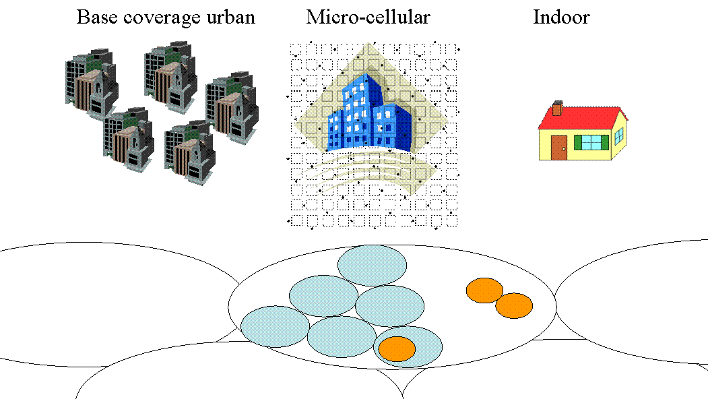
1.2 Test scenarios
For evaluation of the key questions listed above in four selected test environments, a set of reliable and measurement-based channel models are needed.
For evaluation of the key questions listed above, a set of reliable and measurement-based channel models are needed. Channel models have to be accurate due to the fact that radio propagation has a significant impact on the performance of future broadband systems. This is especially true with future multiple-input multiple-output (MIMO) radio communication systems since more of the radio channel degrees of freedom in space, time, frequency, and polarization may be exploited to meet the demands on bit rate, spectrum efficiency and cost. Channel models are needed in performance evaluation of wireless systems, and when choosing modulation and coding, in multi antenna system design, selection of channel estimation method, channel equalization and other baseband algorithm design as well as network planning. It is important to use common and uniform channel models for evaluation, comparison and selection of technologies. In this context it is clear that realistic and reliable multidimensional channel models are important part of performance evaluation of IMT-Advanced.
A central factor of mobile radio propagation environments is multi-path propagation causing fading and channel time dispersion as well as angular dispersion in Tx and Rx. The fading characteristics vary with the propagation environment and its impact on the communication quality (i.e. bit error patterns) is highly dependent on the speed of the mobile station relative to the serving base station.
The purpose of the test environments is to challenge the RITs. Instead of constructing propagation models for all possible IMT-ADVANCED operating environments, a smaller set of test environments is defined which adequately span the overall range of possible environments. The descriptions of these test environments may therefore not correspond with those of the actual operating environments.
This section will identify the propagation model for each test operating environment listed below. For practical reasons, these test operating environments are an appropriate subset of the
IMT-ADVANCED operating environments. While simple models are adequate to evaluate the performance of individual radio links, more complex models are needed to evaluate the overall system-level reliability and suitability of specific technologies. For wideband technologies the number, strength, and relative time delay as well as the directions at Tx and Rx of the many signal components become important. For some technologies (e.g. those employing power control) these models must include coupling between all co-channel propagation links to achieve maximum accuracy. Also, in some cases, the large-scale (shadow fading) temporal variations of the environment must be modelled.
The key parameters to describe each propagation model would include:
– time delay-spread, its structure, and its statistical variability (e.g., probability distribution of time delay spread);
- angular spreads at Tx and Rx;
– geometrical path loss rules;
– shadow fading;
– multipath fading characteristics (e.g. Doppler spectrum, Rician vs. Rayleigh) for the envelope of channels;
- operating radio frequency and bandwidth
- physical structure of deployment (e.g., BS height).
Statistical models are proposed in Section 1.3 to generate path losses and time delay structures for paths in each test environment.
It should be noted that IMT-ADVANCED will be a world-wide standard. Therefore, the models proposed for evaluation of RITs should consider a broad range of environment characteristics, e.g. large and small cities, tropical, rural, and desert areas.
The following sections provide a brief description of the conditions that might be expected in the identified environments. The specific channel parameters are found in the appropriate parts of Annex II.
IMT-ADVANCED may include both mobile wireless and fixed wireless applications. It should be noted that for the purpose of evaluation, operation in the fixed environment is considered to be covered by the mobile test environments. Generally, the fixed wireless channel model will be less complex due to lack of mobility. As a result, there is a trade-off possible between fixed and mobile users which should be considered while evaluating RITs.
1.2.1 Base Coverage Urban test environment
The base coverage urban test environment is intended to proof that continuous, ubiquitous, and cost-effective coverage in built-up areas is feasible in the IMT-Advanced bands by the technology applying to be in the IMT-Advanced family. This scenario will therefore be interference-limited, using macro cells (i.e. radio access points above rooftop level) and still assume that the users require access to demanding services beyond baseline voice and text messages. Evaluations shall be performed by statistical modelling of shadowing effects.
1.2.1.1 Urban macro-cell scenario
In typical urban macro-cell (scenario C2) mobile station is located outdoors at street level and fixed base station clearly above surrounding building heights. As for propagation conditions, non- or obstructed line-of-sight is a common case, since street level is often reached by a single diffraction over the rooftop. The building blocks can form either a regular Manhattan type of grid, or have more irregular locations. Typical building heights in urban environments are over four floors. Buildings height and density in typical urban macro-cell are mostly homogenous.
1.2.1.2 Bad urban macro-cell scenario
Bad urban environment (C3) describes cities with buildings with distinctly inhomogeneous building heights or densities, and results to a clearly dispersive propagation environment in delay and angular domain. The inhomogeneities in city structure can be e.g. due to large water areas separating the built-up areas, or the high-rise skyscrapers in otherwise typical urban environment. Increased delay and angular dispersion can also be caused by mountainous surrounding the city. Base station is typically located above the average rooftop level, but within its coverage range there can also be several high-rise buildings exceeding the base station height. From modelling point of view this differs from typical urban macro-cell by an additional far scatterer cluster.
1.2.1.3 Suburban macro-cell scenario
In suburban macro-cells (scenario C1) base stations are located well above the rooftops to allow wide area coverage, and mobile stations are outdoors at street level. Buildings are typically low residential detached houses with one or two floors, or blocks of flats with a few floors. Occasional open areas such as parks or playgrounds between the houses make the environment rather open. Streets do not form urban-like regular strict grid structure. Vegetation is modest.
1.2.2 Microcellular test environment
The microcellular test environment focuses on smaller cells and higher user densities and traffic loads in city centres and dense urban areas, i.e. it targets the high-performance layer of an
IMT-Advanced system in metropolitan areas. It is thus intended to test performance in high traffic loads and using demanding user requirements, including detailed modelling of buildings (e.g. Manhattan grid deployment) and outdoor-to-indoor coverage. A continuous cellular layout and the associated interference shall be assumed. Radio access points shall be below rooftop level.
1.2.2.1 Outdoor to indoor scenario
In outdoor-to-indoor scenario B4 the MS antenna height is assumed to be at 1 – 2 m (plus the floor height), and the BS antenna height below roof-top, at 5 - 15 m depending on the height of surrounding buildings (typically over four floors high). Outdoor environment is metropolitan area B1, typical urban microcell where the user density is typically high, and thus the requirements for system throughput and spectral efficiency are high. The corresponding indoor environment is A1, typical indoor small office.
1.2.2.2 Urban micro-cell scenario
In urban micro-cell scenario B1 the height of both the antenna at the BS and that at the MS is assumed to be well below the tops of surrounding buildings. Both antennas are assumed to be outdoors in an area where streets are laid out in a Manhattan-like grid. The streets in the coverage area are classified as “the main street”, where there is LOS from all locations to the BS, with the possible exception of cases in which LOS is temporarily blocked by traffic (e.g. trucks and busses) on the street. Streets that intersect the main street are referred to as perpendicular streets, and those that run parallel to it are referred to as parallel streets. This scenario is defined for both LOS and NLOS cases. Cell shapes are defined by the surrounding buildings, and energy reaches NLOS streets as a result of propagation around corners, through buildings, and between them.
1.2.2.3 Bad Urban micro-cell scenario
Bad urban micro-cell scenarios B2 are identical in layout to Urban Micro-cell scenarios, as described above. However, propagation characteristics are such that multipath energy from distant objects can be received at some locations.
This energy can be clustered or distinct, has significant power (up to within a few dB of the earliest received energy), and exhibits long excess delays. Such situations typically occur when there are clear radio paths across open areas, such as large squares, parks or bodies of water.

1.2.3 Indoor test environment
1.2.3.1 Indoor office scenario (A1)
The indoor office scenario investigates isolated cells for office coverage. Both, access point and users are indoors and a detailed modelling of the indoor environment shall be used. High user densities and requirements must be satisfied for stationary or pedestrian users. To further address the large market of small networks serving the needs of nomadic users, also ease of deployment and self-configurability are core parts of this scenario.
Indoor environment A1 represents typical office environment, where the area per floor is
5 000 m2, number of floors is 3 and room dimensions are 10 m x 10 m x 3 m and the corridors have the dimensions 100 m x 5 m x 3 m. The layout of the scenario is shown in Figure 2.
Figure 2
Layout of the indoor office scenario

Rooms: 10 x 10 x 3 m
Corridors: 5 x 100 x 3 m

1.2.3.2 Indoor hotspot scenario (A2)
The indoor hotspot test scenario concentrates on the propagation conditions in a hotspot in the urban with the very higher traffic, like the conference hall, shopping mall and teaching building. The indoor hotspot scenario is also different from the indoor office scenario due to the construction structure. Scenario A2 represents a typical shopping building, where the area per floor is about 5 400 m2, number of floors is 8 and wider hall dimensions are different. The layout of the scenario is shown in Figure 3.

FIGURE 3
Layout of the indoor hotspot scenario
1.2.4 High-speed test environment
The high speed test environment has a challenge in a wide-area system concept since is should allows for reliable links to high-speed trains of up to 350km/h or cars at high velocities. Repeater technology or relays (relaying to the same wide area system, IMT-2000, or to a local area system) can be applied in the vehicle, to allow local access by the customers.
1.2.4.1 Rural macro-cell
Propagation scenario Rural macro-cell D1 represents radio propagation in large areas (radii up to 10 km) with low building density. The height of the AP antenna is typically in the range from 20 to 70 m, which is much higher than the average building height. Consequently, LOS conditions can be expected to exist in most of the coverage area. In case the UE is located inside a building or vehicle, an additional penetration loss is experienced which can possibly be modelled as a (frequency-dependent) constant value. The AP antenna location is fixed in this propagation scenario, and the UE antenna velocity is in the range from 0 to 200 km/h.
1.2.4.2 Moving network
Propagation scenario D2 (Rural Moving Network) represents radio propagation in environments where both the AP and the UE are moving, possibly at very high speed, in a rural area. A typical example of this scenario occurs in carriages of high-speed trains where wireless coverage is provided by so-called moving relay stations (MRSs) which can be mounted, for example, to the ceiling. Note that the link between the fixed network and the moving network (train) is typically a LOS wireless link whose propagation characteristics are represented by propagation scenario D1.

1.3 Channel models
The following sections provide both path loss models and channel models for the terrestrial component.
For the terrestrial environments, the propagation effects are divided into three distinct types of model. These are mean path loss, slow variation about the mean due to shadowing and scattering, and the rapid variation in the signal due to multipath effects. Equations are given for mean path loss for each of the four terrestrial environments. The slow variation is considered to be log-normally distributed. This is described by the standard deviation (given in the deployment model section).
Finally, the rapid variation is characterized by the channel impulse response. Channel impulse response is modelled using a generalised tapped delay line implementation, which also includes the directions of the multipath components in Tx and Rx. The characteristics of the tap variability is characterized by the Doppler spectrum. [Editors note: MIMO aspects should be considered.]

1.3.1 Path loss models
Equations are given for mean path loss as a function of distance for each of the terrestrial environments The slow variation is considered to be log-normally distributed. This is described by the standard deviation (dB) and the decorrelation length of this long-term fading for the vehicular test environment.
Path-loss models at 2 to 6 GHz for considered scenarios have been developed based on measurement results or from literature. The path-loss models have been summarized in the Table 2. MS antenna height dependency is not shown in the table, but can be found in the later sections. Free space attenuation referred in the table is
${\text{PL}}_{\text{free}}=\text{46}\text{.}{\text{4+20log}}_{\text{10}}(d\left[m\right]){\text{+20log}}_{\text{10}}(f\left[\text{GHz}\right]\text{/5}\text{.}0)$ (1.1)
The shadow fading is log-Normal distributed and standard deviation of the distribution is given in decibels.
An empirical propagation loss formula for NLOS outdoor macrocellular scenario such as C1, C2 and C3, which can take the city structure into account and apply the carrier frequency range up to the SHF band and is given as follows.
(dB) (1.2)
where h_{b}, <H> , W denote the BS antenna height, the average building height, and the street width, respectively. f_{c} denotes the carrier frequency. a(h_{m}) is the correction factor for mobile antenna height h_{m} as follows:
. (dB) (1.3)

Table 1
Summary table of the extended path-loss models
Scenario |  | path loss [dB] |  | shadow fading standard dev. (dB) |  | applicability  range and antenna height default values
A1 | LOS |  | 18.7 log₁₀ (d[m]) + 46.8 +  20log₁₀ (f_{c}[GHz]/5.0) |  | σ = 3 |  | 3 m < d < 100 m,  h_{BS} = h_{MS} = 1– 2.5m
A1 | NLOS (Room- Corridor)  NLOS (Room-Room trough wall) |  | PL = 36.8 log₁₀ (d[m]) + 43.8 +  20log₁₀ (f [GHz]/5.0)  PL = 20 log₁₀ (d[m]) + 46.4 +  n_{W} · 5 + 20log₁₀ (f [GHz]/5.0)  PL = 20 log₁₀ (d[m]) + 46.4 +  n_{W} · 12 + 20log₁₀ (f[GHz]/5.0)  where n_{w} is the number of walls between BS and MS. |  | σ = 4  σ = 6  σ = 8 |  | 3 m < d < 100 m,  h_{BS} = h_{MS} = 1– 2.5m  3 m < d < 100 m  (light walls),  h_{BS} = h_{MS} = 1– 2.5m  3 m < d < 100 m  (heavy walls),  h_{BS} = h_{MS} = 1– 2.5m
A2 | LOS |  | 11.8log₁₀(d[m])+49.3+  20log₁₀(f_{c}[GHz]/5.0) |  | σ = 1.5 |  | 20 m < d <60 m  h_{BS} = h_{MS} =1-2.5 m
 | NLOS |  | 43.3log₁₀(d[m])+25.5+  20log₁₀(f_{c}[GHz]/5.0) |  | σ = 1.1 |  | 20 m < d <80 m  h_{BS} =h_{MS} =1-2.5 m
B1 | LOS |  | PL_{LOS} = max(22.7 log₁₀ (d₁ [m]) + 41.0 + 20 log₁₀ (f [GHz]/5.0), PL_{Free})  PL_{LOS} = 40.0 log₁₀ (d₁ [m]) + 9.45 - 17.3log₁₀ (h’_{BS} [m]) +  - 17.3log₁₀ (h’_{MS} [m]) +  +2.7log₁₀(f [GHz]/5.0) |  | σ = 3  σ = 3 |  | 30 m < d₁ < d’_{BP}²⁾  h_{BS} = 10 m  h_{MS} = 1.5 m  d’_{BP} < d₁ < 5 km

 |  | NLOS |  | PL_{NLOS} = PL_{LOS}(d₁) + 20 – 12.5∙n_{j} + 10n_{j}∙log₁₀ (d₂[m])  where n_{j} = max((2.8 – 0.0024d₁[m]), 1.84) | σ = 4 | 10 m < d₁ < 5 km,  w/2 < d₂ < 2 km ³⁾  w =20m  h_{BS} = 10 m  h_{MS} = 1.5 m
B2 | NLOS |  | Same as B1.
B4 | NLOS |  | PL = PL_{b} + PL_{tw} + PL_{in}  where  PL_{b} = PL_{B1}(d_{out} + d_{in}) ,  PL_{tw} = 14 + 15(1 - cos(θ))² ,  PL_{in} = 0.5 d_{in} |  | σ = 7 | 3 m <d_{out}+ d_{in} < 1000 m  h_{BS} = 3n_{Fl} + 2 m  h_{MS} = 1.5 m  See ¹⁾ for explanation of parameters
C1 |  | LOS |  | PL = 23.8 log₁₀ (d [m]) + 41.2 +  20 log₁₀ (f [GHz]/5.0)  PL = 40.0 log₁₀ (d [m]) +  11.65 - 16.2log₁₀ (h_{BS} [m])  - 16.2log₁₀ (h_{MS} [m]) +  3.8log10(f [GHz]/5.0) | σ = 4  σ = 6 | 30 m < d < d_{BP} ⁴⁾  h_{BS} = 25 m  h_{MS} = 1.5 m  d_{BP} < d < 5 km
 |  | NLOS |  | [PL = [44.9-6.55log₁₀(h_{BS}[m])]log₁₀(d[m]) + 31.46 + 5.83log₁₀(h_{BS}[m]) + 20log₁₀(f [GHz]/5.0)] | [σ = 8] | [50 m < d < 5 km  h_{BS} = 25 m  h_{MS} = 1.5 m]
C2 | NLOS |  | [PL = [44.9-6.55log₁₀(h_{BS}[m])]log₁₀(d[m]) + 34.46 + 5.83log₁₀(h_{BS}[m]) + 20log₁₀(f [GHz]/5.0)] |  | [σ = 8] | [50 m < d < 5 km  h_{BS} = 25 m  h_{MS} = 1.5 m]
C3 |  |  | [Same as C2.]
D1 |  | LOS |  | PL = 44.2 + 21.5 log10(d) + 20 log10(f [GHz]/5)  PL = 10.5 + 40.0 log₁₀ (d₁ [m]) - 18.5log₁₀(h_{BS}[m]) - 18.5log₁₀ (h_{MS} [m]) + 1.5log₁₀(f [GHz]/5) | σ = 4  σ = 6 | 30 m < d < d_{BP}⁴⁾  h_{BS} = 32 m  h_{MS} = 1.5 m  d_{BP} < d < 10 km,
 |  | NLOS |  | PL = max((55.4+25.1log₁₀(d[m])  -0.13log₁₀(h_{BS}[m]-25))log₁₀ (d[m]/100)  - 0.9(h_{MS}[m]-1.5) +  21.3 log₁₀(f [GHz]/5.0), PL_{Free}) | σ = 8 | 50 m < d < 5 km  h_{BS} = 32 m  h_{MS} = 1.5 m
D2a |  | LOS |  | PL = 44.2 + 21.5 log10(d) + 20 log10(f [GHz]/5) | σ = 4 | 30 m < d < 2 km  h_{BS} = 32 m  h_{MS} = 3 m

- PL_{B1} is B1 path-loss, d_{out} is the distance between the outside terminal and closest point of the wall to the inside terminal, d_{in} is the distance from wall to the inside terminal , θ is the angle between the outdoor path and the normal of the wall. n_{Fl} is the number of the floor. (Ground floor is the number 1.)
- d’_{BP} = 4 h’_{BS} h’_{MS} f/c, where f = center frequency and c = velocity of light and h’_{BS} and h’_{MS} are the effectice antenna heights at BS and MS respectively: h’_{BS} = h_{BS}-1.0 m, h’_{MS} = h_{MS} – 1.0 m, where 1.0 m is the effective environment height in the urban environment.
- d₁ and d₂ have been explained below.
- d_{BP} = 4 h_{BS} h_{MS} f/c,, where h_{BS} and h_{MS} are the actual antenna heights
The geometry for the d₁- d₂ model is shown in Figure 4, where the BS is located in one street/corridor and the MS is moving in the perpendicular street /corridor. d₁ is the distance from
the BS to the middle point of the street/corridor and d₂ is the distance apart from the middle point
of the crossing of the MS.
Figure 4
Geometry for d₁ - d₂ path-loss model

1.3.1.1 Decorrelation length of the long-term fading
The long-term (log-normal) fading in the logarithmic scale around the mean path loss L (dB) is characterized by a Gaussian distribution with zero mean and standard deviation. Due to the slow fading process versus distance Δx, adjacent fading values are correlated. Its normalized autocorrelation function R(Δx) can be described with sufficient accuracy by an exponential function [3]:
$R\left(Dx\right)=e^{−\frac{\left|Dx\right|}{d_{\text{cor}}}\text{ln}2}$ (1.4)
with the decorrelation length dcor, which is dependent on the environment.

1.3.2 Channel Model Parameters
1.3.2.1 Temporal-Spatial Properties Description
[Editor Note: The angular and delay profiles shape and distribution should be also described in this section. The model details for this sub-section will be described in the later phase and will be discussed during the adhoc meeting within the DG EVAL CHANNEL between Kyoto and Geneva Meeting Feb 2008.]
1.3.2.2 [Primary] Models
The primary models are created using the parameters listed in the Table 2. The channel realizations are obtained by the following step-wise procedure [2]. It has to be noted, that the geometric description covers arrival angles from the last bounce scatterers and respectively departure angles to the first scatterers interacted from the transmitting side. The propagation between the first and the last interaction is not defined. Thus this approach can model also multiple interactions with the scattering media. This indicates also that e.g., the delay of a multipath component can not be determined by the geometry.
[Editor Note: Simulation methodology and procedure will be replaced/enhanced by a flowchart.]

General parameters:
Step 1: Set environment, network layout and antenna array parameters
  - Choose one of the scenarios (A1, A2, B1,…)
  - Give number of BS and MS
  - Give locations of BS and MS, or equally distances of each BS and MS and relative directions ϕ_{LOS} and φ_{LOS} of each BS and MS
  - Give BS and MS antenna field patterns F_{rx} and F_{tx} , and array geometries
  - Give BS and MS array orientations with respect to north (reference) direction
  - Give speed and direction of motion of MS
  - Give system centre frequency
Large scale parameters:
Step 2: Assign propagation condition (LOS/NLOS).
Step 3: Calculate path loss with formulas of Table 1 for each BS-MS link to be modelled.
Step 4: Generate correlated large scale parameters, i.e. delay spread, angular spreads, Ricean K-factor and shadow fading term like explained in [2, section 3.2.1] (Correlations between large scale parameters).
[Editor Note: Ricean spatial K-factor will be considered as a lognormal distributed random variable after further discussion.]
[Editor Note: The dependency of large-scale parameters e.g., delay and angular spread on street-angle (e.g., mean angles etc.) and the incorporation of continuous profile simulation using Markov chain as proposed in Japan Doc. 1243 will be discussed in more details before next meeting during the adhoc.]
Small scale parameters:
Step 5: Generate delays τ.
Delays are drawn randomly from delay distribution defined in Table 2. With exponential delay distribution calculate
$τ_{n}'=−r_{τ}σ_{τ}\text{log}\left(X_{n}\right)$, (1.5)
where r_{τ} is delay distribution proportionality factor, X_{n} ~ Uni(0,1) and cluster index n = 1,…,N. With uniform delay distribution the delay values τ_{n}’ are drawn from the corresponding range. Normalise the delays by subtracting with minimum delay and sort the normalised delays to descending order.
$τ_{n}=\text{sort}\left(τ_{n}'−\text{min}\left(τ_{n}'\right)\right)$. (1.6)
In the case of LOS condition additional scaling of delays is required to compensate the effect of LOS peak addition to the delay spread. Heuristically determined Ricean K-factor dependent scaling constant is
$D=0\text{.}\text{7705}−0\text{.}\text{0433}K+0\text{.}\text{0002}K^{2}+0\text{.}\text{000017}K^{3}$, (1.7)
where K [dB] is the Ricean K-factor defined in Table 2. Scaled delays are
$τ_{n}^{\text{LOS}}={τ_{n}}/D$, (1.8)
they are not to be used in cluster power generation.
[Editor Note: Please reconfirm whether the K=factor in Eq. (1.7) is in dB or linear scale.]
Step 6: Generate cluster powers P.
Cluster powers are calculated assuming a single slope exponential power delay profile. Power assignment depends on the delay distribution defined in Table 2. With exponential delay distribution the cluster powers are determined by
$P_{n}^{'}=\text{exp}\left(−τ_{n}\frac{r_{τ}−1}{r_{τ}σ_{τ}}\right)⋅{\text{10}}^{\frac{−Ζ_{n}}{\text{10}}}$ (1.9)
and with uniform delay distribution they are determined by
$P_{n}^{'}=\text{exp}\left(\frac{−τ_{n}}{σ_{τ}}\right)⋅{\text{10}}^{\frac{−Ζ_{n}}{\text{10}}}$, (1.10)
where Ζ_{n} ~ N(0, ζ ) is the per cluster shadowing term in [dB]. Average the power so that sum power of all clusters is equal to one
$P_{n}=\frac{P_{n}^{'}}{\sum{P_{n}^{'}}}$ (1.11)
Assign the power of each ray within a cluster as P_{n} / M, where M is the number of rays per cluster.
Step 7: Generate arrival angles ϕ and departure angles φ.
As the composite PAS of all clusters is modelled as wrapped Gaussian (see Table 2) the AoA are determined by applying inverse Gaussian function with input parameters P_{n} and RMS angle spread σ_{ϕ}
$ϕ_{n}'=\frac{2σ_{\text{AoA}}\sqrt{−\text{ln}\left(P_{n}/\text{max}\left(P_{n}\right)\right)}}{C}$. (1.12)
On equation above $σ_{\text{AoA}}=σ_{ϕ}/1\text{.}4$ is the standard deviation of arrival angles (factor 1.4 is the ratio of Gaussian std and corresponding “RMS spread”). Constant C is a scaling factor related to total number of clusters and is given in the table below:

# clusters | 4 | 5 | 8 | 10 | 11 | 12 | 14 | 15 | 16 | 20
C | 0.779 | 0.860 | 1.018 | 1.090 | 1.123 | 1.146 | 1.190 | 1.211 | 1.226 | 1.289

In the LOS case constant C is dependent also on Ricean K-factor. Constant C in eq. (1.10) is substituted by C^{LOS}. Additional scaling of angles is required to compensate the effect of LOS peak addition to the angle spread. Heuristically determined Ricean K-factor dependent scaling constant is
$C^{\text{LOS}}=C⋅\left(1\text{.}\text{1035}−0\text{.}\text{028}K−0\text{.}\text{002}K^{2}+0\text{.}\text{0001}K^{3}\right)$, (1.13)
where K [dB] is the Ricean K-factor defined in Table 2.

Assign positive or negative sign to the angles by multiplying with a random variable X_{n} with uniform distribution to discrete set of {1,–1}, add component $Y_{n}\text{\sim }N\left(0,σ_{\text{AoA}}/5\right)$ to introduce random variation
$ϕ_{n}=X_{n}ϕ_{n}'+Y_{n}+ϕ_{\text{LOS}}$, (1.14)
where ϕ_{LOS} is the LOS direction defined in the network layout description Step1.c.

In the LOS case substitute (0.10) by (0.11) to enforce the first cluster to the LOS direction ϕ_{LOS}
$ϕ_{n}=\left(X_{n}ϕ_{n}'+Y_{n}\right)−\left(X_{n}ϕ_{1}'+Y_{1}−ϕ_{\text{LOS}}\right)$. (1.15)
Finally add offset angles α_{m} from [XX] to cluster angles
$ϕ_{n,m}=ϕ_{n}+c_{\text{AoA}}α_{m}$, (1.16)
where c_{AoA} is the cluster-wise rms azimuth spread of arrival angles (cluster ASA) in the Table 2.

Table 1-1
Ray offset angles within a cluster, given for 1° rms angle spread.
Ray number m | Basis vector of offset angles α_{m}
1,2 | ± 0.0447
3,4 | ± 0.1413
5,6 | ± 0.2492
7,8 | ± 0.3715
9,10 | ± 0.5129
11,12 | ± 0.6797
13,14 | ± 0.8844
15,16 | ± 1.1481
17,18 | ± 1.5195
19,20 | ± 2.1551

For departure angles φ_{n} the procedure is analogous.
Step 8: Random coupling of rays within the clusters.
[Editor Note: Clarify the differences between ray, path, sub-path and cluster.]
Couple randomly departure ray angles φ_{n,m} to arrival ray angles ϕ_{n,m} within a cluster n, or within a sub-cluster in the case of two strongest clusters (see step 11 and Table 1-1).

Step 9: Generate vertical-to-horizontal and horizontal-to-vertical cross polarisation power ratios (XPR) κ^{vh} and κ^{hv} respectively for each ray m of each cluster n.
XPR is log-Normal distributed. Draw vertical-to-horizontal XPR values as
$κ_{m,n}^{\text{vh}}={\text{10}}^{X/\text{10}}$, (1.17)
where ray index m = 1,…,M, X ~ N(σ,μ) is Gaussian distributed with σ and μ from Table 2 for XPR_{VH}.
For the horizontal-to-vertical XPR the procedure is analogous.

[Editor Note: The distance dependency of XPR will need further discussion.]

Coefficient generation:
Step 10: Draw random initial phase $\left\{Φ_{n,m}^{\text{vv}},Φ_{n,m}^{\text{vh}},Φ_{n,m}^{\text{hv}},Φ_{n,m}^{\text{hh}}\right\}$ for each ray m of each cluster n and for four different polarisation combinations (vv,vh,hv,hh). Distribution for initial phases is uniform,
Uni(-π,π).
In the LOS case draw also random initial phases $\left\{Φ_{\text{LOS}}^{\text{vv}},Φ_{\text{LOS}}^{\text{hh}}\right\}$ for both VV and HH polarisations.

Step 11: Generate channel coefficients for each cluster n and each receiver and transmitter element pair u,s.
For the N – 2 weakest clusters, say n = 3,4,…,N, and uniform linear arrays (ULA), the channel coefficient are given by:
$\begin{aligned}H_{u,s,n}\left(t\right)=\sqrt{P_{n}}\sum_{m=1}^{M}{}{\left[\begin{matrix}F_{\text{tx},s,V}\left(ϕ_{n,m}\right) \\ F_{\text{tx},s,H}\left(ϕ_{n,m}\right)\end{matrix}\right]}^{T}\left[\begin{matrix}\text{exp}\left({jΦ}_{n,m}^{\text{vv}}\right) & \sqrt{κ_{n,m}^{\text{vh}}}\text{exp}\left({jΦ}_{n,m}^{\text{vh}}\right) \\ \sqrt{κ_{n,m}^{\text{hv}}}\text{exp}\left({jΦ}_{n,m}^{\text{hv}}\right) & \text{exp}\left({jΦ}_{n,m}^{\text{hh}}\right)\end{matrix}\right]\left[\begin{matrix}F_{\text{rx},u,V}\left(φ_{n,m}\right) \\ F_{\text{rx},u,H}\left(φ_{n,m}\right)\end{matrix}\right] \\ ⋅\text{exp}\left({\text{jd}}_{s}2{\text{πλ}}_{0}^{−1}\text{sin}\left(φ_{n,m}\right)\right)\text{exp}\left({\text{jd}}_{u}2{\text{πλ}}_{0}^{−1}\text{sin}\left(ϕ_{n,m}\right)\right)\text{exp}\left(j2{\text{πυ}}_{n,m}t\right)\end{aligned}$ (1.18)

[Editor Note: Ideal dipole antenna pattern has to be extracted from the Finland contribution.]
where F_{rx,u,V} and F_{rx,u,H} are the antenna element u field patterns for vertical and horizontal polarisations respectively, d_{s} and d_{u} are the uniform distances [m] between transmitter elements and receiver elements respectively, and λ₀ is the wave length on carrier frequency. If polarisation is not considered, 2x2 polarisation matrix can be replaced by scalar $\text{exp}\left({jΦ}_{n,m}\right)$ and only vertically polarised field patterns applied.
The Doppler frequency component is calculated from angle of arrival (downlink), MS speed v and direction of travel θ_{v}
$υ_{n,m}=\frac{\left\|v\right\|\text{cos}\left(ϕ_{n,m}−θ_{v}\right)}{λ_{0}}$, (1.19)
For the two strongest clusters, say n = 1 and 2, rays are spread in delay to three sub-clusters (per cluster), with fixed delay offset {0,5,10 ns} (see Table 1-2). Delays of sub-clusters are
$\begin{aligned}τ_{n,1}=τ_{n}+0\text{ns} \\ τ_{n,2}=τ_{n}+5\text{ns} \\ τ_{n,3}=τ_{n}+\text{10}\text{ns}\end{aligned}$ (1.20)
Twenty rays of a cluster are mapped to sub-clusters like presented in Table 1-2 below. Corresponding offset angles are taken from Table 1-1 with mapping of Table 1-2.
Table 1-2
Sub-cluster information for intra cluster delay spread clusters.
sub-cluster # | mapping to rays | power | delay offset
1 | 1,2,3,4,5,6,7,8,19,20 | 10/20 | 0 ns
2 | 9,10,11,12,17,18 | 6/20 | 5 ns
3 | 13,14,15,16 | 4/20 | 10 ns
In the LOS case define $H'_{u,s,n}=H_{u,s,n}$ and determine the channel coefficients by adding single line-of-sight ray and scaling down the other channel coefficient generated by (1.21). The channel coefficients are given by:
$\begin{aligned}H_{u,s,n}\left(t\right)=\sqrt{\frac{1}{K_{R}+1}}H'_{u,s,n}\left(t\right) \\ +δ\left(n−1\right)\sqrt{\frac{1}{K_{R}+1}}{\left[\begin{matrix}F_{\text{tx},s,V}\left(ϕ_{\text{LOS}}\right) \\ F_{\text{tx},s,H}\left(ϕ_{\text{LOS}}\right)\end{matrix}\right]}^{T}\left[\begin{matrix}\text{exp}\left({jΦ}_{\text{LOS}}^{\text{vv}}\right) & 0 \\ 0 & \text{exp}\left({jΦ}_{\text{LOS}}^{\text{hh}}\right)\end{matrix}\right]\left[\begin{matrix}F_{\text{rx},u,V}\left(φ_{\text{LOS}}\right) \\ F_{\text{rx},u,H}\left(φ_{\text{LOS}}\right)\end{matrix}\right] \\ ⋅\text{exp}\left({\text{jd}}_{s}2{\text{πλ}}_{0}^{−1}\text{sin}\left(φ_{\text{LOS}}\right)\right)\text{exp}\left({\text{jd}}_{u}2{\text{πλ}}_{0}^{−1}\text{sin}\left(ϕ_{\text{LOS}}\right)\right)\text{exp}\left(j2{\text{πυ}}_{\text{LOS}}t\right)\end{aligned}$ (1.21)
where δ(.) is the Dirac’s delta function and K_{R} is the Ricean K-factor defined in Table 2 converted to linear scale.
If non-ULA arrays are used the equations must be modified. For arbitrary array configurations on horizontal plane, see [Figure XX], the distance term d_{u} in equations (1.21) and ([1.19]) is replaced by
$d_{u,n,m}^{'}=\frac{\sqrt{x_{u^{2}}+y_{u^{2}}}\text{cos}\left(\text{arctan}\left(y_{u}/x_{u}\right)−ϕ_{n,m}\right)}{\text{sin}ϕ_{n,m}}$, (1.22)
where (x_{u},y_{u}) are co-ordinates of uth element A_{u} and A₀ is the reference element.
Figure 4-1
Modified distance of antenna element u with non-ULA array
Step 12: Apply path loss and shadowing for the channel coefficients.

Generation of bad urban channels (B2, C3)
Bad urban channel realizations can be created as modified C2 and B1 NLOS procedures as follows:
Step 1:
Choose a proportion of mobile users, p (between 0 and 1), which will experience bad urban channel characteristics. Recommended values for bad urban users are 5-15% for C3 and 1-5% for B2. For the remaining 1-p of the users generate typical micro- or macrocellular (B1 or C2) channel realisations as described in [2, section 1.3.2.1].
Step 2:
Drop five far scatterers within a hexagonal cell, within radius [FSmin, FSmax]. For FSmin and FSmax values see Table 1-3. For each mobile user determine the closest two far scatteres, which are then used for calculating far scatterer cluster parameters.
Table 1-3
Far scatterer radii and attenuations for B2 and C3
Scenario | FS_{min} | FS_{max} | FS_{loss}
B2 | 150 m | 500 m | 4 dB/μs
C3 | 300 m | 1500 m | 2 dB/μs
Step 3:
For C3 create 20 delays as described for C2 model in [2, section 1.3.2.1]. step 5. For the shortest 18 delays create a typical urban C2 channel profile (powers and angles) as in [2, section 1.3.2.1].
Similarly, create 14 delays for B1 NLOS, and for the shortest 12 delays create a typical B1 NLOS channel profile as in [2, section 1.3.2.1].
The last two delays in B2 and C3 are assigned for far scatterer clusters.
Step 4:
Set the delays of both the FS clusters zero, and create them typical urban channel powers, as in [2, section 1.3.2.1].
Step 5:
Next create excess delays due to far scatterer clusters as
$τ_{\text{excess}}=\frac{d_{\text{BS}−\text{FS}−\text{MS}}−d_{\text{LOS}}}{c}$ (1.23)
Attenuate FS clusters as FS_{loss,} given in Table 1-3.
Step 6:
Select directions of departure and arrival for each FS cluster according to far scatterer locations. i.e., corresponding to a single reflection from far scatterer.
It is worth noticing that depending on the location of the mobile user within the cell the FS clusters may appear also at shorter delays than the maximum C2 or B1 NLOS cluster. In such cases the far scatterers do not necessarily result to increased angular or delay dispersion. Also the actual channel statistics of the bad urban users depend somewhat on the cell size.
Table 2 - Channel model parameters parameter
[Editor’s Note: The table 2 should also be modified to incorporate C1, C2 and C3 for NLOS scenario as proposed by Doc. 1244 with the condition that the channel coefficients given Eq. (3) of Section 7.2 can be produced by Doc. 1244.]
Table 3
Expectation (median) output values for large scale parameters
Scenario |  | DS (ns) | AS at BS (º) | AS at MS (º) | ES at BS (º) | ES at MS (º)
A1 | LOS | 40 | 44 | 45 | 8 | 9
A1 | NLOS | 25 | 53 | 49 | 11 | 13
A2 | LOS | 27 | 40 | 42
 | NLOS | 41 | 43 | 59
B1 | LOS | 36 | 3 | 25
B1 | NLOS | 76 | 15 | 35
B2 | NLOS | 480 | 33 | 51
B4 | NLOS | 49 | 12 | 58 | 10 | 10
C1 | LOS | 59 | 6 | 30
C1 | NLOS | 75 | 8 | 45
C2 | NLOS | 234 | 8 | 53
C3 | NLOS | 630 | 17 | 55
D1 | LOS | 16 | 17 | 33
D1 | NLOS | 37 | 9 | 33
D2a | LOS | 39 | 5 | 30

[Editor Note: The table 3 should also be modified to incorporate C1, C2 and C3 for NLOS scenario as proposed by Doc. 1244 with the condition that the channel coefficients given Eq. (3) of Section 7.2 can be produced by Doc. 1244.]
[Editor Note: Elevation spread for bothe MS and BS for A2 scenario will be submitted by next meeting.]
1.3.2.2 Reduced Variability Models
In the CDL model each cluster is composed of 20 rays with fixed offset angles and identical power. In the case of cluster where a ray of dominant power exists, the cluster has 20+1 rays. This dominant ray has a zero angle offset. The departure and arrival rays are coupled randomly. The CDL table of all scenarios of interest are give below, where the cluster power and the power of each ray are tabulated. The CDL models offer well-defined radio channels with fixed parameters to obtain comparable simulation results with relatively non-complicated channel models.
Delay spread and azimuth spreads medians of the CDL models are equal to median values given in Table 3.
The following steps are used to generate a MIMO channel with transmit and receive antennas using the reduced variability or CDL model. For the purpose of illustration, let us assume that the target channel profile has taps.

Step 1:
Generate the path loss based on the distance between the transmitter and receiver based using the path loss models in Error: Reference source not found Error: Reference source not found.
Step 2:
Generate the shadow fading loss using the model in Error: Reference source not found Error: Reference source not found
Step 3:
For each tap , in the targeted channel model, generate a transmit and receive correlation matrices and using the transmit and receive antenna geometry, the per tap mean AoA, mean AoD, and the corresponding cluster ASD and ASA.

Step 4:
Generate SISO links based on the chosen channel profile as follows
  - Let and represent the power-delay profile for the specified channel model.
  - Generate independent fading processes each having a Doppler spread (function of the chosen mobile speed). [ One issue that needs to be resolved here is the issue of the Doppler spectrum or the scattering processes associated with each fading process. Note that each CDLN model specifies an departure and arrival angle spread which in some sense defines the scattering process, i..e the Doppler spectrum]
  - Scale the -th Rayleigh process by where

Step 5:
Given the SISO links generated in step 4 above, each is described by processes, we define the following -th tap gain matrix for every channel sample (i.e. for every )
Step 6:
Color the tap gain matrix by the receive and transmit correlation matrices as follows

Step 7:
The channel tap gains with corresponding tap delays fully describe the multipath channel between transmit antenna and receive antenna . In order to generate an equivalent digital channel, say with taps, the effect of the pulse shaping, transmit, and receive filters needs to be taken into account. The following steps may be used to generate the equivalent digital channel.
- Let be the combined effect of the pulse shaping, transmit, and receive filters.
- Define the pulse shaping matrix as
where is the channel sampling period.
- The equivalent digital channel taps can be calculated as

A1 – Indoor office
The CDL parameters of LOS and NLOS condition are given below. In the LOS model Ricean K-factor is 8.1 dB, which corresponds to 3m distance between Tx and Rx.
Table 4
Scenario A1: LOS Clustered delay line model, indoor office
Cluster # | Delay [ns] |  |  | Power [dB] |  |  | AoD [º] | AoA [º] | Ray power [dB] |  | Cluster ASD = 5º | Cluster ASA = 5º
1 | 0 |  |  | 0.0 |  |  | 0 | 0 | -0.08* | -30.2** | Cluster ASD = 5º | Cluster ASA = 5º
2 | 20 |  |  | -25.3 |  |  | -160 | 164 | -38.3 |  | Cluster ASD = 5º | Cluster ASA = 5º
3 | 35 | 40 | 45 | -15.7 | -17.9 | -19.7 | -113 | -116 | -25.7 |  | Cluster ASD = 5º | Cluster ASA = 5º
4 | 45 |  |  | -21.0 |  |  | -146 | 149 | -34.0 |  | Cluster ASD = 5º | Cluster ASA = 5º
5 | 45 |  |  | -19.4 |  |  | 140 | 143 | -32.4 |  | Cluster ASD = 5º | Cluster ASA = 5º
6 | 90 |  |  | -23.3 |  |  | 153 | 157 | -36.3 |  | Cluster ASD = 5º | Cluster ASA = 5º
7 | 110 | 115 | 120 | -18.8 | -21.0 | -22.7 | 148 | 151 | -28.8 |  | Cluster ASD = 5º | Cluster ASA = 5º
8 | 155 |  |  | -25.2 |  |  | -159 | 163 | -38.2 |  | Cluster ASD = 5º | Cluster ASA = 5º
9 | 190 |  |  | -21.6 |  |  | 148 | 151 | -34.7 |  | Cluster ASD = 5º | Cluster ASA = 5º
10 | 245 |  |  | -19.1 |  |  | -139 | -142 | -32.1 |  | Cluster ASD = 5º | Cluster ASA = 5º
11 | 255 |  |  | -27.9 |  |  | -168 | -172 | -40.9 |  | Cluster ASD = 5º | Cluster ASA = 5º
12 | 320 |  |  | -30.5 |  |  | 176 | -180 | -43.5 |  | Cluster ASD = 5º | Cluster ASA = 5º
* Power of dominant ray,
** Power of each other ray

Figure 5
PDP and frequency correlation (FCF) of CDL model
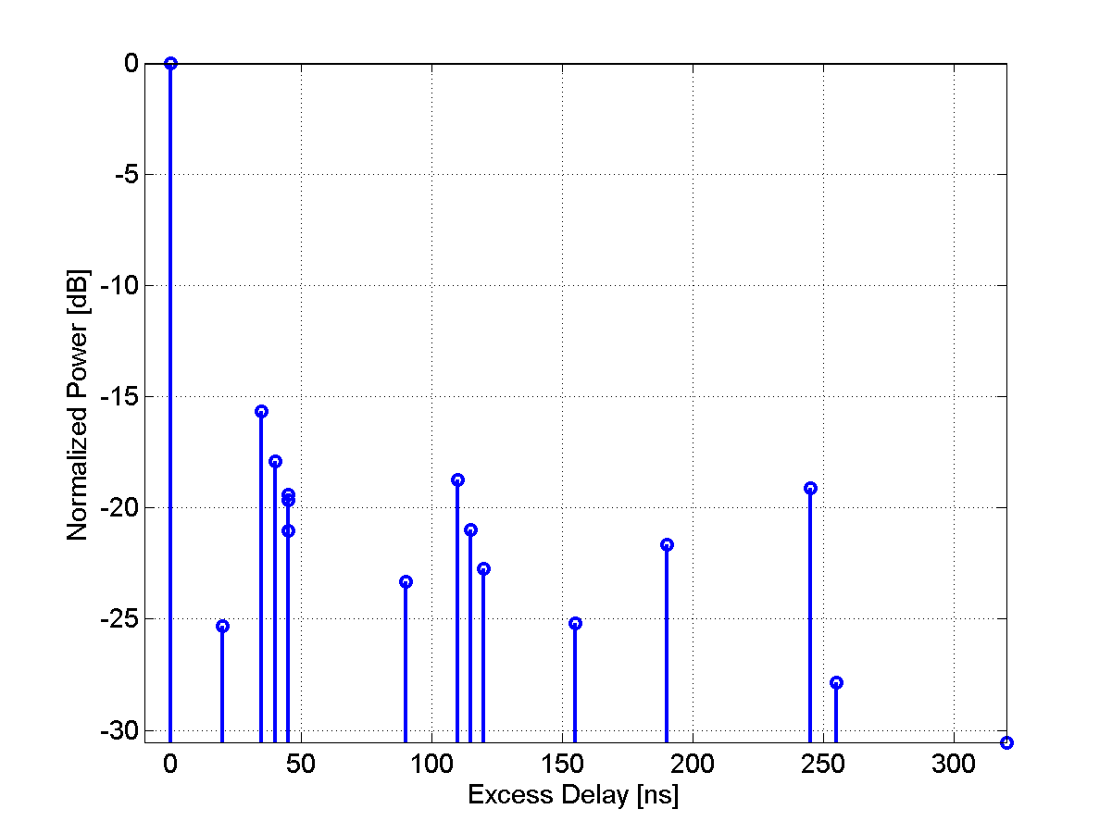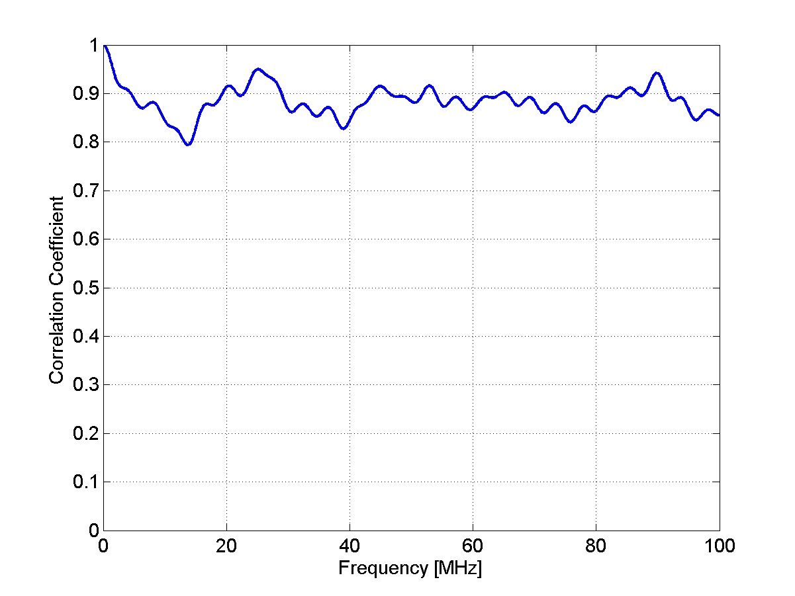
Table 5
Scenario A1 NLOS Clustered delay line model, indoor office
Cluster # | Delay [ns] |  |  | Power [dB] |  |  | AoD [º] | AoA [º] | Ray power [dB] | Cluster ASD = 5º | Cluster ASA = 5º
1 | 0 | 5 | 10 | -3.0 | -5.2 | -7.0 | 0 | 0 | -13.0 | Cluster ASD = 5º | Cluster ASA = 5º
2 | 5 |  |  | -4.0 |  |  | 59 | -55 | -17.0 | Cluster ASD = 5º | Cluster ASA = 5º
3 | 20 |  |  | -4.7 |  |  | -64 | -59 | -17.7 | Cluster ASD = 5º | Cluster ASA = 5º
4 | 25 |  |  | -9.0 |  |  | 89 | -82 | -22.0 | Cluster ASD = 5º | Cluster ASA = 5º
5 | 30 |  |  | -8.0 |  |  | 83 | -77 | -21.0 | Cluster ASD = 5º | Cluster ASA = 5º
6 | 30 | 35 | 40 | -4.0 | -6.2 | -8.0 | -67 | 62 | -14.0 | Cluster ASD = 5º | Cluster ASA = 5º
7 | 35 |  |  | -1.1 |  |  | 32 | 29 | -14.2 | Cluster ASD = 5º | Cluster ASA = 5º
8 | 45 |  |  | -5.2 |  |  | -67 | 62 | -18.2 | Cluster ASD = 5º | Cluster ASA = 5º
9 | 55 |  |  | -9.5 |  |  | -91 | -84 | -22.5 | Cluster ASD = 5º | Cluster ASA = 5º
10 | 65 |  |  | -7.9 |  |  | -83 | 77 | -20.9 | Cluster ASD = 5º | Cluster ASA = 5º
11 | 75 |  |  | -6.8 |  |  | -77 | -71 | -19.8 | Cluster ASD = 5º | Cluster ASA = 5º
12 | 90 |  |  | -14.8 |  |  | -113 | 105 | -27.8 | Cluster ASD = 5º | Cluster ASA = 5º
13 | 110 |  |  | -12.8 |  |  | -106 | 98 | -25.8 | Cluster ASD = 5º | Cluster ASA = 5º
14 | 140 |  |  | -14.1 |  |  | 111 | -103 | -27.2 | Cluster ASD = 5º | Cluster ASA = 5º
15 | 210 |  |  | -26.7 |  |  | -152 | 141 | -39.7 | Cluster ASD = 5º | Cluster ASA = 5º
16 | 250 |  |  | -32.5 |  |  | -168 | -156 | -45.5 | Cluster ASD = 5º | Cluster ASA = 5º

Figure 6
PDP and frequency correlation (FCF) of CDL model
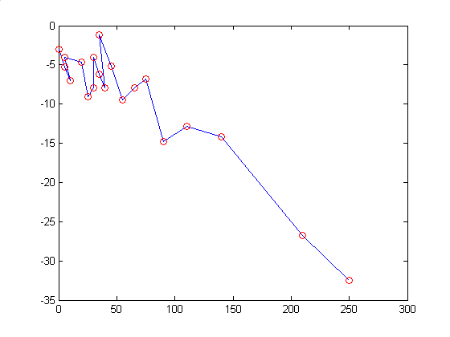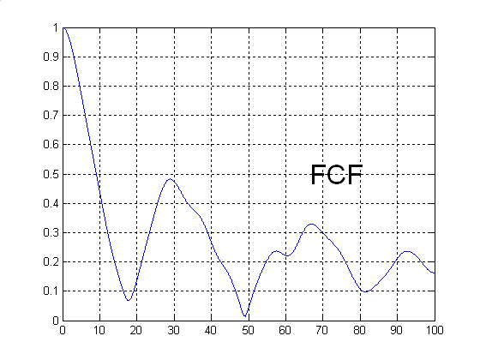
A2 – Indoor hotspot
The CDL parameters of LOS and NLOS condition are given below. In the LOS model Ricean K factor are 15.3 dB and 10.4 dB, respectively for the first and second clusters.
Table 6
Scenario A2 LOS Clustered delay line model, indoor hotspot
Cluster # | Delay [ns] | Power [dB] | AoD [º] | AoA [º] | Ray power [dB] |  | Cluster ASD = 5º | Cluster ASA = 8º
1 | 0 | 0 | 0 | 0 | -0.1* | -28.4** | Cluster ASD = 5º | Cluster ASA = 8º
2 | 5 | -3.4 | 7 | -2 | -3.7* | -27.1** | Cluster ASD = 5º | Cluster ASA = 8º
3 | 10 | -9.2 | 0 | -12 | -22.2 |  | Cluster ASD = 5º | Cluster ASA = 8º
4 | 20 | -18.9 | 7 | 13 | -31.9 |  | Cluster ASD = 5º | Cluster ASA = 8º
5 | 30 | -17.1 | 11 | 16 | -30.1 |  | Cluster ASD = 5º | Cluster ASA = 8º
6 | 40 | -16.3 | -7 | -34 | -29.3 |  | Cluster ASD = 5º | Cluster ASA = 8º
7 | 50 | -13.7 | -60 | -12 | -26.7 |  | Cluster ASD = 5º | Cluster ASA = 8º
8 | 60 | -16.3 | -43 | -17 | -29.3 |  | Cluster ASD = 5º | Cluster ASA = 8º
9 | 70 | -16.8 | 11 | -59 | -29.8 |  | Cluster ASD = 5º | Cluster ASA = 8º
10 | 80 | -17.9 | 8 | -78 | -30.9 |  | Cluster ASD = 5º | Cluster ASA = 8º
11 | 90 | -15.9 | 14 | -65 | -28.9 |  | Cluster ASD = 5º | Cluster ASA = 8º
12 | 100 | -17.4 | -1 | -56 | -30.4 |  | Cluster ASD = 5º | Cluster ASA = 8º
13 | 110 | -25.8 | -11 | -57 | -38.8 |  | Cluster ASD = 5º | Cluster ASA = 8º
14 | 120 | -31.0 | -129 | -22 | -44.0 |  | Cluster ASD = 5º | Cluster ASA = 8º
15 | 130 | -33.4 | -123 | -12 | -46.4 |  | Cluster ASD = 5º | Cluster ASA = 8º
* Power of dominant ray,
** Power of each other ray

FIGURE 7
PDP and frequency correlation (FCF) of CDL model
Table 7
Scenario A2 NLOS Clustered delay line model, indoor hotspot
Cluster # | Delay [ns] | Power [dB] | AoD [º] | AoA [º] | Ray power [dB] | Cluster ASD = 5º | Cluster ASA = 11º
1 | 0 | -6.9 | 2 | 2 | -19.9 | Cluster ASD = 5º | Cluster ASA = 11º
2 | 5 | 0 | -2 | 9 | -13.0 | Cluster ASD = 5º | Cluster ASA = 11º
3 | 10 | -0.7 | -7 | 14 | -13.7 | Cluster ASD = 5º | Cluster ASA = 11º
4 | 15 | -1.0 | -3 | -7 | -14.0 | Cluster ASD = 5º | Cluster ASA = 11º
5 | 20 | -1.4 | -1 | -6 | -14.4 | Cluster ASD = 5º | Cluster ASA = 11º
6 | 25 | -3.8 | -5 | -18 | -16.8 | Cluster ASD = 5º | Cluster ASA = 11º
7 | 30 | -2.6 | 0 | -3 | -15.6 | Cluster ASD = 5º | Cluster ASA = 11º
8 | 35 | -0.2 | -6 | -3 | -13.2 | Cluster ASD = 5º | Cluster ASA = 11º
9 | 45 | -3.6 | -9 | 14 | -16.6 | Cluster ASD = 5º | Cluster ASA = 11º
10 | 55 | -5.7 | 1 | 44 | -18.7 | Cluster ASD = 5º | Cluster ASA = 11º
11 | 65 | -11.6 | 4 | 13 | -24.6 | Cluster ASD = 5º | Cluster ASA = 11º
12 | 75 | -8.9 | -5 | 65 | -21.9 | Cluster ASD = 5º | Cluster ASA = 11º
13 | 95 | -7.3 | -11 | 46 | -20.3 | Cluster ASD = 5º | Cluster ASA = 11º
14 | 115 | -11.2 | -4 | 35 | -24.2 | Cluster ASD = 5º | Cluster ASA = 11º
15 | 135 | -13.5 | -3 | 48 | -26.5 | Cluster ASD = 5º | Cluster ASA = 11º
16 | 155 | -13.4 | -7 | 41 | -26.4 | Cluster ASD = 5º | Cluster ASA = 11º
17 | 175 | -12.2 | 8 | 7 | -25.2 | Cluster ASD = 5º | Cluster ASA = 11º
18 | 195 | -14.7 | 4 | 69 | -27.7 | Cluster ASD = 5º | Cluster ASA = 11º
19 | 215 | -15.8 | -11 | 133 | -28.8 | Cluster ASD = 5º | Cluster ASA = 11º

FIGURE 8
PDP and frequency correlation (FCF) of CDL model

B1 – Urban micro-cell
In the LOS model Ricean K-factor is 3.3 dB, which corresponds to 20m distance between Tx and Rx.
Table 8
Scenario B1: LOS clustered delay line model, urban mico-cell
Cluster # | Delay [ns] |  |  | Power [dB] |  |  | AoD [º] | AoA [º] | Ray power [dB] |  | Cluster ASD = 3º | Cluster ASA = 18º
1 | 0 |  |  | 0.0 |  |  | 0 | 0 | -0.31* | -24.7** | Cluster ASD = 3º | Cluster ASA = 18º
2 | 30 | 35 | 40 | -10.5 | -12.7 | -14.5 | 5 | 45 | -20.5 |  | Cluster ASD = 3º | Cluster ASA = 18º
3 | 55 |  |  | -14.8 |  |  | 8 | 63 | -27.8 |  | Cluster ASD = 3º | Cluster ASA = 18º
4 | 60 | 65 | 70 | -13.6 | -15.8 | -17.6 | 8 | -69 | -23.6 |  | Cluster ASD = 3º | Cluster ASA = 18º
5 | 105 |  |  | -13.9 |  |  | 7 | 61 | -26.9 |  | Cluster ASD = 3º | Cluster ASA = 18º
6 | 115 |  |  | -17.8 |  |  | 8 | -69 | -30.8 |  | Cluster ASD = 3º | Cluster ASA = 18º
7 | 250 |  |  | -19.6 |  |  | -9 | -73 | -32.6 |  | Cluster ASD = 3º | Cluster ASA = 18º
8 | 460 |  |  | -31.4 |  |  | 11 | 92 | -44.4 |  | Cluster ASD = 3º | Cluster ASA = 18º

* Power of dominant ray,
** Power of each other ray
Figure 9
PDP and frequency correlation (FCF) of CDL model
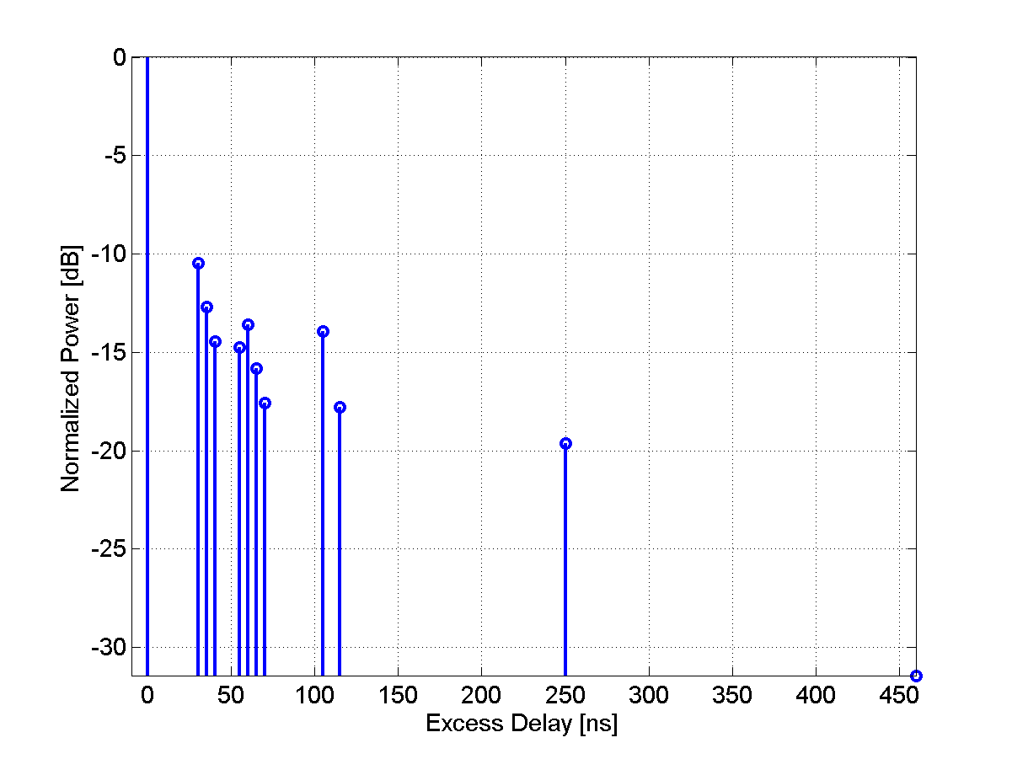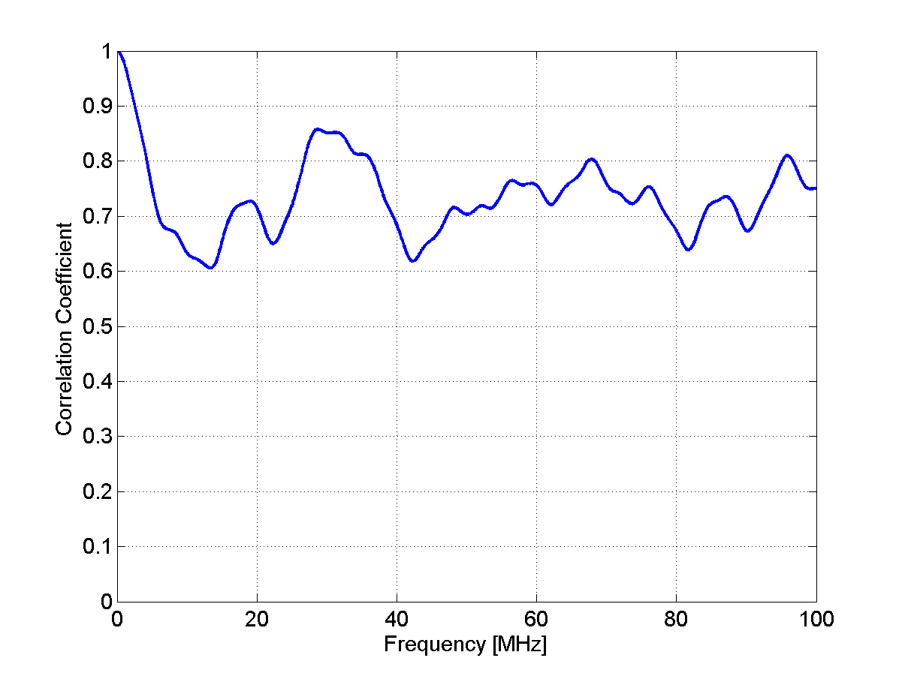
Table 9
Scenario B1: NLOS Clustered delay line model, urban micro-cell
Cluster # | Delay [ns] |  |  | Power [dB] |  |  | AoD [º] | AoA [º] | Ray power [dB] | Cluster ASD =10º | Cluster ASD = 22º
1 | 0 |  |  | -1.0 |  |  | 8 | -20 | -14.0 | Cluster ASD =10º | Cluster ASD = 22º
2 | 90 | 95 | 100 | -3.0 | -5.2 | -7.0 | 0 | 0 | -13.0 | Cluster ASD =10º | Cluster ASD = 22º
3 | 100 | 105 | 110 | -3.9 | -6.1 | -7.9 | -24 | 57 | -13.9 | Cluster ASD =10º | Cluster ASD = 22º
4 | 115 |  |  | -8.1 |  |  | -24 | -55 | -21.1 | Cluster ASD =10º | Cluster ASD = 22º
5 | 230 |  |  | -8.6 |  |  | -24 | 57 | -21.6 | Cluster ASD =10º | Cluster ASD = 22º
6 | 240 |  |  | -11.7 |  |  | 29 | 67 | -24.7 | Cluster ASD =10º | Cluster ASD = 22º
7 | 245 |  |  | -12.0 |  |  | 29 | -68 | -25.0 | Cluster ASD =10º | Cluster ASD = 22º
8 | 285 |  |  | -12.9 |  |  | 30 | 70 | -25.9 | Cluster ASD =10º | Cluster ASD = 22º
9 | 390 |  |  | -19.6 |  |  | -37 | -86 | -32.6 | Cluster ASD =10º | Cluster ASD = 22º
10 | 430 |  |  | -23.9 |  |  | 41 | -95 | -36.9 | Cluster ASD =10º | Cluster ASD = 22º
11 | 460 |  |  | -22.1 |  |  | -39 | -92 | -35.1 | Cluster ASD =10º | Cluster ASD = 22º
12 | 505 |  |  | -25.6 |  |  | -42 | -99 | -38.6 | Cluster ASD =10º | Cluster ASD = 22º
13 | 515 |  |  | -23.3 |  |  | -40 | 94 | -36.4 | Cluster ASD =10º | Cluster ASD = 22º
14 | 595 |  |  | -32.2 |  |  | 47 | 111 | -45.2 | Cluster ASD =10º | Cluster ASD = 22º
15 | 600 |  |  | -31.7 |  |  | 47 | 110 | -44.7 | Cluster ASD =10º | Cluster ASD = 22º
16 | 615 |  |  | -29.9 |  |  | 46 | -107 | -42.9 | Cluster ASD =10º | Cluster ASD = 22º

Figure 10
PDP and frequency correlation (FCF) of CDL model
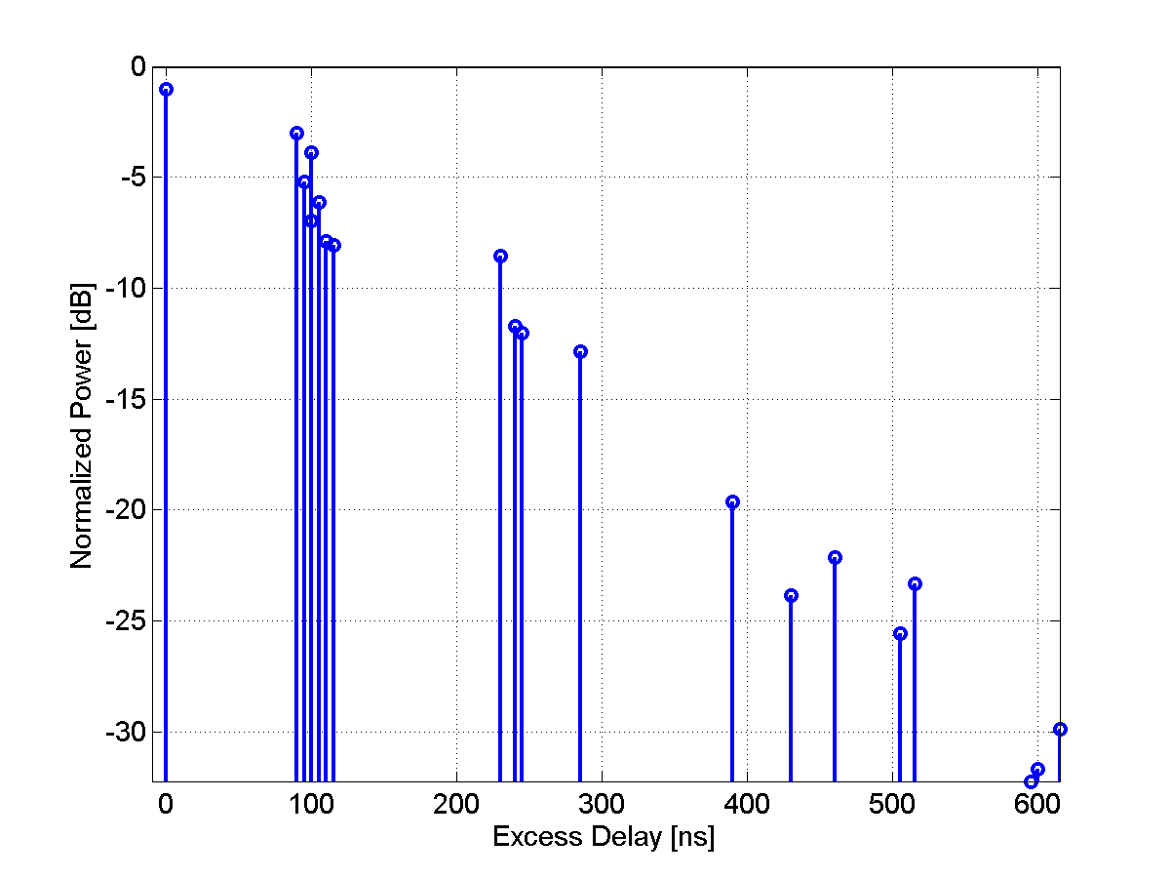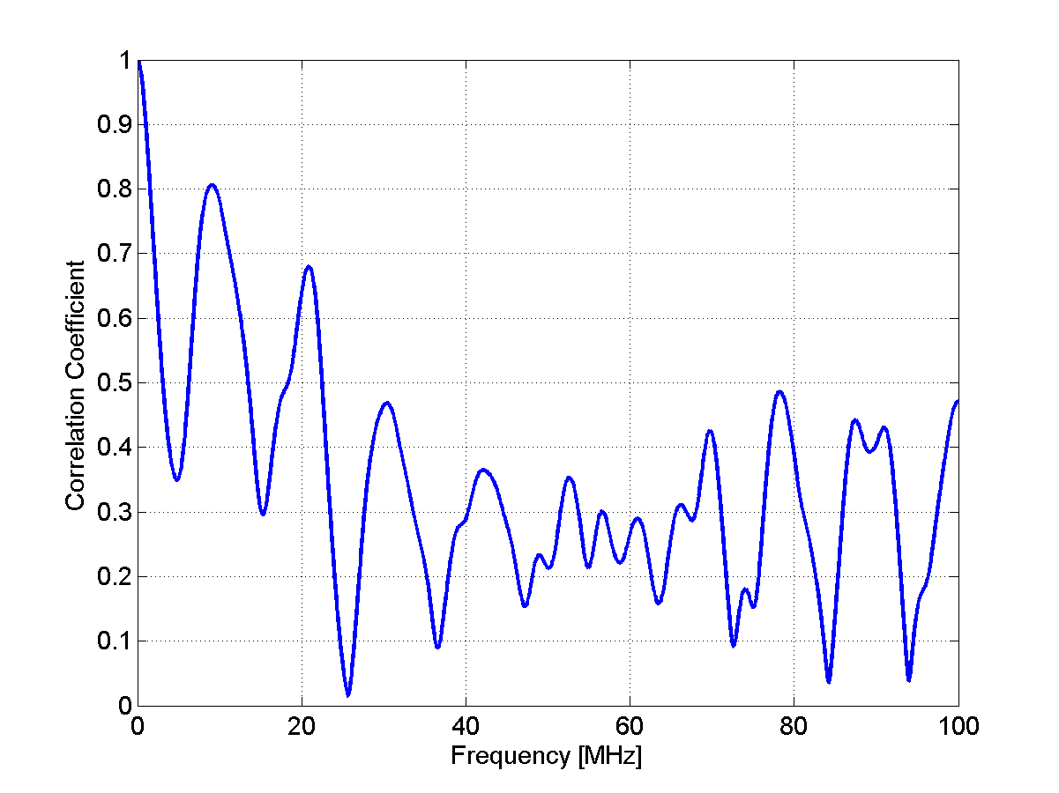
B2 – Bad Urban micro-cell
Table 10
Scenario B2: NLOS Clustered delay line model, bad urban micro-cell
Cluster # | Delay [ns] |  |  | Power [dB] |  |  | AoD [º] | AoA [º] | Ray power [dB] | Cluster ASD = 3º | Cluster ASA = 5º
1 | 0 | 5 | 10 | -3.0 | -5.2 | -7.0 | 0 | 0 | -13.0 | Cluster ASD = 3º | Cluster ASA = 5º
2 | 25 | 30 | 35 | -3.4 | -5.6 | -7.3 | -14 | 31 | -13.4 | Cluster ASD = 3º | Cluster ASA = 5º
3 | 25 |  |  | -1.7 |  |  | -13 | 30 | -14.7 | Cluster ASD = 3º | Cluster ASA = 5º
4 | 35 |  |  | -1.9 |  |  | -14 | 31 | -14.9 | Cluster ASD = 3º | Cluster ASA = 5º
5 | 45 |  |  | -2.2 |  |  | 15 | -34 | -15.2 | Cluster ASD = 3º | Cluster ASA = 5º
6 | 70 |  |  | -5.0 |  |  | 22 | 51 | -18.0 | Cluster ASD = 3º | Cluster ASA = 5º
7 | 70 |  |  | -3.6 |  |  | 19 | 44 | -16.6 | Cluster ASD = 3º | Cluster ASA = 5º
8 | 90 |  |  | -3.8 |  |  | -19 | -45 | -16.8 | Cluster ASD = 3º | Cluster ASA = 5º
9 | 155 |  |  | -6.4 |  |  | -25 | -58 | -19.4 | Cluster ASD = 3º | Cluster ASA = 5º
10 | 170 |  |  | -2.7 |  |  | -17 | -38 | -15.7 | Cluster ASD = 3º | Cluster ASA = 5º
11 | 180 |  |  | -7.5 |  |  | -27 | -63 | -20.5 | Cluster ASD = 3º | Cluster ASA = 5º
12 | 395 |  |  | -16.5 |  |  | -41 | 93 | -29.5 | Cluster ASD = 3º | Cluster ASA = 5º
13 | 1600 |  |  | -5.7 |  |  | -110 | 15 | -18.7 | Cluster ASD = 3º | Cluster ASA = 5º
14 | 2800 |  |  | -7.7 |  |  | 75 | -25 | -20.7 | Cluster ASD = 3º | Cluster ASA = 5º

Figure 11
PDP and frequency correlation (FCF) of CDL model
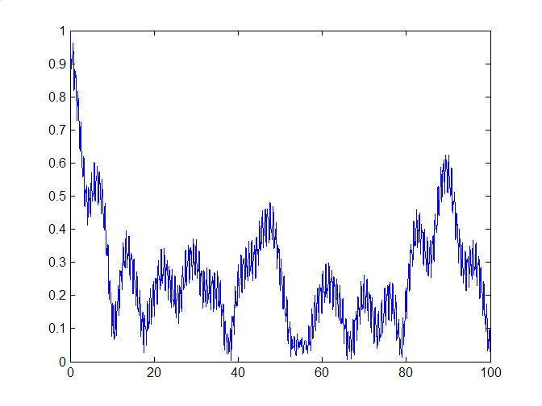
B4 – Outdoor to indoor
[Editor’s Note: The B4 terminology is a concern since it doesn’t have a flow with the previous B1 and B2 models. Further discussion required to make all test scenarios terminology more consistent.]
Table 11
Scenario B4: NLOS Clustered delay line model, outdoor to indoor
Cluster # | Delay [ns] |  |  | Power [dB] |  |  | AoD [º] | AoA [º] | Ray power [dB] | Cluster ASD = 5º | Cluster ASA = 8º
1 | 0 |  |  | -7.7 |  |  | 29 | 102 | -20.8 | Cluster ASD = 5º | Cluster ASA = 8º
2 | 10 | 15 | 20 | -3.0 | -5.2 | -7.0 | 0 | 0 | -13.0 | Cluster ASD = 5º | Cluster ASA = 8º
3 | 20 |  |  | -3.7 |  |  | 20 | 70 | -16.7 | Cluster ASD = 5º | Cluster ASA = 8º
4 | 35 |  |  | -3.0 |  |  | -18 | -64 | -16.0 | Cluster ASD = 5º | Cluster ASA = 8º
5 | 35 |  |  | -3.0 |  |  | 18 | -63 | -16.0 | Cluster ASD = 5º | Cluster ASA = 8º
6 | 50 |  |  | -3.7 |  |  | 20 | 70 | -16.7 | Cluster ASD = 5º | Cluster ASA = 8º
7 | 55 | 60 | 65 | -5.4 | -7.6 | -9.4 | 29 | 100 | -15.4 | Cluster ASD = 5º | Cluster ASA = 8º
8 | 140 |  |  | -5.3 |  |  | 24 | 84 | -18.3 | Cluster ASD = 5º | Cluster ASA = 8º
9 | 175 |  |  | -7.6 |  |  | 29 | 100 | -20.6 | Cluster ASD = 5º | Cluster ASA = 8º
10 | 190 |  |  | -4.3 |  |  | -21 | 76 | -17.3 | Cluster ASD = 5º | Cluster ASA = 8º
11 | 220 |  |  | -12.0 |  |  | 36 | -126 | -25.0 | Cluster ASD = 5º | Cluster ASA = 8º
12 | 585 |  |  | -20.0 |  |  | 46 | 163 | -33.0 | Cluster ASD = 5º | Cluster ASA = 8º

Figure 12
PDP and frequency correlation (FCF) of CDL model
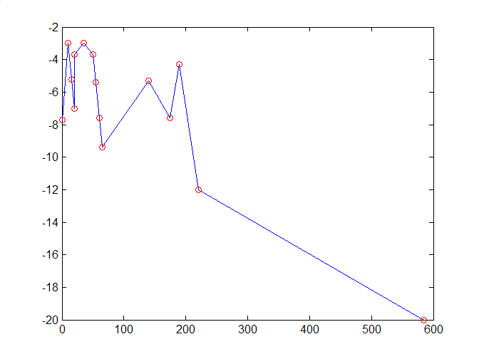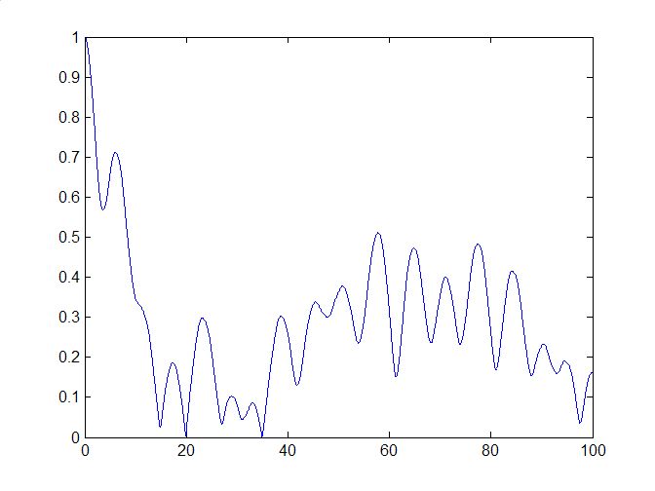
C1 – Suburban
The CDL parameters of LOS and NLOS condition are given below. In the LOS model Ricean K-factor is 12.9 dB, which corresponds to 200m distance between Tx and Rx.
[Editor Note: Japan Doc. 1244 proposed to incorporate the distance dependency of the C1 NLOS scenario into the table. This issue will need to be further discussed in the next meeting.]
Table 12
Scenario C1: LOS Clustered delay line model, suburban
Cluster # | Delay [ns] |  |  | Power [dB] |  |  | AoD [º] | AoA [º] | Ray power [dB] |  | Cluster ASD = 5º | Cluster ASD = 5º
1 | 0 | 5 | 10 | 0.0 | -25.3 | -27.1 | 0 | 0 | -0.02* | -33.1** | Cluster ASD = 5º | Cluster ASD = 5º
2 | 85 |  |  | -21.6 |  |  | -29 | -144 | -34.7 |  | Cluster ASD = 5º | Cluster ASD = 5º
3 | 135 |  |  | -26.3 |  |  | -32 | -159 | -39.3 |  | Cluster ASD = 5º | Cluster ASD = 5º
4 | 135 |  |  | -25.1 |  |  | -31 | 155 | -38.1 |  | Cluster ASD = 5º | Cluster ASD = 5º
5 | 170 |  |  | -25.4 |  |  | 31 | 156 | -38.4 |  | Cluster ASD = 5º | Cluster ASD = 5º
6 | 190 |  |  | -22.0 |  |  | 29 | -146 | -35.0 |  | Cluster ASD = 5º | Cluster ASD = 5º
7 | 275 |  |  | -29.2 |  |  | -33 | 168 | -42.2 |  | Cluster ASD = 5º | Cluster ASD = 5º
8 | 290 | 295 | 300 | -24.3 | -26.5 | -28.2 | 35 | -176 | -34.3 |  | Cluster ASD = 5º | Cluster ASD = 5º
9 | 290 |  |  | -23.2 |  |  | -30 | 149 | -36.2 |  | Cluster ASD = 5º | Cluster ASD = 5º
10 | 410 |  |  | -32.2 |  |  | 35 | -176 | -45.2 |  | Cluster ASD = 5º | Cluster ASD = 5º
11 | 445 |  |  | -26.5 |  |  | -32 | -159 | -39.5 |  | Cluster ASD = 5º | Cluster ASD = 5º
12 | 500 |  |  | -32.1 |  |  | 35 | -176 | -45.1 |  | Cluster ASD = 5º | Cluster ASD = 5º
13 | 620 |  |  | -28.5 |  |  | 33 | -165 | -41.5 |  | Cluster ASD = 5º | Cluster ASD = 5º
14 | 655 |  |  | -30.5 |  |  | 34 | -171 | -43.5 |  | Cluster ASD = 5º | Cluster ASD = 5º
15 | 960 |  |  | -32.6 |  |  | 35 | 177 | -45.6 |  | Cluster ASD = 5º | Cluster ASD = 5º
* Power of dominant ray,
** Power of each other ray
Figure 13
PDP and frequency correlation (FCF) of CDL model
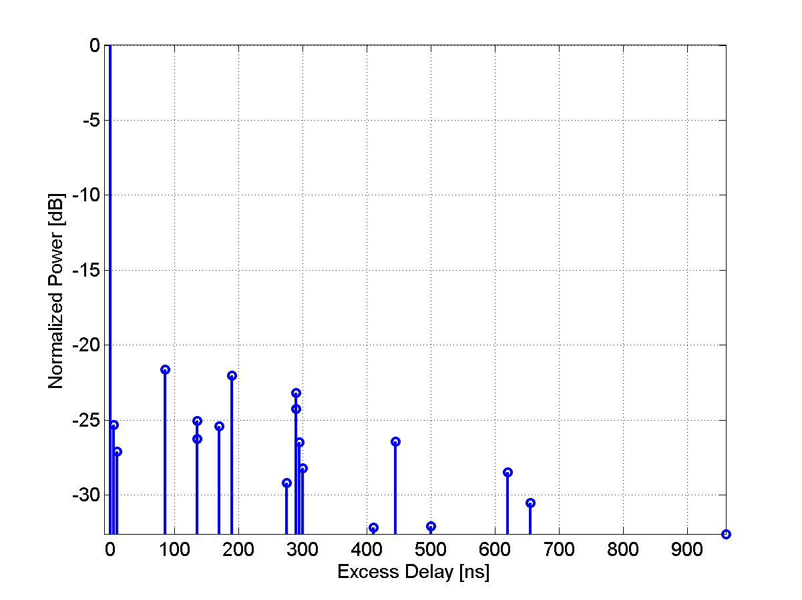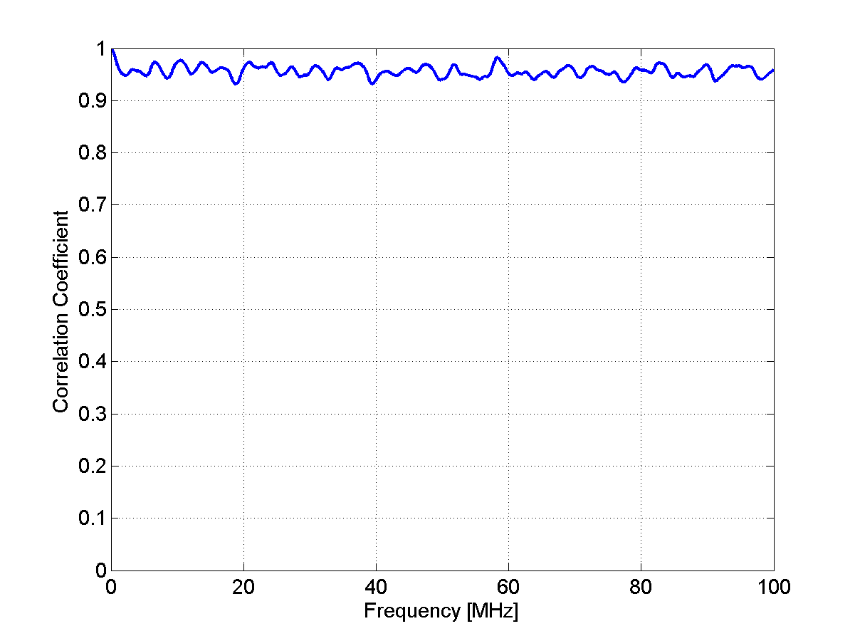
Table 13
Scenario C1: NLOS Clustered delay-line model, suburban
Cluster # | Delay [ns] |  |  | Power [dB] |  |  | AoD [º] | AoA [º] | Ray power [dB] | Cluster ASD = 2º | Cluster ASD = 10º
1 | 0 | 5 | 10 | -3.0 | -5.2 | -7.0 | 0 | 0 | -13.0 | Cluster ASD = 2º | Cluster ASD = 10º
2 | 25 |  |  | -7.5 |  |  | 13 | -71 | -20.5 | Cluster ASD = 2º | Cluster ASD = 10º
3 | 35 |  |  | -10.5 |  |  | -15 | -84 | -23.5 | Cluster ASD = 2º | Cluster ASD = 10º
4 | 35 |  |  | -3.2 |  |  | -8 | 46 | -16.2 | Cluster ASD = 2º | Cluster ASD = 10º
5 | 45 | 50 | 55 | -6.1 | -8.3 | -10.1 | 12 | -66 | -16.1 | Cluster ASD = 2º | Cluster ASD = 10º
6 | 65 |  |  | -14.0 |  |  | -17 | -97 | -27.0 | Cluster ASD = 2º | Cluster ASD = 10º
7 | 65 |  |  | -6.4 |  |  | 12 | -66 | -19.4 | Cluster ASD = 2º | Cluster ASD = 10º
8 | 75 |  |  | -3.1 |  |  | -8 | -46 | -16.1 | Cluster ASD = 2º | Cluster ASD = 10º
9 | 145 |  |  | -4.6 |  |  | -10 | -56 | -17.6 | Cluster ASD = 2º | Cluster ASD = 10º
10 | 160 |  |  | -8.0 |  |  | -13 | 73 | -21.0 | Cluster ASD = 2º | Cluster ASD = 10º
11 | 195 |  |  | -7.2 |  |  | 12 | 70 | -20.2 | Cluster ASD = 2º | Cluster ASD = 10º
12 | 200 |  |  | -3.1 |  |  | 8 | -46 | -16.1 | Cluster ASD = 2º | Cluster ASD = 10º
13 | 205 |  |  | -9.5 |  |  | 14 | -80 | -22.5 | Cluster ASD = 2º | Cluster ASD = 10º
14 | 770 |  |  | -22.4 |  |  | 22 | 123 | -35.4 | Cluster ASD = 2º | Cluster ASD = 10º

Figure 14
PDP and frequency correlation (FCF) of CDL model
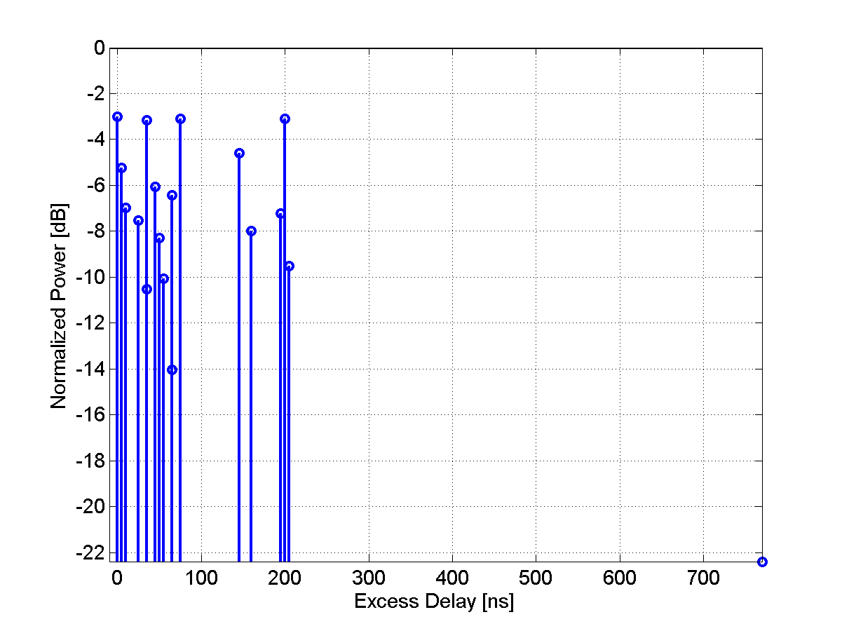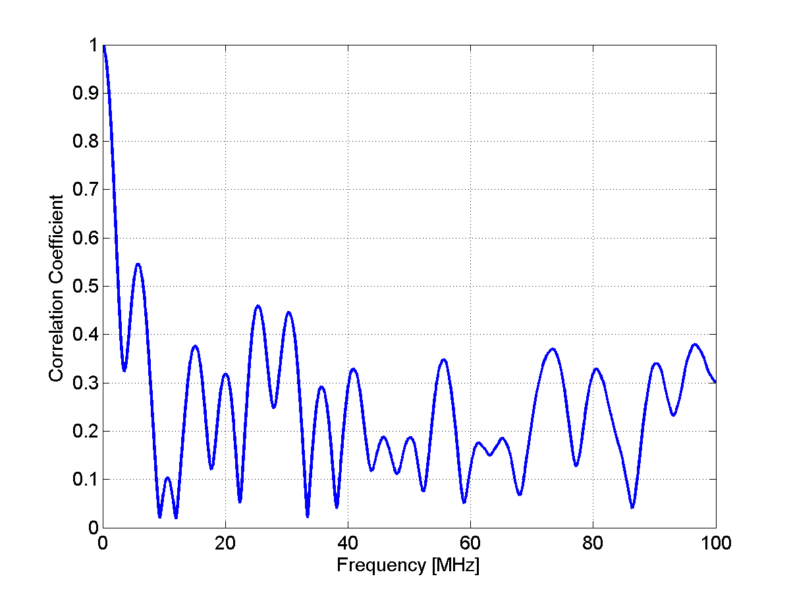
C2 – Urban macro-cell
[Editor’s Note: Japan Doc. 1244 proposed to incorporate the distance dependency of the C2 NLOS scenario into the table. This issue will need to be further discussed in the next meeting.]
Table 14
Scenario C2: NLOS clustered delay line model, urban macro-cell
Cluster # | Delay [ns] |  |  | Power [dB] |  |  | AoD [º] | AoA [º] | Ray power [dB] | Cluster ASD = 2º | Cluster ASD = 15º
1 | 0 |  |  | -6.4 |  |  | 11 | 61 | -19.5 | Cluster ASD = 2º | Cluster ASD = 15º
2 | 60 |  |  | -3.4 |  |  | -8 | 44 | -16.4 | Cluster ASD = 2º | Cluster ASD = 15º
3 | 75 |  |  | -2.0 |  |  | -6 | -34 | -15.0 | Cluster ASD = 2º | Cluster ASD = 15º
4 | 145 | 150 | 155 | -3.0 | -5.2 | -7.0 | 0 | 0 | -13.0 | Cluster ASD = 2º | Cluster ASD = 15º
5 | 150 |  |  | -1.9 |  |  | 6 | 33 | -14.9 | Cluster ASD = 2º | Cluster ASD = 15º
6 | 190 |  |  | -3.4 |  |  | 8 | -44 | -16.4 | Cluster ASD = 2º | Cluster ASD = 15º
7 | 220 | 225 | 230 | -3.4 | -5.6 | -7.4 | -12 | -67 | -13.4 | Cluster ASD = 2º | Cluster ASD = 15º
8 | 335 |  |  | -4.6 |  |  | -9 | 52 | -17.7 | Cluster ASD = 2º | Cluster ASD = 15º
9 | 370 |  |  | -7.8 |  |  | -12 | -67 | -20.8 | Cluster ASD = 2º | Cluster ASD = 15º
10 | 430 |  |  | -7.8 |  |  | -12 | -67 | -20.8 | Cluster ASD = 2º | Cluster ASD = 15º
11 | 510 |  |  | -9.3 |  |  | 13 | -73 | -22.3 | Cluster ASD = 2º | Cluster ASD = 15º
12 | 685 |  |  | -12.0 |  |  | 15 | -83 | -25.0 | Cluster ASD = 2º | Cluster ASD = 15º
13 | 725 |  |  | -8.5 |  |  | -12 | -70 | -21.5 | Cluster ASD = 2º | Cluster ASD = 15º
14 | 735 |  |  | -13.2 |  |  | -15 | 87 | -26.2 | Cluster ASD = 2º | Cluster ASD = 15º
15 | 800 |  |  | -11.2 |  |  | -14 | 80 | -24.2 | Cluster ASD = 2º | Cluster ASD = 15º
16 | 960 |  |  | -20.8 |  |  | 19 | 109 | -33.8 | Cluster ASD = 2º | Cluster ASD = 15º
17 | 1020 |  |  | -14.5 |  |  | -16 | 91 | -27.5 | Cluster ASD = 2º | Cluster ASD = 15º
18 | 1100 |  |  | -11.7 |  |  | 15 | -82 | -24.7 | Cluster ASD = 2º | Cluster ASD = 15º
19 | 1210 |  |  | -17.2 |  |  | 18 | 99 | -30.2 | Cluster ASD = 2º | Cluster ASD = 15º
20 | 1845 |  |  | -16.7 |  |  | 17 | 98 | -29.7 | Cluster ASD = 2º | Cluster ASD = 15º
Figure 15
PDP and frequency correlation (FCF) of CDL model
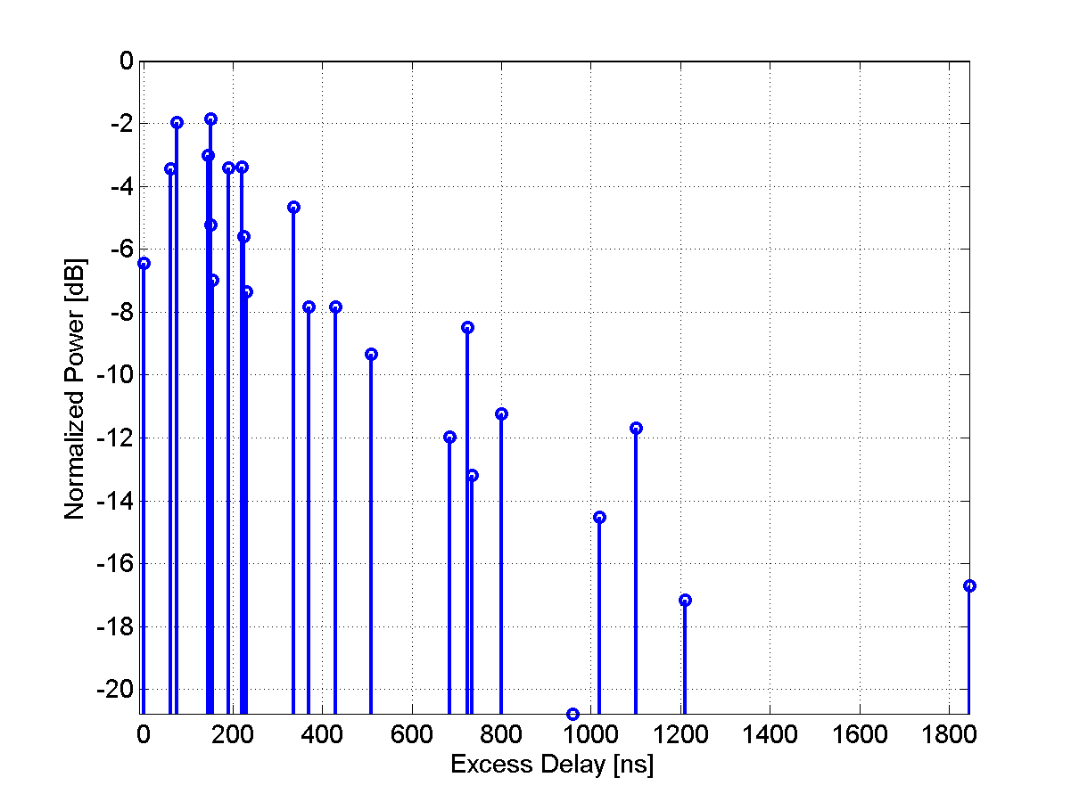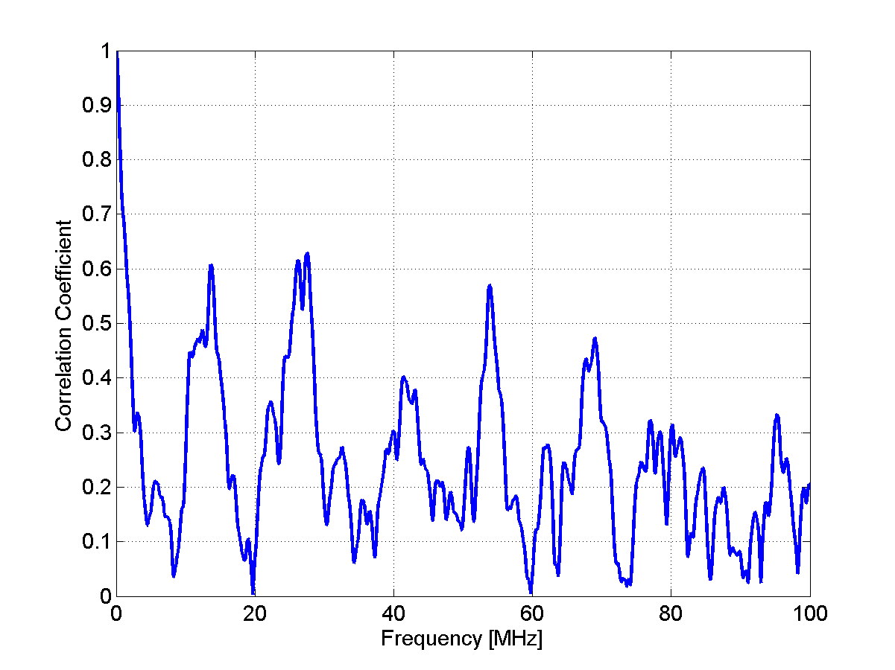
C3 – Bad urban macro-cell
[Editor’s Note: Japan Doc. 1244 proposed to incorporate the distance dependency of the C3 NLOS scenario into the table. This issue will need to be further discussed in the next meeting.]
The CDL parameters of NLOS condition are given below.
Table 15
Scenario C3: NLOS Clustered delay line model, bad urban, macrocell
Cluster # | Delay [ns] |  |  | Power [dB] |  |  | AoD [º] | AoA [º] | Ray power [dB] | Cluster ASD = 2º | Cluster ASA = 15º
1 | 0 |  |  | -4.7 |  |  | -10 | 61 | -17.7 | Cluster ASD = 2º | Cluster ASA = 15º
2 | 0 | 5 | 10 | -3 | -5.2 | -7 | 0 | 0 | -13 | Cluster ASD = 2º | Cluster ASA = 15º
3 | 10 |  |  | -7.2 |  |  | 12 | -75 | -20.2 | Cluster ASD = 2º | Cluster ASA = 15º
4 | 10 |  |  | -6.3 |  |  | -11 | -70 | -19.3 | Cluster ASD = 2º | Cluster ASA = 15º
5 | 30 | 35 | 40 | -4.8 | -7 | -8.8 | -12 | 76 | -14.8 | Cluster ASD = 2º | Cluster ASA = 15º
6 | 50 |  |  | -3.7 |  |  | -9 | 53 | -16.7 | Cluster ASD = 2º | Cluster ASA = 15º
7 | 80 |  |  | -7.4 |  |  | -12 | 76 | -20.4 | Cluster ASD = 2º | Cluster ASA = 15º
8 | 110 |  |  | -7.2 |  |  | 12 | -75 | -20.2 | Cluster ASD = 2º | Cluster ASA = 15º
9 | 155 |  |  | -9.6 |  |  | 14 | -87 | -22.7 | Cluster ASD = 2º | Cluster ASA = 15º
10 | 165 |  |  | -5.2 |  |  | -10 | 64 | -18.3 | Cluster ASD = 2º | Cluster ASA = 15º
11 | 165 |  |  | -6.3 |  |  | 11 | 70 | -19.3 | Cluster ASD = 2º | Cluster ASA = 15º
12 | 250 |  |  | -8.9 |  |  | 14 | 83 | -21.9 | Cluster ASD = 2º | Cluster ASA = 15º
13 | 280 |  |  | -8.5 |  |  | 13 | -81 | -21.5 | Cluster ASD = 2º | Cluster ASA = 15º
14 | 440 |  |  | -8.4 |  |  | 13 | -81 | -21.4 | Cluster ASD = 2º | Cluster ASA = 15º
15 | 490 |  |  | -8.5 |  |  | -13 | 81 | -21.5 | Cluster ASD = 2º | Cluster ASA = 15º
16 | 525 |  |  | -5 |  |  | 10 | 62 | -18 | Cluster ASD = 2º | Cluster ASA = 15º
17 | 665 |  |  | -10.9 |  |  | 15 | 92 | -23.9 | Cluster ASD = 2º | Cluster ASA = 15º
18 | 685 |  |  | -10.9 |  |  | 15 | 92 | -24 | Cluster ASD = 2º | Cluster ASA = 15º
19 | 4800 |  |  | -9.7 |  |  | -135 | 25 | -22.7 | Cluster ASD = 2º | Cluster ASA = 15º
20 | 7100 |  |  | -13 |  |  | 80 | 40 | -26 | Cluster ASD = 2º | Cluster ASA = 15º

[Editor’s note: The plots for profile will need to be inserted by Finland by next meeting.]
D1 – Rural macro-cell
The CDL parameters of LOS and NLOS condition are given below. In the LOS model Ricean K-factor is 13.7 dB, which corresponds to 500m distance between Tx and Rx.
Table 16
Scenario D1: LOS Clustered delay line model, rural macro-cell
Cluster # | Delay [ns] |  |  | Power [dB] |  |  | AoD [º] | AoA [º] | Ray power [dB] |  | Cluster ASD = 2º | Cluster ASD = 3º
1 | 0 |  |  | 0.0 |  |  | 0 | 0 | -0.02* | -35.9** | Cluster ASD = 2º | Cluster ASD = 3º
2 | 40 |  |  | -22.3 |  |  | -95 | 189 | -35.3 |  | Cluster ASD = 2º | Cluster ASD = 3º
3 | 40 |  |  | -25.6 |  |  | 102 | 203 | -38.6 |  | Cluster ASD = 2º | Cluster ASD = 3º
4 | 40 | 45 | 50 | -23.1 | -25.3 | -27.1 | -90 | -179 | -33.1 |  | Cluster ASD = 2º | Cluster ASD = 3º
5 | 40 | 45 | 50 | -23.7 | -25.9 | -27.7 | 104 | -208 | -33.7 |  | Cluster ASD = 2º | Cluster ASD = 3º
6 | 60 |  |  | -27.4 |  |  | -105 | 210 | -40.4 |  | Cluster ASD = 2º | Cluster ASD = 3º
7 | 115 |  |  | -27.0 |  |  | 104 | -208 | -40.0 |  | Cluster ASD = 2º | Cluster ASD = 3º
8 | 135 |  |  | -25.2 |  |  | -101 | -201 | -38.2 |  | Cluster ASD = 2º | Cluster ASD = 3º
9 | 175 |  |  | -30.1 |  |  | 110 | -219 | -43.1 |  | Cluster ASD = 2º | Cluster ASD = 3º
10 | 195 |  |  | -32.5 |  |  | 114 | 228 | -45.5 |  | Cluster ASD = 2º | Cluster ASD = 3º
11 | 215 |  |  | -31.7 |  |  | -113 | -225 | -44.7 |  | Cluster ASD = 2º | Cluster ASD = 3º
12 | 235 |  |  | -33.9 |  |  | -117 | -233 | -46.9 |  | Cluster ASD = 2º | Cluster ASD = 3º
13 | 235 |  |  | -31.0 |  |  | -112 | 223 | -44.0 |  | Cluster ASD = 2º | Cluster ASD = 3º
* Power of dominant ray,
** Power of each other ray
Figure 16
PDP and frequency correlation (FCF) of CDL model
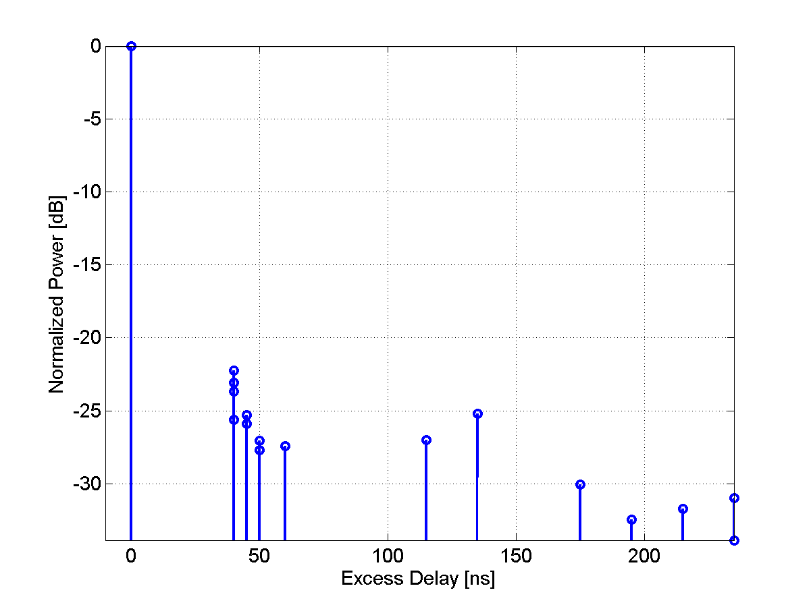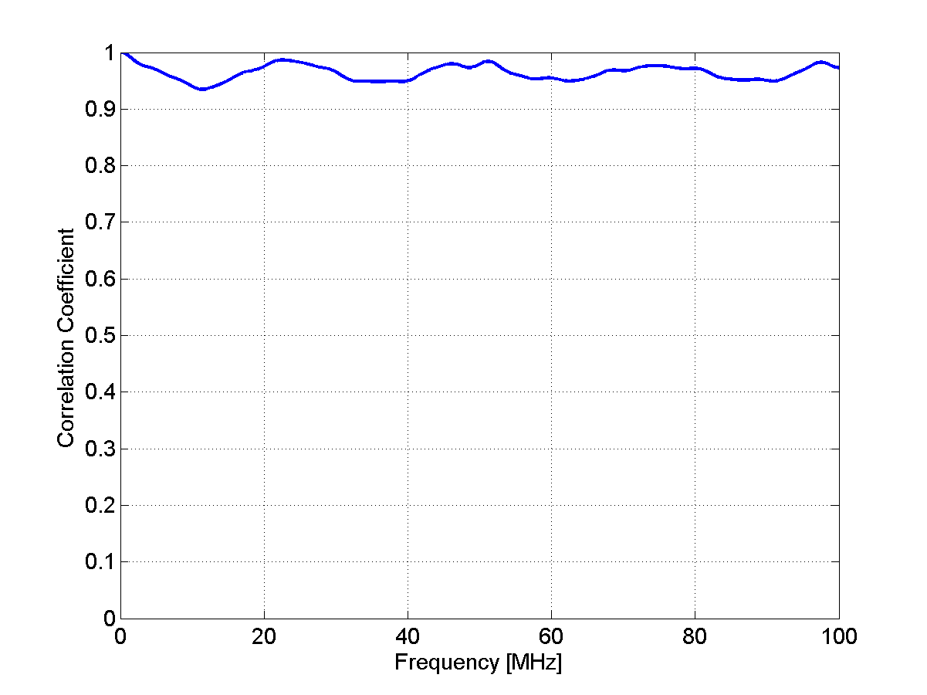

Table 17
Scenario D1: NLOS Clustered delay line model, rural macro-cell
Cluster # | Delay [ns] |  |  | Power [dB] |  |  | AoD [º] | AoA [º] | Ray power [dB] | Cluster ASD = 2º | Cluster ASD = 3º
1 | 0 | 5 | 10 | -3.0 | -5.2 | -7.0 | 0 | 0 | -13.0 | Cluster ASD = 2º | Cluster ASD = 3º
2 | 0 |  |  | -1.8 |  |  | -8 | 28 | -14.8 | Cluster ASD = 2º | Cluster ASD = 3º
3 | 5 |  |  | -3.3 |  |  | -10 | 38 | -16.3 | Cluster ASD = 2º | Cluster ASD = 3º
4 | 10 | 15 | 20 | -4.8 | -7.0 | -8.8 | 15 | -55 | -14.8 | Cluster ASD = 2º | Cluster ASD = 3º
5 | 20 |  |  | -5.3 |  |  | 13 | 48 | -18.3 | Cluster ASD = 2º | Cluster ASD = 3º
6 | 25 |  |  | -7.1 |  |  | 15 | -55 | -20.1 | Cluster ASD = 2º | Cluster ASD = 3º
7 | 55 |  |  | -9.0 |  |  | -17 | 62 | -22.0 | Cluster ASD = 2º | Cluster ASD = 3º
8 | 100 |  |  | -4.2 |  |  | -12 | 42 | -17.2 | Cluster ASD = 2º | Cluster ASD = 3º
9 | 170 |  |  | -12.4 |  |  | 20 | -73 | -25.4 | Cluster ASD = 2º | Cluster ASD = 3º
10 | 420 |  |  | -26.5 |  |  | 29 | 107 | -39.5 | Cluster ASD = 2º | Cluster ASD = 3º
Figure 17
PDP and frequency correlation (FCF) of CDL model
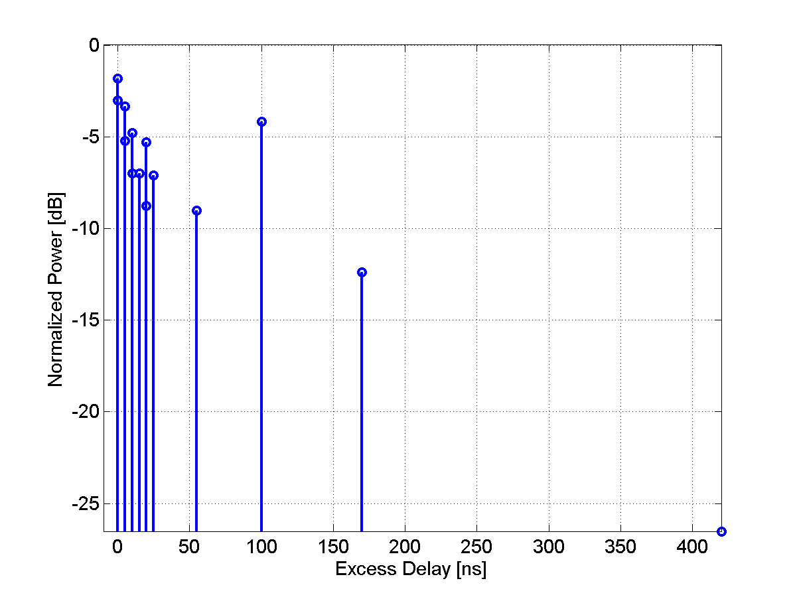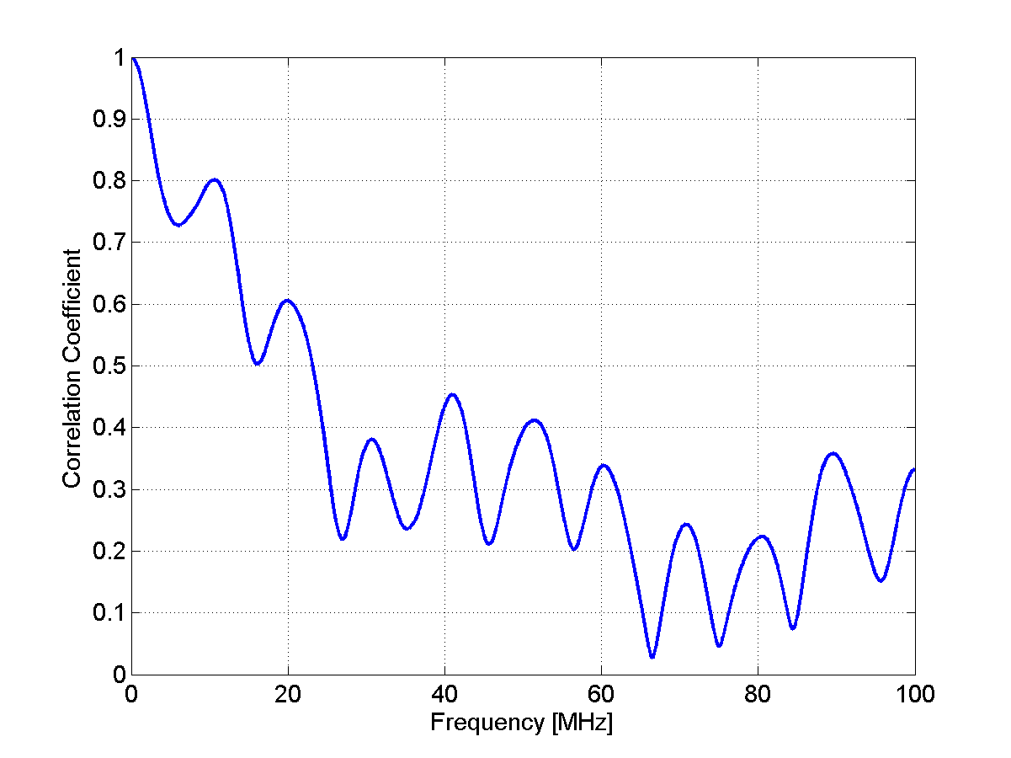

D2a – Moving networks
The CDL parameters of LOS condition are given below. In the LOS model Ricean K-factor is 6 dB.

Table 18
Scenario D2a: LOS Clustered delay line model, moving networks
Cluster # | Delay [ns] |  |  | Power [dB] |  |  | AoD [º] | AoA [º] | Ray power [dB] |  | Cluster ASD = 2º | Cluster ASA = 3º
1 | 0 | 5 | 10 | 0.0 | -14.1 | -15.8 | 0 | 0 | -0.29* | -21.9** | Cluster ASD = 2º | Cluster ASA = 3º
2 | 70 | 75 | 80 | -13.1 | -15.3 | -17.1 | -64 | -171 | -23.1 |  | Cluster ASD = 2º | Cluster ASA = 3º
3 | 465 |  |  | -23.8 |  |  | -60 | 162 | -36.8 |  | Cluster ASD = 2º | Cluster ASA = 3º
4 | 510 |  |  | -26.6 |  |  | -64 | -171 | -39.6 |  | Cluster ASD = 2º | Cluster ASA = 3º
* Power of dominant ray,
** Power of each other ray
Figure 18
PDP and frequency correlation (FCF) of CDL model
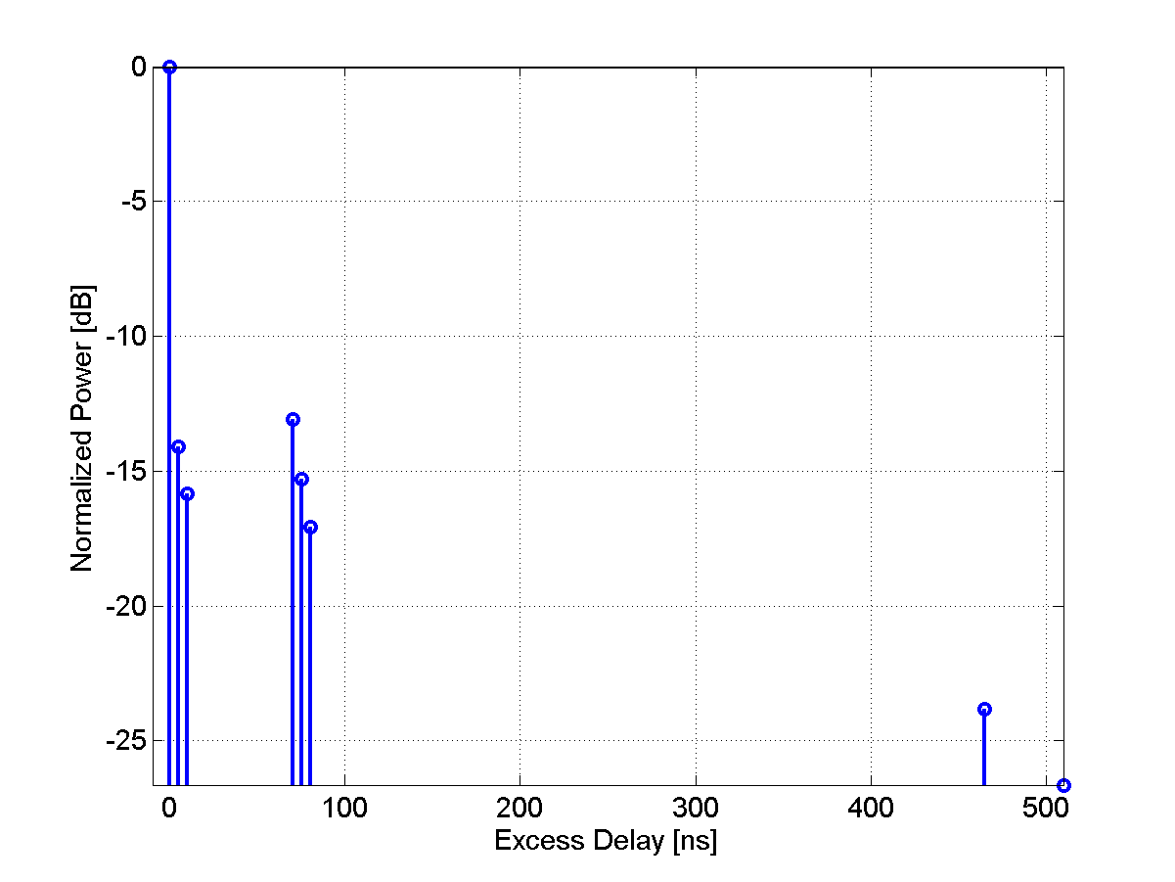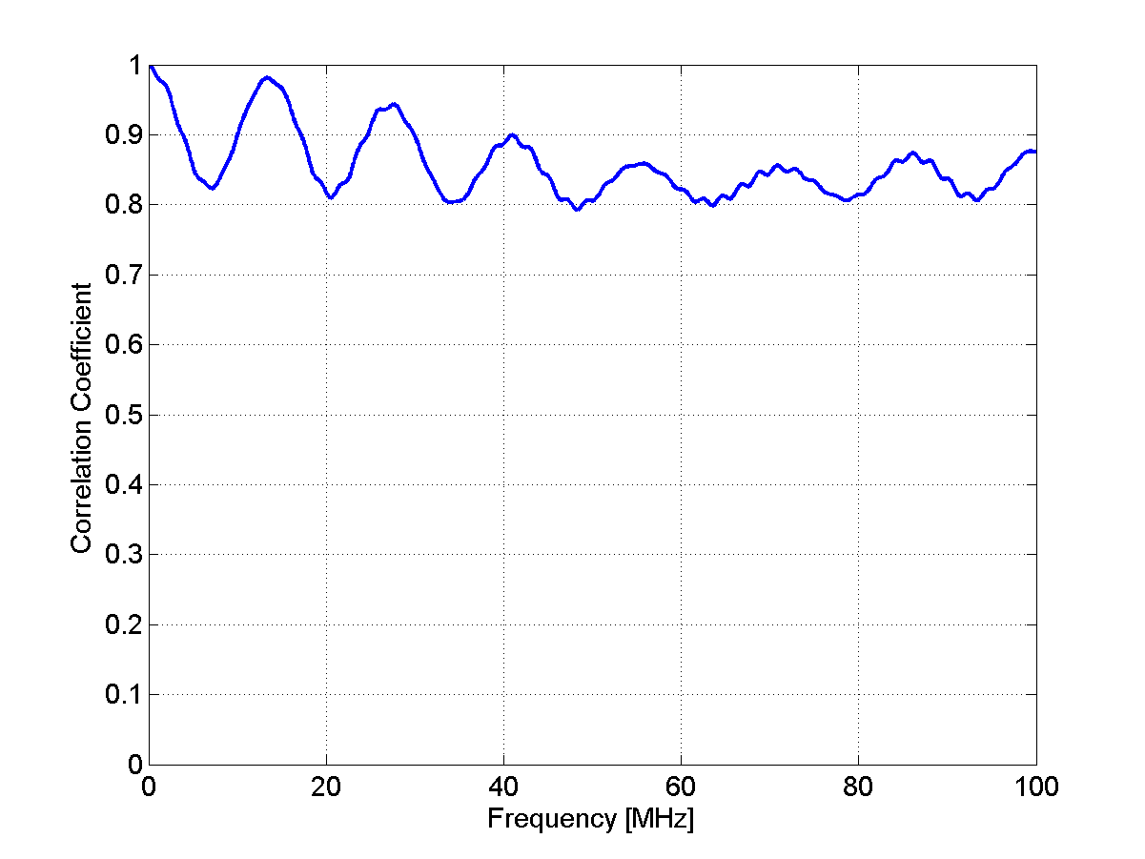
1.3.3 Advanced Features
1.3.3.1 Elevation angles
For the indoor and outdoor-to-indoor cases it is possible to use also the elevation spread to specify the angles of arrival and departure as given in Table 3.
[Editor’s Note: This issue required further discussion during the adhoc meeting.]
1.3.3.2 Cross-polarization values as function of BS–MS separation distance
[Editor’s note: To be investigated until the next meeting. Consider also including recommended antenna configurations]
1.3.3.3 Fixed BS and MS with moving scatterers
[Editor’s note: Temporal K-factor to be investigated until the following meeting]

References
- 3GPP TR25.996 V6.1.0 (2003-09) “Spatial channel model for multiple input multiple output (MIMO) simulations” Release 6.
- IST-WINNER II Deliverable D1.1.1 v1.0, “WINNER II Interim Channel Models”,
December 2006.
- Gudmundson, M. Correlation Model for Shadow Fading in Mobile Radio Systems. Electron. Lett, Vol. 27, 23, 2145-2146). November, 1991.

1.4 Traffic Models
[This section introduce typical traffic models used for simulation.]
A major objective of system simulations is to provide an operator with a view of the maximum number of active users that can be supported for a given service under a specified configuration at a given coverage level.
1.4.1 Introduction
[Give some general introduction to traffic model, lay out typical traffic models such as: WWW，FTP，Gaming, VoIP, Streaming, etc.]

1.4.2 Traffic models description
[Give the detail traffic model description for the traffic listed above.]

1.4.2.1 Web Browsing (HTTP) Traffic Model
HTTP traffic characteristics are governed by the structure of the web pages on the World Wide Web (WWW), and the nature of human interaction. The nature of human interaction with the WWW causes the HTTP traffic to have a bursty profile, where the HTTP traffic is characterized by ON/OFF periods as shown in Figure 6.
Figure 6
HTTP Traffic Pattern

The ON periods represent the sequence of packets in which the web page is being transferred from source to destination; while the OFF periods represent the time the user spends reading the webpage before transitioning to another page. This time is also known as Reading Time [1][2].
The amount of information passed from the source to destination during the ON period is governed by the web page structure. A webpage is usually composed of a main object and several embedded objects. The size of the main object, in addition to the number and size of the embedded objects define the amount of traffic passed from source to destination.
In summary, the HTTP traffic model is defined by the following parameters:
SM: Size of main object in page
Nd: Number of embedded objects in a page
SE: Size of an embedded object in page
Dpc: Reading time
Tp: Parsing time for the main page
In addition to the model parameters, HTTP traffic behavior is also dependent on the HTTP version used. Currently HTTP 1.0 and HTTP 1.1 are widely used by servers and browsers [3]-[6]. In HTTP 1.0, also known as burst mode transfer, a distinct TCP connection is used for each object in the page, thereby facilitating simultaneous transfer of objects. The maximum number of simultaneous TCP connections is configurable, with most browsers using a maximum of 4 simultaneous TCP connections. In HTTP/1.1, also known as persistent mode transfer, all objects are transferred serially over a single persistent TCP connection. Table 4 provides the model parameters for HTTP traffic.
Table 4
HTTP Traffic Parameters
Component | Distribution | Parameters | PDF
Main  object  Size (SM) | Truncated Lognormal | Mean = 10710 bytes  SD = 25032 bytes  Min = 100 bytes  Max = 2 Mbytes (before truncation) | $$σ=1\text{.}\text{37},μ=8\text{.}\text{37}$$  if x>max or x<min, discard and generate a new value for x
Embedded object size (SE) | Truncated Lognormal | Mean = 7758 bytes  SD = 126168 bytes  Min = 50 bytes  Max = 2 Mbytes (before truncation) | $$σ=2\text{.}\text{36},μ=6\text{.}\text{17}$$  f x>max or x<min, discard and generate a new value for x
Number of embedded objects per page (Nd) | Truncated Pareto | Mean = 5.64  Max. = 53 (before truncation) | Subtract k from the generated random value to obtain Nd  if x>max, discard and regenerate a new value for x
Reading time (Dpc) | Exponential | Mean = 30 sec | λ = 0.033
Parsing time (Tp) | Exponential | Mean = 0.13 sec | $$f_{x}=λe^{−λx},x≥0$$  $$λ=7\text{.}\text{69}$$
To request an HTTP session, the client sends an HTTP request packet, which has a constant size of 350 bytes. From the statistics presented in the literature, a 50%-50% distribution of HTTP versions between HTTP 1.0 and HTTP 1.1 has been found to closely approximate web browsing traffic in the internet [7].
Further studies also showed that the maximum transmit unit (MTU) sizes most common to in the internet are 576 bytes and 1500 bytes (including the TCP header) with a distribution of 24% and 76% respectively. Thus, the web traffic generation process can be described as in FIGURE 7.
FIGURE 7
HTTP Traffic Profiles

A user is defined in outage for HTTP service if the average packet call throughput is less than the minimum average throughput requirement of 128 kbps. The system outage requirement is such that no more than 2% of users can be in outage. The air link PER of MAC SDUs for HTTP traffic should be not be greater than 1%.

1.4.2.1.1 HTTP and TCP interactions for DL HTTP traffic
Two versions of the HTTP protocol, HTTP/1.0 and HTTP/1.1, are widely used by servers and browsers. Users shall specify 50% HTTP/1.0 and 50% HTTP/1.1 for HTTP traffic. For people who have to model the actual interaction between HTTP traffic and the underling TCP connection, refer to 4.1.3.2, 4.2.4.3 of [8] for details.

1.4.2.1.2. HTTP and TCP interactions for UL HTTP traffic
HTTP/1.1 is used for UL HTTP traffic. For details regarding the modeling of the interaction between HTTP traffic and the underling TCP connection, refer to 4.2.4.1, 4.2.4.2 of [8].

1.4.2.2 File Transfer Protocol (FTP) Traffic Model
File transfer traffic is characterized by a session consisting of a sequence of file transfers, separated reading times. Reading time is defined as the time between end of transfer of the first file and the transfer request for the next file. The packet call size is therefore equivalent to the file size and the packet call inter-arrival time is the reading time. A typical FTP session is shown in Figure 8.
Figure 8: FTP Traffic Parameters

First Transfer
Reading Time
Reading Time
Second Transfer
Third Transfer

provides the model parameters for FTP traffic that includes file downloads as well as uploads [9][10]. In the case of file uploads, the arrival of new users is Poisson distributed and each user transfers a single file before leaving the network.
The FTP traffic generation process is described in FIGURE 9. Based on the results on packet size distribution, 76% of the files are transferred using an MTU size of 1500 bytes and 24% of the files are transferred using an MTU size of 576 bytes. Note that these two packet sizes also include a 40 byte IP packet header and this header overhead for the appropriate number of packets must be added to the file sizes calculated from the statistical distributions in TABLE 5. For each file transfer a new TCP connection is used whose initial congestion window size is 1 segment.
A user is defined in outage for FTP service if the average packet call throughput is less than the minimum average throughput requirement of 128 kbps. The system outage requirement is such that no more than 2% of users can be in outage. The air link PER of MAC SDUs for FTP traffic should be not be greater than 1%.
TABLE 5
FTP Traffic Parameters
Component | Distribution | Parameters | PDF
File  size (S) | Truncated Lognormal | Mean = 2 Mbytes  SD = 0.722 Mbytes  Max = 5 Mbytes | $\begin{aligned}f_{x}=\frac{1}{\sqrt{2π}σx}\text{exp}\left[\frac{−{\left(\text{ln}x−μ\right)}^{2}}{2σ^{2}}\right],x≥0 \\ \end{aligned}$$σ=0\text{.}\text{35},μ=\text{14}\text{.}\text{45}$  if x>max or x<min, discard and generate a new value for x
Reading  time (D_{pc}) | Exponential | Mean = 180 sec. | e

FIGURE 9
FTP Traffic Profiles

1.4.2.3 Speech Source Model (VoIP)
VoIP refers to real-time delivery of voice packet across networks using the Internet protocols. A VoIP session is defined as the entire user call time and VoIP session occurs during the whole simulation period.

There are a variety of encoding schemes for voice (i.e., G.711, G.722, G.722.1, G.723.1, G.728, G.729, and AMR) that result in different bandwidth requirements. Including the protocol overhead, it is very common for a VoIP call to require between 5 Kbps and 64 Kbps of bi-directional bandwidth.

Basic VoIP Model
A typical phone conversation is marked by periods of active talking / talk spurts (ON periods) interleaved by silence / listening periods (or OFF periods) as shown in FIGURE 10.

FIGURE 10
Typical Phone Conversation Profile
Consider the simple 2-state voice activity Markov model shown in FIGURE 11
FIGURE 11
2-state voice activity Markov model
In the model, the conditional probability of transitioning from state 1 (the active speech state) to state 0 (the inactive or silent state) while in state 1 is equal to a, while the conditional probability of transitioning from state 0 to state 1 while in state 0 is c. The model is assumed to be updated at the speech encoder frame rate R=1/T, where T is the encoder frame duration (typically, 20 ms). Packets are generated at time intervals T+ τ, where τ is the network packet arrival delay jitter. During the active state, packets of fixed sizes are generated at these intervals, while the model is updated at regular frame intervals. The size of packet and the rate at which the packets are sent depends on the corresponding voice codecs and compression schemes. TABLE 6 provides information on some common vocoders.
TABLE 6
Information on various vocoders
Vocoder | EVRC | AMR | GSM 6.10 | G.711 | G.723.1 |  | G.729A
Source Bit rate  [Kb/s] | 0.8/2/4/8.55 | 4.75-12.2 | 13 | 64 | 5.3 | 6.3 | 8
Frame duration [ms] | 20 | 20 | 20 | 10 | 30 | 30 | 10
Information bits per frame | 16/40/80/171 | 95-244 | 260 | 640 | 159 | 189 | 80
Among the various vocoders in TABLE 6 a simplified AMR (Adaptive Multi-Rate) audio data compression model can be used to simplify the VoIP modeling process. AMR is optimized for speech coding and was adopted as the standard speech codec by 3GPP and widely used in GSM. The original AMR codec uses link adaptation to select from one of eight different bit rates based on link conditions. If the radio condition is bad, source coding is reduced (less bits to represent speech) and channel coding (stronger FEC) is increased. This improves the quality and robustness of the network condition while sacrificing some voice clarity. In the simplified version in this document, link adaptation has been disabled and the full rate of 12.2 kbps is used in the active state. This model captures the worst case scenario.
Table 7 shows the VoIP packet size calculation for simplified AMR operation with or without header compression when using IPv4 or IPv6. In the table, the MAC CRC of 4 bytes for ARQ is not included and only CRC for HARQ is included because the ARQ process can be assumed to be disabled for VoIP services.
To calculate the total packet size, technology specific MAC headers and CRC need to be accounted for. Header compression, IP version also need to be accounted for.
The voice capacity assumes a 12.2. kbps codec with a 50% activity factor such that the percentage of users in outage is less than 2% where a user is defined to have experienced voice outage if more than 2% of the VoIP packets are dropped, erased or not delivered successfully to the user within the delay bound of 50 ms.
The packet delay is defined based on the 98th percentile of the CDF of all individual users’ 98th percentiles of packet delay (i.e., the 98th percentile of the packet delay CDF first determined for each user and then the 98th percentile of the CDF that describes the 98th percentiles of the individual user delay is obtained).
Bidirectional VoIP capacity is measured in Active Users/MHz/Sector. The total number of active users on the DL and UL is divided by total bandwidth occupied by the system accounting for frequency reuse. For an FDD configuration, the bandwidth is calculated as the sum of the uplink and downlink channel bandwidths. For a TDD configuration, the bandwidth is simply the channel bandwidth.
Table 7
VoIP Packet Calculation for AMR and G.729
Description | AMR without  Header  Compression  IPv4/IPv6 | AMR with Header  Compression IPv4/IPv6 | G.729 without  Header  Compression  IPv4/IPv6 | G.729 with Header  Compression  IPv4/IPv6
Voice Payload  (20 ms aggregation interval) | 7 bytes for inactive  33 bytes for active | 7 bytes for inactive  33 bytes for active | 0 bytes for inactive  20 bytes for active | 0 bytes for inactive  20 bytes for active
Protocol  Headers  (including UDP checksum) | 40 bytes /  60 bytes | 3 bytes /  5 bytes | 40 bytes /  60 bytes | 3 bytes /  5 bytes
RTP | 12 bytes |  | 12 bytes
UDP | 8 bytes |  | 8 bytes
IPv4 / IPv6 | 20 bytes /  40 bytes |  | 20 bytes /  40 bytes
Generic MAC  Header | Technology Specific | Technology Specific | Technology Specific | Technology Specific
CRC | Technology Specific | Technology Specific | Technology Specific | Technology Specific
Total VoIP  packet size | Technology Specific | Technology Specific | Technology Specific | Technology Specific
        - VoIP Traffic Model Parameters

During each call (each session), a VoIP user will be in the Active or Inactive state. The duration of each state is exponentially distributed. In the Active/Inactive state, packets of fixed sizes will be generated at intervals of T seconds, where T is the VoIP frame interval of 20 ms. Table 8 specifies the distributions and parameters associated with the VoIP traffic model.
Table 8
VoIP traffic model parameters specification
Component | Distribution | Parameters | PDF
Active/Inactive state duration | Exponential | Mean = 1.5 second | f _{x} = λ e^{− λ x}, x≥0  λ=1/ Mean
Probability of state transition | N/A | 0.016 | N/A
 |  |  | $f_{x}=\frac{1}{2β}e^{−\frac{\left|τ\right|}{β}}$

Link adaptation of AMR codec is disabled in order to evaluate performance under worst case, and to simplify the voice traffic model.
During the inactive state, we have chosen to generate comfort noise with smaller packet sizes at regular intervals instead of no packet transmission. This simplified model does not include a feature called hangover, which generates additional seven frames at the same rate as speech to ensure the correct estimation of comfort noise parameters at the receiver side even if there is a silence period at the end of a talk spurt (ON state), and after the hangover period, a SID_FIRST frame is sent. The voice traffic model specifies only one rate during the ON state (talk spurt) of the AMR codec (12.2 kbps) and another rate for the comfort noise (SID_UPDATE) during the OFF state of the AMR codec. SID_UPDATE frames are generated every 8th frame during the silence period.

      - Near Real Time Video Streaming
This section describes a model for streaming video traffic for DL direction. FIGURE 12 illustrates the steady state of video streaming traffic from the network as observed by the base station. Call setup latency and overhead are not considered in this model.
FIGURE 12
Video Streaming Traffic Model
Each frame of video data arrives at a regular interval T. Each frame can be treated as a packet call and there will be zero OFF duration within a session. Within each frame (packet call), packets (or datagrams) arrive randomly and the packet sizes are random as well.
To counter the jittering effect caused by the random packet arrival rate within a frame at the MS, the MS uses a de-jitter buffer window to guarantee a continuous display of video streaming data. The de-jitter buffer window for video streaming service is 5 seconds. At the beginning of the simulation, the MS de-jitter buffer shall be full with video data. During simulation, data is leaked out of this buffer at the source video data rate and filled as DL traffic reaches the MS from the BS. As a performance criterion, the simulation shall record the length of time, if any, during which the de-jitter buffer runs dry.
The packet sizes and packet inter-arrival rate can be found in when using a source rate of 64 kbps.
TABLE 9 lists the parameters for the video streaming model.
TABLE 9
Near Real Time Video Streaming Traffic Model Parameters
Component | Distribution | Parameters | PDF
Inter-arrival time between the beginning of each frame | Deterministic | 100 ms (Based on 10 frames per second)
Number of packets (slices) in a frame | Deterministic | 8 packets per frame
Packet (slice) size | Truncated Pareto | Mean =10 bytes, Max = 250 bytes (before truncation) | $$f_{x}=\frac{{αk}^{α}}{x^{α+1}},k≤x<m$$  $$f_{x}={\left(\frac{k}{m}\right)}^{α},x=m$$  $$α=1\text{.}2,k=\text{40}\text{bytes},m=\text{250}\text{bytes}$$  if x>max, discard and regenerate a new value for x
Inter-arrival time between packets (slices) in a frame | Truncated Pareto | Mean=6 ms, Max=12.5 ms (before truncation) | $$f_{x}=\frac{{αk}^{α}}{x^{α+1}},k≤x<m$$  $f_{x}={\left(\frac{k}{m}\right)}^{α},x=m$  $α=1\text{.}2,k=2\text{.}5\text{ms},m=\text{12}\text{.}5$ms  if x>max, discard and regenerate a new value for x

The other network protocol overhead, such as IP, TCP/UDP header should be added on each packet (slice) generated by the video streaming model described above.
A user is defined in outage for streaming video service if the 98th percentile video frame delay is larger than 5 seconds. The system outage requirement is such that no more than 2% of users can be in outage.

      - Video Telephony
Based on the compression efficiency and market acceptance as described in the section Error: Reference source not found, MPEG 4 has been selected for the video codec. The estimated values for the parameters to model a video stream vary from one trace to another. For parameters associated with the statistical distributions, the estimates depend strongly on the dimensions of the captured frames. For the video telephony traffic model, medium quality of an Office Cam trace is used and the trace library is available at [12]. For the traffic model, two different qualities for the video have been considered; high and medium quality. For the medium quality encoding the quantization parameters for all three frame types were fixed at 10, and for the high quality encoding the quantization parameters for all three frame types were fixed at 4 [12].
The scene length for the video telephony is assumed to be the entire application session since the background or the main subject may not be so dynamic.
TABLE 10
Video Telephony Traffic Model
Parameter | Value
Service | Video Telephony
Video Codec | MPEG-4
Protocols | UDP
Scene Length (sec) | Session duration
Direction | Bi-direction (DL and UL)
Frames/sec | 25 frames/sec
GOP | N=12, M=3
Display size | 176x144
Color depth (bit) | 8
Video Quality | Medium
Mean BW | 110 kbps
I frame size (byte) | Weibull($α=$5.15, $β=$863), shift=3949, μ= 4742 , σ=178 , min=4034, max=5184
P frame size (byte) | Lognormal(μ=259 , σ=134), min=100, max=1663
B frame size (byte) | Lognormal(μ=147 ,σ=74), min=35, max=882
      - Gaming Traffic Model
Gaming is a rapidly growing application embedded into communication devices, and thus wireless gaming needs to be considered. Games in different genre, such as First Person Shooter (FPS), Role Play Game (RPG), etc., show dramatic different traffic behaviors. FPS model is recommended to represent the gaming traffic model in this document because it posts additional requirements to the system performance, such as real time delay with irregular traffic arrivals.
FPS is a genre of video games. It is a good representation of the modern Massively Multiplayer Online (MMO) game. Due to the nature of the FPS game, it has stringent network delay requirement. For the FPS game, if the client to server to client round trip delay (i.e., ping time, or end to end delay) is below 150 ms, the delay is considered excellent. When the delay is between 150 ms to 200 ms, the delay is noticeable especially to the experienced player. It is considered good or playable. When ping time is beyond 200 ms, the delay becomes intolerable.
This end to end delay budget can be broken down into internet delay, server processing delay, cellular network delay, air interface delay, and client processing delay, etc. Let the IP packet delay be the time that the IP packet entering the MAC SDU buffer to the time that the IP packet is received by the receiver and reassembled into IP packet. The IP packet delay is typically budgeted as 50 ms to meet the 200 ms end to end delay. A gamer is considered in outage if 10% of its packet delay is either lost or delayed beyond the budget, i.e., 50 ms. The system outage requirement is such that no more than 2% of users can be in outage.

The FPS traffic can be modeled by the Largest Extreme Value distribution. The starting time of a network gaming mobile is uniformly distributed between 0 and 40 ms to simulate the random timing relationship between client traffic packet arrival and reverse link frame boundary. The parameters of initial packet arrival time, the packet inter arrival time, and the packet sizes are illustrated in TABLE 11.

TABLE 11
FPS Internet Gaming Model
Component | Distribution |  | Parameters |  | PDF
Component | DL | UL | DL | UL | PDF
Initial packet arrival | Uniform | Uniform | a = 0,  b = 40 ms | a=0,  b=40 ms | $$\begin{matrix}f(x)=\frac{1}{b−a} & a≤x≤b\end{matrix}$$
Packet arrival time | Extreme | Extreme | a = 50 ms,  b = 4.5 ms | a = 40 ms,  b = 6 ms | $$f(x)=\frac{1}{b}e^{−\frac{x−a}{b}}e^{−e^{−\frac{x−a}{b}}},b>0$$  $$Y∈U(0,1)$$
Packet size | Extreme | Extreme | a = 330 bytes,  b = 82 bytes | a = 45 bytes, b = 5.7 bytes | $$f(x)=\frac{1}{b}e^{−\frac{x−a}{b}}e^{−e^{−\frac{x−a}{b}}},b>0$$  $X=\left\lfloor a−b\text{ln}\left(−\text{ln}Y\right)\right\rfloor +2$*,  $$Y∈U(0,1)$$
* A compressed UDP header of 2 bytes is included in the packet size

Email is an important application that constitutes a high percentage of internet traffic. Email application traffic is included in the UMTS Forum 3G traffic models and ITU R M.2072 [15][16].
Interactions between email servers and clients are governed by email protocols. The three most common email protocols are POP, IMAP and MAPI. Most email software operates under one of these (and many products support more than one) protocols. The Post Office Protocol (currently in version 3, hence POP3) allows email client software to retrieve email from a remote server. The Internet Message Access Protocol (now in version 4 or IMAP4) allows a local email client to access email messages that reside on a remote server. The Messaging Application Programming Interface (MAPI) is a proprietary email protocol of Microsoft that can be used by Outlook to communicate with Microsoft Exchange Server. It provides somewhat similar but more functionality than an IMAP protocol.
The email traffic model in this section considers both POP3 and MAPI since these protocols generate different traffic patterns. To model POP3, an FTP model can be used, and an email transaction with MAPI protocol can be modeled with multiple MAPI segment transactions in series. Each MAPI fragment is transmitted using the TCP protocol and segmented into smaller segments again based on the TCP configuration. A maximum MAPI fragment size of 16896 bytes has been found so far, and this information is indicated in the first packet of a MAPI fragment. Outlook finishes all the TCP ACK packet transmission for the current MAPI segment and the Exchange server waits for the MAPI fragment completion indication packet before sending the next one. The last packet in the MAPI fragment sets the “PUSH” bit in the TCP packet to transmit all of the packets in the TCP buffer to the application layer at the receiver side [17].

Email traffic can be characterized by ON/OFF states. During the ON-state an email could be transmitted or received, and during the OFF-state a client is writing or reading an email. FIGURE 13 depicts a simplified email traffic pattern.

FIGURE 13
Email Traffic Model
The parameters for the email traffic model are summarized in TABLE 12 [17][18][19][20][21].
TABLE 12
Email Traffic Parameters

Parameter | Distribution | Parameters | PDF
E-Mail Protocol | N/A | POP3, MAPI | N/A
E-Mail Average Header Size (Bytes) | Deterministic | 1 K | N/A
Number of email receive | Lognormal | Mean = 30  Std Deviation = 17 | $f_{x}=\frac{1}{\sqrt{2π}σ}\text{exp}\left[\frac{−(\text{ln}x−μ)^{2}}{2σ^{2}}\right]$$x≥0$  $$σ=3\text{.}\text{262},μ=0\text{.}\text{5277}$$
Number of email send | Lognormal | Mean = 14  Std Deviation = 12 | $f_{x}=\frac{1}{\sqrt{2π}σ}\text{exp}\left[\frac{−(\text{ln}x−μ)^{2}}{2σ^{2}}\right]$$x≥0$  $$σ=2\text{.}\text{364},μ=0\text{.}\text{742}$$
Email reading time (sec) | Pareto | $α=1\text{.}1\text{,,}k=2,m=\text{65}$, mean = 60,  maximum = 63 | $$\begin{aligned}f_{x}=\frac{α\begin{matrix}k^{α}\end{matrix},}{x^{α\begin{matrix}+1\end{matrix}}},k≤x<m \\ f_{x}={\left(\frac{k}{m}\right)}^{α},x=m\end{aligned}$$
Email writing time (sec) | Pareto | $α=1\text{.}1,k=2,m=\text{125}$, mean = 120,  maximum = 123 | $$\begin{aligned}f_{x}=\frac{α\begin{matrix}k^{α},\end{matrix}}{x^{α\begin{matrix}+1\end{matrix}}},k≤x<m \\ f_{x}={\left(\frac{k}{m}\right)}^{α},x=m\end{aligned}$$
Size of email receive/send without attachment (Kbytes) | Cauchy | median $μ=\text{22}\text{.}7$ Kbytes, 90%-tile = 80Kbytes | $f_{x}=\frac{A}{π((x−μ)^{2}+1)}$, A is selected to satisfy 90%-tile value
Size of email receive/send with attachment (Kbytes) | Cauchy | median $μ=\text{227}$ Kbytes , 90%-tile = 800 Kbytes | $f_{x}=\frac{A}{π((x−μ)^{2}+1)}$, A is selected to satisfy 90%-tile value
Ratio of email with attachment | Deterministic | Without attachment: 80%  With attachment: 20% | N/A

1.4.3 Traffic selection and parameters for the test environments
[List the typical models and the distribution rate of the mix of several traffics for the test environments defined in section 1.1 of Annex 2, at which four test environments are defined.]

1.5 Link Adaptation
Link adaptation can enhance system performance by optimizing resource allocation in varying channel conditions. System level simulations should include adaptation of the modulation and coding schemes, according to link conditions.

The purpose of this section is to provide guidelines for link adaptation in system evaluations. The use of link adaptation is left to the proponent as it may not pertain to all system configurations. The link adaptation algorithms implemented in system level simulations are left to Individual proponents for each proposal. Proponents should specify link adaptation algorithms including power, MIMO rank, and MCS adaptation per resource block.
1.5.1 Adaptive Modulation and Coding
The evaluation methodology assumes that adaptive modulation and coding with various modulation schemes and channel coding rates is applied to packet data transmissions. In the case of MIMO, different modulation schemes and coding rates may be applied to different streams.
1.5.2 Link Adaptation with HARQ
The link adaptation algorithm should be optimized to maximize the performance at the end of the HARQ process (e.g. maximize the average throughput under constraint on the delay and PER, or maximize number of users per service).

1.5.3 Channel Quality Feedback
A Channel Quality Indicator (CQI) channel is utilized to provide channel-state information from the user terminals to the base station scheduler. Relevant channel-state information can be fed back. For example, Physical CINR, effective CINR, MIMO mode selection and frequency selective sub-channel selection may be included in CQI feedback. Some implementations may use other methods, such as channel sounding, to provide accurate channel measurements. CQI feedback granularity and its impact may also be considered. Proponents should describe the CQI feedback type and assumptions of how the information is obtained.

1.5.3.1 Channel Quality Feedback Delay and Availability
Channel quality feedback delay accounts for the latency associated with the measurement of channel at the receiver, the decoding of the feedback channel, and the lead-time between the scheduling decision and actual transmission. The delay in reception of the channel quality feedback shall be modeled to accurately predict system performance.

Channel quality feedback may not be available every frame due to system constraints such as limited feedback overhead or intermittent bursts. The availability of the channel quality feedback shall be modeled in the system simulations.

The proponents should indicate the assumptions of channel quality feedback delay and availability for system proposals.
1.5.3.2 Channel Quality Feedback Error
System simulation performance should include channel quality feedback error by modeling appropriate consequences, such as misinterpretation of feedback or erasure.

The proposals shall describe if CQI estimation errors are taken into account and how those errors are modeled.

1.6 HARQ
The Hybrid ARQ (HARQ) protocol should be implemented in system simulations. Multiple parallel HARQ streams may be present in each frame, and each stream may be associated with a different packet transmission, where a HARQ stream is an encoder packet transaction pending, i.e., a HARQ packet has been transmitted but has not been acknowledged. Different MIMO configurations may also have an impact on the HARQ implementation.

Each HARQ transmission results in one of the following outcomes: successful decoding of the packet, unsuccessful decoding of the packet transmission requiring further re-transmission, or unsuccessful decoding of the packet transmission after maximum number of re-transmissions resulting in packet error. The effective SINR for packet transmissions after one or more HARQ transmissions used in system simulations is determined according to the link to system mapping.

When HARQ is enabled, retransmissions are modeled based on the HARQ option chosen. For example, HARQ can be configured as synchronous/asynchronous with adaptive/non-adaptive modulation and coding schemes for Chase combining or incremental redundancy operation. Synchronous HARQ may include synchronous HARQ acknowledgement and/or synchronous HARQ retransmissions. Synchronous HARQ acknowledgement means that the HARQ transmitter side expects the HARQ acknowledgments at a known delay after the HARQ transmission. Synchronous HARQ retransmission means that the HARQ receiver side expects the HARQ retransmissions at known times. In the case of asynchronous HARQ, the acknowledgement and/or retransmission may not occur at known times. Adaptive H-ARQ, in which the parameters of the retransmission (e.g. power, MCS) are changed according to channel conditions reported by the MS may be considered. In the case of non-adaptive HARQ, the parameters of the retransmission are not changed according to channel conditions.

The HARQ model and type shall be specified with chosen parameters, such as maximum number of retransmissions, minimum retransmission delay, incremental redundancy, Chase combining, etc. HARQ overhead (associated control) should be accounted for in the system simulations on both the uplink and downlink

HARQ Acknowledgement
The HARQ acknowledgment is used to indicate whether or not a packet transmission was successfully received.

Modeling of HARQ requires waiting for HARQ acknowledgment after each transmission, prior to proceeding to the next HARQ transmission. The HARQ acknowledgment delay should include the processing time which includes, decoding of the traffic packet, CRC check, and preparation of acknowledgment transmissions. The amount of delay is determined by the system proposal.

Misinterpretation, missed detection, or false detection of the HARQ acknowledgment message results in transmission (frame or encoder packet) error or duplicate transmission. Proponents of each system proposal shall justify the system performance in the presence of error of the HARQ acknowledgment.

Scheduling
The scheduler allocates system resources for different packet transmissions according to a set of scheduling metrics, which can be different for different traffic types. The same scheduling algorithm shall be used for all simulation drops. System performance evaluation and comparison require that fairness be preserved or at least known in order to promote comparisons. On the other hand it is clear that various scheduling approaches will have different performance and overhead impacts and will need to be aligned. The scheduling algorithm should be specified along with assumptions on feedback. The scheduling will be done with consideration of the reported metric where the reported metric may include CQI and other information. The scheduler shall calculate the available resources after accounting for all control channel overhead and protocol overhead.

DL scheduler
For the baseline simulation, a generic proportionally fair scheduler shall be used for the full-buffer traffic model.
The proponent may also present additional results with an alternative scheduler and shall specify the scheduler algorithm in detail, with assumptions, if any.

UL scheduler
The UL scheduler is very similar to DL Scheduler. The UL scheduler maintains the request-grant status of various uplink service flows. Bandwidth requests arriving from various uplink service flows at the BS will be granted in a similar fashion as the downlink traffic.

Handover
The system simulation defined elsewhere in the document deals with throughput, spectral efficiency, and latency. User experience in a mobile broadband wireless system is also influenced by the performance of handover. This section focuses on the methods to study the performance of handover which affects the end-users experience. Proponents of system proposals specifically relating to handover should provide performance evaluations according to this section.
For parameters such as cell size, DL&UL transmit powers, number of users in a cell, traffic models, and channel models; the simulation follows the simulation methodology defined elsewhere in the document. In this document, only intra-radio access technology handover is considered; inter-radio access technology handover is not considered.
The handover procedure consists of cell reselection via scanning, handover decision and initiation, and network entry including synchronization and ranging with a target BS.
Latency is a key metric to evaluate and compare various handover schemes as it has direct impact on application performance perceived by a user. Total handover latency is decomposed into several latency elements. Further, data loss rate and unsuccessful handover rate are important metrics.

System Simulation with Mobility
Two possible simulation models for mobility related performance are given in this section. The first is a reduced complexity model that considers a single USER moving along one of three trajectories with all other users at fixed locations, and a second simulation model that considers all mobiles in the system moving along random trajectories.

Single Moving User Model
Two possible simulation models for mobility related performance are given in this section. The first is a reduced complexity model that considers a single user moving along one of three trajectories with all other users at fixed locations, and a second simulation model that considers all mobiles in the system moving along random trajectories.

Trajectories
The movement of the single moving user is constrained to one of the trajectories defined in this section. More detailed and realistic mobility models may be considered.

Trajectory 1
In this trajectory, the user moves from Cell 1 to Cell 2 along the arrow shown in FIGURE 14. The trajectory starts from the center of Cell 1 to the center of Cell 2 while passing through the midpoint of the sector boundaries as shown in . The purpose of this trajectory is to evaluate handover performance in a scenario where the signal strength from the serving sector continuously decreases whereas the signal strength from the target sector continuously increases.
Cell 1
Cell 2
FIGURE 14: Trajectory 1

Trajectory 2
In this trajectory, the single moving user moves from Cell 1 to Cell 2 along the arrow shown in FIGURE 15. The user moves along the sector boundary between Cell 1 and Cell 2 until the midpoint of the cell boundary between Cell 1 and Cell 2. The purpose of this trajectory is to evaluate handover performance when the user moves along the boundary of two adjacent sectors.
Cell 1
Cell 2
FIGURE 15: Trajectory 2

Trajectory 3
In this trajectory, the single moving user moves from Cell 2 to Cell 1 along the arrow shown in Figure 16. The user starts from the center of Cell 2, moves along the boundary of two adjacent sectors of Cell 2 and towards the center of the Cell 1. The purpose of this trajectory is to evaluate a handover performance in the scenario where the user traverses multiple sector boundaries.

Cell 1
Cell 2
Figure 16: Trajectory 3

10 Cell Topology
As a reduced complexity option, a 10 cell topology may be used for handover evaluation with a single moving user. In the 10 cell topology, both serving and target cells should have one tier of neighboring cells as interferers shown in FIGURE 17.
FIGURE 17
10 Cell Topology

Handover Evaluation Procedure
- The system may be modeled using the 10 cell topology as illustrated in FIGURE 15 for the evaluation of handover performance. Each cell has three sectors and frequency reuse is modeled by planning frequency allocations in different sectors in the network.

- N users are dropped independently with uniform distribution across the cell area. Different load levels in the network are simulated by changing the number of users and the traffic generated.

- Path loss, shadow fading and fast fading models for each user should be consistent with the models defined in Section 1.3.1. Fading signal and fading interference are computed from each mobile station into each sector and from each sector to each mobile for each simulation interval.

- In the single user model, the trajectories defined in Section 1.8.1.1.1 should be used to model the movement of a single user associated with the center cell. The locations of all other users are assumed to be fixed and the serving sector for the fixed users does not change for the duration of the drop.

- Path loss, shadow fading and fast fading are updated based on location and velocity of a moving user. As the user moves along the specified trajectory, the target sector is chosen according to the metric used to perform handover.

- Traffic generated by the users should be according to the mixes specified. The moving user may be assigned one of the traffic types in the chosen traffic mix to analyze the effect of handover on the performance of the assigned traffic application. Traffic from the fixed users constitutes background load. Start times for each traffic type for each user should be randomized as specified in the traffic model being simulated.

- Statistics related to handover metrics are collected for the moving user only.

- Packets are not blocked when they arrive into the system (i.e. queue depths are infinite). Packets are scheduled with a packet scheduler using the required fairness metric. Channel quality feedback delay, PDU errors are modeled and packets are retransmitted as necessary. The HARQ process is modeled by explicitly rescheduling a packet as part of the current packet call after a specified HARQ feedback delay period.

- Sequences of simulation are run, each with a different random seed. For a given drop the simulation is run for this duration, and then the process is repeated with the users dropped at new random locations. A sufficient number of drops are simulated to ensure convergence in the system performance metrics.

Multiple Moving Users Model
In this model, multiple moving users are uniformly placed over the simulation environment and given a random trajectory and speed. The parameters selected remain in effect until a drop is completed.

Trajectories
Each user is assigned an angle of trajectory at the beginning of a call. The assigned angle is picked from a uniform distribution across the range of 0-359 degrees in one degree increments. The angle of zero degrees points directly North in the simulation environment. Movement of the user is established by selecting a random speed for the users according to defined profiles such that the population of users meets the desired percentages. The user remains at the selected random speed and direction for the duration of the simulation drop. When a user crosses a wrap around boundary point within the simulation space, the user will wrap around to the associated segment, continuing to keep the same speed and trajectory. FIGURE 18 depicts an example of the movement process for a 19-cell system.
FIGURE 18
19 cell abbreviated example of user movement in a wrap around topology *

* Blue lines denote paired wrap around boundary segments

19 Cell Topology
The 19 cell topology with wrap around can be used for handover evaluation with multiple moving users.

Trajectories
For the 19 cell topology with wrap around defined for the multiple moving user model, the simulation procedure outlined in Section 7.2.3.3 should be followed. In step 7 of this procedure, for the purposes of simulating handover performance, it may additionally be assumed that an user is initially connected to a specific serving sector. As the user moves along the trajectory described in Section 1.8.1.2.3 , the target sector is chosen according to the metric used to perform handover.

Handover Performance Metrics
The following parameters should be collected in order to evaluate the performance of different handover schemes. These statistics defined in this section should be collected in relation to the occurrence of handovers. A CDF of each metric may be generated to evaluate a probability that the corresponding metric exceeds a certain value.

For a simulation run, we assume:

- The total number of successful handovers occurred during the simulation time = N_{HO_success}
- The total number of failed handover during the simulation time = N_{HO_fail}
- The total number of handover attempts during the simulation time = N_{attempt}, where N_{attempt} = N_{HO_success} + N_{HO_fail}

Radio Layer Latency
This value measures the delay between the time instance T_{1,i} that a user transmits a serving BS its commitment to HO (for a hard handover (HHO), this is the time that the user disconnects from the serving BS) and the time instance T_{2,i} that the user successfully achieves PHY layer synchronization at the target BS (i.e., frequency and DL timing synchronization) due to handover occurrence i. The exact thresholds for successful PHY synchronization are for further study. For this metric, the average radio latency will be measured as
Average Radio Layer Latency =

Network Entry and Connection Setup Time
This value represents the delay between an user’s radio layer synchronization at T_{2,i}, and the start of transmission of first data packet from the target BS at T_{3,i} due to handover occurrence i. In the case of the reference system, this consists of ranging, UL resource request processes (contention or non-contention based), negotiation of capabilities, registration, DL packet coordination and a path switching time. The transmission error rate of MAC messages associated with network entry can be modeled dynamically or with a fixed value (e.g., 1%). A path switching time, as a simulation input parameter, may vary depending on network architecture.
Average Network Entry and Connection Setup Time =

Handover Interruption Time
This value represents time duration that a user can not receive any service from any BS. It is defined as the time interval from when the MS disconnects from the serving BS to the start of transmission of first data packet from the target BS.

Data Loss
This value represents the number of lost bits during the handover processes. This document uses DL data loss to evaluate the data loss performance of the air link. D_{RX,i} and D_{TX,i} denotes the number of received bits by the user and the number of total bits transmitted by the serving and the target BSs during the user performs handover occurrence i, respectively. Traffic profiles used for the simulation experiments to compare different handover schemes need to be identical.

Data Loss =

Handover Failure Rate
This value represents the ratio of failed handover to total handover attempts. Handover failure occurs if handover is executed while the reception conditions are inadequate on either the DL or the UL such that the mobile would have to go to a network entry state.

Handover Failure Rate =

1.9 Summary of Deployment Scenarios
[Give a extreme summary of the deployment scenarios. Define the link channel models, the system channel models, the propagation models, and the traffic models for each scenarios. Those scenarios will be used as simulation cases.]
Appendix 1

A1 Time-spatial propagation models

A1.1 Principle
The propagation model for IMT-Advanced should be at least considering the following items:
(1) Evaluation for broadband land mobile systems with up to 100 MHz bandwidth using the frequencies of UHF and SHF bands.
(2) Eevaluation for time and spatial processing techniques such as adaptive array antenna (AAA) and multi-input-multi-output (MIMO).
To evaluate above items accurately, a time-spatial profile model, which provides not only path loss characteristics but also delay (time) and arrival angular (spatial) profile characteristics, is necessary. It is well known that time-spatial profile characteristics depend on the distance from base station (BS), the antenna height of BS, city structure such as buildings and roads, etc. as well as carrier frequency and bandwidth. These parameters are key to accurately characterizing the time-spatial profile. Therefore, a time-spatial profile that considers these key parameters is required.
Actual radio propagation environments are very complicate. In order to characterize such environments accurately, a very complex time-spatial profile model is necessary. On the other hand, from a practical point of view, propagation model should be as simple as possible without loss of generality. Furthermore, in order to evaluate the time variant characteristics of the receiver, time variant model of received level is also necessary.

A.2 Time-spatial propagation models
The proposed model consists of three models; long-term time-spatial profile model, short-term time-spatial profile model, and instantaneous time-spatial profile model as shown in Fig. 1.
The instantaneous time-spatial profile is a snapshot of the time-spatial characteristics. Short-term time-spatial profile is obtained by spatial averaging the instantaneous time-spatial profiles over several tens of wavelength in order to suppress the variation of rapid fading. Long-term time-spatial profile is obtained by spatial averaging the short-term time-spatial profiles at approximately the same distance from the BS in order to suppress the variation due to shadowing. On the other hand, delay profile and arrival angular profiles are obtained by focusing on just the delay time or arrival angle yielded the time-spatial profile as shown in Fig. 2.
The time-spatial profiles in Fig.1 and the delay profile and arrival angular profile in Fig. 2 are expressed in terms of a continuous function with respect to delay time and arrival angle. In evaluations based on link level and system level simulations, a discrete model is generally more convenient than a continuous model as shown in Fig. 3 and Fig. 4.

A.3 Key parameters
The key parameters in the proposed model are as follows.
<H>: average building height (m, 5-50 m: height above the mobile station ground level)
hb : BS antenna height (m, 20-150 m: height above the mobile station ground level)
d : distance from the BS (km, 0.1-3 km)
B : bandwidth or chip rate (MHz, 0.5-100 MHz)
f_{c}: carrier frequency (GHz, 2-6 GHz)
λ : wavelength of carrier frequency( m)
v : moving speed of MS(m/s)
ΔL : level difference between the peak path’s power and cut off power
: number of observable paths.

A.4 Generation of time-spatial path profile model
Fig. A2-1-1 shows the concept of generating a time-spatial path profile model. After inputting the key parameters, a time-spatial path profile is generated by setting the pseudo random number. This allows a lot of different time-spatial path profile models with the same characteristics such as, for example, delay spread and arrival angular spread to be obtained easily. The time-spatial profile model taking the time variant characteristics into consideration is proposed based on measurement results in various cellular environments.
FIGURE A2-1-1
FIGURE A2-1-2
FIGURE A2-1-3
FIGURE A2-1-4
FIGURE A2-1-5

[1 C3 d=0.5km, h_{b}=40m]
[2 C3 d=1km, h_{b}=40m]

[3 C3 d=1.5km, h_{b}=40m]

4. C2 d=0.5km, h_{b}=40m

[5 C2 d=1km, h_{b}=40m]

[6 C2 d=1.5km, h_{b}=40m]

[7. C1 d=0.5km, h_{b}=30m]

[8. C1 d=1km, h_{b}=30m]

[9. C1 d=1.5km, h_{b}=30m]

Appendix 2

A simple modelling approach based on the Markov chain can be used for the time-evolution simulations in which the dynamic properties are completely modelled by the state transition probability matrix that describe how the clusters “appear” (or “birth”) and “disappear” (or “death”). By knowing the birth and death of a cluster, the cluster lifespan can also be derived. A 4-state Markov channel model (MCM) is proposed in order to model the dynamic evolution of clusters when the MS is in motion, where each state is defined as follows:
- S₀ – No “birth” or “death”,
- S₁ – 1 “death” only,
- S₂ – 1 “birth” only,
- S₃ – 1 “birth” and 1 “death”.
Note that four states are required in order to account for the correlation that exists between number of cluster births, n_{B} and number of cluster deaths, n_{D}. Figure A2-2-1 illustrates the state transition diagram of the 4-state MCM in which each node is numbered to represent one state of the model.
FIGURE A2-2-1
State transition diagram of the 4-state Markov channel model
The probabilistic switching process between states in the channel model is controlled by the state transition probability matrix, P, given by
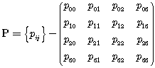, (A2-2-1)

where i and j denotes the state index, while p_{ij} is the state probability that a process currently in state i will occupy state j after its next transition. Note that p_{ij} must satisfy the following requirement

, (A2-2-2)

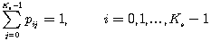, (A2-2-3)

where K_{s} is the number of states i.e., K_{s}=4 in our case and P describes how clusters appear and disappear when the MS moves.

[Editor’s note: The Markov model to be modified for a constant number of paths/clusters. The change of state is achieved by the power levels. The constant number of taps is essential to keep the model simple enough]
Appendix 3
The variation of large scale parameters is conjectured to affect the number of clusters. The cluster generation process proposed in this model can be summarized as follows:
- The received powers estimated using the conventional Okumura-Hata path loss model is defined as a standard cluster.
- The standard cluster is separated into N_{t} delay cluster in the delay domain by using the power profile estimation equation given by equation (A2-3-1).
- Based on the ellipse scattering model, each of the delay clusters can be spatially separated in the angular domain, N_{a}.
Finally, the total number of clusters in the spatial-temporal domain can be generated as N_{t}×N_{a}. Figure A2-3-1 shows the process for the above 3 steps. Note that the scattering model assumed that the effective scattering area around the MS can be expressed by an ellipse in which the MS is located in the center of the ellipse, and major axis of the ellipse runs in parallel along the street in which the MT is being located.
FIGURE A2-3-1
The generation of clusters in the spatial-temporal domains

As described above, the standard cluster can be estimated using the Okumura-Hata path loss model. Then, the delay cluster can be generated from the power delay profile and can be expressed as follows:
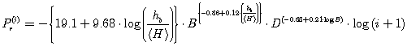, (A2-3-1)
where is the relative receiving power of ith path, B is the chip rate in Mcps, D is the transmitter and receiver separation distance in meter, h_{b} is the BS antenna height. Conformed condition is h_{b} > <H>.
Afterwards, the delay cluster will be spatially separated by deploying the method proposed in Figure A2-3-3. Based on this methodology, it is assumed that the position of the angular cluster exits at the intersection point between the arriving time at the MS and the scattering distribution ellipse as illustrated by Figure A2-3-2. Thus, a single delay cluster will be split into two delay clusters in which their angles θ₁ and θ₂ are given by:

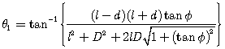, (A2-3-2)
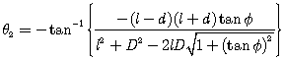. (A2-3-3)
where , if , θ₁ and θ₂ can be interchanged. Figure A-3-3 shows the example on how the angular information can be obtained from equations (A2-3-2 and A2-3-3).

FIGURE A2-3-2
The angular cluster estimation model
FIGURE A2-3-3
The spatial-temporal cluster estimation results
After identifying the spatial-temporal cluster, their received power needs to characterize. In general, the cluster located nearer to the MS has larger received power as compared to cluster located further away from the MS. When the delay cluster of received power P_{r} is spatially separated into angular clusters with angle of arrivals θ₁ and θ₂, their received power can be expressed as and , respectively, which are defined as follows:

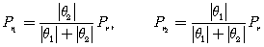. (A2-3-4)

In the case when becoming small i.e., , it can be assumed that and .

Figure A2-3-4 shows the figure in which the estimation using the proposed model was compared with the result obtained from a measurement. From the figure, it is clearly shown that for each cluster, the short section changes with a standard deviation σ=6dB. It is understood that the proposed model can be applied to most measurements to be included in the estimation.

FIGURE A2-3-4
The comparison of the estimation of spatial-temporal cluster based
on the proposed model and measurement results

1.4 Link budget template and deployment models
[Editors note: Text need to be inserted. Startpoint could be M.1225 and MIMO models etc.]
[Editor note: From the document 1143
The detailed evaluation procedures and the technical attributes which should be considered for the evaluation of radio interface technologies against each of the criteria and gives indication on what possible impact upon the different criteria could be included in this section. Radio interface technologies performance evaluation is to be based on a common set of verifiable parameter assumptions for all evaluation criteria for each test environment; if conditions change the technology descriptions should explain it.
To facilitate such criteria evaluation summaries, this part will identify the importance or relative ranking of the various technical attributes within each evaluation criteria. Ranking of some attributes may be different for different test environments. These rankings are based upon current anticipated market needs within some countries. It is also recognized that some new technical attributes or important considerations may be identified during the evaluation procedure that could impact any evaluation criteria summary.]

[Editor’s note: source [8F/1257, NZ] proposes to add a new annex]

Annex 3
Requirements for assessment of candidate technologies
[Editors note: the purpose of this section is to develop a template for evaluation]
[Editors note: the overlap between this template and the template developed in Annex 6 of the Circular Letter need to be considered.]
The table below lists the specific requirements for evaluation as described in [IMT.EVAL]. It also lists the requirements that constitute a positive assessment for a IMT-Advanced candidate technology.

Required technology items for evaluation | Evaluation Results
Peak data rates
Coverage of data rates over the cell area
Cell edge data rates
Area spectrum efficiency
Spectrum efficiency/ Coverage efficiency
Technology complexity
Quality for each class of service;
– conversational;
– interactive;
– streaming;
– background
Service Types
Flexibility of radio interface
Implication on network interfaces
Cell Coverage
Power efficiency
Spectrum compatibility
Mobility

References
- P. Barford and M Crovella, "Generating Representative Web Workloads for Network and Server Performance Evaluation" In Proc. ACM SIGMETRICS International Conference on Measurement and Modeling of Computer Systems, pp. 151-160, July 1998.
- S. Deng. “Empirical Model of WWW Document Arrivals at Access Link.” In Proceedings of the 1996 IEEE International Conference on Communication, June 1996
- R. Fielding, J. Gettys, J. C. Mogul, H. Frystik, L. Masinter, P. Leach, and T. Berbers-Lee, "Hypertext Transfer Protocol - HTTP/1.1", RFC 2616, HTTP Working Group, June 1999. ftp://ftp.Ietf.org/rfc2616.txt.
- B. Krishnamurthy and M. Arlitt, "PRO-COW: Protocol Compliance on the Web", Technical Report 990803-05-TM, AT&T Labs, August 1999, http://www.research.att.com/~bala/papers/procow-1.ps.gz. 29 30 31 32 33 34 35 36 37
- B. Krishnamurthy, C. E. Wills, "Analyzing Factors That Influence End-to-End Web Performance", http://www9.org/w9cdrom/371/371.html
- H. K. Choi, J. O. Limb, "A Behavioral Model of Web Traffic", Proceedings of the seventh International Conference on Network Protocols, 1999 (ICNP '99), pages 327-334.
- F. D. Smith, F. H. Campos, K. Jeffay, D. Ott, "What TCP/IP Protocol Headers Can Tell Us About the Web", Proc. 2001 ACM SIGMETRICS International Conference on Measurement and Modeling of Computer Systems, pp. 245-256, Cambridge, MA June 2001.
- 3GPP2/TSG-C30-20061204-062A, “cdma2000 Evaluation Methodology (V6)”, Maui, HI., December 2006
- J. Cao, William S. Cleveland, Dong Lin, Don X. Sun., "On the Non-stationarity of Internet Traffic", Proc. ACM SIGMETRICS 2001, pp. 102-112, 2001.
- K. C. Claffy, "Internet measurement and data analysis: passive and active measurement", http://www.caida.org/outreach/papers/Nae/4hansen.html.
- 3GPP2-TSGC5, HTTP and FTP Traffic Model for 1xEV-DV Simulations
- http://www-tkn.ee.tu-berlin.de/research/trace/ltvt.html
- F. Fitzek and M. Reisslein. MPEG-4 and H.263 traces for network performance evaluation (extended version). Technical Report TKN-00-06, Technical University Berlin, Dept. of Electrical Eng., Germany, October 2000.
- W. R. Stevens, "TCP/IP Illustrated, Vol. 1", Addison-Wesley Professional Computing Series, 1994.
- UMTS Forum, 3G Offered Traffic Report, 30 June 2003.
- ITU R M.2072, World mobile telecommunication market forecast.
- B. H. Kim, and Y. Hur, “Application Traffic Model for WiMAX Simulation,” POSDATA, Ltd, April 2007.
- L. A. Dabbish, R. E. Kraut, S. Fussell and S. Kiesler, “Understanding Email Use: Predicting Action on a Message,” Proceedings of the ACM Conference on Human Factors in Computing Systems (CHI’05), NY: ACM Press, pp.691-700.Ffff.
- V. Bolotin, Y. Levy, and D. Liu,” Characterizing Data Connection and Messages by Mixtures of Distributions on Logarithmic Scale, ITC 99, Edinburgh.
- G.. Brasche, B. Walke, “ Concepts Services, and Protocols of the New GSM Phase 2+ General Packet Radio Service, IEEE Communications Magazine, August 1997.
- M. S. Borella,” Source Models of Network Game Traffic”, Computer Communications, 23 (4), pp. 403-410.
_____________________

The term system-level means here that the model is able to cover multiple links, cells and terminals.

