Project | IEEE 802.16 Broadband Wireless Access Working Group <http://ieee802.org/16>
Title | Priority Access Framework for IEEE 802.16n System Architecture Reference Model
Date Submitted | 2010-11-01
Source(s) | An Nguyen  DHS/NCS  D. J. Shyy  Casey Reardon  MITRE  Matthew Sherman  BAE Systems | An.P.Nguyen@dhs.gov  djshyy@mitre.org  creardon@mitre.org  matthew.sherman@baesystems.com
Re: | 802.16n SARM
Abstract | The document describes requirements and architecture framework for supporting priority access in 802.16n
Purpose | Request consideration of concepts contained herein for the 802.16n SARM.
Notice | This document does not represent the agreed views of the IEEE 802.16 Working Group or any of its subgroups. It represents only the views of the participants listed in the “Source(s)” field above. It is offered as a basis for discussion. It is not binding on the contributor(s), who reserve(s) the right to add, amend or withdraw material contained herein.
Release | The contributor grants a free, irrevocable license to the IEEE to incorporate material contained in this contribution, and any modifications thereof, in the creation of an IEEE Standards publication; to copyright in the IEEE’s name any IEEE Standards publication even though it may include portions of this contribution; and at the IEEE’s sole discretion to permit others to reproduce in whole or in part the resulting IEEE Standards publication. The contributor also acknowledges and accepts that this contribution may be made public by IEEE 802.16.
Patent Policy | The contributor is familiar with the IEEE-SA Patent Policy and Procedures:  <http://standards.ieee.org/guides/bylaws/sect6-7.html#6> and <http://standards.ieee.org/guides/opman/sect6.html#6.3>.  Further information is located at <http://standards.ieee.org/board/pat/pat-material.html> and <http://standards.ieee.org/board/pat>.

Priority Access Framework for IEEE 802.16n System Architecture Reference Model

Introduction
Priority access is one of the important requirements of Emergency Telecommunications Service (ETS) [1]. ETS is a telecommunications service to facilitate emergency recovery operations for restoring the community infrastructure and for returning the population to normal living conditions after serious disasters and events, such as floods, earthquakes, hurricanes, and terrorist attacks. The ETS will be provided through shared resources from the public telecommunications infrastructure, which includes wireline, wireless, satellite, broadband cable, and any hybrid networks. ETS traffic needs to access, traverse, and egress these networks. Voice, video and data services are supported by ETS.

The DHS/NCS initiatives: Next Generation Network (NGN) Government Emergency Telecommunications Service (GETS), Legacy GETS, and Wireless Priority Service (WPS) are the USA instantiation of the international standard for ETS. Especially, the GETS and WPS respond to the White House’s requirement for "national security and emergency preparedness communications …under all circumstances including crisis or emergency, attack, recovery, and reconstitution…" (Executive Order 12472). Priority access is required for National Security and Emergency Preparedness (NS/EP) users for conducting their missions effectively during disasters using various 3G/4G wireless technologies including WiMAX.

IEEE 802.16m has priority access requirements and priority access techniques for NS/EP users. In Section 5.8 of IEEE 802.16m-07/002r10, it says: “IEEE 802.16m shall be able to support public safety first responders, military and emergency services such as call-prioritization, pre-emption, and push-to-talk”. P802.16m/D8, includes the following priority access techniques:
- Access class control is available for bandwidth request messages
- Priority ranging can be performed using the purpose indicator bit designated for NS/EP users on the AAI_RNG_REQ messages
- A pre-defined index on bandwidth request messages is available that can map to different QoS levels which can be leveraged to provide priority access
- Prioritized service flow management is available for NS/EP users (such as accelerated service flow setup and receiving priority in admission control for service flows)
- If a service provider wants to support National Security/Emergency Preparedness (NS/EP) priority services, the ABS uses its own algorithm as defined by its local country regulation body. For example, in the US the algorithm to support NS/EP is defined by the FCC in Hard Public Use Reservation by Departure Allocation (PURDA).

In the 802.16n SRD [15], it says: ”IEEE 802.16n should support services that require a higher degree of assurance of maintaining sufficient connectivity than can be provided by IEEE 802.16 legacy systems. Examples of such services can be found in PPDR (Public Protection and Disaster Recovery) …“.

Enhanced access priority was discussed in the 802.16p study report [16]. It says: “Enhanced access priority implies that the M2M device is given priority over other network nodes when contending for network access”.

Priority access requirements or techniques are also reflected in the following WiMAX Forum standards:
- Service Provider Working Group (SPWG) ETS Phase 1 Requirements (for Release 1.6) – WFM-T31-122-R016v01 (completed in 2/2009)
- SPWG ETS Requirements, Release 2.0 – WFM-T31-122-R020v01 (completed in 11/2009)
- Network Working Group (NWG) Network Architecture Stage 2 Base Specifications – WFM-T32-001-R016v01, Section 7.14: Emergency Telecommunications Service (ETS) Support (completed in 6/2010)
- Network Working Group (NWG) Network Architecture Stage 3 Base Specifications – WFM-T33-001-R016v01, Section 4.19: Emergency Telecommunications Service (ETS) Support (completed in 6/2010)

  - Scope
The end-to-end solution for WiMAX network priority treatment should be across both access and transport networks. In this document, the main focus is priority access to the radio access network.
  - Purpose
The major purpose of this document is to provide a framework to support ETS priority access based on WiMAX network and the new features identified in 802.16n SRD. The identified framework is our recommendations for 802.16n SARM text.
  - Document Organization
Section 2 presents more detailed ETS requirements, especially in the area of priority access.
Section 3 presents a general prioritized framework to support priority access to be considered by 802.16n.
Sections 4 – 7 present considerations of supporting priority access for various air-interface connections in 802.16n.
Section 8 is our text proposal for the 802.16n SARM.

Priority Access Requirements
  - Priority Access Service
ETS is a super set of all emergency services for an authorized select group of users. Wireless Priority Service (WPS) is one of the ETS that is on wireless networks. The Wireless Priority Service should provide end-to-end treatment across the network (e.g., access, transport, and egress) so that higher communication session completion rates, as compared with public communication session completion rates, would be successfully achieved. Communication sessions in this context include voice, multimedia, and data.” [1]

DHS/NCS has worked with service providers as well as equipment vendors to have WPS implemented [3]:
- “Priority access service is intended to facilitate emergency response and recovery operations in response to natural and man-made disasters and events, such as floods, earthquakes, hurricanes, and terrorist attacks. Priority access service is also intended to support both national and international emergency communications.”
- “Priority access service is based upon, and complies with, the FCC Second Report and Order (R&O) 00-242 (Wireless Telecommunications (WT) Docket No. 96-86).
- “Priority access service is intended to allow qualified and authorized National Security and Emergency Preparedness (NS/EP) users to obtain priority access to radio traffic channels and core network resources during situations when Commercial Mobile Radio Service (CMRS) provider network congestion is blocking call attempts”.

WiMAX networks should support priority service too. The end-to-end priority service needs to cover radio accessing, data transportation and interconnection with other networks. Priority access service only focuses on the radio accessing part of the priority service. The NS/EP authorized user shall have a higher priority level to obtain radio resources when accessing WiMAX networks to facilitate emergency recovery.

End-to-end ETS is across different telecommunication networks and different countries. There are ETS standardization activities around the globe. The following standards bodies have ETS activities:
- ITU (International Telecommunication Union)
- IETF (Internet Engineering Task Force)
- ETSI (European Telecommunications Standards Institute)
- ATIS (Alliance for Telecommunications Industry Solution)
- TIA (Telecommunications Industry Association)
- 3GPP (3rd Generation Partnership Project)
- 3GPP2 (3rd Generation Partnership Project 2)

  - Requirements
The associated requirements for priority access service [1] include:
- Ubiquitous Services:
  - Able to make a call/session in times of disaster, national emergency, or for executive/governmental communications relating to National Security / Emergency Preparedness (NS/EP).
  - Applies to voice, video, and data services.
- Availability:
  - Available to NS/EP users at all times.
- QoS
  - End-to-end QoS should be provided based on 802.16e QoS classes and parameters.
- Security
  - Networks must have protection against corruption and intrusion such as unauthorized access, control and traffic.
- Priority treatment
  - ETS communications should be provided preferential end-to-end treatment so that higher communication session completion rates, as compared with public communication session completion rates, would be successfully achieved.

802.16n Prioritized Framework to Support Priority Access

This section describes the proposed prioritized framework to be considered by 802.16n.

To support priority access in 802.16n, the following procedures are required
- User subscription
- Service priority invocation (service priority indication)
- User authentication (user identity; verifies the service indication is from a priority user)
- Service authorization (specifies the service privileges of a priority user)
- Service priority treatment (service differentiation)

This document discusses the techniques used for service priority treatment. To provide service priority treatment using 802.16n networks, the following techniques are required:
- Prioritized network entry (specially in initial ranging)
- Prioritized (initial) service flow setup and admission
- Prioritized transport connection setup and maintenance
- Prioritized management messages (e.g. bandwidth request for admitted service flow)
- Prioritized paging
- Prioritized handover (intra-ASN, inter-ASN, inter-CSN and inter-RAT)
- Prioritized network exit

The congestion points for radio access occur at contention-based and allocation-based transmission (shown in Figure 1). The contention-based transmission is mainly used for initial ranging and bandwidth request. The allocation-based is to allocate OFDMA capacity for both management and transport messages. This contribution discusses the prioritized framework to support priority access for both contention based and allocation-based transmission.

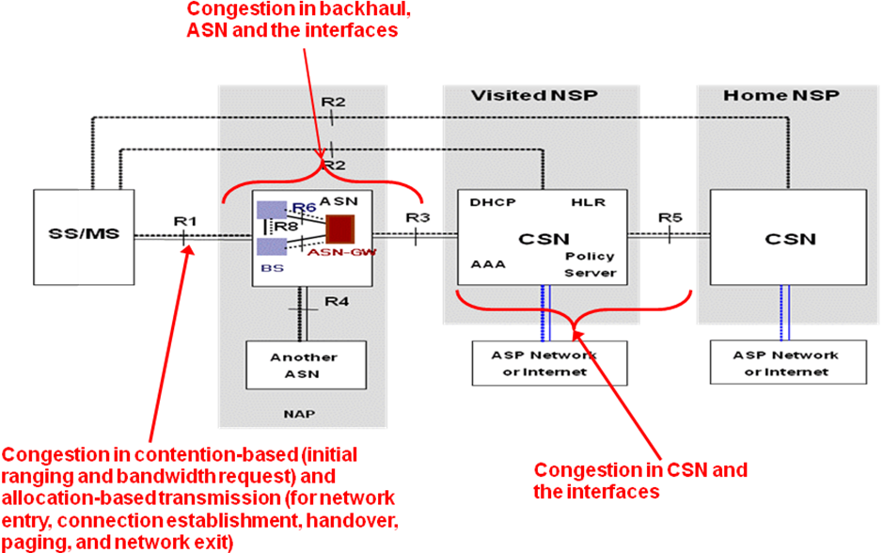
Figure 1: WiMAX Network Congestion Points

By incorporating the priority treatments shown in Table 1, the probability of success can be increased for the priority call/session at different stages of call/session flow.

Table 1: Priority treatments for different congestion points in a WiMAX network

 | Congestion points | Priority treatment
 | Network entry before initial service flow | √
 | Network entry at or after Initial service flow establishment | √ (admission control for initial service flow is out of scope)
 | Connection establishment | √ (admission control for service flow is out of scope)
 | DL management messages | √ (with priority indication using ISF)
 | DL resource scheduling | √ (using prioritized CID)
 | UL management messages | √ (CID-based priority indication technique, e.g., for bandwidth request)
 | UL resource scheduling | √ (priority scheduling of radio resources can be applied for bandwidth request messages)
 | Intra-ASN HO | √
 | Inter-ASN HO | √
 | Inter-CSN HO | √
 | Paging | √
 | Network exit | √

The prioritization techniques used in different functional elements of a WiMAX network is provided below.

The AAA contains the subscriber QoS profile defined on a per subscriber basis. The QoS profile contains the user’s priority level. After the subscriber sends SBC-REQ message to the BS to start negotiating basic capability with the BS, the BS send MS_Pre_Attachment request informing ASN GW that a new subscriber has joined the network. At this step, the ANS GW is aware of the subscriber’s capability. After the completion of MS Pre-Attachment transaction, the ASN GW initiates the EAP authentication procedure with the subscriber. During the EAP authentication procedure, the ASN GW forwards the EAP messages to AAA using RADIUS Access-Request packets. The ASN GW receives a RADIUS Access-Accept packet from the AAA to indicate that successful completion of EAP-based authentication. The RADIUS Access-Accept packet contains a pre-provisioned service flow descriptor and its corresponding QoS descriptor (which is derived from the subscriber QoS profile). The QoS descriptor contains the user’s priority level. The ASN GW sends (initial) service flow information to the BS using the Path_Reg_Req message. The (initial) service flow information contains SFID, SF type, QoS and other parameters. The QoS parameters contain the user’s priority level. From the user’s priority level, the BS can mark those ISF and SF with a priority indicator, and the BS can apply prioritized admission control to those ISF and SF. After the prioritized SF is admitted, the connection ID mapped to the prioritized SF will be identified as a prioritized connection ID, and receive priority treatment. The prioritized treatment includes prioritized scheduling/queuing of radio resources for DL management/transport messages as well as UL bandwidth request messages.

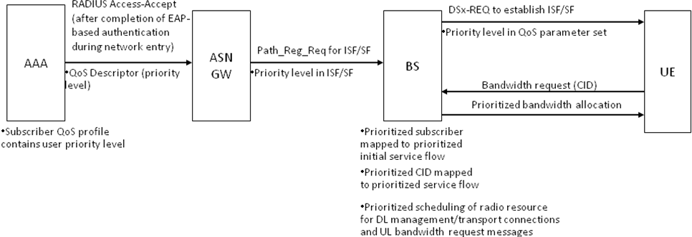

References 6, 7 and 9 provide detailed recommendations for priority access techniques in different stages of call flow and analysis of a WiMAX network to quantify the performance improvements for NS/EP users under the proposed techniques. The recommendations are listed below:

a. Assign one or more dedicated initial ranging slots for regular users and one dedicated initial ranging slot for priority user for a larger channel bandwidth (e.g. 10 MHz). Also assign a set of dedicated codes for regular users and another dedicated set for priority users.

b. Assign dedicated initial ranging slots in one or more frames for regular users and dedicated initial ranging slots in a separate set of frames for priority users when using a smaller channel bandwidth (e.g. 5 MHz).

c. a) and b) are also applicable to bandwidth requests.

Priority access techniques using code allocation was also mentioned in Reference 13. In addition, some of the techniques proposed in Reference 13 for accommodating a large number of devices when entering the network are applicable for priority access. They include:

- Regulation of network entry based on traffic load, i.e., users are blocked from network entry in a fair manner so the random access channel can be prevented from being heavily congested
- Prioritized network entry based on traffic classes
- Similar to our proposed techniques [6][7][9], increase the initial ranging slot and dynamically allocate the ranging codes for the ranging channel
- Using the ranging channel to send SMS (up to 140 bytes) via AAI_RNG_REQ messages. The benefit of using SMS is that no service flow and connection need to be established which reduces a lot of overhead for the network [14]. Priority access using SMS via ranging channels needs to be supported.

Priority Access Considerations for Mobile to Mobile Communication

In general, mobile to mobile communication for 802.16n can be achieved using a concept similar to 802.11 ad-hoc mode. In Reference 12, a dynamically allocated dedicated ad-hoc zone with periodic beacon transmission was proposed for mobile to mobile communication. In addition, the SMS proposed in the 802.16p needs to be supported for mobile to mobile communication such that a disadvantaged mobile can communicate with others using the simplest form of communication: SMS.

For NS/EP users, if their mobiles become disadvantaged mobiles, they will take advantage of mobile to mobile communication (to regular and NS/EP users) to obtain IP services or SMS services. In addition, their service will receive priority treatment over other regular users. However, NS/EP mobiles will provide mobile to mobile communication services to other NS/EP users only, not regular users.

Priority Access Considerations for Relay to Relay Communication

In References 4 and 5, intra-cell and inter-cell relay to relay communications were proposed to achieve load balancing and MESH-MANET. Dedicated relay zones are used to provide resource for these two types of communications.

NS/EP users shall have priority access over intra-cell and inter-cell HR-RS to HR-RS communication.

NS/EP users shall have priority access during local forwarding [15] [17] for HR-MS to HR-RS to HS-MS communication.

Priority Access Considerations for BS to BS Communication

Similar to relay to relay communication, dedicated BS zones are used to provide resource for HR-BS to HR-BS communication.

NS/EP users shall have priority access over HR-BS to HR-BS communication.

Priority Access Considerations for Standalone Networks

NS/EP users shall have priority access in an 802.16n standalone network.

Texts to be Considered in 802.16n SARM
The following texts in this clause should be added in appropriate locations in the SARM:

802.16n shall support priority access techniques in the initial ranging channel during network entry, bandwidth request channel in connection establishment, and dedicated code ranging during handover. Priority access techniques supported by 802.16m shall also be supported by 802.16n. In addition the following techniques shall be supported:

Priority access techniques supported by HR-BS & HR-RS:

- HR-BS and HR-RS shall assign one or more dedicated initial ranging slots for regular users and a separate dedicated initial ranging slot for priority users when supporting larger channel bandwidths (e.g. 10 MHz or greater). The HR-BS shall also assign a set of dedicated ranging codes for regular user and a separate dedicated set for priority user.
- HR-BS and HR-RS shall assign a dedicated slot for initial ranging in a set of frames for regular user and a dedicated slot for initial ranging in a separate set of frames for priority user when supporting smaller channel bandwidth (e.g. 5 MHz or less). For example, out of every four frames, one frame is dedicated for priority user initial ranging and other three frames are for regular user initial ranging.
- HR-BS and HR-RS shall also apply the techniques described in a) and b) to bandwidth request messages.
- HR-BS and HR-RS shall regulate network entry based on traffic load, i.e., users are blocked from network entry in a fair manner so the random access channel can be prevented from being heavily congested. The following provides a possible implementation to clarify this concept. There is a blocking probability associated with each user, and the user obtains the blocking probability from the downlink system messages. Before a user attempts to initiate an initial ranging, the user needs to generate a random number between 0 and 1. If the random number is less than the blocking probability, the initial ranging request can go through; otherwise, the initial ranging request is blocked. If the initial ranging request is blocked, following the binary exponential backoff specified in IEEE 802.16, the initial ranging will be re-initiated.
- HR-BS and HR-RS shall provide prioritized network entry based on traffic classes. As an example, the blocking probability in d) can be a function of the traffic classes.
- HR-BS and HR-RS shall support priority access using SMS via ranging channels.
- HR-BS and HR-RS shall provide NS/EP users priority access over regular users.

Priority access techniques supported by HR-MS:

HR-MS shall support priority access techniques a) to f) as required. In addition the following shall be supported by HR-MS:

- 802.16n mobile to mobile communication shall support SMS.
- If disadvantaged, NS/EP users shall take advantage of mobile to mobile communication (from regular and NS/EP users) to obtain IP services or SMS services. In addition, when NS/EP users indicate that they require priority services, NS/EP user traffic shall receive priority treatment over traffic from regular users. However, NS/EP mobiles shall only provide mobile to mobile communication services to other NS/EP users, not regular users.

Priority access techniques supported by HR-RS:
HR-RS shall support priority access techniques a) to f) as identified. In addition HR-RS shall support the following capabilities:

- HR-RS shall support intra-cell and inter-cell relay to relay communications.
- HR-RS shall provide NS/EP users priority access over intra-cell and inter-cell HR-RS to HR-RS communication.
- HR-RS shall provide NS/EP users priority access during local forwarding for HR-MS to HR-RS to HS-MS communication.

Conclusion

We have presented requirements for priority access and a framework for priority access techniques from an ETS view point. We have presented a system architecture that supports these services and requirements. We would like this concept to be included in the 802.16n SARM.

References
[1] “Overview of Standards in Support of Emergency Telecommunication Service (ETS),” ATIS-pp-0100009, November 2006.
[2] Wireless Priority Service (WPS) Industry Requirements For UMTS – Phase 1 – Redirection to GSM,” DHS/NCS IR Document, Version 0.3, April 2005
[3] An Nguyen, "Priority Access for IEEE 802.16m", C802.16m-07/253r3, Jan. 2008
[4] D. J. Shyy etal, "Secure, Cooperative, Scalable and Multi-Dimensional Scheduling - A SDD Proposal for IEEE 802.16m", C802.16m-07/251r3, Nov. 2007.
[5] D. J. Shyy, "Relay to Relay Communication - A SDD Proposal for 802.16m", C802.16m-08/047, Jan. 2008.
[6] An Nguyen and D. J. Shyy, "Prioritized QoS Framework in Network Entry", C802.16m-08/1046r1, September 2008.
[7] An Nguyen and D. J. Shyy, "Prioritized QoS Framework in Connection Establishment and Maintenance", C802.16m-08/1049r1, September 2008.
[8] An Nguyen and D. J. Shyy, "Priority Access Service for Femtocells for IEEE 802.16m", C80216m-08/1337r1, Oct. 2008.
[9] An Nguyen and D. J. Shyy, "IEEE 802.16m – Traffic Load Analysis for NS/EP (Priority) Users", C80216m-08/1338r1, Oct. 2008.
[10] An Nguyen and D. J. Shyy, "Emergency Service – NS/EP Vs E-911 for IEEE 802.16m", C80216m-10_0698.ppt, June. 2010.
[11] An Nguyen and D. J Shyy, "Proposed text for Emergency Service – NS/EP for IEEE 802.16m", C80216m-10_1257.doc, Sept. 2010.
[12] Jeff Bonta etal, “Ad Hoc Relay Frame Structure”, S80216m-08/003r1, Jan. 2008.
[13] N. Himayat etal, “Functional Requirements for Network Entry and Random Access by Large Number of Devices”, C80216ppc-10/0049r1, Aug. 2010.
[14] N. Himayat etal, “Analysis of signaling overhead to establish network connectivity,” C80216ppc-10_0055r1, Sept. 2010.
[15] 802.16n System Requirements Document, 802.16gman-10/0038r1, Sept. 2010.
[16] HanGyu Cho, Jose Puthenkulam, “Machine to Machine (M2M) Communication Study Report”, C802.16ppc-10/0002r7, May 2010.
[17] Arnaud Tonnerre etal, “Cross Communication”, C80216j-06/100r1, Sept. 2006.
Appendix A: More Information on ETS

[1] Quality of Service Attributes for Diameter,” draft-ietf-dime-qos-attributes-02.txt
[2] “Quality of Service Parameters for Usage with the AAA Framework,” draft-ietf-dime-qos-parameters-01.txt
[3] “RSVP Extensions for Emergency Services,” draft-ietf-tsvwg-emergency-rsvp-03.txt
[4] “QoS NSLP QSPEC Template,” draft-ietf-nsis-qspec-18.txt
[5] Report ITU-R.[PPDR]: “Radiocommunication objectives and requirements for public protection and disaster relief (PPDR)”
[6] Recommendation H.460.4 – Call priority designation for H.323 calls
[7] Draft recommendation H.SETS – security for ETS (H.235)
[8] E.106 – Description of an international emergency preference scheme (IEPS)
[9] Draft Recommendation U.roec – network requirements and capabilities to support ETS
[10] RFC3523: “Internet Emergency Preparedness (IEPREP) Telephony Topology Terminology”
[11] TETRA: “Mobile narrowband and wideband communications for public safety applications”
[12] TR41.4 TSB146: “Telecommunications – IP Telephony Infrastructure – IP Telephony Support for Emergency Calling Service)
[13] 3GPP TS 22.153, “Technical Specification Group Services and System Aspects; Multimedia priority service”, Release 8.
[14] 3GPP S.R0017-0, “Multimedia Priority Service (MMPS) for MMD-based Networks – Stage 1 Requirements”

