Project | IEEE 802.16 Broadband Wireless Access Working Group <http://ieee802.org/16>
Title | Proposed Text for 802.16n System Architecture Reference Model
Date Submitted | 2010-11-01
Source(s) | An Nguyen  DHS/NCS | An.P.Nguyen@dhs.gov
Re: | 802.16n SARM
Abstract | This provides proposed texts to draft 802.16n SARM document
Purpose | To be discussed and adapted by TGgman for drafting 802.16n SARM.
Notice | This document does not represent the agreed views of the IEEE 802.16 Working Group or any of its subgroups. It represents only the views of the participants listed in the “Source(s)” field above. It is offered as a basis for discussion. It is not binding on the contributor(s), who reserve(s) the right to add, amend or withdraw material contained herein.
Release | The contributor grants a free, irrevocable license to the IEEE to incorporate material contained in this contribution, and any modifications thereof, in the creation of an IEEE Standards publication; to copyright in the IEEE’s name any IEEE Standards publication even though it may include portions of this contribution; and at the IEEE’s sole discretion to permit others to reproduce in whole or in part the resulting IEEE Standards publication. The contributor also acknowledges and accepts that this contribution may be made public by IEEE 802.16.
Patent Policy | The contributor is familiar with the IEEE-SA Patent Policy and Procedures:  <http://standards.ieee.org/guides/bylaws/sect6-7.html#6> and <http://standards.ieee.org/guides/opman/sect6.html#6.3>.  Further information is located at <http://standards.ieee.org/board/pat/pat-material.html> and <http://standards.ieee.org/board/pat>.

Figure 1 and Table 1 show the IEEE 802.16n interfaces that are to be supported and those which are not required to be supported in the specification. They also indicate the specific 802.16 protocol that is to be used for supporting the particular connection. Note that Figure 1 and Table use 802.16m as an example to illustrate the backwards compatibility between 802.16n and 802.16m. Same interfaces can be extended to those between 802.16n and 802.16e.

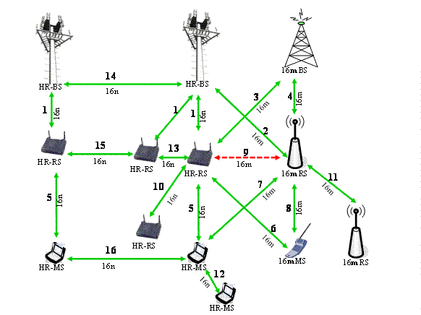
Figure 1: Diagram showing the 802.16n connections
Table 1 summarizes Figure 1 as follows:

Table1: Interconnections between the entities shown in Figure 1 and the protocol used.

Connection # | Connected Entities | Protocol used | Supported (Y/N)
1 | 16n BS -16n RS | 16n | Y
2 | 16n BS – 16m RS | 16m | Y
3 | 16n RS – 16m BS | 16m | Y
4 | 16m BS – 16m RS | 16m | Y
5 | 16n RS – 16n MS | 16n | Y
6 | 16n RS – 16m MS | 16m | Y
7 | 16n MS – 16m RS | 16m | Y
8 | 16m RS – 16m MS | 16m | Y
9 | 16n RS – 16m RS | N/A | N
10 | 16n RS – 16n RS (tree) | 16n | Y
11 | 16m RS – 16m RS (tree) | 16m | Y
12 | 16n MS – 16n MS (intra-cell) | 16n | Y
13 | 16n RS – 16n RS (peer; intra-cell) | 16n | Y
14 | 16n BS – 16n BS | 16n, other air interfaces and wired | Y
15 | 16n RS – 16n RS (peer; inter-cell) | 16n | Y
16 | 16n MS – 16n MS (peer; inter-cell) | 16n | Y

Figure 1 and Table 1 capture the interfaces which may exist between the IEEE 802.16n and 802.16m. The figure and table are not intended to specify any constraints on the usage of these interfaces. For example, the figure and table do not provide rules for which interfaces a particular station can utilize at the same time, or how many connections a station can have over each of the specified interfaces.

The usage of the interfaces described in Figure 1 and Table 1 is constrained as follows: A IEEE 802.16n MS may connect to a 16n BS either directly or via one or more IEEE 802.16n RSs. The number of hops between the IEEE 802.16n BS and a IEEE 802.16n MS can be two or greater than two. The topology for IEEE 802.16n RSs within a cell can be a tree or peer to peer. The topology for IEEE 802.16n RSs between cells is restricted to peer to peer. A IEEE 802.16m MS may connect to a IEEE 802.16n BS either directly or via one or more IEEE 802.16n RSs.

Connection 10 indicates a connection between a IEEE 802.16n RS and another directly connected IEEE 802.16n RS as in a tree topology. Such connections exist in order to support topologies in which the number of hops between the IEEE 802.16n BS and an IEEE 802.16n MS is greater than two hops.

Connection 12 indicates a connection between a IEEE 802.16n MS and another IEEE 802.16n MS in the same cell. Such connections exist in order to support a (disadvantaged) IEEE 802.16n MS that is out of range.

Connection 13 indicates a connection between a IEEE 802.16n RS and another IEEE 802.16n RS in the same cell where both these two RSs have peer to peer relationship.

Connection 14 indicates a connection between a IEEE 802.16n BS and another IEEE 802.16n BS where both these two BSs have peer to peer relationship. Note that this connection can be over the air using 802.16n, other air interfaces (e.g. microwave) or using wired technologies (e.g. T1/E1).

Connection 15 indicates a connection between a IEEE 802.16n RS and another IEEE 802.16n RS in different cells where both these two RSs have peer to peer relationship.

Connection 16 indicates a connection between a IEEE 802.16n MS and another IEEE 802.16n MS in different cells. Such connections exist in order to support a (disadvantaged) IEEE 802.16n MS that is out of range.

