Project | IEEE 802.16 Broadband Wireless Access Working Group <http://ieee802.org/16>
Title | Proposed System Reference Model for 802.16n
Date Submitted | 2010-10-21
Source(s) | Woo-Geun Ahn, Donghan Chee, Ju Yong Lee  KAIST | E-mail: wgahn@itc.kaist.ac.kr
Re: | Call for contributions on 802.16n system reference model (802.16gman-10_0040)
Abstract | In this contribution, we propose a system reference model for IEEE 802.16n.
Purpose | Contribution to IEEE 802.16n for the proposal of system reference architecture
Notice | This document does not represent the agreed views of the IEEE 802.16 Working Group or any of its subgroups. It represents only the views of the participants listed in the “Source(s)” field above. It is offered as a basis for discussion. It is not binding on the contributor(s), who reserve(s) the right to add, amend or withdraw material contained herein.
Release | The contributor grants a free, irrevocable license to the IEEE to incorporate material contained in this contribution, and any modifications thereof, in the creation of an IEEE Standards publication; to copyright in the IEEE’s name any IEEE Standards publication even though it may include portions of this contribution; and at the IEEE’s sole discretion to permit others to reproduce in whole or in part the resulting IEEE Standards publication. The contributor also acknowledges and accepts that this contribution may be made public by IEEE 802.16.
Patent Policy | The contributor is familiar with the IEEE-SA Patent Policy and Procedures:  <http://standards.ieee.org/guides/bylaws/sect6-7.html#6> and <http://standards.ieee.org/guides/opman/sect6.html#6.3>.  Further information is located at <http://standards.ieee.org/board/pat/pat-material.html> and <http://standards.ieee.org/board/pat>.

Proposed System Reference Model for 802.16n
Woo-Geun Ahn
Donghan Chee
Ju Yong Lee
KAIST

I. Introduction

The 802.16n standard is developed as an amendment to 802.16 to enable increased robustness and alternative radio path in degraded network environments. In this contribution, we propose a system reference architecture of IEEE 802.16n for high reliability network.

II. Usage model

The 802.16n standard supports direct communications among mobile-stations (MSs) and operates with radio path redundancy.

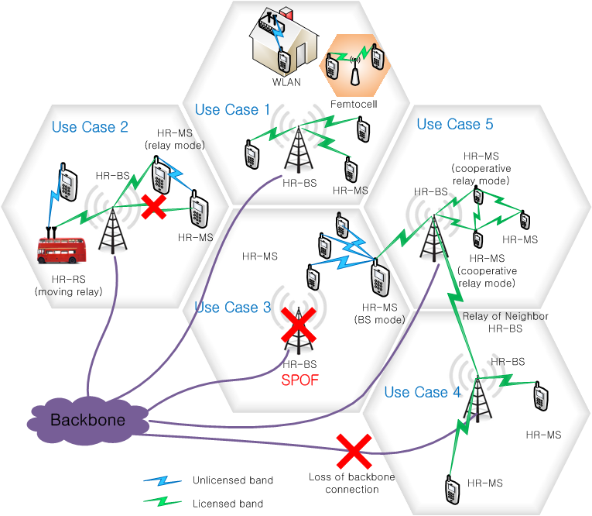

Figure 1: Usage Model of IEEE 802.16n Architecture

The usage models of 802.16n are illustrated in Figure 1, which addresses the concepts of multi-mode operation, infrastructure SPOF (single point of failure), link reliability, and coexistence, etc.

Use case 1: This illustrates the basic function of HR-BS and HR-MS which coexist with WLAN or femto-cell. Since 802.16 allows the use of unlicensed band for its operation, MS can access to the WLAN AP.

Use case 2: The 802.16n system supports moving HR-RS. HR-MS can obtain a reliable communication link via HR-RS. A HR-MS may have a redundancy path via HR-MS of RS-mode to increase the communication reliability.

Use case 3: In case of SPOF of HR-BS, HR-MS operates like BS. Then, HR-network can provide local connectivity to the HR-MSs within the coverage of the broken HR-BS.

Use case 4: In case of the loss of backbone connection, neighbor HR-BS operates as the relay, which can provide continuous network connectivity to the HR-MSs within the coverage of the disconnected HR-BS.

Use case 5: In order to increase the robustness of HR-MS (far away from HR-BS), HR-MSs relay to each other in a cooperative manner.

III. Network reference model

As mentioned in the previous section, the 802.16n system can be operated in the unlicensed band as well as the licensed band. Also the 802.16n system supports multi-mode operation of HR-BS/MS. Moreover, alternate radio path can be established to increase the reliability.

Figure 2: IEEE 802.16n Network Reference Model

Figure 2 shows a network reference model. HR-MS basically has a radio access control unit and a route control unit. Radio access control unit may periodically monitor the received signals of each access network and control the accessibility. When the on-going link is unavailable, the radio control unit can determine whether it uses another reliable link with the current access technology or new access technology. Route control unit performs the path discovery and path maintenance with or without network support. HR-MS can communicate with HR-BS directly. Otherwise, it can communicate with the aid of HR-MS operating as RS mode or BS mode. When the HR-BS such as 802.16 BS and 802.11 AP loses the backbone connectivity, neighbor HR-BS operates as the relay. Then, it can provide continuous connection to the HR-MSs within the disconnected HR-BS.

IV. Proposed system reference model

The Figure 3 shows the 802.16n system reference model.

Figure 3: IEEE 802.16n System Reference Model

The PHY and MAC functions can be categorized as data plane, control plane, and management plane. The data plane contains the functions of creating and processing PHY/MAC data. The control plane has the functions of radio resource management and control signaling. The management plane functions deal with system configuration and external management. In 802.16n, reliability sublayer can be defined in management plane.

