Project | IEEE 802.16 Broadband Wireless Access Working Group <http://ieee802.org/16>
Title | Text modifications for the Working Draft for 802.16n System Requirements Document: Performance Requirements
Date Submitted | 2010-11-10
Source(s) | Eldad Zeira  InterDigital Communications LLC  Youngbin Chang  Samsung Electronics | Eldad.zeira@interdigital.com  yb.chang@samsung.com
Re: | 802.16n requirements
Abstract | This document proposes performance requirements for 802.16n SRD.
Purpose | To be discussed and included in 802.16n SRD
Notice | This document does not represent the agreed views of the IEEE 802.16 Working Group or any of its subgroups. It represents only the views of the participants listed in the “Source(s)” field above. It is offered as a basis for discussion. It is not binding on the contributor(s), who reserve(s) the right to add, amend or withdraw material contained herein.
Release | The contributor grants a free, irrevocable license to the IEEE to incorporate material contained in this contribution, and any modifications thereof, in the creation of an IEEE Standards publication; to copyright in the IEEE’s name any IEEE Standards publication even though it may include portions of this contribution; and at the IEEE’s sole discretion to permit others to reproduce in whole or in part the resulting IEEE Standards publication. The contributor also acknowledges and accepts that this contribution may be made public by IEEE 802.16.
Patent Policy | The contributor is familiar with the IEEE-SA Patent Policy and Procedures:  <http://standards.ieee.org/guides/bylaws/sect6-7.html#6> and <http://standards.ieee.org/guides/opman/sect6.html#6.3>.  Further information is located at <http://standards.ieee.org/board/pat/pat-material.html> and <http://standards.ieee.org/board/pat>.

Discussion

The current draft of the 802.16n SRD does not include any performance requirements. Lack of agreed performance requirements will make it difficult to evaluate various technical proposals. Moreover, it makes it difficult to assess at what point standard development is sufficient.

Performance requirements should be matched to the intended application or applications of the amendment and should reflect accepted requirements for such applications.

The UCA International Users Group is a not-for-profit corporation focused on assisting users and vendors in the deployment of standards for real-time applications for several industries with related requirements. The Users Group does not write standards, however works closely with those bodies that have primary responsibility for the completion of standards (from http://www.ucaiug.org/default.aspx)

The OSGug Technical Subcommittee operates under the UCAiug. Its mission (from http://osgug.ucaiug.org/org/default.aspx) is to “foster enhanced functionality, lower costs and speed market adoption of Advanced Metering networks and Demand Response solutions through the development of an open standards-based information/data model, reference design & interoperability guidelines”.

The Technical Committee has been working on defining a network reference model that shows electrical grid elements as well as the communication network to support it (in SG-NET-diagram-r0.6e.vsd). See Figure 1: Network entities and their connections (ref [1])

In the context of this model, the TC has compiled a set of messages used between network entities [2].

Information provided for each message includes its delivery chain, frequency of occurrence and latency and reliability requirements. It should be noted that not all links can be assumed to be implemented for all Smart Grid deployments.

Figure 2: Latency and Reliability Requirements of Smart Grid Messages (From OSGug) provides a summary of the latency and reliability requirements of the proposed SG messages. It should be noted that the requirements are written from the point of view of the application and therefore should be considered as end to end, application layer requirements. In many cases the delivery involves several successive links. The SAP requirement at the top of the MAC should be considerably tighter.

Note the large number of messages that require end to end latency of 1 second with a reliability of better than 99.5%.

Figure 1: Network entities and their connections

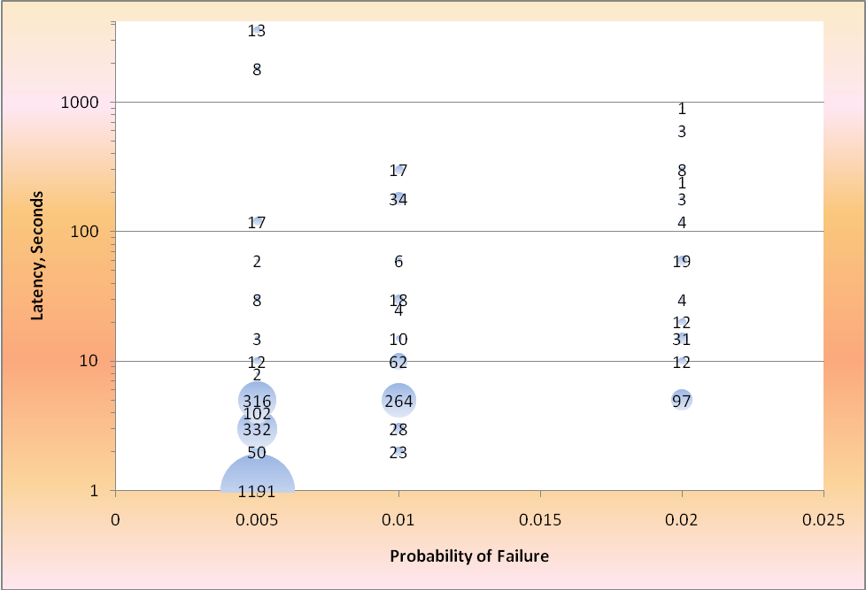
Figure 2: Latency and Reliability Requirements of Smart Grid Messages (From OSGug)
Notes:
- Bubble size and label indicate count of distinct messages
- Latency should be understood to refer to end to end message delivery at application layer, not MAC SAP. In many cases the end to end delivery involves several links or their combinations.

A more detailed analysis was performed for residential and related links see Table 1: Analysis of AMI and WAN links. In the table below, usage “AMI” refers to links used between e.g. a residence and a DAP (but not inside the residence) and usage “WAN” refers to links between the AMI and operations on a WAN (the latter could be wired or wireless, I have assumed wireless).

Notation: (from [2]) “+” sign implies chaining of links where “or” implies that message may be sent on one or the other due to implementation (as not all links are assumed always implemented).

The red links are the ones we want to specify here.

Table 1: Analysis of AMI and WAN links
# | Usage | Chain | Critical chain | Ref in [2] | HAN | AMI | WAN | P2P or wired | Lat. (S) | Rel.  % | Size  (Bytes) | Frequency of occurence | Comments
 |  |  |  |  | Link /  latency (s) /  reliability %) | ➔ | ➔ | ➔
1 | AMI | 16Aa or 1D + 5Bb + 16Cb | 1D + 5Bb + 16Cb | 103 | 16Cb / 1 / 99.6% | 1D, 5Bb / 2 / 99.6% |  |  | 5 | 99 | 25 | 1-10 / day / customer
2 | AMI | 16Ca or 1D + 5Bb + 16Ab | 1D + 5Bb + 16Ab | 108 | 16Ab / 1 / 99.6% | 1D, 5Bb / 2 / 99.6% |  |  | 5 | 99 | 25 | 1-10 / day / customer | 16Ca not found
3 | AMI | 5Bb +  [1Ca or (1Cba + 1Cb) or (1Cba + 1Cc)] +  9 | 5Bb + 1Ca + 9 | 124 |  | 5Bb / 7.5 / 99.7 | 1Ca / 7.5 / 99.7 | 9 / 0 / ∞ | 15 | 99.5 | 50 | 1 per 1000 mtrs / day | 1Cc not found
4 | WAN | 1B +  [1Ca or (1Cba + 1Cb) or (1Cba + 1Cc)] +  1D | 1B + 1Ca + 1D | 30 |  | 1D / 10 / 99.7 | 1Ca / 5 / 99.7 | 1B / 0 / ∞ | 15 | 99.5 | 25 | 0.025/day/meter
5 | WAN | [1Ca or (1Cba + 1Cb) or (1Cba + 1Cc)] +  [(5Ba + 16Ba + 16B1) or (5Bb + 16Bb + 16B1)] | 1Ca + 5Ba + 16Ba | 180 | 16Ba / 2 / 99.8 | 5Ba / 4 / 99.8 | 1Ca / 4 / 99.8 |  | 10 | 99.5 | 50 | 1/meter/day
6 | WAN | 1Ca | 1Ca | E.g. 652 |  |  | 1Ca / 1 / 99.5 |  | 1 | 99.5 | 150 | 1/hour/device
7 | WAN | [4DRG + (1Ca or (1Cb + 1Cba) or (1Cc + 1Cba)) + 10] or  [(4GRG or (4FRG + 4F) or (4ERG + ((4Eb + 4Ca) or ((4Ea or (4Eb + 4ERU)) + 4Ba)))) + 4A] | 4DRG + 1Ca + 10 | 1762 |  | 4DRG / 2 / 99.7 | 1Ca / 2 / 99.7 | 1B / 0 / ∞ | 4 | 99.5 | 250 | 0.2/min
8 | WAN | [4A + ((((4Ba + ((4ERU + 4Eb) or 4Ea)) or (4Ca + 4Eb)) + 4ES) or (4F + 4FS) or 4GS)] or  [10 + ((1Ca or (1Cb + 1Cba) or (1Cc + 1Cba)) + 4DS] | 10 + 1Ca + 4DS | 878 |  | 4DS / 2 / 99.7 | 1Ca / 2 / 99.7 | 1B / 0 / ∞ | 4 | 99.5 | 50 | 0.2/sec/each fdrFS

To derive requirements for specific links we note that:
- “Operational” entities (e.g. Distribution Ops) use point to point or wired connections and therefore have a much shorter latency and higher reliability. (“Cloud” latency is taken into account elsewhere)
- all wireless networks have the same reliability. HAN latency is ½ that of AMI and WAN.
- Reliability requirements include both over the air success rate and the equipment reliability. For the latter, if we assume e.g. MTBF of 10 years and MTTR (mean time to replace) of 10 hours we get a failure rate of 10⁻⁴ which is much smaller than the over the air failure rates we discuss
(~10⁻³) and therefore can be neglected.

From the above we have derived specific requirements for WAN or AMI links, see Table 2. It seems that the basic latency / reliability requirement is for 1 second and 99.5% reliability. Higher reliability requirements exist at a suitably higher allowed latency.

Table 2: End to end requirements for single links
Network | Latency (s) | Reliability (%) | ^{Table 1} Ref.
WAN | 1 | 99.5 | 6
WAN | 2 | 99.7 | 7, 8
WAN | 4 | 99.8 | 5
AMI | 2 | 99.6 | 1
AMI | 7.5 | 99.7 | 3

The last remaining step is to convert those requirements to MAC SAP requirements. From Table 1 we note that:
- The message size for the lower latency / high reliability is such that it most likely require one or two bursts, which does not meaningfully impact the latency.
- AMI links involve HAN, AMI and WAN. The presence of application layer element at the DAP implies that there is a packet gateway at the DAP. Likewise there is a packet gateway at OPS. The per-link latency includes therefore a single gateway delay. Packet gateway and delay over wired networks is assumed to be 100ms.
- Higher layer (above MAC) processing delays, excluding backhaul communications, are assumed to be 40ms.
- Low latency AMI messages aren’t likely to be buffered for aggregation due to the low frequency per single device (number of aggregated devices isn't realistic). Therefore aggregation isn't considered for this case.
- Some WAN messages (e.g. line 8 in Table 1) may benefit from aggregation so it makes sense to reduce the MAC SAP latency time to allow for more buffering.

From all the above we propose MAC latency of 200ms for AMI and 100ms for WAN applications.

As the above numbers were driven from the application side down, they need to include latency of the signaling that is required prior to data transmission. Several scenarios can be considered (examples only).

- Pre-scheduled access doesn’t make any sense for events which happen rarely and have a latency of seconds (as we can simply advance the scheduling and provide for longer latency…).

For event driven access we can consider two mechanisms.
- Polling based access isn't optimal for a large number of subscribers with low access rate but can still be considered here.
- The most realistic access mechanism is based on ranging.

Rather than specifying the data only, we specify the latency and reliability for the over-all data transfer.

References
[1] SG-NET-diagram-r0.6e.vsd at http://osgug.ucaiug.org/default.aspx.

[2] “SG Network System Requirements Specification v4.1-draft3.xls” at http://osgug.ucaiug.org/default.aspx.

>>>>>>>>>>>>>>>>>>>>>>>> Proposed Text <<<<<<<<<<<<<<<<<<<<<<<<<<<<<

Performance Requirements

Message delivery reliability and latency

Message delivery reliability is defined as the probability of success in delivering a message within a specific time from MAC SAP of HR-MS to MAC SAP of HR-BS and vice versa. It includes any MAC and PHY signaling that is required for the data transfer.

When used for stationary devices, (e.g. for Smart Grid applications) HR-Network shall support message delivery reliability of at least 99.5% with latency not to exceed 100ms, 99.7% with latency of 200ms and 99.8% with latency of 400ms.

These requirements apply within 2 hops, operationally loaded network. The latency does not include any time required for the repair in case of a degraded network.

Rounded down to 3’rd decimal

