Project | IEEE 802.16 Broadband Wireless Access Working Group <http://ieee802.org/16>
Title | Japanese Public Safety Use Case Model for 16n
Date Submitted | 2011-01-06
Source(s) | Liru LU (Alina)¹  Xin Zhang¹  Mingtuo Zhou¹  Masayuki Oodo²  Hiroshi Harada^{1,2}1: 20 Science Park Road, #01-09A/10 TeleTech Park, Singapore 117674  2: 3-4, Hikarino-oka, Yokosuka, Kanagawa, Japan. 239 0847 | E-mail: liru@nict.com.sg  zhangxin@nict.com.sg  mingtuo@nict.com.sg  moodo@nict.go.jp  harada@nict.go.jp
Abstract | This document presents the public safety use case model for 16n
Purpose | To support the performance requirements specified for draft 802.16n SRD
Notice | This document does not represent the agreed views of the IEEE 802.16 Working Group or any of its subgroups. It represents only the views of the participants listed in the “Source(s)” field above. It is offered as a basis for discussion. It is not binding on the contributor(s), who reserve(s) the right to add, amend or withdraw material contained herein.
Release | The contributor grants a free, irrevocable license to the IEEE to incorporate material contained in this contribution, and any modifications thereof, in the creation of an IEEE Standards publication; to copyright in the IEEE’s name any IEEE Standards publication even though it may include portions of this contribution; and at the IEEE’s sole discretion to permit others to reproduce in whole or in part the resulting IEEE Standards publication. The contributor also acknowledges and accepts that this contribution may be made public by IEEE 802.16.
Patent Policy | The contributor is familiar with the IEEE-SA Patent Policy and Procedures:  <http://standards.ieee.org/guides/bylaws/sect6-7.html#6> and <http://standards.ieee.org/guides/opman/sect6.html#6.3>.  Further information is located at <http://standards.ieee.org/board/pat/pat-material.html> and <http://standards.ieee.org/board/pat>.

Public Safety Use Case Model for 802.16n
Liru Lu (Alina), Xin Zhang, Ming-Tuo Zhou, Masayuki Oodo, Hiroshi Harada
NICT

Introduction
This document presents the public safety use case model for the IEEE 802.16n High-Reliability (HR) Network, in particular, the public safety use case model for Japanese public broadband network.
In Japan, the existing terrestrial analogue TV broadcasting service is scheduled for retirement on July 24th 2011. A public broadband radio system operated from 170MHz to 205MHz will replace the existing individual narrowband public radio system. More interoperability will be provided via the new system. Broadband multimedia applications such as video streaming will be supported and shared among public agencies such as fire department, police agencies and other local public authorities [1]. This network is especially important in the case of disaster strike, hence high reliability is essential.
The following sections present a typical use case of the IEEE 802.16n HR-Network operating in the VHF band and its corresponding performance requirements.

Public Safety Usage Model for 802.16n

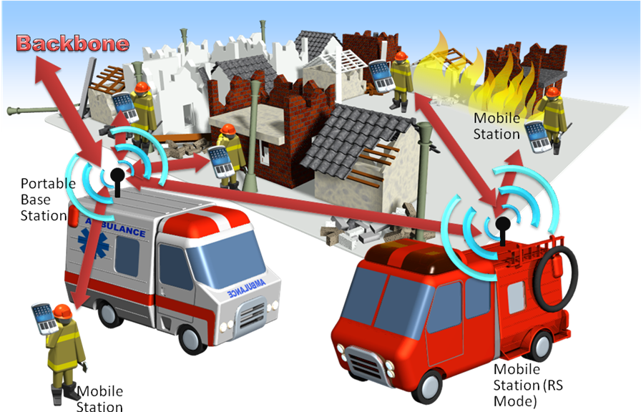

Figure 1

Public Safety Usage Model is one of the use cases of the IEEE 802.16n HR-network. Figure 1 illustrates a scene of fire accident. In this use case, a portable Base Stations (BS), multiple numbers of Mobile Stations (MS) and a vehicle MS operating in relay mode are shown. In principle, the portable BS is fixed on the top of a vehicle or it can be any MS acting as portable BS (role changing). MSs connected to video camera(s) are situated near the spot of disaster/accident. They are communicating and transmitting the video to the mobile BS simultaneously in real time. The applications require the support of higher data rate and more number of uplink traffics.

Corresponding performance requirements

For the public safety use case as specified above, control messages and audio signal are mainly used for downlink traffics while data signals such as video and audio type of traffics are required in the uplink transmission. In order to support more uplink traffics and meet the requirements, the frame structure with a wide range of adjustable downlink/uplink ratio shall be supported.
In 802.16e, for TDD based frame, when combined with 2x2 MIMO, WiMAX can support more than 46.08Mbps peak data rate for the downlink and 4.03Mbps for the uplink over 10MHz bandwidth when DL/UL ratio is 3:1. If DL/UL ratio is changed to 3:2, the downlink and uplink peak data rate will be 37.44Mbps and 6.05Mbps in a 10MHz channel, respectively [2]. For the use case model mentioned above, 5MHz channel bandwidth is specified so that available 35MHz VHF band can be fully utilized in 6 channels. Support for higher uplink data rate is desired so as to support the uplink video applications in PPDR scenarios due to the reduced channel bandwidth. It can be achieved by either reducing the DL/UL ratio or the header of each packet. To ensure a high quality video transmission, based on a typical broadband video encoded with 320×240 resolution window size, at least 300kbps data rate is required. For a broadband video with higher resolution of 1920*1080 and same image quality, 27 times of data rate, i.e., 8.1Mbps data rate is necessary for each unicast application. An even higher video resolution may be demanded in certain application scenarios.

References
- M. Oodo, N. Soma and H. Harada, "Radio Propagation Experiments for Broadband Wireless Communication System in the VHF Band", the 11th International Symposium on Wireless Personal Multimedia Communications (WPMC 2008)
- "Mobile WiMax Part I - A Technical Overview and Performance Evaluation",WiMax Forum 2006

