Project | IEEE 802.16 Broadband Wireless Access Working Group <http://ieee802.org/16>
Title | Priority Access for Mobile to Mobile Direct Communication and Forwarding
Date Submitted | 2011-03-04
Source(s) | An Nguyen  DHS/NCS | An.P.Nguyen@dhs.gov
Re: | Call for Contribution on 802.16n Amendment Working Draft
Abstract | The document describes the proposed text for supporting priority access for mobile to mobile direct communication and forwarding
Purpose | Request consideration of texts contained herein for the 802.16n Amendment Working Draft.
Notice | This document does not represent the agreed views of the IEEE 802.16 Working Group or any of its subgroups. It represents only the views of the participants listed in the “Source(s)” field above. It is offered as a basis for discussion. It is not binding on the contributor(s), who reserve(s) the right to add, amend or withdraw material contained herein.
Release | The contributor grants a free, irrevocable license to the IEEE to incorporate material contained in this contribution, and any modifications thereof, in the creation of an IEEE Standards publication; to copyright in the IEEE’s name any IEEE Standards publication even though it may include portions of this contribution; and at the IEEE’s sole discretion to permit others to reproduce in whole or in part the resulting IEEE Standards publication. The contributor also acknowledges and accepts that this contribution may be made public by IEEE 802.16.
Patent Policy | The contributor is familiar with the IEEE-SA Patent Policy and Procedures:  <http://standards.ieee.org/guides/bylaws/sect6-7.html#6> and <http://standards.ieee.org/guides/opman/sect6.html#6.3>.  Further information is located at <http://standards.ieee.org/board/pat/pat-material.html> and <http://standards.ieee.org/board/pat>.

Priority Access for Mobile to Mobile Direct Communication and Forwarding

Introduction
Priority access is one of the important requirements of the Emergency Telecommunications Service (ETS) [1]. ETS is a telecommunications service to facilitate emergency recovery operations for restoring the community infrastructure and for returning the population to normal living conditions after serious disasters and events, such as floods, earthquakes, hurricanes, and terrorist attacks. The ETS will be provided through shared resources from the public telecommunications infrastructure, which includes wireline, wireless, satellite, broadband cable, and any hybrid networks. ETS traffic needs to access, traverse, and egress these networks. Voice, video and data services are supported by ETS.

The DHS/NCS initiatives: Next Generation Network (NGN) Government Emergency Telecommunications Service (GETS), Legacy GETS, and Wireless Priority Service (WPS) are the USA instantiation of the international standard for ETS. Especially, the GETS and WPS respond to the White House’s requirement for "national security and emergency preparedness communications …under all circumstances including crisis or emergency, attack, recovery, and reconstitution…" (Executive Order 12472). Priority access is required for National Security and Emergency Preparedness (NS/EP) users for conducting their missions effectively during disasters using various 3G/4G wireless technologies including WiMAX.

IEEE 802.16m has priority access requirements and priority access techniques for NS/EP users. In Section 5.8 of IEEE 802.16m-07/002r10, it says: “IEEE 802.16m shall be able to support public safety first responders, military and emergency services such as call-prioritization, pre-emption, and push-to-talk”. P802.16m/D12 includes the following priority access techniques:
- Access class control is available for bandwidth request messages
- Priority ranging can be performed using the purpose indicator bit designated for NS/EP users on the AAI_RNG_REQ messages
- A pre-defined index on bandwidth request messages is available that can map to different QoS levels which can be leveraged to provide priority access
- Prioritized service flow management is available for NS/EP users (such as accelerated service flow setup and receiving priority in admission control for service flows)
- If a service provider wants to support National Security/Emergency Preparedness (NS/EP) priority services, the ABS uses its own algorithm as defined by its local country regulation body. For example, in the US the algorithm to support NS/EP is defined by the FCC in Hard Public Use Reservation by Departure Allocation (PURDA).

In Section 6.2.3 of 802.16n SRD [15] entitled Priority Access Service, it says: ”The HR-Network MAC shall be able to support a priority access service for ETS (Emergency Telecommunications Services) and other priority applications“.

Priority access requirements or specifications are also reflected in the following WiMAX Forum documents:
- Service Provider Working Group (SPWG) ETS Phase 1 Requirements (for Release 1.6) – WFM-T31-122-R016v01 (completed in 2/2009)
- SPWG ETS Requirements, Release 2.0 – WFM-T31-122-R020v01 (completed in 11/2009)
- Network Working Group (NWG) Network Architecture Stage 2 Base Specifications – WFM-T32-001-R016v01, Section 7.14: Emergency Telecommunications Service (ETS) Support (completed in 6/2010)
- Network Working Group (NWG) Network Architecture Stage 3 Base Specifications – WFM-T33-001-R016v01, Section 4.19: Emergency Telecommunications Service (ETS) Support (completed in 6/2010)

  - Purpose
The purpose of this document is to provide proposed text to support ETS for mobile to mobile direct communication/forwarding in 802.16n Amendment Working draft. The text below should be inserted into the indicated clauses of the AWD.

    - Direct Communication Between HR-MSs
In general, MS to MS direct communication/forwarding in 802.16n can be achieved using a dynamically allocated dedicated ad-hoc zone with periodic beacon transmission was proposed for MS to MS communication requesting IP services. In addition to IP services, the access techniques can be used to support SMS for MS to MS direct communication/forwarding in 802.16n such that a MS can communicate with others using the simplest form of communication.

If a MS wishes to support direct communication or forwarding capabilities, before offering the capabilities, the ASN needs to set up a Mobile Direct Communication (MDC) zone. A small amount of capacity in the MDC zone is used for a MS to broadcast MDC beacons such that peer relationships can be established between MSs. As illustrated in Figure 1, the MDC Zone would have the following elements: a preamble used for synchronization with peer MSs, a Beacon Broadcast Channel (BBC) during which a MS will broadcast its beacon to surrounding MSs, and a Contention Zone (CZ) during which neighboring MSs may attempt to transmit service requests to a selected donor MS to facilitate MS to MS communication. The preamble marks the beginning of MDC Zone and occupies one symbol. The CZ is primarily used to support the transmission of service requests and SMS. Once service requests are granted, dedicated resources will be scheduled by the BS in the uplink frame. Guard time (GT) is also included in the MDC zone as needed. The optional MDC zone is allocated by the BS during the uplink portion of the frame, similar to the proposed ad hoc relay frame in Reference 18. Placing the MDC zone at the end of the uplink frame could eliminate the need a guard time at the end of the zone. Since scheduling is still performed at the BS, MS to MS communication is not supported unless one of the participants is within range of a BS.

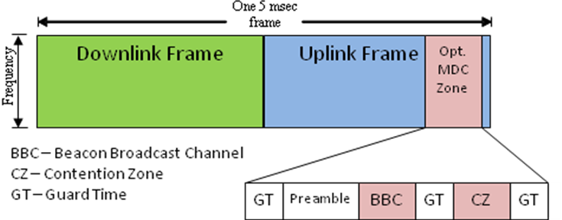
Figure 1: Possible MDC Zone Frame Structure

All MSs, participating in MS to MS direct communication/forwarding, broadcast their beacons in their respective BBC slot in a MDC zone. Each MS will send its beacon once every n frames where n is the number of participating users in the cell. Thus as the number of participating users in the cell increases, the frequency of each individual beacon decreases to limit the amount of overhead created by the beacons. The beacons are used to allow a MS to track its neighbors that can potentially be used as a direct communication peer or a forwarding MS. Each MS must maintain a table of one-hop neighbors and the SINR of each neighbor. This table will be sent by each MS to the BS periodically or at the request of the BS.

The MDC beacon also includes a description of how much capacity a donor MS is able to support. Note that the capacity supported is a function of the user’s Service Level Agreement (SLA); more capacity to be provided by the MS implies more battery power drainage; hence, the SLA articulates the monetary compensation for the donor MS. The discussion on how to negotiate SLA is beyond the scope. However, it should be clear that not every MS will become a donor MS.

The need for MSs to maintain the SINR in its neighbor table and send the table to the BS is illustrated in the example network in Figure 2. In this example, MS1, MS3, and MS4 are within range of the BS, while MS2 is a disadvantaged node beyond the BS’s range. MS1 may act as a donor forwarding node to the disadvantaged node MS2 (discussed in clause 7.2.3), or as a direct communication peer with MS3, but is out of range of direct communication with MS4 and subsequently does not hear its beacons. The BS will check the neighbor tables for each MS, and determines whether direct communication is possible among the pairs of these MSs. The SINR specified in the neighbor table can also be used by the BS to determine the best modulation and coding scheme used to support the direct communication between two peer MSs and the appropriate number of slots to allocate for the request.

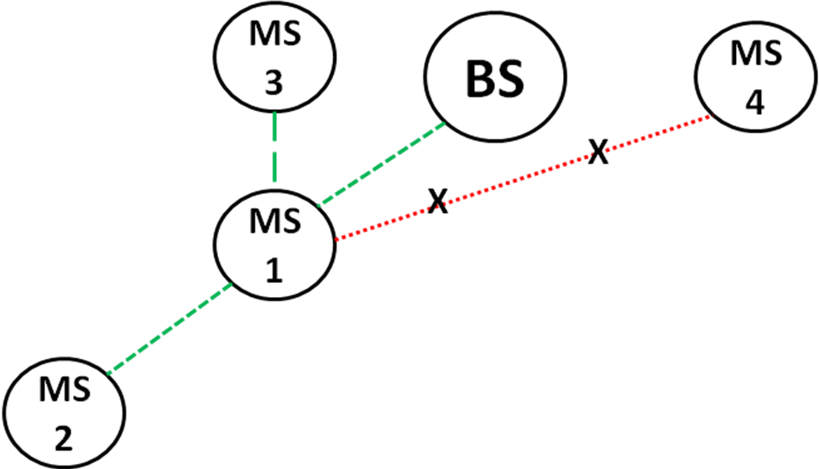
Figure 2: Sample Topology w/ disadvantaged node, hidden node, and direct-communication peers
The capacity request and allocation for MS to MS direct communication is centralized and performed by ASN. In cases where both the source and destination MSs are within range of the ASN, the messaging sequence in Figure 3 is to be followed. The initiating MS sends a normal service request to the ASN. The ASN then examines the request, and if both the source and destination MSs are local to the BS and neighbors with each other, then the ASN forwards the request to the destination MS with a direct-connection flag set. The destination MS then must acknowledge the request to the BS, who will then send an acknowledgment to the source MS. At this point, the BS will allocate the capacity for this request. In the case of a voice or video service request, the capacity allocation is semi-permanent which reduces the size of subsequent MAPs.
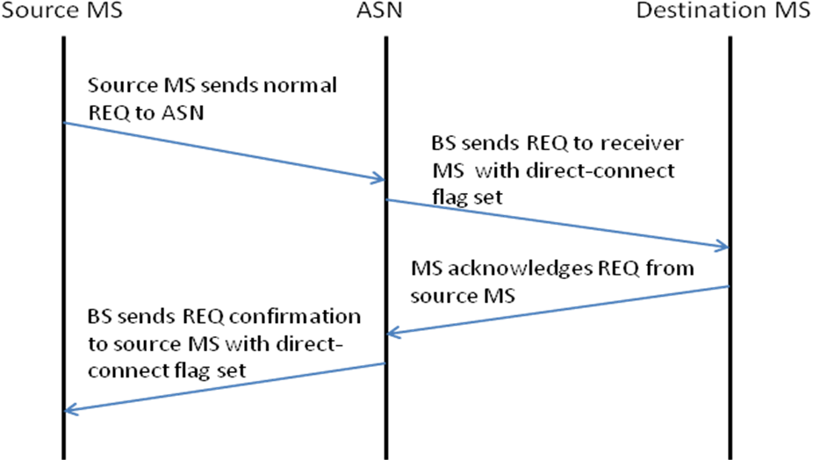
Figure 3: Messaging Sequence for MDC Requests

17.3.2 Direct communication between HR-MSs

For NS/EP users, if their MS becomes a disadvantaged MS, they will take advantage of MS to MS direct communication/forwarding to obtain IP or SMS services through a donor MS that belongs to an NS/EP user or non-NS/EP user. Their service will receive priority treatment over other regular users (requesting MS to MS direct communication/forwarding service or conventional communication service). However, NS/EP MS will provide MS to MS direct communication/forwarding services to other NS/EP users only, not to regular users.

When a disadvantaged MS requests a service from another MS, the initiating MS must first examine the beacon of the other MS to determine if direct to direct communication or forwarding service is available and if there is a donor MS with sufficient capacity to accommodate the request. If yes, the initiating (in this case, a disadvantaged MS) MS sends a service request to the donor MS, and the donor MS, in turn, forwards the request to the ASN (Figure 4). If the ASN grants the service, the ASN adjusts the MDC zone accordingly and informs the initiating MS to start direct communication or forwarding service using a modulation and coding scheme (MCS) derived from the reported SINR measurements between the two MSs.

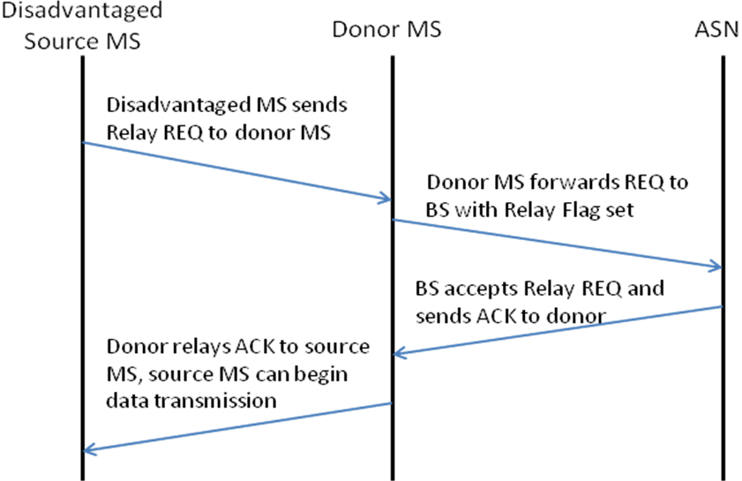
Figure 4: Messaging Sequence for MDC Forwarding with a Disadvantaged Source MS

For MS to MS direct communication, the initiating MS can be a disadvantaged user or a MS that simply wants to establish peer to peer communication. In the case where the source MS is a disadvantaged node, the messaging sequence in Figure 4 should be followed if the source is disadvantaged. If the destination MS is disadvantaged, then the sequence in Figure 5 should be followed. It is worth noting again that at least one MS must be in range of the BS.

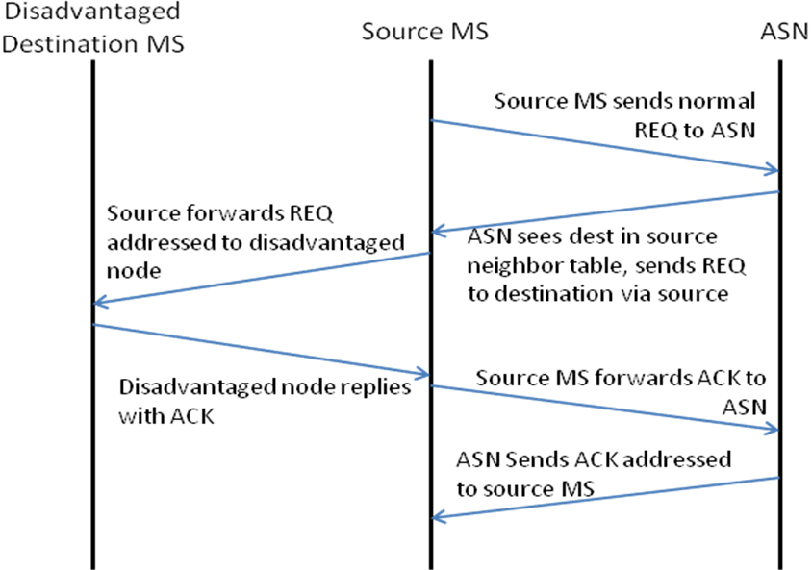
Figure 5: Messaging Sequence for MDC Forwarding with a Disadvantaged Destination MS

Note that for MS to MS direct communication, the maximal capacity (i.e., the MCS) is decided by the link between these two MSs. While for MS to MS forwarding, the maximal capacity of the link is decided by the minimum of the capacity between MSs and that between donor MS and the BS. NS/EP users may offer themselves as donor MSs; however, they provide MS to MS direct communication/forwarding only to another NS/EP user, except 911 calls from regular users. The mechanism of supporting 911 calls is beyond of the scope of this contribution.

When service requests are received from multiple initiating MSs, the following guideline is used.

- The service request from a NS/EP user has precedence over a regular user.
- The service request for MS to MS direct communication peer to peer service has precedence over forwarding service for the same priority level of NS/EP users. Note that NS/EP user may have multiple priority levels.

When granting the service requests at the ASN, NS/EP users should have priority over radio resources. For the US, the algorithm to support priority scheduling is defined by the FCC in Hard Public Use Reservation by Departure Allocation (PURDA).

Recommended Texts for SRD Section 6.2.3

The following texts should be added to SRD section 6.2.3.

MS to MS direct communication/forwarding support the following services: peer to peer IP service, peer to peer SMS, forwarding IP service and forwarding SMS.

NS/EP users will provide MS to MS direct communication/forwarding services to other NS/EP users only, not to regular users (except 911 calls).

NS/EP users with equal or lower priority level must offer themselves to act as a donor MS, and provide forwarding services only to the other NS/EP users with a priority level equal or higher.

Priority indication needs to be marked on the service request for MS to MS direct communication/forwarding. The network authenticates the identity of NS/EP user, and further determines their priority level.

When service requests are received from multiple initiating MSs for MS to MS direct communication/forwarding, the following guideline is used.

- The service request from a NS/EP user has precedence over a regular user.
- The service request for MS to MS direct communication peer to peer service has precedence over forwarding service for the same priority level of NS/EP users. Note that NS/EP user may have multiple priority levels.

When granting the service requests at the ASN, NS/EP users should have priority over radio resources. For the US, the algorithm to support priority scheduling is defined by the FCC in Hard Public Use Reservation by Departure Allocation (PURDA).

Conclusion

We have presented an architecture to support MS to MS direct communication and forwarding, and the associated priority access scheme. We would like the proposed scheme to be included in the 802.16n AWD.

References
[1] “Overview of Standards in Support of Emergency Telecommunication Service (ETS),” ATIS-pp-0100009, November 2006.
[2] Wireless Priority Service (WPS) Industry Requirements For UMTS – Phase 1 – Redirection to GSM,” DHS/NCS IR Document, Version 0.3, April 2005
[3] An Nguyen, "Priority Access for IEEE 802.16m", C802.16m-07/253r3, Jan. 2008
[4] D. J. Shyy etal, "Secure, Cooperative, Scalable and Multi-Dimensional Scheduling - A SDD Proposal for IEEE 802.16m", C802.16m-07/251r3, Nov. 2007.
[5] D. J. Shyy, "Relay to Relay Communication - A SDD Proposal for 802.16m", C802.16m-08/047, Jan. 2008.
[6] An Nguyen and D. J. Shyy, "Prioritized QoS Framework in Network Entry", C802.16m-08/1046r1, September 2008.
[7] An Nguyen and D. J. Shyy, "Prioritized QoS Framework in Connection Establishment and Maintenance", C802.16m-08/1049r1, September 2008.
[8] An Nguyen and D. J. Shyy, "Priority Access Service for Femtocells for IEEE 802.16m", C80216m-08/1337r1, Oct. 2008.
[9] An Nguyen and D. J. Shyy, "IEEE 802.16m – Traffic Load Analysis for NS/EP (Priority) Users", C80216m-08/1338r1, Oct. 2008.
[10] An Nguyen and D. J. Shyy, "Emergency Service – NS/EP Vs E-911 for IEEE 802.16m", C80216m-10_0698.ppt, June. 2010.
[11] An Nguyen and D. J Shyy, "Proposed text for Emergency Service – NS/EP for IEEE 802.16m", C80216m-10_1257.doc, Sept. 2010.
[12] Jeff Bonta etal, “Ad Hoc Relay Frame Structure”, S80216m-08/003r1, Jan. 2008.
[13] N. Himayat etal, “Functional Requirements for Network Entry and Random Access by Large Number of Devices”, C80216ppc-10/0049r1, Aug. 2010.
[14] N. Himayat etal, “Analysis of signaling overhead to establish network connectivity,” C80216ppc-10_0055r1, Sept. 2010.
[15] 802.16n System Requirements Document including SARM annex, 802.16n-10/0048, Jan. 2011.
[16] HanGyu Cho, Jose Puthenkulam, “Machine to Machine (M2M) Communication Study Report”, C802.16ppc-10/0002r7, May 2010.
[17] Arnaud Tonnerre etal, “Cross Communication”, C80216j-06/100r1, Sept. 2006.
[18] Jeff Bonta, Mike Baker, George Calcev, Benedito Fonseca, Nitin Mangalvedhe, Nathan Smith, “Ad Hoc Relay Frame Structure,” Motorola Corp., IEEE C802.16m-08/003, January 16, 2010.
Appendix A: More Information on ETS

[1] Quality of Service Attributes for Diameter,” draft-ietf-dime-qos-attributes-02.txt
[2] “Quality of Service Parameters for Usage with the AAA Framework,” draft-ietf-dime-qos-parameters-01.txt
[3] “RSVP Extensions for Emergency Services,” draft-ietf-tsvwg-emergency-rsvp-03.txt
[4] “QoS NSLP QSPEC Template,” draft-ietf-nsis-qspec-18.txt
[5] Report ITU-R.[PPDR]: “Radiocommunication objectives and requirements for public protection and disaster relief (PPDR)”
[6] Recommendation H.460.4 – Call priority designation for H.323 calls
[7] Draft recommendation H.SETS – security for ETS (H.235)
[8] E.106 – Description of an international emergency preference scheme (IEPS)
[9] Draft Recommendation U.roec – network requirements and capabilities to support ETS
[10] RFC3523: “Internet Emergency Preparedness (IEPREP) Telephony Topology Terminology”
[11] TETRA: “Mobile narrowband and wideband communications for public safety applications”
[12] TR41.4 TSB146: “Telecommunications – IP Telephony Infrastructure – IP Telephony Support for Emergency Calling Service)
[13] 3GPP TS 22.153, “Technical Specification Group Services and System Aspects; Multimedia priority service”, Release 8.
[14] 3GPP S.R0017-0, “Multimedia Priority Service (MMPS) for MMD-based Networks – Stage 1 Requirements”

The rational for this decision is that MS to MS direct communication is more efficient than MS forwarding.
The rational for this decision is that MS to MS direct communication is more efficient than MS forwarding.

