Project | IEEE 802.16 Broadband Wireless Access Working Group <http://ieee802.org/16>
Title | Priority Access for Mobile to Mobile Direct Communication and Forwarding – Simulation Results
Date Submitted | 2011-03-04
Source(s) | An Nguyen  DHS/NCS | An.P.Nguyen@dhs.gov
Re: | Call for Contribution on 802.16n Amendment Working Draft
Abstract | The document describes the performance simulation results of our proposed scheme for supporting priority access for mobile to mobile direct communication and forwarding
Purpose | Request consideration of texts contained herein for the 802.16n Amendment Working Draft.
Notice | This document does not represent the agreed views of the IEEE 802.16 Working Group or any of its subgroups. It represents only the views of the participants listed in the “Source(s)” field above. It is offered as a basis for discussion. It is not binding on the contributor(s), who reserve(s) the right to add, amend or withdraw material contained herein.
Release | The contributor grants a free, irrevocable license to the IEEE to incorporate material contained in this contribution, and any modifications thereof, in the creation of an IEEE Standards publication; to copyright in the IEEE’s name any IEEE Standards publication even though it may include portions of this contribution; and at the IEEE’s sole discretion to permit others to reproduce in whole or in part the resulting IEEE Standards publication. The contributor also acknowledges and accepts that this contribution may be made public by IEEE 802.16.
Patent Policy | The contributor is familiar with the IEEE-SA Patent Policy and Procedures:  <http://standards.ieee.org/guides/bylaws/sect6-7.html#6> and <http://standards.ieee.org/guides/opman/sect6.html#6.3>.  Further information is located at <http://standards.ieee.org/board/pat/pat-material.html> and <http://standards.ieee.org/board/pat>.

Priority Access for Mobile to Mobile Direct Communication and Forwarding – Simulation Results

Introduction
Priority access is one of the important requirements of the Emergency Telecommunications Service (ETS) [1]. ETS is a telecommunications service to facilitate emergency recovery operations for restoring the community infrastructure and for returning the population to normal living conditions after serious disasters and events, such as floods, earthquakes, hurricanes, and terrorist attacks. The ETS will be provided through shared resources from the public telecommunications infrastructure, which includes wireline, wireless, satellite, broadband cable, and any hybrid networks. ETS traffic needs to access, traverse, and egress these networks. Voice, video and data services are supported by ETS.

The DHS/NCS initiatives: Next Generation Network (NGN) Government Emergency Telecommunications Service (GETS), Legacy GETS, and Wireless Priority Service (WPS) are the USA instantiation of the international standard for ETS. Especially, the GETS and WPS respond to the White House’s requirement for "national security and emergency preparedness communications …under all circumstances including crisis or emergency, attack, recovery, and reconstitution…" (Executive Order 12472). Priority access is required for National Security and Emergency Preparedness (NS/EP) users for conducting their missions effectively during disasters using various 3G/4G wireless technologies including WiMAX.

IEEE 802.16m has priority access requirements and priority access techniques for NS/EP users. In Section 5.8 of IEEE 802.16m-07/002r10, it says: “IEEE 802.16m shall be able to support public safety first responders, military and emergency services such as call-prioritization, pre-emption, and push-to-talk”. P802.16m/D12 includes the following priority access techniques:
- Access class control is available for bandwidth request messages
- Priority ranging can be performed using the purpose indicator bit designated for NS/EP users on the AAI_RNG_REQ messages
- A pre-defined index on bandwidth request messages is available that can map to different QoS levels which can be leveraged to provide priority access
- Prioritized service flow management is available for NS/EP users (such as accelerated service flow setup and receiving priority in admission control for service flows)
- If a service provider wants to support National Security/Emergency Preparedness (NS/EP) priority services, the ABS uses its own algorithm as defined by its local country regulation body. For example, in the US the algorithm to support NS/EP is defined by the FCC in Hard Public Use Reservation by Departure Allocation (PURDA).

In Section 6.2.3 of 802.16n SRD [15] entitled Priority Access Service, it says: ”The HR-Network MAC shall be able to support a priority access service for ETS (Emergency Telecommunications Services) and other priority applications“.

Priority access requirements or specifications are also reflected in the following WiMAX Forum documents:
- Service Provider Working Group (SPWG) ETS Phase 1 Requirements (for Release 1.6) – WFM-T31-122-R016v01 (completed in 2/2009)
- SPWG ETS Requirements, Release 2.0 – WFM-T31-122-R020v01 (completed in 11/2009)
- Network Working Group (NWG) Network Architecture Stage 2 Base Specifications – WFM-T32-001-R016v01, Section 7.14: Emergency Telecommunications Service (ETS) Support (completed in 6/2010)
- Network Working Group (NWG) Network Architecture Stage 3 Base Specifications – WFM-T33-001-R016v01, Section 4.19: Emergency Telecommunications Service (ETS) Support (completed in 6/2010)

  - Purpose
The purpose of this document is to provide the simulation results of our proposed scheme to support ETS for mobile to mobile direct communication/forwarding in the 802.16n Amendment Working draft.

Priority Access for MS to MS Direct Communication and Forwarding

Our proposed priority access scheme for MS to MS direction communication and forward is detailed in Reference 19, and will not be repeated here.

Performance Analysis
A simulator was developed using C++ and an open-source discrete-event library to evaluate the effectiveness of the proposed priority access scheme for MS to MS direct communication (MDC). The following subsections describe the system configuration and parameters used to conduct the simulation, and the statistics to be collected and analyzed.
  - System Overview
Our simulation assumes the following categories of MS to MS direct communication/forwarding are supported, which are illustrated in the sample system in Figure 1 (one BS and no ASN gateway). Regular user 911 calls are not included here since it is beyond the scope of this contribution.

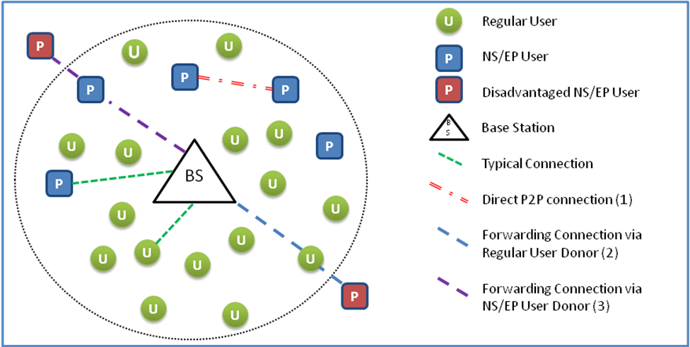
Figure 1: Sample Simulated System Diagram

Category #1: Direct Communication between two NS/EP Users
When two NS/EP users have direct communication within the same BS, the BS will allow them to communicate directly with each other, without requiring transferring data to/from the BS. The scheduling of semi-permanent capacity used for data transmission between the NS/EP users is performed by the BS.

Category #2: NS/EP User requesting forwarding service through a regular user
A disadvantaged NS/EP user, out of range of the BS, requests forwarding service through a regular user. Only certain regular users, who have opted themselves to act as a donor MS, will perform this function. As discussed in Reference 19, the maximum amount of resources a regular user will provide will be derived from their SLA and advertised in the beacons.

Category #3: NS/EP User requesting forwarding service through a NS/EP user
A disadvantaged NS/EP user, out of range of the BS, requests forwarding service through another NS/EP user. During NS/EP events, all NS/EP users with equal or lower priority level must offer themselves to act as a donor MS, and provide forwarding services only to the other NS/EP user with a priority level equal or higher.

  - Simulation Scenarios and Parameters
In each simulation, 1000 MSs will be simulated in the system, uniformly distributed within the BS’s range. In this scenario, each MS would broadcast their beacon approximately once every 5 seconds. We assume the beacon information has already been broadcasted to all neighbors within range when the simulation begins. Ten of the priority users are disadvantaged nodes in each case, though their requests will generally not be included in the overall system statistics unless specifically noted. Our simulation is limited to simulating the uplink portion of the channel. The coverage range of each MS is assumed to be 632 meters in an urban environment. Each simulation is run for 10 hours.

Overviews of parameters used in each of the simulations are summarized in Table 1. Table 2 summarizes the breakdown of traffic volume generated by application per user type. The traffic generator models used for each MS are summarized in Table 3.

Table 1: Simulation System Parameters
Parameter | Value
BS Uplink Capacity | 140 slots
Fraction of NS/EP Users in Total Population | 10%
Maximum Capacity Reserved for NS/EP Traffic | 25%
BS NS/EP Request Queue Size | 30
NS/EP Request Timeout | 30 seconds
BS Regular User Request Queue Size | 0

Table 2: Application Traffic Volume per User Type
User Type | Voice/VoIP | Video Streaming | Data Traffic
Regular User | 67.5% | 22.5% | 10%
NS/EP User | 75% | 25% | 0%

Table 3: Traffic Generator Models
Application | Parameters | Mode
VoIP | - Data rate  - Call holding time | - 4 Kbytes/sec (2 Kbytes/sec when silence suppression is ON)  - Exponential: μ =210 sec
Video Streaming | - Data rate  - Session Duration | - 24 Kbytes/sec  - Exponential: μ =10 sec
FTP | - Session Duration (SD)  - Data rate (DR)  - Session Size (SS) = | - 125 Kbytes/sec  - Session size parameters  - Number of files per session (S_{p}): Lognormal : μ = 17, σ = 22.  - File size (Fs): Truncated Lognormal: μ = 2 Mbytes, σ = 0.722 Mbytes, max. = 5 Mbytes.  - Reading time (D_{pc}): Exponential: μ = 180 sec.

The overall average inter-arrival times for each type of traffic request in our baseline traffic load are summarized in Table 4. An exponential distribution is used to generate requests at each user with the means in Table 4. The baseline (or 1x) traffic load will be scaled proportionally in subsequent simulations to generate 2x and 5x traffic loads to evaluate the priority access performance of the WiMAX network under heavily overloaded conditions. In each scenario, NS/EP traffic will make up 10% of the total traffic load. Furthermore, 90% of the requests generated by NS/EP users will be to other NS/EP users in the simulated system (i.e. potentially eligible for MDC). This is because during a disaster scenario, we expect most NS/EP communication to be between NS/EP responders at the disaster scene. We also design the system and traffic load such that a higher percentage of video and data transfer requests will be blocked, since we expect VoIP requests to get the highest priority given their importance and modest resource requirements compared to video and data.
Table 4: Baseline (1x) Request Inter-arrival Times and Blocking Rates
Application | Regular Users | NS/EP Users | Designed Blocking Rate
VoIP | 4.37 | 13.073s | 2%
Video Streaming | 13.07s | 117.65s | 5%
Data Transfer | 100s | N/A | 10%

To evaluate the performance of MDC for NS/EP users during a crisis scenario, several scenarios will be simulated. First the system will be simulated with no support for MDC, to serve as a baseline. Second, Category #1 MDC connections will be enabled to study the increase in services for NS/EP users observed in the system. In the final scenario, Category #2 and #3 connections will be enabled to evaluate the performance of the forwarding service for disadvantaged users.

  - Simulation Results
The simulation experiments describe in this section will be used to analyze the benefits of MDC support for NS/EP users. All simulation experiments follow the parameters summarized in Section 3.2, unless stated otherwise. Three sets of simulation experiments were conducted: A baseline set where no MDC or MS forwarding is enabled, a scenario where MDC is enabled, and a scenario where MS forwarding is enabled.

The first simulation results show the benefits of the prioritized queuing scheme alone. In these experiments no MDC or forwarding services are enabled. The plot in Figure 2 displays the request blocking rate for each priority level under each traffic load. These results show that under a simple priority scheduling scheme, priority users see dramatically improved performance versus regular users. These blocking rate numbers do not account for the disadvantaged nodes that can’t be serviced.

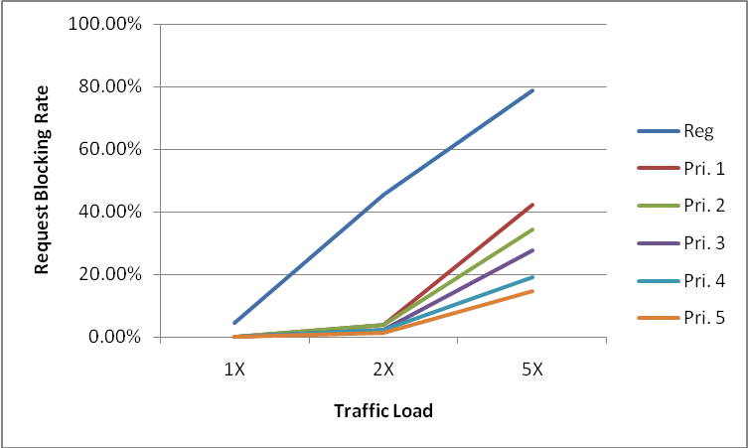
Figure 2: Block rate vs. Traffic Load and Priority Level
In the second set of simulation experiments, priority users can communicate directly with each other if the data rate between them is at least half the data rate between each MS and the BS. The same system was simulated under the same traffic loads for this scenario. The benefits of MDC seen from these experiments are summarized in Table 5. For each traffic load, we calculated the average Slot Savings (SS) for both the uplink (UL) and downlink (DL) due to using direct communication. The SS values are reported as a percentage of the slots allocated for priority traffic. The ∆Reqs column reports the additional number of priority requests that were serviced throughout the entire simulation versus the baseline scenario where no MDC is enabled. The change in the overall blocking rate observed by priority users is reported in the ∆Block% column.

The SS values are calculated by first determining the number of UL and DL slots that would have been needed to service this request without MDC, i.e. using normal BS forwarding. For the SS UL values, we subtract the number of UL slots needed to support the MC request from the number of UL slots needed for BS forwarding. Since MDC requests are assumed to reside within the UL portion of the frame, no DL resources are used to support the communication. Thus, the SS DL is simply set to the number of DL slots needed to support the request through BS forwarding.

Table 5: Results Summary for MDC Simulations
Traffic Load | SS UL | SS DL | ∆Reqs | ∆Block%
1X | 2.3% | 8.7% | 5 | -0.0%
2X | 4.4% | 15.8% | 63 | -0.3%
5X | 9.9% | 42.1% | 265 | -5.7%

As Table 5 shows, the biggest benefits of supporting MDC are seen in the savings in the DL, since as previously mentioned MDC requests use no DL resources. The benefits seen in the UL channel are not as significant as those in the DL, since in some cases the MDC requests may use more UL slots than a non-MDC request would need (note that weo assume a fixed UL frame size). But the overall results still show modest benefits in the UL in most cases in addition to substantial savings in the DL that can benefit both priority and regular users. The modest savings allows the system to support slightly more priority requests in the uplink for each case. We would expect to see even higher benefits in scenarios where priority users are clustered in groups around a small geographical area, as would be expected during a disaster scenario as NS/EP personnel gather at the scene.

The final simulation experiments analyze the benefits of MS forwarding. In these simulation, any priority MS will forward their data to the BS through a single MS donor if the resulting combined signaling rate will be at least 1.5 times better than its baseline signaling rate with the base station (where ). Additionally, disadvantaged nodes can be supported assuming a suitable MS donor is available.

Table 6: Results Summary for MS Forwarding Simulations
Traffic Load | SS UL | ∆Reqs | ∆Block%, w/o DMS | ∆Block%, w/ DMS
1X | 2.3% | 112 | -0.00% | -10.0%
2X | 5.9% | 263 | -0.65% | -10.3%
5X | 13.8% | 270 | -2.28% | -7.4%

The key results of the MS forwarding simulations are summarized in Table 6. As in the MDC experiments, the slots savings per frame are reported for the UL channel (DL savings are not applicable to MS forwarding requests), as are the additional number of priority user requests serviced throughout the entire simulation. Additionally, two sets ∆Block% statistics are given. The first, “∆Block%, w/o DMS” shows the improvement in the observed blocking rate for priority requests from normal priority users, i.e. not including any requests from a disadvantaged MS (DMS). The last column “∆Block%, w/ DMS” shows the change in blocking rate when the requests from disadvantaged MSs are included.

As can be seen in the table, enabling MS forwarding slightly improves the blocking rate seen by priority users among non-disadvantaged requests, even when there is an additional 10% of priority traffic now competing for the same channel. This is due to the fact that users on the edge of the BS’s range can use forwarding to improve their data rate to the BS, increasing the efficiency of the channel. When the newly-supported DMS requests are included in the calculations in the last column, the overall improvement in observed blocking rate is improved significantly. Since the baseline scenario does not provide any means for a DMS to communicate with the BS, those 10 priority users will go unsupported the entire simulation. This is what allows the MS forwarding system to offer substantial improvements over the baseline scenario even in the 1x and 2x cases where the priority traffic is not saturating its allocated resources.

Conclusion

We have presented performance simulation results for our proposed priority access scheme for MS to MS direction communication and forwarding. The results illustrate the benefits in performance that can be observed using resource prioritization, MDC and MS forwarding with priority users. MDC can be highly beneficial when many users gathered in one area wish to communicate largely with each other. MS forwarding allows more efficient use of the channel while also extending support to disadvantaged nodes that otherwise would go without service, which could have serious consequences during a crisis period. We would like the proposed scheme to be included in the 802.16n AWD.

References
[1] “Overview of Standards in Support of Emergency Telecommunication Service (ETS),” ATIS-pp-0100009, November 2006.
[2] Wireless Priority Service (WPS) Industry Requirements For UMTS – Phase 1 – Redirection to GSM,” DHS/NCS IR Document, Version 0.3, April 2005
[3] An Nguyen, "Priority Access for IEEE 802.16m", C802.16m-07/253r3, Jan. 2008
[4] D. J. Shyy etal, "Secure, Cooperative, Scalable and Multi-Dimensional Scheduling - A SDD Proposal for IEEE 802.16m", C802.16m-07/251r3, Nov. 2007.
[5] D. J. Shyy, "Relay to Relay Communication - A SDD Proposal for 802.16m", C802.16m-08/047, Jan. 2008.
[6] An Nguyen and D. J. Shyy, "Prioritized QoS Framework in Network Entry", C802.16m-08/1046r1, September 2008.
[7] An Nguyen and D. J. Shyy, "Prioritized QoS Framework in Connection Establishment and Maintenance", C802.16m-08/1049r1, September 2008.
[8] An Nguyen and D. J. Shyy, "Priority Access Service for Femtocells for IEEE 802.16m", C80216m-08/1337r1, Oct. 2008.
[9] An Nguyen and D. J. Shyy, "IEEE 802.16m – Traffic Load Analysis for NS/EP (Priority) Users", C80216m-08/1338r1, Oct. 2008.
[10] An Nguyen and D. J. Shyy, "Emergency Service – NS/EP Vs E-911 for IEEE 802.16m", C80216m-10_0698.ppt, June. 2010.
[11] An Nguyen and D. J Shyy, "Proposed text for Emergency Service – NS/EP for IEEE 802.16m", C80216m-10_1257.doc, Sept. 2010.
[12] Jeff Bonta etal, “Ad Hoc Relay Frame Structure”, S80216m-08/003r1, Jan. 2008.
[13] N. Himayat etal, “Functional Requirements for Network Entry and Random Access by Large Number of Devices”, C80216ppc-10/0049r1, Aug. 2010.
[14] N. Himayat etal, “Analysis of signaling overhead to establish network connectivity,” C80216ppc-10_0055r1, Sept. 2010.
[15] 802.16n System Requirements Document including SARM annex, 802.16n-10/0048, Jan. 2011.
[16] HanGyu Cho, Jose Puthenkulam, “Machine to Machine (M2M) Communication Study Report”, C802.16ppc-10/0002r7, May 2010.
[17] Arnaud Tonnerre etal, “Cross Communication”, C80216j-06/100r1, Sept. 2006.
[18] Jeff Bonta, Mike Baker, George Calcev, Benedito Fonseca, Nitin Mangalvedhe, Nathan Smith, “Ad Hoc Relay Frame Structure,” Motorola Corp., IEEE C802.16m-08/003, January 16, 2010.
[19] An Nguyen, "Priority Access for Mobile to Mobile Direct Communication and Forwarding", C80216m-11_0001.doc, Feb. 2011.
Appendix A: More Information on ETS

[1] Quality of Service Attributes for Diameter,” draft-ietf-dime-qos-attributes-02.txt
[2] “Quality of Service Parameters for Usage with the AAA Framework,” draft-ietf-dime-qos-parameters-01.txt
[3] “RSVP Extensions for Emergency Services,” draft-ietf-tsvwg-emergency-rsvp-03.txt
[4] “QoS NSLP QSPEC Template,” draft-ietf-nsis-qspec-18.txt
[5] Report ITU-R.[PPDR]: “Radiocommunication objectives and requirements for public protection and disaster relief (PPDR)”
[6] Recommendation H.460.4 – Call priority designation for H.323 calls
[7] Draft recommendation H.SETS – security for ETS (H.235)
[8] E.106 – Description of an international emergency preference scheme (IEPS)
[9] Draft Recommendation U.roec – network requirements and capabilities to support ETS
[10] RFC3523: “Internet Emergency Preparedness (IEPREP) Telephony Topology Terminology”
[11] TETRA: “Mobile narrowband and wideband communications for public safety applications”
[12] TR41.4 TSB146: “Telecommunications – IP Telephony Infrastructure – IP Telephony Support for Emergency Calling Service)
[13] 3GPP TS 22.153, “Technical Specification Group Services and System Aspects; Multimedia priority service”, Release 8.
[14] 3GPP S.R0017-0, “Multimedia Priority Service (MMPS) for MMD-based Networks – Stage 1 Requirements”

