Project | IEEE 802.16 Broadband Wireless Access Working Group <http://ieee802.org/16>
Title | A Framework for HR-MS to HR-MS Direct Communication without Infrastructure Stations
Date Submitted | 2011-03-06
Source(s) | Haiguang Wang, Hoang Anh Tuan, Jaya Shankar, Shoukang Zheng, Yeow Wai Leong, Joseph Teo Chee Ming, Mar Choong Hock  Institute for Infocomm Research  1 Fusionopolis Way, #21-01, Connexis (South Tower)  Singapore 138632 | Voice: +65 6408-2256  E-mail: hwang@i2r.a-star.edu.sg
Re: | Call for contributions for 802.16n AWD
Abstract | In this contribution, we propose a framework for the HR-MSs communicate to each in case there is no infrastructure station such as HR-BS or HR-RS presented in the network.
Purpose | To discuss and adopt the proposed text in the 802.16n draft Text
Notice | This document does not represent the agreed views of the IEEE 802.16 Working Group or any of its subgroups. It represents only the views of the participants listed in the “Source(s)” field above. It is offered as a basis for discussion. It is not binding on the contributor(s), who reserve(s) the right to add, amend or withdraw material contained herein.
Copyright Policy | The contributor is familiar with the IEEE-SA Copyright Policy <http://standards.ieee.org/IPR/copyrightpolicy.html>.
Patent Policy | The contributor is familiar with the IEEE-SA Patent Policy and Procedures:  <http://standards.ieee.org/guides/bylaws/sect6-7.html#6> and <http://standards.ieee.org/guides/opman/sect6.html#6.3>.  Further information is located at <http://standards.ieee.org/board/pat/pat-material.html> and <http://standards.ieee.org/board/pat>.

A Framework for Direct HR-MS Communication without Infrastructure Stations

Haiguang Wang, Hoang Anh Tuan, Jaya Shankar,
Shoukang Zheng, Yeo Wai Leong

Institute for Infocomm Research (I2R)
1 Fusionopolis Way, #21-01, Connexis South Tower
Singapore 138632

1. Introduction

HR-MS to HR-MS direct communication is new feature for IEEE 802.16 networks. It will be defined in the IEEE 802.16n amendment. This feature will significantly improve the capability of HR-MS in various harsh environment and increase network throughput when local traffic dominates the network.
In 802.16n System Requirement Document [1] section 6.1.3.1, it says that “HR-MS shall provide direct communication i.e. the origination and termination of the data are at the HR-MS. Association establishment procedure of an HR-MS to another HR-MS shall be supported.”.
Since the requirement does not set constraint on whether HR-MSs have associated to an infrastructure stations, in this contribution, we assume HR-BS/HR-RS is not presented in the network and the HR-MSs communicate to each other directly. They may also help each other in data forwarding.

2. HR-MS to HR-MS Direct Communication

Supporting the HR-MS to HR-MS direct communication without infrastructure node is required by IEEE 802.16n network. In this contribution, we focus on the use cases of HR-MSs communicate to each other without getting support from infrastructure stations as figure 1 shows. A few HR-MSs connect to each other and form a communication network.
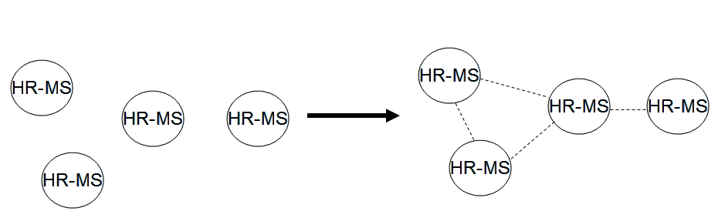
Figure 1: Use cases of HR-MS to HR-MS direct communication without infrastructure stations
Since the communication of HR-MS with and without the supporting from infrastructure node are significantly different, we propose to classify the communication mode of HR-MS into two modes, infrastructure mode and ad hoc mode, the same as IEEE 802.11 standard. In infrastructure mode, HR-MSs should associate to a infrastructure node, an HR-BS/HR-RS, before they can communicate. While in ad hoc node, HR-MSs are allowed to transmit before they associate to any infrastructure nodes.
Figure 2 shows a state machine for HR-MS in ad hoc mode. First of all, after an HR-MS is turned into ad hoc mode, it does some initialization work first. After that, it enters a discovery state. In this state, the node transmits system configuration information from time to time to let other nodes to know the current node. Once there are HR-MSs that have intention to communicate to each other, the HR-MSs should enter communication mode and transmit data to each other. Once data communication finishes, the HR-MSs may transit back to discovery mode.
Figure 2: System state of HR-MS in ad hoc mode

2.1 Initialization

The node should set operation mode to ad hoc mode. For other part of initialization, it just follows the general HR-MS initialization procedure.

2.2 Discovery

In discovery state, a node transmits messages from time to time to tell others of its information. It also scans the channel for other HR-MSs’ information when it does not transmit its own messages.

Since a few nodes may transmit discovery messages at the same time, some collision avoidance mechanism should be defined. One possible method is to insert a random back-off interval between two adjacent discovery messages transmissions.

It transmits to communication state when it either joins a network formed by other HR-MSs or it choose to form a HR-MSs network by itself. We will explain how to form a HR-MS network in the following subsection.

2.3 Communication

HR-MS can communicate to each other directly only if they form a network first. Since there is no infrastructure station and considering the 802.16 frame structures, we propose that one of the HR-MS becomes a coordinator first and transmit frame preambles regularly and other HR-MS may join the network and follow the frame structure defined by the coordinator.

The coordinator should help in radio resource management and data forwarding, from one HR-MS to another HR-MS in case they do not have direct communication link. The procedure of network entry, ranging and radio resource management can be similar to existing protocols.

3. Summary

In this contribution, we propose a framework for 802.16n HR-MSs in setting up HR-MS direct communication network by themselves without turning any node into base station or relay station.

4. Text Proposal for IEEE 802.16n AWD
Xxx
Note:
The text in BLACK color: the existing text in AWD
The text in RED color: the removal of existing AWD text
The text in BLUE color: the new text added to the Multi-Carrier DG Text

[-------------------------------------------------Start of Text Proposal---------------------------------------------------]
[Adopt the following text in the 802.16n Document (XXX --- document number)]

16.1 Overview

An HR-MS should be able to work in two communication modes, infrastructure mode or ad hoc mode. In infrastructure mode, it can only transmit when it synchronizes to an infrastructure stations such as HR-BS or HR-RS. In ad hoc mode, an HR-MS is allowed to transmit information before it synchronizes to any other HR stations.

16.2.2 Direct communication between HR-MSs

16.2.2.1 A Framework for the Direct communication between HR-MSs in ad hoc mode

In ad hoc mode, an HR-MS can be in three states as following Figure shows.
- Initialization state: initialize the system for ad hoc mode.
- Discovery state: only transmit node configuration information from time to time.
- Communication state: setup communication links with other HR-MS and transmit data to each other.

Figure XXX: State machine for HR-MS in Ad Hoc Mode

During the initialization for HR-MS direct communication without infrastructure, HR-MS should set its working mode as ad hoc mode.
After initialization, HR-MS should listen to channel first. It should check whether there are other HR-MSs or HR-MSs networks formed by HR-MSs in the same area. The HR-MS should transmit some node information to let other HR-MSs know its existence.

For the HR-MSs to communicate each other, a HR-MS network should be setup first. One of HR-MS should play the role of coordinator. The functionality of coordinator is to transmit frame preambles and DL/UL MAP regularly, manage the node association and leaving, manage the radio resource etc.

17.1 Overview

An HR-MS should be able to work in two communication modes, infrastructure mode or ad hoc mode. In infrastructure mode, it can only transmit when it synchronizes to an infrastructure stations such as HR-BS or HR-RS. In ad hoc mode, an HR-MS is allowed to transmit information before it synchronizes to any other HR stations.

17.2.2 Direct communication between HR-MSs

For HR-MS based on 802.16m technology, they should take the same framework as proposed in section 16.2.2.

[-------------------------------------------------End of Text Proposal----------------------------------------------------]

References
- IEEE 802.16n-10/0048, “802.16n System Requirements Document including SARM annex”, January 2011.
- IEEE 802.16n-10/0049, “802.16n Table of Contents for Amendment Working Draft”, January 201.

