Project | IEEE 802.16 Broadband Wireless Access Working Group <http://ieee802.org/16>
Title | Network-aided and Autonomous Secure Direct Communications in wireless access network
Date Submitted | 2011-03-06
Source(s) | Joseph Chee Ming Teo, Jaya Shankar, Yeow Wai Leong, Hoang Anh Tuan, Wang Haiguang, Zheng Shoukang, Mar Choon Hock  Institute for Infocomm Research  1 Fusionopolis Way, #21-01, Connexis (South Tower)  Singapore 138632 | Voice: +65 6408-2292  E-mail: cmteo@i2r.a-star.edu.sg
Re: | Call for contributions for 802.16n AWD
Abstract | In this document, we propose security procedures for network aided mutual authentication of HR-MS and data security. The secret key DMK established during the network aided security procedure shall subsequently be used for Autonomous Mutual Authentication of HR-MS and data security for Direct Communications when there is no infrastructure in the HR network.
Purpose | To discuss and adopt the proposed text in the 802.16n draft Text
Notice | This document does not represent the agreed views of the IEEE 802.16 Working Group or any of its subgroups. It represents only the views of the participants listed in the “Source(s)” field above. It is offered as a basis for discussion. It is not binding on the contributor(s), who reserve(s) the right to add, amend or withdraw material contained herein.
Copyright Policy | The contributor is familiar with the IEEE-SA Copyright Policy <http://standards.ieee.org/IPR/copyrightpolicy.html>.
Patent Policy | The contributor is familiar with the IEEE-SA Patent Policy and Procedures:  <http://standards.ieee.org/guides/bylaws/sect6-7.html#6> and <http://standards.ieee.org/guides/opman/sect6.html#6.3>.  Further information is located at <http://standards.ieee.org/board/pat/pat-material.html> and <http://standards.ieee.org/board/pat>.

Network Aided and Autonomous Secure Direct Communications in wireless access network

Joseph Chee Ming Teo, Jaya Shankar, Yeow Wai Leong, Hoang Anh Tuan, Wang Haiguang, Zheng Shoukang, Mar Choon Hock

Institute for Infocomm Research (I2R)
1 Fusionopolis Way, #21-01, Connexis South Tower
Singapore 138632

1. Introduction
Suppose two HR-MSs (High-Reliability-Mobile Stations) wishes to communicate securely with each other in the event of a network failure (i.e. there is no backbone infrastructure), then an Authentication and Key Exchange (AKE) protocol is required to provide mutual authentication and data security for such secure direct communications. The IEEE 802.16n System Requirement Document (SRD) [1] specifies the requirement for security procedures for Network aided (i.e. with HR-BS (Base station) assistance) and Autonomous (i.e. no network infrastructure present) mutual authentication and data security for direct communications. Currently, the existing security protocols (PKMv3) in existing IEEE 802.16 standards do not support such secure direct communication scenarios. In this contribution, we propose security procedures for network aided mutual authentication of HR-MS and data security. The secret key DMK established during the network aided security procedure shall subsequently be used for Autonomous Mutual Authentication of HR-MS and data security for Direct Communications when there is no infrastructure in the HR network.

2. Security procedures for HR-Networks

2.1 Network Aided Mutual Authentication of HR-MS and Data Security
Suppose HR-MS1 wishes to establish a direct communication pre-shared key DMK with HR-MS2 so that HR-MS1 and HR-MS2 can securely communicate with each other directly in the event of a backbone failure (i.e. there is no HR-BS around). Then a security procedure shall be executed between HR-BS, HR-MS1 and HR-MS2 to establish the direct communication pre-shared key DMK. This DMK shall be used for mutual authentication and data security for direct communication when the network infrastructure fails. Figure 1 shows the depicted scenario.
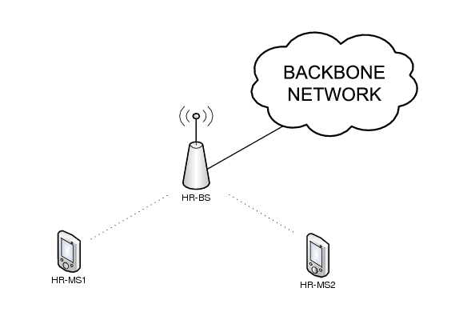
Figure 1: Network-Aided Direct Communication Scenario

2.2 Autonomous Mutual Authentication of HR-MS and data security for Direct Communications
Suppose HR-MS1 and HR-MS2 has already established a pre-shared key DMK with the aid of the Network Infrastructure using the solution in Section 2.1 and wishes to communicate directly. Then the pre-established DMK can be used for mutual authentication and Key Management to establish a secret key for data security in direct communications in the case of backbone failure. Figure 2 shows this scenario. 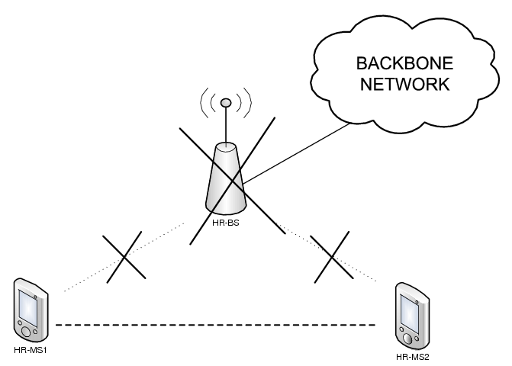
Figure 2: HR-MS to HR-MS Direct Communication scenario without infrastructure.

3. Summary

In this contribution, we proposed security procedures for mutual authentication and data security for IEEE 802.16n HR networks in both network aided and autonomous scenarios are proposed. In the network-aided security procedure, the HR-BS (base station) shall assist the two HR-MSs to establish a Direct Communication Master Key (DMK) which would be used for data security and mutual authentication for direct communications
The security procedure for Autonomous Mutual Authentication of HR-MS and data security for Direct Communications takes place in the event where two HR-MSs wishes to establish direct communications with each other autonomously and they have already established a pre-shared key DMK using the network-aided security procedure described above.

4. Text Proposal for IEEE 802.16n AWD

Note:
The text in BLACK color: the existing text in AWD
The text in RED color: the removal of existing AWD text
The text in BLUE color: the new text added to the Multi-Carrier DG Text

[-------------------------------------------------Start of Text Proposal---------------------------------------------------]
[Adopt the following text in the 802.16n AWD Document (C802.16x-xx/xxxx)]

17.2.10.1 Security procedures for HR-Networks
The following protocols shall be used for secure communication and session establishment amongst HR-stations, and between HR-stations and external AAA-server.

17.2.10.1.1 Network Aided Mutual Authentication of HR-MS and Data Security
The security procedure below shall be executed between HR-BS, HR-MS1 and HR-MS2 to establish the direct communication pre-shared key DMK between HR-MS1 and HR-MS2 so that HR-MS1 and HR-MS2 can communicate with each other directly in the event of a backbone failure (i.e. there is no HR-BS around). The flow diagram is shown in Figure 3 while the flow chart is shown in Figure 4.
This security procedure includes the following steps:
Step 1: HR-MS1 selects nonce N_{HR-MS1}, computes θ_{HR-MS1} = MAC_{CMAC1}(“DC_REQ_MS”|T_{HR-MS1}| N_{HR-MS1}|HR-MS1Addr|HR-MS2Addr and sends a DC_Request_MSG#1 message to HR-BS to request for a direct communication pre-shared key DMK to be shared with HR-MS2, where DC_Request_MSG#1 = “DC_REQ_MS"|T_{HR-MS1}| N_{HR-MS1}|HR-MS1Addr|HR-MS2Addr| θ_{HR-MS1} .
Step 2: HR-BS checks T_{HR-MS1}, N_{HR-MS1} for message freshness and θ_{HR-MS1} for message authentication. If the verifications are correct, HR-BS selects N_{HR-BS}, computes θ_{HR-BS} = MAC_{CMAC2}(“DC_REQ_BS”| T_{HR-BS}|N_{HR-BS}|HR- MS1Addr|HR-MS2Addr and sends DC_Request_MSG#2 to HR-MS2 to inform HR-MS2 of the direct connection request from HR-MS1, where DC_Request_MSG#2 = “DC_REQ_BS”|T_{HR-BS}|N_{HR-BS}|HR- MS1Addr|HR-MS2Addr|θ_{HR-BS}.
Step 3: HR-MS2 checks T_{HR-BS}, N_{HR-BS} for message freshness and θ_{HR-BS} for message authentication. If the verifications are correct, HR-MS2 selects N_{HR-MS2}, computes θ_{HR-MS2} = MAC_{CMAC2}(“DC_REPLY_MSG”| T_{HR-MS2}|N_{HR-MS2}|HR-MS1Addr|HR-MS2Addr|N_{HR-BS} and sends DC_REPLY_MSG#3 to HR-BS to inform HR-BS of its decision to directly communication with HR-MS1, where DC_REPLY_MSG#3 = “DC_REPLY_MSG”|T_{HR-MS2}|N_{HR-MS2}|HR-MS1Addr|HR-MS2Addr|N_{HR-BS}| θ_{HR-MS2}. Note that “DC_REPLY_MSG” = “DC_REPLY_OK” if HR-MS2 agrees for direct communications with HR-MS1 and “DC_REPLY_MSG” = “DC_REPLY_NOTOK” if HR-MS2 refuses direct communications with HR-MS1.
Step 4: HR-BS checks T_{HR-MS2}, N_{HR-MS2} for message freshness and θ_{HR-MS2} for message authentication. If the verifications are correct, HR-BS checks the response from HR-MS2. If “DC_REPLY_MSG” = “DC_REPLY_NOTOK”, then the protocol stops and HR-BS selects N_{HR-BS}', computes θ_{HR-BS}' = MAC_{CMAC1}(“DC_REPLY_NOK_BS”|T_{HR-BS}'|N_{HR-BS}'| N_{HR-MS1}) and sends DC_REPLY_MSG#4 message to HR-MS1, where DC_REPLY_MSG#4 = DC_REPLY_NOK_BS”|T_{HR-BS}'|N_{HR-BS}'|N_{HR-MS1}| θ_{HR-BS}'.
Otherwise, If “DC_REPLY_MSG” = “DC_REPLY_OK”, then HR-BS generates DMK, selects N_{HR-BS}' and encrypts E_{HR-MS1_KEK}(DMK, key_lifetime, HR-MS1Addr, HR-MS2Addr) and computes θ_{HR-BS}' = MAC_{CMAC1}(“DC_REPLY_OK_BS”| T_{HR-BS}'|N_{HR-BS}'| E_{HR-MS1_KEK}(DMK, key_lifetime, HR-MS1Addr, HR-MS2Addr)|HR-MS1Addr|HR-MS2Addr| N_{HR-MS1}) and sends DC_REPLY_MSG#5 message to HR-MS1, where DC_REPLY_MSG#5 = “DC_REPLY_OK_BS”| T_{HR-BS}'|N_{HR-BS}'| E_{HR-MS1_KEK}(DMK, key_lifetime, HR-MS1Addr, HR-MS2Addr)|HR-MS1Addr|HR-MS2Addr| N_{HR-MS1}|θ_{HR-BS}'.
HR-BS also encrypts E_{HR-MS2_KEK}(DMK, key_lifetime, HR-MS2Addr, HR-MS1Addr) and computes θ_{HR-BS}'' = MAC _{CMAC2}(“DC_REPLY_OK_BS”|T_{HR-BS}''|N_{HR-BS}|E_{HR-MS2_KEK}(DMK, key_lifetime, HR-MS2Addr, HR-MS1Addr)|HR-MS2Addr|HR-MS1Addr|N_{HR-MS2}) and sends DC_REPLY_MSG#6 message to HR-MS2, where DC_REPLY_MSG#6 = “DC_REPLY_OK_BS”| T_{HR-BS}''|N_{HR-BS}|E_{HR-MS2_KEK}(DMK, key_lifetime, HR-MS2Addr, HR-MS1Addr)|HR-MS2Addr|HR-MS1Addr|N_{HR-MS2}| θ_{HR-BS}''.
Step 5a: HR-MS1 first checks T_{HR-BS}', N_{HR-BS}' and N_{HR-MS1} for freshness and θ_{HR-BS}' for message authentication. If the verifications are correct, then HR-MS1 decrypts E_{HR-MS1_KEK}(DMK, key_lifetime, HR-MS1Addr, HR-MS2Addr) and obtains DMK and its lifetime key_lifetime.
Step 5b: HR-MS2 first checks T_{HR-BS}'', N_{HR-BS} and N_{HR-MS2} for freshness and θ_{HR-BS}'' for message authentication. If the verifications are correct, then HR-MS2 decrypts E_{HR-MS2_KEK}(DMK, key_lifetime, HR-MS2Addr, HR-MS1Addr) and obtains DMK and its lifetime key_lifetime.
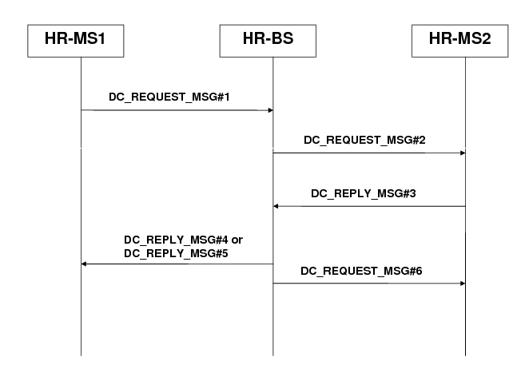
Figure 3: Flow Diagram of Authentication and Key Establishment of Network Aided Direct Communication scenario.

HR-MS1 sends a DC_Request_MSG#1
message to HR-BS to request for a direct communication pre-shared
key DMK to be shared with HR-MS2.
HR-BS verifies the received message. If the verification is correct, HR-BS sends a DC_Request_MSG#2 message to HR-MS2
HR-MS2 verifies the received message. If the verification is correct, then HR-MS2 decides on whether to accept or deny the direct communication key establishment request. HR-MS2 sends its response in DC_Reply_MSG#3 to HR-BS.
HR-BS verifies the received message. If the verification is correct, then HR-BS checks the response from HR-MS2. If HR-MS2 denies the direct communication key establishment, then the protocol stops and HR-BS sends DC_Reply_MSG#4 to inform HR-MS1. Otherwise, HR-BS generates the DMK and sends the DMK securely to HR-MS1 and HR-MS2 via DC_Reply_MSG#5 and DC_Reply_MSG#6 respectively.
HR-MS1 and HR-MS2 verifies the received message. If the verification is correct, then HR-MS1 and HR-MS2 decrypts and obtains DMK and key_lifetime for direct communications.
Figure 4: Flow Chart of Network Aided Direct Communication Authentication and Key Establishment Security Procedure.

17.2.10.1.2 Autonomous Mutual Authentication of HR-MS and data security for Direct Communications
HR-MS shall mutually authenticate themselves without access to a security server using the pre-established shared key DMK. The following security procedure shall be executed to provide Autonomous Mutual Authentication of HR-MS and data security for Direct Communications. HR-MS1 and HR-MS2 has already established a pre-shared key DMK with the aid of the Network Infrastructure. The establishment of the pre-shared key DMK can be done using the procedure mentioned in Section 17.2.10.1.1. Figure 5 shows the flow diagram while Figure 6 shows the flow chart for this scenario.
This security procedure includes the following steps:
Step 1: HR-MS1 selects nonce N_{HR-MS1} and uses the shared DMK and computes DAK = Dot16KDF ( DMK, HR-MS1Addr|HR-MS2Addr| “DAK”, 160), the DCMAC = Dot16KDF(DAK, “DCMAC_KEYS”, 128) and θ_{HR-MS1} = MAC_{DCMAC}(N _{HR-MS1}|DMK_Sequence_No|DAKID|Key_lifetime) and DTEK = DOT16KDF(DAK, “DTEK_KEY”, 128). Finally, HR-MS1 sends the DirectComms_KeyAgreement_MSG_#1 message to HR-MS2, where DirectComms_KeyAgreement_MSG_#1 = N_{HR-MS1}| DMK_Sequence_No| DAKID|Key_lifetime| θ_{HR-MS1}.
Step 2: HR-MS2 first verifies the received nonce is fresh and uses the shared DMK and computes DAK =Dot16KDF (DMK, {HR-MS1Addr|{HR-MS2Addr|”DAK”, 160), the DCMAC = Dot16KDF(DAK, “DCMAC_KEYS”, 128), DTEK = DOT16KDF(DAK, “DTEK_KEY”, 128) and uses DCMAC to checks θ_{HR-MS1}. If the verification is correct, HR-MS2 selects N_{HR-MS2} and computes θ_{HR-MS2} = MAC_{DCMAC}(N _{HR-MS1}|N _{HR-MS2}|DAKID|DMK_Sequence_No|DC_Security_Parameters). Finally, HR-MS2 sends DirectComms_KeyAgreement_MSG_#2 message to HR-MS1, where DirectComms_KeyAgreement_MSG_#2 = N _{HR-MS1}|N _{HR-MS2}|DAKID|DMK_Sequence_No|DC_Security_Parameters|θ_{HR-MS2}.
Step 3: HR-MS1 receives the above message from HR-MS2 and checks the received nonces for freshness and also checks DAKID and θ _{HR-MS2}. If the verifications are correct, HR-MS1 computes θ_{HR-MS1}' = MAC_{DCMAC}(N_{HR-MS1}|N _{HR-MS2}|DMK_Sequence_No|DC_SAID|DC_Security_Parameters). Finally, HR-MS1 sends DirectComms_KeyAgreement_MSG_#3 message to HR-MS2, where DirectComms_KeyAgreement_MSG_#3 = N_{HR-MS1}|N _{HR-MS2}|DMK_Sequence_No|DC_SAID|DC_Security_Parameters|θ_{HR-MS1}'.
Step 4: Upon receiving the above message, HR-MS2 checks the received nonces for freshness and θ_{HR-MS1}'. If the verifications are correct, HR-MS2 applies the negotiated security parameters and is ready for direct communications with HR-MS1. Otherwise, if θ_{HR-MS1}' is invalid, then HR-MS2 shall ignore the DirectComms_KeyAgreement_MSG_#3 message.
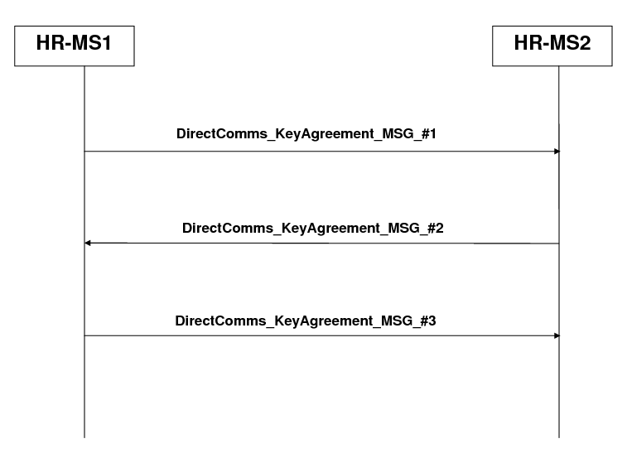
Figure 5: Flow Diagram of Authentication and Key Establishment of Direct Communication without Infrastructure (Pre-shared key case).

HR-MS2 verifies the received CMAC tuple. If the verification is correct, HR-MS2 generates its nonce and uses the pre-shared DMK to compute DAK, DCMAC key and DTEK. HR-MS2 then computes the CMAC tuple and sends DirectComms_KeyAgreement_MSG_#2 message to HR-MS1.
HR-MS1 verifies the received CMAC tuple and checks the DAKID. If the verifications are correct, then HR-MS1 computes its new CMAC tuple and sends DirectComms_KeyAgreement_MSG_#3 message to HR-MS2.
HR-MS1 selects its nonce and uses the pre-shared DMK to compute DAK, DCMAC key and DTEK. HR-MS1 then computes the CMAC tuple and sends DirectComms_KeyAgreement_MSG_#1 message to HR-MS2.
HR-MS2 receives the above message and verifies the CMAC tuple. If the verification is correct, then HR- MS2 confirms that HR-MS1 has computed the correct keys and commence secure direct communications.
Figure 6: Flow Chart of Pre-shared key-based Autonomous Direct Communication Authentication and Key Establishment Security Procedure.

17.2.10.1.3 Key Derivation

17.2.10.1.3.1 DMK Derivation
The DMK is a 160-bit key that is randomly generated by HR-BS or a network entity (e.g. an AAA Server etc) in the Network-aided Security Procedure, by HR-MS2 in Solution 1 - PKI, and by HR-BS* in Solution 2 - HR-MS converts to HR-BS* of the Autonomous Security Procedure. It is already pre-established in Solution 3 - Pre-shared key.
The DMK may be used as a source for keying materials required by upper layers.
17.2.10.1.3.2 DAK Derivation
DAK is derived from DMK and belongs to a pair of HR-MSs. The DAK is used for Direct Communications in the event of failure in the backbone.
The DAK derivation is as follows:
DAK =Dot16KDF (DMK, HR-MS1Addr|HR-MS2Addr|”DAK”, 160)
where: HR-MS1Addr and HR-MS2Addr are the addresses of HR-MS1 and HR-MS2 respectively.
17.2.10.1.3.3 DCMAC Key Derivation
DCMAC key is derived from DAK and used for message authentication for the messages sent during direct communications.
DCMAC key is derived as follows:
DCMAC = Dot16KDF(DAK, “DCMAC_KEYS”, 128)
17.2.10.1.3.4 DTEK Derivation
DTEK is used to transport encryption key used to encrypt data in direct communications.
DTEK is derived as follows:
DTEK = Dot16KDF(DAK, “DTEK_KEY”, 128)

[-------------------------------------------------End of Text Proposal----------------------------------------------------]

References
- IEEE 802.16n-10/0048, “802.16n System Requirements Document including SARM annex”, January 2011.
- IEEE 802.16n-10/0049, “802.16n Table of Contents for Amendment Working Draft”, January 2011.

Use of IEEE-Copyrighted Conference and Journal Papers
The IEEE 802.16 Working Group has obtained permission to post IEEE-copyrighted material from IEEE conferences and publications when received in an official contribution to the Working Group. IEEE requires two conditions:
- A full copyright and credit notice must be posted at the top of the paper in the following format:
Copyright ©2002 Institute of Electrical and Electronics Engineers, Inc. Reprinted, with permission, from [all relevant journal info].
This material is posted here with permission of the IEEE. Internal or personal use of this material is permitted. However, permission to reprint/republish this material for advertising or promotional purposes or for creating new collective works for resale or redistribution must be obtained from the IEEE (contact pubs–permissions@ieee.org).
By choosing to view this document, you agree to all provisions of the copyright laws protecting it.
- If the author is not the submitter of the contribution, the author’s written approval for the reuse of the material must be attached.

