Project | IEEE 802.16 Broadband Wireless Access Working Group <http://ieee802.org/16>
Title | Secure Direct Communications in wireless access network without network infrastructure
Date Submitted | 2011-03-06
Source(s) | Joseph Chee Ming Teo  Institute for Infocomm Research  1 Fusionopolis Way, #21-01, Connexis (South Tower)  Singapore 138632 | Voice: +65 6408-2292  E-mail: cmteo@i2r.a-star.edu.sg
Re: | Call for contributions for 802.16n AWD
Abstract | In this document, we propose a security procedure for two HR-MS nodes to mutually authenticate each other and establish a security key DMK for data security without network infrastructure. We assume that the HR-MS nodes in this scenario possess public and private key pairs as well as public key certificates (X.509) for authentication and key exchange purposes.
Purpose | To discuss and adopt the proposed text in the 802.16n draft Text
Notice | This document does not represent the agreed views of the IEEE 802.16 Working Group or any of its subgroups. It represents only the views of the participants listed in the “Source(s)” field above. It is offered as a basis for discussion. It is not binding on the contributor(s), who reserve(s) the right to add, amend or withdraw material contained herein.
Copyright Policy | The contributor is familiar with the IEEE-SA Copyright Policy <http://standards.ieee.org/IPR/copyrightpolicy.html>.
Patent Policy | The contributor is familiar with the IEEE-SA Patent Policy and Procedures:  <http://standards.ieee.org/guides/bylaws/sect6-7.html#6> and <http://standards.ieee.org/guides/opman/sect6.html#6.3>.  Further information is located at <http://standards.ieee.org/board/pat/pat-material.html> and <http://standards.ieee.org/board/pat>.
Secure Direct Communications in wireless access network without network infrastructure

Joseph Chee Ming Teo

Institute for Infocomm Research (I2R)
1 Fusionopolis Way, #21-01, Connexis South Tower
Singapore 138632

1. Introduction
Suppose two HR-MSs (High-Reliability-Mobile Stations) wishes to communicate securely with each other in the event of a network failure (i.e. there is no backbone infrastructure), then a security procedure is required to provide mutual authentication and data security for such secure direct communications. The IEEE 802.16n System Requirement Document (SRD) [1] specifies the requirement for security procedures for Autonomous (i.e. no network infrastructure present) mutual authentication and data security for direct communications. Currently, the existing security protocols (PKMv3) in existing IEEE 802.16 standards do not support such secure direct communication scenarios. In this contribution, we propose a security procedure for two HR-MS nodes to mutually authenticate each other and establish a security key DMK for data security without network infrastructure. We assume that the HR-MS nodes in this scenario possess public and private key pairs as well as public key certificates (X.509) for authentication and key exchange purposes.

Autonomous Mutual Authentication of HR-MS and data security for Direct Communications
Figure 1 shows the direct communications scenario where there is no backbone network. In this scenario, it is assumed that each node has a public and private key pairs as well as public key certificates (X.509) issued by a certification authority for mutual authentication and key exchange. A security procedure shall be executed by HR-MS1 and HR-MS2 to mutually authenticate each other and establish a security key for data security between HR-MS1 and HR-MS2.
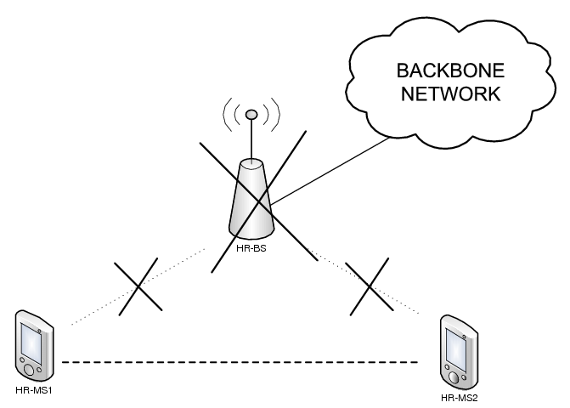
Figure 1: HR-MS to HR-MS Direct Communication scenario without infrastructure.

3. Summary

In this contribution, we propose a security procedure for Autonomous Mutual Authentication of HR-MS and data security for Direct Communications where each HR-MS possess a digital certificate that can be used for mutual authentication and key exchange for data security in direct communications between two HR-MSs without backbone network.

4. Text Proposal for IEEE 802.16n AWD

Note:
The text in BLACK color: the existing text in AWD
The text in RED color: the removal of existing AWD text
The text in BLUE color: the new text added to the Multi-Carrier DG Text

[-------------------------------------------------Start of Text Proposal---------------------------------------------------]
[Adopt the following text in the 802.16n AWD Document (C802.16x-xx/xxxx)]

17.2.10.1 Security procedures for HR-Networks
The following protocols shall be used for secure communication and session establishment amongst HR-stations, and between HR-stations and external AAA-server.
Figure 3: Flow Chart of Network Aided Direct Communication Authentication and Key Establishment Security Procedure.

17.2.10.1.2 Autonomous Mutual Authentication of HR-MS and data security for Direct Communications
HR-MS shall mutually authenticate themselves without access to a security server using the security procedure described below. Each HR-node has a public/private key pair and digital certificate (e.g. X.509) issued by a certification authority for mutual authentication and key exchange. The flow diagram for this scenario is depicted in Figure X and the Flow Chart for this scenario is shown in Figure Y.
The security procedure includes the following steps:
Step 1: …
Step 2: …
Figure 6: Flow Chart of PKI-based Autonomous Direct Communication Authentication and Key Establishment Security Procedure.
Figure 8: Flow Diagram of Authentication and Key Establishment of Direct Communication without Infrastructure (HR-MS becomes HR-BS*case).
Figure 9: Flow Chart of Multimode-based (HR-MS converts to HR-BS*) Autonomous Direct Communication Authentication and Key Establishment Security Procedure.

[-------------------------------------------------End of Text Proposal----------------------------------------------------]

References
- IEEE 802.16n-10/0048, “802.16n System Requirements Document including SARM annex”, January 2011.
- IEEE 802.16n-10/0049, “802.16n Table of Contents for Amendment Working Draft”, January 2011.

Use of IEEE-Copyrighted Conference and Journal Papers
The IEEE 802.16 Working Group has obtained permission to post IEEE-copyrighted material from IEEE conferences and publications when received in an official contribution to the Working Group. IEEE requires two conditions:
- A full copyright and credit notice must be posted at the top of the paper in the following format:
Copyright ©2002 Institute of Electrical and Electronics Engineers, Inc. Reprinted, with permission, from [all relevant journal info].
This material is posted here with permission of the IEEE. Internal or personal use of this material is permitted. However, permission to reprint/republish this material for advertising or promotional purposes or for creating new collective works for resale or redistribution must be obtained from the IEEE (contact pubs–permissions@ieee.org).
By choosing to view this document, you agree to all provisions of the copyright laws protecting it.
- If the author is not the submitter of the contribution, the author’s written approval for the reuse of the material must be attached.

