Project | IEEE 802.16 Broadband Wireless Access Working Group <http://ieee802.org/16>
Title | Autonomous Secure Direct Communications in wireless access network
Date Submitted | 2011-03-06
Source(s) | Joseph Chee Ming Teo, Jaya Shankar, Yeow Wai Leong, Hoang Anh Tuan, Wang Haiguang  Institute for Infocomm Research  1 Fusionopolis Way, #21-01, Connexis (South Tower)  Singapore 138632 | Voice: +65 6408-2292  E-mail: cmteo@i2r.a-star.edu.sg
Re: | Call for contributions for 802.16n AWD
Abstract | In this document, we propose a security procedure for two HR-MS nodes to mutually authenticate each other and establish a security key DMK for data security without network infrastructure. We assume that one of the HR-MS nodes in this scenario will change mode to an HR-BS and denote this role-changed node as HR-BS*.
Purpose | To discuss and adopt the proposed text in the 802.16n draft Text
Notice | This document does not represent the agreed views of the IEEE 802.16 Working Group or any of its subgroups. It represents only the views of the participants listed in the “Source(s)” field above. It is offered as a basis for discussion. It is not binding on the contributor(s), who reserve(s) the right to add, amend or withdraw material contained herein.
Copyright Policy | The contributor is familiar with the IEEE-SA Copyright Policy <http://standards.ieee.org/IPR/copyrightpolicy.html>.
Patent Policy | The contributor is familiar with the IEEE-SA Patent Policy and Procedures:  <http://standards.ieee.org/guides/bylaws/sect6-7.html#6> and <http://standards.ieee.org/guides/opman/sect6.html#6.3>.  Further information is located at <http://standards.ieee.org/board/pat/pat-material.html> and <http://standards.ieee.org/board/pat>.

Autonomous Secure Direct Communications in wireless access network

Joseph Chee Ming Teo

Institute for Infocomm Research (I2R)
1 Fusionopolis Way, #21-01, Connexis South Tower
Singapore 138632

1. Introduction
Suppose two HR-MSs (High-Reliability-Mobile Stations) wishes to communicate securely with each other in the event of a network failure (i.e. there is no backbone infrastructure), then a security procedure is required to provide mutual authentication and data security for such secure direct communications. The IEEE 802.16n System Requirement Document (SRD) [1] specifies the requirement for security procedures for Autonomous (i.e. no network infrastructure present) mutual authentication and data security for direct communications. Currently, the existing security protocols (PKMv3) in existing IEEE 802.16 standards do not support such secure direct communication scenarios. In this contribution, we propose a security procedure for two HR-MS nodes to mutually authenticate each other and establish a security key DMK for data security without network infrastructure. We assume that one of the HR-MS nodes in this scenario will change mode to an HR-BS and denote this role-changed node as HR-BS*.

2.2 Autonomous Mutual Authentication of HR-MS and data security for Direct Communications
In this section, we propose security procedure for Mutual Authentication of HR-MS and data security for direct Communications in the scenario where HR-MS convert to a base station, denoted as HR-BS*.
Suppose HR-MS1 converts to HR-BS* in order to establish a secure direct communication channel with HR-MS2 as show in Figure 1. A security procedure shall be executed by HR-BS* (HR-MS1) and HR-MS2 to mutually authenticate each other and establish a security key for data security between HR-BS* (HR-MS1) and HR-MS2.

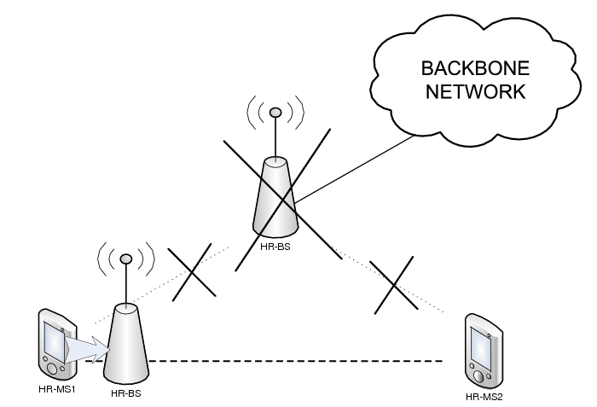
Figure 1: HR-MS to HR-MS Direct Communication scenario without infrastructure with HR-MS converting to HR-BS.

3. Summary

In this contribution, we propose a security procedure for Autonomous Mutual Authentication of HR-MS and data security for Direct Communications where one of the HR-MS is capable of multi-mode operations and converts to a HR-BS (denoted as HR-BS*) to perform mutual authentication and key establishment for data security.

4. Text Proposal for IEEE 802.16n AWD

Note:
The text in BLACK color: the existing text in AWD
The text in RED color: the removal of existing AWD text
The text in BLUE color: the new text added to the Multi-Carrier DG Text

[-------------------------------------------------Start of Text Proposal---------------------------------------------------]
[Adopt the following text in the 802.16n AWD Document (C802.16x-xx/xxxx)]

17.2.10.1 Security procedures for HR-Networks
The following protocols shall be used for secure communication and session establishment amongst HR-stations, and between HR-stations and external AAA-server.
Figure 3: Flow Chart of Network Aided Direct Communication Authentication and Key Establishment Security Procedure.

17.2.10.1.2 Autonomous Mutual Authentication of HR-MS and data security for Direct Communications
In the case where one of the HR-MS, say HR-MS1 is capable of multi-mode operations and is able to switch to a base station (HR-BS*) for secure direct communication with HR-MS2, then the two direct communicating HR-MSs (HR-MS1(HR-BS*) and HR-MS2) shall mutually authenticate each other without access to a security server.
Figure 6: Flow Chart of PKI-based Autonomous Direct Communication Authentication and Key Establishment Security Procedure.
The security procedure below shall be executed establish a secure direct communication channel between HR-MS1 (HR-BS*) and HR-MS2. Figure 2 shows the flow diagram and Figure 3 shows the flow chart in this scenario.
Step 1: The transformed HR-BS* shall send the DirectComms_KeyAgreement_MSG_#1 message to HR-MS2, where DirectComms_KeyAgreement_MSG_#1 = Cert(HR-BS*).
Step 2: HR-MS2 first verifies the certificate Cert(HR-BS*). If the verifications are correct, then HR-MS2 generates nonce N_{HR-MS2}. Next, HR-MS2 computes the signature σ_{HR-MS2} = SIGN(T_{HR-MS2}|N_{HR-MS2}|HR-BS*Addr|HR-MS2Addr) and sends the DirectComms_KeyAgreement_MSG_#2 message to HR-BS*, where DirectComms_KeyAgreement_MSG_#2 = T_{HR-MS2}|N_{HR-MS2}|HR-BS*Addr|HR-MS2Addr|σ_{HR-MS2}|Cert(HR-MS2).
Step 3: HR-BS* first verifies the received timestamp and nonce for freshness and certificate Cert(HR-MS2) and signature σ_{HR-MS2}. If the verifications are correct, then HR-BS* generates nonce N_{HR-BS*} and DMK and computes DAK =Dot16KDF ( DMK, HR-BS*Addr|HR-MS2Addr| “DAK”, 160), the DCMAC = Dot16KDF( DAK, “DCMAC_KEYS”, 128), the DTEK = DOT16KDF(DAK, “DTEK_KEY”, 128) and θ_{HR-BS*} = MAC_{DCMAC}(N _{HR-BS*}|N _{HR-MS2}|{HR-BS*Addr|{HR-MS2Addr). HR-BS* then uses HR-MS2's public key to encrypt and obtain E_{HR-MS2_PK}(DMK, key_lifetime, HR-BS*Addr, HR-MS2Addr). Finally, HR-BS* computes signature σ_{HR-BS*} = SIGN(T _{HR-BS*}|N _{HR-BS*}|HR-MS2Addr|HR-BS*Addr|N _{HR-MS2}|E_{HR-MS2_PK}(DMK, key_lifetime, HR-BS*Addr, HR-MS2Addr)| θ_{HR-BS*}) and sends DirectComms_KeyAgreement_MSG_#3 message to HR-MS2, where DirectComms_KeyAgreement_MSG_#3 = T _{HR-BS*}|N _{HR-BS*}|HR-MS2Addr|HR-BS*Addr|N _{HR-MS2}|E_{HR-MS2_PK}(DMK, key_lifetime, HR-BS*Addr, HR-MS2Addr)| θ_{HR-BS*} | σ_{HR-BS*}|Cert(HR-BS*).
Step 4: HR-MS2 first verifies the received timestamp, nonce and signature σ_{HR-BS*}. If the verifications are correct, then HR-MS2 decrypts E_{HR-MS2_PK}(DMK, key_lifetime, HR-BS*Addr, HR-MS2Addr) and obtains DMK and its lifetime key_lifetime. Next, HR-MS2 computes DAK, DCMAC key and DTEK and verifies θ _{HR-BS*}. If the verification is correct, then HR-MS2 can compute θ_{HR-MS2} = MAC_{DCMAC}(N _{HR-MS2}|N_{HR-BS*}|HR-MS2Addr|HR-BS*Addr) and sends DirectComms_KeyAgreement_MSG_#4 message to HR-BS*, where DirectComms_KeyAgreement_MSG_#4 = N_{HR-BS*}|HR-BS*Addr|HR-MS2Addr|θ_{HR-MS2}.
Step 5: HR-BS* receives the above message and verifies the received nonce and CMAC tuple. If the verification are correct, then HR-BS* confirms that HR-MS2 has computed the correct keys and commence secure direct communications.

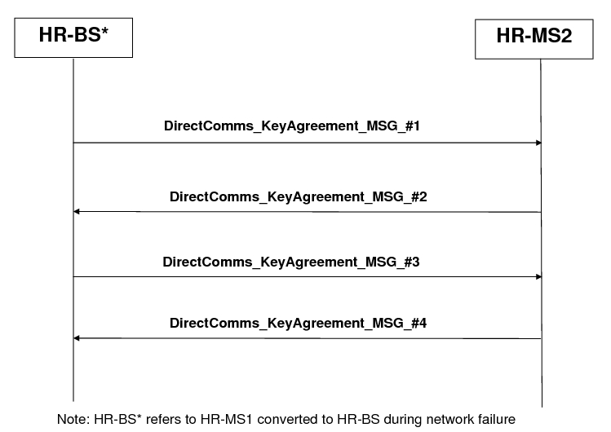

Figure 2: Flow Diagram of Autonomous Authentication and Key Establishment of Direct Communication without Infrastructure
HR-MS1 converts to HR-BS*.
HR-MS2 verifies the received certificate. If the verification is correct, HR-MS2 generates its nonce and computes the signature and sends DirectComms_KeyAgreement_MSG_#2 message to HR-MS1. The message also contains HR-MS2’s digital certificate.
HR-BS* verifies the received certificate and signature. If the verification is correct, then HR-BS* generates its nonce and DMK and computes DAK, DCMAC key and DTEK. HR-BS* then encrypts the DMK using HR-MS2’s public key and computes its CMAC tuple and signature. Finally, HR-BS* sends DirectComms_KeyAgreement_MSG_#3 message to HR-MS2.
HR-MS2 receives the above message and verifies the received signature. If the verification is correct, HR-MS2 decrypts and obtains DMK. Next, HR-MS2 computes DAK, DCMAC key and DTEK and verifies the CMAC tuple. If the verification is correct, HR-MS2 computes its CMAC tuple and sends DirectComms_KeyAgreement_MSG_#4 back to HR-BS*.
HR-BS* sends DirectComms_KeyAgreement_MSG_#1 message to HR-MS2 which contains its certificate.
HR-BS* receives the above message and verifies the CMAC tuple. If the verification is correct, then HR- BS* confirms that HR-MS2 has computed the correct keys and commence secure direct communications.
Figure 3: Flow Chart of Autonomous Direct Communication Authentication and Key Establishment Security Procedure.

17.2.10.1.3 Key Derivation

17.2.10.1.3.1 DMK Derivation
The DMK is a 160-bit key that is randomly generated by HR-BS or a network entity (e.g. an AAA Server etc) in the Network-aided Security Procedure, by HR-MS2 in Solution 1 - PKI, and by HR-BS* in Solution 2 - HR-MS converts to HR-BS* of the Autonomous Security Procedure. It is already pre-established in Solution 3 - Pre-shared key.
The DMK may be used as a source for keying materials required by upper layers.
17.2.10.1.3.2 DAK Derivation
DAK is derived from DMK and belongs to a pair of HR-MSs. The DAK is used for Direct Communications in the event of failure in the backbone.
The DAK derivation is as follows:
DAK =Dot16KDF (DMK, HR-MS1Addr|HR-MS2Addr|”DAK”, 160)
where: HR-MS1Addr and HR-MS2Addr are the addresses of HR-MS1 and HR-MS2 respectively.
17.2.10.1.3.3 DCMAC Key Derivation
DCMAC key is derived from DAK and used for message authentication for the messages sent during direct communications.
DCMAC key is derived as follows:
DCMAC = Dot16KDF(DAK, “DCMAC_KEYS”, 128)
17.2.10.1.3.4 DTEK Derivation
DTEK is used to transport encryption key used to encrypt data in direct communications.
DTEK is derived as follows:
DTEK = Dot16KDF(DAK, “DTEK_KEY”, 128)

[-------------------------------------------------End of Text Proposal----------------------------------------------------]

References
- IEEE 802.16n-10/0048, “802.16n System Requirements Document including SARM annex”, January 2011.
- IEEE 802.16n-10/0049, “802.16n Table of Contents for Amendment Working Draft”, January 2011.

Use of IEEE-Copyrighted Conference and Journal Papers
The IEEE 802.16 Working Group has obtained permission to post IEEE-copyrighted material from IEEE conferences and publications when received in an official contribution to the Working Group. IEEE requires two conditions:
- A full copyright and credit notice must be posted at the top of the paper in the following format:
Copyright ©2002 Institute of Electrical and Electronics Engineers, Inc. Reprinted, with permission, from [all relevant journal info].
This material is posted here with permission of the IEEE. Internal or personal use of this material is permitted. However, permission to reprint/republish this material for advertising or promotional purposes or for creating new collective works for resale or redistribution must be obtained from the IEEE (contact pubs–permissions@ieee.org).
By choosing to view this document, you agree to all provisions of the copyright laws protecting it.
- If the author is not the submitter of the contribution, the author’s written approval for the reuse of the material must be attached.

