Project | IEEE 802.16 Broadband Wireless Access Working Group <http://ieee802.org/16>
Title | Multicast Key Management for IEEE 802.16n HR-Network
Date Submitted | 2011-03-06
Source(s) | Joseph Chee Ming Teo, Jaya Shankar, Yeow Wai Leong, Hoang Anh Tuan, Zheng Shoukang, Mar Choon Hock  Institute for Infocomm Research  1 Fusionopolis Way, #21-01, Connexis (South Tower)  Singapore 138632 | Voice: +65 6408-2292  E-mail: cmteo@i2r.a-star.edu.sg
Re: | Call for contributions for 802.16n AWD
Abstract | In this document, we first consider the multicast key management scenario where there is network infrastructure and it is assumed that each node shares a unicast security key MSKi with the base station HR-BS. Next, we focus on the situation where there is no backbone infrastructure and all multicast group members possess a private/public key pair and public key certificate (X.509 certificate) signed by a certification authority (e.g. Manufacturer), that is, we assume that there is X.509 PKI infrastructure in place. We propose multicast key management procedures for Initial Group Formation, Node Join events and Node leave events to secure multicast communications in 802.16n HR-networks for the above two scenarios.
Purpose | To discuss and adopt the proposed text in the 802.16n draft Text
Notice | This document does not represent the agreed views of the IEEE 802.16 Working Group or any of its subgroups. It represents only the views of the participants listed in the “Source(s)” field above. It is offered as a basis for discussion. It is not binding on the contributor(s), who reserve(s) the right to add, amend or withdraw material contained herein.
Copyright Policy | The contributor is familiar with the IEEE-SA Copyright Policy <http://standards.ieee.org/IPR/copyrightpolicy.html>.
Patent Policy | The contributor is familiar with the IEEE-SA Patent Policy and Procedures:  <http://standards.ieee.org/guides/bylaws/sect6-7.html#6> and <http://standards.ieee.org/guides/opman/sect6.html#6.3>.  Further information is located at <http://standards.ieee.org/board/pat/pat-material.html> and <http://standards.ieee.org/board/pat>.

Multicast Key Management for IEEE 802.16n HR-Network

Joseph Chee Ming Teo, Jaya Shankar, Yeow Wai Leong, Hoang Anh Tuan, Zheng Shoukang, Mar Choon Hock

Institute for Infocomm Research (I2R)
1 Fusionopolis Way, #21-01, Connexis South Tower
Singapore 138632

1. Introduction

The IEEE 802.16n System Requirements Document (SRD) [1] specifies shall provide the security architecture that provides a group of HR-MSs with authentication, authorization, encryption and integrity protection. The HR-Network shall provide multicast key management for the group of HR-MSs and the key shared within the group should be distributed securely and efficiently. The multicast communications should be able to take place with or without Base Station (HR-BS) in order to provide high reliability.

To ensure that an attacker is not able to masquerade as a multicast member or eavesdrop in the multicast communications, multicast key management (MKM) protocols have to be designed for the 802.16n networks. Although multicast is already supported in existing IEEE 802.16 standards and a Multicast and Broadcast Rekeying Algorithm (MBRA) has already been proposed, however, it was pointed out in existing literature that MBRA is not scalable and also does not provide backward and forward secrecy, i.e. a new joining member is able to decrypt previous secure multicast communications sent before it joined (backward secrecy) and a leaving member can still decrypt future secure multicast communications after leaving the multicast group (forward secrecy).

In this contribution, we first consider the multicast key management scenario where there is network infrastructure and it is assumed that each node shares a unicast security key MSKi with the base station HR-BS. Next, we focus on the situation where there is no backbone infrastructure and all multicast group members possess a private/public key pair and public key certificate (X.509 certificate) signed by a certification authority (e.g. Manufacturer), that is, we assume that there is X.509 PKI infrastructure in place. We propose multicast key management procedures for Initial Group Formation, Node Join events and Node leave events to secure multicast communications in 802.16n HR-networks for the above two scenarios.

2. Multicast Key Management
Figure 1 shows a group of multicast members that wishes to establish a secure multicast. The “controller” node HR-MSX/BS refers to either an appointed HR-MS node (HR-MSX) in the case where there is no Base Station (HR-BS) around or it can also refer to the Base Station node (HR-BS) in the case where an HR-BS is present. We present two use case scenario, namely the pre-shared key approach and the PKI approach. The pre-shared key approach assumes that each HR-MS shares a unicast security key MSKi with the base station HR-BS and uses this key in the multicast key management to obtain the multicast group key. The PKI-based approach assumes that there is no backbone infrastructure and that all nodes possess a private/public key pair and public key certificate (X.509 certificate). In the case of Figure 1, an Initial Group Formation Procedure will be executed to establish a secure multicast key GTEK for secure multicast communications as well as pairwise shared keys MSKi that will be shared between the controller node and each HR-MSi in the multicast group (for PKI approach only).

Controller node can be either HR-BS or an appointed HR-MS (Denoted as HR-MSX if HR-BS is not present)
Figure 1: Initial Group Formation

Figure 2 below shows the multicast group where new node HR-MSj joins the multicast group. In this case, the existing multicast group key has to be changed in order to prevent the new node from reading previous secure multicast communications (backward secrecy). The Join Event Procedure will also establish a pairwise shared key between controller node and the new joining node HR-MSj (for PKI-based approach only).

Figure 2: Join Event
Figure 3 below shows the scenario where a multicast member HR-MSl leaves the multicast group. In this case, the multicast group key has to be changed to prevent the leaving multicast member from obtaining future secure multicast communications (forward secrecy).

Figure 2: Leave Event

As such, the Multicast Key management protocol in the IEEE 802.16n standards has to provide procedures to update the key whenever the multicast group is formed or whenever a user joins or leaves the multicast group.

3. Summary
Suppose a group of HR-MSs (High-Reliability-Mobile Stations) wishes to communicate securely with each other for multicast applications such as Push-to-Talk or multicast data transfer, then a multicast group has to be formed. In order to prevent malicious nodes from masquerading as a legitimate multicast member and send malicious message to disrupt the multicast communications, multicast key management (MKM) protocols has to be used to establish a multicast key for secure multicast communications in the group. The data encrypted with the multicast key will also be secure against eavesdropper trying to listen in to the secure multicast communications.
The MKM protocols also has to take into account backward and forward secrecy, i.e. i.e. a new joining member is able to decrypt previous secure multicast communications sent before it joined (backward secrecy) and a leaving member can still decrypt future secure multicast communications after leaving the multicast group (forward secrecy).

4. Text Proposal for IEEE 802.16n AWD

Note:
The text in BLACK color: the existing text in AWD
The text in RED color: the removal of existing AWD text
The text in BLUE color: the new text added to the AWD Text

[-------------------------------------------------Start of Text Proposal---------------------------------------------------]
[Adopt the following text in the 802.16n AWD Document (C802.16x-xx/xxxx)]

17.2.10.2 Multicast Key Management

17.2.10.2.x Multicast Key Management – Pre-shared key
The following procedures shall be used to 1) establish multicast key for a group of HR-MS nodes that wishes to establish secure multicast communications with each other, 2) change the multicast key whenever new nodes join the multicast group and 3) change the multicast key whenever nodes leave the multicast group. The HR nodes shall use the pre-established shared key MSKi with controller node HR-BS to perform authentication and multicast key management.

17.2.10.2.x.1 Initial Group Formation Procedure
The Initial Group Formation procedure takes place during initial multicast group formation to establish a multicast key GTEK for secure multicast communications amongst the HR-MS nodes in the multicast group. Figure X1 shows the flow diagram while Figure Y1 shows the flow chart for the Initial Group Formation Procedure.

The Initial Group Formation Procedure includes the following steps:

Step 1: HR-BS sends the multicast group information message (MulticastGrpInfo message) to all potential members of the multicast group comprising of HR-MSi for 1 ≤ i ≤ n, where MulticastGrpInfo = MulticastGrpID|HR-BSAddr.
Step 2: Each HR-MSi for 1 ≤ i ≤ n first generates nonce N_{HR-MSi}. Next, HR-MSi computes the MAC θ_{HR-MSi} = MAC(MSKi|MulticastGrpID|T_{HR-MSi}|N_{HR-MSi}|HR-BSAddr|HR-MSiAddr) and sends Multicast_MSG_#1 message to HR-BS, where Multicast_MSG_#1 = MulticastGrpID|T_{HR-MSi}|N_{HR-MSi}|HR-BSAddr|HR-MSiAddr|θ_{HR-MSi}.
Step 3: HR-BS first verifies the received timestamps and nonces for freshness and θ_{HR-MSi} for 1 ≤ i ≤ n. If the verifications are correct, then HR-BS generates nonce N_{HR-BS}, GTEK and computes θ_{HR-MSi}' = MAC(MSKi|GTEK|N_{HR-BS}|N_{HR-MSi}|HR-BSAddr|HR-MSiAddr). HR-BS then encrypt and obtain c_{i} = E_{MSKi}(GTEK, GTEK_lifetime, HR-MSiAddr, HR-BSAddr). Finally, HR-BS sends Multicast_MSG_#2 message to HR-MSi for 1 ≤ i ≤ n, where Multicast_MSG_#2 = MulticastGrpID|T_{HR-BS}|N_{HR-BS}|HR-MSiAddr|HR-BSAddr| N_{HR-MSi}|c_{i}|θ_{HR-MSi}'.
Step 4: Each HR-MSi for 1 ≤ i ≤ n first verifies the received timestamp and nonces for freshness and decrypts c_{i} using MSKi and obtains GTEK and GTEK_lifetime. Next, each HR-MSi verifies θ_{HR-MSi}'. If the verification is correct, then HR-MSi can commence secure multicast.
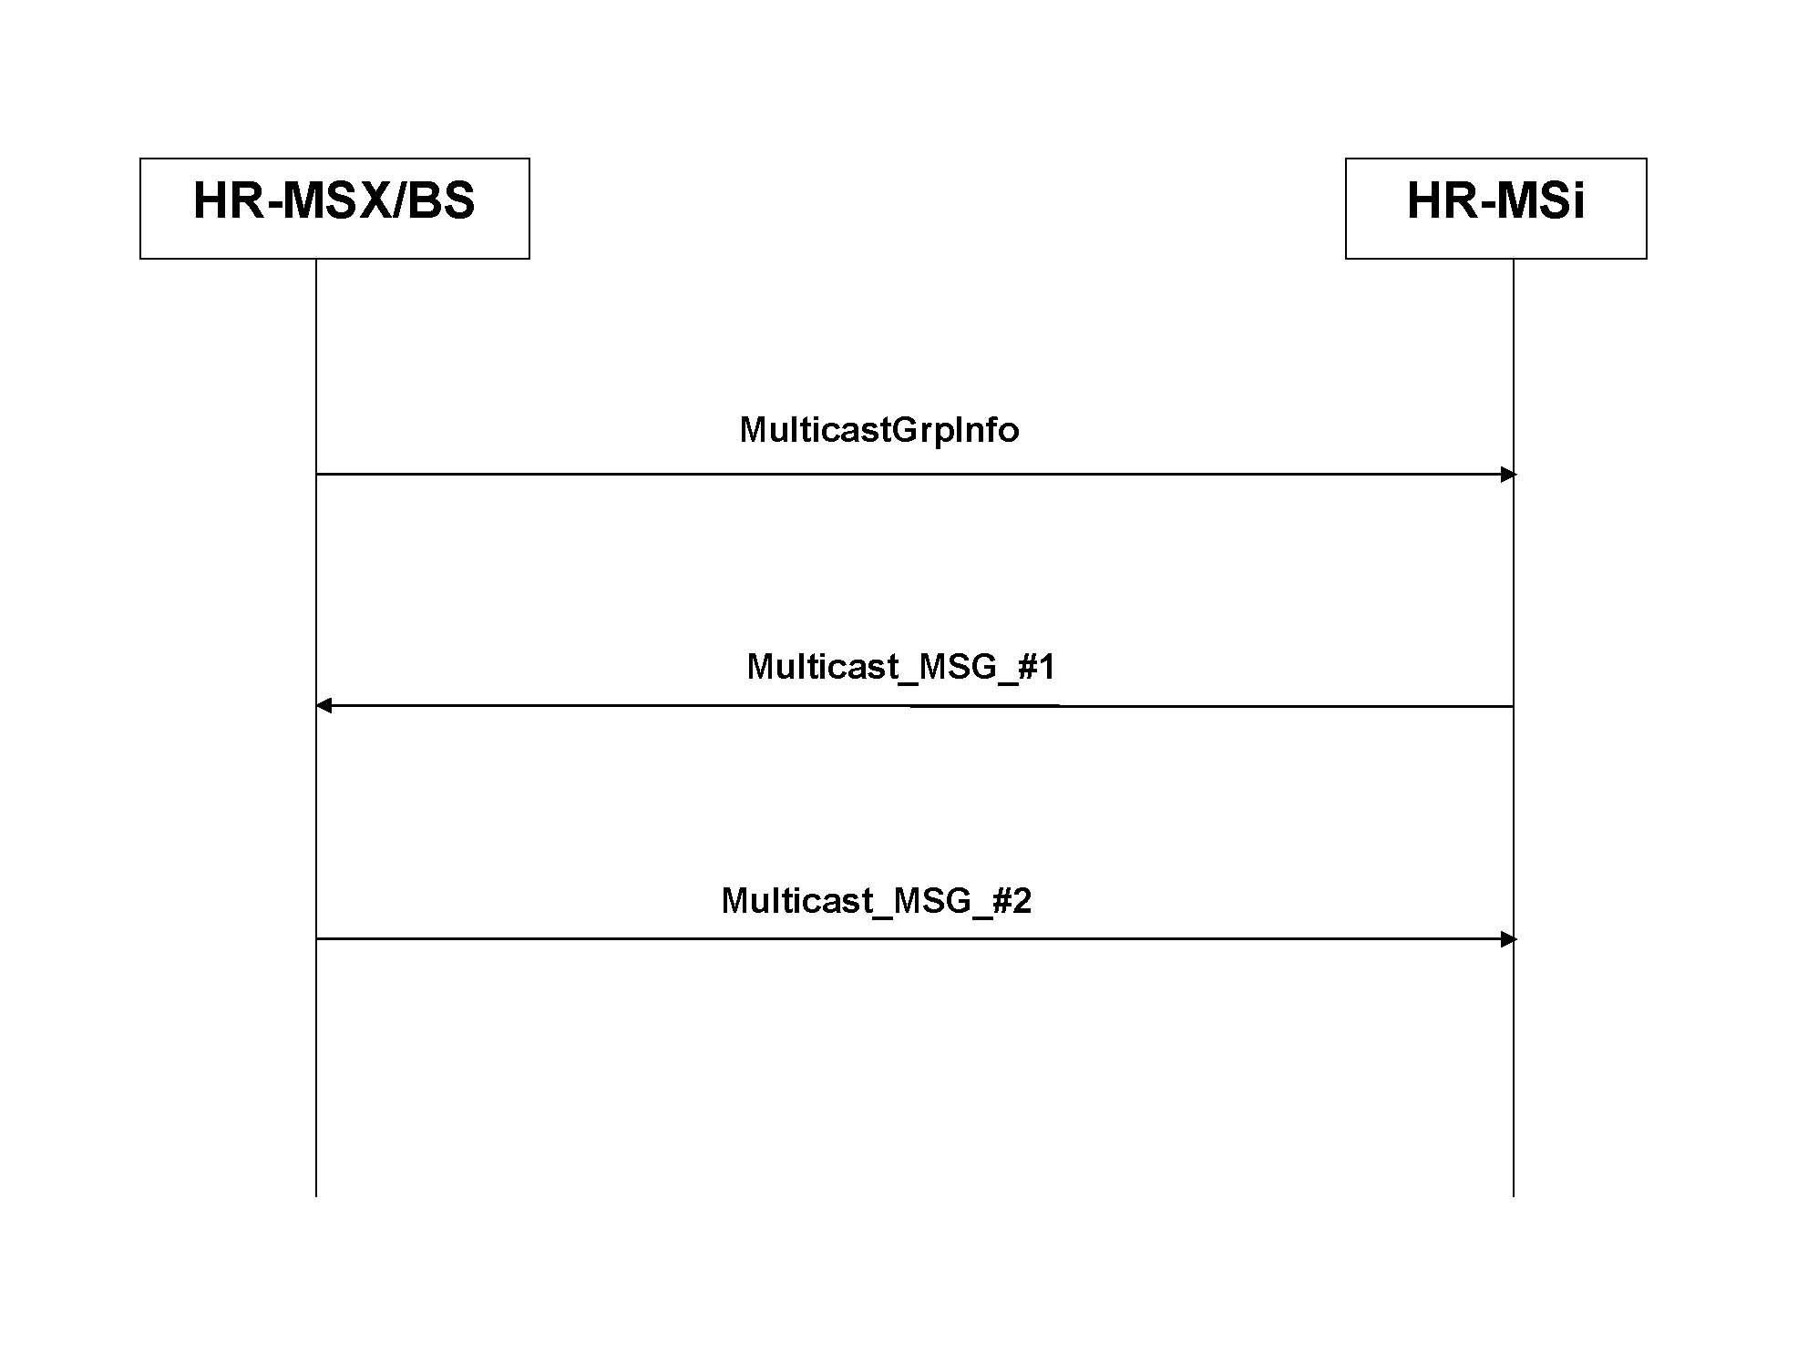
Figure X1 - Flow Diagram for Initial Group Formation Procedure
HR-MSX/BS sends the multicast group information MulticastGrpInfo to all potential members of the multicast group comprising of HR-MSi for 1 <= i <= n
Each HR-MSi generates nonce, computes the MAC and sends Multicast_MSG_#1 to HR-MSX/BS.
HR-MSX/BS verifies the received timestamps, nonce, messages and MACs. If the verifications are correct, HR-MSX/BS generates its nonce, the GTEK and computes the MACs. HR-MSX/BS then encrypts GTEK and its lifetime using shared key MSKi and obtains cB_{iB}. Finally, HR-MSX/BS sends Multicast_MSG_#2 to each HR-MSi.
Each HR-MSi verifies the received timestamp and nonces and decrypts cB_{iB} to obtain GTEK and its lifetime. Each HR-MSi then verifies the MAC and commence secure multicast if the verification is correct.
Figure Y1 - Flow Chart for Initial Group Formation Procedure

17.2.10.2.x.2 Join Event Procedure
The Join Event Procedure takes place whenever there are nodes that join the multicast group and the multicast key has to be changed in order to prevent the new joining nodes from obtaining previous secure multicast communications. Figure X2 shows the flow diagram while Figure Y2 shows the flow chart for the Join Event Procedure.

The Join Event Procedure includes the following steps:

Step 1: New mobile station HR-MSj first generates nonce N_{HR-MSj}. Next, HR-MSj computes the MAC θ_{HR-MSj} = MAC(MSKj|MulticastGrpID|T_{HR-MSj}|N_{HR-MSj}|HR-BSAddr|HR-MSjAddr) and sends Join_MG_MSG_#1 message to HR-BS, where Join_MG_MSG_#1 = MulticastGrpID| T_{HR-MSj}|N_{HR-MSj}|HR-BSAddr| HR-MSjAddr|θ_{HR-MSj}.
Step 2: HR-BS first verifies the received timestamps and nonces for freshness and θ_{HR-MSj}. If the verifications are correct, then HR-BS generates nonce N_{HR-BS}', GTEK' and computes θ_{HR-BS} = MAC(GTEK'|N_{HR-BS}'|HR-BSAddr|MulticastGrpID) and θ_{HR-MSj}' =MAC(MSKj|GTEK'|N_{HR-BS}'|N_{HR-MSj}|HR-BSAddr|HR-MSjAddr). HR-BS then encrypt and obtain c_{j} = E_{MSKj}(GTEK', GTEK'_lifetime, HR-MSjAddr, HR-BSAddr). HR-BS also encrypts using the existing GTEK and obtains c' = E_{GTEK}(GTEK', GTEK'_lifetime, HR-BSAddr, N_{HR-BS}') Finally, HR-BS sends Multicast_Join_MSG_#2 message to HR-MSi for 1 ≤ i ≤ n and Multicast_Join_MSG_#3 message to HR-MSj respectively, where Multicast_Join_MSG_#2 = MulticastGrpID|T_{HR-BS}'|N_{HR-BS}'|HR-BSAddr| c'|θ_{HR-BS} and Multicast_Join_MSG_#3 = MulticastGrpID|T_{HR-BS}'|N_{HR-BS}'|HR-MSjAddr|HR-BSAddr|N_{HR-MSj}|c_{j}| θ_{HR-MSj}'.
Step 3a: Each HR-MSi for 1 ≤ i ≤ n first verifies the received timestamp and nonce for freshness. If the verifications are correct, then each HR-MSi decrypts c' and obtains the new GTEK', and GTEK'_lifetime. Next, each HR-MSi verifies θ_{HR-BS}. If the verification is correct, then HR-MSi can commence secure multicast.
Step 3b: HR-MSj first verifies the received timestamp and nonces for freshness. If the verifications are correct, then HR-MSj uses MSKj to decrypt c_{_j} and obtains GTEK' and GTEK'_lifetime. Next, HR-MSj verifies θ_{HR-MSj}'. If the verification is correct, then HR-MSj can commence secure multicast.
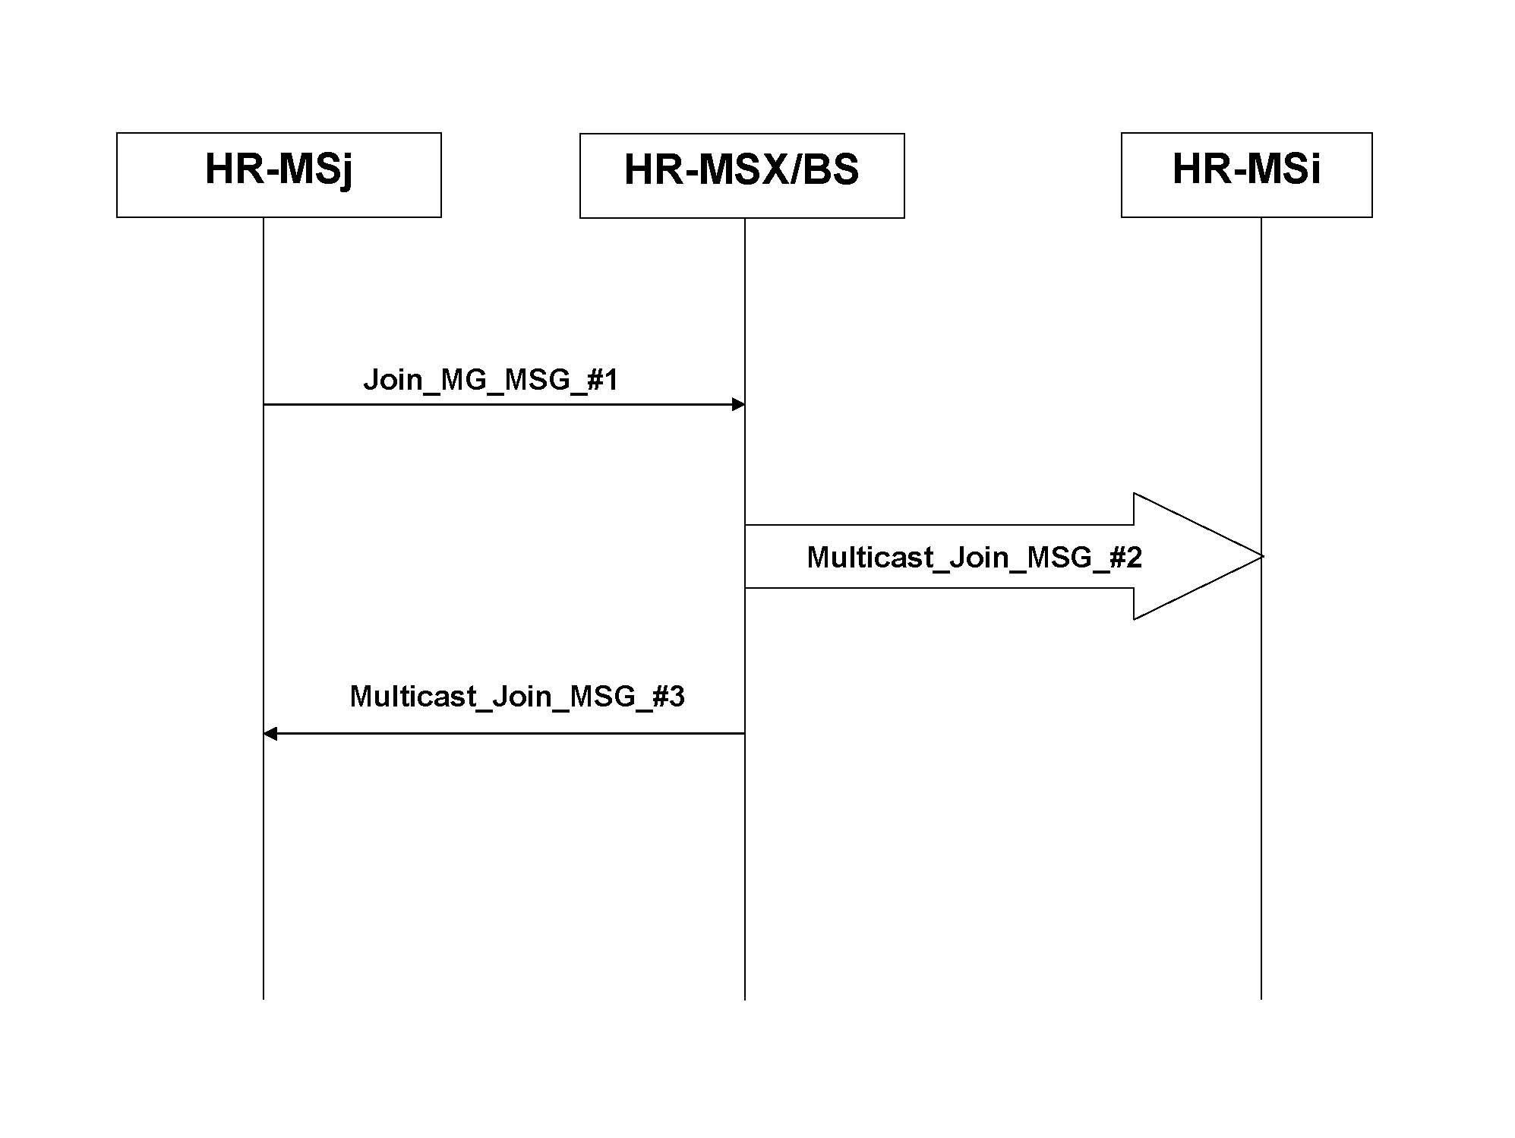
Figure X2 - Flow Diagram for Join Procedure
HR-MSX/BS verifies the received timestamp, nonce and MAC. If the verifications are correct, HR-MSX/BS generates nonce, GTEK’ and computes the respective MACs. Next HR-MSX/BS uses the pre-shared key MSKj to encrypt GTEK’ and its key lifetime and obtains c_{j}. HR-MSX/BS also encrypts GTEK’ and its lifetime using current GTEK and obtains c’. Finally, HR-MSX/BS sends the message Multicast_Join_MSG_#2 to HR-MSi for 1 <= i <= n and message Multicast_Join_MSG_#3 to HR-MSj for 1 <= j <= m.
New HR-MSj for 1 <= j <= m generates nonce, computes MAC using MSKj and sends message Join_MG_MSG_#1 to HR-MSX/BS.
HR-MSj verifies the received timestamp and nonces. If the verifications are correct, then HR-MSj decrypts c_{j} and obtains GTEK’ and its lifetime. Next HR-MSj verifies the MAC and commence secure multicast if the verification is correct.
Each HR-MSi verifies the received timestamp and nonce. If the verifications are correct, HR-MSi decrypts c’ and obtains the new GTEK’ and its lifetime. Next, HR-MSi verifies the MAC and continues secure multicast if the verification is correct.
Figure Y2 - Flow Chart for Join Procedure

17.2.10.2.x.3 Leave Event Procedure
The Leave Event Procedure takes place whenever there are nodes leaving the multicast group and the multicast key has to be changed in order to prevent the leaving nodes from obtaining future secure multicast communications. Figure X3 shows the flow diagram while Figure Y3 shows the flow chart for the Leave Event Procedure.

The Leave Event Procedure includes the following steps:

Step 1: HR-BS generates nonce N_{HR-BS}', new group key GTEK' and computes θ_{HR-MSi}' = MAC(MSKi|GTEK'|N_{HR-BS}'|HR-BSAddr|HR-MSiAddr|MulticastGrpID) for 1 ≤ i \!= L ≤ n. HR-BS then uses the shared key MSKi with the remaining HR-MSi for 1 ≤ i != L ≤ n to encrypt and obtain c_{i}' = E_{MSKi}(GTEK',GTEK'_lifetime, HR-BSAddr, N_{HR-BS}'). Finally, HR-BS sends Multicast_Leave_MSG_#1 messages to remaining HR-MSi for 1 ≤ i != L ≤ n, where Multicast_Leave_MSG_#1 = MulticastGrpID|T_{HR-BS}'|N_{HR-BS}'|HR-BSAddr|c_{i}'|θ_{HR-MSi}'.

Step 2: Each remaining HR-MSi for 1 ≤ i != L ≤ n first verifies the received timestamp and nonce for freshness. If the verifications are correct, then each remaining HR-MSi uses its shared key MSKi to decrypt c_{i} ' and obtains the new GTEK' and GTEK'_lifetime. Next, each remaining HR-MSi verifies θ_{HR-MSi}'. If the verification is correct, then each remaining HR-MSi can commence secure multicast.

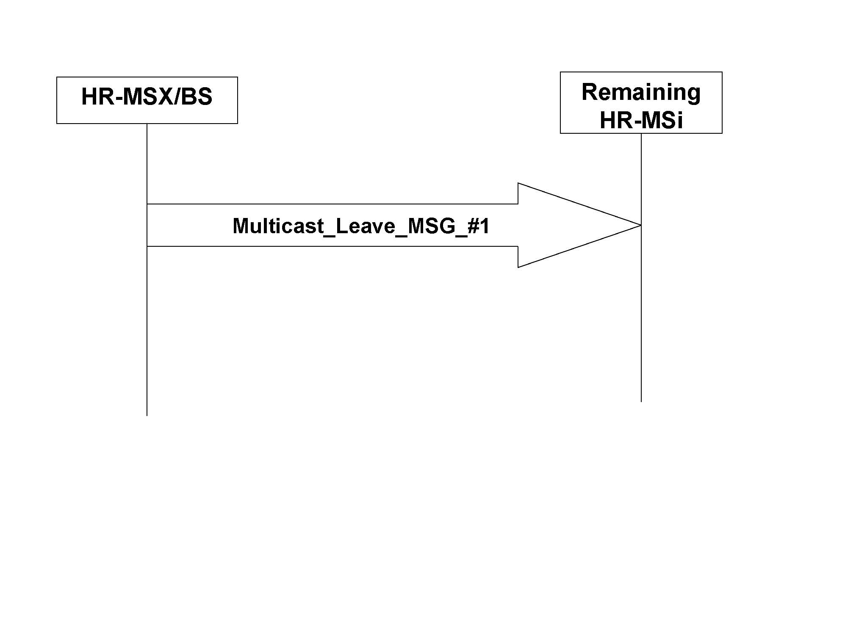
Figure X3 - Flow Diagram for Leave Procedure
Each remaining HR-MSi first verifies the received timestamp and nonce. If the verifications are correct, each HR-MSi decrypts c_{i}’ and obtains the new GTEK’ and its lifetime. Each HR-MSi then verifies the received MAC and continues secure multicast if the verification is correct.
HR-MSX/BS generates nonce, new GTEK’ and computes the MAC for each remaining HR-MSi. Next, HR-MSX/BS uses the shared key MSKi to encrypt the new GTEK’ and its lifetime and obtains c_{i}’. Finally, HR-MSX/BS sends message Multicast_Leave_MSG_#1 to each remaining HR-MSi.
Figure Y3 - Flow Chart for Leave Procedure

17.2.10.2.y Multicast Key Management – PKI
The following procedures shall be used to 1) establish pairwise key MSKi between controller node HR-MSX/BS and HR-MS nodes and the multicast key GTEK for a group of HR-MS nodes to establish secure multicast communications with each other, 2) change the multicast key whenever new nodes join the multicast group and establish pairwise key MSKj with the new nodes and 3) change the multicast key whenever nodes leave the multicast group. The HR nodes shall use PKI to perform authentication and multicast key management.

17.2.10.2.y.1 Initial Group Formation Procedure
The Initial Group Formation procedure takes place during initial multicast group formation to establish a pairwise key MSKi between the controller node HR-MSX/BS and multicast members HR-MSi as well as establish a multicast key GTEK for secure multicast communications amongst the HR-MS nodes in the multicast group. Figure A1 shows the flow diagram while Figure A2 shows the flow chart for the Initial Group Formation Procedure.

The Initial Group Formation Procedure includes the following steps:

Step 1: HR-MSX/BS sends the MulticastGrpInfo message to all potential members of the multicast group comprising of HR-MSi for 1 ≤ i ≤ n, where MulticastGrpInfo = MulticastGrpID|HR-MSX/BSAddr|Cert(HR-MSX/BS).
Step 2: Each HR-MSi for 1 ≤ i ≤ n first generates nonce N_{HR-MSi}. Next, HR-MSi computes the signature σ_{HR-MSi} = SIGN(MulticastGrpID|T_{HR-MSi}|N_{HR-MSi}|HR-MSX/BSAddr|HR-MSiAddr) and sends Multicast_MSG_#1 message to HR-MSX/BS, where Multicast_MSG_#1 = MulticastGrpID|T_{HR-MSi}|N_{HR-MSi}|HR-MSX/BSAddr|HR-MSiAddr |σ_{HR-MSi}|Cert(HR-MSi).
Step 3: HR-MSX/BS first verifies the received timestamps and nonces for freshness and the certificate Cert(HR-MSi) and signature σ_{HR-MSi} for 1 ≤ i ≤ n. If the verifications are correct, then HR-MSX/BS generates nonce N_{HR-MSX/BS}, GTEK and MSKi for 1 ≤ i ≤ n and computes key confirmation/message authentication code θ_{HR-MSi} = MAC(MSKi|GTEK|N_{HR-MSX/BS}|N_{HR-MSi}|HR-MSX/BSAddr|HR-MSiAddr). HR-MSX/BS then uses HR-MSi's public key to encrypt and obtain c_{i} = E_{HR-MSi_PK}(MSKi, GTEK, MSKi_lifetime, GTEK_lifetime, HR-MSiAddr, HR-MSX/BSAddr). Finally, HR-MSX/BS computes signature σ_{HR-MSi}' = SIGN(MulticastGrpID|T_{HR-MSX/BS}|N_{HR-MSX/BS}|HR-MSiAddr|HR-MSX/BSAddr|N_{HR-MSi}|c_{i}|θ_{HR-MSi}) and sends Multicast_MSG_#2 message to HR-MSi for 1 ≤ i ≤ n, where Multicast_MSG_#2 = MulticastGrpID|T_{HR-MSX/BS}|N_{HR-MSX/BS}|HR-MSiAddr|HR-MSX/BSAddr|N_{HR-MSi}|c_{i}|θ_{HR-MSi}|σ_{HR-MSi}'.
Step 4: Each HR-MSi for 1 ≤ i ≤ n first verifies the received timestamp and nonces for freshness and the signature σ_{HR-MSi}'. If the verifications are correct, then each HR-MSi decrypts c_{i} = E_{HR-MSi_PK}(MSKi, GTEK, MSKi_lifetime, GTEK_lifetime, HR-MSiAddr, HR-MSX/BSAddr) and obtains MSKi, GTEK, MSKi_lifetime and GTEK_lifetime. Next, each HR-MSi verifies θ_{HR-MSi}. If the verification is correct, then HR-MSi can commence secure multicast.
Figure A1 - Flow Diagram for Initial Group Formation Procedure

HR-MSX/BS sends the multicast group information MulticastGrpInfo to all potential members of the multicast group comprising of HR-MSi for 1 <= i <= n
Each HR-MSi generates nonce, computes the signature and sends Multicast_MSG_#1 to HR-MSX/BS.
HR-MSX/BS verifies the received timestamps, nonce, messages and MACs. If the verifications are correct, HR-MSX/BS generates its nonce, the GTEK and MSKi for 1 <= i <= n and computes the MAC. HR-MSX/BS then encrypts the secret keys using each HR-MSi’s public key, computes the signatures for each message and sends Multicast_MSG_#2 to each HR-MSi.
Each HR-MSi verifies the received timestamp, nonces and signature. If the verification is correct, each HR-MSi decrypts and obtains MSKi, GTEK and their lifetimes. Each HR-MSi then verifies the MAC and commence secure multicast if the verification is correct.
Figure A2 - Flow Chart for Initial Group Formation Procedure

17.2.10.2.y.2 Join Event Procedure
The Join Event Procedure takes place whenever there are nodes that join the multicast group and the multicast key has to be changed in order to prevent the new joining nodes from obtaining previous secure multicast communications. A pairwise key MSKj will also be established between controller node HR-MSX/BS and new joining node HR-MSj. Figure A3 shows the flow diagram while Figure A4 shows the flow chart for the Join Event Procedure.

The Join Event Procedure includes the following steps:

Step 1: New mobile station HR-MSj first generates nonce N_{HR-MSj}. Next, HR-MSj computes the signature σ_{HR-MSj} = SIGN(MulticastGrpID|T_{HR-MSj}|N_{HR-MSj}|HR-MSX/BSAddr|HR-MSjAddr) and sends Join_MG_MSG_#1 message to HR-MSX/BS, where Join_MG_MSG_#1 = MulticastGrpID|T_{HR-MSj}|N_{HR-MSj}|HR-MSX/BSAddr|HR-MSjAddr |σ_{HR-MSj}|Cert(HR-MSj).
Step 2: HR-MSX/BS first verifies the received timestamps and nonces for freshness and the certificate Cert(HR-MSj) and signature σ_{HR-MSj}. If the verifications are correct, then HR-MSX/BS generates nonce N_{HR-MSX/BS}', GTEK' and MSKj and computes θ_{HR-MSX/BS} = MAC(GTEK'|N_{HR-MSX/BS}'|HR-MSX/BSAddr| MulticastGrpID) and θ_{HR-MSj} = MAC(MSKj|GTEK'|N_{HR-MSX/BS}'|N_{HR-MSj}|HR-MSX/BSAddr|HR-MSjAddr). HR-MSX/BS then uses HR-MSj's public key to encrypt and obtain c_{j} = E_{HR-MSj_PK}(MSKj, GTEK', MSKj_lifetime, GTEK'_lifetime, HR-MSjAddr, HR-MSX/BSAddr). HR-MSX/BS also use existing GTEK to encrypt GTEK' and obtains c' = E_{GTEK}(GTEK', GTEK'_lifetime, HR-MSX/BSAddr, N_{HR-MSX/BS}') Finally, HR-MSX/BS computes signature σ_{HR-MSj}' = SIGN(MulticastGrpID|T_{HR-MSX/BS}'|N_{HR-MSX/BS}'|HR-MSjAddr|HR-MSX/BSAddr| N_{HR-MSj}|c_{j}|θ_{HR-MSj}) and sends Multicast_Join_MSG_#2 message to HR-MSi for 1 ≤ i ≤ n and Multicast_Join_MSG_#3 message to HR-MSj respectively, where Multicast_Join_MSG_#2 = MulticastGrpID| T_{HR-MSX/BS}'|N_{HR-MSX/BS}'|HR-MSX/BSAddr|c'|θ_{HR-MSX/BS} and Multicast_Join_MSG_#3 = MulticastGrpID|T_{HR-MSX/BS}'|N_{HR-MSX/BS}'|HR-MSjAddr|HR-MSX/BSAddr|N_{HR-MSj}|c_{j}|θ_{HR-MSj}|σ_{HR-MSj}'.

Step 3a: Each HR-MSi for 1 ≤ i ≤ n first verifies the received timestamp and nonce for freshness. If the verifications are correct, then each HR-MSi decrypts c' and obtains the new GTEK', and GTEK'_lifetime. Next, each HR-MSi verifies θ_{HR-MSX/BS}. If the verification is correct, then HR-MSi can commence secure multicast.

Step 3b: HR-MSj first verifies the received timestamp and nonces for freshness and the signature σ_{HR-MSj}'. If the verifications are correct, then HR-MSj decrypts c_{j} and obtains MSKj, GTEK', MSKj_lifetime and GTEK'_lifetime. Next, HR-MSj verifies θ_{HR-MSj}. If the verification is correct, then HR-MSj can commence secure multicast.

Figure A3 - Flow Diagram for Join Procedure
HR-MSX/BS verifies the received timestamp, nonce, certificate and signature. If the verifications are correct, HR-MSX/BS generates nonce, GTEK’ and MSKj and computes the respective MACs. Next HR-MSX/BS uses HR-MSj’s public key to encrypt MSKj and GTEK’ and their key lifetimes and obtains c_{j}. HR-MSX/BS also encrypts GTEK’ and its lifetime using current GTEK and obtains c’. Finally, HR-MSX/BS computes signature and sends the message Multicast_Join_MSG_#2 to HR-MSi for 1 <= i <= n and message Multicast_Join_MSG_#3 to HR-MSj for 1 <= j <= m.
New HR-MSj for 1 <= j <= m generates nonce, computes signature and sends message Join_MG_MSG_#1 to HR-MSX/BS.
HR-MSj verifies the received timestamp, nonces and signatures. If the verifications are correct, then HR-MSj decrypts c_{j} and obtains MSKj, GTEK’ and their lifetimes. Next HR-MSj verifies the MAC and commence secure multicast if the verification is correct.
Each HR-MSi verifies the received timestamp and nonce. If the verifications are correct, HR-MSi decrypts c’ and obtains the new GTEK’ and its lifetime. Next, HR-MSi verifies the MAC and continues secure multicast if the verification is correct.
Figure A4 - Flow Chart for Join Procedure

17.2.10.2.y.3 Leave Event Procedure
The Leave Event Procedure takes place whenever there are nodes leaving the multicast group and the multicast key has to be changed in order to prevent the leaving nodes from obtaining future secure multicast communications. Figure A5 shows the flow diagram while Figure A6 shows the flow chart for the Leave Event Procedure.

The Leave Event Procedure includes the following steps:

Step 1: HR-MSX/BS generates nonce N_{HR-MSX/BS}', new group key GTEK' and computes θ_{HR-MSi}' = MAC(MSKi|GTEK'|N_{HR-MSX/BS}'|HR-MSX/BSAddr|HR-MSiAddr|MulticastGrpID) for 1 ≤ i \!= l ≤ n. HR-MSX/BS then uses the shared key MSKi with the remaining HR-MSi for 1 ≤ i != L ≤ n to encrypt and obtain c_{i}' = E_{MSKi}(GTEK',GTEK'_lifetime, HR-MSX/BSAddr, N_{HR-MSX/BS}'). Finally, HR-MSX/BS sends Multicast_Leave_MSG_#1 messages to remaining HR-MSi for 1 ≤ i != L ≤ n, where Multicast_Leave_MSG_#1 = MulticastGrpID|T_{HR-MSX/BS}'|N_{HR-MSX/BS}'|HR-MSX/BSAddr|c_{i}'|θ_{HR-MSi}'.

Step 2: Each remaining HR-MSi for 1 ≤ i != L ≤ n first verifies the received timestamp and nonce for freshness. If the verifications are correct, then each remaining HR-MSi uses its shared key MSKi to decrypt c_{i} ' and obtains the new GTEK' and GTEK'_lifetime. Next, each remaining HR-MSi verifies θ_{HR-MSi}'. If the verification is correct, then each remaining HR-MSi can commence secure multicast.
Figure A5 - Flow Diagram for Leave Procedure
Each remaining HR-MSi first verifies the received timestamp and nonce. If the verifications are correct, each HR-MSi decrypts c_{i}’ and obtains the new GTEK’ and its lifetime. Each HR-MSi then verifies the received MAC and continues secure multicast if the verification is correct.
HR-MSX/BS generates nonce, new GTEK’ and computes the MAC for each remaining HR-MSi. Next, HR-MSX/BS uses the shared key MSKi to encrypt the new GTEK’ and its lifetime and obtains c_{i}’. Finally, HR-MSX/BS sends message Multicast_Leave_MSG_#1 to each remaining HR-MSi.
Figure A6 - Flow Chart for Leave Procedure

[-------------------------------------------------End of Text Proposal----------------------------------------------------]

References
- IEEE 802.16n-10/0048, “802.16n System Requirements Document including SARM annex”, January 2011.
- IEEE 802.16n-10/0049, “802.16n Table of Contents for Amendment Working Draft”, January 2011.

Use of IEEE-Copyrighted Conference and Journal Papers
The IEEE 802.16 Working Group has obtained permission to post IEEE-copyrighted material from IEEE conferences and publications when received in an official contribution to the Working Group. IEEE requires two conditions:
- A full copyright and credit notice must be posted at the top of the paper in the following format:
Copyright ©2002 Institute of Electrical and Electronics Engineers, Inc. Reprinted, with permission, from [all relevant journal info].
This material is posted here with permission of the IEEE. Internal or personal use of this material is permitted. However, permission to reprint/republish this material for advertising or promotional purposes or for creating new collective works for resale or redistribution must be obtained from the IEEE (contact pubs–permissions@ieee.org).
By choosing to view this document, you agree to all provisions of the copyright laws protecting it.
- If the author is not the submitter of the contribution, the author’s written approval for the reuse of the material must be attached.

