Project | IEEE 802.16 Broadband Wireless Access Working Group <http://ieee802.org/16>
Title | A Proposal of Self-Coexistence Mechanism for 802.16n-GRIDMAN Stations
Date Submitted | 2011-03-06
Source(s) | Ming-Tuo Zhou, Xin Zhang, Liru Lu (Alina), Hoang Vinh Dien, Masayuki Oodo, Hiroshi Harada  NICT | E-mail: mingtuo@nict.com.sg; zhangxin@nict.com.sg; liru@nict.com.sg; hvdien@nict.com.sg; moodo@nict.go.jp; harada@nict.go.jp
Re: | Call for contributions for the 802.16n Amendment Working Draft
Abstract | This provides a proposal of self-coexistence for interference mitigation in 802.16n networks
Purpose | To be discussed and adapted by TGn for draft 802.16n AWD
Notice | This document does not represent the agreed views of the IEEE 802.16 Working Group or any of its subgroups. It represents only the views of the participants listed in the “Source(s)” field above. It is offered as a basis for discussion. It is not binding on the contributor(s), who reserve(s) the right to add, amend or withdraw material contained herein.
Copyright Policy | The contributor is familiar with the IEEE-SA Copyright Policy <http://standards.ieee.org/IPR/copyrightpolicy.html>.
Patent Policy | The contributor is familiar with the IEEE-SA Patent Policy and Procedures:  <http://standards.ieee.org/guides/bylaws/sect6-7.html#6> and <http://standards.ieee.org/guides/opman/sect6.html#6.3>.  Further information is located at <http://standards.ieee.org/board/pat/pat-material.html> and <http://standards.ieee.org/board/pat>.

A Proposal of Self-Coexistence Mechanism for 802.16n-GRIDMAN Stations
Ming-Tuo Zhou, Xin Zhang, Liru Lu (Alina), Hoang Vinh Dien, Masayuki Oodo, Hiroshi Harada
NICT

Abstract

This document presents mechanism of self-coexistence in IEEE 802.16 GRIDMAN networks, for purpose to enable acceptable operation in the presence of co-channel interference among HR-stations within the same geographical area.

Background

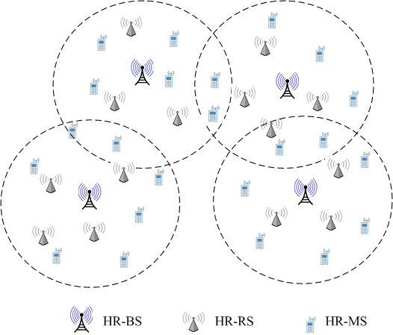

Figure 1 Example of 802.16n deployment.

In SRD of IEEE 802.16 GRIDMAN, it is required that the IEEE 802.16 GRIDMAN networks shall support mechanisms which enable acceptable operation in the presence of co-channel interference among the IEEE 802.16n stations within the same geographical area as depicted in Fig. 1.

Self-Coexistence Measures

- Basic concepts
Coexistence: A state by which multiple wireless communications systems share a same radio frequency channel while minimizing harmful interference to each other by proper measures.

Self-coexistence: In IEEE 802.16n, Self-coexistence is coexistence of multiple nearby IEEE 802.16n cells.

