Project | IEEE 802.16 Broadband Wireless Access Working Group <http://ieee802.org/16>
Title | A Proposal of Self-Coexistence Mechanism for 802.16n-GRIDMAN Stations
Date Submitted | 2011-03-11
Source(s) | Ming-Tuo Zhou, Xin Zhang, Liru Lu (Alina), Hoang Vinh Dien, Masayuki Oodo, Hiroshi Harada  NICT | E-mail: mingtuo@nict.com.sg; zhangxin@nict.com.sg; liru@nict.com.sg; hvdien@nict.com.sg; moodo@nict.go.jp; harada@nict.go.jp
Re: | Call for contributions for the 802.16n Amendment Working Draft
Abstract | This provides a proposal of self-coexistence for interference mitigation in 802.16n networks
Purpose | To be discussed and adapted by TGn for draft 802.16n AWD
Notice | This document does not represent the agreed views of the IEEE 802.16 Working Group or any of its subgroups. It represents only the views of the participants listed in the “Source(s)” field above. It is offered as a basis for discussion. It is not binding on the contributor(s), who reserve(s) the right to add, amend or withdraw material contained herein.
Copyright Policy | The contributor is familiar with the IEEE-SA Copyright Policy <http://standards.ieee.org/IPR/copyrightpolicy.html>.
Patent Policy | The contributor is familiar with the IEEE-SA Patent Policy and Procedures:  <http://standards.ieee.org/guides/bylaws/sect6-7.html#6> and <http://standards.ieee.org/guides/opman/sect6.html#6.3>.  Further information is located at <http://standards.ieee.org/board/pat/pat-material.html> and <http://standards.ieee.org/board/pat>.

A Proposal of Self-Coexistence Mechanism for 802.16n-GRIDMAN Stations
Ming-Tuo Zhou, Xin Zhang, Liru Lu (Alina), Hoang Vinh Dien, Masayuki Oodo, Hiroshi Harada
NICT

Introduction

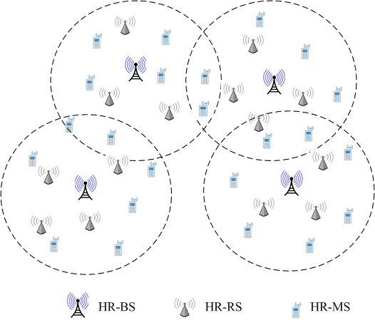

Figure 1 Example of 802.16n deployment.

In SRD of IEEE 802.16 GRIDMAN [1], it is required that the HR networks shall support mechanisms which enable acceptable operation in the presence of co-channel interference among the HR stations within the same geographical area. The specification is as following:

“6.1.5 Coexistence requirements
6.1.5.3 Interference Mitigation
HR-Network shall support mechanisms which enable acceptable operation in the presence of co-channel interference among HR-stations within the same geographical area.”

As depicted in Fig. 1, co-channel interference at an HR cell is introduced by an overlapping cell operating on same frequency channel simultaneously.

This document presents mechanism of self-coexistence to reduce co-channel interference in HR networks. In this mechanism, Self-coexistence Beacon (SCB) is used to exchange information for purpose of self-coexistence. SCBs are transmitted in Self-coexistence Zone (SCZ), which is a zone allocated at the end of a Virtual Superframe. A virtual Superframe consists of 16 frames as described in [2].

Basic Concepts

Coexistence
Coexistence is a state by which multiple wireless communications systems in same vicinity share a same radio frequency channel while minimizing harmful interference to each other by appropriate measures.

Self-coexistence
In HR network, Self-coexistence is coexistence of multiple HR cells.

Self-coexistence Mechanism

Self-Coexistence Zone
A Self-coexistence Zone (SCZ) is a space allocated at the end of each virtual frame as illustrated in Fig. 2. At the beginning of each self-coexistence zone, self-coexistence preamble (SCP) is transmitted. Following SCP is space for transmission of self-coexistence packets. The structure of a SCZ is shown in Fig. 2. A Self-coexistence Zone can be shared by multiple HR cells via contention or reservation.

Figure 2 Self-coexistence Zone for GRIDMAN.

Self-coexistence Preamble
Self-coexistence Preamble shall be transmitted at the beginning of each Self-coexistence Zone. It is different from other preambles of HR networks. Self-coexistence preamble can be used to recognize the starting of a virtual superframe, which is T_{scz} delayed from the starting of a self-coexistence zone. T_{scz} is the time duration of a self-coexistence zone.

Self-coexistence Beacon
Self-coexistence Beacon is a series of message bursts transmitted by HR stations in Self-coexistence Zone to enable Self-coexistence in HR networks. The transmission of Self-coexistence Beacons can be controlled by HR-BS or be scheduled in a distributed manner.

Figure 3 Structure of Self-Coexistence Beacon Packet for IEEE 802.16n-GRIDMAN.

Self-coexistence Beacon Packet
The structure of a Self-Coexistence Beacon packet is shown in Fig. 3. It contains a Self-coexistence Preamble which is different from other preambles of HR networks. After the Self-coexistence Preamble, Self-coexistence (SC) MAC PDU shall be transmitted. The SC MAC PDU includes Schedule of the Self-Coexistence, SCB IEs.

Self-coexistence Mode
In self-coexistence mode, multiple HR cells share the same frequency channel and each coexisting HR cell operates on one or several different frames.

Figure 4 Illustration of self-coexistence mode.

Reference
[1] 802.16n System Requirements Document including SARM annex, IEEE 802.16n-10/0048
[2] A Proposal of Frame Structure for 802.16n-GRIDMAN Networks, IEEE 802.16n-10/0013r1

