Project | IEEE 802.16 Broadband Wireless Access Working Group <http://ieee802.org/16>
Title | A Proposal of HR-MS Direct Communication in IEEE 802.16n-GRIDMAN Network
Date Submitted | 2011-03-15
Source(s) | Ming-Tuo Zhou, Liru Lu (Alina), Xin Zhang, HOANG Vinh Dien, Masayuki Oodo, Hiroshi Harada | E-mail: mingtuo@nict.com.sg; liru@nict.com.sg; zhangxin@nict.com.sg; hvdien@nict.com.sg; moodo@nict.go.jp; harada@nict.go.jp
Re: | Call for contributions for the 802.16n Amendment Working Draft
Abstract | This provides a proposal of self-coexistence for interference mitigation in 802.16n networks
Purpose | To be discussed and adapted by TGn for draft 802.16n AWD
Notice | This document does not represent the agreed views of the IEEE 802.16 Working Group or any of its subgroups. It represents only the views of the participants listed in the “Source(s)” field above. It is offered as a basis for discussion. It is not binding on the contributor(s), who reserve(s) the right to add, amend or withdraw material contained herein.
Copyright Policy | The contributor is familiar with the IEEE-SA Copyright Policy <http://standards.ieee.org/IPR/copyrightpolicy.html>.
Patent Policy | The contributor is familiar with the IEEE-SA Patent Policy and Procedures:  <http://standards.ieee.org/guides/bylaws/sect6-7.html#6> and <http://standards.ieee.org/guides/opman/sect6.html#6.3>.  Further information is located at <http://standards.ieee.org/board/pat/pat-material.html> and <http://standards.ieee.org/board/pat>.

A Proposal of HR-MS Direct Communication in IEEE 802.16n-GRIDMAN Network
Ming-Tuo Zhou, Liru Lu (Alina), Xin Zhang, Masayuki Oodo, Hiroshi Harada
NICT

Introduction
HR-MS shall provide direct communication, i.e., the origination and termination of the data are at the HR-MS. This document presents proposal of facilities to support HR-MS direct communication in IEEE GRIDMAN network, including Direct Communication Zone, procedures, messages, and scheduling methods.

HR-MS to HR-MS Direct Communication

HR-MS communication within same cell and between cells

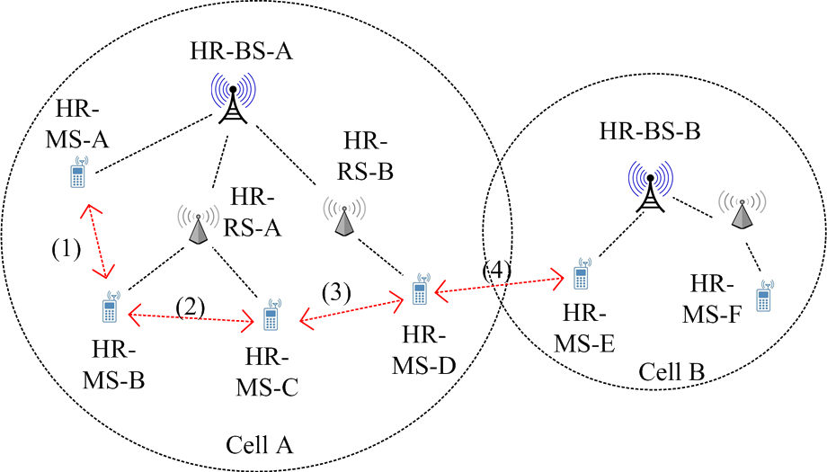

Figure 1 Illustration of direct communication of HR-MSs in IEEE 802.16n-GRIDMAN networks.

Figure 1 illustrates HR-MS to HR-MS direct communication. HR-MS to HR-MS direct communication is not limited among HR-MSs of a same cell. In this proposal, when the HR-MSs involved are from different cells and they are one-hop away neighbors, direct communication between them is also possible.

Hops of HR-MS Direct Communication
(a) (b)

Figure 2 Example of one-hop and two-hop HR-MS to HR-MS direct communication.

In SRD of IEEE 802.16n-GRIDMAN, HR-MS direct communication is specified in Section 6.1.3.1 [1]:

“2.1.1.1 MS to MS Direct Communication
HR-MS shall provide direct communication i.e. the origination and termination of the data are at the HR-MS. Association establishment procedure of an HR-MS to another HR-MS shall be supported.

2.1.1.1.1 Single hop
HR-MS shall support communication of user data and control signaling between an HR-MS and one or more HR-MSs that are 1-hop away.

2.1.1.1.1 Two-hop
HR-MS shall support forwarding of user data and control signaling between an HR-MS and one or more HR-MSs.”

Based on the above specifications, HR-MS to HR-MS direct communication (HR-MS DC) is categorized into one-hop HR-MS DC and two-hop HR-MS DC, as shown in Fig. 2.

In one-hop HR-MS DC, an HR-MS transmits or receives data packets to or from another HR-MS (or more than one HR-MS) directly, without relaying on or passing through other stations.

Two-hop HR-MS DC is that an HR-MS communicate with another HR-MS (or more HR-MSs) by user data and control signaling forwarding provided by a middle HR-MS.

Network topology of HR-MS direct communication
HR-MS direct communication can happen in case of the HR-network has infrastructure stations as well as has no infrastructure stations.
(a) (b)

Figure 3 Example of HR-MS to HR-MS direct communication (a) with and (b) without infrastructure stations.

Scheduling of HR-MS direct communication

Direct Communication Zone
A DCZ is a space of continuous subchannels along frequency and continuous symbols along time in a frame allocated for HR-MS direct communication [2].

DCZ is for priority transmission of HR-MS direct communication for purpose of QoS provision and mitigating transmit/receive transition time of HR-MSs. Its size is not fixed but can be configured dynamically.

When an HR-network has no infrastructure stations, a DCZ can occupy all of the frame space.

HR-MS direct communication has higher priority being scheduled in a DCZ than downlink and uplink communication for purpose to provide QoS support of HR-MS direct communication.

An HR-MS DC can be scheduled in space other than DCZ (like normal uplink and downlink communication space) if the current DCZ is occupied by other HR-MS DC.

Scheduling Schemes
An HR-MS DC can be scheduled in two ways: centralized scheduling and distributed scheduling. In centralized scheduling, an HR-BS schedules the HR-MS DC transmission. In distributed scheduling, HR-MSs involved in the direct communication and their neighbors schedule the transmission in a distributed manner.

2.3.2.1 Centralized Scheduling
Centralized scheduling of HR-MS DC is performed by HR-BS.

Centralized scheduling can be used for one-hop and two-hop HR-MS DC transmission. For two-hop HR-MS DC, in centralized scheduling, an HR-BS can assign resources for the first hop and second hop HR-MS DC by a single action. Through this way, delay in resource assignment for two-hop HR-MS DC can be saved compared to assign resource step by step.

DCCS (Direct Communication Centralized Scheduling) message is used for resource request. As shown in Fig. 4, DCCS: Request is sent by requester HR-MS and is delivered to HR-BS.

HR-BS collects bandwidth request of HR-MSs in the cell and grants resource accordingly. DC-MAP message is used to deliver resource granted for HR-MS DC. DC-MAP message should be delivered to HR-MS stations involved in the related direct communication. The grant can be acknowledged if needed.

The transmission of DCCS message is scheduled in UL subframe by HR-BS.

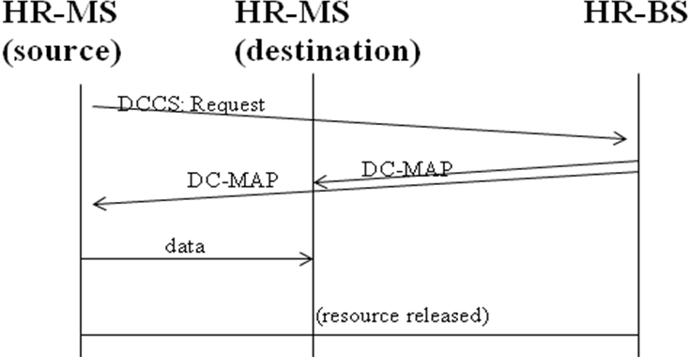

Figure 4 Procedure of centralized scheduling.

2.3.2.1 Distributed Scheduling

In Distributed Scheduling, an HR-MS DC is scheduled by the data-source HR-MS, data-destination HR-MS, HR-MSs and HR-RSs in one-hop communication range.

Distributed Scheduling is only used to schedule one-hop HR-MS DC in Direct Communication Zone.

Distributed Scheduling can be used in HR-MS direct communication with or without infrastructure.

A three-way handshaking procedure (Request, Grant, Grant Acknowledgement) is used in Distributed Scheduling.
Figure 5 Illustration of three-way handshake procedure of Distributed Scheduling in wireless network.

Three-way handshake procedure is shown in Fig. 5. DCDS (Direct Communication Distributed Scheduling) message is used in three-way handshake procedure in Distributed Scheduling.

As shown in Fig. 5, DCDS: Request is sent by HR-MS requester. DCDS: Grant is sent by HR-MS granter and replies a subset of the suggested resource to fit the Request if possible. DCDS: Grant ACK is sent by the original HR-MS requester and contains the granted resource to confirm the schedule. One-hop neighbors of requester and granter are informed the schedule by either DCDS: Grant or DCDS: Grant Ack.

In case of there is an HR-BS in the cell, the transmission of DCDS messages is centralized scheduled by the HR-BS. In case that there is no HR-BS, the transmission of DCDS messages is distributed scheduled by HR-MSs.

In case of there is a HR-BS, the resource allocation is reported to the HR-BS by DCDS: Report. Upon reception of DCDS: Report, an HR-BS is aware of the resource allocation and will not assign the same resource to other stations if no appropriate mechanism is adopted to resolve the issue of co-channel interference.

Direct Communication MAP Message
The Direct Communication MAP (DC-MAP) message is to signal resource assignment and other control information for HR-MS to HR-MS direct communication when the cell has HR-BS. The resource assignment is not limited in Direct Communication Zone since HR-MS to HR-MS direct communication is not limited to be scheduled in Direct Communication Zone.

HR-MS DC between HR-MSs from Different Cells
HR-MSs from different cells that are one-hop away is possible to communicate directly.

Handover Solution
If a HR-MS needs to communicate with HR-MS(s) of another cell, a direct way is the HR-MS handover and associate with the other cell’s HR-BS (as shown in Fig. 6). After handover, it can start direct communicate within HR-MSs in that cell by using the protocol of HR-MS DC in the same cell. When finish direct communication, the HR-MS handover back to its original cell.

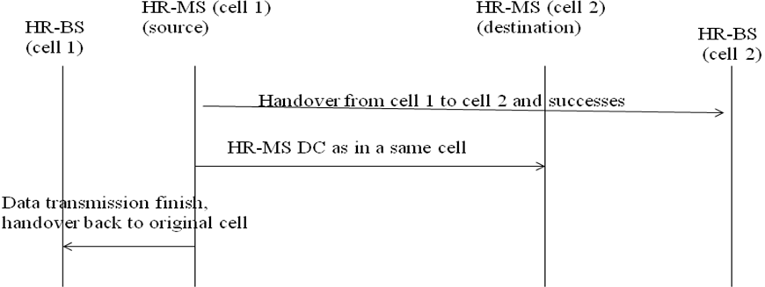

Fig. 6 Procedurel of handover solution for communication between HR-MSs from different cells.

Self-coexistence Solution
If multiple nearby cells operate on a same frequency channel, and self-coexistence mechanism of fame sharing is applied, HR-MS DC between MSs from different cells can be addressed by a self-coexistence solution.

Self-coexistence mechanism of fame sharing is that multiple nearby cells operate in different frames in time domain on the same frequency channel as illustrated in Fig. 7. Self-coexistence beacons are transmitted among cells in specified Self-coexistence Zone [2]. Transmission of self-coexistence beacons among different cells is scheduled by Self-coexistence mechanism [3]. Nearby cells can exchange control information by exchanging self-coexistence beacons.

Figure 7 Illustration of frame sharing among nearby multiple cells in cellular wireless network.

As shown in Fig. 8, in this case (of sharing different frames on same frequency channel), if an HR-MS needs to communicate with HR-MS(s) of another cell, it sends resource request to the destination HR-MSs of the other cell via transmission of self-coexistence beacons. Upon receiving resource request message carried in self-coexistence beacon from a one-hop neighbor of another cell, an HR-MS reports this request to its HR-BS and the resource is centralized allocated. The resource within frames that are assigned to the cell of the destination HR-MS is granted to the requester HR-MS. This source grant is delivered to the request HR-MS via self-coexistence beacon.

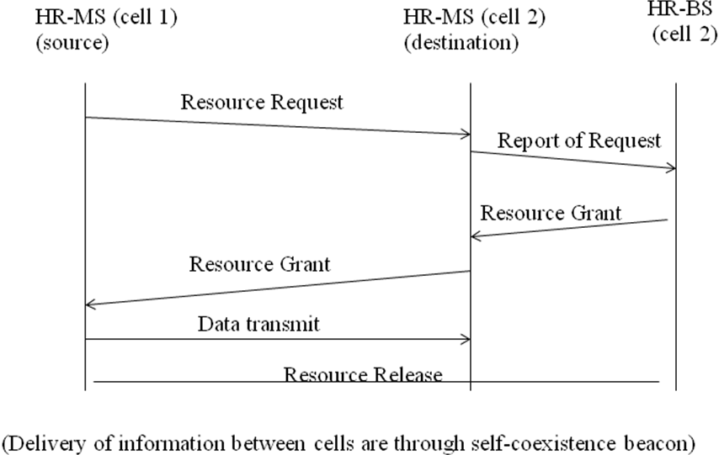

Figure 8 Basic procedure for direct communication of HR-MSs from different cells based on self-coexistence.

Text Proposal for IEEE 802.16n AWD

--------------Start of Proposed Text --------------------------------------------------------------------

16.2.30 Direct communication between HR-MSs
HR-MS direct communication can happen in case of the HR-network has infrastructure stations as well as has no infrastructure stations.
HR-MS direct communication is not limited among HR-MSs of a same cell.
HR-MS direct communication (HR-MS DC) is categorized into one-hop HR-MS DC and two-hop HR-MS DC. In one-hop HR-MS DC, an HR-MS transmits or receives data packets to or from another HR-MS (or more than one HR-MS) directly. In two-hop HR-MS DC, an HR-MS communicate with another HR-MS (or more HR-MSs) by user data and control signaling forwarding provided by a middle HR-MS.
HR-MS direct communication has priority to be scheduled in direct communication zone for QoS provision and mitigating transmit/receive transition time of HR-MSs. It also can be scheduled out of direct communication zone when the present direct communication zone is occupied by other HR-MS direct communications with same or higher priority.
An HR-MS DC can be scheduled in two ways: centralized scheduling and distributed scheduling. In centralized scheduling, an HR-BS schedules the HR-MS DC transmission. In distributed scheduling, HR-MSs involved in the direct communication and their neighbors schedule the transmission in a distributed manner. A three-way handshaking procedure (Request, Grant, Grant Acknowledgement) is used in Distributed Scheduling.
The Direct Communication MAP (DC-MAP) message is to signal resource assignment and other control information for HR-MS direct communication if it is under control of infrastructure stations.
Both one-hop and two-hop HR-MS DC can be scheduled by centralized scheduling that is controlled by an HR-BS.
For direct communication between HR-MSs from different cells, a direct way is the source HR-MS handover and associate with the other cell’s HR-BS. After handover, it can start direct communicate within HR-MSs in that cell by using the protocol of HR-MS DC in the same cell. When finish direct communication, the HR-MS handover back to its original cell.
If multiple nearby cells operate on a same frequency channel, and self-coexistence mechanism of fame sharing is applied, direct communication between HR-MSs from different cells can be addressed by a self-coexistence solution, where resource grant and grant are negotiated by self-coexistence beacons.

--------------End of Proposed Text ---------------------------------------------------------------------

Reference
[1] 802.16n System Requirements Document including SARM annex, IEEE 802.16n-10/0048
[2] Ming-Tuo Zhou, Liru Lu (Alina), Xin Zhang, Masayuki Oodo, Hiroshi Harada, A Proposal of Frame Structure for 802.16n-GRIDMAN Networks, IEEE C802.16n-11/0013r2
[3] Ming-Tuo Zhou, Xin Zhang, Liru Lu (Alina), Masayuki Oodo, Hiroshi Harada, A Proposal of Self-Coexistence Mechanism for 802.16n-GRIDMAN Stations, IEEE C802.16n-11/0014r2

