Project | IEEE 802.16 Broadband Wireless Access Working Group <http://ieee802.org/16>
Title | Operating Frequencies (17.1.1)
Date Submitted | 2011-03-06
Source(s) | Yih-Guang Jan, Yang-Han Lee,  Jheng-Yao Lin, Chih-Yuan Lo,  Liang-Yu, Yen  Tamkang University (TKU)  Hsien-Wei Tseng  De Lin Institute of Technology (DLIT)  Youn-Tai Lee, Chun-Yen Hsu  Institute for Information Industry (III)  Shiann-Tsong Sheu  National Central University (NCU)  Whai-En Chen  National Ilan University (NIU) | yihjan@yahoo.com  hwtseng@mail.dlit.edu.tw  lyt@nmi.iii.org.tw  stsheu@ce.ncu.edu.tw  wechen@niu.edu.tw
Re: | Call for contributions for 802.16n AWD
Abstract | In this contribution we make contribution on Operating Frequencies (17.1.1) by including ITU regions map for IEEE 802.16n draft text
Purpose | To discuss and adopt the proposed text in the 802.16n draft Text
Notice | This document does not represent the agreed views of the IEEE 802.16 Working Group or any of its subgroups. It represents only the views of the participants listed in the “Source(s)” field above. It is offered as a basis for discussion. It is not binding on the contributor(s), who reserve(s) the right to add, amend or withdraw material contained herein.
Release | The contributor grants a free, irrevocable license to the IEEE to incorporate material contained in this contribution, and any modifications thereof, in the creation of an IEEE Standards publication; to copyright in the IEEE’s name any IEEE Standards publication even though it may include portions of this contribution; and at the IEEE’s sole discretion to permit others to reproduce in whole or in part the resulting IEEE Standards publication. The contributor also acknowledges and accepts that this contribution may be made public by IEEE 802.16.
Patent Policy | The contributor is familiar with the IEEE-SA Patent Policy and Procedures:  <http://standards.ieee.org/guides/bylaws/sect6-7.html#6> and <http://standards.ieee.org/guides/opman/sect6.html#6.3>.  Further information is located at <http://standards.ieee.org/board/pat/pat-material.html> and <http://standards.ieee.org/board/pat>.

Operating frequencies

Yih-Guang Jan, Yang-Han Lee, Jheng-Yao Lin, Chih-Yuan Lo, Liang-Yu Yen
Tamkang University (TKU)
Hsien-Wei Tseng
De Lin Institute of Technology (DLIT)
Youn-Tai Lee, Chun-Yen Hsu
Institute for Information Industry (III)
Shiann-Tsong Sheu

National Central University (NCU)

Whai-En Chen

National Ilan University (NIU)

- Introduction
This contribution provides the information of Operating frequencies in IEEE 802.16n AWD.

- Proposed IEEE 802.16n AWD Text Modification

The text in BLACK color: the existing text in AWD
The text in BLUE color: the new text added to the Definitions

===================Start of Proposed Text====================

17.1.1 Operating frequencies

The HR-Network can operate in frequencies less than 6 GHz and are deployed in licensed, unlicensed and light licensed spectrum to co-exist with other radio access technologies (RATs).
The following frequency bands have been identified by WRC 2003, Resolution on Public Protection and Disaster Relief (PPDR):

- Region 1: 380- 470 MHz as the frequency range within which the band 380-385/390-395 MHz is a preferred core harmonized band for public protection activities within certain countries of Region 1.
- Region 2: 746-806 MHz, 806-869 MHz,4940-4990 MHz
- Region 3: 406.1-430 MHz, 440-470 MHz, 806-824/851-869 MHz, 4940-4990 MHz and 5850 – 5925 MHz Japan Ministry of Internal Affairs and Communication (MIC) will allocate 175-205 MHz for public broadband wireless system after July 2011. This 200 MHz band is divided into 6 channels each with 5 MHz width.

The ITU regions considered are distributed in the following figure, Fig. xxxxx:

ITU Regions
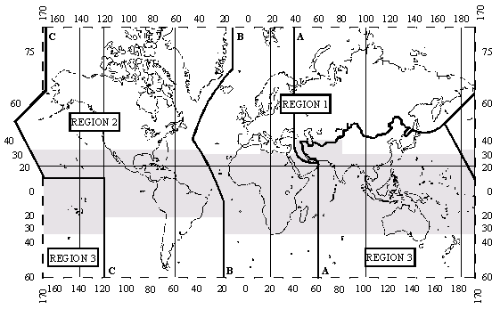
Fig. xxxxx

====================End of Proposed Text====================

References
- IEEE 802.16n-10/0048, “802.16n System Requirements Document including SARM annex”, January 2011.
- IEEE 802.16n-10/0049, “802.16n Table of Contents for Amendment Working Draft”, January 2011.

