Project | IEEE 802.16 Broadband Wireless Access Working Group <http://ieee802.org/16>
Title | Format of Network Discovery Signals for HR-MS Direct Communication without Infrastructure Stations
Date Submitted | 2011-05-09
Source(s) | Haiguang Wang, Hoang Anh Tuan, Jaya Shankar, Shoukang Zheng, Yeow Wai Leong, Joseph Teo Chee Ming, Mar Choong Hock  Institute for Infocomm Research  1 Fusionopolis Way, #21-01, Connexis (South Tower)  Singapore 138632 | Voice: +65 6408-2256  E-mail: hwang@i2r.a-star.edu.sg
Re: | Call for Comments for 802.16n AWD
Abstract | In this contribution, we propose a framework for the HR-MSs communicate to each in case there is no infrastructure station such as HR-BS or HR-RS presented in the network.
Purpose | To discuss and adopt the proposed text in the 802.16n draft Text
Notice | This document does not represent the agreed views of the IEEE 802.16 Working Group or any of its subgroups. It represents only the views of the participants listed in the “Source(s)” field above. It is offered as a basis for discussion. It is not binding on the contributor(s), who reserve(s) the right to add, amend or withdraw material contained herein.
Copyright Policy | The contributor is familiar with the IEEE-SA Copyright Policy <http://standards.ieee.org/IPR/copyrightpolicy.html>.
Patent Policy | The contributor is familiar with the IEEE-SA Patent Policy and Procedures:  <http://standards.ieee.org/guides/bylaws/sect6-7.html#6> and <http://standards.ieee.org/guides/opman/sect6.html#6.3>.  Further information is located at <http://standards.ieee.org/board/pat/pat-material.html> and <http://standards.ieee.org/board/pat>.
Format of Network Discovery Signals for HR-MS Direct Communication without Infrastructure Stations

Haiguang Wang, Hoang Anh Tuan, Jaya Shankar,
Shoukang Zheng, Yeo Wai Leong

Institute for Infocomm Research (I2R)
1 Fusionopolis Way, #21-01, Connexis South Tower
Singapore 138632

1. Introduction

HR-MS to HR-MS direct communication is new feature for IEEE 802.16 networks. It will be defined in the IEEE 802.16n amendment. This feature will significantly improve the capability of HR-MS in various harsh environment and increase network throughput when local traffic dominates the network.
In 802.16n System Requirement Document [1] section 6.1.3.1, it says that “HR-MS shall provide direct communication i.e. the origination and termination of the data are at the HR-MS. Association establishment procedure of an HR-MS to another HR-MS shall be supported.”.
Since the requirement does not set constraint on whether HR-MSs have associated to an infrastructure stations, in this contribution, we assume HR-BS/HR-RS is not presented in the network and the HR-MSs communicate to each other directly. They may also help each other in data forwarding.
Supporting the HR-MS to HR-MS direct communication without infrastructure node is required by IEEE 802.16n network. In this contribution, we focus on the use cases of HR-MSs communicate to each other without getting support from infrastructure stations as figure 1 shows. A few HR-MSs connect to each other and form a communication network.
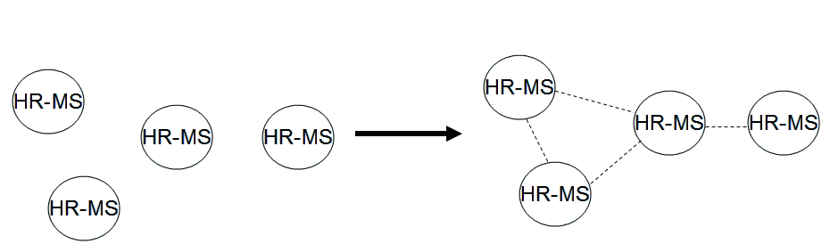
Figure 1: Use cases of HR-MS to HR-MS direct communication without infrastructure stations

2. Format of Network Discovery Signals

3. Summary

4. Text Proposal for IEEE 802.16n AWD
Xxx
Note:
The text in BLACK color: the existing text in AWD
The text in RED color: the removal of existing AWD text
The text in BLUE color: the new text added to the Multi-Carrier DG Text

[-------------------------------------------------Start of Text Proposal---------------------------------------------------]
[Adopt the following text in the 802.16n Document (XXX --- document number)]

[-------------------------------------------------End of Text Proposal----------------------------------------------------]

References
- IEEE 802.16n-10/0048, “802.16n System Requirements Document including SARM annex”, January 2011.
- IEEE 802.16n-10/0049, “802.16n Table of Contents for Amendment Working Draft”, January 201.

