Project | IEEE 802.16 Broadband Wireless Access Working Group <http://ieee802.org/16>
Title | Text Proposal for Format of Network Discovery Signals for HR-MS Direct Communication without Infrastructure Stations
Date Submitted | 2011-05-09
Source(s) | Haiguang Wang, Hoang Anh Tuan, Jaya Shankar, Shoukang Zheng, Yeow Wai Leong, Joseph Teo Chee Ming, Mar Choong Hock  Institute for Infocomm Research  1 Fusionopolis Way, #21-01, Connexis (South Tower)  Singapore 138632 | Voice: +65 6408-2256  E-mail: hwang@i2r.a-star.edu.sg
Re: | Call for Comments for 802.16n AWD
Abstract | In this contribution, we propose a framework for the HR-MSs communicate to each in case there is no infrastructure station such as HR-BS or HR-RS presented in the network.
Purpose | To discuss and adopt the proposed text in the 802.16n draft Text
Notice | This document does not represent the agreed views of the IEEE 802.16 Working Group or any of its subgroups. It represents only the views of the participants listed in the “Source(s)” field above. It is offered as a basis for discussion. It is not binding on the contributor(s), who reserve(s) the right to add, amend or withdraw material contained herein.
Copyright Policy | The contributor is familiar with the IEEE-SA Copyright Policy <http://standards.ieee.org/IPR/copyrightpolicy.html>.
Patent Policy | The contributor is familiar with the IEEE-SA Patent Policy and Procedures:  <http://standards.ieee.org/guides/bylaws/sect6-7.html#6> and <http://standards.ieee.org/guides/opman/sect6.html#6.3>.  Further information is located at <http://standards.ieee.org/board/pat/pat-material.html> and <http://standards.ieee.org/board/pat>.
Text Proposal for Format of Network Discovery Signals for HR-MS Direct Communication without Infrastructure Stations

Haiguang Wang, Hoang Anh Tuan, Jaya Shankar, Shoukang Zheng, Yeow Wai Leong, Joseph Teo Chee Ming, Mar Choong Hock
Institute for Infocomm Research (I2R)
1 Fusionopolis Way, #21-01, Connexis South Tower
Singapore 138632

1. Introduction

HR-MS to HR-MS direct communication is a new feature for IEEE 802.16 networks. It will be defined in the IEEE 802.16n amendment. This feature will improve the capability of HR-MS significantly in various harsh environment and increase network throughput when local traffic dominates the network. In this contribution, we focus on the use cases of HR-MSs communicate to each other without getting support from infrastructure stations as figure 1 shows. A few HR-MSs connect to each other and form a communication network.
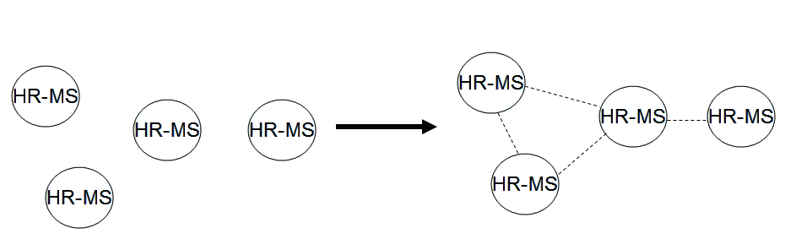
Figure 1: Use cases of HR-MS to HR-MS direct communication without infrastructure stations

2. Format of Network Discovery Signals

The current 802.16 standard is designed for cellular communication and a BS, which is a central network controller, is necessary for the communication. Transmissions of MSs in the networks are controlled by BS. To avoid significant change over the protocols, we also propose to a central network controller, named as coordinator, in the networks formed by HR-MS. The coordinator basically is a simplified BS. Since every HR-BS has the potential to become a coordinator in certain location, and in many cases, only one of them should become a coordinator, else, the network may be separated into a few networks. Therefore, HR-MS should discover the network topology before they make a decision to become a coordinator.
To facilitate HR-MSs discover the network topology, a signaling format should be defined for both 802.16-2009 and 802.16m interface. To avoid redesign of the preambles, we propose to reuse the preambles defined in both 802.16-2009 and 802.16m.
For 802.16-2009, we propose to send out a preamble and followed by some necessary discovery information. The content of information is TBD. Other HR-MS should know that the signal is from HR-MS by decoding the information followed the preamble. Figure 1 shows an example.
Figure 1: Network Discovery Message Transmission in 802.16n Network

For 802.16m, we propose that HR-MS transmits PA-Preamble first, and is followed by an SA-Preamble. Discovery information should follow the SA-Preamble. Figure 2 shows an example.

Figure 2: Discovery Signals Transmission for 802.16m-based HR-MS Networks without Infrastructure stations

3. Summary

In this proposal, we have proposed format of signals used by HR-MS in discovering other HR-MSs nearby when there is no infrastructure stations.

4. Text Proposal for IEEE 802.16n AWD
Xxx
Note:
The text in BLACK color: the existing text in AWD
The text in RED color: the removal of existing AWD text
The text in BLUE color: the new text added to the Multi-Carrier DG Text

[-------------------------------------------------Start of Text Proposal---------------------------------------------------]
[Adopt the following text in the 802.16n Document (XXX --- document number)]

17.2.2 Direct communication between HR-MSs

17.2.2.x HR-MS Direct Communication without Infrastructure

When HR-MS cannot receive any BS preamble from any infrastructure station and HR-MS direct communication without infrastructure is permitted by device configuration, HR-MSs are allowed to transmit network discovery signals to the network.
The network discovery message shall take the following format: a frame preamble shall be transmitted first and the discovery information follows the preamble and the format is TBD.

17.3.2 Direct communication between HR-MSs

17.3.2.x HR-MS Direct Communication without Infrastructure

When HR-MS cannot receive any BS preamble from any infrastructure station and HR-MS direct communication without infrastructure is permitted by device configuration, HR-MSs are allowed to transmit network discovery signals to the network.
The network discovery message shall take following format: frame preambles, PA-Preamble and SA-Preamble shall be transmitted first. They occupy the first two symbols sent by HR-MS. The network discovery information follows the preamble and the format is TBD.

[-------------------------------------------------End of Text Proposal----------------------------------------------------]

References
- IEEE 802.16n-10/0048, “802.16n System Requirements Document including SARM annex”, January 2011.
- IEEE 802.16n-10/0049, “802.16n Table of Contents for Amendment Working Draft”, January 201.

