Project | IEEE 802.16 Broadband Wireless Access Working Group <http://ieee802.org/16>
Title | Text Proposals for Transmission of Network Discovery Signals for HR-MS Direct Communication without Infrastructure Stations
Date Submitted | 2011-05-09
Source(s) | Haiguang Wang, Hoang Anh Tuan, Jaya Shankar, Shoukang Zheng, Yeow Wai Leong, Joseph Teo Chee Ming, Mar Choong Hock  Institute for Infocomm Research  1 Fusionopolis Way, #21-01, Connexis (South Tower)  Singapore 138632 | Voice: +65 6408-2256  E-mail: hwang@i2r.a-star.edu.sg
Re: | Call for Comments for 802.16n AWD
Abstract | In this contribution, we propose a framework for the HR-MSs communicate to each in case there is no infrastructure station such as HR-BS or HR-RS presented in the network.
Purpose | To discuss and adopt the proposed text in the 802.16n draft Text
Notice | This document does not represent the agreed views of the IEEE 802.16 Working Group or any of its subgroups. It represents only the views of the participants listed in the “Source(s)” field above. It is offered as a basis for discussion. It is not binding on the contributor(s), who reserve(s) the right to add, amend or withdraw material contained herein.
Copyright Policy | The contributor is familiar with the IEEE-SA Copyright Policy <http://standards.ieee.org/IPR/copyrightpolicy.html>.
Patent Policy | The contributor is familiar with the IEEE-SA Patent Policy and Procedures:  <http://standards.ieee.org/guides/bylaws/sect6-7.html#6> and <http://standards.ieee.org/guides/opman/sect6.html#6.3>.  Further information is located at <http://standards.ieee.org/board/pat/pat-material.html> and <http://standards.ieee.org/board/pat>.
Text Proposals for Transmission of Network Discovery Signals for HR-MS Direct Communication without Infrastructure Stations

Haiguang Wang, Hoang Anh Tuan, Jaya Shankar,
Shoukang Zheng, Yeo Wai Leong, Joseph Teo Chee Ming, Mar Choong Hock

Institute for Infocomm Research (I2R)
1 Fusionopolis Way, #21-01, Connexis South Tower
Singapore 138632

1. Introduction

HR-MS to HR-MS direct communication is a new feature for IEEE 802.16 networks. It will be defined in the IEEE 802.16n amendment. This feature will improve the capability of HR-MS significantly in various harsh environment and increase network throughput when local traffic dominates the network. In this contribution, we focus on the use cases of HR-MSs communicate to each other without getting support from infrastructure stations as figure 1 shows. A few HR-MSs connect to each other and form a communication network.
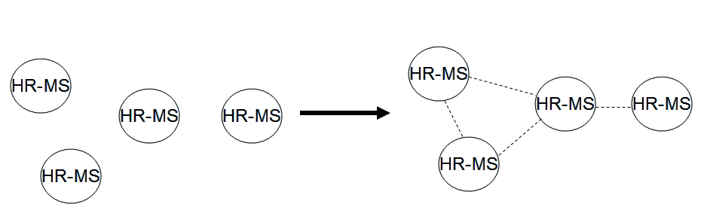
Figure 1: Use cases of HR-MS to HR-MS direct communication without infrastructure stations

2. Method for the Transmission of Network Discovery Signals

The current 802.16 standard is designed for cellular communication and a BS, which is a central network controller, is necessary for the communication. Transmissions of MSs in the networks are controlled by BS. To avoid significant change over the protocols, we also propose to a central network controller, named as coordinator, in the networks formed by HR-MS. The coordinator basically is a simplified BS.
Since every HR-BS has the potential to become a coordinator in certain location, and in many cases, only one of them should become a coordinator. Therefore, HR-MS should discover the network topology before they can make a decision to become a coordinator. Since a few HR-MSs may transmit the discovery message at the same time, collision among the discovery message can happen. Therefore, a collision avoidance mechanism is necessary.
When HR-MS is turned on, if it cannot find an infrastructure station by scanning and the device is allowed to transmit discovery messages. To avoid collision, a random back-off mechanism should be defined. Before the transmission of a discovery message, HR-MS should choose back-off duration and start a back-off timer. After the back-off timer timeout, HR-MS should sense the channel and then transmit the discovery message if the channel is idle. If the channel is busy, HR-MS has to take another back-off period before they can make the transmission.
The back-off value can take from a window, for example, [w_{min}, w_{max}], the size of window can be adjusted based on the traffic of networks.

3. Summary

4. Text Proposal for IEEE 802.16n AWD
Xxx
Note:
The text in BLACK color: the existing text in AWD
The text in RED color: the removal of existing AWD text
The text in BLUE color: the new text added to the Multi-Carrier DG Text

[-------------------------------------------------Start of Text Proposal---------------------------------------------------]
[Adopt the following text in the 802.16n Document (XXX --- document number)]

16.2.2 Direct communication between HR-MSs

16.2.2.x HR-MS Direct Communication without Infrastructure

When HR-MS sends out network discovery messages, to avoid collision with other HR-MSs, it should follow a random-back off mechanism as follows:
1) A back-off timer should be started for the transmission of network discovery messages.
2) When the timer is timeout, HR-MS should sense the channel first. If the channel is idle, then the HR-MS should transmit the discovery message. If the channel is busy, then node should hold the transmission and restart the back-off process again.
3) HR-MS should get the value for the duration of back-off from a window, for example, from a window of [w_{min}, w_{max}], the size of window can be adjusted based on the traffic of networks. The value of W_{min} and W_{max} are TBD.

17.3.2 Direct communication between HR-MSs

17.2.2.x HR-MS Direct Communication without Infrastructure

When HR-MS sends out network discovery messages, to avoid collision with other HR-MSs, it should follow a random-back off mechanism as follows:
1) A back-off timer should be started for the transmission of network discovery messages.
2) When the timer is timeout, HR-MS should sense the channel first. If the channel is idle, then the HR-MS should transmit the discovery message. If the channel is busy, then node should hold the transmission and restart the back-off process again.
3) HR-MS should get the value for the duration of back-off from a window, for example, from a window of [w_{min}, w_{max}], the size of window can be adjusted based on the traffic of networks. The value of W_{min} and W_{max} are TBD.

[-------------------------------------------------End of Text Proposal----------------------------------------------------]

References
- IEEE 802.16n-10/0048, “802.16n System Requirements Document including SARM annex”, January 2011.
- IEEE 802.16n-10/0049, “802.16n Table of Contents for Amendment Working Draft”, January 201.

