Project | IEEE 802.16 Broadband Wireless Access Working Group <http://ieee802.org/16>
Title | HR-MS Neighbor Discovery – Use Case 2: Out-of-coverage HR-MS Discovers Network Infrastructure
Date Submitted | 2011-05-09
Source(s) | Haiguang Wang, Hoang Anh Tuan, Jaya Shankar, Zhongding Lei, Shoukang Zheng, Yeow Wai Leong, Teo Joseph Chee Ming, Mar Choon Hock  Institute for Infocomm Research  1 Fusionopolis Way, #21-01, Connexis (South Tower)  Singapore 138632 | Voice: +65 6408-2256  E-mail: hwang@i2r.a-star.edu.sg
Re: | Call for contributions for 802.16n AWD
Abstract | In this document, we discuss approaches for HR-MS neighbor discovery in 802.16n
Purpose | To discuss and adopt the proposed text in the 802.16n draft Text
Notice | This document does not represent the agreed views of the IEEE 802.16 Working Group or any of its subgroups. It represents only the views of the participants listed in the “Source(s)” field above. It is offered as a basis for discussion. It is not binding on the contributor(s), who reserve(s) the right to add, amend or withdraw material contained herein.
Copyright Policy | The contributor is familiar with the IEEE-SA Copyright Policy <http://standards.ieee.org/IPR/copyrightpolicy.html>.
Patent Policy | The contributor is familiar with the IEEE-SA Patent Policy and Procedures:  <http://standards.ieee.org/guides/bylaws/sect6-7.html#6> and <http://standards.ieee.org/guides/opman/sect6.html#6.3>.  Further information is located at <http://standards.ieee.org/board/pat/pat-material.html> and <http://standards.ieee.org/board/pat>.
HR-MS Neighbor Discovery – Use Case 2: Out-of-coverage HR-MS Discovers Network Infrastructure

Haiguang Wang, Hoang Anh Tuan, Jaya Shankar,
Zhongding Lei, Shoukang Zheng, Yeow Wai Leong,
Teo Joseph Chee Ming, Mar Choon Hock

Institute for Infocomm Research (I2R)

1. Introduction
In Section 6.1.3.3 of 802.16n System Requirement Document [1], it is stated that “HR-Network shall support neighbor and path discovery between HR-MSs as well as between HR-MS and HR-Network infrastructure stations”. In fact, neighbor discovery by HR-MS will be one of the enabling mechanisms to support other advanced features of 802.16n such that HR-MS direct communications (DCm), HR-MS forwarding to network (FTN), path discovery and management, and fast network recovery. This contribution discusses HR-MS neighbor discovery under the scenario when out-of-coverage HR-MSs discover network infrastructure with the help of a registered HR-MS.

2. Design Considerations
When designing HR-MS neighbor discovery, the following criteria should be taken into account:
- Minimizing changes to the existing 802.16 specifications;
- Reliable but incurring low overhead and complexity;
- Allowing flexible scheduling and configuration.

3. HR-MS Discover Network Infrastructure (Coverage Extension)
As specified in the 802.16n SRD [1], HR-MS network is required to support forwarding to network (FTN) (illustrated in Figure 1). To enable an outside-of-coverage HR-MS to discover network infrastructure and get connected, a nearby/registered HR-MS at cell edge can transmit preamble signals, together with network configuration information (NCI). At the same time, when the registered HR-MS transmits such preambles, it also allows other registered HR-MS to scan and discover their neighboring relationship (i.e., neighbor discovery can aslo be carried out based on broadcasted preambles).
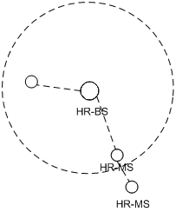
Figure 1: Neighbor discovery method supports HR-MS forwarding

- Coverage extension for 802.16-2009 operation
When the HR-Network follows 802.16-2009 configurations, an inside-of-coverage/registered HR-MS can transmit preamble, FCH and network configuration information (NCI) to enable the HR-MS outside the coverage to be able to associate to the 802.16 networks. HR-BS/HR-RS may reserve a short duration at the end of uplink subframe, the period can be two or three symbols duration, and transmit the preamble, FCH and other network configuration information. The network configuration tells outside-of-coverage HR-MSs of the ranging codes and the location of sub-channels for them sending in the ranging signals in the following uplink sub-frames. The fields of the FCH and network configuration information are TBD. After receiving the preambles, FCH and network configuration information, the HR-MS outside the coverage should transmit the ranging signal in the scheduled ranging slot.
The preamble transmitted by the HR-MS for coverage extension can also be measured by other HR-MSs as neighbor discovery signals.
The transmission opportunity of the preambles, FCH and neighbor configuration information can be scheduled dynamically by the HR-BS/HR-RS.
Figure 2 shows an example configuration. The preamble occupies one symbol duration and FCH and network configuration information may take one symbol duration. The HR-BS may schedule an additionally symbol duration for TTG purposes. This may allow those HR-MSs in transmitting state to change to receiving state and measuring the signals for the neighbor discovery purpose.
Figure 2: MS1 transmit preambles together with Network Configuration Information (NCI) to help out-of-coverage MS2 to register with BS
- Coverage extension for 802.16m operation
When the HR-Network follows 802.16m configuration, the inside-of-coverage/registered HR-MS can transmit PA/SA preamble signals to enable coverage extension toward a outside-of-coverage HR-MS. We propose that the registered HR-MS transmits PA preamble at the beginning of the 2nd frame and SA preamble at the beginning of the 3rd frame (of a super-frame). Transmitting in this way allows the coverage-extension PA/SA preambles to be aligned with those transmitted by the serving HR-BS/HR-RS.
Any non-registered HR-MS scanning for DL preambles for possible network entry should be able to differentiate between preambles transmitted by normal infrastructure stations (HR-BS/HR-RS) and those transmitted by a coverage-extending HR-MS. Mechanisms to enable such a differentiation (e.g., by reserving a subset of SA-preambles for coverage extension) is [TBD].
After receiving the SA-preamble transmitted by a potential forwarding HR-MS, the out-of-coverage HR-MS should also be able to determine where to look for the network configuration information (NCI). The mechanism to enable this is [TBD]. NCI message contains essential PHY/MAC configurations that are required for the out-of-coverage HR-MS to configure its transceiver and subsequently send a ranging signal toward the coverage-extending HR-MS. The content of NCI message is [TBD].
Upon receiving the ranging signal from the out-of-coverage HR-MS, the coverage-extending HR-MS shall assist this HR-MS to carry out subsequent adjustments and handshaking with the serving HR-BS/HR-RS. The process finishes when the out-of-coverage HR-MS becomes registered with the serving HR-BS/HR-RS.
The process of coverage extension for 802.16m operation is illustrated in Figure 3.

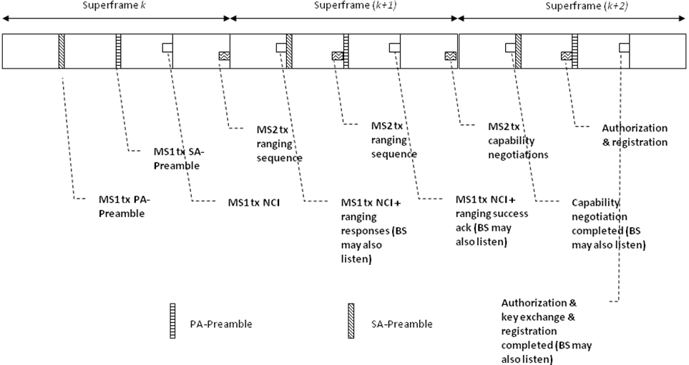
Figure 3. MS1 is a registered HR-MS that transmits PA/SA preambles together with Network Configuration Information (NCI) to help out-of-coverage MS2 to register with BS.

4. Text Proposal for IEEE 802.16n AWD
Xxx
Note:
The text in BLACK color: the existing text in AWD
The text in RED color: the removal of existing AWD text
The text in BLUE color: the new text added to the Multi-Carrier DG Text

[-------------------------------------------------Start of Text Proposal---------------------------------------------------]
[Adopt the following text in the 802.16n Document (XXX places)]

17.2.7 Path Discovery and Management

17.2.7.3 HR-MS Discover Network Infrastructure (802.16-2009)
To enable an HR-MS that is outside the coverage of an HR-BS to discover network infrastructure and get connected, a nearby registered HR-MS at cell edge can transmit preambles, together with network configuration information, for the far-away HR-MS to start network entry. OFDMA resource shall also be allocated for the out-of-coverage HR-MS to carry out ranging and other necessary steps with the cell-edge HR-MS so that it can eventually join the network. At the same time, when the cell-edge HR-MS transmits preamble signal (for coverage extension), other registered HR-MSs can also scan to discover their neighbor relationship.

HR-BS may schedule HR-MSs selected as forwarding HR-MSs to transmit frame preamble, FCH and network configuration information at the end of uplink subframes. The schedule duration can be a variable number of OFDMA symbols. The first symbol can be optionally used as an MS transmit-receive transition gap (MS-TTG) for HR-MSs inside the network to switch their transceiver to receiving mode for neighbor discovery purpose. Following the TTG is a preamble, FCH, and network configuration information. The HR-BS shall also schedule a ranging subchannel in the following subframes so that HR-MS outside the coverage can transmit ranging signals at the reserved location for network entry purpose. The transmission opportunity is dynamic and may not appear in every frame. The content of FCH and network configuration information is TBD.

Figure xxx illustrates how the process of HR-MS discovering network infrastructure is supported in 802.16-2009.

Figure xxx: MS1 transmit preambles together with Network Configuration Information (NCI) to help out-of-coverage MS2 to register with BS

17.3.7 Path Discovery and Management

17.3.7.3 HR-MS Discover Network Infrastructure (802.16m)
To enable coverage extension, a serving HR-BS/HR-RS shall schedule some of its registered HR-MSs to transmit PA/SA preamble signals so that an outside-of-coverage HR-MS can detect and start network entry.
The registered HR-MS shall transmit PA preamble at the beginning of the 2nd frame and SA preamble at the beginning of the 3rd frame (of a super-frame). Any non-registered HR-MS scanning for DL preambles for possible network entry shall be able to differentiate between the SA preambles transmitted by normal infrastructure stations (HR-BS/HR-RS) and those transmitted by a coverage-extending HR-MS. This is based on the [TBD] mechanism.
After receiving the SA-preamble transmitted by a potential forwarding HR-MS, the out-of-coverage HR-MS shall also be able to determine where to look for the network configuration information (NCI). This is achieved by:
- Scheduling the NCI within the last subframe of the frame in which the SA preamble is transmitted by the coverage-extending HR-MS.
- The particular logical resource units allocated for NCI shall be determinable based on the index and segment ID of the transmitted SA preamble.
NCI message contains essential PHY/MAC configurations that are required for the out-of-coverage HR-MS to configure its transceiver and subsequently send a ranging signal toward the coverage-extending HR-MS. Upon receiving the ranging signal from the out-of-coverage HR-MS, the coverage-extending HR-MS shall assist this HR-MS to carry out subsequent adjustments and handshaking with the serving HR-BS/HR-RS. The process finishes when the out-of-coverage HR-MS becomes registered with the serving HR-BS/HR-RS. This process is further described in 17.3.7.3.1.

17.3.7.3.1 Network Entry Process for an Out-of Coverage HR-MS
Figure yyy illustrates how the process of HR-MS discovering network infrastructure is supported in 802.16m. In this figure, MS1 is the cell-edge HR-MS that helps its serving HR-BS/RS to extend coverage. MS2 is the out-of-coverage HR-MS that attempt to carry out network entry with the help of MS1.

HR-BS/RS can schedule multiple registered HR-MSs to transmit PA/SA preambles and perform subsequent forwarding activities. In that case, an out-of-coverage HR-MS like MS2 may be able to receive PA/SA preambles transmitted by different registered HR-MSs. At the same time, these registered HR-MSs can transmit NCI at the same or different time/frequency locations.

HR-BS/RS can schedule multiple registered HR-MSs to transmit the same NCI at the same location. In that case, the out-of-coverage HR-MS, MS2, can perform diversity combining to enhance the reception of the common NCI. HR-BS/RS can also schedule different registered HR-MSs to transmit different NCI at different locations. In that case, MS2 shall select the particular NCI it wants to receive. This selection can be based on the signal strength of the SA-preambles being received by MS2.

After decoding the NCI and configure its transceiver, an outside-of-coverage HR-MS like MS2 can transmit ranging signal toward MS1. Meanwhile, MS1 shall listen on the allocated ranging channels to detect if any out-of-coverage MS tries to transmit ranging signal for network entry. If MS1 detects some signal is transmitted (either successful or with collision) MS1 shall broadcast a ranging response message in a subsequent pre-define time/frequency location.

MS2, upon receiving the ranging responses from MS1 shall carry out necessary actions to achieve time/frequency/power synchronization with MS1. After that, MS1 subsequently helps MS2 to carry out the rest of the network entry procedure with BS, including capability negotiations, authorization and authentication, and registration.

Figure yyy illustrates how the process of HR-MS discovering network infrastructure is supported in 802.16m.
Figure yyy. MS1 is a registered HR-MS that transmits PA/SA preambles together with Network Configuration Information (NCI) to help out-of-coverage MS2 to register with BS.

17.3.7.3.1 Dynamic Resource Allocation for Coverage Extension Purpose
This process is again illustrated by Figure yyy. The resources for the register HR-MS, i.e., MS1, and out-of-coverage HR-MS, i.e., MS2, to transmit control/data signaling are assigned by the serving HR-BS/RS in UL. To further conserve bandwidth spent for coverage extension, HR-BS can carry out the following dynamic allocation approach:
- HR-BS first allocates resources (PA/SA preambles, OFDMA resources, and ranging sequences, channels) for MS1 to broadcast preambles, NCI, and receive, response to ranging signal (from out-of-coverage MSs) for only a limited number of frames.

- HR-BS then listens on the channel in which MS1 is supposed to transmit a ranging response to any out-of-coverage HR-MS. If there is no signal transmitted by MS1, HR-BS can conclude that there is no out-of-coverage MS near to MS1 and therefore stop the resource allocation.

- However, if HR-BS detects a ranging response message sent by MS1 toward MS2, it will be able to determine how much extra resources need to be further reserved.

[-------------------------------------------------End of Text Proposal----------------------------------------------------]

References
- IEEE 802.16n-10/0048, “802.16n System Requirements Document including SARM annex”, January 2011.
- IEEE 802.16n-10/0049, “802.16n Table of Contents for Amendment Working Draft”, January 2011.

Use of IEEE-Copyrighted Conference and Journal Papers
The IEEE 802.16 Working Group has obtained permission to post IEEE-copyrighted material from IEEE conferences and publications when received in an official contribution to the Working Group. IEEE requires two conditions:
- A full copyright and credit notice must be posted at the top of the paper in the following format:
Copyright ©2002 Institute of Electrical and Electronics Engineers, Inc. Reprinted, with permission, from [all relevant journal info].
This material is posted here with permission of the IEEE. Internal or personal use of this material is permitted. However, permission to reprint/republish this material for advertising or promotional purposes or for creating new collective works for resale or redistribution must be obtained from the IEEE (contact pubs–permissions@ieee.org).
By choosing to view this document, you agree to all provisions of the copyright laws protecting it.
- If the author is not the submitter of the contribution, the author’s written approval for the reuse of the material must be attached.

