Project | IEEE 802.16 Broadband Wireless Access Working Group <http://ieee802.org/16>
Title | Frame Structure and Resource Allocation for HR-MS Direct Communications and HR-MS Forwarding to Network
Date Submitted | 2011-05-09
Source(s) | Hoang Anh Tuan, Haiguang Wang, Jaya Shankar, Joseph Chee Ming Teo, Wai Leong Yeow, Shoukang Zheng, and Mar Choon Hock  Institute for Infocomm Research  1 Fusionopolis Way, #21-01, Connexis (South Tower)  Singapore 138632 | Voice: +65 6408-2271  E-mail: athoang@i2r.a-star.edu.sg
Re: | Call for contributions for 802.16n AWD
Abstract | We discuss approaches to allocate OFDMA resources to the direct links between HR-MSs under HR-MS direct communications and HR-MS forwarding to network.
Purpose | To discuss and adopt the proposed text in the 802.16n draft Text
Notice | This document does not represent the agreed views of the IEEE 802.16 Working Group or any of its subgroups. It represents only the views of the participants listed in the “Source(s)” field above. It is offered as a basis for discussion. It is not binding on the contributor(s), who reserve(s) the right to add, amend or withdraw material contained herein.
Copyright Policy | The contributor is familiar with the IEEE-SA Copyright Policy <http://standards.ieee.org/IPR/copyrightpolicy.html>.
Patent Policy | The contributor is familiar with the IEEE-SA Patent Policy and Procedures:  <http://standards.ieee.org/guides/bylaws/sect6-7.html#6> and <http://standards.ieee.org/guides/opman/sect6.html#6.3>.  Further information is located at <http://standards.ieee.org/board/pat/pat-material.html> and <http://standards.ieee.org/board/pat>.

Frame Structure and Resource Allocation for HR-MS Direct Communications and HR-MS Forwarding to Network

Hoang Anh Tuan, Haiguang Wang, Jaya Shankar,
Joseph Chee Ming Teo, Yeow Wai Leong, Shoukang Zheng, and Mar Choon Hock

Institute for Infocomm Research (I2R)

1. Introduction
The IEEE 802.16n System Requirement Document (SRD) [1] mandates the requirements to support HR-MS direct communications (DCm) as well as HR-MS forwarding to network (FTN). During these operations, a pair of HR-MSs will transmit to and receive from each other directly over the radio link. This contribution discusses approaches to allocate OFDMA resources to support these HR-MS direct radio links and proposes text to be adopted into the 802.16n AWD.

2. Use Cases
2.1. HR-MS Direct Communications
As specified in Section 6.1.3.1 of 802.16n SRD [1]:
“HR-MS shall provide direct communication i.e. the origination and termination of the data are at the HR-MS. Association establishment procedure of an HR-MS to another HR-MS shall be supported.
HR-MS shall support communication of user data and control signaling between an HR-MS and one or more HR-MSs that are 1-hop away.
HR-MS shall support forwarding of user data and control signaling between an HR-MS and one or more HR-MSs.”

The above specifications cater for two main use cases of HR-MS direct communications (DCm), i.e., when both HR-MSs are under control of a serving HR-BS (or HR-RS) and when there is no infrastructural station in the network and HR-MSs need to relay data for each other. In this contribution, we only focus on the first use case, when there exists an HR-BS/HR-RS in the network.

2.2. HR-MS Forwarding to Network
As specified in Section 6.1.3.2 of 802.16n SRD [1]:
“HR-MS forwarding is defined as the case where the origination and termination of data are at the HR-MS and network respectively and vice versa.
HR-Network shall support HR-MS forwarding of user data and control signaling between HR-MS and HR-BS and between HR-MS and HR-RS. The control signaling and data transmission for the HR-MS to HR-MS direct link shall at least be capable of operating within the frequency band that the HR-BS operates. An association establishment shall be supported.”

Based on the above specifications, there can be two main use cases for HR-MS forwarding to network (FTN), i.e., when the forwarded HR-MS is within or outside the coverage of the corresponding HR-BS (or HR-RS).

3. Design Criteria
In designing mechanisms to support HR-MS DCm and HR-MS FTN, the important design criteria are as follows:
- Minimizing changes to the existing 802.16 specifications;
- Avoiding interference to other 802.16 operations;
- Incurring low overhead and complexity;
- Allowing flexible scheduling and configuration.

4. Discussion of Approaches
4.1. DL versus UL Resource Allocation
In current 802.16 specifications, each frame is divided into two main areas, i.e., DL and UL. OFDMA resources for MSs to transmit control/data messages are allocated in UL subframes by the serving BS/RS. The activation of HR-MS DCm and HR-MS FTN in 802.16n, therefore, should be considered opportunistic, e.g., for performance-improvement purposes such as throughput enhancement, interference mitigation, and improved latency/robustness. This opportunistic nature of HR-MS DCm and HR-MS FTN implies that priority should still be given to maintaining the reliability of the normal links, i.e., those tree-based connections between HR-MSs and the serving HR-BS/HR-RS.

Furthermore, as both HR-MSs are under the control of the serving HR-BS/HR-RS, it is desirable that the serving HR-BS/HR-RS can control/monitor these HR-MSs in the ways that are as close as possible to controlling/monitoring those HR-MSs that do not perform DCm/FTN. In fact, one or both HR-MSs that perform DCm/FTN can still have normal DL and UL communications with the serving HR-BS/HR-MS.

Based on the above argument, to support HR-MS DCm and FTN, 802.16n should stick to the same allocation principle, i.e., data/control transmissions from HR-MSs will only be scheduled in UL area of each frame. However, this restriction should not apply to the case when an HR-MS need to transmit preamble signals for synchronization or other purposes. In that case, the location of preambles can be either in DL or UL and is [TBD].

Scheduling all HR-MS/HR-MS direct transmissions in the UL area brings the following benefits:
- Keeping the frame structure close to what has been specified for 802.16-2009 and 802.16m;
- Making it easier to control/mitigate interference caused to normal 802.16 communications (between HR-MSs and serving HR-BS/HR-RS). This is because in the UL area, the number of receiving entities are limited to HR-BS and HR-RS (not to count those directly involved in DCm/FTN);
- Allowing HR-BS to have better control of HR-MSs.

Furthermore, to minimize UL interference, we propose to use centralized resource scheduling, where resource allocations to HR-MSs in DCm and FTN will be determined by the serving HR-BS/HR-RS.

4.2. Frame Structure
As explained above, HR-MS DCm and FTN are opportunistic in nature. Furthermore, these connections can often be short-lived due to nodes’ mobility and changes in other network conditions. As such, the serving HR-BS/HR-RS should allocate OFDMA resources for the DCm/FTN in the on-demand basis, and can dynamically mix that with normal UL allocations. This on-demand allocation approach brings the following benefits:
- Flexibility in multiplexing between normal and direct HR-MS communications;
- Avoiding PHY new design for the new zone for direct HR-MS communications.

It is then up to the serving HR-BS/HR-RS to arrange the resource for DCm and FTN within the UL area of each particular frame. For examples, in Figure 1, for 802.16m TDD frame structure, UL resources for DCm/FTN can be mixed with normal UL transmission in a distributed manner, while in Figure 2, resources for DCm/FTN are localized within the UL area and effectively form a separate zone for DCm/FTN.

A-MAP
A-MAP
A-MAP
A-MAP
A-MAP
PA/SA preamble
Midamble
TTG
HR-MS switches from TX to RX mode or vice versa during DCm/FTN
HR-MS switches from TX to RX mode or vice versa during DCm/FTN; 1 symbol is quiet for TX-RX switching.

Normal UL
Normal UL
Normal UL
RTG
SFH
Figure 1: TDD 802.16m Frame structure where resources for HR-MS DCm/FTN are mixed with normal UL transmissions in a distributed manner.

A-MAP
A-MAP
A-MAP
A-MAP
SFH
PA/SA Preamble
Midamble
TTG
HR-MS switches from TX to RX mode or vice versa during DCm/FTN.

Normal UL
Normal UL
Normal UL
RTG
A-MAP
Figure 2: TDD 802.16m Frame structure where resources for HR-MS DCm/FTN are localized within the UL area and effectively form a separate zone for DCm/FTN.

Figure 3 illustrates how the processes of coverage extension (through HR-MS FTN) and bandwidth request for HR-MS direct communication can be supported. MS1 is the inside-of-coverage HR-MS while MS2 and MS3 are outside of HR-BS/HR-RS coverage.

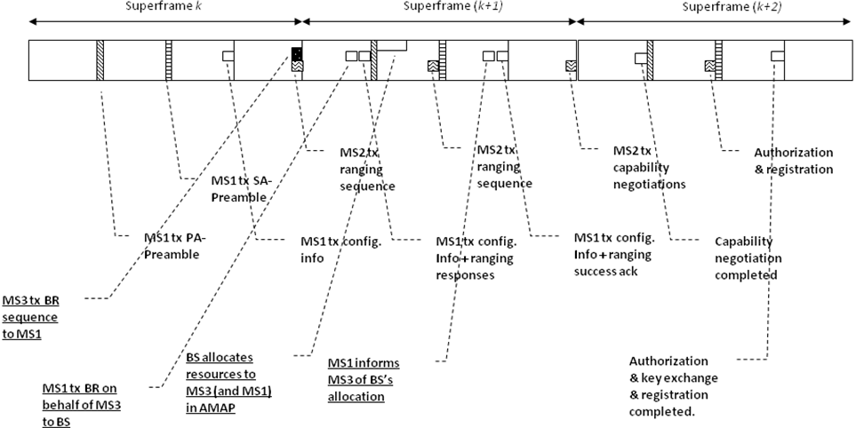
Figure 1. Supporting coverage extension and bandwidth requests in HR-MS DCm and FTN (MS1 is a registered/inside-of-coverage HR-MS while MS2 & MS3 are outside-of-coverage HR-MSs).

5. Text Proposal for IEEE 802.16n AWD

Note:
The text in BLACK color: the existing text in AWD
The text in RED color: the removal of existing AWD text
The text in BLUE color: the new text added to the Multi-Carrier DG Text

[-------------------------------------------------Start of Text Proposal---------------------------------------------------]
[Adopt the following text in the 802.16n AWD Document (C802.16x-xx/xxxx)]

17.2.2 Direct communication between HR-MSs
17.2.2.1 Frame Structure and Resource Allocation
Resources for HR-MS Direct Communications (DCm) shall be scheduled by the serving HR-BS/RS when one exists. When it does not, one of the HR-MS shall fulfill this coordinating role. It is understood that the coordinating HR-MS needs to take on some of the functionality of a HR-BS and may also require new functionality.
For HR-MS DCm under the control of an HR-BS/HR-RS, the OFDMA resources shall be scheduled in a centralized manner by the serving HR-BS/HR-RS. All resource scheduling shall be dynamically conveyed through MAP or DL control messages from serving HR-BS/RS or a coordinating HR-MS.

For HR-MS direct communications under the control of an HR-BS/HR-RS, the OFDMA resources shall be allocated in UL subframes of the HR-BS/HR-RS. This will apply to all control/data transmissions from HR-MSs during DCm, except for the case when an HR-MS transmits preamble signals, which may happen in either DL or UL parts of a frame.

The serving HR-BS/HR-RS can scatter the allocated resources over the entire UL area. It also can localize these DCm resources to effectively form a separate zone for HR-MS DCm. When scheduling these resources, HR-BS/HR-RS shall take into account time required for HR-MS to switch between transmitting and receiving modes.

17.2.3 HR-MS Forwarding to Network
17.2.3.1 Frame Structure and Resource Allocation

Resources for HR-MS forwarding to network (FTN) shall be scheduled by the serving HR-BS/RS when one exists. When it does not, one of the HR-MS shall fulfill this coordinating role. It is understood that the coordinating HR-MS needs to take on some of the functionality of a HR-BS and may also require new functionality.
For HR-MS FTN, the OFDMA resources shall be scheduled in a centralized manner by the serving HR-BS/HR-RS. All resource scheduling shall be dynamically conveyed through MAP or DL control messages from serving HR-BS/RS or a coordinating HR-MS. The scheduling messages shall be forwarded by the forwarding HR-MS.

For HR-MS forwarding to network (FTN), the OFDMA resources shall be allocated in UL subframes of the HR-BS/HR-RS. This will apply to all control/data transmissions from HR-MSs during FTN, except for the case when an HR-MS transmits preamble signals, which may happen in either DL or UL parts of a frame.

The serving HR-BS/HR-RS can scatter the allocated resources over the entire UL area (Figure X1). It can also localize these FTN resources to effectively form a separate zone for HR-MS FTN (Figure X2). When scheduling these resources, HR-BS/HR-RS shall take into account time required for HR-MS to switch between transmitting and receiving modes.

17.3.2 Direct communication between HR-MSs
17.3.2.1 Frame Structure and Resource Allocation
Resources for HR-MS Direct Communications (DCm) shall be scheduled by the serving HR-BS/RS when one exists. When it does not, one of the HR-MS shall fulfill this coordinating role. It is understood that the coordinating HR-MS needs to take on some of the functionality of a HR-BS and may also require new functionality.
For HR-MS DCm under the control of an HR-BS/HR-RS, the OFDMA resources shall be scheduled in a centralized manner by the serving HR-BS/HR-RS. All resource scheduling shall be dynamically conveyed through A-MAP or DL control messages from serving HR-BS/RS or a coordinating HR-MS.

For HR-MS direct communications under the control of an HR-BS/HR-RS, the OFDMA resources shall be allocated in UL subframes of the HR-BS/HR-RS. This will apply to all control/data transmissions from HR-MSs during DCm, except for the case when an HR-MS transmits preamble signals, which may happen in either DL or UL parts of a frame.

The serving HR-BS/HR-RS can scatter the allocated resources over the entire UL area (Figure X1). It also can localize these DCm resources to effectively form a separate zone for HR-MS DCm (Figure X2). When scheduling these resources, HR-BS/HR-RS shall take into account time required for HR-MS to switch between transmitting and receiving modes.

A-MAP
A-MAP
A-MAP
A-MAP
A-MAP
PA/SA preamble
Midamble
TTG
HR-MS switches from TX to RX mode or vice versa during DCm/FTN
HR-MS switches from TX to RX mode or vice versa during DCm/FTN; 1 symbol is quiet for TX-RX switching.

Normal UL
Normal UL
Normal UL
RTG
SFH
Figure X1: TDD 802.16m Frame structure where resources for HR-MS DCm/FTN are mixed with normal UL transmissions in a distributed manner.

A-MAP
A-MAP
A-MAP
A-MAP
SFH
PA/SA Preamble
Midamble
TTG
HR-MS switches from TX to RX mode or vice versa during DCm/FTN.

Normal UL
Normal UL
Normal UL
RTG
A-MAP
Figure X2: TDD 802.16m Frame structure where resources for HR-MS DCm/FTN are localized within the UL area and effectively form a separate zone for DCm/FTN.

17.3.3 HR-MS Forwarding to Network

17.3.3.1 Frame Structure and Resource Allocation

Resources for HR-MS forwarding to network (FTN) shall be scheduled by the serving HR-BS/RS when one exists. When it does not, one of the HR-MS shall fulfill this coordinating role. It is understood that the coordinating HR-MS needs to take on some of the functionality of a HR-BS and may also require new functionality.
For HR-MS FTN, the OFDMA resources shall be scheduled in a centralized manner by the serving HR-BS/HR-RS. All resource scheduling shall be dynamically conveyed through A-MAP or DL control messages from serving HR-BS/RS or a coordinating HR-MS. The scheduling messages shall be forwarded by the forwarding HR-MS.

For HR-MS forwarding to network (FTN), the OFDMA resources shall be allocated in UL subframes of the HR-BS/HR-RS. This will apply to all control/data transmissions from HR-MSs during FTN, except for the case when an HR-MS transmits preamble signals, which may happen in either DL or UL parts of a frame.

The serving HR-BS/HR-RS can scatter the allocated resources over the entire UL area (Figure X1). It can also localize these FTN resources to effectively form a separate zone for HR-MS FTN (Figure X2). When scheduling these resources, HR-BS/HR-RS shall take into account time required for HR-MS to switch between transmitting and receiving modes.

17.3.3.2 Bandwidth Requests from Forwarded HR-MS
Supporting bandwidth requests from forwarded MSs is a critical functionality for coverage extension. An out-of-coverage forwarded HR-MS can request bandwidth by transmitting some known sequences (Bandwidth Request (BR) preambles) toward the forwarding HR-MS. The forwarded HR-MS can transmit BR preambles either within some UL subframe or in the 1st symbol of the 4th frame of a superframe.

The case when a BR preamble is transmitted within a UL subframe is illustrated in Figure xxx. The process can be described as follows.

- Serving HR-BS/RS schedules resources in an uplink subframe for forwarded HR-MSs to transmit BR messages to their corresponding forwarding HR-MS.
- A forwarding HR-MS, say MS1, upon receiving BR messages from one of its forwarded HR-MS, say MS3, forwards the requests to serving HR-BS/RS.
- HR-BS announces bandwidth allocations for MS3 in A-MAP.
- MS1 reads the A-MAP, discovers resource assignments for MS3, and forwards this information to MS3.

Figure xxx. Out-of-coverage forwarded MS3 transmits BW preambles to forwarding MS1 in a uplink subframe (also illustrated in the figure is an out-of-coverage MS2 going through network entry under coverage extension).

The case when a BR preamble is transmitted in the 1st OFDMA symbol of the 4th frame of a superframe is illustrated in Figure yyy. The process goes as follows:
- MS3 picks a preamble among a set of predefined preambles and maps it into the 1st OFMA symbol of the 4th frame of a superframe and transmit toward MS1.
- MS1, upon receiving BR preamble from MS3, forwards the requests to BS.
- BS announces bandwidth allocations for MS3 in A-MAP.
- MS1 reads the A-MAP, discovers resource assignments for MS3, and forwards this information to MS3.
In the above process, MS1 shall always monitor the 1st OFDMA symbol of the 4th frame to determine if any preamble is transmitted. Furthermore, when receiving a preamble in this location, MS1 shall be able to determine if such preamble was transmitted by one of the MSs that MS1 helps forwarding data. The mechanism to enable this is TBD.

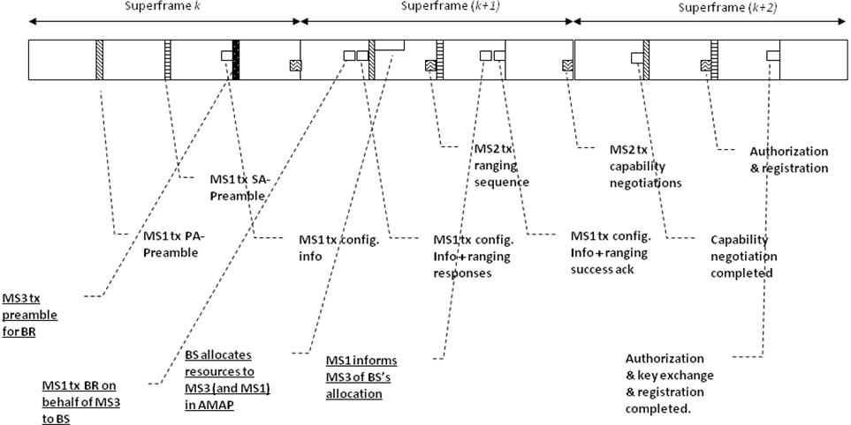
Figure yyy. Out-of-coverage MS3 transmits BW requests to registered MS1 via a preamble transmitted at the first symbol of the 4th frame (also illustrated in the figure is an out-of-coverage MS2 going through network entry under coverage extension).

[-------------------------------------------------End of Text Proposal----------------------------------------------------]

References
- IEEE 802.16n-10/0048, “802.16n System Requirements Document including SARM annex”, January 2011.
- IEEE 802.16n-10/0049, “802.16n Table of Contents for Amendment Working Draft”, January 2011.

Use of IEEE-Copyrighted Conference and Journal Papers
The IEEE 802.16 Working Group has obtained permission to post IEEE-copyrighted material from IEEE conferences and publications when received in an official contribution to the Working Group. IEEE requires two conditions:
- A full copyright and credit notice must be posted at the top of the paper in the following format:
Copyright ©2002 Institute of Electrical and Electronics Engineers, Inc. Reprinted, with permission, from [all relevant journal info].
This material is posted here with permission of the IEEE. Internal or personal use of this material is permitted. However, permission to reprint/republish this material for advertising or promotional purposes or for creating new collective works for resale or redistribution must be obtained from the IEEE (contact pubs–permissions@ieee.org).
By choosing to view this document, you agree to all provisions of the copyright laws protecting it.
- If the author is not the submitter of the contribution, the author’s written approval for the reuse of the material must be attached.

