Project | IEEE 802.16 Broadband Wireless Access Working Group <http://ieee802.org/16>
Title | Multicast Key Management for IEEE 802.16n HR-Network
Date Submitted | 2011-07-11
Source(s) | Joseph Teo Chee Ming, Jaya Shankar, Yeow Wai Leong, Hoang Anh Tuan, Wang Haiguang, Zheng Shoukang, Mar Choon Hock  Institute For Infocomm Research | E-mail:  cmteo@i2r.a-star.edu.sg
Re: | Call for contributions for 802.16n AWD
Abstract | Detail description of Multicast Security to be discussed and adopted to IEEE 802.16n AWD
Purpose | To discuss and adopt the proposed text in the 802.16n draft Text
Notice | This document does not represent the agreed views of the IEEE 802.16 Working Group or any of its subgroups. It represents only the views of the participants listed in the “Source(s)” field above. It is offered as a basis for discussion. It is not binding on the contributor(s), who reserve(s) the right to add, amend or withdraw material contained herein.
Release | The contributor grants a free, irrevocable license to the IEEE to incorporate material contained in this contribution, and any modifications thereof, in the creation of an IEEE Standards publication; to copyright in the IEEE’s name any IEEE Standards publication even though it may include portions of this contribution; and at the IEEE’s sole discretion to permit others to reproduce in whole or in part the resulting IEEE Standards publication. The contributor also acknowledges and accepts that this contribution may be made public by IEEE 802.16.
Patent Policy | The contributor is familiar with the IEEE-SA Patent Policy and Procedures:  <http://standards.ieee.org/guides/bylaws/sect6-7.html#6> and <http://standards.ieee.org/guides/opman/sect6.html#6.3>.  Further information is located at <http://standards.ieee.org/board/pat/pat-material.html> and <http://standards.ieee.org/board/pat>.

Multicast Key Management for IEEE 802.16n HR-Network

Joseph Chee Ming Teo, Jaya Shankar, Yeow Wai Leong, Hoang Anh Tuan, Zheng Shoukang, Mar Choon Hock

Institute for Infocomm Research (I2R)
1 Fusionopolis Way, #21-01, Connexis South Tower
Singapore 138632

1. Introduction

The IEEE 802.16n System Requirements Document (SRD) [1] specifies shall provide the security architecture that provides a group of HR-MSs with authentication, authorization, encryption and integrity protection. The HR-Network shall provide multicast key management for the group of HR-MSs and the key shared within the group should be distributed securely and efficiently. The multicast communications should be able to take place with or without Base Station (HR-BS) in order to provide high reliability.

To ensure that an attacker is not able to masquerade as a multicast member or eavesdrop in the multicast communications, multicast key management (MKM) protocols have to be designed for the 802.16n networks. Although multicast is already supported in existing IEEE 802.16 standards and a Multicast and Broadcast Rekeying Algorithm (MBRA) has already been proposed, however, it was pointed out in existing literature that MBRA is not scalable and also does not provide backward and forward secrecy, i.e. a new joining member is able to decrypt previous secure multicast communications sent before it joined (backward secrecy) and a leaving member can still decrypt future secure multicast communications after leaving the multicast group (forward secrecy).

In this contribution, we propose multicast key management procedures for Initial Group Formation, Node Join events and Node leave events to secure multicast communications in 802.16n HR-networks.

2. Multicast Key Management
Figure 1 shows a group of multicast members that wishes to establish a secure multicast. The “controller” node is the base station HR-BS. Each HR-MS shares a unicast security key USKi with the base station HR-BS (established during network entry) and uses this key in the multicast key management to obtain the multicast group key. In the case of Figure 1, an Initial Group Formation Procedure will be executed to establish a secure multicast key MMK for secure multicast communications.

Figure 1: Initial Group Formation

Figure 2 below shows the multicast group where new node HR-MSj joins the multicast group. In this case, the existing multicast group key has to be changed in order to prevent the new node from reading previous secure multicast communications (backward secrecy).

Figure 2: Join Event
Figure 3 below shows the scenario where a multicast member HR-MSl leaves the multicast group. In this case, the multicast group key has to be changed to prevent the leaving multicast member from obtaining future secure multicast communications (forward secrecy).

Figure 3: Leave Event

As such, the Multicast Key management protocol in the IEEE 802.16n standards has to provide procedures to update the key whenever the multicast group is formed or whenever a user joins or leaves the multicast group.

3. Summary
Suppose a group of HR-MSs wishes to communicate securely with each other for multicast applications such as Push-to-Talk or multicast data transfer, then a multicast group has to be formed. In order to prevent malicious nodes from masquerading as a legitimate multicast member and send malicious message to disrupt the multicast communications, multicast key management (MKM) protocols has to be used to establish a multicast key for secure multicast communications in the group. The data encrypted with the multicast key will also be secure against eavesdropper trying to listen in to the secure multicast communications.
The MKM protocols also has to take into account backward and forward secrecy, i.e. i.e. a new joining member is able to decrypt previous secure multicast communications sent before it joined (backward secrecy) and a leaving member can still decrypt future secure multicast communications after leaving the multicast group (forward secrecy).

[-------------------------------------------------Begin of Text Proposal----------------------------------------------------]
[Adopt the following text in the 802.16n AWD Document (C802.16x-xx/xxxx)]

17.3.9.3 Multicast key management

Multicast key is managed as described in 17.3.10.x.

17.3.10.2 Security Procedure for Multicast Operation

If the multicast operation is to be encrypted, then each HR-MS in the multicast group shall have multicast keys and a multicast Security Association (multicast SA) that allows secure multicast communications.

The following section describes security procedures that shall be used to 1) establish multicast keys for a group of HR-MS nodes that wishes to establish secure multicast communications with each other, 2) change the multicast keys whenever new nodes join the multicast group and 3) change the multicast keys whenever nodes leave the multicast group.

The HR-MSs shall use the unicast security key USKi that is shared with HR-BS to perform authentication and multicast key management.

17.3.10.2.x Initial Group Formation Procedure

The Initial Group Formation procedure takes place during initial multicast group formation to establish a multicast keys for secure multicast communications amongst the HR-MS nodes in the multicast group. Figure X1 shows the flow diagram while Figure Y1 shows the flow chart for the Initial Group Formation Procedure.

The Initial Group Formation Procedure includes the following steps:

Step 1: HR-BS sends the multicast group information message (MulticastGrpInfo message) to all potential members of the multicast group comprising of HR-MSi for 1 ≤ i ≤ n, where MulticastGrpInfo = MulticastGrpID|HR-BSAddr.

Step 2: Each HR-MSi for 1 ≤ i ≤ n first generates nonce N_{HR-MSi}. Next, HR-MSi computes the MAC θ_{HR-MSi} = MAC(USKi|MulticastGrpID|T_{HR-MSi}|N_{HR-MSi}|HR-BSAddr|HR-MSiAddr) and sends Multicast_MSG_#1 message to HR-BS, where Multicast_MSG_#1 = MulticastGrpID|T_{HR-MSi}|N_{HR-MSi}|HR-BSAddr|HR-MSiAddr|θ_{HR-MSi}.

Step 3: HR-BS first verifies the received timestamps and nonces for freshness and θ_{HR-MSi} for 1 ≤ i ≤ n. If the verifications are correct, then HR-BS generates nonce N_{HR-BS}, MMK and computes MCMAC = Dot16KDF(MMK, “MCMAC_KEY”, 128), θ_{HR-MSi}' = MAC(USKi|MCMAC|N_{HR-BS}|N_{HR-MSi}|HR-BSAddr|HR-MSiAddr) and MTEK = DOT16KDF(MMK, “MTEK_KEY”, 128). HR-BS then encrypt and obtain c_{i} = E_{USKi}(MMK, MMK_lifetime, HR-MSiAddr, HR-BSAddr). Finally, HR-BS sends Multicast_MSG_#2 message to HR-MSi for 1 ≤ i ≤ n, where Multicast_MSG_#2 = MulticastGrpID|T_{HR-BS}|N_{HR-BS}|HR-MSiAddr|HR-BSAddr| N_{HR-MSi}|c_{i}|θ_{HR-MSi}'.

Step 4: Each HR-MSi for 1 ≤ i ≤ n first verifies the received timestamp and nonces for freshness and decrypts c_{i} using USKi and obtains MMK and MMK_lifetime. Next, each HR-MSi computes MCMAC = Dot16KDF(MMK, “MCMAC_KEY”, 128), MTEK = DOT16KDF(MMK, “MTEK_KEY”, 128) and verifies θ_{HR-MSi}'. If the verification is correct, then HR-MSi can commence secure multicast.
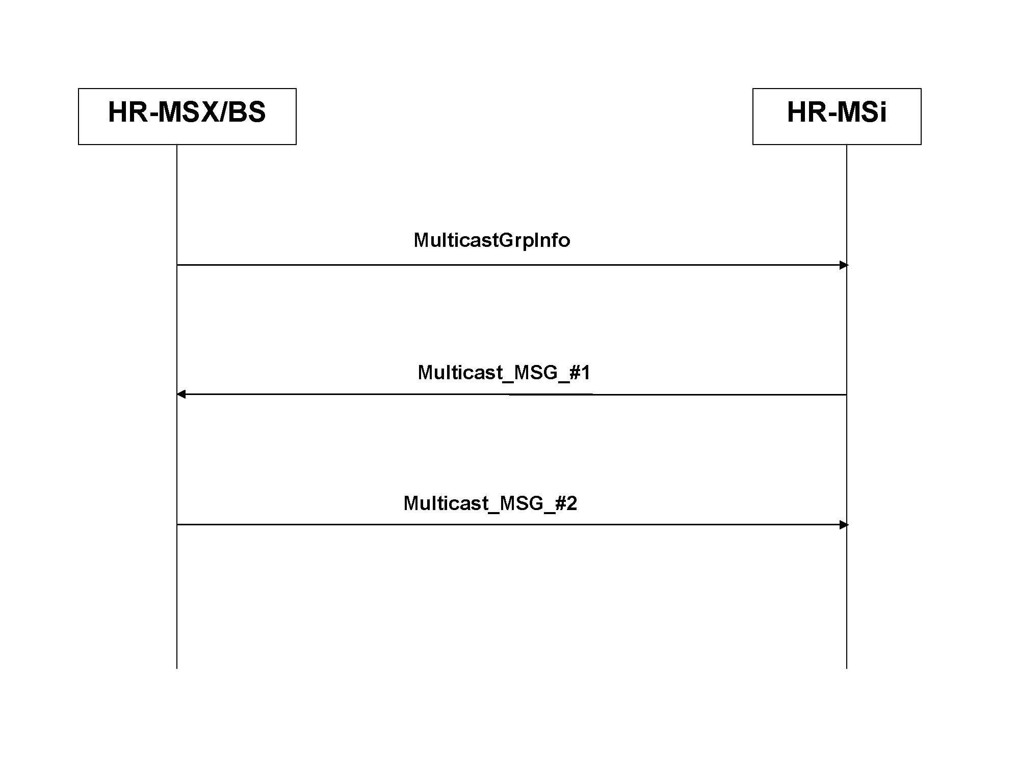
Figure X1 - Flow Diagram for Initial Group Formation Procedure
HR-MSX/BS sends the multicast group information MulticastGrpInfo to all potential members of the multicast group comprising of HR-MSi for 1 <= i <= n
Each HR-MSi generates nonce, computes the MAC and sends Multicast_MSG_#1 to HR-MSX/BS.
HR-MSX/BS verifies the received timestamps, nonce, messages and MACs. If the verifications are correct, HR-MSX/BS generates its nonce, the GTEK and computes the MACs. HR-MSX/BS then encrypts GTEK and its lifetime using shared key MSKi and obtains cB_{iB}. Finally, HR-MSX/BS sends Multicast_MSG_#2 to each HR-MSi.
Each HR-MSi verifies the received timestamp and nonces and decrypts cB_{iB} to obtain GTEK and its lifetime. Each HR-MSi then verifies the MAC and commence secure multicast if the verification is correct.
Figure Y1 - Flow Chart for Initial Group Formation Procedure

17.2.10.2.x.a Message Type

Table aaa – Message Type
Code | Message Type | MAC control message name
 | MulticastGrpInfo
 | Multicast_MSG_#1
 | Multicast_MSG_#2

17.2.10.2.x.b Message Attributes

Table aaa – MulticastGrpInfo message attribute
Attribute | Contents
MulticastGrpID | Multicast Group ID
HR-BSAddr | HR-BS Address

Table bbb – Multicast_MSG_#1 message attribute
Attribute | Contents
MulticastGrpID | Multicast Group ID
T_{HR-MSi} | Timestamp generated by HR-MSi
N_{HR-MSi} | Nonce generated by HR-MSi
HR-BSAddr | HR-BS Address
HR-MSiAddr | HR-MSi Address
θ_{HR-MSi} | Message digest calculated using CMAC key by HR-MS1

Table ccc – Multicast_MSG_#2 message attribute
Attribute | Contents
MulticastGrpID | Multicast Group ID
T_{HR-BS} | Timestamp generated by HR-BS
N_{HR-BS} | Nonce generated by HR-BS
HR-MSiAddr | HR-MSi Address
HR-BSAddr | HR-BS Address
N_{HR-MSi} | Nonce generated by HR-MSi
c_{i} | Encrypted message
θ_{HR-MSi}' | Message digest calculated using CMAC key by HR-BS

17.3.10.2.y Join Event Procedure

The Join Event Procedure takes place whenever there are nodes that join the multicast group and the multicast keys shall be changed in order to prevent the new joining nodes from obtaining previous secure multicast communications. Figure X2 shows the flow diagram while Figure Y2 shows the flow chart for the Join Event Procedure.

The Join Event Procedure includes the following steps:

Step 1: New mobile station HR-MSj first generates nonce N_{HR-MSj}. Next, HR-MSj computes the MAC θ_{HR-MSj} = MAC(USKj|MulticastGrpID|T_{HR-MSj}|N_{HR-MSj}|HR-BSAddr|HR-MSjAddr) and sends Join_MG_MSG_#1 message to HR-BS, where Join_MG_MSG_#1 = MulticastGrpID| T_{HR-MSj}|N_{HR-MSj}|HR-BSAddr| HR-MSjAddr|θ_{HR-MSj}.
Step 2: HR-BS first verifies the received timestamps and nonces for freshness and θ_{HR-MSj}. If the verifications are correct, then HR-BS generates nonce N_{HR-BS}', MMK' and computes MTEK' = DOT16KDF(MMK', “MTEK_KEY”, 128), MCMAC' = Dot16KDF(MMK', “MCMAC_KEY”, 128) and θ_{HR-BS} = MAC(MCMAC'|N_{HR-BS}'|HR-BSAddr|MulticastGrpID) and θ_{HR-MSj}' =MAC(USKj|MCMAC'|N_{HR-BS}'|N_{HR-MSj}|HR-BSAddr|HR-MSjAddr). HR-BS then encrypt and obtain c_{j} = E_{USKj}(MMK', MMK'_lifetime, HR-MSjAddr, HR-BSAddr). HR-BS also encrypts using the existing MTEK and obtains c' = E_{MTEK}(MMK', MMK'_lifetime, HR-BSAddr, N_{HR-BS}') Finally, HR-BS sends Multicast_Join_MSG_#2 message to HR-MSi for 1 ≤ i ≤ n and Multicast_Join_MSG_#3 message to HR-MSj respectively, where Multicast_Join_MSG_#2 = MulticastGrpID|T_{HR-BS}'|N_{HR-BS}'|HR-BSAddr| c'|θ_{HR-BS} and Multicast_Join_MSG_#3 = MulticastGrpID|T_{HR-BS}'|N_{HR-BS}'|HR-MSjAddr|HR-BSAddr|N_{HR-MSj}|c_{j}| θ_{HR-MSj}'.
Step 3a: Each HR-MSi for 1 ≤ i ≤ n first verifies the received timestamp and nonce for freshness. If the verifications are correct, then each HR-MSi decrypts c' and obtains the new MMK' and MMK'_lifetime. Next, each HR-MSi computes MTEK' = DOT16KDF(MMK', “MTEK_KEY”, 128), MCMAC' = Dot16KDF(MMK', “MCMAC_KEY”, 128) and verifies θ_{HR-BS}. If the verification is correct, then HR-MSi can commence secure multicast.
Step 3b: HR-MSj first verifies the received timestamp and nonces for freshness. If the verifications are correct, then HR-MSj uses USKj to decrypt c_{_j} and obtains MMK' and MMK'_lifetime. Next, HR-MSj computes MTEK' = DOT16KDF(MMK', “MTEK_KEY”, 128), MCMAC' = Dot16KDF(MMK', “MCMAC_KEY”, 128) and verifies θ_{HR-MSj}'. If the verification is correct, then HR-MSj can commence secure multicast.
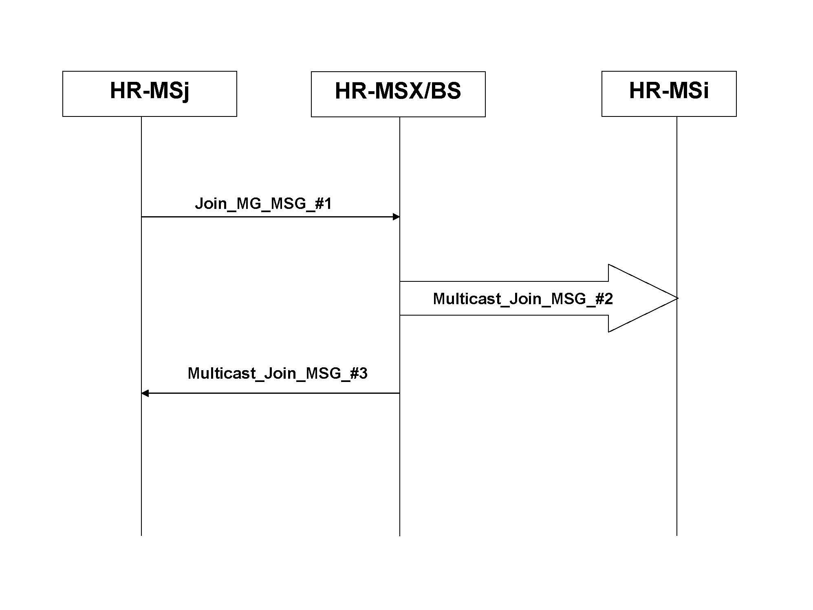
Figure X2 - Flow Diagram for Join Procedure
HR-MSX/BS verifies the received timestamp, nonce and MAC. If the verifications are correct, HR-MSX/BS generates nonce, GTEK’ and computes the respective MACs. Next HR-MSX/BS uses the pre-shared key MSKj to encrypt GTEK’ and its key lifetime and obtains c_{j}. HR-MSX/BS also encrypts GTEK’ and its lifetime using current GTEK and obtains c’. Finally, HR-MSX/BS sends the message Multicast_Join_MSG_#2 to HR-MSi for 1 <= i <= n and message Multicast_Join_MSG_#3 to HR-MSj for 1 <= j <= m.
New HR-MSj for 1 <= j <= m generates nonce, computes MAC using MSKj and sends message Join_MG_MSG_#1 to HR-MSX/BS.
HR-MSj verifies the received timestamp and nonces. If the verifications are correct, then HR-MSj decrypts c_{j} and obtains GTEK’ and its lifetime. Next HR-MSj verifies the MAC and commence secure multicast if the verification is correct.
Each HR-MSi verifies the received timestamp and nonce. If the verifications are correct, HR-MSi decrypts c’ and obtains the new GTEK’ and its lifetime. Next, HR-MSi verifies the MAC and continues secure multicast if the verification is correct.
Figure Y2 - Flow Chart for Join Procedure

17.2.10.2.y.a Message Type

Table aaa – Message Type
Code | Message Type | MAC control message name
 | Join_MG_MSG_#1
 | Multicast_Join_MSG_#2
 | Multicast_Join_MSG_#3

17.2.10.2.y.b Message Attributes

Table aaa – Join_MG_MSG_#1message attribute
Attribute | Contents
MulticastGrpID | Multicast Group ID
T_{HR-MSj} | Timestamp generated by HR-MSj
N_{HR-MSj} | Nonce generated by HR-MSj
HR-BSAddr | HR-BS Address
HR-MSjAddr | HR-MSj Address
θ_{HR-MSj} | Message digest calculated using CMAC key by HR-MSj

Table bbb – Multicast_Join_MSG_#2 message attribute
Attribute | Contents
MulticastGrpID | Multicast Group ID
T_{HR-BS}' | Timestamp generated by HR-BS
N_{HR-BS}' | Nonce generated by HR-BS
HR-BSAddr | HR-BS Address
c' | Encrypted message
θ_{HR-BS} | Message digest calculated using CMAC key by HR-BS

Table ccc – Multicast_Join_MSG_#3 message attribute
Attribute | Contents
MulticastGrpID | Multicast Group ID
T_{HR-BS}' | Timestamp generated by HR-BS
N_{HR-BS}' | Nonce generated by HR-BS
HR-MSjAddr | HR-MSj Address
HR-BSAddr | HR-BS Address
N_{HR-MSj} | Nonce generated by HR-MSj
c_{j} | Encrypted message
θ_{HR-MSj}' | Message digest calculated using CMAC key by HR-BS

17.3.10.2.z Leave Event Procedure
The Leave Event Procedure takes place whenever there are nodes leaving the multicast group and the multicast key has to be changed in order to prevent the leaving nodes from obtaining future secure multicast communications. Figure X3 shows the flow diagram while Figure Y3 shows the flow chart for the Leave Event Procedure.

The Leave Event Procedure includes the following steps:

Step 1: HR-BS generates nonce N_{HR-BS}', new group key MMK', MTEK' = DOT16KDF(MMK', “MTEK_KEY”, 128), MCMAC' = Dot16KDF(MMK', “MCMAC_KEY”, 128) and computes θ_{HR-MSi}' = MAC(USKi|MCMAC'|N_{HR-BS}'|HR-BSAddr|HR-MSiAddr|MulticastGrpID) for 1 ≤ i != L ≤ n. HR-BS then uses the shared key USKi with the remaining HR-MSi for 1 ≤ i != L ≤ n to encrypt and obtain c_{i}' = E_{USKi}(MMK',MMK'_lifetime, HR-BSAddr, N_{HR-BS}'). Finally, HR-BS sends Multicast_Leave_MSG_#1 messages to remaining HR-MSi for 1 ≤ i != L ≤ n, where Multicast_Leave_MSG_#1 = MulticastGrpID|T_{HR-BS}'|N_{HR-BS}'|HR-BSAddr|c_{i}'|θ_{HR-MSi}'.

Step 2: Each remaining HR-MSi for 1 ≤ i != L ≤ n first verifies the received timestamp and nonce for freshness. If the verifications are correct, then each remaining HR-MSi uses its shared key USKi to decrypt c_{i}' and obtains the new MMK' and MMK'_lifetime. Next, each remaining HR-MSi computes MTEK' = DOT16KDF(MMK', “MTEK_KEY”, 128), MCMAC' = Dot16KDF(MMK', “MCMAC_KEY”, 128) and verifies θ_{HR-MSi}'. If the verification is correct, then each remaining HR-MSi can commence secure multicast.

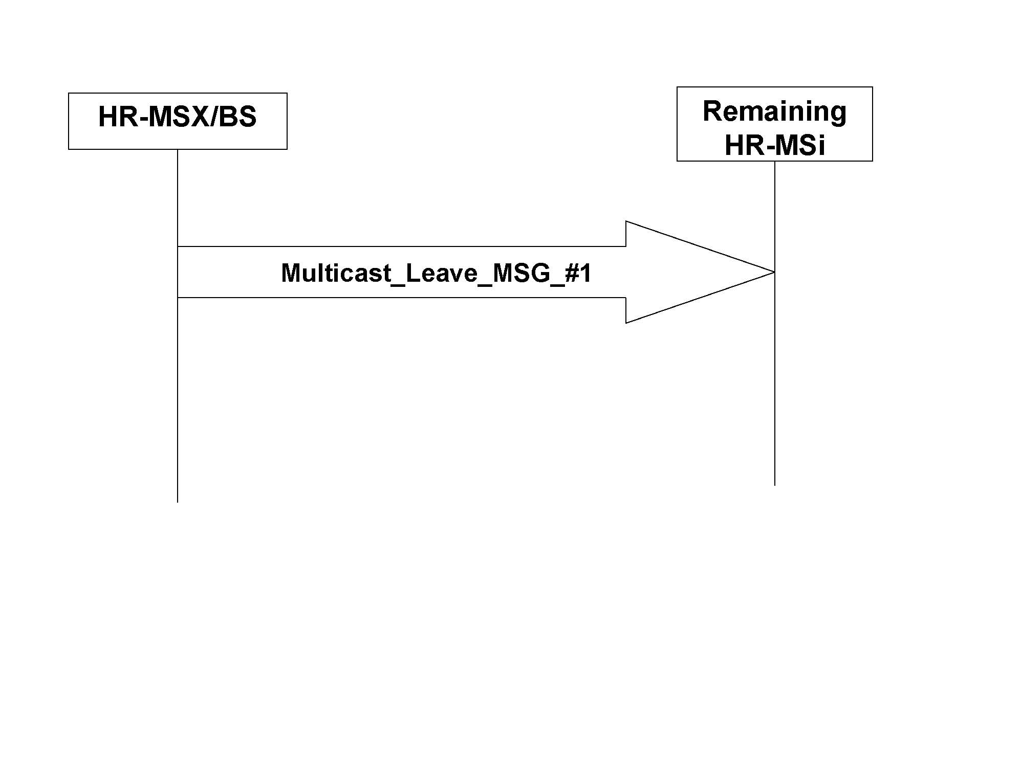
Figure X3 - Flow Diagram for Leave Procedure
Each remaining HR-MSi first verifies the received timestamp and nonce. If the verifications are correct, each HR-MSi decrypts c_{i}’ and obtains the new GTEK’ and its lifetime. Each HR-MSi then verifies the received MAC and continues secure multicast if the verification is correct.
HR-MSX/BS generates nonce, new GTEK’ and computes the MAC for each remaining HR-MSi. Next, HR-MSX/BS uses the shared key MSKi to encrypt the new GTEK’ and its lifetime and obtains c_{i}’. Finally, HR-MSX/BS sends message Multicast_Leave_MSG_#1 to each remaining HR-MSi.
Figure Y3 - Flow Chart for Leave Procedure

17.2.10.2.z.a Message Type

Table aaa – Message Type
Code | Message Type | MAC control message name
 | Multicast_Leave_MSG_#1

17.2.10.2.y.b Message Attributes

Table bbb – Multicast_Leave_MSG_#1 message attribute
Attribute | Contents
MulticastGrpID | Multicast Group ID
T_{HR-BS}' | Timestamp generated by HR-BS
N_{HR-BS}' | Nonce generated by HR-BS
HR-BSAddr | HR-BS Address
c_{i}' | Encrypted message
θ_{HR-MSi}' | Message digest calculated using CMAC key by HR-BS

17.3.10.2.w Security Context for Multicast Communication

The multicast security context describes the set of parameters that links the multicast keys for secure multicast operations.

17.3.10.2.w.a MMK context

The MMK context includes all parameters associate with the MMK. This context is created whenever a new MMK is derived. This context shall be deleted when the MMK is not in used.
The MMK context is as follows:

Table xxx – The MMK context
Parameter | Size (bit) | Usage
MMK | 160 | Multicast Master Key shared by HR-BS and HR-MSs in a multicast group
MAK Lifetime | 32 | MMK Lifetime
MMKID | 64 | Identifies the MMK key.
MCMAC_KEY | 128 | Key which is used for signing Multicast MAC control messages.
MCMAC_PN | 24 | Used to avoid multicast replay attack on the control connection. The initial value of MCMAC_PN is zero.

17.3.10.2.w.c MSA context

The MSA context is the set of parameters managed by each MSA in order to ensure MTEK management and usage in a secure way for secure multicast operations.

The MSA holds the MTEK context and additional information that belongs to the MSA itself.

17.3.10.2.w.c.a MTEK context

The MTEK context includes all parameters of a single MTEK and is described in Table yyy below.
Table yyy – The MTEK context
Parameter | Size (bit) | Usage
MTEK | 128 | Key used for encryption or decryption of Multicast messages
MTEK lifetime | 32 | MTEK lifetime
MTEK_PN | 22 | The PN used for encrypting multicast packets. After each Multicast MAC PDU transmission, the value shall be increased by 1. (0x000000-0x1FFFFF)

17.3.10.2.w.c.b MSA context

The MSA context is described in Table aaa.
Table aaa – The DSA context
Parameter | Size (bit) | Usage
MSAID | 8 | The identifier of this MSA, which decribes the applied encryption/decryption method and MTEK contexts.
MTEK context | Sizeof(MTEK context) | MTEK context for encryption and decryption

17.3.10.2.a Key Derivation

17.3.10.2.a.x Multicast Key Derivation

The multicast key hierarchy defines what keys are present in the system for secure multicast operations and how the keys are generated.

17.3.10.2.a.x.b MMK Derivation

The MMK is the multicast master key that is randomly generated by HR-BS or a network entity and shared among the HR-BS and a group of HR-MSs in a secure HR-multicast group . The MMK is a 160-bit key.

The MMK is used to derive other keys:
- Multicast Cipher-based Message Authentication Code (MCMAC) key
- Multicast Traffic Encryption (MTEK) Key

17.3.10.2.a.x.c MCMAC Key Derivation

MCMAC key is derived from MMK and used for message authentication for the multicast messages sent during secure multicast operation.
MCMAC key is derived as follows:
MCMAC = Dot16KDF(MMK, “MCMAC_KEY”, 128)

17.3.10.2.a.x.d MTEK Derivation

MTEK is the transport encryption key used to encrypt data in secure multicast operations.
MTEK is derived as follows:
MTEK = DOT16KDF(MMK, “MTEK_KEY”, 128)

[-------------------------------------------------End of Text Proposal----------------------------------------------------]

