Project | IEEE 802.16 Broadband Wireless Access Working Group <http://ieee802.org/16>
Title | Alternative Path Preparation and Recovery
Date Submitted | 2011-07-1120
Source(s) | Wai Leong Yeow, Shoukang Zheng, Hoang Anh Tuan, Haiguang Wang, Jaya Shankar, Joseph Teo, Choong Hock Mar  Institute for Infocomm Research  Eunkyung Kim, Sungcheol Chang, Sungkyung Kim, Won-Ik Kim, Miyoung Yun, Hyun Lee, Chulsik Yoon, Kwangjae Lim  ETRI | Voice: +65 6408-2254  E-mail: wlyeow@i2r.a-star.edu.sg  ekkim@etri.re.kr  scchang@etri.re.kr
Re: | Call for Comments on the 802.16n Amendment Working Document <80216n-11_009r1.pdf>
Abstract | We propose signaling messages for alternative paths with multi-mode to prepare against SPOF.
Purpose | To be discussed and adopted in TGn AWD.
Notice | This document does not represent the agreed views of the IEEE 802.16 Working Group or any of its subgroups. It represents only the views of the participants listed in the “Source(s)” field above. It is offered as a basis for discussion. It is not binding on the contributor(s), who reserve(s) the right to add, amend or withdraw material contained herein.
Copyright Policy | The contributor is familiar with the IEEE-SA Copyright Policy <http://standards.ieee.org/IPR/copyrightpolicy.html>.
Patent Policy | The contributor is familiar with the IEEE-SA Patent Policy and Procedures:  <http://standards.ieee.org/guides/bylaws/sect6-7.html#6> and <http://standards.ieee.org/guides/opman/sect6.html#6.3>.  Further information is located at <http://standards.ieee.org/board/pat/pat-material.html> and <http://standards.ieee.org/board/pat>.
Alternative Path Preparation and Recovery
Wai Leong Yeow, Hoang Anh Tuan, Haiguang Wang, Shoukang Zheng, Jaya Shankar, Joseph Teo
Institute for Infocomm Research
Eunkyung Kim, Sungcheol Chang, Sungkyung Kim, Won-Ik Kim, Miyoung Yun, Hyun Lee, Chulsik Yoon, Kwangjae Lim
ETRI

Introduction
A base station failure is very disruptive. All stations served by the BS will have to perform network entry to neighboring BSs, assuming that the stations already skip the neighboring BS scanning phase and use the most recent MOB_NBR_ADV list. Even so, there are three main problems:
- This will cause a usage spike in physical resources, and may cause neighboring BSs to be swarmed.
- Some stations may be left without any network connection even though 802.16n supports range extension with HR-MS forwarding, direct communications, and multi-mode operations.
- There may be further delay incurred since initial ranging is contention-based. Furthermore, all ongoing service flows will have to be reinitiated, resulting in longer delays for service re-connections at the upper layers.
The 802.16n SRD requires the HR-network to support establishment and maintenance of alternative paths to support fast recovery in the event of disruption. In this document, we define alternative path establishment as a preparation phase to deal with possible SPOF. We propose to factor the possibility of multi-mode into alternative path establishment in event of a BS failure, in order to minimize disruption caused in terms of recovery time and physical resource utilization. Specifically, the HR-network shall prepare and maintain a failover topology of alternate paths with role-changed stations, and support fast network recovery with failover configuration. We also discuss the scenario in which BS has backhaul failure and need to switch to RS mode to connect to a neighboring BS in order to maintain connectivity for its subordinate stations.

Alternative Path Information
Switching to alternative path with fast network reentry can be viewed as a handover process but done in two phases. First, the alternative path information and related context is communicated to the HR-MS through an adapted handover command message from the HR-BS. This can be repeated whenever there is a change in the alternative path.
Second, when the trigger for the alternative path is activated, the HR-MS shall perform network reentry along the alternative path as described in the last handover command message.
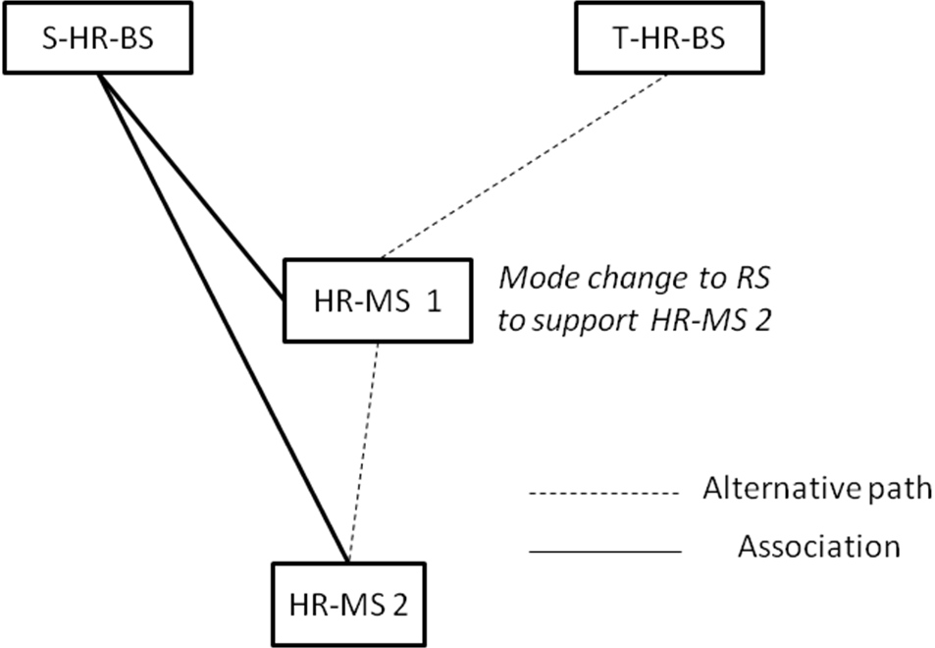
Figure 1: Atlernative Path involving mode change.

An alternative path may involve a mode change in order to support other HR-MS that is affected by the same SPOF (see Figure 1). The target HR-BS does not know in advance the presence of those HR-MSes, hence the mode change has to be initiated from HR-MS itself. The handover command from the serving HR-BS includes a bit to convey this information.

Summary
We propose to factor the possibility of multi-mode into alternative path establishment in event of a BS failure, in order to minimize disruption caused. Specifically, we proposed mechanisms to prepare and maintain a failover topology of alternate paths with role-changed stations, and support fast network recovery with failover configuration.

Text Proposal for IEEE 802.16n AWD
Note:
The text in BLACK color: the existing text in AWD
The text in RED color: the removal of existing AWD text
The text in BLUE color: the new text added to the Multi-Carrier DG Text

[-------------------------------------------------Start of Text Proposal---------------------------------------------------]

17.2.7.2.2 Preparation for SPOF with fast network reentry

To support switching to alternative path with fast network reentry, the serving HR-BS transmits MOB_BSHO-REQ message with mode = 0b111 to the HR-MS.
The target HR-BS of the alternative path can request MS context information from the serving HR-BS and recommend a ranging code and slot from the ranging region to facilitate fast network reentry and reduce contention during ranging. However, how to request and recommend is out of this specification. The serving HR-BS indicates to the HR-MS whether an optimized network reentry should be carried out by setting “HO process optimization” bitmap in the MOB_BSHO-REQ message.
The alternative path information may be updated with a new MOB_BSHO-REQ message.
When the trigger condition specified in the TLV of the last MOB_BSHO-REQ is met, the alternative path is activated and fast network reentry is performed by an HR-MS. If the action time is non-zero, the HR-MS shall perform the fast network reentry after the action time expires.

17.2.7.23 Recovery for SPOF

Network reentry including handover as described in 6.3.21 shall be supported in the event of SPOF. Whether MAC context information of the subordinate HR-MS is shared by the infrastructure stations shall be transmitted to HR-MS.

If role change was indicated in MOB_BSHO-REQ, subordinate HR-MS shall establish relay link described in 17.2.1.2.1 after fast network reentry as described in 17.2.7.2.2. This is to support other HR-MS which are affected by the SPOF.

17.3.7.2.2 Preparation for SPOF with fast network reentry

To support switching to alternative path with fast network reentry, the serving HR-BS transmits AAI-HO-CMD message with mode = 0b11, HO Reentry Mode = 0b0 and CDMA_RNG_FLAG = 1 to the HR-MS.
The target HR-BS of the alternative path can request MS context information from the serving HR-BS and recommend a ranging code and slot from the ranging region to facilitate fast network reentry and reduce contention during ranging. However, how to request and recommend is out of this specification. The serving HR-BS may indicate to the HR-RS that an optimized network reentry should be carried out by setting “Reentry process optimization” bitmap in the AAI-HO-CMD message.
The alternative path information may be updated with a new AAI-HO-CMD message.

When the trigger condition specified in the TLV of the last AAI-HO-CMD is met, the alternative path is activated and fast network reentry is performed by an HR-MS. If the action time is non-zero, the HR-MS shall perform the fast network reentry after the action time expires.

17.3.7.23 Recovery for SPOF

Network reentry including handover as described in 16.2.6 and 16.2.8.2.9 shall be supported in the event of SPOF. Whether MAC context information of the subordinate HR-MS is shared by the infrastructure stations shall be transmitted to HR-MS.

If role change was indicated in AAI-HO-CMD, subordinate HR-MS shall establish relay link described in 17.3.1.2.1 after fast network reentry as described in 17.3.7.2.2. This is to support other HR-MS which are affected by the SPOF.

[Modify 6.3.2.3.47 as follows:]

Table 144 – MOB_BSHO-REQ message format
Syntax | Size (bit) | Notes
…
Mode | 3 | 0b000: HO Request  0b001: MDHO/FBSS request: Anchor BS update with CID update  0b010: MDHO/FBSS request: Anchor BS update without CID update  0b011: MDHO/FBSS request: Diversity set update with CID update  0b100: MDHO/FBSS request: Diversity set update without CID update  0b101: MDHO/FBSS request: Diversity set update with CID update for newly added BS  0b110: MDHO/FBSS request: Diversity set update without CID update for newly added BS  0b111: Reserved.  0b111: Alternative Path (only for HR-Network)
Padding | 5 | Shall be set to zero.
If (Mode == 0b000 or 0b111) | - | -
…
HO_authorization policy indicator | 1 | Indicates whether Seamless HO mode is supported  0: Not supported  1: Supported
Seamless HO mode flag | 1 | Indicates whether Seamless HO mode is supported  0: Not supported  1: Supported
If (Mode == 0b111) { | - | -
Role | 1 | 0b0: Stay as HR-MS;  0b1: Change to HR-RS;
CDMA_code | 8 | -
Transmission_opportunity_offset | 8 | -
Basic CID | 16 | -
}

Action Time
For HO, this value is defined as number of frames until the Target BS allocates a dedicated transmission opportunity for RNG-REQ message to be transmitted by the MS using Fast_Ranging_IE. Dedicated allocation for transmission of RNG-REQ means that channel parameters for that BS learned by the MS before HO stay valid and can be reused during actual Network Re-entry without preceding CDMA-based Ranging. Final Action Time shall be decided by the Serving BS based on the information obtained from potential Target BSs over the backbone network. A value of zero indicates no opportunity to allocate Fast Ranging IE in any candidate target BS.

For MDHO/FBSS, this is the time of update of Anchor BS and/or Diversity Set. A value of zero in this parameter signifies that this parameter shall be ignored.

For Alternative Path, this is the wait time in units of 1 ms before the HR-MS performs fast network reentry to target station.

[Modify 16.2.3.12 as follows:]

Table 695 – AAI-HO-CMD message format
Field | Size (bits) | Value/Description | Condition
Mode | 2 | 0b00: HO command;  0b01: Zone switch command from MZone to LZone;  0b10: AMS HO request rejected (ABS in list unavailable). In this case, AAAI-HO-CMD message shall not include any T-ABS.  0b11: Reserved.  0b11: Alternative Path (only for HR-Network).
If (Mode == 0b00 or 0b11) {
…
Resource_Retain_Time | 16 | The duration in units of 100 ms to which the T-ABD set the ABS-Resource-Retain-Timer | Present if needed
If (HO Reentry Mode == 0b11) {
Role | 1 | 0b0: Stay as HR-MS;  0b1: Change to HR-RS;
} //end of If (HO Reentry Mode == 0b11) | - | -
…
Action Time | 8 | If HO Reentry Mode is 0b11, it is the wait time in units of 1 ms before the HR-MS starts to perform fast network reentry.  Otherwise, it is Tthe 8 least significant bits of the absolute frame number at the TABS where the AMS starts to perform network reentry.  When CDMA_RNG_FLAG is set to 1, it indicates the frame whereafter the AMS starts a CDMA ranging process. The action time should be set to a frame that includes either a nondynamic ranging channel or a dynamic ranging channel.  When CDMA_RNG_FLAG is set to 0, it indicates the frame where the AMS starts to expect the UL bandwidth allocation for transmission of RNG-REQ at target R1 BS or LZone (i.e., Fast ranging opportunity) or AAI-RNG-REQ at T-ABS.

[-------------------------------------------------End of Text Proposal----------------------------------------------------]

Use of IEEE-Copyrighted Conference and Journal Papers
The IEEE 802.16 Working Group has obtained permission to post IEEE-copyrighted material from IEEE conferences and publications when received in an official contribution to the Working Group. IEEE requires two conditions:
- A full copyright and credit notice must be posted at the top of the paper in the following format:
Copyright ©2002 Institute of Electrical and Electronics Engineers, Inc. Reprinted, with permission, from [all relevant journal info].
This material is posted here with permission of the IEEE. Internal or personal use of this material is permitted. However, permission to reprint/republish this material for advertising or promotional purposes or for creating new collective works for resale or redistribution must be obtained from the IEEE (contact pubs–permissions@ieee.org).
By choosing to view this document, you agree to all provisions of the copyright laws protecting it.
- If the author is not the submitter of the contribution, the author’s written approval for the reuse of the material must be attached.

