Project | IEEE 802.16 Broadband Wireless Access Working Group <http://ieee802.org/16>
Title | Priority Access Path Management for 802.16n
Date Submitted | 2011-08-31
Source(s) | An Nguyen  DHS/NCS | An.P.Nguyen@dhs.gov
Re: | Call for Contribution on 802.16n Amendment Working Document.
Abstract | The document describes the proposed text for supporting priority access path management.
Purpose | Request consideration of texts contained herein for the 802.16n Amendment Working Document.
Notice | This document does not represent the agreed views of the IEEE 802.16 Working Group or any of its subgroups. It represents only the views of the participants listed in the “Source(s)” field above. It is offered as a basis for discussion. It is not binding on the contributor(s), who reserve(s) the right to add, amend or withdraw material contained herein.
Release | The contributor grants a free, irrevocable license to the IEEE to incorporate material contained in this contribution, and any modifications thereof, in the creation of an IEEE Standards publication; to copyright in the IEEE’s name any IEEE Standards publication even though it may include portions of this contribution; and at the IEEE’s sole discretion to permit others to reproduce in whole or in part the resulting IEEE Standards publication. The contributor also acknowledges and accepts that this contribution may be made public by IEEE 802.16.
Patent Policy | The contributor is familiar with the IEEE-SA Patent Policy and Procedures:  <http://standards.ieee.org/guides/bylaws/sect6-7.html#6> and <http://standards.ieee.org/guides/opman/sect6.html#6.3>.  Further information is located at <http://standards.ieee.org/board/pat/pat-material.html> and <http://standards.ieee.org/board/pat>.

Priority Access Path Management for 802.16n

Introduction
Priority access is one of the important requirements of the Emergency Telecommunications Service (ETS) [1]. ETS is a telecommunications service to facilitate emergency recovery operations for restoring the community infrastructure and for returning the population to normal living conditions after serious disasters and events, such as floods, earthquakes, hurricanes, and terrorist attacks. The ETS will be provided through shared resources from the public telecommunications infrastructure, which includes wireline, wireless, satellite, broadband cable, and any hybrid networks. ETS traffic needs to access, traverse, and egress these networks. Voice, video and data services are supported by ETS.

The DHS/NCS initiatives: Next Generation Network (NGN) Government Emergency Telecommunications Service (GETS), Legacy GETS, and Wireless Priority Service (WPS) are the USA instantiation of the international standard for ETS. Especially, the GETS and WPS respond to the White House’s requirement for "national security and emergency preparedness communications …under all circumstances including crisis or emergency, attack, recovery, and reconstitution…" (Executive Order 12472). Priority access is required for National Security and Emergency Preparedness (NS/EP) users for conducting their missions effectively during disasters using various 3G/4G wireless technologies including WiMAX.

This contribution proposes text relating to path management for priority access operation for Sections 17.2.8 and 17.3.8 in 802.16n Amendment Working Document (AWD).

Overview
Previous contributions have discussed various communication mechanisms that can be used to enhance priority access services in 802.16n networks, such as mobile direct communication (MDC) [3], mobile forwarding, local forwarding [4], and multi-mode operation [5]. With several possible mechanisms available for an HR-MS to communicate with another HR-MS or backhaul network, the network will need to determine which communication path and their associated mechanisms to use for any given request. To perform this function, infrastructure stations must employ a path management scheme which can discover and maintain all possible paths between endpoints in the 802.16n system. HR-BSs and HR-RSs need to continuously discover and monitor alternate paths through network as the state of the network changes so proper communication paths are chosen for new requests.

It is assumed that all service requests will still be received and processed by the HR-BS serving the area, as is the case in existing 802.16 networks. Thus, only the HR-BS will need to implement and perform the full functions of path management. All other nodes in the network will only be responsible for forwarding data along the path specified by the HR-BS, and relaying network state information to the HR-BS that affects path selection. Much of this data is already collected and maintained at infrastructure nodes during normal operation. Each HR-BS shall maintain a table that summarizes the state of the network, including all connected infrastructure and mobile nodes. From this data, the HR-BS will determine the best communication path to use when a new service request is received or the state of the network changes in a way that affects a currently serviced request. The “best” communication path is determined by combining the weights of each hop in the path.

The implementations details of path management discovery algorithms, such as the exact weighting of path metrics, are to be implementation dependent and beyond the scope of this contribution. The remainder of this contribution discusses general guidelines for inclusion into the 802.16 standard that path management algorithms should follow for providing enhanced priority access services.

Path Selection Precedence Guidelines
Certain paths should be given preference over others in order to provide adequate QoS, maximize device battery life, and maximize spectrum efficiency for priority users. In this section, guidelines for path management selection criteria are summarized. A flow chart that summarizes the order of preferences that path management implementations should follow is provided in Figure 1. An example is shown in Figure 2 and discussed below to illustrate the order of preference that should be used when setting up a communication channel to service a data request.

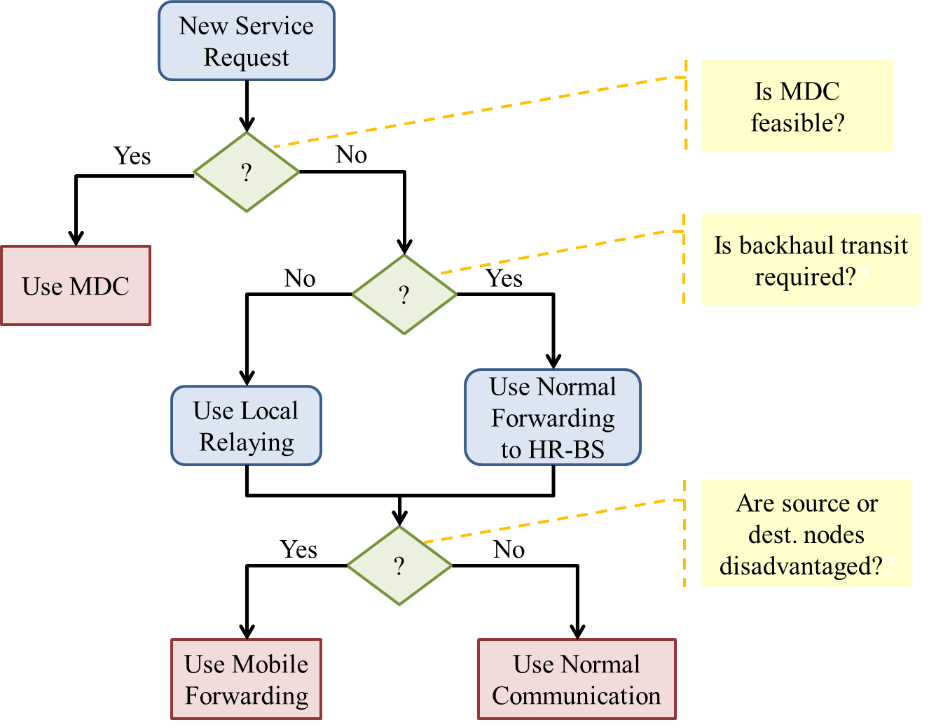
Figure 1: Path Management Flowchart

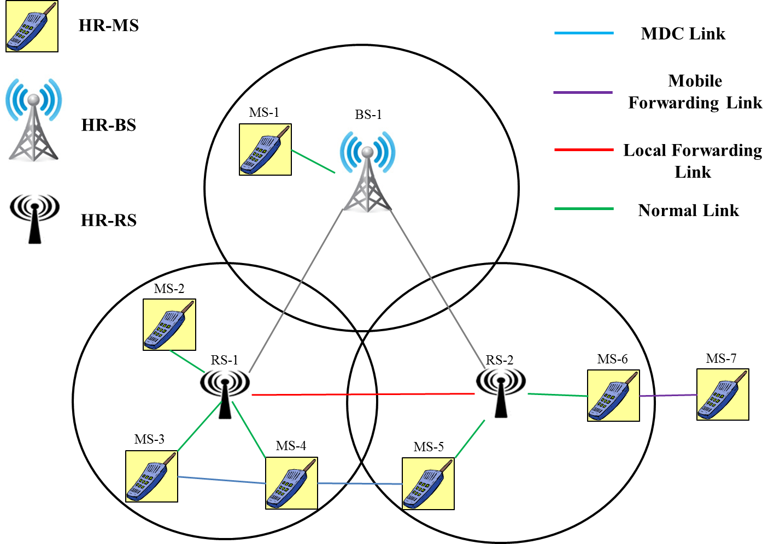
Figure 2: Priority Access Framework Example Network

For communication between two priority users in an 802.16 network, the following order of preferences should be considered:
- MDC – When two HR-MSs are within range to communicate directly with each other, MDC should be considered first as it allows users to communicate directly for transport traffic without the involvement of infrastructure stations. In Figure 1 for example, MDC should be used first for communication between MS-4 and MS-3, or MS-4 and MS-5. MDC also covers the scenario where one, but not both, of the participants are out of range of any infrastructure station (e.g. communication between MS-6 and MS-7).
- Local Relaying – If two HR-MSs are within service range of infrastructure stations, but outside communication range of each other, then local relaying should be employed first to limit the number of infrastructure stations and OTA hops involved in the communication. In the Figure 1 example, communication between MS-2 and MS-6 should use the local relaying connection between RS-1 and RS-2. Local relaying can also be chosen over MDC in cases where the effective data rate between two HR-MSs through the infrastructure station is greater than the achievable data rate via MDC, and a higher data rate is required to meet the service requirement between two MS’s. For example, MS-2 and MS-3 might be within the range of each other to perform MDC, but the effective data rate between the two using local forwarding through RS-1 may be greater which can meet the service requirement, in which case local forwarding via RS-1 should take precedence.
- Normal communication – If MDC or local relaying can’t provide enhanced service, normal service from HR-MS to HR-BS shall be provided. These are represented by the green links in Figure 1.
- Mobile forwarding – Mobile forwarding should only be used to support a disadvantaged node, i.e. when no other means of providing service to the HR-MS is available, since mobile forwarding requires the donor HR-MS to sacrifice its own bandwidth and battery power to support another node’s communication. Priority users are not expected to provide mobile forwarding to normal users. Thus if MS-7 was a normal user and MS-6 was a priority user, MS-6 would not offer mobile forwarding service to MS-7. However, if both MS-7 and MS-6 are priority users, and the priority level of MS-7 is equal to or higher than that of MS-6, MS-6 will offer mobile forwarding service to MS-7.

  - Multi-Mode Nodes
When a node changes roles, the HR-BS serving the area must be notified of the change along with any other information necessary to update its path management database. This includes the case where a multi-mode node changes to assume the role of an HR-BS.

A multi-mode node must be capable of performing all path management activities if it wishes to support the role of an HR-BS. Multi-mode nodes that have assumed the role of an HR-BS shall perform the path management functions the same as any other HR-BS. In any other role, a multi-mode node is not responsible for performing path selection or maintaining path management information.

Recommended Text
Section 17.2.8 (HR-OFDMA Air interface)

Infrastructure stations must employ a path management scheme which can discover and maintain all possible paths between endpoints in the 802.16 system. HR-BSs and HR-RSs need to continuously discover and monitor alternate paths through network as the state of the network changes so proper communication paths are chosen for new requests.

Each HR-BS shall maintain a database of the state of the network to determine the best communication path to use when a new service request is received or the state of the network changes in a way that affects a currently serviced request. The “best” communication path is determined by combining the weights of each hop in the path.

The following precedence order should be followed when performing path selection:
- MDC
- Local Relaying
- Normal Communication
- Mobile Forwarding

Section 17.3.8 (Advanced Air Interface)
Same as the proposed text for 17.2.8.

Conclusions
We have presented the proposed text for path management in relation to priority access operation. We would like the proposed test to be included in Sections 17.2.8 and 17.3.8 of 802.16n AWD.

References
[1] “Overview of Standards in Support of Emergency Telecommunication Service (ETS),” ATIS-pp-0100009, November 2006.
[2] “Wireless Priority Service for National Security / Emergency Preparedness: Algorithms for Public Use Reservation and Network Performance,” Nyquetek Inc., August 30, 2002.
[3] An Nguyen, "Priority Access for Mobile to Mobile Direct Communication and Forwarding", C802.16n-11/0001r1, March 2011.
[4] An Nguyen, "Local Forwarding for Enhanced Priority Access", C802.16n-11/0063, May 2011.
[5] An Nguyen, "Priority Access Operation in 802.16n Networks ", C802.16n-11/0105, July 2011.

