Project | IEEE 802.16 Broadband Wireless Access Working Group <http://ieee802.org/16>
Title | Frame Structure for Talk-around Direct Communications
Date Submitted | 2011-09-20
Source(s) | Young-Ho Jung, Jihoon Choi  Korea Aerospace University  Sungcheol Chang, Seokki Kim, Eunkyung Kim, Miyoung Yun, Won-Ik Kim, Sungkyung Kim, Hyun Lee, Chulsik Yoon, Kwangjae Lim  ETRI | E-mail:  yhjung@kau.ac.kr, jihoon@kau.ac.kr  scchang@etri.re.kr
Re: | Call for Comments on the 802.16n AWD
Abstract | This provides AWD text proposals for frame structure of talk-around direct communications
Purpose | To be discussed and adopted by 802.16 TGn
Notice | This document does not represent the agreed views of the IEEE 802.16 Working Group or any of its subgroups. It represents only the views of the participants listed in the “Source(s)” field above. It is offered as a basis for discussion. It is not binding on the contributor(s), who reserve(s) the right to add, amend or withdraw material contained herein.
Release | The contributor grants a free, irrevocable license to the IEEE to incorporate material contained in this contribution, and any modifications thereof, in the creation of an IEEE Standards publication; to copyright in the IEEE’s name any IEEE Standards publication even though it may include portions of this contribution; and at the IEEE’s sole discretion to permit others to reproduce in whole or in part the resulting IEEE Standards publication. The contributor also acknowledges and accepts that this contribution may be made public by IEEE 802.16.
Patent Policy | The contributor is familiar with the IEEE-SA Patent Policy and Procedures:  <http://standards.ieee.org/guides/bylaws/sect6-7.html#6> and <http://standards.ieee.org/guides/opman/sect6.html#6.3>.  Further information is located at <http://standards.ieee.org/board/pat/pat-material.html> and <http://standards.ieee.org/board/pat>.
Frame Structure for Talk-around Direct Communications
Young-Ho Jung, Jihoon Choi
Korea Aerospace University
Sungcheol Chang, Seokki Kim, Eunkyung Kim, Miyoung Yun, Won-Ik Kim, Sungkyung Kim, Hyun Lee, Chulsik Yoon, Kwangjae Lim
ETRI

1. Introductions
To support direct communication in IEEE 802.16n, some dedicated resources can be assigned as described in [1]. By dedicatedly reserving a part of communication resources for infra-structure communications, the reserved resources are used to provide multiple pairs of direct communication in OFDMA (orthogonal frequency division multiple access) manner with contention based transmission. In the current version of the IEEE 802.16n AWD [2], resources and frame structures for TDC (talk-around direct communication) are described based on the text proposal suggested in [3], however, some additions and changes are required to improve the degree of completion.
This contribution provides AWD text proposals of resource segmentation and frame structure for 16n TDC. In this contribution, “Common Direct Mode Zone Extended (CDMZ-E)” is newly defined, and frame structures for CDMZ-E and Cell Specific Direct Mode Zone (CSDMZ) are proposed. In addition, frame structures for CDMZ are revised to support VOIP packets more efficiently.

2. References
- IEEE C802.16n-11/0051r2, “Dedicated resources allocation for direct communications in IEEE 802.16n,” March 2011.
- IEEE 802.16n-11/0015, “802.16n Amendment Working Draft,” August 2011.
- IEEE C802.16n-11/0130r1, “Frame structure for talk-around direct communications,” July 2011.

3. Proposed Text for the 802.16n Amendment Working Document (AWD)
Note:
The text in BLACK color: the existing text in the 802.16n Amendment Draft Standard
The text in RED color: the removal of existing 802.16n Amendment Draft Standard Text
The text in BLUE color: the new text added to the 802.16n Amendment Draft Standard Text

[-------------------------------------------------Start of Text Proposal---------------------------------------------------]

[Remedy1: Adapt the following change in Section 17.3.2.6 in the 802.16n AWD]
17.3.2.6 Talk-around Direct Communication
[note: This contribution provides text proposals for the following sections:
17.3.2.6.2 Physical layer
17.3.2.6.2.1 Frame structure]

17.3.2.6.2.1 Frame structure
17.3.2.6.2.1.1 Resources for talk-around direct communication
For talk-around direct communication, two types of infra-structure communication resources are dedicatedly assigned:
- Common Direct Mode Zone (CDMZ): set of PRUs in the uplink infra-structure communication resources with fixed size and positions which are commonly assigned to all cells (must be CRU)
- Common Direct Mode Zone Extended (CDMZ-E): set of PRUs in the downlink infra-structure communication resources with fixed size and positions which are commonly assigned to all cells (must be CRU)
- Cell Specific Direct Mode Zone (CSDMZ): additionally assigned direct-mode resource blocks independently assigned by each HR-BS (CRU or DRU) and information to receive cell specific direct mode region can be obtained from common direct mode zone
Figure 912 shows an example of talk-around direct communication resource allocation. In the figure, some part of uplink infra structure resources are assigned for CDMZcommon direct mode zone, some part of downlink infra-structure resources are assigned for CDMZ-E, and some part of uplink and downlink infra structure communication resources are assigned for CDMZcell specific direct mode zone. By assigning the same physical resources for common direct mode zoneCDMZ and CDMZ-E the following benefits can be obtained:
- Reduce the overhead of control channels to transmit allocation information of resources for direct-mode communication
- Reduce the computation complexity and power to obtain synchronization for direct communication, specially for the HR-MSs in the outside of HR-BS coverage
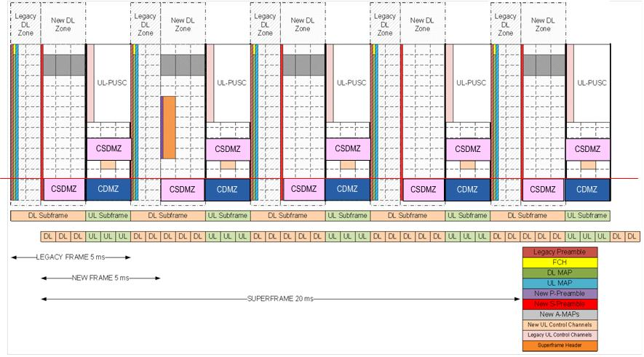
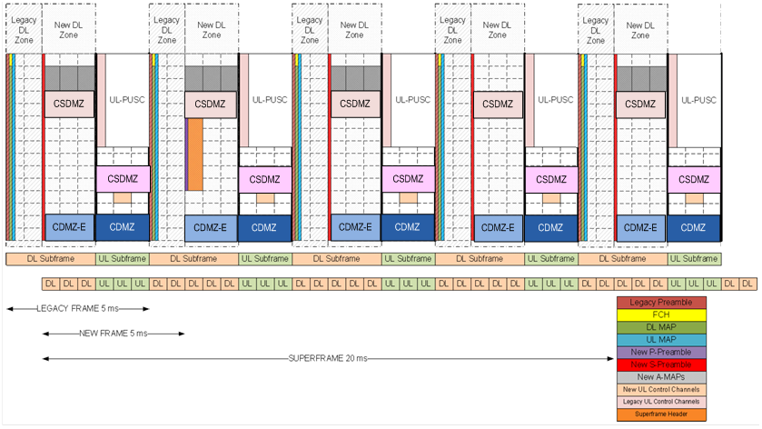

Figure 912. An example of talk-around direct communication resource allocation

The highest four PRUs of uplink resources are assigned for Common Direct Mode Zone (CDMZ). For FFT size = 512, PRU 20, 21, 22, 23 are assigned for CDMZ, for FFT size = 1024, PRU 44, 45, 46, 47 are assigned for CDMZ, and for FFT size = 2048, PRU 92, 93, 94, 95 are assigned for CDMZ. The highest four PRUs of downlink resources are assigned for Common Direct Mode Zone Extended(CDMZ-E). For FFT size = 512, PRU 20, 21, 22, 23 are assigned for CDMZ-E, for FFT size = 1024, PRU 44, 45, 46, 47 are assigned for CDMZ-E, and for FFT size = 2048, PRU 92, 93, 94, 95 are assigned for CDMZ-E. The resources for Cell Specific Direct Mode Zone (CSDMZ) are multiple of four PRUs, and determined by each HR-BS independently and the assignment information is transmitted in the CDMZ.

17.3.2.6.2.1.2 Frame structure for CDMZ
Logical frame of common direct mode zoneCDMZ is composed by collecting all resources of CDMZ in a superframe as shown in Figure 913. In the example, there are three uplink subframes for each 5msec frame. Frame structure of cell specific direct mode zone is extension of common direct mode frame structure and the details are FFS.
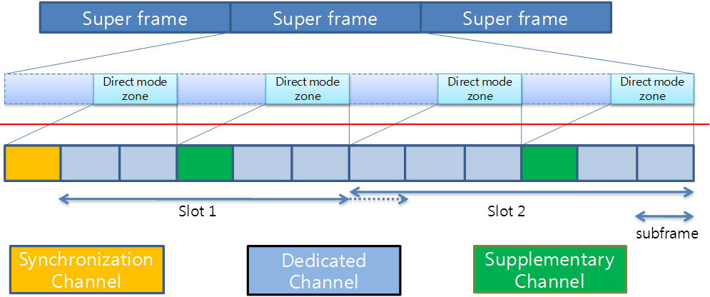

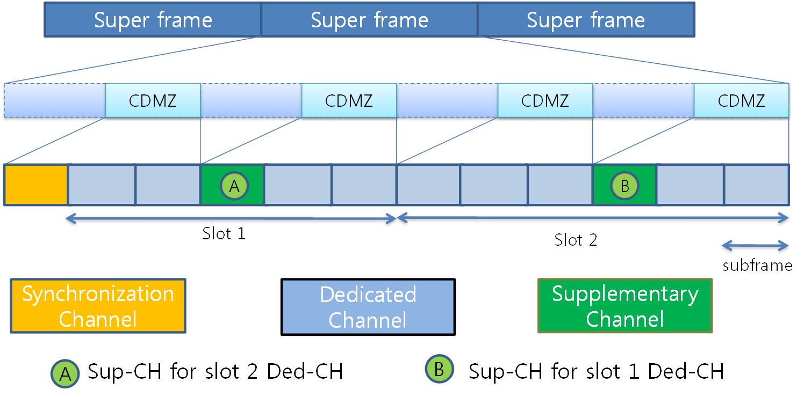
Figure 913. An example of common direct mode logical frame construction

There are three physical channels for CDMZtalk-around direct communication:
- Synchronization Channel (Sync-CH)
- Dedicated Channel(Ded-CH)
- Supplementary Channel(Sup-CH)

The first subframe of the common direct modeCDMZ logical frame is occupied by synchronization channel. All the HR-MSs receives the synchronization signal on the Synchronization channelSync-CH except HR-MSs transmitting the synchronization signalsSync-CH. The HR-MSs are synchronized to the received synchronization signal if the signal timing has priority to HR-MS’s synchronization timing itself. The details of timing priority is FFS. Some HR-MSs sends the synchronization signal on the Sync-CHhronization channel at selected subframes. HR-MS selects its slots for sending synchronization timing in distributed way. The details of how to select is FFS. The synchronization channel is composed of two parts: synchronization channel preamble part (P-SCH1) and synchronization message part (P-SCH2). The synchronization channel preamble part is used for acquiring time and frequency synchronization, and synchronization sequence part is used for transmitting SYNC-CH IE which includes some information including frame structure information, hop count, transmitter ID et. al. The detailed design of synchronization channel is described in 17.3.2.6.2.2.17.3.2.6.2.3.1
Resources excluding the first subframe assigned for Sync-CHsynchronization channel are assigned for Ded-CHdedicated channels and Sup-CHsupplementary channels. If there are N_{subframe_per_fame} subframes in a 5ms frame, (N_{subframe_per_fame} +1)-th subframe and (3N_{subframe_per_fame} +1)-th subframe are assigned for Sup-CH and the other resources are assigned for Ded-CH.
A dDedicated channel is a physical channel resource to send direct communication packets for two HR-MSs or a group of HR-MSs. An HR-MS sends a packet on one or more than one dedicated subchannels of dedicated channel and the other HR-MSs receives the packet on it. If two HR-MSs and a group of HR-MSs are involved, the transmissions are unicast and multicast, respectively. How to configure the resource of dedicated channel is discussed in described in 17.3.2.6.2.3.2. The resources for dedicated channel is divided into small size sub-blocks (mRB: mini-Resource Block), as shown in Figure 914. One mRB is composed of 6 subcarriers-by-6 OFDM symbols, and there are 12 mRBs for each subframe (4PRU/ 1/3 PRU = 12). In the figure 914, mRB i-j denotes j-th mRB in the i-th subframe. A dedicated subchannel is composed of a collection of 9 12 mRBs distributed across the entire frequency region in the slot.
Figure 914. An example of common direct mode zoneCDMZ resource segmentation and construction of mRBs and m-tiles (3 UL subframes/ 5msec frame)

A supplementary sub-channel is one-to-one mapped with each a dedicated sub-channel. As shown in Figure 913, Sup-CH for Ded-CH in slot 1 is located in slot 2, and Sup-CH for Ded-CH in slot 2 is located in slot 1. By using the supplementary sub-channel, the following indication of MAC message transmissions, PHY signalings and short feedback messages related with the corresponding dedicated subchannel are transmitted.
- MAC messages: indication of MAC messages e.g. RTS, CTS for corresponding dedicated subchannel, MCS information, ranging response et. al.
- PHY signalings: periodic ranging sequence, sounding signal et. al.
- Short feedback messages: ACK, NACK, CQI, CSI, RI (rank information) et. al.

An subframe mRB for supplementary sub-channel is divided into 36 mini-tiles divided into two half-mRB as shown in Figure 914, and a mini-tile half mRB is composed of 23 subcarriers-by- 5 OFDM symbols. Since all HR-MSs should listen the supplementary channels, to obtain Tx. And Rx. Switching time, no signal is transmitted in the last OFDM symbol of supplementary channel (6th OFDM symbol). The details of Sup-CHsupplementary channel design are discussed in described in 17.3.2.6.2.417.3.2.6.2.3.3.

17.3.2.6.2.1.3 Frame structure for CDMZ-E and CSDMZ
The frame structure for CDMZ-E and CSDMZ is an extension of the frame structure of CDMZ. The only difference is that there is no Sync-CH in the CDMZ-E and CSDMZ. As shown in Figure xxx, The first subframe is assigned for Ded-CH. If 4 more than four PRUs are assigned for CSDMZ (multiples of 4), a CSDMZ frame is composed by four PRUs in the UL or DL resources, and there are multiple CSDMZ frames. For example, if eight DL PRUs and four UL PRUs are assigned for CSDMZ, there are two CSDMZ frames in the DL resources, and one CSDMZ frame in the UL resource.

Figure xxx. An example of CDMZ-E or CSDMZ resource segmentation and construction of mRBs and m-tiles (3 UL subframes/ 5msec frame)

17.3.2.6.2.1.4 Construction of dedicated subchannels for each TDC frame
For a TDC frame, if there are N_{subframe_per_fame} subframes in a 5ms frame, a logical TDC frame is composed of 4N_{subframe_per_fame} subframes, and resources for Ded-CH are divided into dedicated subchannels. The number of dedicated subchannels in slot 1 and 2 are summarized in the Table aaa, and Table bbb. A dedicated subchannel is composed of 12 mRBs distributed across the entire four PRUs in the slot.
Table aaa. The number of dedicated sub-channels according to N_{subframe_per_fame} (CDMZ)
N_{subframe_per_fame} | The number of dedicated sub-channels in the slot 1  (N_{ded-subchannel,1}) | The number of dedicated sub-channels in the slot 2  (N_{ded-subchannel,2}) | Total number of dedicated sub-channels  (N_{ded-subframe})
2 | 2 | 3 | 5
3 | 4 | 5 | 9
4 | 6 | 7 | 13
5 | 8 | 9 | 17

Table bbb. The number of dedicated sub-channels according to N_{subframe_per_fame} (CDMZ-E and CSDMZ)
N_{subframe_per_fame} | The number of dedicated sub-channels in the slot 1  (N_{ded-subchannel,1}) | The number of dedicated sub-channels in the slot 2  (N_{ded-subchannel,2}) | Total number of dedicated sub-channels  (N_{ded-subframe})
2 | 3 | 3 | 6
3 | 5 | 5 | 10
4 | 7 | 7 | 14
5 | 9 | 9 | 18

mRBs for each dedicated subframe are assigned by the following assignment method:
-Step 1: For each slot 12 successive mRBs are temporally assigned from subframe 1 to subframe N_{ded-subframe,1} in slot 1, and from subframe N_{ded-subchannel,1}+1 to subframe N_{ded-subchannel,1} + N_{ded-subchannel,2} in slot 2, in time first manner.
-Step 2: For each subframe mRBs are permuted by using the permutation sequence generated by using the method in 16.3.4.3.3 with parameters of M=12, and SEED = 343*subframe index.

Figure xyx shows an example of mRB assignment for dedicated subchannels, when N_{subframe_per_fame} = 3, N_{ded-subchannel,1} = 4, and N_{ded-subframe,2}=5.

Figure xyx. An example of mRB assignment for supplementary subchannels when N_{subframe_per_fame} = 3, N_{ded-subchannel,1} = 4, and N_{ded-subchannel,2}=5.

17.3.2.6.2.1.5 Construction of supplementary subchannels for each TDC frame
There are 36 mini-tiles for supplementary subchannels. For the n-th supplementary subchannel corresponding to the n-th dedicated subchannel, four mini-tiles with indices of mod(mini-tile index-1, 9)+1 = mod(n-1, 9)+1 in the different slot are assigned. For example, the 5-th supplementary subchannel is composed of mini-tile 5, 14, 23, and 32, and the 12-th supplementary subchannel is composed of mini-tile 3, 12, 21, and 30.

[-------------------------------------------------End of Text Proposal----------------------------------------------------]

