Project | IEEE 802.16 Broadband Wireless Access Working Group <http://ieee802.org/16>
Title | Local Forwarding in IEEE 802.16n
Date Submitted | 2011-09-12
Source(s) | Eunkyung Kim, Sungcheol Chang, Won-Ik Kim, Seokki Kim, Sungkyung Kim, Miyoung Yun, Hyun Lee, Chulsik Yoon, Kwangjae Lim  ETRI | E-mail:  ekkim@etri.re.kr  scchang@etri.re.kr
Re: | “IEEE 802.16n-11/0013r1,” in response to Call for Comments on 802.16n (GRIDMAN) AWD
Abstract | Proposed text related to local forwarding in 802.16n
Purpose | To discuss and adopt the proposed text in the AWD of 802.16n
Notice | This document does not represent the agreed views of the IEEE 802.16 Working Group or any of its subgroups. It represents only the views of the participants listed in the “Source(s)” field above. It is offered as a basis for discussion. It is not binding on the contributor(s), who reserve(s) the right to add, amend or withdraw material contained herein.
Release | The contributor grants a free, irrevocable license to the IEEE to incorporate material contained in this contribution, and any modifications thereof, in the creation of an IEEE Standards publication; to copyright in the IEEE’s name any IEEE Standards publication even though it may include portions of this contribution; and at the IEEE’s sole discretion to permit others to reproduce in whole or in part the resulting IEEE Standards publication. The contributor also acknowledges and accepts that this contribution may be made public by IEEE 802.16.
Patent Policy | The contributor is familiar with the IEEE-SA Patent Policy and Procedures:  <http://standards.ieee.org/guides/bylaws/sect6-7.html#6> and <http://standards.ieee.org/guides/opman/sect6.html#6.3>.  Further information is located at <http://standards.ieee.org/board/pat/pat-material.html> and <http://standards.ieee.org/board/pat>.

Local Forwarding in IEEE 802.16n
Eunkyung Kim, Sungcheol Chang, Won-Ik Kim, Seokki Kim, Sungkyung Kim, Miyoung Yun, Hyun Lee, Chulsik Yoon, Kwangjae Lim
ETRI

Introductions
IEEE 802.16n AWD [4] describes some functional description based on the 802.16n SRD [1]. Local forwarding is a requirement allowing an HR-MS to communicate with one or more HR-MSs via an HR-infrastructure station without going through the backhaul, while ASN localized routing (ALR) in WiMAX allows communication between MSs whose data paths are anchored on the same ASN-GW.
In order to support local forwarding as well as backward compatibility, ALR needs to be considers how to support local forwarding.
This contribution provides overall concept of ALR and how to support local forwarding.

ASN Localized Routing (ALR) in WiMAX
ALR feature involves creating a direct data-path between two communicating MSs whose data paths are anchored on the same ASN-GW. The ASN-GW capable of ALR can allow IP traffic to directly flow between those MSs without traversing the CSN(s). Enabling ALR on an end-to-end flow requires the involved ASN and CSN(s) to support the ALR feature. CSN(s) to authorize ALR on service flows compose the end-to-end flow, and ASN and/or CSN detect the end-to-end flow. Figure 1 shows scenarios of ALRs. As shown the Figure 1, the shortest path the path for the ALR.

The first scenario, which routes data between MSs inside an ASN, meets the requirement on the local forwarding in IEEE 802.16n.

To detect the ALR, ASN-GW checks following:
- the source & destination IP addresses(IP1, IP2) of the received packet
- the destination MS’ location per the destination IP address
- if both of the addresses are globally routable & both MSs are anchored on the ASN GW
- if destination MS has a DL service flow using the destination IP address
HA/CR also checks
- The source & destination IP address (IP1, IP2) of the received packet
- If both of addresses are belong to the same address domain (i.e., either globally routable or from same private network)
- if destination MS has a DL service flow using the destination IP address

When the ALR is detected, some exchange has to be performed but how to exchange is showing in Figure 2
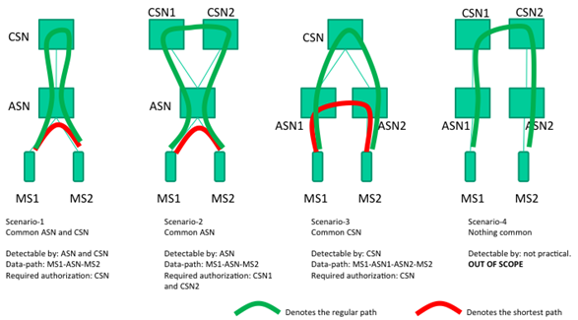
Figure 1 - Scenarios of ALR [5]

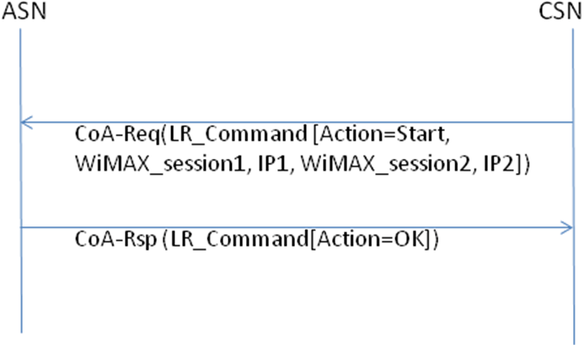
Figure 2 - ALR command for scenario1

Local Forwarding Procedure
Figure 3 shows a local forwarding procedure.
When an MS(1) requests to communicate with the other MS(2), the MS1 requests to establish service flow using REQ1 and RSP4 message. When REQ1 is received by BS1/RS1, BS1/RS1 and ASN-GW exchanges some signaling (REQ2/RSP3) whether destination MS2 is inside the coverage of BS1/RS1. When the local forwarding is possible to operate between MS1 and MS2, an FID for uplink for MS1 and an FID for downlink for MS2 are assigned by BS1/RS1. When the communication between MS1 and MS2 needs to end, similar messages (REQ12/REQ13) are exchanged between BS1/RS1 and ASN-GW. Thus, BS1/RS1 & ASN-GW exchanges some signaling to start/end local FWD (REQ²/REQ³/REQ¹²/REQ¹³). In addition, signaling is exchanged inside ASN (R6; via backbone or internal signaling).
Data transmission between MS and BS is the same operation as that defined in IEEE 802.16.

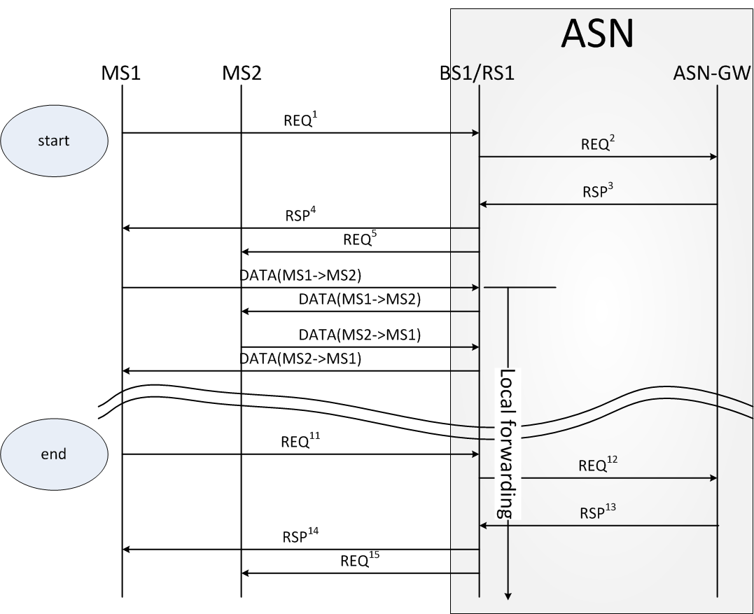
Figure 3 - Local forwarding procedure

References
- IEEE 802.16n-10/0048r2, “802.16n System Requirements Document including SARM annex,” July 2011.
- IEEE Std. 802.16TM-2009, “IEEE Standard for Local and metropolitan area networks; Part 16: Air Interface for Broadband Wireless Access Systems,” May 2009.
- IEEE 802.16mTM-2011, IEEE Standard for Local and metropolitan area networks; Part 16: Air Interface for Broadband Wireless Access Systems; Amendment 3: Advanced Air Interface,” May 2011.
- IEEE 802.16n-11/0015, “802.16n Amendment Working Draft,” August 2011.
- LocalRouting_0004_r001, WiMAX Localized Routing, July 2010

Proposed Text for the 802.16n Amendment Working Document (AWD)

[-------------------------------------------------Start of Text Proposal---------------------------------------------------]
[Remedy: Replace the whole text in 17.3.6 by the following text in the 802.16n AWD.]
When local forwarding opportunity is determined, an HR-MS may communicate with one or more HR-MSs via an HR-infrastructure station without going through the backhaul.
An infrastructure station capable of providing local forwarding shall (re)assign and manage the FID for the HR-MS during DSA procedure. Any available FID may be used for the local forwarding (i.e., there are no dedicated FIDs for local forwarding connections). An HR-MS may not be aware of local forwarding but shall follow the same procedure defined in 16.2.
Data traffic for HR-MSs sent on the connection with the FID shall be forwarded to other one or more HR-MSs without going through the backhaul. Each MAC PDU shall begin with a Generic MAC Header. The format of AGMH is the same as defined in 16.2.2.1.1. The AGMH may be followed by one or more extended headers. The MAC PDU shall also contain a payload. The payload consists of one or more HR-MSs’ data traffic. MAC PDUs sent on the connection used by local forwarding shall follow the same format as shown in Figure 386.

[-------------------------------------------------End of Text Proposal----------------------------------------------------]

