Project | IEEE 802.16 Broadband Wireless Access Working Group <http://ieee802.org/16>
Title | Dual-role operation of HR-MS acting as relay
Date Submitted | 2011-11-08
Source(s) | Won-Ik Kim, Eunkyung Kim, Sungkyung Kim, Sungcheol Chang, Miyoung Yun, Seokki Kim, Hyun Lee, Chulsik Yoon, Kwangjae Lim  ETRI  Seokjoo Shin  Chosun University | E-mail:  woniks@etri.re.kr  ekkim@etri.re.kr  scchang@etri.re.kr  sjshin@chosun.ac.kr
Re: | “IEEE 802.16n-11/0025,” in response to the 802.16n (GRIDMAN) AWD Call for Comments
Abstract | This contribution is a proposal related to multimode operation in IEEE 802.16.1a.
Purpose | To discuss and adopt the proposed text in the AWD of 802.16n
Notice | This document does not represent the agreed views of the IEEE 802.16 Working Group or any of its subgroups. It represents only the views of the participants listed in the “Source(s)” field above. It is offered as a basis for discussion. It is not binding on the contributor(s), who reserve(s) the right to add, amend or withdraw material contained herein.
Release | The contributor grants a free, irrevocable license to the IEEE to incorporate material contained in this contribution, and any modifications thereof, in the creation of an IEEE Standards publication; to copyright in the IEEE’s name any IEEE Standards publication even though it may include portions of this contribution; and at the IEEE’s sole discretion to permit others to reproduce in whole or in part the resulting IEEE Standards publication. The contributor also acknowledges and accepts that this contribution may be made public by IEEE 802.16.
Patent Policy | The contributor is familiar with the IEEE-SA Patent Policy and Procedures:  <http://standards.ieee.org/guides/bylaws/sect6-7.html#6> and <http://standards.ieee.org/guides/opman/sect6.html#6.3>.  Further information is located at <http://standards.ieee.org/board/pat/pat-material.html> and <http://standards.ieee.org/board/pat>.

Dual-role operation of HR-MS acting as relay

Won-Ik Kim, Eunkyung Kim, Sungkyung Kim, Sungcheol Chang, Miyoung Yun, Seokki Kim, Hyun Lee, Chulsik Yoon, Kwangjae Lim
ETRI

Seokjoo Shin
Chosun University

Introductions
According to Section 6.12.1.2 of IEEE 802.16.1a AWD, HR-MS acting as relay shall support functionalities of both MS and RS at the same time. In the case that an HR-MS acting as RS has a single radio such as TTR mode, there are no air interfaces for transmission and reception of its MS mode due to RS operation. However, the current AWD doesn’t provide comprehensive description on the dual-role operation of HR-MS acting as RS. This contribution proposes a method for maintaining MS functionalities during RS operation of the dual-role HR-MS.
Figure 1 shows a proposed procedure for dual-role operation of HR-MS acting as RS.

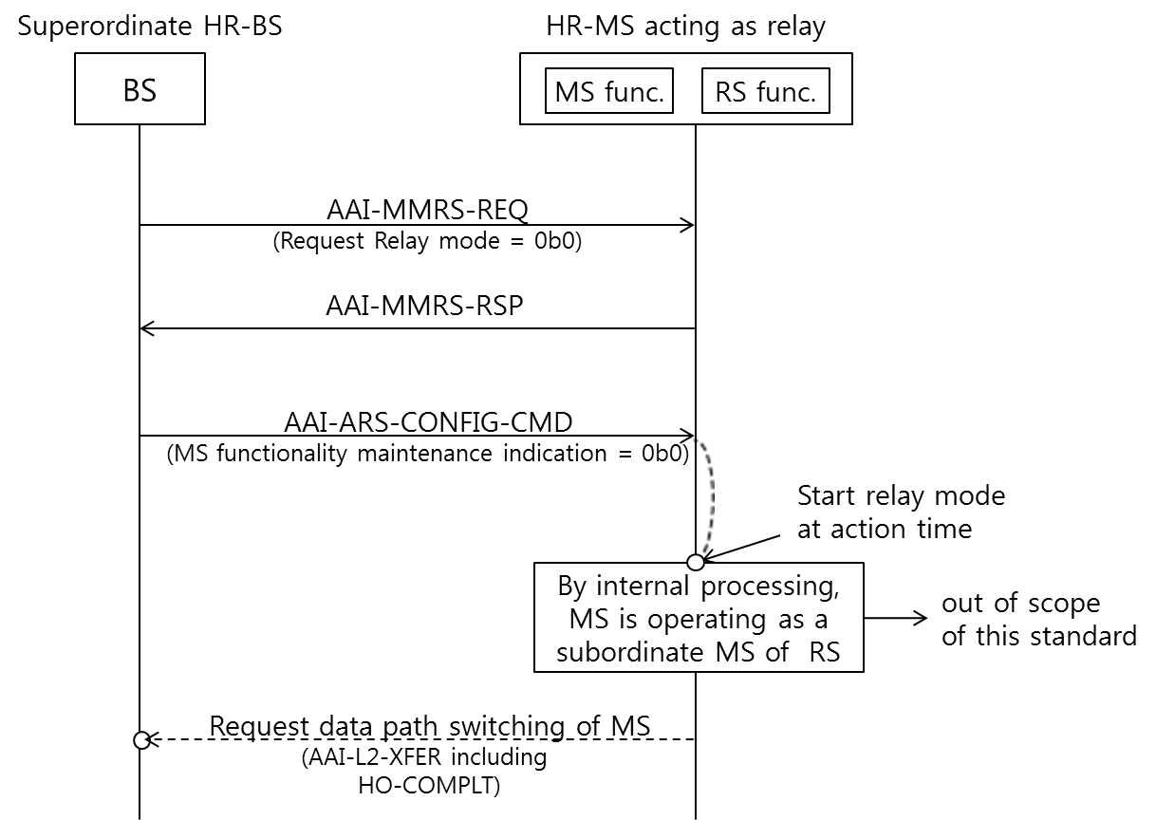
Figure 1. Example of dual-role MS/RS operation procedure

When an HR-MS in TTR relay mode receives AAI-ARS-CONFIG-CMD message with MS functionality maintenance indication that is the value 0b0, it shall perform dual-role MS/RS operation. At the time instance specified by “Superframe Number Action” in the AAI-ARSCONFIG-CMD message, the following procedures shall be performed for dual-role operation of the HR-MS acting as RS.
- The dual-role HR-MS starts TTR relay mode and establishes relay link with the superordinate HR-BS.
- The MS mode in the dual-role HR-MS is behaving as a subordinate station of the RS mode. (It seems as if the MS handovers from the serving HR-BS to the RS. It looks like HO process conceptually but not required a general handover procedure over the radio air interface.) For connecting the MS’s service flow(s), the MS mode shall communicate with the RS mode through internal interfaces in the dual-role HR-MS. The details of MS’s reentry process with the RS through the internal interface is out of scope of this standard.
- The RS mode in the dual-role HR-MS requests to the superordinate HR-BS for switching the data path of the MS mode by sending the AAI-L2-XFER message, as if the MS’ handover process had been performed.

References
- IEEE 802.16n-10/0048r2, “802.16n System Requirements Document including SARM annex,” July 2011.
- IEEE Std. 802.16TM-2009, “IEEE Standard for Local and metropolitan area networks; Part 16: Air Interface for Broadband Wireless Access Systems,” May 2009.
- IEEE 802.16mTM-2011, IEEE Standard for Local and metropolitan area networks; Part 16: Air Interface for Broadband Wireless Access Systems; Amendment 3: Advanced Air Interface,” May 2011.
- IEEE 802.16n-11/0024, “GRIDMAN Amendment Working Draft for 802.16rev3,” Oct 2011.
- IEEE 802.16n-11/0025, “GRIDMAN Amendment Working Draft for 802.16.1,” Oct 2011.

Proposed Text for the 802.16n AWD for 802.16.1a
Note:
The text in BLACK color: the existing text in the 802.16n Amendment Draft Standard
The text in RED color: the removal of existing 802.16n Amendment Draft Standard Text
The text in BLUE color: the new text added to the 802.16n Amendment Draft Standard Text

[-------------------------------------------------Start of Text Proposal---------------------------------------------------]
[Remedy1: Modify the following text in Section 6.12.1.2 in the GRIDMAN AWD for 802.16.1a.]

6.12.1 Multi-mode operation

6.12.1.2 Relay function for HR-MS
An HR-MS may operate as an HR-RS to provide connectivity for multiple out-of-coverage HR-MSs. During basic capability negotiation at network entry, an HR-MS that is capable of role change to HR-RS shall report such capability to the super-ordinate HR-BS/HR-RS. A mode switch to HR-RS shall be commanded by its superordinate HR-BS.
While operating as HR-RS, the station may maintain certain HR-MS functionalities. A mode switch to HR-RS shall be commanded by its superordinate HR-BS. the station maintains MS functionalities by performing dual-role MS/RS operation described in 6.12.1.2.4.

[Remedy2: Add the following text in new Section 16.12.1.4 in the GRIDMAN AWD for 802.16.1a.]

6.12.1.2.4 Dual-role operation of HR-MS
An HR-MS acting as RS may maintain MS functionalities in company with RS functionalities. When an HR-MS in TTR relay mode receives AAI-ARS-CONFIG-CMD message with MS functionality maintenance indication that is the value 0b1, it performs dual-role MS/RS operation. At the time instance specified by “Superframe Number Action” in the AAI-ARS-CONFIG-CMD message, the following procedures shall be performed for dual-role operation of the HR-MS acting as RS.
- The dual-role HR-MS starts TTR relay mode and establishes relay link with the superordinate HR-BS.
- The MS mode in the dual-role HR-MS is behaving as a subordinate station of the RS mode. For connecting the MS’s service flow(s), the MS mode shall communicate with the RS mode through internal interfaces in the dual-role HR-MS. The details of MS’s reentry process with the RS through the internal interface is out of scope of this standard.
- The RS mode in the dual-role HR-MS requests to the superordinate HR-BS for switching the data path of the MS mode by sending the AAI-L2-XFER message, as if the MS’ handover process had been performed.

[-------------------------------------------------End of Text Proposal----------------------------------------------------]

