Project | IEEE 802.16 Broadband Wireless Access Working Group <http://ieee802.org/16>
Title | Ad hoc on SSURF transmission
Date Submitted | 2008-01-15
Source(s) | Shulan Feng  Hisilicon Tech. Co., LTD  Bld.17, No.8, Dongbeiwang West Road, Hai-Dian District, Beijing, P. R. China | Voice: +86-10-82829151  Fax: +86-10-82829075  e-mail to : fengsl@hisilicon.com
Re: | IEEE 802.16 Working Group Letter Ballot #29
Abstract | Ad hoc on SSURF message transmission.
Purpose | Discussion and accept.
Notice | This document does not represent the agreed views of the IEEE 802.16 Working Group or any of its subgroups. It represents only the views of the participants listed in the “Source(s)” field above. It is offered as a basis for discussion. It is not binding on the contributor(s), who reserve(s) the right to add, amend or withdraw material contained herein.
Release | The contributor grants a free, irrevocable license to the IEEE to incorporate material contained in this contribution, and any modifications thereof, in the creation of an IEEE Standards publication; to copyright in the IEEE’s name any IEEE Standards publication even though it may include portions of this contribution; and at the IEEE’s sole discretion to permit others to reproduce in whole or in part the resulting IEEE Standards publication. The contributor also acknowledges and accepts that this contribution may be made public by IEEE 802.16.
Patent Policy | The contributor is familiar with the IEEE-SA Patent Policy and Procedures:  <http://standards.ieee.org/guides/bylaws/sect6-7.html#6> and <http://standards.ieee.org/guides/opman/sect6.html#6.3>.  Further information is located at <http://standards.ieee.org/board/pat/pat-material.html> and <http://standards.ieee.org/board/pat>.
Ad hoc on SSURF transmission
Shulan Feng
HiSilicon

Introduction
We have an ad hoc on SSURF transmission and contribution C802.16h-07/102 has presented during meeting #52. Some comments are proposed during the face to face discussion and the TG decided to continue the ad hoc on SSURF transmission and reciprocal interference identification.
This contribution focuses on SSURF transmission only.

Calculate the number of bytes to transmit the SSURF message
In the contribution C802.16h-07/102, we have gotten the result that for IPV6, 392 bits is needed to transmit the SSURF message. However, C802.16h-07/102 has considered that many IEs in SSURF message are TLV encoded, so additional 12 bytes is needed to transmit the SSURF message as shown in figure 1, that is 488 bits for IPv6 and 408 bits for IPV4.
SSURF message MAC Payload
[296bits or 376bits]
MAC Header
[ 48bits ]
CRC
[32bits]
CX Message Code
[8bits]
SSID
[48bits]
BSID
[48bits]
Management Type
[8bits]
SS EIRP
[8bits]
SS RF Sector ID
[32bits]
BS IP address
[48bits or 128bits]
Type for SSID
[8bits]
Length for SSID
[8bits]
Type for BSID
[8bits]
Length for BSID
[8bits]
Type for SS EIRP
[8bits]
Length for SS EIRP
[8bits]
Type for SS RF Sector ID
[8bits]
Length for SS RF Sector ID
[8bits]
Type for BSID
[8bits]
Length for BSID
[8bits]
SS location
[32bits]
Type for SS location
[8bits]
Length for SS location
[8bits]
Figure 1
There are 48 data subcarrier each uplink slot (section 8.4.6.2.1) and there are 17 subchannels every 3 OFDMA symbols.
For 5MHz bandwidth, the number of OFDMA symbol in one frame is 47. Following the 60%/40% rule, we can get that the number of OFDMA symbol of uplink is 18 or 19.
So if we set the number of OFDMA symbols for CMI_U is 18, we can get 17*6=102 uplink slots available for SSURF.
If we use QPSK 1/2 CC for SSURF, one information bit will need one data subcarrier to carrier. So to transmit one SSURF message, 488 data subcarriers are needed. Then we need 11 uplink slots for IPV6. To simplify the implement, we specify every 12 uplink slots is a SSURF transmission opportunity, there are 8 SSURF transmission opportunity every CMI_U zone. During every SSURF transmission, 576 bits can be transmitted. Since there are only 488 bits now, the other 88 bits are TBD can be used in the future.

Conclusion
From the email ad hoc discussion, we get the following conclusion.
- Following PHY parameters are used for SSURF message transmission. Channel Bandwidth: 5MHz; FFT Size: 512; CP: 1/8 [ 1/4 is not mandatory in WiMAX mobile profile ]; PUSC: use PUSC in 8.4.6.2.1; Partitioning of subcarriers into subchannel: following the way specified in 8.4.6.2.2 with UL_PermBase= 0;
- Defined the length of CMI_U is 16 OFDM symbols.
- QPSK 1/2 CC is used for SSURF transmission.
- Every 12 uplink slots are defined as a SSURF transmission opportunity.
- The first SSUFR transmission opportunity in CMI_U is start at the lowest subchannel and lowest OFDMA slot in the CMI_U zone. The SSURF transmission opportunity continues mapping with OFDMA symbol index is increased. When the edge of the UL zone is reached, continue the mapping from the lowest numbered OFDMA symbol in the next available subchannel. The figure 2 shows the transmission opportunity allocation map.
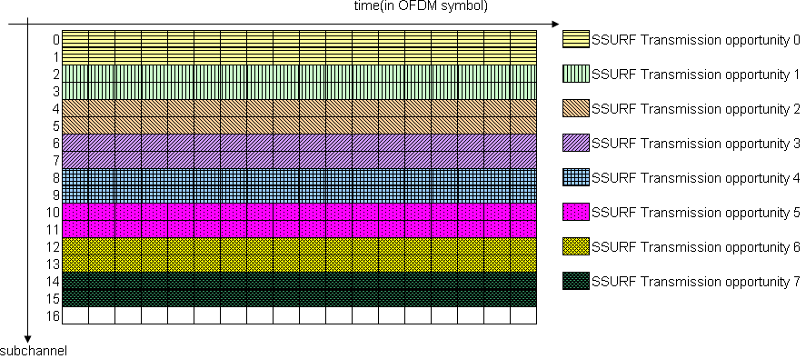
Figure 2

- Modified the table 108ak in section 6.3.2.3.72 to tell the SS during which SSURF transmission opportunity it will send SSURF message.

Proposed Text
[During the discussion of email, John suggested to reserve some TBD bits for future use. And he also suggest not use the repetition coding. So the text below may be modified during the Levi meeting.]

6.3.2.3.72 CX-UL-MAP (CX UL MAP) message
The CX-UL-MAP message defines the access to the UL channel and has an extended scope and flexibility in comparison with the UL-MAP Message. The CX-UL-MAP message shall be as shown in Table h 108ak.

108ak—CX-UL-MAP message format

Syntax | Size(bits) | Notes
CX-UL-MAP_Message_Format() {
Management Message Type = 77 | 8
Reserved | 8 | Shall be set to zero.
UCD Count | 8
Begin PHY-specific section { |  | See applicable PHY subclause.
if (WirelessMAN-OFDMA) {
No. OFDMA symbols | 8 | Number of OFDMA symbols in the UL
} |  | subframe
for (i=1; i <= m; i++) {
for (j = 1; i <= n; j++) { |  | permutation zone.
Allocation Start Time | 32
UL transmission type | 4 | 0 - No condition  1 - Radio power at the receiver for conditional  transmission  2 - Radio Signature transmitted by this system  - no condition  3 - Radio Signature transmitted by another system  - no condition  4 - CXCC sub-channel 1, primary synchronization  5 - CXCC sub-channel 1, no transmission  6 - CXCC sub-channel 2, BSD transmission  7 - CXCC subchannel 3, secondary sync  8 - CXCC sub-channel 3, BS_NUBC with frequency keying  9 - CXCC sub-channel 3, NACK transmission  10 - CXCC sub-channel 4, Radio Signature  11-15 - Reserved
if (Conditional UL transmission type = 001) {
Max power level | 8 | Negative value, in dBm
}
if ( UL transmission type = 110
SSURF transmission opportunity | 8 | Denote the SSURF message transmission opportunity in CX_CMI_U.
}
UL-MAP_IE() | variable
} |  | For each UL-MAP element 1 to n
} |  | For each UL-MAP element 1 to m.
} |  | See corresponding PHY specification.
if !(byte boundary) {
Padding Nibble | 4
} |  | Padding to reach byte boundary.
}

15.3.3.5 Subscriber Station Uplink Radio Frequency (SSURF) Message

Subscriber Station Uplink RF (SSURF) messages are the primary means by which a system defines the extent of the interference caused by its subscriber stations to neighboring base stations and coexistence community members. It is demodulated and effectively sensed by the affected base stations. The message is sent on a periodic basis in the CX_CMI_U(1-3) when requested to by the Base Station and the transmissions can be maintained over a number of Tcxcc cycles, depending on the number of SS the BS controls. All of the SS should have an opportunity to transmit SSURF messages in order to facilitate their detection as interference by other systems. When received as interference at foreign base stations, the demodulated SSURF provides that station with its specific identity and the proxy IP address of the BS controlling it.
The monitoring process for foreign interfering SSURF messages is undertaken by the Base Station. A BS (system n) will monitor CX_CMI_U(n-1) and CX_CMI_U(n+1) in a system where n=3 (max). The BS also monitors its own CX_CMI_U(n), but only for foreign SSURF from co-channel systems that have claimed the same slot. Under most circumstances this should not occur since the IBS undergoes an extensive CMI claiming procedure (15.3.3.3), however, there is always the possibility of sporadic interference which must be identified. To facilitate such detection the scheduling of uplink SSURFs by the controlling BS should be such that the CX_CMI_U(n) slot is never fully occupied with its own SSURF messages in order to allow the opportunity for other foreign SSURFs to be detected without collision (see 15.3.3.1 and Figure h 35).

To send a SSURF message by a SS, the SS is granted an allocation in a UL subframe corresponding to subchannel 2 of the coexistence channel, where the allocation start time in UL-MAP will be the start of uplink sub-frame. These uplink grants for sending SSURF are unicast to SS. SS sends the SSURF by using this grant in a CXCC subchannel 2 frame. A long preamble needs to be added before the SSURF message for WirelessMAN-OFDM PHY. Here the preamble preceeding to the SSURF also uses a predefined CP.
For wirelessMAN-OFDM PHY, Aany interfered-with BS (n) while in listen mode on CX_CMI_U(n+/-1), if detecting any preamble (REF1 and REF2), by using a predefined CP (cyclic prefix), and by using a predefined modulation QPSK1/2, will detect the SSURF.
For WirelessMAN-OFDMA PHY, the following PHY parameters are used for SSURF message transmission: Channel Bandwidth: 5MHz; FFT Size: 512; CP: 1/8; Modulation Type: QPSK; FEC Type: 1/2 CC; PUSC: use PUSC in 8.4.6.2.1; Partitioning of subcarriers into subchannel: following the way specified in 8.4.6.2.2 with UL_PermBase= 0.
CX_CMI_U is the last 18 OFDMA symbols in a 5ms frame. Every 12 uplink slots are defined as a SSURF transmission opportunity in CX_CMI_U zone. So every CX_CMI_U zone contains 8 SSURF transmission opportunities. The first SSURF transmission opportunity in CX_CMI_U is start at the lowest subchannel and lowest OFDMA slot in the CMI_U zone. The SSURF transmission opportunity continues mapping with OFDMA symbol index is increased. When the edge of the UL zone is reached, continue the mapping from the lowest numbered OFDMA symbol in the next available subchannel. The following figure shows the SSURF transmission opportunity allocation map.
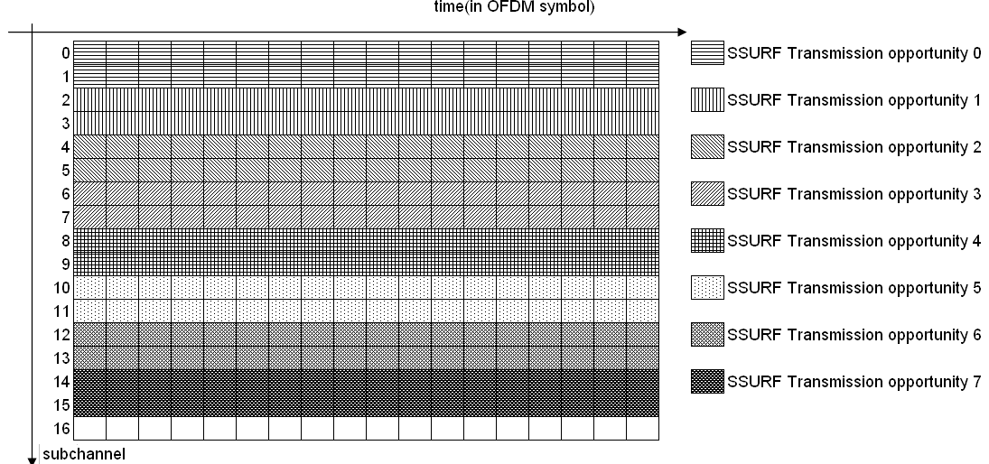
Figure hxx SSURF transmission opportunity allocation map for WirelessMAN-OFDMA
During every SSURF transmission opportunity, 576 bits can be transmitted. The unused bits are reserved to be used in the future.
SSURF_transmission_opportunity IE in CX_UL-MAP is used to SS during which SSURF transmission opportunity it will send SSURF message.

Reference
[1] C802.16h-07/106, Action Items from Session #52
[2] 80216h-07/053r2, Comment database on 16h draft D3
[3] C80216h-07/102, Ad hoc on CMI TX and RX

