Project | IEEE 802.16 Broadband Wireless Access Working Group <http://ieee802.org/16>  IEEE L802.16-07/069
Title | Further proposed edits to [IMT.EVAL] Draft
Date Submitted | 2007-11-15
Source(s) | Reza Arefi  Acting Chair, IEEE 802.16 ITU-R Liaison Group  Intel Corporation | Reza.arefi@intel.com
Re: | IEEE 802.18 TAG Document 18-07-0084-00-0000_IMT-Advanced_Eval_d3.doc
Abstract | This document proposes material towards document [IMT.EVAL] draft (8F/1322 Att. 6.7). This contribution used 802.18 draft document 18-07-0084_IMT-Advanced_Eval_d3 as base document for commenting. All changes are in Annex 2. Only changes with respect to the above-mentioned base document are shown.  This document was prepared (as authorized) by the IEEE 802.16 WG’s ITU-R Liaison Group on behalf of the WG, for submission to the 802.18 TAG.
Purpose | To contribute toward the efforts of the IEEE 802.18 TAG to develop a contribution to the ITU-R on [IMT.EVAL].
Release | The contributor grants a free, irrevocable license to the IEEE to incorporate material contained in this contribution, and any modifications thereof, in the creation of an IEEE Standards publication; to copyright in the IEEE’s name any IEEE Standards publication even though it may include portions of this contribution; and at the IEEE’s sole discretion to permit others to reproduce in whole or in part the resulting IEEE Standards publication. The contributor also acknowledges and accepts that this contribution may be made public by IEEE 802.16.
Patent Policy | The contributor is familiar with the IEEE-SA Patent Policy and Procedures:  <http://standards.ieee.org/guides/bylaws/sect6-7.html#6> and <http://standards.ieee.org/guides/opman/sect6.html#6.3>.  Further information is located at <http://standards.ieee.org/board/pat/pat-material.html> and <http://standards.ieee.org/board/pat>.

Annex 2
Test environments and deployment models
[This Annex describes the reference scenarios (test environments and deployment models) and propagation models necessary to elaborate the performance figures of candidate terrestrial and satellite RITs for IMT-Advanced. The terrestrial and the satellite component are subdivided in Parts 1 and 2, respectively.]
PART 1
Terrestrial component

1 Test environments
[This section will provide the reference model for each test operating environment. These test environments are intended to cover the range of IMT-ADVANCED operating environments. The necessary parameters to identify the reference models include the test propagation environments, traffic conditions, user information rate for prototype voice and data services, and the objective performance criteria for each test operating environment.
The test operating environments are considered as a basic factor in the evaluation process of the RITs. The reference models are used to estimate the critical aspects, such as the spectrum, coverage and power efficiencies. This estimation will be based on system-level calculations and link-level software simulations using propagation and traffic models.
Critical aspects of RITs, such as spectrum and coverage efficiencies, cannot be fairly estimated independently of appropriate IMT-ADVANCED services. These IMT-ADVANCED services are, as minimum, characterised by:
– ranges of supported data rates,
– BER requirements,
– one way delay requirements,
– activity factor,
– traffic models.]

1.1 Test environment descriptions
The proposed test environments are the following to be derived from the ones for IMT-2000:
- Base coverage urban: an urban macro-cellular environment targeting to continuous coverage for pedestrian up to fast vehicular users in built-up areas.
- Microcellular: an urban micro-cellular environment with higher user density focusing on pedestrian and slow vehicular users
- Indoor: an indoor hotspot environment targeting isolated cells at home or in small offices based on stationary and pedestrian users.
- High speed: macro cells environment with high speed vehicular and trains.
Three of these test environments are rather similar to the ones that were used for IMT-2000, “Indoor Office, Outdoor to Indoor and pedestrian and finally Vehicular, and no larger modifications are needed. The new environment is high speed since subscribers nowadays also require connections in this environment.
Figure 1 illustrates the relative positioning of three of the identified test environments. Initial focus for deployment and most challenges in IMT-Advanced system design and performance will be encountered in populated areas. However, in the evaluation the provisions for ubiquitous coverage and the associated performance also in rural areas need to be addressed. The deployment of
IMT-Advanced is believed to be around year 2015 on mass market level and at that point in time the majority of countries should have a rather good coverage of pre-IMT-2000 systems as well as IMT-2000 systems and its enhancements. Also the inter-working with other radio access technologies and spectrum sharing possibilities shall be key parts of the evaluation procedure.
Such deployments could be of course collocated in a layered approach fully benefiting from the flexibility of the IMT-Advanced interface.
Figure 1
Illustrative representation of the three deployment scenarios
envisaged for IMT-Advanced
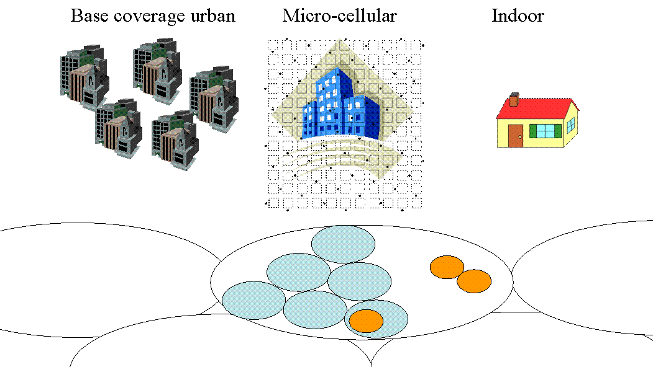
1.2 Test scenarios
For evaluation of the key questions listed above in four selected test environments, a set of reliable and measurement-based channel models are needed.
For evaluation of the key questions listed above, a set of reliable and measurement-based channel models are needed. Channel models have to be accurate due to the fact that radio propagation has a significant impact on the performance of future broadband systems. This is especially true with future multiple-input multiple-output (MIMO) radio communication systems since more of the radio channel degrees of freedom in space, time, frequency, and polarization may be exploited to meet the demands on bit rate, spectrum efficiency and cost. Channel models are needed in performance evaluation of wireless systems, and when choosing modulation and coding, in multi antenna system design, selection of channel estimation method, channel equalization and other baseband algorithm design as well as network planning. It is important to use common and uniform channel models for evaluation, comparison and selection of technologies. In this context it is clear that realistic and reliable multidimensional channel models are important part of performance evaluation of IMT-Advanced.
A central factor of mobile radio propagation environments is multi-path propagation causing fading and channel time dispersion as well as angular dispersion in Tx and Rx. The fading characteristics vary with the propagation environment and its impact on the communication quality (i.e. bit error patterns) is highly dependent on the speed of the mobile station relative to the serving base station.
The purpose of the test environments is to challenge the RITs. Instead of constructing propagation models for all possible IMT-ADVANCED operating environments, a smaller set of test environments is defined which adequately span the overall range of possible environments. The descriptions of these test environments may therefore not correspond with those of the actual operating environments.
This section will identify the propagation model for each test operating environment listed below. For practical reasons, these test operating environments are an appropriate subset of the
IMT-ADVANCED operating environments. While simple models are adequate to evaluate the performance of individual radio links, more complex models are needed to evaluate the overall system-level reliability and suitability of specific technologies. For wideband technologies the number, strength, and relative time delay as well as the directions at Tx and Rx of the many signal components become important. For some technologies (e.g. those employing power control) these models must include coupling between all co-channel propagation links to achieve maximum accuracy. Also, in some cases, the large-scale (shadow fading) temporal variations of the environment must be modelled.
The key parameters to describe each propagation model would include:
– time delay-spread, its structure, and its statistical variability (e.g., probability distribution of time delay spread);
- angular spreads at Tx and Rx;
– geometrical path loss rules;
– shadow fading;
– multipath fading characteristics (e.g. Doppler spectrum, Rician vs. Rayleigh) for the envelope of channels;
- operating radio frequency and bandwidth
- physical structure of deployment (e.g., BS height).
Statistical models are proposed in Section 1.3 to generate path losses and time delay structures for paths in each test environment.
It should be noted that IMT-ADVANCED will be a world-wide standard. Therefore, the models proposed for evaluation of RITs should consider a broad range of environment characteristics, e.g. large and small cities, tropical, rural, and desert areas.
The following sections provide a brief description of the conditions that might be expected in the identified environments. The specific channel parameters are found in the appropriate parts of Annex II.
IMT-ADVANCED may include both mobile wireless and fixed wireless applications. It should be noted that for the purpose of evaluation, operation in the fixed environment is considered to be covered by the mobile test environments. Generally, the fixed wireless channel model will be less complex due to lack of mobility. As a result, there is a trade-off possible between fixed and mobile users which should be considered while evaluating RITs.
1.2.1 Base Coverage Urban test environment
The base coverage urban test environment is intended to proof that continuous, ubiquitous, and cost-effective coverage in built-up areas is feasible in the IMT-Advanced bands by the technology applying to be in the IMT-Advanced family. This scenario will therefore be interference-limited, using macro cells (i.e. radio access points above rooftop level) and still assume that the users require access to demanding services beyond baseline voice and text messages. Evaluations shall be performed by statistical modelling of shadowing effects.
1.2.1.1 Urban macro-cell scenario
In typical urban macro-cell (scenario C2) mobile station is located outdoors at street level and fixed base station clearly above surrounding building heights. As for propagation conditions, non- or obstructed line-of-sight is a common case, since street level is often reached by a single diffraction over the rooftop. The building blocks can form either a regular Manhattan type of grid, or have more irregular locations. Typical building heights in urban environments are over four floors. Buildings height and density in typical urban macro-cell are mostly homogenous.
1.2.1.2 Bad urban macro-cell scenario
Bad urban environment (C3) describes cities with buildings with distinctly inhomogeneous building heights or densities, and results to a clearly dispersive propagation environment in delay and angular domain. The inhomogeneities in city structure can be e.g. due to large water areas separating the built-up areas, or the high-rise skyscrapers in otherwise typical urban environment. Increased delay and angular dispersion can also be caused by mountainous surrounding the city. Base station is typically located above the average rooftop level, but within its coverage range there can also be several high-rise buildings exceeding the base station height. From modelling point of view this differs from typical urban macro-cell by an additional far scatterer cluster.
1.2.1.3 Suburban macro-cell scenario
In suburban macro-cells (scenario C1) base stations are located well above the rooftops to allow wide area coverage, and mobile stations are outdoors at street level. Buildings are typically low residential detached houses with one or two floors, or blocks of flats with a few floors. Occasional open areas such as parks or playgrounds between the houses make the environment rather open. Streets do not form urban-like regular strict grid structure. Vegetation is modest.
1.2.2 Microcellular test environment
The microcellular test environment focuses on smaller cells and higher user densities and traffic loads in city centres and dense urban areas, i.e. it targets the high-performance layer of an
IMT-Advanced system in metropolitan areas. It is thus intended to test performance in high traffic loads and using demanding user requirements, including detailed modelling of buildings (e.g. Manhattan grid deployment) and outdoor-to-indoor coverage. A continuous cellular layout and the associated interference shall be assumed. Radio access points shall be below rooftop level.
1.2.2.1 Outdoor to indoor scenario
In outdoor-to-indoor scenario B4 the MS antenna height is assumed to be at 1 – 2 m (plus the floor height), and the BS antenna height below roof-top, at 5 - 15 m depending on the height of surrounding buildings (typically over four floors high). Outdoor environment is metropolitan area B1, typical urban microcell where the user density is typically high, and thus the requirements for system throughput and spectral efficiency are high. The corresponding indoor environment is A1, typical indoor small office.
1.2.2.2 Urban micro-cell scenario
In urban micro-cell scenario B1 the height of both the antenna at the BS and that at the MS is assumed to be well below the tops of surrounding buildings. Both antennas are assumed to be outdoors in an area where streets are laid out in a Manhattan-like grid. The streets in the coverage area are classified as “the main street”, where there is LOS from all locations to the BS, with the possible exception of cases in which LOS is temporarily blocked by traffic (e.g. trucks and busses) on the street. Streets that intersect the main street are referred to as perpendicular streets, and those that run parallel to it are referred to as parallel streets. This scenario is defined for both LOS and NLOS cases. Cell shapes are defined by the surrounding buildings, and energy reaches NLOS streets as a result of propagation around corners, through buildings, and between them.
1.2.2.3 Bad Urban micro-cell scenario
Bad urban micro-cell scenarios B2 are identical in layout to Urban Micro-cell scenarios, as described above. However, propagation characteristics are such that multipath energy from distant objects can be received at some locations.
This energy can be clustered or distinct, has significant power (up to within a few dB of the earliest received energy), and exhibits long excess delays. Such situations typically occur when there are clear radio paths across open areas, such as large squares, parks or bodies of water.

1.2.3 Indoor test environment
1.2.3.1 Indoor office scenario (A1)
The indoor office scenario investigates isolated cells for office coverage. Both, access point and users are indoors and a detailed modelling of the indoor environment shall be used. High user densities and requirements must be satisfied for stationary or pedestrian users. To further address the large market of small networks serving the needs of nomadic users, also ease of deployment and self-configurability are core parts of this scenario.
Indoor environment A1 represents typical office environment, where the area per floor is
5 000 m2, number of floors is 3 and room dimensions are 10 m x 10 m x 3 m and the corridors have the dimensions 100 m x 5 m x 3 m. The layout of the scenario is shown in Figure 2.
Figure 2
Layout of the indoor office scenario

Rooms: 10 x 10 x 3 m
Corridors: 5 x 100 x 3 m

1.2.3.2 Indoor hotspot scenario (A2)
The indoor hotspot test scenario concentrates on the propagation conditions in a hotspot in the urban with the very higher traffic, like the conference hall, shopping mall and teaching building. The indoor hotspot scenario is also different from the indoor office scenario due to the construction structure. Scenario A2 represents a typical shopping building, where the area per floor is about 5 400 m2, number of floors is 8 and wider hall dimensions are different. The layout of the scenario is shown in Figure 3.

FIGURE 3
Layout of the indoor hotspot scenario
1.2.4 High-speed test environment
The high speed test environment has a challenge in a wide-area system concept since is should allows for reliable links to high-speed trains of up to 350km/h or cars at high velocities. Repeater technology or relays (relaying to the same wide area system, IMT-2000, or to a local area system) can be applied in the vehicle, to allow local access by the customers.
1.2.4.1 Rural macro-cell
Propagation scenario Rural macro-cell D1 represents radio propagation in large areas (radii up to 10 km) with low building density. The height of the AP antenna is typically in the range from 20 to 70 m, which is much higher than the average building height. Consequently, LOS conditions can be expected to exist in most of the coverage area. In case the UE is located inside a building or vehicle, an additional penetration loss is experienced which can possibly be modelled as a (frequency-dependent) constant value. The AP antenna location is fixed in this propagation scenario, and the UE antenna velocity is in the range from 0 to 200 km/h.
1.2.4.2 Moving network
Propagation scenario D2 (Rural Moving Network) represents radio propagation in environments where both the AP and the UE are moving, possibly at very high speed, in a rural area. A typical example of this scenario occurs in carriages of high-speed trains where wireless coverage is provided by so-called moving relay stations (MRSs) which can be mounted, for example, to the ceiling. Note that the link between the fixed network and the moving network (train) is typically a LOS wireless link whose propagation characteristics are represented by propagation scenario D1.

1.3 Channel models
The following sections provide both path loss models and channel models for the terrestrial component.
For the terrestrial environments, the propagation effects are divided into three distinct types of model. These are mean path loss, slow variation about the mean due to shadowing and scattering, and the rapid variation in the signal due to multipath effects. Equations are given for mean path loss for each of the four terrestrial environments. The slow variation is considered to be log-normally distributed. This is described by the standard deviation (given in the deployment model section).
Finally, the rapid variation is characterized by the channel impulse response. Channel impulse response is modelled using a generalised tapped delay line implementation, which also includes the directions of the multipath components in Tx and Rx. The characteristics of the tap variability is characterized by the Doppler spectrum. [Editors note: MIMO aspects should be considered.]

1.3.1 Path loss models
Equations are given for mean path loss as a function of distance for each of the terrestrial environments The slow variation is considered to be log-normally distributed. This is described by the standard deviation (dB) and the decorrelation length of this long-term fading for the vehicular test environment.
Path-loss models at 2 to 6 GHz for considered scenarios have been developed based on measurement results or from literature. The path-loss models have been summarized in the Table 2. MS antenna height dependency is not shown in the table, but can be found in the later sections. Free space attenuation referred in the table is
${\text{PL}}_{\text{free}}=\text{46}\text{.}{\text{4+20log}}_{\text{10}}(d\left[m\right]){\text{+20log}}_{\text{10}}(f\left[\text{GHz}\right]\text{/5}\text{.}0)$ (1.1)
The shadow fading is log-Normal distributed and standard deviation of the distribution is given in decibels.
An empirical propagation loss formula for NLOS outdoor macrocellular scenario such as C1, C2 and C3, which can take the city structure into account and apply the carrier frequency range up to the SHF band and is given as follows.
(dB) (1.2)
where h_{b}, <H> , W denote the BS antenna height, the average building height, and the street width, respectively. f_{c} denotes the carrier frequency. a(h_{m}) is the correction factor for mobile antenna height h_{m} as follows:
. (dB) (1.3)

Table 1
Summary table of the extended path-loss models
Scenario |  | path loss [dB] |  | shadow fading standard dev. (dB) |  | applicability  range and antenna height default values
A1 | LOS |  | 18.7 log₁₀ (d[m]) + 46.8 +  20log₁₀ (f_{c}[GHz]/5.0) |  | σ = 3 |  | 3 m < d < 100 m,  h_{BS} = h_{MS} = 1– 2.5m
A1 | NLOS (Room- Corridor)  NLOS (Room-Room trough wall) |  | PL = 36.8 log₁₀ (d[m]) + 43.8 +  20log₁₀ (f [GHz]/5.0)  PL = 20 log₁₀ (d[m]) + 46.4 +  n_{W} · 5 + 20log₁₀ (f [GHz]/5.0)  PL = 20 log₁₀ (d[m]) + 46.4 +  n_{W} · 12 + 20log₁₀ (f[GHz]/5.0)  where n_{w} is the number of walls between BS and MS. |  | σ = 4  σ = 6  σ = 8 |  | 3 m < d < 100 m,  h_{BS} = h_{MS} = 1– 2.5m  3 m < d < 100 m  (light walls),  h_{BS} = h_{MS} = 1– 2.5m  3 m < d < 100 m  (heavy walls),  h_{BS} = h_{MS} = 1– 2.5m
A2 | LOS |  | 11.8log₁₀(d[m])+49.3+  20log₁₀(f_{c}[GHz]/5.0) |  | σ = 1.5 |  | 20 m < d <60 m  h_{BS} = h_{MS} =1-2.5 m
 | NLOS |  | 43.3log₁₀(d[m])+25.5+  20log₁₀(f_{c}[GHz]/5.0) |  | σ = 1.1 |  | 20 m < d <80 m  h_{BS} =h_{MS} =1-2.5 m
B1 | LOS |  | PL_{LOS} = max(22.7 log₁₀ (d₁ [m]) + 41.0 + 20 log₁₀ (f [GHz]/5.0), PL_{Free})  PL_{LOS} = 40.0 log₁₀ (d₁ [m]) + 9.45 - 17.3log₁₀ (h’_{BS} [m]) +  - 17.3log₁₀ (h’_{MS} [m]) +  +2.7log₁₀(f [GHz]/5.0) |  | σ = 3  σ = 3 |  | 30 m < d₁ < d’_{BP}²⁾  h_{BS} = 10 m  h_{MS} = 1.5 m  d’_{BP} < d₁ < 5 km

 |  | NLOS |  | PL_{NLOS} = PL_{LOS}(d₁) + 20 – 12.5∙n_{j} + 10n_{j}∙log₁₀ (d₂[m])  where n_{j} = max((2.8 – 0.0024d₁[m]), 1.84) | σ = 4 | 10 m < d₁ < 5 km,  w/2 < d₂ < 2 km ³⁾  w =20m  h_{BS} = 10 m  h_{MS} = 1.5 m
B2 | NLOS |  | Same as B1.
B4 | NLOS |  | PL = PL_{b} + PL_{tw} + PL_{in}  where  PL_{b} = PL_{B1}(d_{out} + d_{in}) ,  PL_{tw} = 14 + 15(1 - cos(θ))² ,  PL_{in} = 0.5 d_{in} |  | σ = 7 | 3 m <d_{out}+ d_{in} < 1000 m  h_{BS} = 3n_{Fl} + 2 m  h_{MS} = 1.5 m  See ¹⁾ for explanation of parameters
C1 |  | LOS |  | PL = 23.8 log₁₀ (d [m]) + 41.2 +  20 log₁₀ (f [GHz]/5.0)  PL = 40.0 log₁₀ (d [m]) +  11.65 - 16.2log₁₀ (h_{BS} [m])  - 16.2log₁₀ (h_{MS} [m]) +  3.8log10(f [GHz]/5.0) | σ = 4  σ = 6 | 30 m < d < d_{BP} ⁴⁾  h_{BS} = 25 m  h_{MS} = 1.5 m  d_{BP} < d < 5 km
 |  | NLOS |  | [PL = [44.9-6.55log₁₀(h_{BS}[m])]log₁₀(d[m]) + 31.46 + 5.83log₁₀(h_{BS}[m]) + 20log₁₀(f [GHz]/5.0)] | [σ = 8] | [50 m < d < 5 km  h_{BS} = 25 m  h_{MS} = 1.5 m]
C2 | NLOS |  | [PL = [44.9-6.55log₁₀(h_{BS}[m])]log₁₀(d[m]) + 34.46 + 5.83log₁₀(h_{BS}[m]) + 20log₁₀(f [GHz]/5.0)] |  | [σ = 8] | [50 m < d < 5 km  h_{BS} = 25 m  h_{MS} = 1.5 m]
C3 |  |  | [Same as C2.]
D1 |  | LOS |  | PL = 44.2 + 21.5 log10(d) + 20 log10(f [GHz]/5)  PL = 10.5 + 40.0 log₁₀ (d₁ [m]) - 18.5log₁₀(h_{BS}[m]) - 18.5log₁₀ (h_{MS} [m]) + 1.5log₁₀(f [GHz]/5) | σ = 4  σ = 6 | 30 m < d < d_{BP}⁴⁾  h_{BS} = 32 m  h_{MS} = 1.5 m  d_{BP} < d < 10 km,
 |  | NLOS |  | PL = max((55.4+25.1log₁₀(d[m])  -0.13log₁₀(h_{BS}[m]-25))log₁₀ (d[m]/100)  - 0.9(h_{MS}[m]-1.5) +  21.3 log₁₀(f [GHz]/5.0), PL_{Free}) | σ = 8 | 50 m < d < 5 km  h_{BS} = 32 m  h_{MS} = 1.5 m
D2a |  | LOS |  | PL = 44.2 + 21.5 log10(d) + 20 log10(f [GHz]/5) | σ = 4 | 30 m < d < 2 km  h_{BS} = 32 m  h_{MS} = 3 m

- PL_{B1} is B1 path-loss, d_{out} is the distance between the outside terminal and closest point of the wall to the inside terminal, d_{in} is the distance from wall to the inside terminal , θ is the angle between the outdoor path and the normal of the wall. n_{Fl} is the number of the floor. (Ground floor is the number 1.)
- d’_{BP} = 4 h’_{BS} h’_{MS} f/c, where f = center frequency and c = velocity of light and h’_{BS} and h’_{MS} are the effectice antenna heights at BS and MS respectively: h’_{BS} = h_{BS}-1.0 m, h’_{MS} = h_{MS} – 1.0 m, where 1.0 m is the effective environment height in the urban environment.
- d₁ and d₂ have been explained below.
- d_{BP} = 4 h_{BS} h_{MS} f/c,, where h_{BS} and h_{MS} are the actual antenna heights
The geometry for the d₁- d₂ model is shown in Figure 4, where the BS is located in one street/corridor and the MS is moving in the perpendicular street /corridor. d₁ is the distance from
the BS to the middle point of the street/corridor and d₂ is the distance apart from the middle point
of the crossing of the MS.
Figure 4
Geometry for d₁ - d₂ path-loss model

1.3.1.1 Decorrelation length of the long-term fading
The long-term (log-normal) fading in the logarithmic scale around the mean path loss L (dB) is characterized by a Gaussian distribution with zero mean and standard deviation. Due to the slow fading process versus distance Δx, adjacent fading values are correlated. Its normalized autocorrelation function R(Δx) can be described with sufficient accuracy by an exponential function [3]:
$R\left(Dx\right)=e^{−\frac{\left|Dx\right|}{d_{\text{cor}}}\text{ln}2}$ (1.4)
with the decorrelation length dcor, which is dependent on the environment.

1.3.2 Channel Model Parameters
1.3.2.1 Temporal-Spatial Properties Description
[Editor Note: The angular and delay profiles shape and distribution should be also described in this section. The model details for this sub-section will be described in the later phase and will be discussed during the adhoc meeting within the DG EVAL CHANNEL between Kyoto and Geneva Meeting Feb 2008.]
1.3.2.2 [Primary] Models
The primary models are created using the parameters listed in the Table 2. The channel realizations are obtained by the following step-wise procedure [2]. It has to be noted, that the geometric description covers arrival angles from the last bounce scatterers and respectively departure angles to the first scatterers interacted from the transmitting side. The propagation between the first and the last interaction is not defined. Thus this approach can model also multiple interactions with the scattering media. This indicates also that e.g., the delay of a multipath component can not be determined by the geometry.
[Editor Note: Simulation methodology and procedure will be replaced/enhanced by a flowchart.]

General parameters:
Step 1: Set environment, network layout and antenna array parameters
  - Choose one of the scenarios (A1, A2, B1,…)
  - Give number of BS and MS
  - Give locations of BS and MS, or equally distances of each BS and MS and relative directions ϕ_{LOS} and φ_{LOS} of each BS and MS
  - Give BS and MS antenna field patterns F_{rx} and F_{tx} , and array geometries
  - Give BS and MS array orientations with respect to north (reference) direction
  - Give speed and direction of motion of MS
  - Give system centre frequency
Large scale parameters:
Step 2: Assign propagation condition (LOS/NLOS).
Step 3: Calculate path loss with formulas of Table 1 for each BS-MS link to be modelled.
Step 4: Generate correlated large scale parameters, i.e. delay spread, angular spreads, Ricean K-factor and shadow fading term like explained in [2, section 3.2.1] (Correlations between large scale parameters).
[Editor Note: Ricean spatial K-factor will be considered as a lognormal distributed random variable after further discussion.]
[Editor Note: The dependency of large-scale parameters e.g., delay and angular spread on street-angle (e.g., mean angles etc.) and the incorporation of continuous profile simulation using Markov chain as proposed in Japan Doc. 1243 will be discussed in more details before next meeting during the adhoc.]
Small scale parameters:
Step 5: Generate delays τ.
Delays are drawn randomly from delay distribution defined in Table 2. With exponential delay distribution calculate
$τ_{n}'=−r_{τ}σ_{τ}\text{log}\left(X_{n}\right)$, (1.5)
where r_{τ} is delay distribution proportionality factor, X_{n} ~ Uni(0,1) and cluster index n = 1,…,N. With uniform delay distribution the delay values τ_{n}’ are drawn from the corresponding range. Normalise the delays by subtracting with minimum delay and sort the normalised delays to descending order.
$τ_{n}=\text{sort}\left(τ_{n}'−\text{min}\left(τ_{n}'\right)\right)$. (1.6)
In the case of LOS condition additional scaling of delays is required to compensate the effect of LOS peak addition to the delay spread. Heuristically determined Ricean K-factor dependent scaling constant is
$D=0\text{.}\text{7705}−0\text{.}\text{0433}K+0\text{.}\text{0002}K^{2}+0\text{.}\text{000017}K^{3}$, (1.7)
where K [dB] is the Ricean K-factor defined in Table 2. Scaled delays are
$τ_{n}^{\text{LOS}}={τ_{n}}/D$, (1.8)
they are not to be used in cluster power generation.
[Editor Note: Please reconfirm whether the K=factor in Eq. (1.7) is in dB or linear scale.]
Step 6: Generate cluster powers P.
Cluster powers are calculated assuming a single slope exponential power delay profile. Power assignment depends on the delay distribution defined in Table 2. With exponential delay distribution the cluster powers are determined by
$P_{n}^{'}=\text{exp}\left(−τ_{n}\frac{r_{τ}−1}{r_{τ}σ_{τ}}\right)⋅{\text{10}}^{\frac{−Ζ_{n}}{\text{10}}}$ (1.9)
and with uniform delay distribution they are determined by
$P_{n}^{'}=\text{exp}\left(\frac{−τ_{n}}{σ_{τ}}\right)⋅{\text{10}}^{\frac{−Ζ_{n}}{\text{10}}}$, (1.10)
where Ζ_{n} ~ N(0, ζ ) is the per cluster shadowing term in [dB]. Average the power so that sum power of all clusters is equal to one
$P_{n}=\frac{P_{n}^{'}}{\sum{P_{n}^{'}}}$ (1.11)
Assign the power of each ray within a cluster as P_{n} / M, where M is the number of rays per cluster.
Step 7: Generate arrival angles ϕ and departure angles φ.
As the composite PAS of all clusters is modelled as wrapped Gaussian (see Table 2) the AoA are determined by applying inverse Gaussian function with input parameters P_{n} and RMS angle spread σ_{ϕ}
$ϕ_{n}'=\frac{2σ_{\text{AoA}}\sqrt{−\text{ln}\left(P_{n}/\text{max}\left(P_{n}\right)\right)}}{C}$. (1.12)
On equation above $σ_{\text{AoA}}=σ_{ϕ}/1\text{.}4$ is the standard deviation of arrival angles (factor 1.4 is the ratio of Gaussian std and corresponding “RMS spread”). Constant C is a scaling factor related to total number of clusters and is given in the table below:

# clusters | 4 | 5 | 8 | 10 | 11 | 12 | 14 | 15 | 16 | 20
C | 0.779 | 0.860 | 1.018 | 1.090 | 1.123 | 1.146 | 1.190 | 1.211 | 1.226 | 1.289

In the LOS case constant C is dependent also on Ricean K-factor. Constant C in eq. (1.10) is substituted by C^{LOS}. Additional scaling of angles is required to compensate the effect of LOS peak addition to the angle spread. Heuristically determined Ricean K-factor dependent scaling constant is
$C^{\text{LOS}}=C⋅\left(1\text{.}\text{1035}−0\text{.}\text{028}K−0\text{.}\text{002}K^{2}+0\text{.}\text{0001}K^{3}\right)$, (1.13)
where K [dB] is the Ricean K-factor defined in Table 2.

Assign positive or negative sign to the angles by multiplying with a random variable X_{n} with uniform distribution to discrete set of {1,–1}, add component $Y_{n}\text{\sim }N\left(0,σ_{\text{AoA}}/5\right)$ to introduce random variation
$ϕ_{n}=X_{n}ϕ_{n}'+Y_{n}+ϕ_{\text{LOS}}$, (1.14)
where ϕ_{LOS} is the LOS direction defined in the network layout description Step1.c.

In the LOS case substitute (0.10) by (0.11) to enforce the first cluster to the LOS direction ϕ_{LOS}
$ϕ_{n}=\left(X_{n}ϕ_{n}'+Y_{n}\right)−\left(X_{n}ϕ_{1}'+Y_{1}−ϕ_{\text{LOS}}\right)$. (1.15)
Finally add offset angles α_{m} from [XX] to cluster angles
$ϕ_{n,m}=ϕ_{n}+c_{\text{AoA}}α_{m}$, (1.16)
where c_{AoA} is the cluster-wise rms azimuth spread of arrival angles (cluster ASA) in the Table 2.

Table 1-1
Ray offset angles within a cluster, given for 1° rms angle spread.
Ray number m | Basis vector of offset angles α_{m}
1,2 | ± 0.0447
3,4 | ± 0.1413
5,6 | ± 0.2492
7,8 | ± 0.3715
9,10 | ± 0.5129
11,12 | ± 0.6797
13,14 | ± 0.8844
15,16 | ± 1.1481
17,18 | ± 1.5195
19,20 | ± 2.1551

For departure angles φ_{n} the procedure is analogous.
Step 8: Random coupling of rays within the clusters.
[Editor Note: Clarify the differences between ray, path, sub-path and cluster.]
Couple randomly departure ray angles φ_{n,m} to arrival ray angles ϕ_{n,m} within a cluster n, or within a sub-cluster in the case of two strongest clusters (see step 11 and Table 1-1).

Step 9: Generate vertical-to-horizontal and horizontal-to-vertical cross polarisation power ratios (XPR) κ^{vh} and κ^{hv} respectively for each ray m of each cluster n.
XPR is log-Normal distributed. Draw vertical-to-horizontal XPR values as
$κ_{m,n}^{\text{vh}}={\text{10}}^{X/\text{10}}$, (1.17)
where ray index m = 1,…,M, X ~ N(σ,μ) is Gaussian distributed with σ and μ from Table 2 for XPR_{VH}.
For the horizontal-to-vertical XPR the procedure is analogous.

[Editor Note: The distance dependency of XPR will need further discussion.]

Coefficient generation:
Step 10: Draw random initial phase $\left\{Φ_{n,m}^{\text{vv}},Φ_{n,m}^{\text{vh}},Φ_{n,m}^{\text{hv}},Φ_{n,m}^{\text{hh}}\right\}$ for each ray m of each cluster n and for four different polarisation combinations (vv,vh,hv,hh). Distribution for initial phases is uniform,
Uni(-π,π).
In the LOS case draw also random initial phases $\left\{Φ_{\text{LOS}}^{\text{vv}},Φ_{\text{LOS}}^{\text{hh}}\right\}$ for both VV and HH polarisations.

Step 11: Generate channel coefficients for each cluster n and each receiver and transmitter element pair u,s.
For the N – 2 weakest clusters, say n = 3,4,…,N, and uniform linear arrays (ULA), the channel coefficient are given by:
$\begin{aligned}H_{u,s,n}\left(t\right)=\sqrt{P_{n}}\sum_{m=1}^{M}{}{\left[\begin{matrix}F_{\text{tx},s,V}\left(ϕ_{n,m}\right) \\ F_{\text{tx},s,H}\left(ϕ_{n,m}\right)\end{matrix}\right]}^{T}\left[\begin{matrix}\text{exp}\left({jΦ}_{n,m}^{\text{vv}}\right) & \sqrt{κ_{n,m}^{\text{vh}}}\text{exp}\left({jΦ}_{n,m}^{\text{vh}}\right) \\ \sqrt{κ_{n,m}^{\text{hv}}}\text{exp}\left({jΦ}_{n,m}^{\text{hv}}\right) & \text{exp}\left({jΦ}_{n,m}^{\text{hh}}\right)\end{matrix}\right]\left[\begin{matrix}F_{\text{rx},u,V}\left(φ_{n,m}\right) \\ F_{\text{rx},u,H}\left(φ_{n,m}\right)\end{matrix}\right] \\ ⋅\text{exp}\left({\text{jd}}_{s}2{\text{πλ}}_{0}^{−1}\text{sin}\left(φ_{n,m}\right)\right)\text{exp}\left({\text{jd}}_{u}2{\text{πλ}}_{0}^{−1}\text{sin}\left(ϕ_{n,m}\right)\right)\text{exp}\left(j2{\text{πυ}}_{n,m}t\right)\end{aligned}$ (1.18)

[Editor Note: Ideal dipole antenna pattern has to be extracted from the Finland contribution.]
where F_{rx,u,V} and F_{rx,u,H} are the antenna element u field patterns for vertical and horizontal polarisations respectively, d_{s} and d_{u} are the uniform distances [m] between transmitter elements and receiver elements respectively, and λ₀ is the wave length on carrier frequency. If polarisation is not considered, 2x2 polarisation matrix can be replaced by scalar $\text{exp}\left({jΦ}_{n,m}\right)$ and only vertically polarised field patterns applied.
The Doppler frequency component is calculated from angle of arrival (downlink), MS speed v and direction of travel θ_{v}
$υ_{n,m}=\frac{\left\|v\right\|\text{cos}\left(ϕ_{n,m}−θ_{v}\right)}{λ_{0}}$, (1.19)
For the two strongest clusters, say n = 1 and 2, rays are spread in delay to three sub-clusters (per cluster), with fixed delay offset {0,5,10 ns} (see Table 1-2). Delays of sub-clusters are
$\begin{aligned}τ_{n,1}=τ_{n}+0\text{ns} \\ τ_{n,2}=τ_{n}+5\text{ns} \\ τ_{n,3}=τ_{n}+\text{10}\text{ns}\end{aligned}$ (1.20)
Twenty rays of a cluster are mapped to sub-clusters like presented in Table 1-2 below. Corresponding offset angles are taken from Table 1-1 with mapping of Table 1-2.
Table 1-2
Sub-cluster information for intra cluster delay spread clusters.
sub-cluster # | mapping to rays | power | delay offset
1 | 1,2,3,4,5,6,7,8,19,20 | 10/20 | 0 ns
2 | 9,10,11,12,17,18 | 6/20 | 5 ns
3 | 13,14,15,16 | 4/20 | 10 ns
In the LOS case define $H'_{u,s,n}=H_{u,s,n}$ and determine the channel coefficients by adding single line-of-sight ray and scaling down the other channel coefficient generated by (1.21). The channel coefficients are given by:
$\begin{aligned}H_{u,s,n}\left(t\right)=\sqrt{\frac{1}{K_{R}+1}}H'_{u,s,n}\left(t\right) \\ +δ\left(n−1\right)\sqrt{\frac{1}{K_{R}+1}}{\left[\begin{matrix}F_{\text{tx},s,V}\left(ϕ_{\text{LOS}}\right) \\ F_{\text{tx},s,H}\left(ϕ_{\text{LOS}}\right)\end{matrix}\right]}^{T}\left[\begin{matrix}\text{exp}\left({jΦ}_{\text{LOS}}^{\text{vv}}\right) & 0 \\ 0 & \text{exp}\left({jΦ}_{\text{LOS}}^{\text{hh}}\right)\end{matrix}\right]\left[\begin{matrix}F_{\text{rx},u,V}\left(φ_{\text{LOS}}\right) \\ F_{\text{rx},u,H}\left(φ_{\text{LOS}}\right)\end{matrix}\right] \\ ⋅\text{exp}\left({\text{jd}}_{s}2{\text{πλ}}_{0}^{−1}\text{sin}\left(φ_{\text{LOS}}\right)\right)\text{exp}\left({\text{jd}}_{u}2{\text{πλ}}_{0}^{−1}\text{sin}\left(ϕ_{\text{LOS}}\right)\right)\text{exp}\left(j2{\text{πυ}}_{\text{LOS}}t\right)\end{aligned}$ (1.21)
where δ(.) is the Dirac’s delta function and K_{R} is the Ricean K-factor defined in Table 2 converted to linear scale.
If non-ULA arrays are used the equations must be modified. For arbitrary array configurations on horizontal plane, see [Figure XX], the distance term d_{u} in equations (1.21) and ([1.19]) is replaced by
$d_{u,n,m}^{'}=\frac{\sqrt{x_{u^{2}}+y_{u^{2}}}\text{cos}\left(\text{arctan}\left(y_{u}/x_{u}\right)−ϕ_{n,m}\right)}{\text{sin}ϕ_{n,m}}$, (1.22)
where (x_{u},y_{u}) are co-ordinates of uth element A_{u} and A₀ is the reference element.
Figure 4-1
Modified distance of antenna element u with non-ULA array
Step 12: Apply path loss and shadowing for the channel coefficients.

Generation of bad urban channels (B2, C3)
Bad urban channel realizations can be created as modified C2 and B1 NLOS procedures as follows:
Step 1:
Choose a proportion of mobile users, p (between 0 and 1), which will experience bad urban channel characteristics. Recommended values for bad urban users are 5-15% for C3 and 1-5% for B2. For the remaining 1-p of the users generate typical micro- or macrocellular (B1 or C2) channel realisations as described in [2, section 1.3.2.1].
Step 2:
Drop five far scatterers within a hexagonal cell, within radius [FSmin, FSmax]. For FSmin and FSmax values see Table 1-3. For each mobile user determine the closest two far scatteres, which are then used for calculating far scatterer cluster parameters.
Table 1-3
Far scatterer radii and attenuations for B2 and C3
Scenario | FS_{min} | FS_{max} | FS_{loss}
B2 | 150 m | 500 m | 4 dB/μs
C3 | 300 m | 1500 m | 2 dB/μs
Step 3:
For C3 create 20 delays as described for C2 model in [2, section 1.3.2.1]. step 5. For the shortest 18 delays create a typical urban C2 channel profile (powers and angles) as in [2, section 1.3.2.1].
Similarly, create 14 delays for B1 NLOS, and for the shortest 12 delays create a typical B1 NLOS channel profile as in [2, section 1.3.2.1].
The last two delays in B2 and C3 are assigned for far scatterer clusters.
Step 4:
Set the delays of both the FS clusters zero, and create them typical urban channel powers, as in [2, section 1.3.2.1].
Step 5:
Next create excess delays due to far scatterer clusters as
$τ_{\text{excess}}=\frac{d_{\text{BS}−\text{FS}−\text{MS}}−d_{\text{LOS}}}{c}$ (1.23)
Attenuate FS clusters as FS_{loss,} given in Table 1-3.
Step 6:
Select directions of departure and arrival for each FS cluster according to far scatterer locations. i.e., corresponding to a single reflection from far scatterer.
It is worth noticing that depending on the location of the mobile user within the cell the FS clusters may appear also at shorter delays than the maximum C2 or B1 NLOS cluster. In such cases the far scatterers do not necessarily result to increased angular or delay dispersion. Also the actual channel statistics of the bad urban users depend somewhat on the cell size.
Table 2 - Channel model parameters parameter
[Editor’s Note: The table 2 should also be modified to incorporate C1, C2 and C3 for NLOS scenario as proposed by Doc. 1244 with the condition that the channel coefficients given Eq. (3) of Section 7.2 can be produced by Doc. 1244.]
Table 3
Expectation (median) output values for large scale parameters
Scenario |  | DS (ns) | AS at BS (º) | AS at MS (º) | ES at BS (º) | ES at MS (º)
A1 | LOS | 40 | 44 | 45 | 8 | 9
A1 | NLOS | 25 | 53 | 49 | 11 | 13
A2 | LOS | 27 | 40 | 42
 | NLOS | 41 | 43 | 59
B1 | LOS | 36 | 3 | 25
B1 | NLOS | 76 | 15 | 35
B2 | NLOS | 480 | 33 | 51
B4 | NLOS | 49 | 12 | 58 | 10 | 10
C1 | LOS | 59 | 6 | 30
C1 | NLOS | 75 | 8 | 45
C2 | NLOS | 234 | 8 | 53
C3 | NLOS | 630 | 17 | 55
D1 | LOS | 16 | 17 | 33
D1 | NLOS | 37 | 9 | 33
D2a | LOS | 39 | 5 | 30

[Editor Note: The table 3 should also be modified to incorporate C1, C2 and C3 for NLOS scenario as proposed by Doc. 1244 with the condition that the channel coefficients given Eq. (3) of Section 7.2 can be produced by Doc. 1244.]
[Editor Note: Elevation spread for bothe MS and BS for A2 scenario will be submitted by next meeting.]
1.3.2.2 Reduced Variability Models
In the CDL model each cluster is composed of 20 rays with fixed offset angles and identical power. In the case of cluster where a ray of dominant power exists, the cluster has 20+1 rays. This dominant ray has a zero angle offset. The departure and arrival rays are coupled randomly. The CDL table of all scenarios of interest are give below, where the cluster power and the power of each ray are tabulated. The CDL models offer well-defined radio channels with fixed parameters to obtain comparable simulation results with relatively non-complicated channel models.
Delay spread and azimuth spreads medians of the CDL models are equal to median values given in Table 3.
The following steps are used to generate a MIMO channel with transmit and receive antennas using the reduced variability or CDL model. For the purpose of illustration, let us assume that the target channel profile has taps.

Step 1:
Generate the path loss based on the distance between the transmitter and receiver based using the path loss models in Error: Reference source not found Error: Reference source not found.
Step 2:
Generate the shadow fading loss using the model in Error: Reference source not found Error: Reference source not found
Step 3:
For each tap , in the targeted channel model, generate a transmit and receive correlation matrices and using the transmit and receive antenna geometry, the per tap mean AoA, mean AoD, and the corresponding cluster ASD and ASA.

Step 4:
Generate SISO links based on the chosen channel profile as follows
  - Let and represent the power-delay profile for the specified channel model.
  - Generate independent fading processes each having a Doppler spread (function of the chosen mobile speed). [ One issue that needs to be resolved here is the issue of the Doppler spectrum or the scattering processes associated with each fading process. Note that each CDLN model specifies an departure and arrival angle spread which in some sense defines the scattering process, i..e the Doppler spectrum]
  - Scale the -th Rayleigh process by where

Step 5:
Given the SISO links generated in step 4 above, each is described by processes, we define the following -th tap gain matrix for every channel sample (i.e. for every )
Step 6:
Color the tap gain matrix by the receive and transmit correlation matrices as follows

Step 7:
The channel tap gains with corresponding tap delays fully describe the multipath channel between transmit antenna and receive antenna . In order to generate an equivalent digital channel, say with taps, the effect of the pulse shaping, transmit, and receive filters needs to be taken into account. The following steps may be used to generate the equivalent digital channel.
- Let be the combined effect of the pulse shaping, transmit, and receive filters.
- Define the pulse shaping matrix as
where is the channel sampling period.
- The equivalent digital channel taps can be calculated as

A1 – Indoor office
The CDL parameters of LOS and NLOS condition are given below. In the LOS model Ricean K-factor is 8.1 dB, which corresponds to 3m distance between Tx and Rx.
Table 4
Scenario A1: LOS Clustered delay line model, indoor office
Cluster # | Delay [ns] |  |  | Power [dB] |  |  | AoD [º] | AoA [º] | Ray power [dB] |  | Cluster ASD = 5º | Cluster ASA = 5º
1 | 0 |  |  | 0.0 |  |  | 0 | 0 | -0.08* | -30.2** | Cluster ASD = 5º | Cluster ASA = 5º
2 | 20 |  |  | -25.3 |  |  | -160 | 164 | -38.3 |  | Cluster ASD = 5º | Cluster ASA = 5º
3 | 35 | 40 | 45 | -15.7 | -17.9 | -19.7 | -113 | -116 | -25.7 |  | Cluster ASD = 5º | Cluster ASA = 5º
4 | 45 |  |  | -21.0 |  |  | -146 | 149 | -34.0 |  | Cluster ASD = 5º | Cluster ASA = 5º
5 | 45 |  |  | -19.4 |  |  | 140 | 143 | -32.4 |  | Cluster ASD = 5º | Cluster ASA = 5º
6 | 90 |  |  | -23.3 |  |  | 153 | 157 | -36.3 |  | Cluster ASD = 5º | Cluster ASA = 5º
7 | 110 | 115 | 120 | -18.8 | -21.0 | -22.7 | 148 | 151 | -28.8 |  | Cluster ASD = 5º | Cluster ASA = 5º
8 | 155 |  |  | -25.2 |  |  | -159 | 163 | -38.2 |  | Cluster ASD = 5º | Cluster ASA = 5º
9 | 190 |  |  | -21.6 |  |  | 148 | 151 | -34.7 |  | Cluster ASD = 5º | Cluster ASA = 5º
10 | 245 |  |  | -19.1 |  |  | -139 | -142 | -32.1 |  | Cluster ASD = 5º | Cluster ASA = 5º
11 | 255 |  |  | -27.9 |  |  | -168 | -172 | -40.9 |  | Cluster ASD = 5º | Cluster ASA = 5º
12 | 320 |  |  | -30.5 |  |  | 176 | -180 | -43.5 |  | Cluster ASD = 5º | Cluster ASA = 5º
* Power of dominant ray,
** Power of each other ray

Figure 5
PDP and frequency correlation (FCF) of CDL model
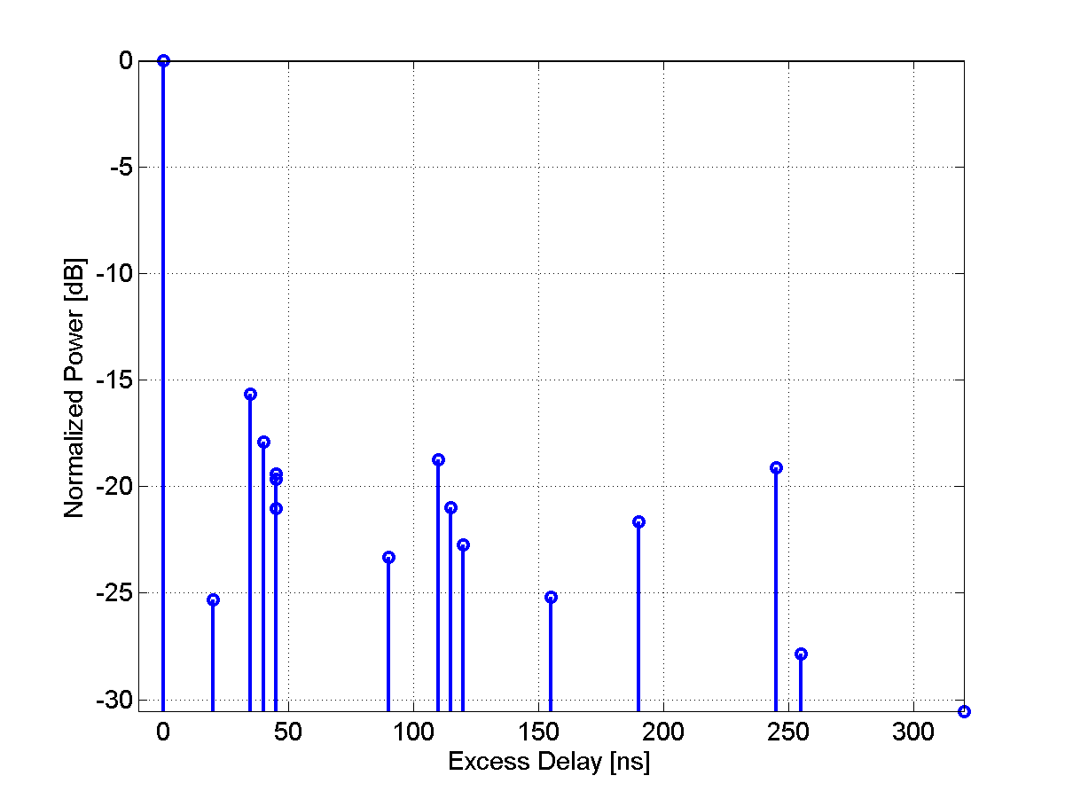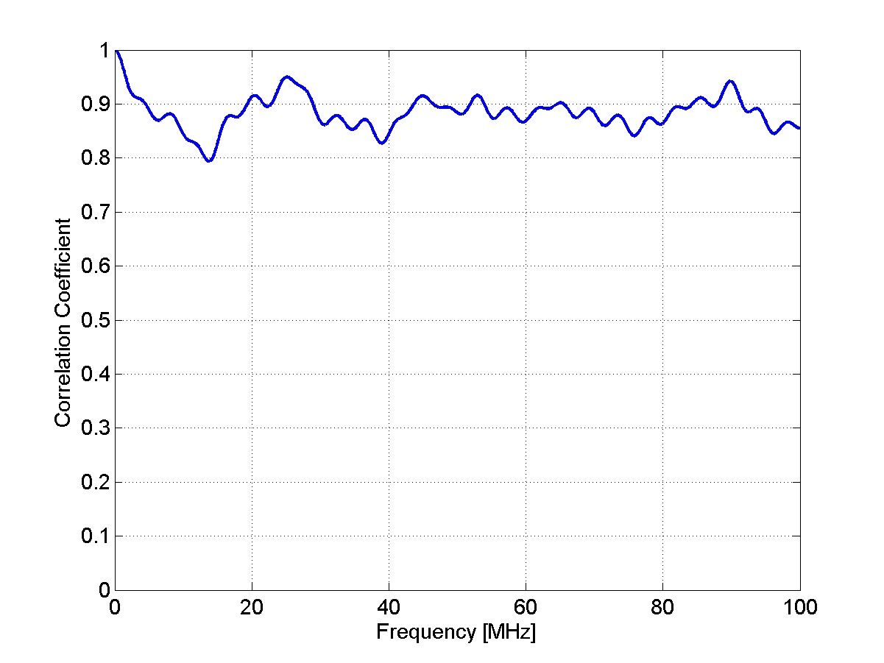
Table 5
Scenario A1 NLOS Clustered delay line model, indoor office
Cluster # | Delay [ns] |  |  | Power [dB] |  |  | AoD [º] | AoA [º] | Ray power [dB] | Cluster ASD = 5º | Cluster ASA = 5º
1 | 0 | 5 | 10 | -3.0 | -5.2 | -7.0 | 0 | 0 | -13.0 | Cluster ASD = 5º | Cluster ASA = 5º
2 | 5 |  |  | -4.0 |  |  | 59 | -55 | -17.0 | Cluster ASD = 5º | Cluster ASA = 5º
3 | 20 |  |  | -4.7 |  |  | -64 | -59 | -17.7 | Cluster ASD = 5º | Cluster ASA = 5º
4 | 25 |  |  | -9.0 |  |  | 89 | -82 | -22.0 | Cluster ASD = 5º | Cluster ASA = 5º
5 | 30 |  |  | -8.0 |  |  | 83 | -77 | -21.0 | Cluster ASD = 5º | Cluster ASA = 5º
6 | 30 | 35 | 40 | -4.0 | -6.2 | -8.0 | -67 | 62 | -14.0 | Cluster ASD = 5º | Cluster ASA = 5º
7 | 35 |  |  | -1.1 |  |  | 32 | 29 | -14.2 | Cluster ASD = 5º | Cluster ASA = 5º
8 | 45 |  |  | -5.2 |  |  | -67 | 62 | -18.2 | Cluster ASD = 5º | Cluster ASA = 5º
9 | 55 |  |  | -9.5 |  |  | -91 | -84 | -22.5 | Cluster ASD = 5º | Cluster ASA = 5º
10 | 65 |  |  | -7.9 |  |  | -83 | 77 | -20.9 | Cluster ASD = 5º | Cluster ASA = 5º
11 | 75 |  |  | -6.8 |  |  | -77 | -71 | -19.8 | Cluster ASD = 5º | Cluster ASA = 5º
12 | 90 |  |  | -14.8 |  |  | -113 | 105 | -27.8 | Cluster ASD = 5º | Cluster ASA = 5º
13 | 110 |  |  | -12.8 |  |  | -106 | 98 | -25.8 | Cluster ASD = 5º | Cluster ASA = 5º
14 | 140 |  |  | -14.1 |  |  | 111 | -103 | -27.2 | Cluster ASD = 5º | Cluster ASA = 5º
15 | 210 |  |  | -26.7 |  |  | -152 | 141 | -39.7 | Cluster ASD = 5º | Cluster ASA = 5º
16 | 250 |  |  | -32.5 |  |  | -168 | -156 | -45.5 | Cluster ASD = 5º | Cluster ASA = 5º

Figure 6
PDP and frequency correlation (FCF) of CDL model
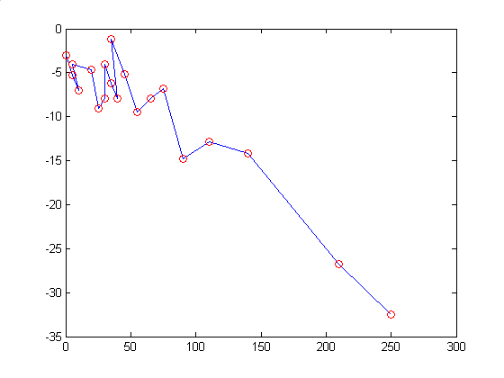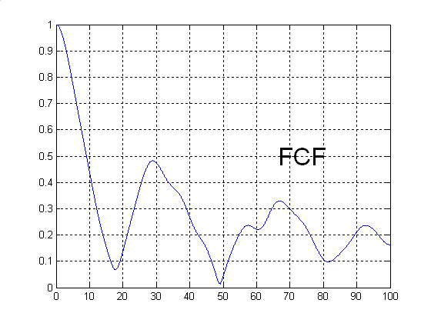
A2 – Indoor hotspot
The CDL parameters of LOS and NLOS condition are given below. In the LOS model Ricean K factor are 15.3 dB and 10.4 dB, respectively for the first and second clusters.
Table 6
Scenario A2 LOS Clustered delay line model, indoor hotspot
Cluster # | Delay [ns] | Power [dB] | AoD [º] | AoA [º] | Ray power [dB] |  | Cluster ASD = 5º | Cluster ASA = 8º
1 | 0 | 0 | 0 | 0 | -0.1* | -28.4** | Cluster ASD = 5º | Cluster ASA = 8º
2 | 5 | -3.4 | 7 | -2 | -3.7* | -27.1** | Cluster ASD = 5º | Cluster ASA = 8º
3 | 10 | -9.2 | 0 | -12 | -22.2 |  | Cluster ASD = 5º | Cluster ASA = 8º
4 | 20 | -18.9 | 7 | 13 | -31.9 |  | Cluster ASD = 5º | Cluster ASA = 8º
5 | 30 | -17.1 | 11 | 16 | -30.1 |  | Cluster ASD = 5º | Cluster ASA = 8º
6 | 40 | -16.3 | -7 | -34 | -29.3 |  | Cluster ASD = 5º | Cluster ASA = 8º
7 | 50 | -13.7 | -60 | -12 | -26.7 |  | Cluster ASD = 5º | Cluster ASA = 8º
8 | 60 | -16.3 | -43 | -17 | -29.3 |  | Cluster ASD = 5º | Cluster ASA = 8º
9 | 70 | -16.8 | 11 | -59 | -29.8 |  | Cluster ASD = 5º | Cluster ASA = 8º
10 | 80 | -17.9 | 8 | -78 | -30.9 |  | Cluster ASD = 5º | Cluster ASA = 8º
11 | 90 | -15.9 | 14 | -65 | -28.9 |  | Cluster ASD = 5º | Cluster ASA = 8º
12 | 100 | -17.4 | -1 | -56 | -30.4 |  | Cluster ASD = 5º | Cluster ASA = 8º
13 | 110 | -25.8 | -11 | -57 | -38.8 |  | Cluster ASD = 5º | Cluster ASA = 8º
14 | 120 | -31.0 | -129 | -22 | -44.0 |  | Cluster ASD = 5º | Cluster ASA = 8º
15 | 130 | -33.4 | -123 | -12 | -46.4 |  | Cluster ASD = 5º | Cluster ASA = 8º
* Power of dominant ray,
** Power of each other ray

FIGURE 7
PDP and frequency correlation (FCF) of CDL model
Table 7
Scenario A2 NLOS Clustered delay line model, indoor hotspot
Cluster # | Delay [ns] | Power [dB] | AoD [º] | AoA [º] | Ray power [dB] | Cluster ASD = 5º | Cluster ASA = 11º
1 | 0 | -6.9 | 2 | 2 | -19.9 | Cluster ASD = 5º | Cluster ASA = 11º
2 | 5 | 0 | -2 | 9 | -13.0 | Cluster ASD = 5º | Cluster ASA = 11º
3 | 10 | -0.7 | -7 | 14 | -13.7 | Cluster ASD = 5º | Cluster ASA = 11º
4 | 15 | -1.0 | -3 | -7 | -14.0 | Cluster ASD = 5º | Cluster ASA = 11º
5 | 20 | -1.4 | -1 | -6 | -14.4 | Cluster ASD = 5º | Cluster ASA = 11º
6 | 25 | -3.8 | -5 | -18 | -16.8 | Cluster ASD = 5º | Cluster ASA = 11º
7 | 30 | -2.6 | 0 | -3 | -15.6 | Cluster ASD = 5º | Cluster ASA = 11º
8 | 35 | -0.2 | -6 | -3 | -13.2 | Cluster ASD = 5º | Cluster ASA = 11º
9 | 45 | -3.6 | -9 | 14 | -16.6 | Cluster ASD = 5º | Cluster ASA = 11º
10 | 55 | -5.7 | 1 | 44 | -18.7 | Cluster ASD = 5º | Cluster ASA = 11º
11 | 65 | -11.6 | 4 | 13 | -24.6 | Cluster ASD = 5º | Cluster ASA = 11º
12 | 75 | -8.9 | -5 | 65 | -21.9 | Cluster ASD = 5º | Cluster ASA = 11º
13 | 95 | -7.3 | -11 | 46 | -20.3 | Cluster ASD = 5º | Cluster ASA = 11º
14 | 115 | -11.2 | -4 | 35 | -24.2 | Cluster ASD = 5º | Cluster ASA = 11º
15 | 135 | -13.5 | -3 | 48 | -26.5 | Cluster ASD = 5º | Cluster ASA = 11º
16 | 155 | -13.4 | -7 | 41 | -26.4 | Cluster ASD = 5º | Cluster ASA = 11º
17 | 175 | -12.2 | 8 | 7 | -25.2 | Cluster ASD = 5º | Cluster ASA = 11º
18 | 195 | -14.7 | 4 | 69 | -27.7 | Cluster ASD = 5º | Cluster ASA = 11º
19 | 215 | -15.8 | -11 | 133 | -28.8 | Cluster ASD = 5º | Cluster ASA = 11º

FIGURE 8
PDP and frequency correlation (FCF) of CDL model

B1 – Urban micro-cell
In the LOS model Ricean K-factor is 3.3 dB, which corresponds to 20m distance between Tx and Rx.
Table 8
Scenario B1: LOS clustered delay line model, urban mico-cell
Cluster # | Delay [ns] |  |  | Power [dB] |  |  | AoD [º] | AoA [º] | Ray power [dB] |  | Cluster ASD = 3º | Cluster ASA = 18º
1 | 0 |  |  | 0.0 |  |  | 0 | 0 | -0.31* | -24.7** | Cluster ASD = 3º | Cluster ASA = 18º
2 | 30 | 35 | 40 | -10.5 | -12.7 | -14.5 | 5 | 45 | -20.5 |  | Cluster ASD = 3º | Cluster ASA = 18º
3 | 55 |  |  | -14.8 |  |  | 8 | 63 | -27.8 |  | Cluster ASD = 3º | Cluster ASA = 18º
4 | 60 | 65 | 70 | -13.6 | -15.8 | -17.6 | 8 | -69 | -23.6 |  | Cluster ASD = 3º | Cluster ASA = 18º
5 | 105 |  |  | -13.9 |  |  | 7 | 61 | -26.9 |  | Cluster ASD = 3º | Cluster ASA = 18º
6 | 115 |  |  | -17.8 |  |  | 8 | -69 | -30.8 |  | Cluster ASD = 3º | Cluster ASA = 18º
7 | 250 |  |  | -19.6 |  |  | -9 | -73 | -32.6 |  | Cluster ASD = 3º | Cluster ASA = 18º
8 | 460 |  |  | -31.4 |  |  | 11 | 92 | -44.4 |  | Cluster ASD = 3º | Cluster ASA = 18º

* Power of dominant ray,
** Power of each other ray
Figure 9
PDP and frequency correlation (FCF) of CDL model
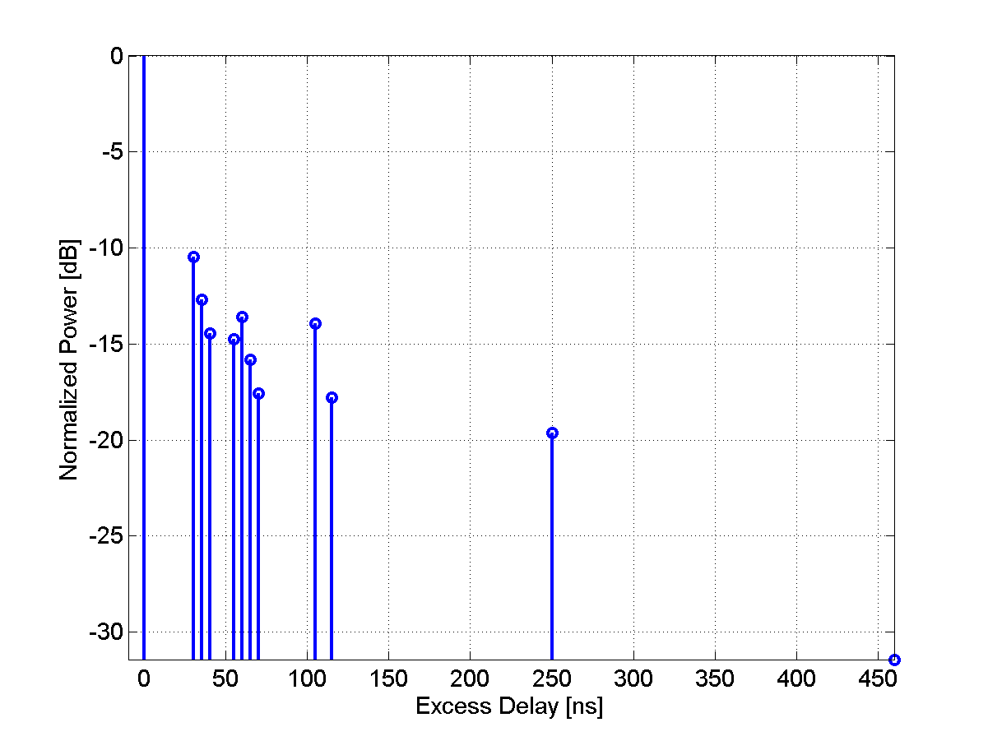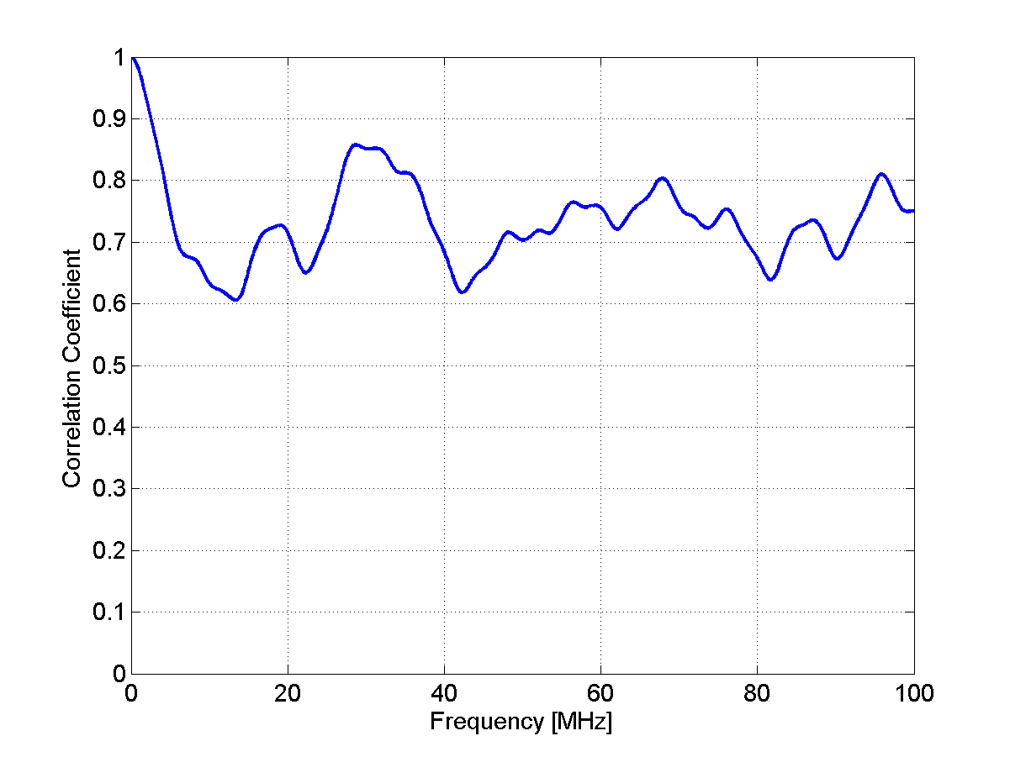
Table 9
Scenario B1: NLOS Clustered delay line model, urban micro-cell
Cluster # | Delay [ns] |  |  | Power [dB] |  |  | AoD [º] | AoA [º] | Ray power [dB] | Cluster ASD =10º | Cluster ASD = 22º
1 | 0 |  |  | -1.0 |  |  | 8 | -20 | -14.0 | Cluster ASD =10º | Cluster ASD = 22º
2 | 90 | 95 | 100 | -3.0 | -5.2 | -7.0 | 0 | 0 | -13.0 | Cluster ASD =10º | Cluster ASD = 22º
3 | 100 | 105 | 110 | -3.9 | -6.1 | -7.9 | -24 | 57 | -13.9 | Cluster ASD =10º | Cluster ASD = 22º
4 | 115 |  |  | -8.1 |  |  | -24 | -55 | -21.1 | Cluster ASD =10º | Cluster ASD = 22º
5 | 230 |  |  | -8.6 |  |  | -24 | 57 | -21.6 | Cluster ASD =10º | Cluster ASD = 22º
6 | 240 |  |  | -11.7 |  |  | 29 | 67 | -24.7 | Cluster ASD =10º | Cluster ASD = 22º
7 | 245 |  |  | -12.0 |  |  | 29 | -68 | -25.0 | Cluster ASD =10º | Cluster ASD = 22º
8 | 285 |  |  | -12.9 |  |  | 30 | 70 | -25.9 | Cluster ASD =10º | Cluster ASD = 22º
9 | 390 |  |  | -19.6 |  |  | -37 | -86 | -32.6 | Cluster ASD =10º | Cluster ASD = 22º
10 | 430 |  |  | -23.9 |  |  | 41 | -95 | -36.9 | Cluster ASD =10º | Cluster ASD = 22º
11 | 460 |  |  | -22.1 |  |  | -39 | -92 | -35.1 | Cluster ASD =10º | Cluster ASD = 22º
12 | 505 |  |  | -25.6 |  |  | -42 | -99 | -38.6 | Cluster ASD =10º | Cluster ASD = 22º
13 | 515 |  |  | -23.3 |  |  | -40 | 94 | -36.4 | Cluster ASD =10º | Cluster ASD = 22º
14 | 595 |  |  | -32.2 |  |  | 47 | 111 | -45.2 | Cluster ASD =10º | Cluster ASD = 22º
15 | 600 |  |  | -31.7 |  |  | 47 | 110 | -44.7 | Cluster ASD =10º | Cluster ASD = 22º
16 | 615 |  |  | -29.9 |  |  | 46 | -107 | -42.9 | Cluster ASD =10º | Cluster ASD = 22º

Figure 10
PDP and frequency correlation (FCF) of CDL model
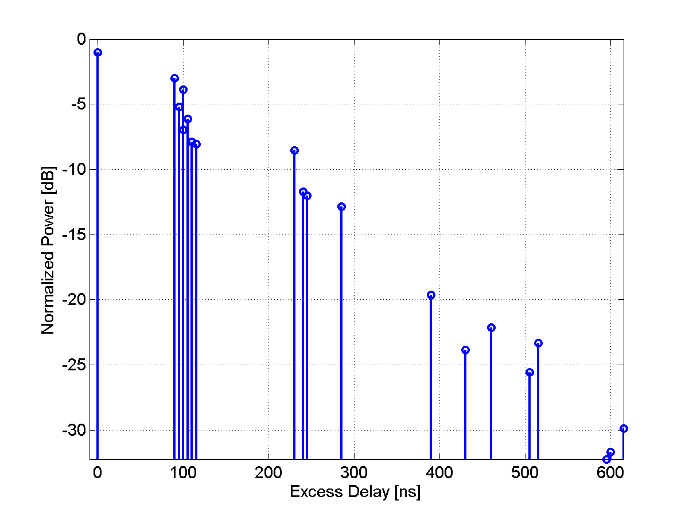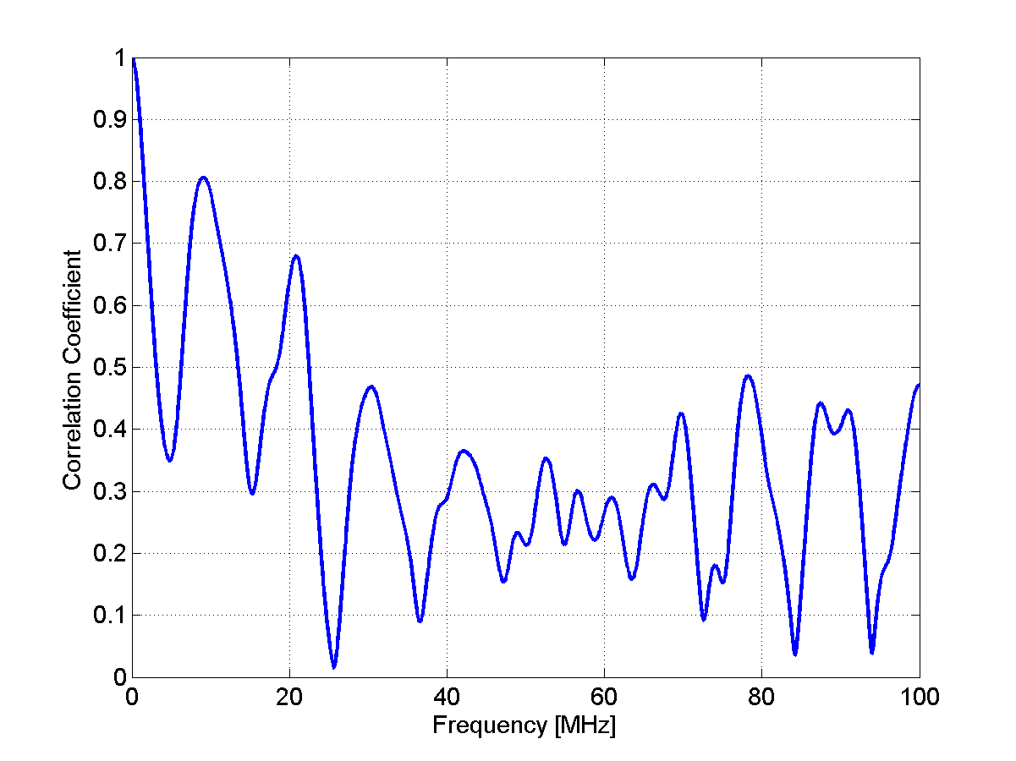
B2 – Bad Urban micro-cell
Table 10
Scenario B2: NLOS Clustered delay line model, bad urban micro-cell
Cluster # | Delay [ns] |  |  | Power [dB] |  |  | AoD [º] | AoA [º] | Ray power [dB] | Cluster ASD = 3º | Cluster ASA = 5º
1 | 0 | 5 | 10 | -3.0 | -5.2 | -7.0 | 0 | 0 | -13.0 | Cluster ASD = 3º | Cluster ASA = 5º
2 | 25 | 30 | 35 | -3.4 | -5.6 | -7.3 | -14 | 31 | -13.4 | Cluster ASD = 3º | Cluster ASA = 5º
3 | 25 |  |  | -1.7 |  |  | -13 | 30 | -14.7 | Cluster ASD = 3º | Cluster ASA = 5º
4 | 35 |  |  | -1.9 |  |  | -14 | 31 | -14.9 | Cluster ASD = 3º | Cluster ASA = 5º
5 | 45 |  |  | -2.2 |  |  | 15 | -34 | -15.2 | Cluster ASD = 3º | Cluster ASA = 5º
6 | 70 |  |  | -5.0 |  |  | 22 | 51 | -18.0 | Cluster ASD = 3º | Cluster ASA = 5º
7 | 70 |  |  | -3.6 |  |  | 19 | 44 | -16.6 | Cluster ASD = 3º | Cluster ASA = 5º
8 | 90 |  |  | -3.8 |  |  | -19 | -45 | -16.8 | Cluster ASD = 3º | Cluster ASA = 5º
9 | 155 |  |  | -6.4 |  |  | -25 | -58 | -19.4 | Cluster ASD = 3º | Cluster ASA = 5º
10 | 170 |  |  | -2.7 |  |  | -17 | -38 | -15.7 | Cluster ASD = 3º | Cluster ASA = 5º
11 | 180 |  |  | -7.5 |  |  | -27 | -63 | -20.5 | Cluster ASD = 3º | Cluster ASA = 5º
12 | 395 |  |  | -16.5 |  |  | -41 | 93 | -29.5 | Cluster ASD = 3º | Cluster ASA = 5º
13 | 1600 |  |  | -5.7 |  |  | -110 | 15 | -18.7 | Cluster ASD = 3º | Cluster ASA = 5º
14 | 2800 |  |  | -7.7 |  |  | 75 | -25 | -20.7 | Cluster ASD = 3º | Cluster ASA = 5º

Figure 11
PDP and frequency correlation (FCF) of CDL model
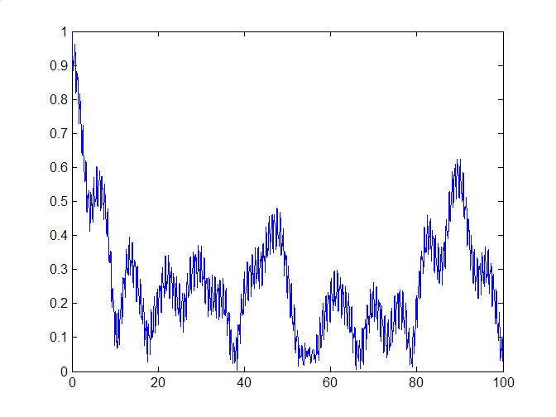
B4 – Outdoor to indoor
[Editor’s Note: The B4 terminology is a concern since it doesn’t have a flow with the previous B1 and B2 models. Further discussion required to make all test scenarios terminology more consistent.]
Table 11
Scenario B4: NLOS Clustered delay line model, outdoor to indoor
Cluster # | Delay [ns] |  |  | Power [dB] |  |  | AoD [º] | AoA [º] | Ray power [dB] | Cluster ASD = 5º | Cluster ASA = 8º
1 | 0 |  |  | -7.7 |  |  | 29 | 102 | -20.8 | Cluster ASD = 5º | Cluster ASA = 8º
2 | 10 | 15 | 20 | -3.0 | -5.2 | -7.0 | 0 | 0 | -13.0 | Cluster ASD = 5º | Cluster ASA = 8º
3 | 20 |  |  | -3.7 |  |  | 20 | 70 | -16.7 | Cluster ASD = 5º | Cluster ASA = 8º
4 | 35 |  |  | -3.0 |  |  | -18 | -64 | -16.0 | Cluster ASD = 5º | Cluster ASA = 8º
5 | 35 |  |  | -3.0 |  |  | 18 | -63 | -16.0 | Cluster ASD = 5º | Cluster ASA = 8º
6 | 50 |  |  | -3.7 |  |  | 20 | 70 | -16.7 | Cluster ASD = 5º | Cluster ASA = 8º
7 | 55 | 60 | 65 | -5.4 | -7.6 | -9.4 | 29 | 100 | -15.4 | Cluster ASD = 5º | Cluster ASA = 8º
8 | 140 |  |  | -5.3 |  |  | 24 | 84 | -18.3 | Cluster ASD = 5º | Cluster ASA = 8º
9 | 175 |  |  | -7.6 |  |  | 29 | 100 | -20.6 | Cluster ASD = 5º | Cluster ASA = 8º
10 | 190 |  |  | -4.3 |  |  | -21 | 76 | -17.3 | Cluster ASD = 5º | Cluster ASA = 8º
11 | 220 |  |  | -12.0 |  |  | 36 | -126 | -25.0 | Cluster ASD = 5º | Cluster ASA = 8º
12 | 585 |  |  | -20.0 |  |  | 46 | 163 | -33.0 | Cluster ASD = 5º | Cluster ASA = 8º

Figure 12
PDP and frequency correlation (FCF) of CDL model
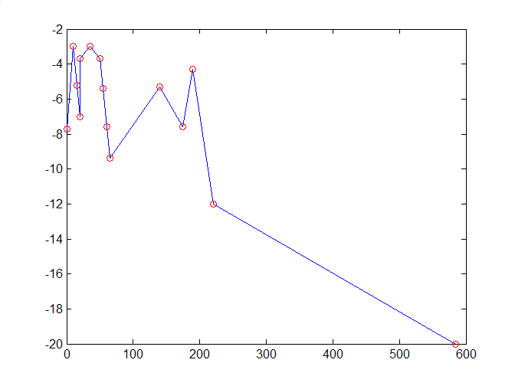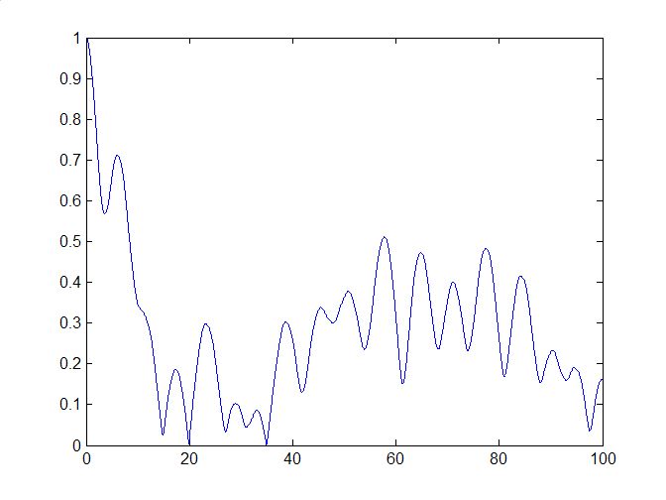
C1 – Suburban
The CDL parameters of LOS and NLOS condition are given below. In the LOS model Ricean K-factor is 12.9 dB, which corresponds to 200m distance between Tx and Rx.
[Editor Note: Japan Doc. 1244 proposed to incorporate the distance dependency of the C1 NLOS scenario into the table. This issue will need to be further discussed in the next meeting.]
Table 12
Scenario C1: LOS Clustered delay line model, suburban
Cluster # | Delay [ns] |  |  | Power [dB] |  |  | AoD [º] | AoA [º] | Ray power [dB] |  | Cluster ASD = 5º | Cluster ASD = 5º
1 | 0 | 5 | 10 | 0.0 | -25.3 | -27.1 | 0 | 0 | -0.02* | -33.1** | Cluster ASD = 5º | Cluster ASD = 5º
2 | 85 |  |  | -21.6 |  |  | -29 | -144 | -34.7 |  | Cluster ASD = 5º | Cluster ASD = 5º
3 | 135 |  |  | -26.3 |  |  | -32 | -159 | -39.3 |  | Cluster ASD = 5º | Cluster ASD = 5º
4 | 135 |  |  | -25.1 |  |  | -31 | 155 | -38.1 |  | Cluster ASD = 5º | Cluster ASD = 5º
5 | 170 |  |  | -25.4 |  |  | 31 | 156 | -38.4 |  | Cluster ASD = 5º | Cluster ASD = 5º
6 | 190 |  |  | -22.0 |  |  | 29 | -146 | -35.0 |  | Cluster ASD = 5º | Cluster ASD = 5º
7 | 275 |  |  | -29.2 |  |  | -33 | 168 | -42.2 |  | Cluster ASD = 5º | Cluster ASD = 5º
8 | 290 | 295 | 300 | -24.3 | -26.5 | -28.2 | 35 | -176 | -34.3 |  | Cluster ASD = 5º | Cluster ASD = 5º
9 | 290 |  |  | -23.2 |  |  | -30 | 149 | -36.2 |  | Cluster ASD = 5º | Cluster ASD = 5º
10 | 410 |  |  | -32.2 |  |  | 35 | -176 | -45.2 |  | Cluster ASD = 5º | Cluster ASD = 5º
11 | 445 |  |  | -26.5 |  |  | -32 | -159 | -39.5 |  | Cluster ASD = 5º | Cluster ASD = 5º
12 | 500 |  |  | -32.1 |  |  | 35 | -176 | -45.1 |  | Cluster ASD = 5º | Cluster ASD = 5º
13 | 620 |  |  | -28.5 |  |  | 33 | -165 | -41.5 |  | Cluster ASD = 5º | Cluster ASD = 5º
14 | 655 |  |  | -30.5 |  |  | 34 | -171 | -43.5 |  | Cluster ASD = 5º | Cluster ASD = 5º
15 | 960 |  |  | -32.6 |  |  | 35 | 177 | -45.6 |  | Cluster ASD = 5º | Cluster ASD = 5º
* Power of dominant ray,
** Power of each other ray
Figure 13
PDP and frequency correlation (FCF) of CDL model
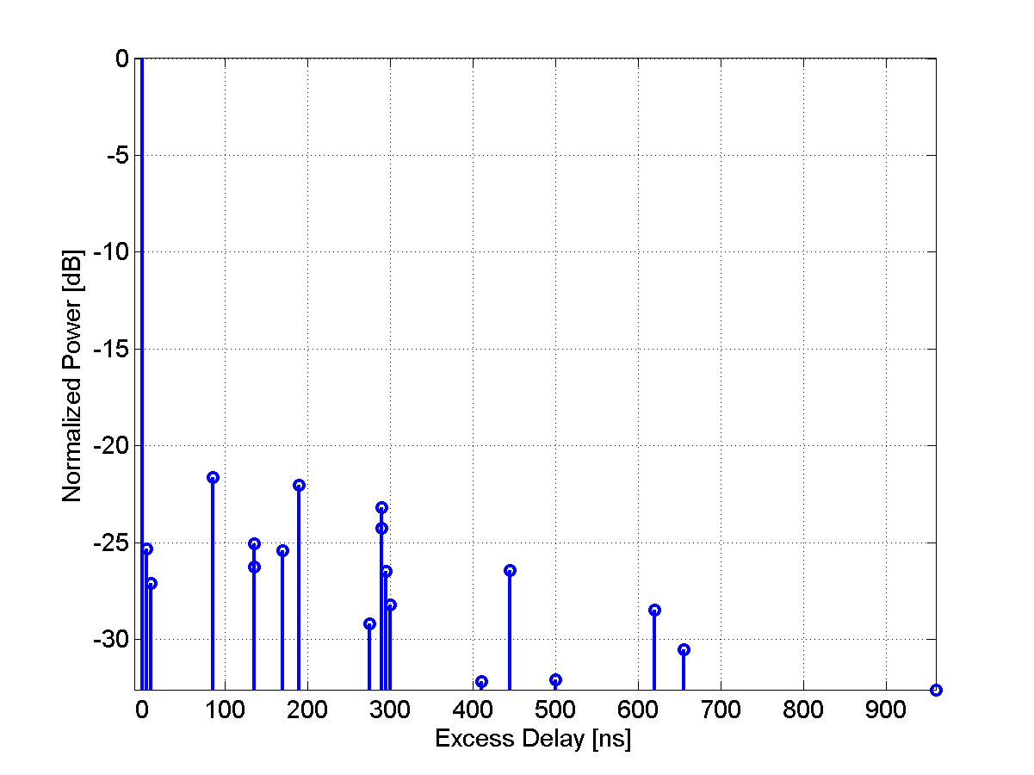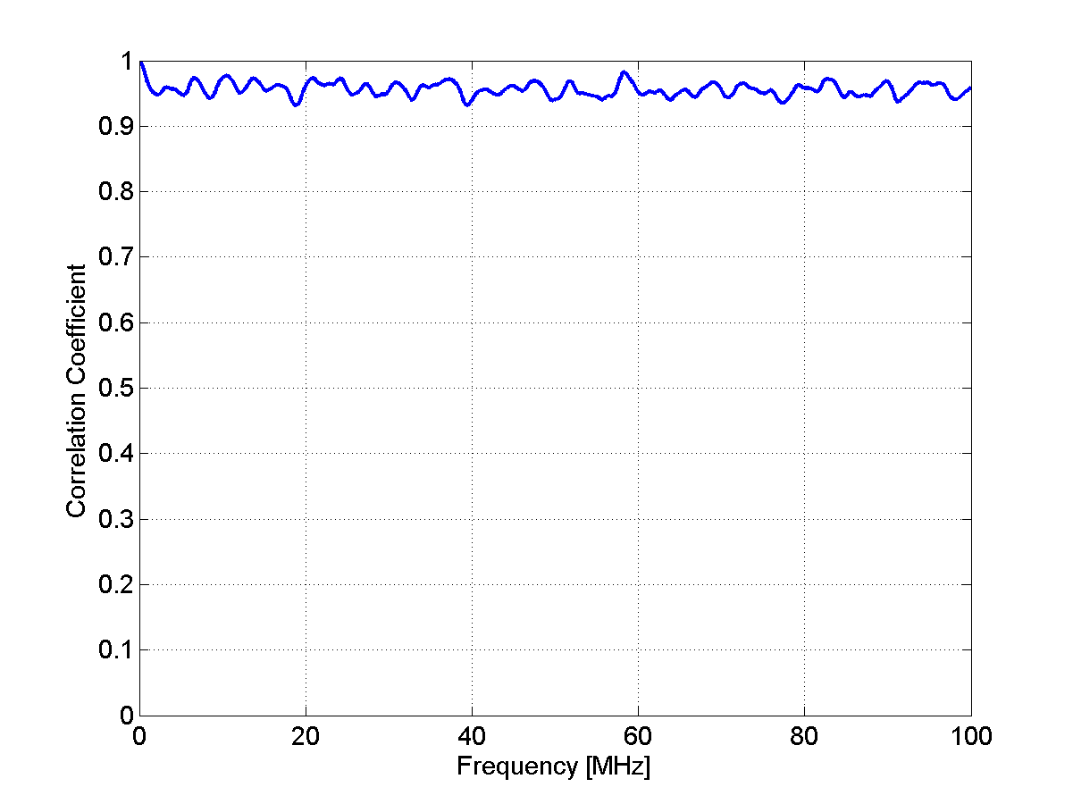
Table 13
Scenario C1: NLOS Clustered delay-line model, suburban
Cluster # | Delay [ns] |  |  | Power [dB] |  |  | AoD [º] | AoA [º] | Ray power [dB] | Cluster ASD = 2º | Cluster ASD = 10º
1 | 0 | 5 | 10 | -3.0 | -5.2 | -7.0 | 0 | 0 | -13.0 | Cluster ASD = 2º | Cluster ASD = 10º
2 | 25 |  |  | -7.5 |  |  | 13 | -71 | -20.5 | Cluster ASD = 2º | Cluster ASD = 10º
3 | 35 |  |  | -10.5 |  |  | -15 | -84 | -23.5 | Cluster ASD = 2º | Cluster ASD = 10º
4 | 35 |  |  | -3.2 |  |  | -8 | 46 | -16.2 | Cluster ASD = 2º | Cluster ASD = 10º
5 | 45 | 50 | 55 | -6.1 | -8.3 | -10.1 | 12 | -66 | -16.1 | Cluster ASD = 2º | Cluster ASD = 10º
6 | 65 |  |  | -14.0 |  |  | -17 | -97 | -27.0 | Cluster ASD = 2º | Cluster ASD = 10º
7 | 65 |  |  | -6.4 |  |  | 12 | -66 | -19.4 | Cluster ASD = 2º | Cluster ASD = 10º
8 | 75 |  |  | -3.1 |  |  | -8 | -46 | -16.1 | Cluster ASD = 2º | Cluster ASD = 10º
9 | 145 |  |  | -4.6 |  |  | -10 | -56 | -17.6 | Cluster ASD = 2º | Cluster ASD = 10º
10 | 160 |  |  | -8.0 |  |  | -13 | 73 | -21.0 | Cluster ASD = 2º | Cluster ASD = 10º
11 | 195 |  |  | -7.2 |  |  | 12 | 70 | -20.2 | Cluster ASD = 2º | Cluster ASD = 10º
12 | 200 |  |  | -3.1 |  |  | 8 | -46 | -16.1 | Cluster ASD = 2º | Cluster ASD = 10º
13 | 205 |  |  | -9.5 |  |  | 14 | -80 | -22.5 | Cluster ASD = 2º | Cluster ASD = 10º
14 | 770 |  |  | -22.4 |  |  | 22 | 123 | -35.4 | Cluster ASD = 2º | Cluster ASD = 10º

Figure 14
PDP and frequency correlation (FCF) of CDL model
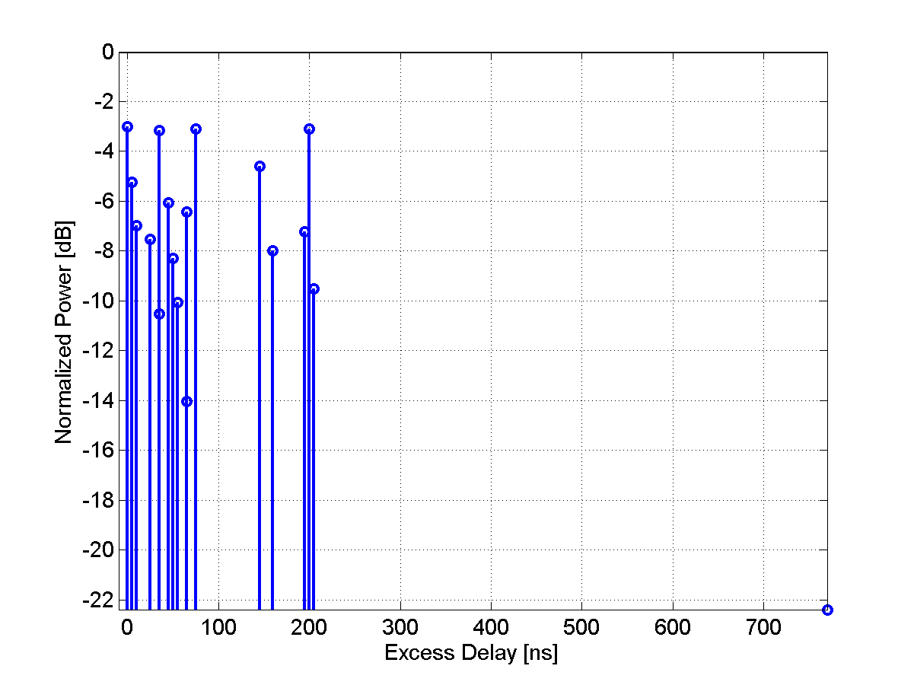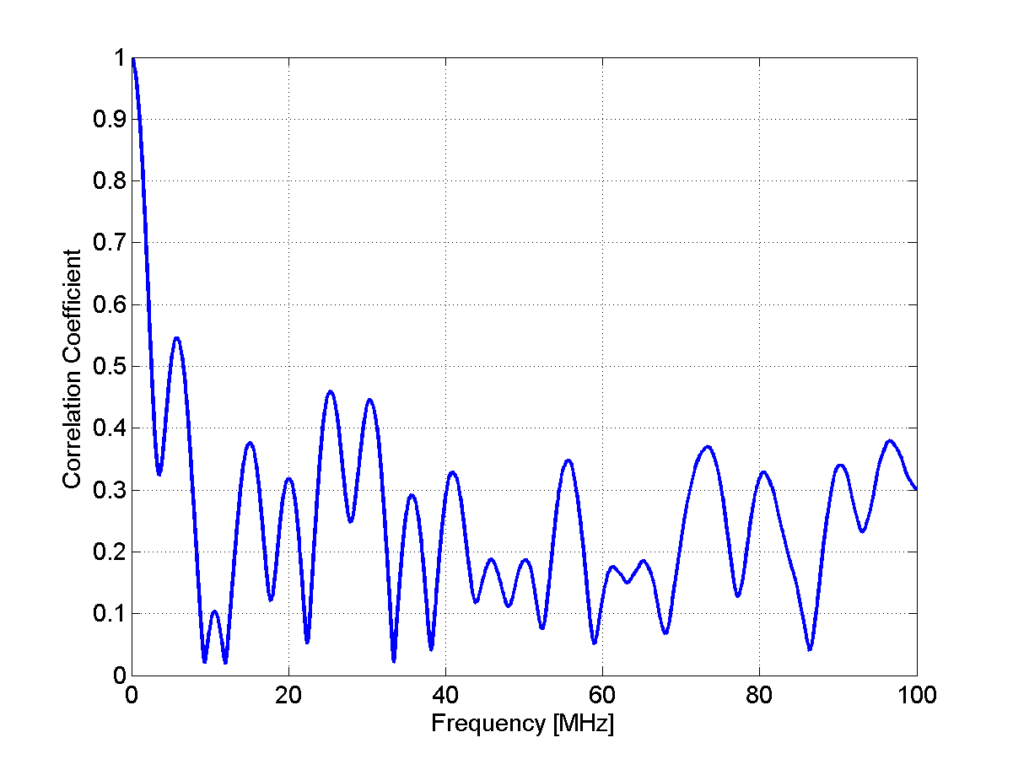
C2 – Urban macro-cell
[Editor’s Note: Japan Doc. 1244 proposed to incorporate the distance dependency of the C2 NLOS scenario into the table. This issue will need to be further discussed in the next meeting.]
Table 14
Scenario C2: NLOS clustered delay line model, urban macro-cell
Cluster # | Delay [ns] |  |  | Power [dB] |  |  | AoD [º] | AoA [º] | Ray power [dB] | Cluster ASD = 2º | Cluster ASD = 15º
1 | 0 |  |  | -6.4 |  |  | 11 | 61 | -19.5 | Cluster ASD = 2º | Cluster ASD = 15º
2 | 60 |  |  | -3.4 |  |  | -8 | 44 | -16.4 | Cluster ASD = 2º | Cluster ASD = 15º
3 | 75 |  |  | -2.0 |  |  | -6 | -34 | -15.0 | Cluster ASD = 2º | Cluster ASD = 15º
4 | 145 | 150 | 155 | -3.0 | -5.2 | -7.0 | 0 | 0 | -13.0 | Cluster ASD = 2º | Cluster ASD = 15º
5 | 150 |  |  | -1.9 |  |  | 6 | 33 | -14.9 | Cluster ASD = 2º | Cluster ASD = 15º
6 | 190 |  |  | -3.4 |  |  | 8 | -44 | -16.4 | Cluster ASD = 2º | Cluster ASD = 15º
7 | 220 | 225 | 230 | -3.4 | -5.6 | -7.4 | -12 | -67 | -13.4 | Cluster ASD = 2º | Cluster ASD = 15º
8 | 335 |  |  | -4.6 |  |  | -9 | 52 | -17.7 | Cluster ASD = 2º | Cluster ASD = 15º
9 | 370 |  |  | -7.8 |  |  | -12 | -67 | -20.8 | Cluster ASD = 2º | Cluster ASD = 15º
10 | 430 |  |  | -7.8 |  |  | -12 | -67 | -20.8 | Cluster ASD = 2º | Cluster ASD = 15º
11 | 510 |  |  | -9.3 |  |  | 13 | -73 | -22.3 | Cluster ASD = 2º | Cluster ASD = 15º
12 | 685 |  |  | -12.0 |  |  | 15 | -83 | -25.0 | Cluster ASD = 2º | Cluster ASD = 15º
13 | 725 |  |  | -8.5 |  |  | -12 | -70 | -21.5 | Cluster ASD = 2º | Cluster ASD = 15º
14 | 735 |  |  | -13.2 |  |  | -15 | 87 | -26.2 | Cluster ASD = 2º | Cluster ASD = 15º
15 | 800 |  |  | -11.2 |  |  | -14 | 80 | -24.2 | Cluster ASD = 2º | Cluster ASD = 15º
16 | 960 |  |  | -20.8 |  |  | 19 | 109 | -33.8 | Cluster ASD = 2º | Cluster ASD = 15º
17 | 1020 |  |  | -14.5 |  |  | -16 | 91 | -27.5 | Cluster ASD = 2º | Cluster ASD = 15º
18 | 1100 |  |  | -11.7 |  |  | 15 | -82 | -24.7 | Cluster ASD = 2º | Cluster ASD = 15º
19 | 1210 |  |  | -17.2 |  |  | 18 | 99 | -30.2 | Cluster ASD = 2º | Cluster ASD = 15º
20 | 1845 |  |  | -16.7 |  |  | 17 | 98 | -29.7 | Cluster ASD = 2º | Cluster ASD = 15º
Figure 15
PDP and frequency correlation (FCF) of CDL model
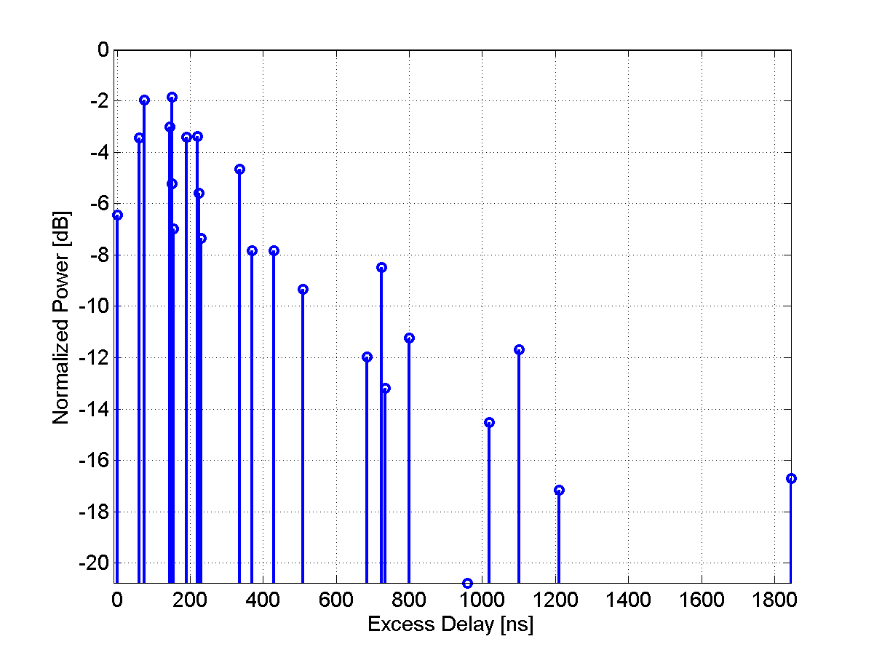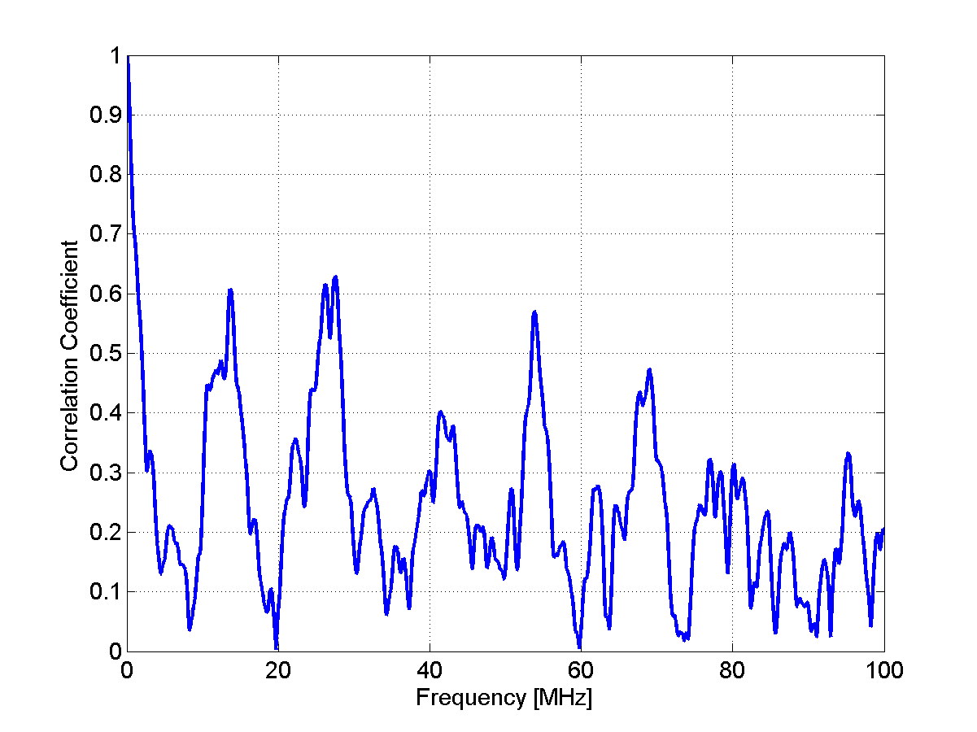
C3 – Bad urban macro-cell
[Editor’s Note: Japan Doc. 1244 proposed to incorporate the distance dependency of the C3 NLOS scenario into the table. This issue will need to be further discussed in the next meeting.]
The CDL parameters of NLOS condition are given below.
Table 15
Scenario C3: NLOS Clustered delay line model, bad urban, macrocell
Cluster # | Delay [ns] |  |  | Power [dB] |  |  | AoD [º] | AoA [º] | Ray power [dB] | Cluster ASD = 2º | Cluster ASA = 15º
1 | 0 |  |  | -4.7 |  |  | -10 | 61 | -17.7 | Cluster ASD = 2º | Cluster ASA = 15º
2 | 0 | 5 | 10 | -3 | -5.2 | -7 | 0 | 0 | -13 | Cluster ASD = 2º | Cluster ASA = 15º
3 | 10 |  |  | -7.2 |  |  | 12 | -75 | -20.2 | Cluster ASD = 2º | Cluster ASA = 15º
4 | 10 |  |  | -6.3 |  |  | -11 | -70 | -19.3 | Cluster ASD = 2º | Cluster ASA = 15º
5 | 30 | 35 | 40 | -4.8 | -7 | -8.8 | -12 | 76 | -14.8 | Cluster ASD = 2º | Cluster ASA = 15º
6 | 50 |  |  | -3.7 |  |  | -9 | 53 | -16.7 | Cluster ASD = 2º | Cluster ASA = 15º
7 | 80 |  |  | -7.4 |  |  | -12 | 76 | -20.4 | Cluster ASD = 2º | Cluster ASA = 15º
8 | 110 |  |  | -7.2 |  |  | 12 | -75 | -20.2 | Cluster ASD = 2º | Cluster ASA = 15º
9 | 155 |  |  | -9.6 |  |  | 14 | -87 | -22.7 | Cluster ASD = 2º | Cluster ASA = 15º
10 | 165 |  |  | -5.2 |  |  | -10 | 64 | -18.3 | Cluster ASD = 2º | Cluster ASA = 15º
11 | 165 |  |  | -6.3 |  |  | 11 | 70 | -19.3 | Cluster ASD = 2º | Cluster ASA = 15º
12 | 250 |  |  | -8.9 |  |  | 14 | 83 | -21.9 | Cluster ASD = 2º | Cluster ASA = 15º
13 | 280 |  |  | -8.5 |  |  | 13 | -81 | -21.5 | Cluster ASD = 2º | Cluster ASA = 15º
14 | 440 |  |  | -8.4 |  |  | 13 | -81 | -21.4 | Cluster ASD = 2º | Cluster ASA = 15º
15 | 490 |  |  | -8.5 |  |  | -13 | 81 | -21.5 | Cluster ASD = 2º | Cluster ASA = 15º
16 | 525 |  |  | -5 |  |  | 10 | 62 | -18 | Cluster ASD = 2º | Cluster ASA = 15º
17 | 665 |  |  | -10.9 |  |  | 15 | 92 | -23.9 | Cluster ASD = 2º | Cluster ASA = 15º
18 | 685 |  |  | -10.9 |  |  | 15 | 92 | -24 | Cluster ASD = 2º | Cluster ASA = 15º
19 | 4800 |  |  | -9.7 |  |  | -135 | 25 | -22.7 | Cluster ASD = 2º | Cluster ASA = 15º
20 | 7100 |  |  | -13 |  |  | 80 | 40 | -26 | Cluster ASD = 2º | Cluster ASA = 15º

[Editor’s note: The plots for profile will need to be inserted by Finland by next meeting.]
D1 – Rural macro-cell
The CDL parameters of LOS and NLOS condition are given below. In the LOS model Ricean K-factor is 13.7 dB, which corresponds to 500m distance between Tx and Rx.
Table 16
Scenario D1: LOS Clustered delay line model, rural macro-cell
Cluster # | Delay [ns] |  |  | Power [dB] |  |  | AoD [º] | AoA [º] | Ray power [dB] |  | Cluster ASD = 2º | Cluster ASD = 3º
1 | 0 |  |  | 0.0 |  |  | 0 | 0 | -0.02* | -35.9** | Cluster ASD = 2º | Cluster ASD = 3º
2 | 40 |  |  | -22.3 |  |  | -95 | 189 | -35.3 |  | Cluster ASD = 2º | Cluster ASD = 3º
3 | 40 |  |  | -25.6 |  |  | 102 | 203 | -38.6 |  | Cluster ASD = 2º | Cluster ASD = 3º
4 | 40 | 45 | 50 | -23.1 | -25.3 | -27.1 | -90 | -179 | -33.1 |  | Cluster ASD = 2º | Cluster ASD = 3º
5 | 40 | 45 | 50 | -23.7 | -25.9 | -27.7 | 104 | -208 | -33.7 |  | Cluster ASD = 2º | Cluster ASD = 3º
6 | 60 |  |  | -27.4 |  |  | -105 | 210 | -40.4 |  | Cluster ASD = 2º | Cluster ASD = 3º
7 | 115 |  |  | -27.0 |  |  | 104 | -208 | -40.0 |  | Cluster ASD = 2º | Cluster ASD = 3º
8 | 135 |  |  | -25.2 |  |  | -101 | -201 | -38.2 |  | Cluster ASD = 2º | Cluster ASD = 3º
9 | 175 |  |  | -30.1 |  |  | 110 | -219 | -43.1 |  | Cluster ASD = 2º | Cluster ASD = 3º
10 | 195 |  |  | -32.5 |  |  | 114 | 228 | -45.5 |  | Cluster ASD = 2º | Cluster ASD = 3º
11 | 215 |  |  | -31.7 |  |  | -113 | -225 | -44.7 |  | Cluster ASD = 2º | Cluster ASD = 3º
12 | 235 |  |  | -33.9 |  |  | -117 | -233 | -46.9 |  | Cluster ASD = 2º | Cluster ASD = 3º
13 | 235 |  |  | -31.0 |  |  | -112 | 223 | -44.0 |  | Cluster ASD = 2º | Cluster ASD = 3º
* Power of dominant ray,
** Power of each other ray
Figure 16
PDP and frequency correlation (FCF) of CDL model
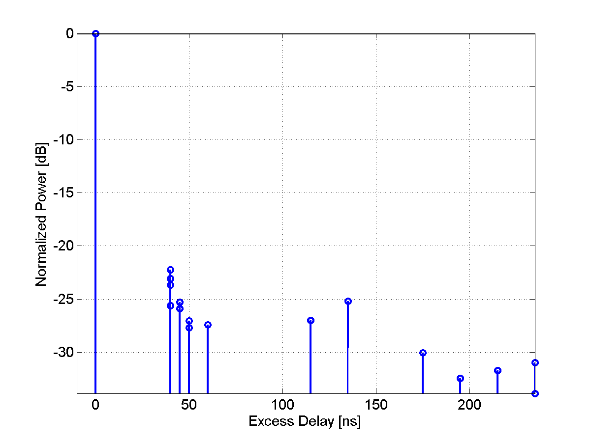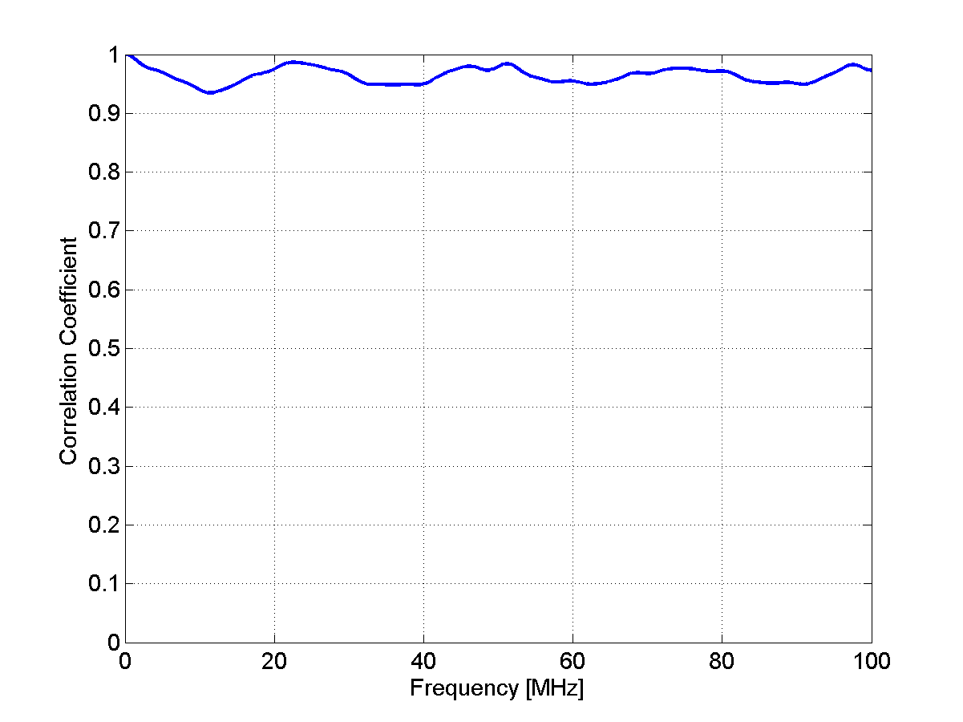

Table 17
Scenario D1: NLOS Clustered delay line model, rural macro-cell
Cluster # | Delay [ns] |  |  | Power [dB] |  |  | AoD [º] | AoA [º] | Ray power [dB] | Cluster ASD = 2º | Cluster ASD = 3º
1 | 0 | 5 | 10 | -3.0 | -5.2 | -7.0 | 0 | 0 | -13.0 | Cluster ASD = 2º | Cluster ASD = 3º
2 | 0 |  |  | -1.8 |  |  | -8 | 28 | -14.8 | Cluster ASD = 2º | Cluster ASD = 3º
3 | 5 |  |  | -3.3 |  |  | -10 | 38 | -16.3 | Cluster ASD = 2º | Cluster ASD = 3º
4 | 10 | 15 | 20 | -4.8 | -7.0 | -8.8 | 15 | -55 | -14.8 | Cluster ASD = 2º | Cluster ASD = 3º
5 | 20 |  |  | -5.3 |  |  | 13 | 48 | -18.3 | Cluster ASD = 2º | Cluster ASD = 3º
6 | 25 |  |  | -7.1 |  |  | 15 | -55 | -20.1 | Cluster ASD = 2º | Cluster ASD = 3º
7 | 55 |  |  | -9.0 |  |  | -17 | 62 | -22.0 | Cluster ASD = 2º | Cluster ASD = 3º
8 | 100 |  |  | -4.2 |  |  | -12 | 42 | -17.2 | Cluster ASD = 2º | Cluster ASD = 3º
9 | 170 |  |  | -12.4 |  |  | 20 | -73 | -25.4 | Cluster ASD = 2º | Cluster ASD = 3º
10 | 420 |  |  | -26.5 |  |  | 29 | 107 | -39.5 | Cluster ASD = 2º | Cluster ASD = 3º
Figure 17
PDP and frequency correlation (FCF) of CDL model
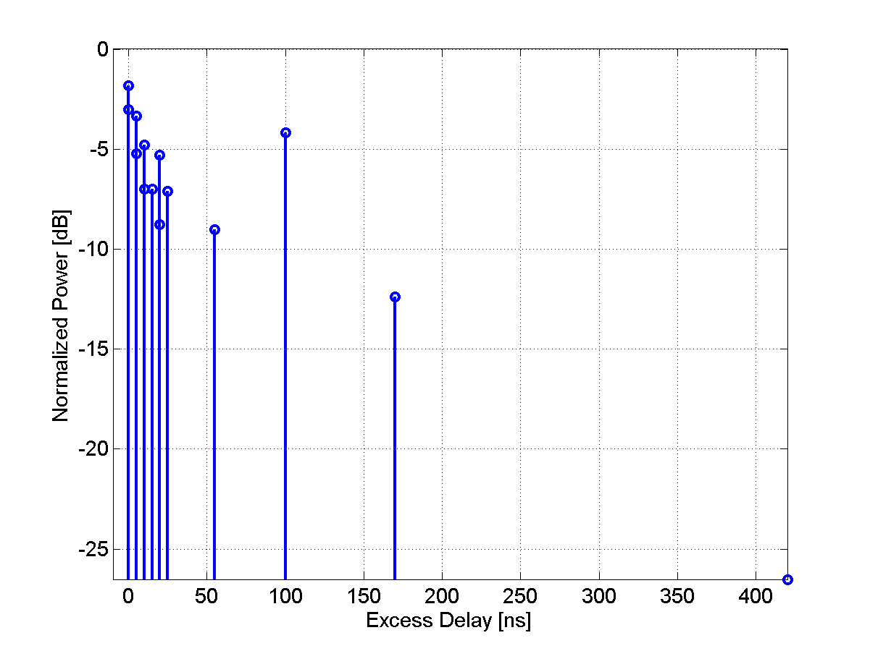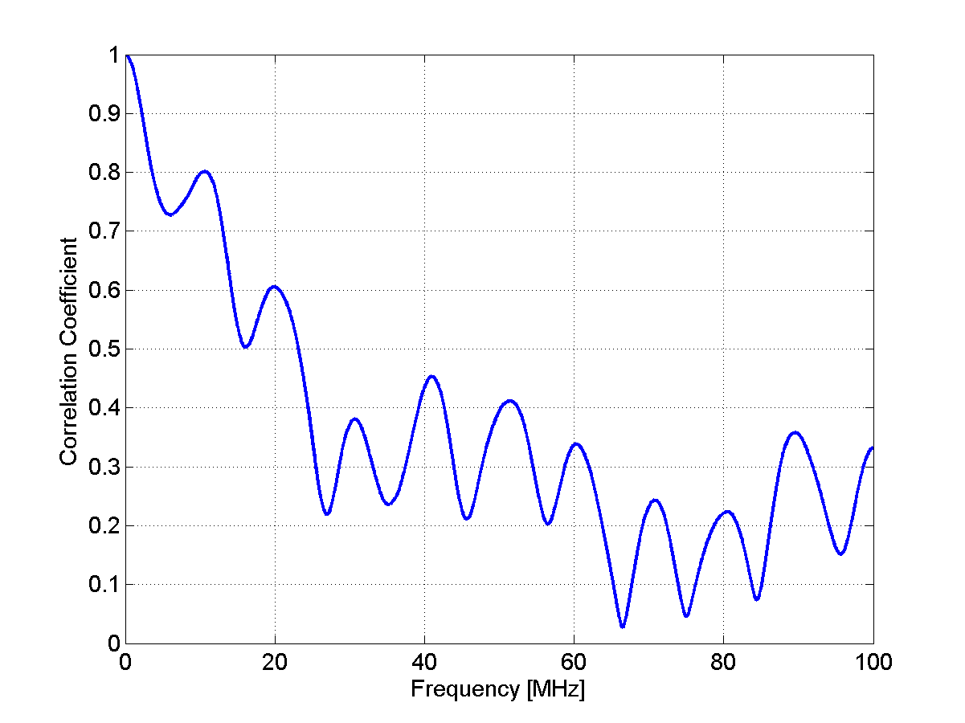

D2a – Moving networks
The CDL parameters of LOS condition are given below. In the LOS model Ricean K-factor is 6 dB.

Table 18
Scenario D2a: LOS Clustered delay line model, moving networks
Cluster # | Delay [ns] |  |  | Power [dB] |  |  | AoD [º] | AoA [º] | Ray power [dB] |  | Cluster ASD = 2º | Cluster ASA = 3º
1 | 0 | 5 | 10 | 0.0 | -14.1 | -15.8 | 0 | 0 | -0.29* | -21.9** | Cluster ASD = 2º | Cluster ASA = 3º
2 | 70 | 75 | 80 | -13.1 | -15.3 | -17.1 | -64 | -171 | -23.1 |  | Cluster ASD = 2º | Cluster ASA = 3º
3 | 465 |  |  | -23.8 |  |  | -60 | 162 | -36.8 |  | Cluster ASD = 2º | Cluster ASA = 3º
4 | 510 |  |  | -26.6 |  |  | -64 | -171 | -39.6 |  | Cluster ASD = 2º | Cluster ASA = 3º
* Power of dominant ray,
** Power of each other ray
Figure 18
PDP and frequency correlation (FCF) of CDL model
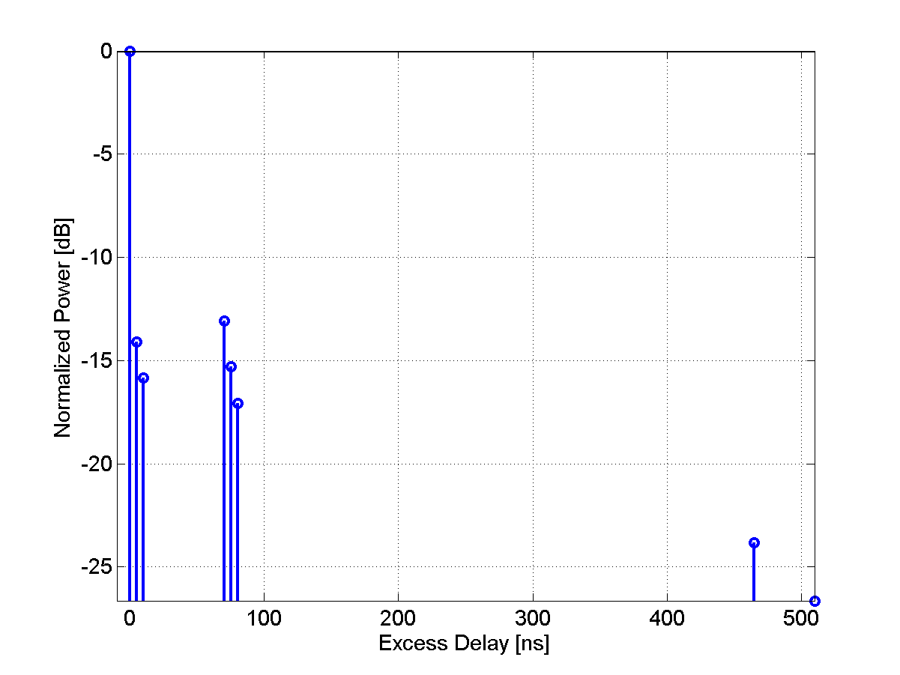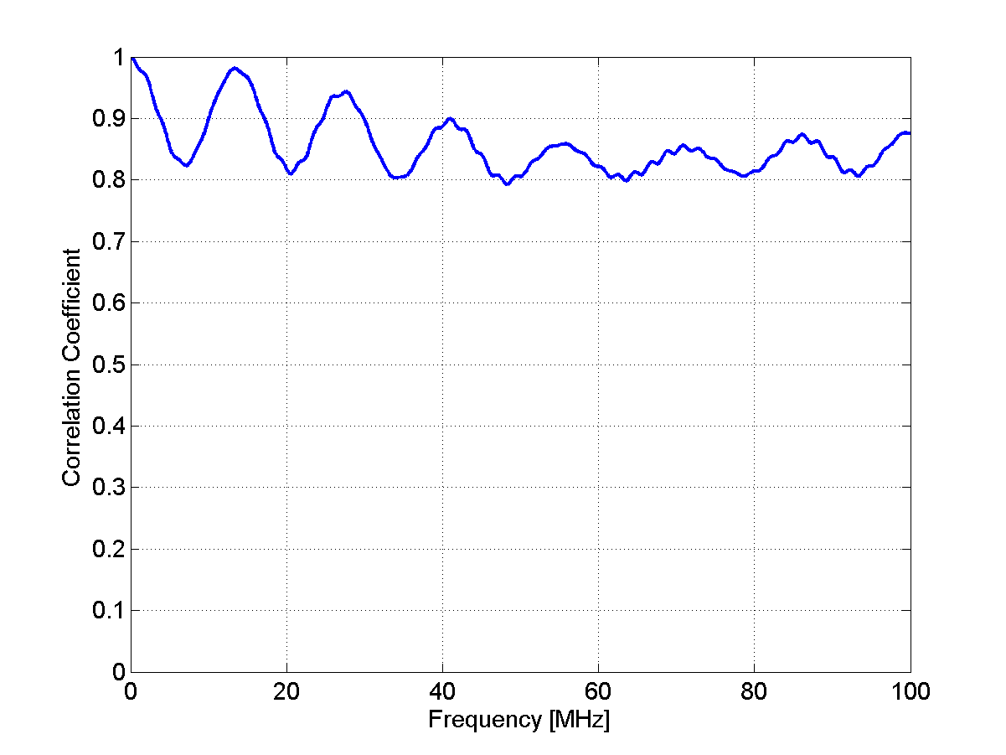
1.3.3 Advanced Features
1.3.3.1 Elevation angles
For the indoor and outdoor-to-indoor cases it is possible to use also the elevation spread to specify the angles of arrival and departure as given in Table 3.
[Editor’s Note: This issue required further discussion during the adhoc meeting.]
1.3.3.2 Cross-polarization values as function of BS–MS separation distance
[Editor’s note: To be investigated until the next meeting. Consider also including recommended antenna configurations]
1.3.3.3 Fixed BS and MS with moving scatterers
[Editor’s note: Temporal K-factor to be investigated until the following meeting]

References
- 3GPP TR25.996 V6.1.0 (2003-09) “Spatial channel model for multiple input multiple output (MIMO) simulations” Release 6.
- IST-WINNER II Deliverable D1.1.1 v1.0, “WINNER II Interim Channel Models”,
December 2006.
- Gudmundson, M. Correlation Model for Shadow Fading in Mobile Radio Systems. Electron. Lett, Vol. 27, 23, 2145-2146). November, 1991.

1.4 Traffic Models
[This section introduce typical traffic models used for simulation.]

A major objective of system simulations is to provide an operator with a view of the maximum number of active users that can be supported for a given service under a specified configuration at a given coverage level.1.4.1 Introduction
[Give some general introduction to traffic model, lay out typical traffic models such as: WWW，FTP，Gaming, VoIP, Streaming, etc.]

1.4.2 Traffic models description
[Give the detail traffic model description for the traffic listed above.]

1.4.2.1 Web Browsing (HTTP) Traffic Model
HTTP traffic characteristics are governed by the structure of the web pages on the World Wide Web (WWW), and the nature of human interaction. The nature of human interaction with the WWW causes the HTTP traffic to have a bursty profile, where the HTTP traffic is characterized by ON/OFF periods as shown in Figure 1.
Figure 1
HTTP Traffic Pattern

The ON periods represent the sequence of packets in which the web page is being transferred from source to destination; while the OFF periods represent the time the user spends reading the webpage before transitioning to another page. This time is also known as Reading Time Error: Reference source not foundError: Reference source not found.
The amount of information passed from the source to destination during the ON period is governed by the web page structure. A webpage is usually composed of a main object and several embedded objects. The size of the main object, in addition to the number and size of the embedded objects define the amount of traffic passed from source to destination.
In summary, the HTTP traffic model is defined by the following parameters:
SM: Size of main object in page
Nd: Number of embedded objects in a page
SE: Size of an embedded object in page
Dpc: Reading time
Tp: Parsing time for the main page
In addition to the model parameters, HTTP traffic behavior is also dependent on the HTTP version used. Currently HTTP 1.0 and HTTP 1.1 are widely used by servers and browsers Error: Reference source not found-Error: Reference source not found. In HTTP 1.0, also known as burst mode transfer, a distinct TCP connection is used for each object in the page, thereby facilitating simultaneous transfer of objects. The maximum number of simultaneous TCP connections is configurable, with most browsers using a maximum of 4 simultaneous TCP connections. In HTTP/1.1, also known as persistent mode transfer, all objects are transferred serially over a single persistent TCP connection. Table 1 provides the model parameters for HTTP traffic.
Table 1
HTTP Traffic Parameters
Component | Distribution | Parameters | PDF
Main  object  Size (SM) | Truncated Lognormal | Mean = 10710 bytes  SD = 25032 bytes  Min = 100 bytes  Max = 2 Mbytes (before truncation) | $$σ=1\text{.}\text{37},μ=8\text{.}\text{37}$$  if x>max or x<min, discard and generate a new value for x
Embedded object size (SE) | Truncated Lognormal | Mean = 7758 bytes  SD = 126168 bytes  Min = 50 bytes  Max = 2 Mbytes (before truncation) | $$σ=2\text{.}\text{36},μ=6\text{.}\text{17}$$  f x>max or x<min, discard and generate a new value for x
Number of embedded objects per page (Nd) | Truncated Pareto | Mean = 5.64  Max. = 53 (before truncation) | Subtract k from the generated random value to obtain Nd  if x>max, discard and regenerate a new value for x
Reading time (Dpc) | Exponential | Mean = 30 sec | λ = 0.033
Parsing time (Tp) | Exponential | Mean = 0.13 sec | $$f_{x}=λe^{−λx},x≥0$$  $$λ=7\text{.}\text{69}$$
To request an HTTP session, the client sends an HTTP request packet, which has a constant size of 350 bytes. From the statistics presented in the literature, a 50%-50% distribution of HTTP versions between HTTP 1.0 and HTTP 1.1 has been found to closely approximate web browsing traffic in the internet Error: Reference source not found.
Further studies also showed that the maximum transmit unit (MTU) sizes most common to in the internet are 576 bytes and 1500 bytes (including the TCP header) with a distribution of 24% and 76% respectively. Thus, the web traffic generation process can be described as in FIGURE 2.
FIGURE 2
HTTP Traffic Profiles

A user is defined in outage for HTTP service if the average packet call throughput is less than the minimum average throughput requirement of 128 kbps. The system outage requirement is such that no more than 2% of users can be in outage. The air link PER of MAC SDUs for HTTP traffic should be not be greater than 1%.

1.4.2.1.1 HTTP and TCP interactions for DL HTTP traffic
Two versions of the HTTP protocol, HTTP/1.0 and HTTP/1.1, are widely used by servers and browsers. Users shall specify 50% HTTP/1.0 and 50% HTTP/1.1 for HTTP traffic. For people who have to model the actual interaction between HTTP traffic and the underling TCP connection, refer to 4.1.3.2, 4.2.4.3 of Error: Reference source not found for details.

1.4.2.1.2. HTTP and TCP interactions for UL HTTP traffic
HTTP/1.1 is used for UL HTTP traffic. For details regarding the modeling of the interaction between HTTP traffic and the underling TCP connection, refer to 4.2.4.1, 4.2.4.2 of Error: Reference source not found.

1.4.2.2 File Transfer Protocol (FTP) Traffic Model
File transfer traffic is characterized by a session consisting of a sequence of file transfers, separated reading times. Reading time is defined as the time between end of transfer of the first file and the transfer request for the next file. The packet call size is therefore equivalent to the file size and the packet call inter-arrival time is the reading time. A typical FTP session is shown in Figure 4.
Figure 3: FTP Traffic Parameters

Figure 4: FTP Traffic Parameters

First Transfer
Reading Time
Reading Time
Second Transfer
Third Transfer

provides the model parameters for FTP traffic that includes file downloads as well as uploads Error: Reference source not foundError: Reference source not found. In the case of file uploads, the arrival of new users is Poisson distributed and each user transfers a single file before leaving the network.
The FTP traffic generation process is described in FIGURE 5. Based on the results on packet size distribution, 76% of the files are transferred using an MTU size of 1500 bytes and 24% of the files are transferred using an MTU size of 576 bytes. Note that these two packet sizes also include a 40 byte IP packet header and this header overhead for the appropriate number of packets must be added to the file sizes calculated from the statistical distributions in TABLE 2. For each file transfer a new TCP connection is used whose initial congestion window size is 1 segment.
A user is defined in outage for FTP service if the average packet call throughput is less than the minimum average throughput requirement of 128 kbps. The system outage requirement is such that no more than 2% of users can be in outage. The air link PER of MAC SDUs for FTP traffic should be not be greater than 1%.
TABLE 2
FTP Traffic Parameters
Component | Distribution | Parameters | PDF
File  size (S) | Truncated Lognormal | Mean = 2 Mbytes  SD = 0.722 Mbytes  Max = 5 Mbytes | $\begin{aligned}f_{x}=\frac{1}{\sqrt{2π}σx}\text{exp}\left[\frac{−{\left(\text{ln}x−μ\right)}^{2}}{2σ^{2}}\right],x≥0 \\ \end{aligned}$$σ=0\text{.}\text{35},μ=\text{14}\text{.}\text{45}$  if x>max or x<min, discard and generate a new value for x
Reading  time (D_{pc}) | Exponential | Mean = 180 sec. | e

FIGURE 5
FTP Traffic Profiles

1.4.2.3 Speech Source Model (VoIP)
VoIP refers to real-time delivery of voice packet across networks using the Internet protocols. A VoIP session is defined as the entire user call time and VoIP session occurs during the whole simulation period.

There are a variety of encoding schemes for voice (i.e., G.711, G.722, G.722.1, G.723.1, G.728, G.729, and AMR) that result in different bandwidth requirements. Including the protocol overhead, it is very common for a VoIP call to require between 5 Kbps and 64 Kbps of bi-directional bandwidth.

Basic VoIP Model
A typical phone conversation is marked by periods of active talking / talk spurts (ON periods) interleaved by silence / listening periods (or OFF periods) as shown in FIGURE 6.

FIGURE 6
Typical Phone Conversation Profile
Consider the simple 2-state voice activity Markov model shown in FIGURE 7
FIGURE 7
2-state voice activity Markov model
In the model, the conditional probability of transitioning from state 1 (the active speech state) to state 0 (the inactive or silent state) while in state 1 is equal to a, while the conditional probability of transitioning from state 0 to state 1 while in state 0 is c. The model is assumed to be updated at the speech encoder frame rate R=1/T, where T is the encoder frame duration (typically, 20 ms). Packets are generated at time intervals T+ τ, where τ is the network packet arrival delay jitter. During the active state, packets of fixed sizes are generated at these intervals, while the model is updated at regular frame intervals. The size of packet and the rate at which the packets are sent depends on the corresponding voice codecs and compression schemes. TABLE 3 provides information on some common vocoders.
TABLE 3
Information on various vocoders
Vocoder | EVRC | AMR | GSM 6.10 | G.711 | G.723.1 |  | G.729A
Source Bit rate  [Kb/s] | 0.8/2/4/8.55 | 4.75-12.2 | 13 | 64 | 5.3 | 6.3 | 8
Frame duration [ms] | 20 | 20 | 20 | 10 | 30 | 30 | 10
Information bits per frame | 16/40/80/171 | 95-244 | 260 | 640 | 159 | 189 | 80
Among the various vocoders in TABLE 3 a simplified AMR (Adaptive Multi-Rate) audio data compression model can be used to simplify the VoIP modeling process. AMR is optimized for speech coding and was adopted as the standard speech codec by 3GPP and widely used in GSM. The original AMR codec uses link adaptation to select from one of eight different bit rates based on link conditions. If the radio condition is bad, source coding is reduced (less bits to represent speech) and channel coding (stronger FEC) is increased. This improves the quality and robustness of the network condition while sacrificing some voice clarity. In the simplified version in this document, link adaptation has been disabled and the full rate of 12.2 kbps is used in the active state. This model captures the worst case scenario.
Table 4 shows the VoIP packet size calculation for simplified AMR operation with or without header compression when using IPv4 or IPv6. In the table, the MAC CRC of 4 bytes for ARQ is not included and only CRC for HARQ is included because the ARQ process can be assumed to be disabled for VoIP services.
To calculate the total packet size, technology specific MAC headers and CRC need to be accounted for. Header compression, IP version also need to be accounted for.
The voice capacity assumes a 12.2. kbps codec with a 50% activity factor such that the percentage of users in outage is less than 2% where a user is defined to have experienced voice outage if more than 2% of the VoIP packets are dropped, erased or not delivered successfully to the user within the delay bound of 50 ms.
The packet delay is defined based on the 98th percentile of the CDF of all individual users’ 98th percentiles of packet delay (i.e., the 98th percentile of the packet delay CDF first determined for each user and then the 98th percentile of the CDF that describes the 98th percentiles of the individual user delay is obtained).
Bidirectional VoIP capacity is measured in Active Users/MHz/Sector. The total number of active users on the DL and UL is divided by total bandwidth occupied by the system accounting for frequency reuse. For an FDD configuration, the bandwidth is calculated as the sum of the uplink and downlink channel bandwidths. For a TDD configuration, the bandwidth is simply the channel bandwidth.
Table 4
VoIP Packet Calculation for AMR and G.729
Description | AMR without  Header  Compression  IPv4/IPv6 | AMR with Header  Compression IPv4/IPv6 | G.729 without  Header  Compression  IPv4/IPv6 | G.729 with Header  Compression  IPv4/IPv6
Voice Payload  (20 ms aggregation interval) | 7 bytes for inactive  33 bytes for active | 7 bytes for inactive  33 bytes for active | 0 bytes for inactive  20 bytes for active | 0 bytes for inactive  20 bytes for active
Protocol  Headers  (including UDP checksum) | 40 bytes /  60 bytes | 3 bytes /  5 bytes | 40 bytes /  60 bytes | 3 bytes /  5 bytes
RTP | 12 bytes |  | 12 bytes
UDP | 8 bytes |  | 8 bytes
IPv4 / IPv6 | 20 bytes /  40 bytes |  | 20 bytes /  40 bytes
Generic MAC  Header | Technology Specific | Technology Specific | Technology Specific | Technology Specific
CRC | Technology Specific | Technology Specific | Technology Specific | Technology Specific
Total VoIP  packet size | Technology Specific | Technology Specific | Technology Specific | Technology Specific
        - VoIP Traffic Model Parameters

During each call (each session), a VoIP user will be in the Active or Inactive state. The duration of each state is exponentially distributed. In the Active/Inactive state, packets of fixed sizes will be generated at intervals of T seconds, where T is the VoIP frame interval of 20 ms. Table 5 specifies the distributions and parameters associated with the VoIP traffic model.
Table 5
VoIP traffic model parameters specification
Component | Distribution | Parameters | PDF
Active/Inactive state duration | Exponential | Mean = 1.5 second | f _{x} = λ e^{− λ x}, x≥0  λ=1/ Mean
Probability of state transition | N/A | 0.016 | N/A
 |  |  | $f_{x}=\frac{1}{2β}e^{−\frac{\left|τ\right|}{β}}$

Link adaptation of AMR codec is disabled in order to evaluate performance under worst case, and to simplify the voice traffic model.
During the inactive state, we have chosen to generate comfort noise with smaller packet sizes at regular intervals instead of no packet transmission. This simplified model does not include a feature called hangover, which generates additional seven frames at the same rate as speech to ensure the correct estimation of comfort noise parameters at the receiver side even if there is a silence period at the end of a talk spurt (ON state), and after the hangover period, a SID_FIRST frame is sent. The voice traffic model specifies only one rate during the ON state (talk spurt) of the AMR codec (12.2 kbps) and another rate for the comfort noise (SID_UPDATE) during the OFF state of the AMR codec. SID_UPDATE frames are generated every 8th frame during the silence period.

      - Near Real Time Video Streaming
This section describes a model for streaming video traffic for DL direction. FIGURE 8 illustrates the steady state of video streaming traffic from the network as observed by the base station. Call setup latency and overhead are not considered in this model.
FIGURE 8
Video Streaming Traffic Model
Each frame of video data arrives at a regular interval T. Each frame can be treated as a packet call and there will be zero OFF duration within a session. Within each frame (packet call), packets (or datagrams) arrive randomly and the packet sizes are random as well.
To counter the jittering effect caused by the random packet arrival rate within a frame at the MS, the MS uses a de-jitter buffer window to guarantee a continuous display of video streaming data. The de-jitter buffer window for video streaming service is 5 seconds. At the beginning of the simulation, the MS de-jitter buffer shall be full with video data. During simulation, data is leaked out of this buffer at the source video data rate and filled as DL traffic reaches the MS from the BS. As a performance criterion, the simulation shall record the length of time, if any, during which the de-jitter buffer runs dry.
The packet sizes and packet inter-arrival rate can be found in when using a source rate of 64 kbps.
TABLE 6 lists the parameters for the video streaming model.
TABLE 6
Near Real Time Video Streaming Traffic Model Parameters
Component | Distribution | Parameters | PDF
Inter-arrival time between the beginning of each frame | Deterministic | 100 ms (Based on 10 frames per second)
Number of packets (slices) in a frame | Deterministic | 8 packets per frame
Packet (slice) size | Truncated Pareto | Mean =10 bytes, Max = 250 bytes (before truncation) | $$f_{x}={\left(\frac{k}{m}\right)}^{α},x=m$$  $$α=1\text{.}2,k=\text{20}\text{bytes},m=\text{10}\text{bytes}$$  if x>max, discard and regenerate a new value for x
Inter-arrival time between packets (slices) in a frame | Truncated Pareto | Mean=6 ms, Max=12.5 ms (before truncation) | $$f_{x}={\left(\frac{k}{m}\right)}^{α},x=m$$  $α=1\text{.}2,k=2\text{.}5\text{ms},m=6$ms  if x>max, discard and regenerate a new value for x

The other network protocol overhead, such as IP, TCP/UDP header should be added on each packet (slice) generated by the video streaming model described above.
A user is defined in outage for streaming video service if the 98th percentile video frame delay is larger than 5 seconds. The system outage requirement is such that no more than 2% of users can be in outage.

      - Video Telephony
Based on the compression efficiency and market acceptance as described in the section Error: Reference source not found, MPEG 4 has been selected for the video codec. The estimated values for the parameters to model a video stream vary from one trace to another. For parameters associated with the statistical distributions, the estimates depend strongly on the dimensions of the captured frames. For the video telephony traffic model, medium quality of an Office Cam trace is used and the trace library is available at Error: Reference source not found. For the traffic model, two different qualities for the video have been considered; high and medium quality. For the medium quality encoding the quantization parameters for all three frame types were fixed at 10, and for the high quality encoding the quantization parameters for all three frame types were fixed at 4 Error: Reference source not found.
The scene length for the video telephony is assumed to be the entire application session since the background or the main subject may not be so dynamic.
TABLE 7
Video Telephony Traffic Model
Parameter | Value
Service | Video Telephony
Video Codec | MPEG-4
Protocols | UDP
Scene Length (sec) | Session duration
Direction | Bi-direction (DL and UL)
Frames/sec | 25 frames/sec
GOP | N=12, M=3
Display size | 176x144
Color depth (bit) | 8
Video Quality | Medium
Mean BW | 110 kbps
I frame size (byte) | Weibull($α=$5.15, $β=$863), shift=3949, μ= 4742 , σ=178 , min=4034, max=5184
P frame size (byte) | Lognormal(μ=259 , σ=134), min=100, max=1663
B frame size (byte) | Lognormal(μ=147 ,σ=74), min=35, max=882
      - Gaming Traffic Model
Gaming is a rapidly growing application embedded into communication devices, and thus wireless gaming needs to be considered. Games in different genre, such as First Person Shooter (FPS), Role Play Game (RPG), etc., show dramatic different traffic behaviors. FPS model is recommended to represent the gaming traffic model in this document because it posts additional requirements to the system performance, such as real time delay with irregular traffic arrivals.
FPS is a genre of video games. It is a good representation of the modern Massively Multiplayer Online (MMO) game. Due to the nature of the FPS game, it has stringent network delay requirement. For the FPS game, if the client to server to client round trip delay (i.e., ping time, or end to end delay) is below 150 ms, the delay is considered excellent. When the delay is between 150 ms to 200 ms, the delay is noticeable especially to the experienced player. It is considered good or playable. When ping time is beyond 200 ms, the delay becomes intolerable.
This end to end delay budget can be broken down into internet delay, server processing delay, cellular network delay, air interface delay, and client processing delay, etc. Let the IP packet delay be the time that the IP packet entering the MAC SDU buffer to the time that the IP packet is received by the receiver and reassembled into IP packet. The IP packet delay is typically budgeted as 50 ms to meet the 200 ms end to end delay. A gamer is considered in outage if 10% of its packet delay is either lost or delayed beyond the budget, i.e., 50 ms. The system outage requirement is such that no more than 2% of users can be in outage.

The FPS traffic can be modeled by the Largest Extreme Value distribution. The starting time of a network gaming mobile is uniformly distributed between 0 and 40 ms to simulate the random timing relationship between client traffic packet arrival and reverse link frame boundary. The parameters of initial packet arrival time, the packet inter arrival time, and the packet sizes are illustrated in TABLE 8.

TABLE 8
FPS Internet Gaming Model
Component | Distribution |  | Parameters |  | PDF
Component | DL | UL | DL | UL | PDF
Initial packet arrival | Uniform | Uniform | a = 0,  b = 40 ms | a=0,  b=40 ms | $$\begin{matrix}f(x)=\frac{1}{b−a} & a≤x≤b\end{matrix}$$
Packet arrival time | Extreme | Extreme | a = 50 ms,  b = 4.5 ms | a = 40 ms,  b = 6 ms | $$f(x)=\frac{1}{b}e^{−\frac{x−a}{b}}e^{−e^{−\frac{x−a}{b}}},b>0$$  $$Y∈U(0,1)$$
Packet size | Extreme | Extreme | a = 330 bytes,  b = 82 bytes | a = 45 bytes, b = 5.7 bytes | $$f(x)=\frac{1}{b}e^{−\frac{x−a}{b}}e^{−e^{−\frac{x−a}{b}}},b>0$$  $X=\left\lfloor a−b\text{ln}\left(−\text{ln}Y\right)\right\rfloor +2$*,  $$Y∈U(0,1)$$
* A compressed UDP header of 2 bytes is included in the packet size

Email is an important application that constitutes a high percentage of internet traffic. Email application traffic is included in the UMTS Forum 3G traffic models and ITU R M.2072 Error: Reference source not foundError: Reference source not found.
Interactions between email servers and clients are governed by email protocols. The three most common email protocols are POP, IMAP and MAPI. Most email software operates under one of these (and many products support more than one) protocols. The Post Office Protocol (currently in version 3, hence POP3) allows email client software to retrieve email from a remote server. The Internet Message Access Protocol (now in version 4 or IMAP4) allows a local email client to access email messages that reside on a remote server. The Messaging Application Programming Interface (MAPI) is a proprietary email protocol of Microsoft that can be used by Outlook to communicate with Microsoft Exchange Server. It provides somewhat similar but more functionality than an IMAP protocol.
The email traffic model in this section considers both POP3 and MAPI since these protocols generate different traffic patterns. To model POP3, an FTP model can be used, and an email transaction with MAPI protocol can be modeled with multiple MAPI segment transactions in series. Each MAPI fragment is transmitted using the TCP protocol and segmented into smaller segments again based on the TCP configuration. A maximum MAPI fragment size of 16896 bytes has been found so far, and this information is indicated in the first packet of a MAPI fragment. Outlook finishes all the TCP ACK packet transmission for the current MAPI segment and the Exchange server waits for the MAPI fragment completion indication packet before sending the next one. The last packet in the MAPI fragment sets the “PUSH” bit in the TCP packet to transmit all of the packets in the TCP buffer to the application layer at the receiver side Error: Reference source not found.

Email traffic can be characterized by ON/OFF states. During the ON-state an email could be transmitted or received, and during the OFF-state a client is writing or reading an email. FIGURE 9 depicts a simplified email traffic pattern.

FIGURE 9
Email Traffic Model
The parameters for the email traffic model are summarized in TABLE 9 Error: Reference source not foundError: Reference source not foundError: Reference source not foundError: Reference source not foundError: Reference source not found.
TABLE 9
Email Traffic Parameters

Parameter | Distribution | Parameters | PDF
E-Mail Protocol | N/A | POP3, MAPI | N/A
E-Mail Average Header Size (Bytes) | Deterministic | 1 K | N/A
Number of email receive | Lognormal | Mean = 30  Std Deviation = 17 | $f_{x}=\frac{1}{\sqrt{2π}σ}\text{exp}\left[\frac{−(\text{ln}x−μ)^{2}}{2σ^{2}}\right]$$x≥0$  $$σ=3\text{.}\text{262},μ=0\text{.}\text{5277}$$
Number of email send | Lognormal | Mean = 14  Std Deviation = 12 | $f_{x}=\frac{1}{\sqrt{2π}σ}\text{exp}\left[\frac{−(\text{ln}x−μ)^{2}}{2σ^{2}}\right]$$x≥0$  $$σ=2\text{.}\text{364},μ=0\text{.}\text{742}$$
Email reading time (sec) | Pareto | $α=1\text{.}1\text{,,}k=2,m=\text{65}$, mean = 60,  maximum = 63 | $$\begin{aligned}f_{x}=\frac{α\begin{matrix}k^{α}\end{matrix},}{x^{α\begin{matrix}+1\end{matrix}}},k≤x<m \\ f_{x}={\left(\frac{k}{m}\right)}^{α},x=m\end{aligned}$$
Email writing time (sec) | Pareto | $α=1\text{.}1,k=2,m=\text{125}$, mean = 120,  maximum = 123 | $$\begin{aligned}f_{x}=\frac{α\begin{matrix}k^{α},\end{matrix}}{x^{α\begin{matrix}+1\end{matrix}}},k≤x<m \\ f_{x}={\left(\frac{k}{m}\right)}^{α},x=m\end{aligned}$$
Size of email receive/send without attachment (Kbytes) | Cauchy | median $μ=\text{22}\text{.}7$ Kbytes, 90%-tile = 80Kbytes | $f_{x}=\frac{A}{π((x−μ)^{2}+1)}$, A is selected to satisfy 90%-tile value
Size of email receive/send with attachment (Kbytes) | Cauchy | median $μ=\text{227}$ Kbytes , 90%-tile = 800 Kbytes | $f_{x}=\frac{A}{π((x−μ)^{2}+1)}$, A is selected to satisfy 90%-tile value
Ratio of email with attachment | Deterministic | Without attachment: 80%  With attachment: 20% | N/A

1.4.3 Traffic selection and parameters for the test environments
[List the typical models and the distribution rate of the mix of several traffics for the test environments defined in section 1.1 of Annex 2, at which four test environments are defined.]

1.5 Link Adaptation
Link adaptation can enhance system performance by optimizing resource allocation in varying channel conditions. System level simulations should include adaptation of the modulation and coding schemes, according to link conditions.

The purpose of this section is to provide guidelines for link adaptation in system evaluations. The use of link adaptation is left to the proponent as it may not pertain to all system configurations. The link adaptation algorithms implemented in system level simulations are left to Individual proponents for each proposal. Proponents should specify link adaptation algorithms including power, MIMO rank, and MCS adaptation per resource block.
1.5.1 Adaptive Modulation and Coding
The evaluation methodology assumes that adaptive modulation and coding with various modulation schemes and channel coding rates is applied to packet data transmissions. In the case of MIMO, different modulation schemes and coding rates may be applied to different streams.
1.5.2 Link Adaptation with HARQ
The link adaptation algorithm should be optimized to maximize the performance at the end of the HARQ process (e.g. maximize the average throughput under constraint on the delay and PER, or maximize number of users per service).

1.5.3 Channel Quality Feedback
A Channel Quality Indicator (CQI) channel is utilized to provide channel-state information from the user terminals to the base station scheduler. Relevant channel-state information can be fed back. For example, Physical CINR, effective CINR, MIMO mode selection and frequency selective sub-channel selection may be included in CQI feedback. Some implementations may use other methods, such as channel sounding, to provide accurate channel measurements. CQI feedback granularity and its impact may also be considered. Proponents should describe the CQI feedback type and assumptions of how the information is obtained.

1.5.3.1 Channel Quality Feedback Delay and Availability
Channel quality feedback delay accounts for the latency associated with the measurement of channel at the receiver, the decoding of the feedback channel, and the lead-time between the scheduling decision and actual transmission. The delay in reception of the channel quality feedback shall be modeled to accurately predict system performance.

Channel quality feedback may not be available every frame due to system constraints such as limited feedback overhead or intermittent bursts. The availability of the channel quality feedback shall be modeled in the system simulations.

The proponents should indicate the assumptions of channel quality feedback delay and availability for system proposals.
1.5.3.2 Channel Quality Feedback Error
System simulation performance should include channel quality feedback error by modeling appropriate consequences, such as misinterpretation of feedback or erasure.

The proposals shall describe if CQI estimation errors are taken into account and how those errors are modeled.

1.6 HARQ
The Hybrid ARQ (HARQ) protocol should be implemented in system simulations. Multiple parallel HARQ streams may be present in each frame, and each stream may be associated with a different packet transmission, where a HARQ stream is an encoder packet transaction pending, i.e., a HARQ packet has been transmitted but has not been acknowledged. Different MIMO configurations may also have an impact on the HARQ implementation.

Each HARQ transmission results in one of the following outcomes: successful decoding of the packet, unsuccessful decoding of the packet transmission requiring further re-transmission, or unsuccessful decoding of the packet transmission after maximum number of re-transmissions resulting in packet error. The effective SINR for packet transmissions after one or more HARQ transmissions used in system simulations is determined according to the link to system mapping.

When HARQ is enabled, retransmissions are modeled based on the HARQ option chosen. For example, HARQ can be configured as synchronous/asynchronous with adaptive/non-adaptive modulation and coding schemes for Chase combining or incremental redundancy operation. Synchronous HARQ may include synchronous HARQ acknowledgement and/or synchronous HARQ retransmissions. Synchronous HARQ acknowledgement means that the HARQ transmitter side expects the HARQ acknowledgments at a known delay after the HARQ transmission. Synchronous HARQ retransmission means that the HARQ receiver side expects the HARQ retransmissions at known times. In the case of asynchronous HARQ, the acknowledgement and/or retransmission may not occur at known times. Adaptive H-ARQ, in which the parameters of the retransmission (e.g. power, MCS) are changed according to channel conditions reported by the MS may be considered. In the case of non-adaptive HARQ, the parameters of the retransmission are not changed according to channel conditions.

The HARQ model and type shall be specified with chosen parameters, such as maximum number of retransmissions, minimum retransmission delay, incremental redundancy, Chase combining, etc. HARQ overhead (associated control) should be accounted for in the system simulations on both the uplink and downlink

HARQ Acknowledgement
The HARQ acknowledgment is used to indicate whether or not a packet transmission was successfully received.

Modeling of HARQ requires waiting for HARQ acknowledgment after each transmission, prior to proceeding to the next HARQ transmission. The HARQ acknowledgment delay should include the processing time which includes, decoding of the traffic packet, CRC check, and preparation of acknowledgment transmissions. The amount of delay is determined by the system proposal.

Misinterpretation, missed detection, or false detection of the HARQ acknowledgment message results in transmission (frame or encoder packet) error or duplicate transmission. Proponents of each system proposal shall justify the system performance in the presence of error of the HARQ acknowledgment.

Scheduling
The scheduler allocates system resources for different packet transmissions according to a set of scheduling metrics, which can be different for different traffic types. The same scheduling algorithm shall be used for all simulation drops. System performance evaluation and comparison require that fairness be preserved or at least known in order to promote comparisons. On the other hand it is clear that various scheduling approaches will have different performance and overhead impacts and will need to be aligned. The scheduling algorithm should be specified along with assumptions on feedback. The scheduling will be done with consideration of the reported metric where the reported metric may include CQI and other information. The scheduler shall calculate the available resources after accounting for all control channel overhead and protocol overhead.

DL scheduler
For the baseline simulation, a generic proportionally fair scheduler shall be used for the full-buffer traffic model.
The proponent may also present additional results with an alternative scheduler and shall specify the scheduler algorithm in detail, with assumptions, if any.

UL scheduler
The UL scheduler is very similar to DL Scheduler. The UL scheduler maintains the request-grant status of various uplink service flows. Bandwidth requests arriving from various uplink service flows at the BS will be granted in a similar fashion as the downlink traffic.

Handover
The system simulation defined elsewhere in the document deals with throughput, spectral efficiency, and latency. User experience in a mobile broadband wireless system is also influenced by the performance of handover. This section focuses on the methods to study the performance of handover which affects the end-users experience. Proponents of system proposals specifically relating to handover should provide performance evaluations according to this section.
For parameters such as cell size, DL&UL transmit powers, number of users in a cell, traffic models, and channel models; the simulation follows the simulation methodology defined elsewhere in the document. In this document, only intra-radio access technology handover is considered; inter-radio access technology handover is not considered.
The handover procedure consists of cell reselection via scanning, handover decision and initiation, and network entry including synchronization and ranging with a target BS.
Latency is a key metric to evaluate and compare various handover schemes as it has direct impact on application performance perceived by a user. Total handover latency is decomposed into several latency elements. Further, data loss rate and unsuccessful handover rate are important metrics.

System Simulation with Mobility
Two possible simulation models for mobility related performance are given in this section. The first is a reduced complexity model that considers a single USER moving along one of three trajectories with all other users at fixed locations, and a second simulation model that considers all mobiles in the system moving along random trajectories.

Single Moving User Model
Two possible simulation models for mobility related performance are given in this section. The first is a reduced complexity model that considers a single user moving along one of three trajectories with all other users at fixed locations, and a second simulation model that considers all mobiles in the system moving along random trajectories.

Trajectories
The movement of the single moving user is constrained to one of the trajectories defined in this section. More detailed and realistic mobility models may be considered.

Trajectory 1
In this trajectory, the user moves from Cell 1 to Cell 2 along the arrow shown in FIGURE 11. The trajectory starts from the center of Cell 1 to the center of Cell 2 while passing through the midpoint of the sector boundaries as shown in . The purpose of this trajectory is to evaluate handover performance in a scenario where the signal strength from the serving sector continuously decreases whereas the signal strength from the target sector continuously increases.
FIGURE 10: Trajectory 1
Cell 1
Cell 2
FIGURE 11: Trajectory 1

Trajectory 2
In this trajectory, the single moving user moves from Cell 1 to Cell 2 along the arrow shown in FIGURE 13. The user moves along the sector boundary between Cell 1 and Cell 2 until the midpoint of the cell boundary between Cell 1 and Cell 2. The purpose of this trajectory is to evaluate handover performance when the user moves along the boundary of two adjacent sectors.
FIGURE 12: Trajectory 2
Cell 1
Cell 2
FIGURE 13: Trajectory 2

Trajectory 3
In this trajectory, the single moving user moves from Cell 2 to Cell 1 along the arrow shown in Figure 15. The user starts from the center of Cell 2, moves along the boundary of two adjacent sectors of Cell 2 and towards the center of the Cell 1. The purpose of this trajectory is to evaluate a handover performance in the scenario where the user traverses multiple sector boundaries.

Figure 14: Trajectory 3
Cell 1
Cell 2
Figure 15: Trajectory 3

10 Cell Topology
As a reduced complexity option, a 10 cell topology may be used for handover evaluation with a single moving user. In the 10 cell topology, both serving and target cells should have one tier of neighboring cells as interferers shown in FIGURE 16.
FIGURE 16
10 Cell Topology

Handover Evaluation Procedure
- The system may be modeled using the 10 cell topology as illustrated in FIGURE 13 for the evaluation of handover performance. Each cell has three sectors and frequency reuse is modeled by planning frequency allocations in different sectors in the network.

- N users are dropped independently with uniform distribution across the cell area. Different load levels in the network are simulated by changing the number of users and the traffic generated.

- Path loss, shadow fading and fast fading models for each user should be consistent with the models defined in Section 1.3.1. Fading signal and fading interference are computed from each mobile station into each sector and from each sector to each mobile for each simulation interval.

- In the single user model, the trajectories defined in Section 1.8.1.1.1 should be used to model the movement of a single user associated with the center cell. The locations of all other users are assumed to be fixed and the serving sector for the fixed users does not change for the duration of the drop.

- Path loss, shadow fading and fast fading are updated based on location and velocity of a moving user. As the user moves along the specified trajectory, the target sector is chosen according to the metric used to perform handover.

- Traffic generated by the users should be according to the mixes specified. The moving user may be assigned one of the traffic types in the chosen traffic mix to analyze the effect of handover on the performance of the assigned traffic application. Traffic from the fixed users constitutes background load. Start times for each traffic type for each user should be randomized as specified in the traffic model being simulated.

- Statistics related to handover metrics are collected for the moving user only.

- Packets are not blocked when they arrive into the system (i.e. queue depths are infinite). Packets are scheduled with a packet scheduler using the required fairness metric. Channel quality feedback delay, PDU errors are modeled and packets are retransmitted as necessary. The HARQ process is modeled by explicitly rescheduling a packet as part of the current packet call after a specified HARQ feedback delay period.

- Sequences of simulation are run, each with a different random seed. For a given drop the simulation is run for this duration, and then the process is repeated with the users dropped at new random locations. A sufficient number of drops are simulated to ensure convergence in the system performance metrics.

Multiple Moving Users Model
In this model, multiple moving users are uniformly placed over the simulation environment and given a random trajectory and speed. The parameters selected remain in effect until a drop is completed.

Trajectories
Each user is assigned an angle of trajectory at the beginning of a call. The assigned angle is picked from a uniform distribution across the range of 0-359 degrees in one degree increments. The angle of zero degrees points directly North in the simulation environment. Movement of the user is established by selecting a random speed for the users according to defined profiles such that the population of users meets the desired percentages. The user remains at the selected random speed and direction for the duration of the simulation drop. When a user crosses a wrap around boundary point within the simulation space, the user will wrap around to the associated segment, continuing to keep the same speed and trajectory. FIGURE 17 depicts an example of the movement process for a 19-cell system.
FIGURE 17
19 cell abbreviated example of user movement in a wrap around topology *

* Blue lines denote paired wrap around boundary segments

19 Cell Topology
The 19 cell topology with wrap around can be used for handover evaluation with multiple moving users.

Trajectories
For the 19 cell topology with wrap around defined for the multiple moving user model, the simulation procedure outlined in Section 7.2.3.3 should be followed. In step 7 of this procedure, for the purposes of simulating handover performance, it may additionally be assumed that an user is initially connected to a specific serving sector. As the user moves along the trajectory described in Section 1.8.1.2.3 , the target sector is chosen according to the metric used to perform handover.

Handover Performance Metrics
The following parameters should be collected in order to evaluate the performance of different handover schemes. These statistics defined in this section should be collected in relation to the occurrence of handovers. A CDF of each metric may be generated to evaluate a probability that the corresponding metric exceeds a certain value.

For a simulation run, we assume:

- The total number of successful handovers occurred during the simulation time = N_{HO_success}
- The total number of failed handover during the simulation time = N_{HO_fail}
- The total number of handover attempts during the simulation time = N_{attempt}, where N_{attempt} = N_{HO_success} + N_{HO_fail}

Radio Layer Latency
This value measures the delay between the time instance T_{1,i} that a user transmits a serving BS its commitment to HO (for a hard handover (HHO), this is the time that the user disconnects from the serving BS) and the time instance T_{2,i} that the user successfully achieves PHY layer synchronization at the target BS (i.e., frequency and DL timing synchronization) due to handover occurrence i. The exact thresholds for successful PHY synchronization are for further study. For this metric, the average radio latency will be measured as
Average Radio Layer Latency =

Network Entry and Connection Setup Time
This value represents the delay between an user’s radio layer synchronization at T_{2,i}, and the start of transmission of first data packet from the target BS at T_{3,i} due to handover occurrence i. In the case of the reference system, this consists of ranging, UL resource request processes (contention or non-contention based), negotiation of capabilities, registration, DL packet coordination and a path switching time. The transmission error rate of MAC messages associated with network entry can be modeled dynamically or with a fixed value (e.g., 1%). A path switching time, as a simulation input parameter, may vary depending on network architecture.
Average Network Entry and Connection Setup Time =

Handover Interruption Time

This value represents time duration that a user can not receive any service from any BS. It is defined as the time interval from when the MS disconnects from the serving BS to the start of transmission of first data packet from the target BS.

Data Loss
This value represents the number of lost bits during the handover processes. This document uses DL data loss to evaluate the data loss performance of the air link. D_{RX,i} and D_{TX,i} denotes the number of received bits by the user and the number of total bits transmitted by the serving and the target BSs during the user performs handover occurrence i, respectively. Traffic profiles used for the simulation experiments to compare different handover schemes need to be identical.

Data Loss =

Handover Failure Rate
This value represents the ratio of failed handover to total handover attempts. Handover failure occurs if handover is executed while the reception conditions are inadequate on either the DL or the UL such that the mobile would have to go to a network entry state.

Handover Failure Rate =

1.9 Summary of Deployment Scenarios
[Give a extreme summary of the deployment scenarios. Define the link channel models, the system channel models, the propagation models, and the traffic models for each scenarios. Those scenarios will be used as simulation cases.]
Appendix 1

A1 Time-spatial propagation models

A1.1 Principle
The propagation model for IMT-Advanced should be at least considering the following items:
(1) Evaluation for broadband land mobile systems with up to 100 MHz bandwidth using the frequencies of UHF and SHF bands.
(2) Eevaluation for time and spatial processing techniques such as adaptive array antenna (AAA) and multi-input-multi-output (MIMO).
To evaluate above items accurately, a time-spatial profile model, which provides not only path loss characteristics but also delay (time) and arrival angular (spatial) profile characteristics, is necessary. It is well known that time-spatial profile characteristics depend on the distance from base station (BS), the antenna height of BS, city structure such as buildings and roads, etc. as well as carrier frequency and bandwidth. These parameters are key to accurately characterizing the time-spatial profile. Therefore, a time-spatial profile that considers these key parameters is required.
Actual radio propagation environments are very complicate. In order to characterize such environments accurately, a very complex time-spatial profile model is necessary. On the other hand, from a practical point of view, propagation model should be as simple as possible without loss of generality. Furthermore, in order to evaluate the time variant characteristics of the receiver, time variant model of received level is also necessary.

A.2 Time-spatial propagation models
The proposed model consists of three models; long-term time-spatial profile model, short-term time-spatial profile model, and instantaneous time-spatial profile model as shown in Fig. 1.
The instantaneous time-spatial profile is a snapshot of the time-spatial characteristics. Short-term time-spatial profile is obtained by spatial averaging the instantaneous time-spatial profiles over several tens of wavelength in order to suppress the variation of rapid fading. Long-term time-spatial profile is obtained by spatial averaging the short-term time-spatial profiles at approximately the same distance from the BS in order to suppress the variation due to shadowing. On the other hand, delay profile and arrival angular profiles are obtained by focusing on just the delay time or arrival angle yielded the time-spatial profile as shown in Fig. 2.
The time-spatial profiles in Fig.1 and the delay profile and arrival angular profile in Fig. 2 are expressed in terms of a continuous function with respect to delay time and arrival angle. In evaluations based on link level and system level simulations, a discrete model is generally more convenient than a continuous model as shown in Fig. 3 and Fig. 4.

A.3 Key parameters
The key parameters in the proposed model are as follows.
<H>: average building height (m, 5-50 m: height above the mobile station ground level)
hb : BS antenna height (m, 20-150 m: height above the mobile station ground level)
d : distance from the BS (km, 0.1-3 km)
B : bandwidth or chip rate (MHz, 0.5-100 MHz)
f_{c}: carrier frequency (GHz, 2-6 GHz)
λ : wavelength of carrier frequency( m)
v : moving speed of MS(m/s)
ΔL : level difference between the peak path’s power and cut off power
: number of observable paths.

A.4 Generation of time-spatial path profile model
Fig. A2-1-1 shows the concept of generating a time-spatial path profile model. After inputting the key parameters, a time-spatial path profile is generated by setting the pseudo random number. This allows a lot of different time-spatial path profile models with the same characteristics such as, for example, delay spread and arrival angular spread to be obtained easily. The time-spatial profile model taking the time variant characteristics into consideration is proposed based on measurement results in various cellular environments.
FIGURE A2-1-1
FIGURE A2-1-2
FIGURE A2-1-3
FIGURE A2-1-4
FIGURE A2-1-5

[1 C3 d=0.5km, h_{b}=40m]
[2 C3 d=1km, h_{b}=40m]

[3 C3 d=1.5km, h_{b}=40m]

4. C2 d=0.5km, h_{b}=40m

[5 C2 d=1km, h_{b}=40m]

[6 C2 d=1.5km, h_{b}=40m]

[7. C1 d=0.5km, h_{b}=30m]

[8. C1 d=1km, h_{b}=30m]

[9. C1 d=1.5km, h_{b}=30m]

Appendix 2

A simple modelling approach based on the Markov chain can be used for the time-evolution simulations in which the dynamic properties are completely modelled by the state transition probability matrix that describe how the clusters “appear” (or “birth”) and “disappear” (or “death”). By knowing the birth and death of a cluster, the cluster lifespan can also be derived. A 4-state Markov channel model (MCM) is proposed in order to model the dynamic evolution of clusters when the MS is in motion, where each state is defined as follows:
- S₀ – No “birth” or “death”,
- S₁ – 1 “death” only,
- S₂ – 1 “birth” only,
- S₃ – 1 “birth” and 1 “death”.
Note that four states are required in order to account for the correlation that exists between number of cluster births, n_{B} and number of cluster deaths, n_{D}. Figure A2-2-1 illustrates the state transition diagram of the 4-state MCM in which each node is numbered to represent one state of the model.
FIGURE A2-2-1
State transition diagram of the 4-state Markov channel model
The probabilistic switching process between states in the channel model is controlled by the state transition probability matrix, P, given by
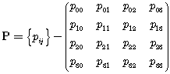, (A2-2-1)

where i and j denotes the state index, while p_{ij} is the state probability that a process currently in state i will occupy state j after its next transition. Note that p_{ij} must satisfy the following requirement

, (A2-2-2)

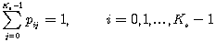, (A2-2-3)

where K_{s} is the number of states i.e., K_{s}=4 in our case and P describes how clusters appear and disappear when the MS moves.

[Editor’s note: The Markov model to be modified for a constant number of paths/clusters. The change of state is achieved by the power levels. The constant number of taps is essential to keep the model simple enough]
Appendix 3
The variation of large scale parameters is conjectured to affect the number of clusters. The cluster generation process proposed in this model can be summarized as follows:
- The received powers estimated using the conventional Okumura-Hata path loss model is defined as a standard cluster.
- The standard cluster is separated into N_{t} delay cluster in the delay domain by using the power profile estimation equation given by equation (A2-3-1).
- Based on the ellipse scattering model, each of the delay clusters can be spatially separated in the angular domain, N_{a}.
Finally, the total number of clusters in the spatial-temporal domain can be generated as N_{t}×N_{a}. Figure A2-3-1 shows the process for the above 3 steps. Note that the scattering model assumed that the effective scattering area around the MS can be expressed by an ellipse in which the MS is located in the center of the ellipse, and major axis of the ellipse runs in parallel along the street in which the MT is being located.
FIGURE A2-3-1
The generation of clusters in the spatial-temporal domains

As described above, the standard cluster can be estimated using the Okumura-Hata path loss model. Then, the delay cluster can be generated from the power delay profile and can be expressed as follows:
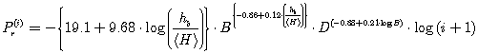, (A2-3-1)
where is the relative receiving power of ith path, B is the chip rate in Mcps, D is the transmitter and receiver separation distance in meter, h_{b} is the BS antenna height. Conformed condition is h_{b} > <H>.
Afterwards, the delay cluster will be spatially separated by deploying the method proposed in Figure A2-3-3. Based on this methodology, it is assumed that the position of the angular cluster exits at the intersection point between the arriving time at the MS and the scattering distribution ellipse as illustrated by Figure A2-3-2. Thus, a single delay cluster will be split into two delay clusters in which their angles θ₁ and θ₂ are given by:

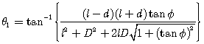, (A2-3-2)
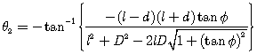. (A2-3-3)
where , if , θ₁ and θ₂ can be interchanged. Figure A-3-3 shows the example on how the angular information can be obtained from equations (A2-3-2 and A2-3-3).

FIGURE A2-3-2
The angular cluster estimation model
FIGURE A2-3-3
The spatial-temporal cluster estimation results
After identifying the spatial-temporal cluster, their received power needs to characterize. In general, the cluster located nearer to the MS has larger received power as compared to cluster located further away from the MS. When the delay cluster of received power P_{r} is spatially separated into angular clusters with angle of arrivals θ₁ and θ₂, their received power can be expressed as and , respectively, which are defined as follows:

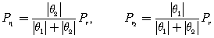. (A2-3-4)

In the case when becoming small i.e., , it can be assumed that and .

Figure A2-3-4 shows the figure in which the estimation using the proposed model was compared with the result obtained from a measurement. From the figure, it is clearly shown that for each cluster, the short section changes with a standard deviation σ=6dB. It is understood that the proposed model can be applied to most measurements to be included in the estimation.

FIGURE A2-3-4
The comparison of the estimation of spatial-temporal cluster based
on the proposed model and measurement results

1.4 Link budget template and deployment models
[Editors note: Text need to be inserted. Startpoint could be M.1225 and MIMO models etc.]
[Editor note: From the document 1143
The detailed evaluation procedures and the technical attributes which should be considered for the evaluation of radio interface technologies against each of the criteria and gives indication on what possible impact upon the different criteria could be included in this section. Radio interface technologies performance evaluation is to be based on a common set of verifiable parameter assumptions for all evaluation criteria for each test environment; if conditions change the technology descriptions should explain it.
To facilitate such criteria evaluation summaries, this part will identify the importance or relative ranking of the various technical attributes within each evaluation criteria. Ranking of some attributes may be different for different test environments. These rankings are based upon current anticipated market needs within some countries. It is also recognized that some new technical attributes or important considerations may be identified during the evaluation procedure that could impact any evaluation criteria summary.]

[Editor’s note: source [8F/1257, NZ] proposes to add a new annex]

