IEEE 802.16 ITU-R Liaison Group Workplan

The following table represents a workplan for the IEEE 802.16 ITU-R Liaison Group based on ITU-R and IEEE events relevant to the IEEE 802.16 Working Group.

Note: The Annexes provide more details on the IMT-Advanced work items, which are highlighted.

Group/Event | # | Start | End | Location | Actions/Comments
IEEE 802.18 |  | 8-Sep-08 | 12-Sep-08 | Kona, HI, USA
IEEE 802.16 | 57 | 16-Sep-08 | 19-Sep-08 | Kobe, Japan | - Need for ITU-R Liaison Group meeting in September 2008 is not currently anticipated.  - Identify acting chair of ITU-R Liaison Group for November meeting.  - Prepare contribution for the IMT-Advanced workshop
 |  |  |  |  | - No time for IEEE 802 EC correspondence activity to approve contribution(s) to ITU-R.
WiMAX Forum |  | 22-Sep-08 | 26-Sep-08 | Macao, China
WP 5D contr. Due: |  |  | 1-Oct-08
IMT-Adv Workshop |  | 07-Oct-08 | 07-Oct-08 | Seoul, Korea | - Presentation by José Costa
ITU-R WP 5D | 3 | 08-Oct-08 | 15-Oct-08 | Seoul, Korea
WP 5A contr. Due: |  |  | 21-Oct-08
ITU-R WP 5A | 2 | 28-Oct-08 | 06-Nov-08 | Geneva, CH
SG5 contr. Due: |  |  | 3-Nov-08
ITU-R SG5 | 2 | 10-Nov-08 | 11-Nov-08 | Geneva, CH
IEEE 802.16 | 58 | 10-Nov-08 | 13-Nov-08 | Dallas, TX | - Plan for the IMT-Advanced submission package development in 2009  - Prepare contribution #1 towards IMT-Advanced indicating intent to submit candidate RIT proposal  - Prepare the third contribution on IMT-2000 Rev. 9  - Consider SG 5 results  - Prepare more detailed workplan and Timelines for the ITU-R contribution development  - Provide comments to 802.18 on the IEEE 802 IMT-Advanced Process
IEEE 802.18 |  | 10-Nov-08 | 14-Nov-08 | Dallas, TX | - Definition of IMT-Advanced submission process in IEEE 802.18
IEEE 802 |  | 10-Nov-08 | 14-Nov-08 | Dallas, TX | - Definition of IMT-Advanced submission process in IEEE 802, with minimized lead time  - Approval of contribution #1 by the EC
IEEE 802.16 | 59 | 12-Jan-09 | 15-Jan-09 | La Jolla, CA, USA | - Review 802-approved contributions from Session #58; if necessary, update and seek approval as replacements.  - Issue a call for contributions for TDT (including LBT), SCT. SPECT.  - submission of statement of intent to 802.18
IEEE 802.18 |  | 19-Jan-09 | 23-Jan-09 | Los Angeles, CA, USA | If necessary, update 802-approved contributions from Session #58.
WP 5D contr. Due: |  |  | 4-Feb-09 |  | - Deadline for submission of IEEE contributions for WP 5D  - Deadline for letters of conveyance for IMT-2000 Rev. 9
WiMAX Forum |  | 5-Feb-09 | 10-Feb-09 | Orlando, FL, USA
ITU-R WP 5D | 4 | 10-Feb-09 | 17-Feb-09 | Geneva, CH | - Present contribution #1 on IMT-Advanced  - Present contribution for meeting x+2 of M.1457 update
IEEE 802.16 | 60 | 9-Mar-09 | 12-Mar-09 | Vancouver, BC, Canada | - Prepare draft of contribution #2 on IMT-Advanced  - Review input contributions. Prepare preliminary drafts of TDT (including LBT), SCT, SPECT.  - Call for Contributions on simulation package and templates  - prepare contribution for 5A on update of M.1801 and update of M.[LMS.UHF.PPDR.TECH]
IEEE 802 |  | 9-Mar-09 | 13-Mar-09 | Vancouver, BC, Canada | - Review by 802.18 and approval by the EC of IMT-Advanced contribution #2  - Review contribution for 5A on update of M.1801 and update of M.[LMS.UHF.PPDR.TECH] with 802.18; forward for EC approval  - approval of other ITU-R contributions by the EC
IEEE 802.16 | 61 | 4-May-09 | 7-May-09 | Cairo, Egypt | - Review contribution #2 for IMT-Advanced; if necessary, update and seek approval as replacements.  - Initiate development of final submission package towards IMT-Advanced  - Update drafts of TDT (including LBT), SCT, SPECT for the final submission  - Call for Contributions for PCT including supporting simulations  - Prepare contribution towards update of Revision 9 of Recommendation ITU-R M.1457
IEEE 802.18 |  | 11-May-09 | 15-May-09 | Montreal, Canada | - If necessary, update contribution #2.  - Review contribution towards update of Rev. 9 of M.1457 with 802.18; forward for EC approval
WP 5A contr. Due: |  |  | 11-May-09
ITU-R WP 5A | 3 | 18-May-09 | 27-May-09 | Geneva, CH | -deliver IEEE contributions on updates of M.1801, C-band parameters, and M.[LMS.UHF.PPDR.TECH]
ITU-R SG 5 |  | 29-May-09 | 29-May-09 | Geneva, CH
WP 5D contr. Due: |  |  | 3-Jun-09 |  | - Deadline for submission of IEEE contributions for WP 5D
ITU-R WP 5D | 5 | 10-Jun-09 | 17-Jun-09 | [TBD] | -Present contribution #2 on IMT-Advanced  - present contribution on update of Rev. 9 of M.1457
IEEE 802.16 | 62 | 13-Jul-09 | 16-Jul-09 | San Francisco, CA, USA | - Review input contributions for the PCT  - Draft submission package for IMT-Advanced (contribution #3)
IEEE 802.18 |  | 13-Jul-09 | 16-Jul-09 | San Francisco, CA, USA | - Review draft submission for IMT-Advanced.
IEEE 802 |  | 13-Jul-09 | 17-Jul-09 | San Francisco, CA, USA | - Review/approve draft submission for IMT-Advanced.
M.1457 related deadline |  | 3-Aug-09 |  |  | - Certification of references and transposition for M.1457-9
IEEE 802.16 | 63 | 31-Aug-09 | 3-Sep-09 | Jeju, Korea | - Conclude submission package including self evaluation for IMT-Advanced (Contribution #3, Parts I, II, and III)  - start development of presentation to 3rd IMT-Advanced workshop
IEEE 802.18 due date: |  |  | 4-Sep-09 |  | - Send IMT-Advanced submission package to 802.18 and interested external organizations
IEEE 802.16 | 63.5 | 21-Sep-09 | 24-Sep-09 | Kona, HI, USA | - Fine-tune Contribution #3, with improvements, if necessary  - Finalize presentation to 3rd IMT-Advanced workshop
IEEE 802.18 |  | 21-Sep-09 | 25-Sep-09 | Kona, HI, USA | - Review and approval of IMT-Advanced proposal  - Review presentation to 3rd IMT-Advanced workshop
WP 5D contr. Due: |  |  | 7-Oct-09 |  | - Submit no later than 6-Oct-09
ITU-R WP 5D | 6 | 14-Oct-09 | 21-Oct-09 | Germany | - Present final submission for IMT-Advanced (Contribution #3, Parts I, II, and III)  - Present at 3rd IMT-Advanced workshop (15-Oct-09)  - Present M.1457-10 meeting X notification
IEEE 802.16 | 64 | 16-Nov-09 | 19-Nov-09 | Atlanta, GA, USA | - Consider feedback from WP 5D #6 and external evaluation groups and prepare necessary responses for submission to WP 5D #7 in Feb. 2010  - Prepare communications with external organizations as necessary  - Prepare M.1457-10 meeting X+1 contribution
IEEE 802.18 |  | 16-Nov-09 | 19-Nov-09 | Atlanta, GA, USA | - Review M.1457-10 meeting X+1 contribution with 802.18  - Review any IMT-Advanced related contributions
IEEE 802 |  | 16-Nov-09 | 20-Nov-09 | Atlanta, GA, USA | - Approve M.1457-10 meeting X+1 contribution at 802 EC  - Approve any IMT-Advanced related contributions  - Agree to process regarding later necessary contributions to WP 5D #7  - Agree to general process for approval of contributions to WP 5D outside of 802 plenary schedule
ITU-R WP 5A | 4 | 23-Nov-09 | 3-Dec-09 | Geneva, Switzerland
ITU-R SG 5 |  | 7-Dec-09 | 9-Dec-09 | Geneva, Switzerland
IEEE 802.16 | 65 | 11-Jan-10 | 14-Jan-10 | San Diego, CA, USA | - Continue to prepare necessary responses on IMT-Advanced evaluations for submission to future WP 5D meetings  - Prepare communications with external organizations as necessary
IEEE 802.18 |  | 18-Jan-10 | 22-Jan-10 | Los Angeles, CA, USA | - Review any IMT-Advanced related contributions  - Review any ITU-R liaison statements
ITU-R WP 5D | 7 | 17-Feb-10 | 24-Feb-10 | [TBD] | - Present M.1457-10 meeting X+1 contribution
IEEE 802.16 | 66 | 15-Mar-10 | 18-Mar-10 | Orlando, FL, USA | - Prepare M.1457-10 meeting X+2 contribution
IEEE 802.18 |  | 15-Mar-10 | 18-Mar-10 | Orlando, FL, USA | - Review M.1457-10 meeting X+2 contribution with 802.18
IEEE 802 |  | 15-Mar-10 | 19-Mar-10 | Orlando, FL, USA | - Approve M.1457-10 meeting X+2 contribution at 802 EC
ITU-R WP 5A | 5 |  |  | Geneva, Switzerland
IEEE 802.16 | 67 | [10-May-10] | [13-May-09] | [Istanbul] | - Continue to prepare necessary responses on IMT-Advanced evaluations for submission to future WP 5D meetings  - Prepare communications with external organizations as necessary
IEEE 802.18 |  | 17-May-10 | 21-May-10 |  | - Review any IMT-Advanced related contributions  - Review any ITU-R liaison statements
ITU-R WP 5D | 8 | 9-Jun-10 | 16-Jun-10 | [TBD] | - Present M.1457-10 meeting X+2 contribution
Note: Regarding IMT-Advanced deadlines in IEEE 802, the above timeline assumes the process according to IEEE 802.18 document IEEE 802.18-08-0058r6:
< https://mentor.ieee.org/802.18/file/08/18-08-0058-06-0000-ieee-802-18-imt-advanced-review-process.ppt>.

Annex 1: IMT-Advanced Candidate RIT Components

The following are the components that have been identified as required as part of the IMT-Advanced Candidate RIT final submission package or Step 3 Contribution per the IMT-Advanced schedule [1] and Rec. [IMT.REST]:

- Technology Description Template (TDT)
- Link Budget Template (LBT)
- Self Evaluation:
  - Services Compliance Template (SCT)
  - Spectrum Compliance Template (SPECT)
  - Performance Compliance Template (PCT)
- Indication of ITU-R Patent Policy Compliance

Annex 2: IEEE Project 802.16m IMT-Advanced Candidate RIT Timelines

The following figure highlights the development timeline for all the components of the IEEE 802.16m IMT-Advanced Candidate RIT proposal taking into account the TGm schedule [2].

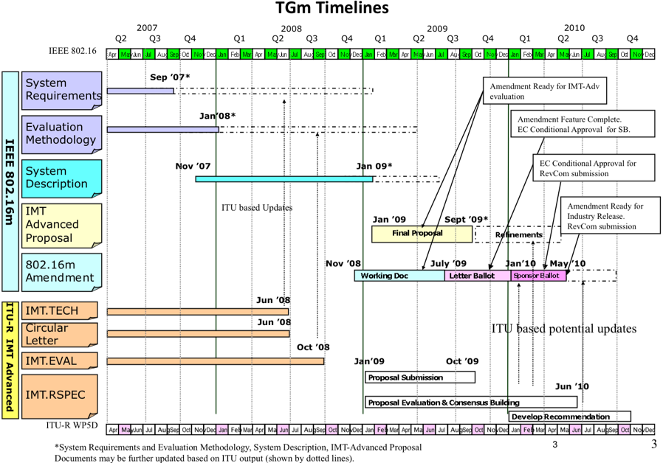

References:

[1] IMT-Advanced Schedule <http://www.itu.int/ITU-R/study-groups/docs/imt-advanced-schedule.doc>
[2] IEEE 802.16m-09/0019 (“Work Plan for Development of IEEE P802.16m Draft Standard”) <http://ieee802.org/16/tgm/core.html#09_0019>.

