Radiocommunication Study Groups | 
 | Document 5D/422-E
 | 26 March 2009
English only

TECHNOLOGY ASPECTS
Germany, Federal Republic of
information on Sections 5.2 and 5.6 as requested
in 5D/413, Chapter 1, Section 3.1

1 Background
The third meeting of Working Party 5D was held in Geneva, Switzerland, from 10 to 17 February 2009. With regard to the completion of draft Revision 9 of Recommendation ITU-R M.1457, significant discussion arose on the update for certain technology submissions. Some administrations raised a point as an exceptional circumstance that they need to have further investigation in order to reach a conclusion on these specific technology submissions.
Consequently WP 5D developed a plan for closure of these open areas as delineated in Attachment 6.5 of Document 5D/413. To this end the following plan was agreed by WP 5D:
1) The concerned administrations as per Documents 5D/389 and 5D/399, seeking information in the “Areas of investigation” are to provide an early input contribution to WP 5D through the normal means by no later than 25 March 2009 to provide specific guidance to the technology proponents on what additional information is required to satisfactorily agreed and conclude the additional radio transmission technologies proposed for Sections 5.2 and 5.6.
2) The proponents are requested to provide inputs to the June meeting of WP 5D towards closure of this open area.
3) The administrations and the proponents are encouraged to conduct dialog in the intervening period to promote understanding and a positive closure of this open area.
This document provides information on item 1) above.

2 Questions resulting from the evaluation process of IMT-2000 OFDMA TDD WMAN
As outlined in Document 5D/389, for the proposed update of Sections 5.2 and 5.6 the evaluation process as contained in Circular Letters 8/LCCE/47 and 8/LCCE/95 should be followed. This was done for updates of other existing IMT-2000 interfaces as well, while taking into account those results of the initial evaluation process which are still valid / can be reused, to avoid duplication of work. As the addition of a new duplex method to an IMT 2000 technology is sourced by the same SDO, the evaluation process can be restricted to only those aspects that are directly related to the addition of the new duplex method.
When looking back to the year 2007 and analysing the experience made when evaluating “IMT-2000 OFDMA TDD WMAN”, the following steps have been assessed at that time:
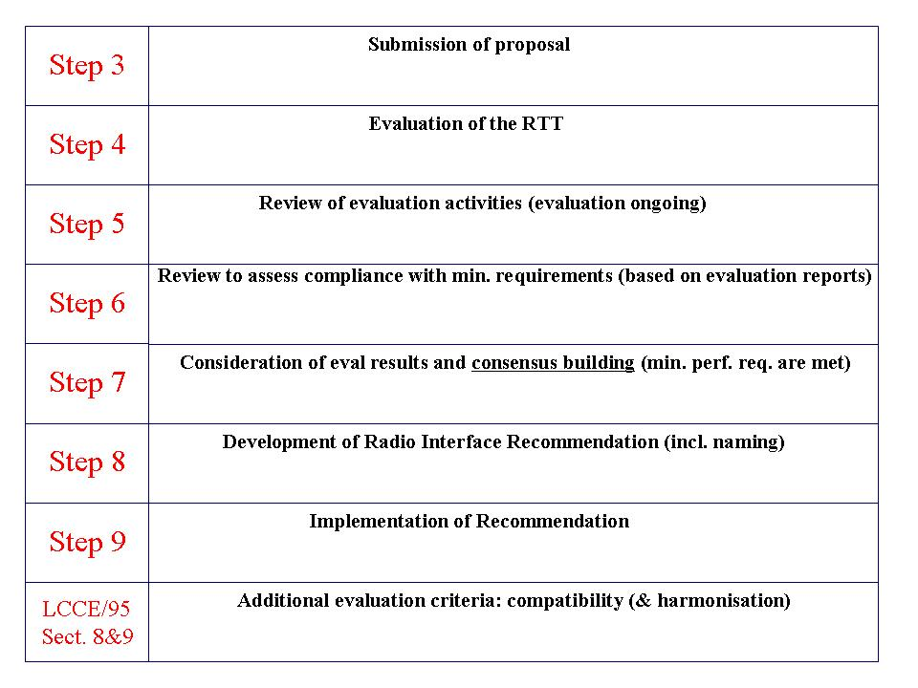
Applying this process to the current proposed updates by bearing in mind to avoid duplication of work, we can state the following:
- Step 3: Done for Section 5.2 (5D/288) and Section 5.6 (5D/246).
- Step 4 & 5: According to 8-LCCE-95 Chapter 4, (a) a self evaluation of the proposed update against the evaluation criteria and (b) a self-declaration that the proposed amendments are self-consistent between Section 5.x.1, Section 5.x.2 and the GCS has to be provided. If WP 5D considers this as being sufficiently done with the submissions for each section in step 3, a short-cut is possible here.
- Step 6 & 7: Both steps haven’t been done in detail so far (neither for each Section 5.2 nor Section 5.6), but are seen as mandatory. A simple list with compliance of the minimum requirements would ease the discussions at the forthcoming meeting of ITU-R WP 5D.
- Step 8: The new RITs will be incorporated in ITU-R M.1457 as new chapters in the according sections as described in 5D/413, Att. 6.5. In particular for Section 5.6 the naming has to be aligned to distinguish between TDD and FDD variant.
- Step 9: Has to be done at the forthcoming meetings of ITU-R WP 5D and ITU-R SG 5.
- LCCE/95 Sect. 8 & 9: These sections demand the following consideration:
  - 7.1 Modification of the existing radio interfaces in Recommendation ITU-R M.1457: Considerations of the technical impact on the other radio interfaces should be provided by the proponents.
  - 8.1 Compatibility with the existing IMT-2000 radio interfaces: Should be proved by sharing studies (see Chapter 3).
  - 8.2 Harmonization within multiple proposals: Not seen necessary in these cases.
  - 9.1 Benefits of the proposed enhancement: Should be provided by the proponents.
  - 9.2 Harmonization and consensus building: It should be proved that harmonization and consensus building between the SDOs that are stakeholders of the proposed changes was achieved during the development of the proposal.
  - 9.3 Enhanced performance capabilities: Not seen as necessary in these cases.
In the overall process of applying 8/LCCE/47 and 8/LCCE/95, the main remainders of evaluating “IMT-2000 OFDMA TDD WMAN” were related to ITU-R M.1225. Major open issues have been summarized in Doc. 8F/567(Rev.1) incorporating also the statement “Throughout the process, indication became obvious that some of the related and referenced documents (e.g. ITU-R M.1225 and various attachments to 8/LCCE/47) may have to be reviewed.” As this review has not happen to date, this must be well considered when applying the overall process to the here proposed update of Sections 5.2 and 5.6.

3 Questions resulting from existing sharing studies
In contribution 5D/389 to the last WP 5D meeting the German Administration raised the issue of the validity of existing sharing studies as one relevant item for the inclusion of a new duplex method to an existing IMT-2000 interface. The contribution pointed out that, “it has to be verified to which extent these studies were specific to the original duplex method. Based on that, the need for a revision of the sharing studies or the development of new sharing studies will have to be addressed to ensure continued coexistence of the IMT-2000 interface in question with other radio systems.”
Concerning the update of the CDMA-MC system in Section 5.2 of ITU-R M.1457, the German Administration is of the opinion that the Report ITU-R M.2110 should be revised, if the TDD component is considered to be deployed in the band 450-470 MHz.
Moreover, no sharing studies exist for the bands 1 710-1 755 and 2 110-2 155 MHz for IMT-technologies, in which OFDMA TDD WMAN FDD mode is intended to be deployed. As there are already IMT-technologies deployed in those bands, the German Administration is of the view, that sharing studies are necessary to assess the impact of a new technology on those already deployed.
If the FDD component of OFDMA TDD WMAN will be submitted for other bands than 1 710-1 755 and 2 110-2 155 MHz, other sharing studies would need to be adjusted as well (e.g. for 2 500-2 690 MHz, the MBWA Sharing Report “Draft new Report on coexistence between IMT-2000 CDMA-DS and IMT-2000 OFDMA-TDD-WMAN in the 2500-2690 MHz band operating in adjacent bands in the same geographical area” which was approved at the last WP5D meeting needs to be adjusted).
General discussion
The MBWA Sharing Report “Draft new Report on coexistence between IMT-2000 CDMA-DS and IMT-2000 OFDMA-TDD-WMAN in the 2 500-2 690 MHz band operating in adjacent bands in the same geographical area” (Document 5D/TEMP/142 or 5/129) is used as an example how the change of duplex method from TDD to FDD could influence the sharing situation.
The MBWA Sharing Report describes that adjacent-channel sharing of a frequency band by two systems deployed in the same geographical area creates the following four general cases for potential interference:
a) Base to base.
b) Base to subscriber.
c) Subscriber to base.
d) Subscriber to subscriber.
The interference paths that can exist when CDMA-DS and OFDMA-TDD-WMAN operate in adjacent spectrum are as follows:
1) CDMA-DS base station interferes OFDMA-TDD-WMAN base station.
2) CDMA-DS base station interferes OFDMA-TDD-WMAN mobile station.
3) CDMA-DS mobile station interferes OFDMA-TDD-WMAN base station.
4) CDMA-DS mobile station interferes OFDMA-TDD-WMAN mobile station.
5) OFDMA-TDD-WMAN base station interferes CDMA-DS base station.
6) OFDMA-TDD-WMAN base station interferes CDMA-DS mobile station.
7) OFDMA-TDD-WMAN mobile station interferes CDMA-DS base station.
8) OFDMA-TDD-WMAN mobile station interferes CDMA-DS mobile station.
When TDD and FDD systems operate in adjacent bands, all 8 interference paths are relevant. If the OFDMA-TDD-WMAN system is replaced by a similar system operating in FDD mode, base station to base station interference and mobile station to mobile station interference are significantly reduced due to the paired channelling arrangement which separates the uplink and downlink transmissions in frequency rather than time. In this case, interference is mainly an issue between a base station on one channel and a mobile station on the adjacent channel (and vice versa). The relevant interference paths are 2, 3, 6 & 7.
However, the level of interference for those cases will likely be higher than for the current simulations as reflected in the MBWA Sharing Report since that report assumes a certain uplink-downlink ratio for the OFDMA-TDD-WMAN system as described in Figure 3.4.2.7-1 on page 26 of Document 5D/TEMP/142 (see below).
Figure 3.4.2.7-1
CDMA-DS and OFDMA-TDD-WMAN frames in time domain
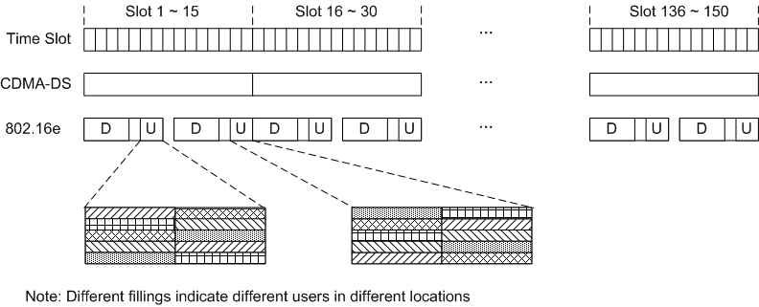
As a consequence, the TDD system (802.16e) will only interfere the CDMA-DS downlink for roughly 60% of the time and the CDMA-DS uplink for roughly 30% of the time (taken from the figure). Similarly, the TDD system would only be susceptible to interference from the CDMA-DS system for those periods of time.
It is unclear from the report, which uplink-downlink ratio was assumed in the simulations and to what extent it was taken into account when deriving the overall interference into the victim system. To adequately model the interference from a 802.16e system operating in FDD mode into a CDMA-DS system and vice versa the simulation would have to assume a frame structure with all-downlink and all-uplink blocks in the time domain.
Additionally, the emission characteristics like spectrum emission mask and ACLR but also receiver characteristics like ACS will likely be different for the FDD mode of OFDMA-TDD-WMAN compared to the TDD mode. Again, this will have an impact on the isolation requirements when deriving the overall interference situation.
Furthermore, the current MBWA Sharing Report considers a frequency reuse of one (1x3x1) as well as three (1x3x3) in the studies for OFDMA-TDD-WMAN with conclusions regarding interference, that vary for the two scenarios. It is unclear, whether a frequency reuse of three (1x3x3) is also realistic for FDD which should be clarified.

4 Naming
In Document 5D/389 the German Administration raised several questions regarding the update of M.1457, including the naming issue (Method of placement within Recommendation ITU-R M.1457 (incl. naming of the interface) i.e. update of the existing IMT-2000 technology or addition of a new IMT-2000 technology). The German Administration has considered the issue and is of the opinion that having a “FDD interface” under the name of “TDD” or vice versa would be technically incorrect and could lead to confusion. It is therefore strongly recommended that the names of the IMT-2000 radio interfaces properly reflect and do not contradict with the different radio access methods, modulation types, etc, they contain.

5 Questions in relation to the comments made in Doc. 5D/348
In Document 5D/348 from Nortel Networks (Canada) and Sprint Nextel Corporation guidance was given on the role of Recommendation ITU-R M.1457 in the context of interoperability standards and regulations. The views expressed in Document 5D/348 were supported by a number of WP 5D participants.
In Document 5D/348 it is stated, that
“it is necessary to distinguish between regulatory standards and interoperability standards. Recommendation ITU-R M.1457 is an interoperability standard and there are other Recommendations that address regulatory aspects, for example, frequency arrangements.
The deployment of systems based on Recommendation ITU-R M.1457 will always need to fulfill a number of regulatory conditions that are outside the scope of Recommendation ITU-R M.1457.
It would not be practical to separate all implementation possibilities in different sections of Recommendation ITU-R M.1457 according to regulations.”
The German Administration has considered the issue in detail and could support such an interpretation in general, as it would provide much more clarity on the whole IMT process:
- what is required to become an IMT-family member;
- what is needed to gain access to a certain IMT frequency band;
- etc.
The German Administration is therefore considering that in the future there would be certain benefits to follow such an approach. However, when studying the proposal in detail, the complexity of this approach appeared. The German Administration is therefore further studying the approach and will provide detailed proposals for a more general approach to one of the next WP 5D meetings. It should be mentioned that such proposals would not necessarily be connected to the timeline for Revision 9 of Recommendation ITU-R M.1457.
Furthermore, and also related to the approach described above, the German Administration is seeking more clarity and transparency on the information provided for each interface in different deliverables. This relates to completeness of documentation:
    - for which IMT bands is information provided by the IMT family member (list each interface);
    - parameters of which IMT family members have been used for compatibility studies (list for each frequency band);
    - etc.
The German Administration will consider how to address these issues in the future in IMT deliverables. For Revision 9 of M.1457, the German Administration will already develop a footnote (specific to Germany), that will cover the issues addressed above to provide more clarify in M.1457 with regard to regulatory and interoperability standards.

6 Summary
As agreed at the WP 5D meeting in Geneva in February 2009 (and as requested in Doc. 5D/413), the German Administration has described those items, where further information/clarity is needed, before the revision of Recommendation ITU-R M.1457 can be adopted (see Chapter 2-4). In addition to this (based on the considerations in Doc. 5D/348), the German Administration will request more clarity and transparency in future IMT deliverables (see Chapter 5).

_______________

