IEEE 802.16 ITU-R Liaison Group Workplan

The following table represents a workplan for the IEEE 802.16 ITU-R Liaison Group for 2010 and beyond based on ITU-R and IEEE events relevant to the IEEE 802.16 Working Group. For historical information related to 2009 and prior, please see L802.16-08/058r5.

Note: Highlighted items pertain to IMT-Advanced activities. The Annexes provide more details on the IMT-Advanced work items.

Group/Event | # | Start | End | Location | Actions/Comments
IEEE 802.16 | 65 | 11-Jan-10 | 14-Jan-10 | San Diego, CA, USA | - Hold IEEE 802.16 IMT-Advanced Evaluation Group Coordination Meeting (13 January) and prepare a meeting report  - Continue to prepare necessary responses on IMT-Advanced evaluations for submission to future WP 5D meetings  - Prepare communications with external organizations as necessary  - Prepare contribution to WP 5D on external evaluation matters including questions raised in ITU-R CG
IEEE 802.18 |  | 18-Jan-10 | 22-Jan-10 | Los Angeles, CA, USA | - Review any IMT-Advanced related contributions  - Approve ITU-R WP 5D contribution(s) on behalf of the EC and submit to the ITU-R  - Review any ITU-R liaison statements
ITU-R WP 5D | 7 | 17-Feb-10 | 24-Feb-10 | Italy | - Present M.1457-10 meeting X+1 contribution (5D/601)  - Present IEEE contributions/reports on IMT-Advanced activities including evaluation group coordination meeting
IEEE 802.16 | 66 | 15-Mar-10 | 18-Mar-10 | Orlando, FL, USA | - Prepare M.1457-10 meeting X+2 contribution  - Prepare any contribution needed for WP 5A  - Examination of preliminary Independent Evaluation Group reports  - Prepare contribution(s) on IMT-Advanced activities  - Send invitation letter to IEGs for 2nd coordination meeting
IEEE 802.18 |  | 15-Mar-10 | 18-Mar-10 | Orlando, FL, USA | - Review M.1457-10 meeting X+2 contribution with 802.18  - Review any IMT-Advanced related contributions  - Review any ITU-R liaison statements/contributions
IEEE 802 |  | 15-Mar-10 | 19-Mar-10 | Orlando, FL, USA | - Approve M.1457-10 meeting X+2 contribution at 802 EC  - Approve any ITU Liaison and/or contributions including on IMT-Advanced
ITU-R WP 5A | 5 | 10-May-2010 | 21-May-2010 | Geneva, Switzerland | - Present IEEE contributions
IEEE 802.16 | 67 | 10-May-10 | 13-May-09 | India | - Continue to prepare necessary responses on IMT-Advanced evaluations for submission to June WP 5D meeting  - Prepare for 2nd IMT-Advanced IEG coordination meeting, including authorizing ITU-R LG chair to send the meeting report to 802.18 for review  - Prepare any contributions needed for IMT-Advanced  - Prepare communications with external organizations as necessary  - Develop text for Letter of Conveyance for IMT-2000 (Revision 10 of M.1457)
Second IEEE 802.16 IMT-Advanced Evaluation Group Coordination Meeting |  | 17-May-10 | 17-May-10 | Beijing, China | - Hold 2nd IEEE 802.16 IMT-Advanced Evaluation Group Coordination Meeting and prepare a meeting report (Monday 17 May)  - Include the report in a contribution to WP 5D (June 2010) and send to 802.18 for review
IEEE 802.18 |  | 17-May-10 | 21-May-10 | Beijing, China | - Review and approve any IMT-Advanced related contributions  - Review and approve any ITU-R liaison statements and contributions
ITU-R WP 5D | 8 | 9-Jun-10 | 16-Jun-10 | Vietnam | - Present M.1457-10 meeting X+2 contribution  - Present any IMT-Advanced contributions/reports on IMT-Advanced activities including evaluation group coordination meeting
IEEE 802.16 | 68 | 12 July 2010 | 15 July 2010 | San Diego, USA | - Examination of finalized Independent Evaluation Group reports  - Prepare contribution to WP 5D on external evaluation matters including questions raised in ITU-R CG  - Prepare input material for WP 5D Workshop on IMT for the Next Decade (October 2010)  - Prepare a contribution to WP 5D on IMT.UPDATE  - Prepare meeting X contribution for M.1457-11
IEEE 802.18 |  | 12-Jul- 2010 | 15-Jul-2010 | San Diego, USA | - Review any ITU-R related contributions  - Review any ITU-R liaison statements/contributions
IEEE 802 |  | 12-Jul-2010 | 15-Jul-2010 | San Diego, USA | - Approve any ITU Liaison and/or contributions including on IMT-Advanced
IEEE 802.16 | 69 | 13-Sep-2010 | 16-Sep-2010 | St. Petersburg, Russia | - Prepare contributions to WP 5D as necessary
IEEE 802.18 |  | 13-Sep-2010 | 17-Sep-2010 | Waikoloa, USA | - Review any IMT-Advanced related contributions  - Approve ITU-R WP 5D contribution(s) on behalf of the EC and submit to the ITU-R  - Review any ITU-R liaison statements/contributions
ITU-R WP 5D | 9 | 13-Oct-2010 | 20-Oct-2010 | China | - Present IEEE contributions
IEEE 802.16 | 70 | 7-Nov-2010 | 12-Nov-2010 | Dallas, USA
IEEE 802.18 |  | 7-Nov-2010 | 12-Nov-2010 | Dallas, USA
IEEE 802 |  | 7-Nov-2010 | 12-Nov-2010 | Dallas, USA
ITU-R WP 5A | 6 | 8-Nov-2010 | 19-Nov-2010 | Geneva, Switzerland
SG 5 |  | 22-Nov-2010 | 23-Nov-2010 | Geneva, Switzerland
ITU-R WP 5D | 10 | 9-Mar-2011 | 16-Mar-2011 | [TBD]
IEEE 802.16 | 71 | 14-Mar-2011 | 17-Mar-2011 | Singapore
IEEE 802.18 |  | 14-Mar-2011 | 17-Mar-2011 | Singapore
IEEE 802 |  | 14-Mar-2011 | 17-Mar-2011 | Singapore
Note: An 802 Executive Committee (EC) motion of 2009-11-20 was approved “to authorize 802.18 TAG to approve, on behalf of the EC, contributions to ITU-R WP 5D meetings #7, #8, and #9 on IMT-Advanced topics, as agreed by the 802.16 WG.”

Annex 1: IMT-Advanced Process

For more details, see [1].

Annex 2: IEEE Project 802.16m IMT-Advanced Candidate RIT Timelines

The following figure highlights the development timeline for all the components of the IEEE 802.16m IMT-Advanced Candidate RIT proposal taking into account the TGm schedule [2].

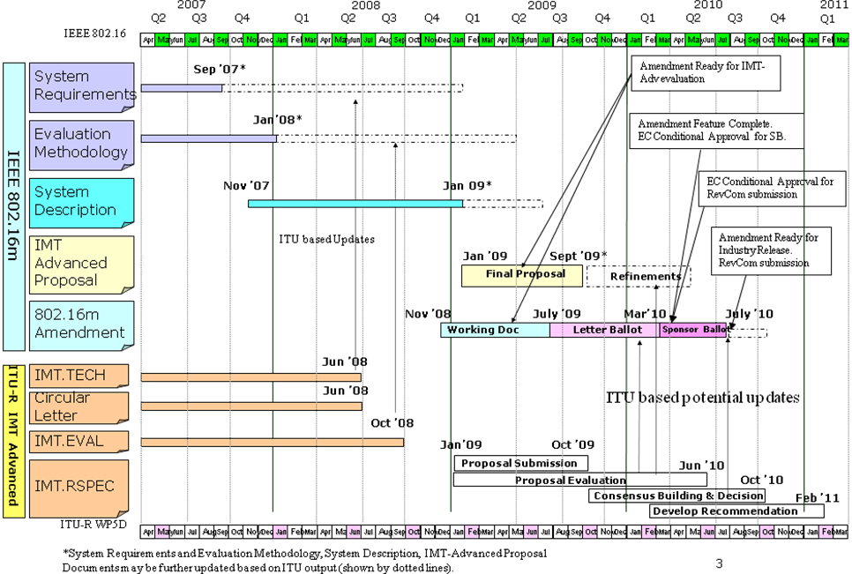

References:

[1] IMT-Advanced Submission and Evaluation Process < http://www.itu.int/ITU-R/index.asp?category=study-groups&rlink=rsg5-imt-advanced&lang=en >
[2] IEEE 802.16m-09/0019r2 (“Work Plan for Development of IEEE P802.16m Draft Standard”) <http://ieee802.org/16/tgm/#09_0019>.

