To:
Roger Marks
Chair, IEEE 802.16 Working Group
r.b.marks@ieee.org
Reference: TWG Inter-Operability Problem Reports (IOPR TIO_59555 )
September 19, 2011

Subject: Liaison Statement to IEEE 802.16 WG on modifications to the IEEE Std 802.16 needed to support WiMAX certification.

Dear Dr. Marks,
In the course of development and validation of product certification test cases based on IEEE Std 802.16, the WiMAX Forum TWG has identified critical issues with the 802.16 specification that impede product interoperability. The WiMAX Forum TWG believes these issues require clarification and/or correction. TWG respectfully requests that the IEEE 802.16 working group take the following actions.
- Review the attached problem statement and/or WiMAX contemplated remedies for each one of the problem statements (see Annex A)
- Develop a remedy for each one of the issues
- Inform the WiMAX Forum TWG of the results of IEEE 802.16 working group’s actions on this matter.

Should the IEEE 802.16 working group develop any specific remedy in response to the problems identified in the Annexes, and should these remedies be incorporated into IEEE Std 802.16, the WiMAX Forum Technical Working Group (TWG) would appreciate further communication giving specific details of the remedies including affected IEEE Std 802.16 sections.

Thank you very much for your attention to this matter of mutual importance.

Sincerely,

Wonil Roh
Chair, WiMAX Forum Technical Working Group (TWG)

- UL Coverage Enhancement with Fast Ranging (IOPR TIO-59555)
  - Interoperability Problem Statement
The Fast Ranging IE is used to reduce the delay in handover. Even if the BS assigns the Fast Ranging IE in multiple times until RNG-RSP message is transmitted, the MS may send RNG-REQ message at one time. If the MS send the RNG-REQ message in multiple times, the BS can get a combining gain, and so the UL coverage can be improved.
To support HARQ operation by Fast Ranging IE, BS needs to know whether the assigned RNG-REQ message is transmitted by MS or not. If the MS doesn’t send the RNG-REQ message, there will be only noise and interference in resource location assigned by Fast Ranging IE. In this case, the received CNIR would be lower than the CINR of data when MS transmits RNG-REQ message. The Figure 1 shows the received CINR of data in BS when the MS transmits RNG-REQ message and there is no UL traffic where RNG-REQ message is modulated by QPSK 1/2.

Figure 1. Received CINR with and without UL Traffic (Ped B, 3km/h)

Figure 1 show significant CINR difference between UL traffic transmitted and No UL traffic. By calculating received CINR in BS, it can be possible to recognize whether RNG-REQ message is transmitted or not.
To check the existence of RNG-REQ message in the n-th frame, the following decision criterion can be applied using DATA CINR in n-th frame (UL_CINR_{n-th frame}) and CINR threshold (TH_{burst_detect}).
If UL_CINR_{n-th frame} > TH_{burst_detect ,} there is RNG-REG message transmitted in the n-th frame. Otherwise, there is no RNG-REQ message transmitted in the n-th frame. Figure 2, Figure 3 and Figure 4 show the detection probability of RNG-REQ message according to CINR threshold in different channel model.

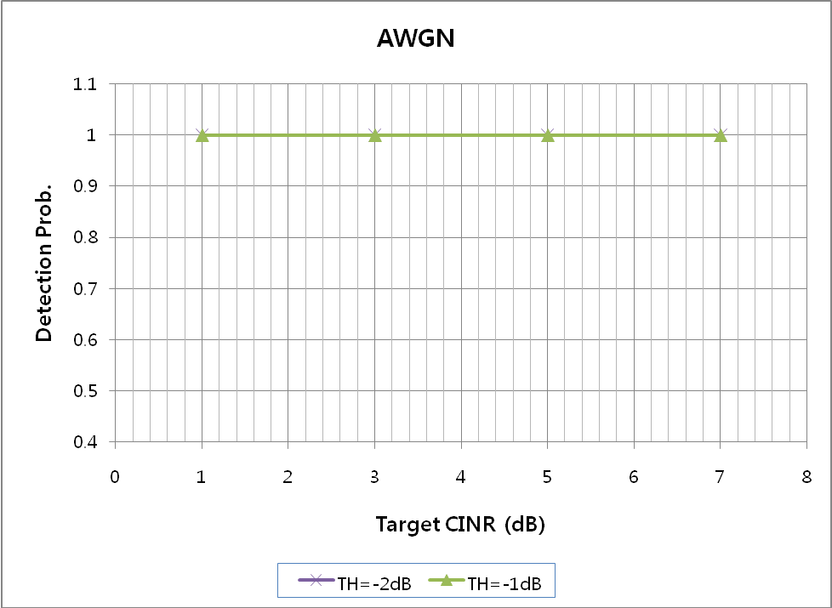
Figure 2. Detection probability of RNG-REQ message in AWGN channel

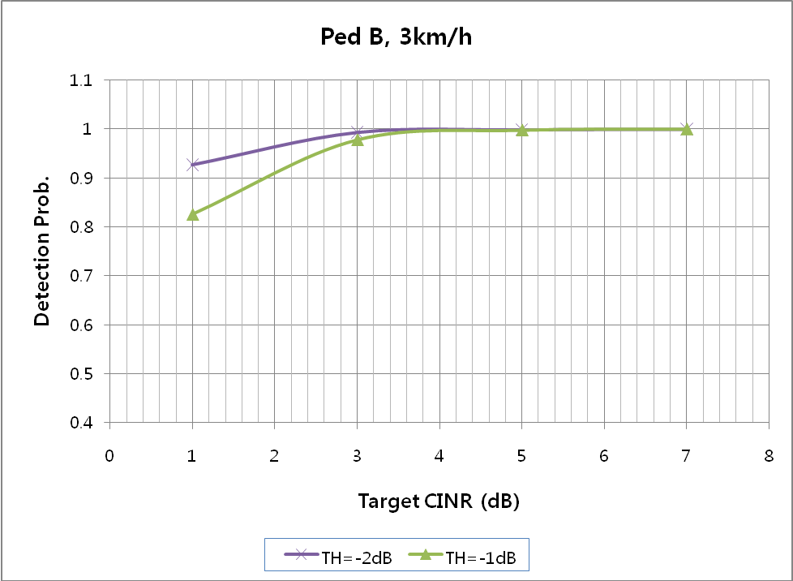
그림 3. Detection probability of RNG-REQ message in Ped-B 3km/h

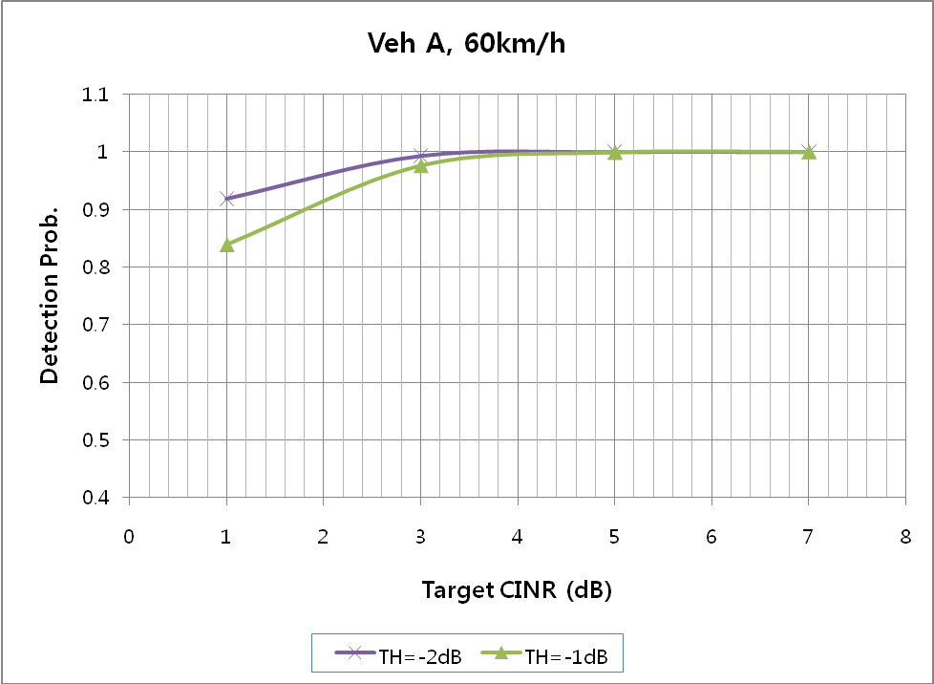
그림 4. Detection probability of RNG-REQ message in Veh-A 60km/h

Fast Ranging IE is transmitted with QPSK 1/2 so that the target CINR is 7dB. Since UL power control is not applied after handover, the target CINR can be degraded. Hence, the target CINR of RNG-REQ message can be decreased up to 3dB or less. If TH_{burst_detect}=-2dBis applied, BS can detect most of RNG-REQ message up to 99% when target CINR is 3dB.
From the simulation results (Figure 1~Figure4), BS can successfully recognize whether the MS transmit RNG-REQ message or not by checking received CINR.
To support HARQ process, when MS receives Fast Ranging IE, the MS needs to retransmit the same RNG-REQ message. BS don’t have any information whether the MS can has capability of retransmitting RNG-REQ message or not. If the BS detects RNG-REQ message retransmitted, the BS considers that the MS can support retransmission of RNG-REQ message and can request additional retransmission of REG-REQ message to the MS. If there is no RNG-REQ message transmitted, the BS recognizes that the MS can not support retransmission of RNG-REQ message and do not request retransmission of RNG-REQ message any more.
  - Possible Changes in IEEE Std 802.16

[Adopt the following changes in section 6.3.21.2.4 in IEEE802.16-2009:]

6.3.21.2.4 Fast ranging
For the purpose of expediting NW re-entry of the MS with the target BS, the serving BS may negotiate with target BS allocation of a non-contention-based ranging opportunity for the MS, i.e., an unsolicited UL allocation for transmission of RNG-REQ message. The agreed time shall take into account the Handover Indication Readiness Timer (see 11.7.12.6) and BS Switching Timer (see 11.7.12.7).

The MS may learn the required ranging parameters at the target BS at the time of HO. Ranging parameters are based on PHY parameters of the serving BS at the time of HO indication and PHY parameters acquired from the target BS during or prior to HO, or during scanning of target neighbor BSs and optionally via association.

The serving BS should indicate the time of the fast (i.e., non-contention-based) ranging opportunity, negotiated with the potential target BSs, via Action Time field in the MOB_BSHO-REQ/RSP message.

The target BS(s) shall indicate the fast ranging allocation in the UL-MAP via Fast_Ranging_IE (see 8.3.6.3.9, and 8.4.5.4.19 Fast ranging Information Element). The Action time + T55 provides a bounded interval during which the MS may expect to receive Fast_Ranging_IE.

T55 starts in the frame after the MS expects to receive Fast_Ranging_IE, derived by Action Time.

Upon expiration of this timer, the MS shall not expect the Target BS to grant an UL allocation via Fast_Ranging_IE and shall release the HO_ID.

To request retransmission of a RNG-REQ message that is assigned by Fast Ranging IE, the target BS may transmit a Fast Ranging IE with the same ranging attributes (Duration and Repetition coding indication) which were sent in the original Fast Ranging IE. The process of retransmitting the Fast Ranging IE shall be terminated by the frame N+9 where N is the frame number when the BS allocated the first Fast Ranging IE. When the MS receives a Fast Ranging IE before frame N+10 and the parameters in the Fast Ranging IE are set to the same values as the original Fast Ranging IE, the MS shall transmit the same RNG-REQ message where CMAC packet number counter is not changed. The target BS may perform combining processing on the UL bursts allocated by the Fast Ranging IEs. The target BS can check the CINR of received UL bursts to identify whether the MS sends the RNG-REQ message or not.

Upon expiration of T3 timer, the MS may either transmit a ranging code to the target BS or perform the cell reselection procedure as described in 6.3.21.2.1.

Figure XX— Message flows during network entry with Fast Ranging

