Project | IEEE 802.16 Broadband Wireless Access Working Group <http://ieee802.org/16>
Title | Supporting Power Outage Management for Smart Metering Applications
Date Submitted | 2010-11-08
Source(s) | R. Golla, W. Bell, M. Lin, GridNet  N. Himayat, S. Talwar, K. Johnsson, Intel Corp.  R. Mao, Huawei Technologies | E-mail: rgolla@gridnet.com  nageen.himayat@intel.com
Re: | Requirements to support Smart Grid power outage management with IEEE 802.16p
Abstract | IEEE C802.16ppc-10_0054r1 identified an important use case related to power outage reporting for smart metering applications. This contribution further clarifies this use case and suggests modifications to the IEEE 802.16p proposed functional requirement on the ability to distinguish power outage alarms from voluntary power down by devices.
Purpose | For review and adoption into the IEEE 802.16p Systems Requirements Document
Notice | This document does not represent the agreed views of the IEEE 802.16 Working Group or any of its subgroups. It represents only the views of the participants listed in the “Source(s)” field above. It is offered as a basis for discussion. It is not binding on the contributor(s), who reserve(s) the right to add, amend or withdraw material contained herein.
Release | The contributor grants a free, irrevocable license to the IEEE to incorporate material contained in this contribution, and any modifications thereof, in the creation of an IEEE Standards publication; to copyright in the IEEE’s name any IEEE Standards publication even though it may include portions of this contribution; and at the IEEE’s sole discretion to permit others to reproduce in whole or in part the resulting IEEE Standards publication. The contributor also acknowledges and accepts that this contribution may be made public by IEEE 802.16.
Patent Policy | The contributor is familiar with the IEEE-SA Patent Policy and Procedures:  <http://standards.ieee.org/guides/bylaws/sect6-7.html#6> and <http://standards.ieee.org/guides/opman/sect6.html#6.3>.  Further information is located at <http://standards.ieee.org/board/pat/pat-material.html> and <http://standards.ieee.org/board/pat>.

Background
Contribution IEEE C80216ppc-10_0054r1 [1] highlighted IEEE 802.16p functional requirements for efficiently supporting power outage management for Smart Grid applications. The main requirement pertained to the need to distinguish a power outage event from a voluntary power down event supported by the current standard through a “location-update” mechanism. This contribution further clarifies this use case and the rationale for specifically distinguishing the power outage event at the MAC layer. We also suggest modifications to the text in IEEE 802.16p SRD to support this use case in a more general manner.

Power Outage Alarms & Outage Management
As discussed in [1], it is critical for Utilities to minimize power outages on the grid, as these can result in fairly significant financial penalties. Timely reporting of power outages and subsequent restoration is a very important smart metering feature, which allows the Utilities to assess net duration of power outages. Reporting of power outages is especially challenging as electric meters typically report this alarm without battery support. Here, smart meter devices rely on a charge stored within a capacitor, which allows them to report “one last alarm” on the loss of power before they shut down. Typical time scales involved in reporting this alarm are on the order of 150-250 milliseconds, due to the limited charge available on the smart meter. This event is referred to as the “Last Gasp” by NIST [2], and is an important system capability required by Smart Grid deployments for performing proper outage analysis and management. Note that the reporting of power outage alarms is distinct from voluntary shutdown of power (e.g. due to the manual power down of a device by a human). This involuntary shutdown of power resulting from a power outage can result in different processing by the system e.g. triggering of grouped polling, power outage analysis, network management etc.

Given that a power outage may affect potentially thousands of meters in a given sector, the simultaneous reporting of the power outage alarm by very large number of meters can overwhelm the system. Additionally the large number of devices involved implies that most smart meters are likely to remain in idle state due to limitations on the number of connections and address space supported by the existing standard. A power outage event can therefore result in simultaneous random access attempts by thousands of devices, which means that all power outage alarms cannot be reliably received within the required latency of few hundred milliseconds. However, even if a few outage events are received, the system can initiate appropriate outage management processing to determine the extent of the outage event. Contribution [1], discussed possible outage management solutions the system can initiate upon receiving one or more “last gasp” events, which, for example, may include initiation of efficient group based polling mechanisms to query the large number of devices to determine whether they are in outage.

Figure 1 illustrates a WiMAX system supporting an outage analysis application that can initiate the required polling upon receiving the power outage alarm.
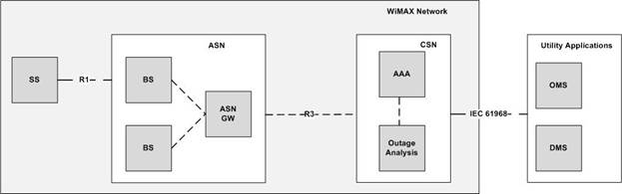
Figure 1: Network architecture supporting “Outage Analysis” for Smart Grid applications
A smart meter implementation may report the power outage alarm by using the “power down location update” mechanism provided by the 802.16m standard MAC layer [3]. The need for MAC layer reporting of this application layer event is necessitated by the tight time budget the smart meter device has for reporting a power outage event (on the order of 250 milliseconds); i.e. application layer processing will be unable to report the alarm before the device runs out of charge. Given the distinct processing that is required upon reception of a power outage event compared to voluntary power down event, the standard must provide means to distinguish the reporting of this alarm event from the existing power down location update mechanism. We therefore propose that IEEE 802.16p provides support at the MAC layer to distinguish between “normal power down” (e.g. associated with a voluntary power outage event) and “abnormal power down” (associated with an involuntary power outage event).

The “power-down location update” call flow processing initiated by the system to support power outage alarms is further clarified using Figure 2.

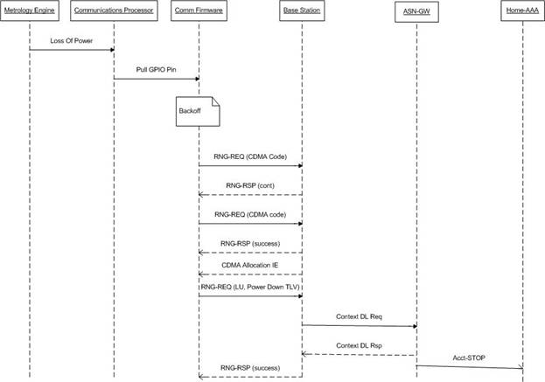
Figure 2: Illustrative call flow processing for reporting power outage alarms by smart metering devices.

The call flow further shows that upon receiving this power outage update the base-station can notify the ASN gateway to initiate an account terminate stop in the network. Support for appropriate account stop codes to identify the cause of the “account stop” is also required and is likely to be addressed by the WiMAX Forum standards and/or the IETF.

Requirements for IEEE 802.16p
Based on the use case discussed in the previous section, we propose that the IEEE 802.16p system should address the following additional requirements. As indicated, some of these requirements are already captured by the 802.16p SRD functional requirements:

- Ability to handle simultaneous alarm events from large number of devices (covered by the IEEE 802.16p SRD).
- Ability to poll a large number of devices in a time and overhead efficient manner (covered by the IEEE 802.16p SRD).
- Ability to distinguish between normal and abnormal power down.
We note that the current draft of the IEEE 802.16p SRD has bracketed text, which aims to cover requirement #3: “[The system shall have the ability to distinguish a power outage alarm from a voluntary power down event.]” In the next section we propose modifications that clearly capture this requirement.

Text Proposal
Add the following functional requirements to Section 6.2 of [4] as shown.
---------------------------Begin Text Proposal-------------------------------

6.2 Large Numbers of Devices

6.2.7 [The system shall have the ability to distinguish a power outage alarm from a voluntary power down event.] Editor’s note: 6.2.6 requires more discussion. Not agreed yet. The system shall have the ability to distinguish between “normal power down” (e.g. associated with a voluntary power outage event) and “abnormal power down” (associated with an involuntary power outage event).

-----------------------------------------End Text Proposal-----------------------

References
- R. Golla, W. Bell, M. Lin, N. Himayat, S, Talwar, K. Johnsson, “Power Outage Alarm for Smart Metering Applications ,” IEEE C802.16ppc-10_0054r1, July 2010.
- NIST priority action plan 2, “Wireless standards for Smart Grid,” sgs-2010-00003r000-NIST_Priority_Action_Plan2_r05.
- IEEE P802.16m/D7.
- IEEE 80216ppc-10_001r2, “IEEE 802.16p Machine to Machine (M2M) System Requirements Document (SRD),” Initial working document, July, 2010.

