Project | IEEE 802.16 Broadband Wireless Access Working Group <http://ieee802.org/16>
Title | Considerations on resource allocation for M2M group
Date Submitted | 2010-12-30
Source(s) | Seunghyun Kang, Kyujin Park, HanGyu Cho, Jeongki Kim, Youngsoo Yuk, Kiseon Ryu and Jin Sam Kwak  LG Electronics | E-mail: seunghyun.kang@lge.com
Re: | 802.16p amendment texts
Abstract | This contribution proposes text related to M2M group control
Purpose | Discuss and adopt proposed texts
Notice | This document does not represent the agreed views of the IEEE 802.16 Working Group or any of its subgroups. It represents only the views of the participants listed in the “Source(s)” field above. It is offered as a basis for discussion. It is not binding on the contributor(s), who reserve(s) the right to add, amend or withdraw material contained herein.
Release | The contributor grants a free, irrevocable license to the IEEE to incorporate material contained in this contribution, and any modifications thereof, in the creation of an IEEE Standards publication; to copyright in the IEEE’s name any IEEE Standards publication even though it may include portions of this contribution; and at the IEEE’s sole discretion to permit others to reproduce in whole or in part the resulting IEEE Standards publication. The contributor also acknowledges and accepts that this contribution may be made public by IEEE 802.16.
Patent Policy | The contributor is familiar with the IEEE-SA Patent Policy and Procedures:  <http://standards.ieee.org/guides/bylaws/sect6-7.html#6> and <http://standards.ieee.org/guides/opman/sect6.html#6.3>.  Further information is located at <http://standards.ieee.org/board/pat/pat-material.html> and <http://standards.ieee.org/board/pat>.

Considerations on resource allocation for M2M group
Seunghyun Kang, Kyujin Park, HanGyu Cho,
Jeongki Kim, Youngsoo Yuk, Kiseon Ryu and Jin Sam Kwak
LG Electronics

Introduction
In 802.16p SRD, M2M group is defined as a group of devices that share one or more features in common, and/or belong to same M2M subscriber. Also, the 802.16p system shall support optimized signaling for resource allocation for large numbers of M2M devices individually or by group [1].
Similarly, 802.16m system has already adopted GRA(Group Resource Allocation) scheme to assign DL/UL resources for a group of users. However, it may be inefficient to adopt 16m GRA scheme directly into 802.16p system considering different requirements and features of M2M.
In this contribution, we have analyzed 16m GRA scheme and summarized considerations on M2M group resource allocation.

Analysis on 16m GRA scheme

16m GRA control information
The control information which is signaled by GRA A-MAP IE or AAI-GRP-CFG of 16m GRA has been listed in Table 1.
Table 1 –Control signaling for 16m GRA
 | Syntax | Description
HARQ | Resource size | 3-bits (Predefined 8 resource sizes in AAI-GRP-CFG) per scheduled user  Contiguous resource assignment for scheduled users in a group
HARQ | Burst size | 2-bits (Predefined 4 burst size sizes in AAI-GRP-CFG) per scheduled user  Burst size also represents MCS level
HARQ | ACID | Determined by parameters in AAI-GRP-CFG(ACID parameters: Initial_ACID, N_ACID)
HARQ | AI_SN | No use of AI_SN since GRA A-MAP is used only for initial transmission
HARQ | SPID in DL | Implicitly SPID=‘0’ since GRA A-MAP is used only for initial transmission
HARQ | CRV in DL | Implicitly CRV=‘0’ since GRA A-MAP is used only for initial transmission
HARQ | HFA | HAF offset for scheduled users(6-bits)  Determined by using User bitmap size and HFA offset
MIMO | MIMO mode selection | MIMO mode sets in AAI-GRP-CFG  DL: Mode 0; Mode 0 or Mode 1(Mt=2); Mode 2(Mt=1)  UL: Mode 0; Mode 0 or Mode 1(Mt=2); Mode 2(Mt=1); Mode 3(Mt=1)  MIMO user bitmap in GRA A-MAP: To indicate Mode 0 or Mode 1(Mt=2)
Long TTI indication | Long TTI indication | 1-bit Long TTI indicator in AAI-GRP-CFG
DL/UL indication | DL/UL indication | dlULindication in AAI-GRA-CFG  Separate DL/UL group management
GRA specific  parameter | User indication in Group | User Bitmap indicates scheduled users in GRA  Bitmap size: # users in a group
GRA specific  parameter | Flow indication | 4-bits FID in AAI-GRA-CFG  To add or delete a user flow in a group
GRA specific  parameter | Group indication | AAI-GRP-CFG: 12-bits Group ID  GRA A-MAP: CRC masking for blind decoding
GRA specific  parameter | Add/delete User in a group | 1-bit Deletion Flag in AAI-GRP-CFG
GRA specific  parameter | Allocation Relevance | 2-bits Allocation Relevance if group corresponds to UL allocations and the number of DL AAI subframes (D) is less than the number of UL AAI subframes (U)
GRA specific  parameter | Segment Flag | 1-bit Segment Flag: GRA A-MAP segmentation flag in AAI-GRP-CFG
 | Periodicity | 2-bits Periodicity: Group transmission period in AAI-GRP-CFG

Control overhead comparison between 16m GRA and Individual resource assignment
In this section, we have compared the control overhead of 16m GRA with that of individual resource assignment (using DL Basic assignment A-MAP IE). The basic assumptions for the comparisons are as follows.

Basic assumptions for the comparison
- Number of scheduled users( = number of uses in GRA): 4, 8, 16 and 32 users
- Control overhead of Group resource assignment
  - AAI-GRP-CFG is transmitted only once to every users in GRA.
  - GRA A-MAP IE is signaled for the users who are scheduled for initial HARQ transmission in the group.
  - Basic assignment A-MAP IE is signaled individually for a user who is scheduled for HARQ retransmission.
- Control overhead of Individual resource assignment
  - Basic assignment A-MAP IE is signaled individually for a user who is scheduled for both initial HARQ transmission and HARQ retransmission.

Table 2 – Average GRA Control overhead (compared to control overhead of individual resource assignment)
# users | 4 users | 8 users | 16 users | 32 users
Avg. GRA overhead | 58% | 40% | 34% | 31%

In Table 2, the GRA overhead has been evaluated as a proportion of the individual resource assignment overhead. The comparison results show that the GRA reduces control overhead maximum 69% comparing to the individual resource assignment.

Segmentation of GRA A-MAP IE
The size of GRA A-MAP IE is variable depending on the number of scheduled users. If the size of GRA A-MAP IE is larger than 56 bits, it shall be divided into multiple A-MAP segments, and there can be additional overheads as follows.
  - A-MAP IE type: 4 bits per segment
  - Segment flag: 1 bit per segment
  - CRC: 16 bits per segment
  - Padding bits: Variable size (1~34 bits) in the last segment

In Figure 1, the number of padding bits and the number of A-MAP segments have been evaluated depending on both the number of GRA group users and number of scheduled users.
As shown in the figure, GRA A-MAP IE segmentation is done in most cases, and it causes too many padding bits in GRA A-MAP IE. Furthermore, there are additional 21 bits overhead (including A-MAP IE type, Segment flag and CRC) per segment.
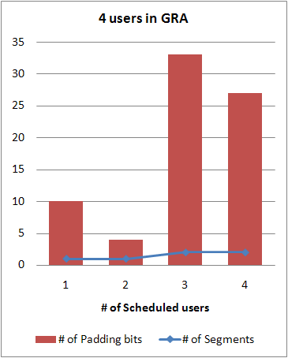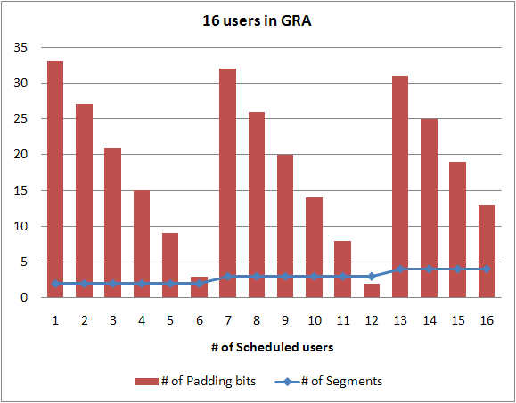
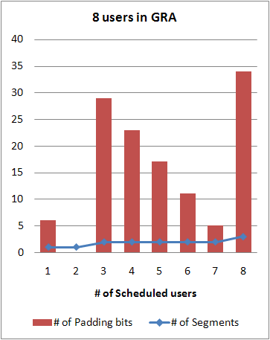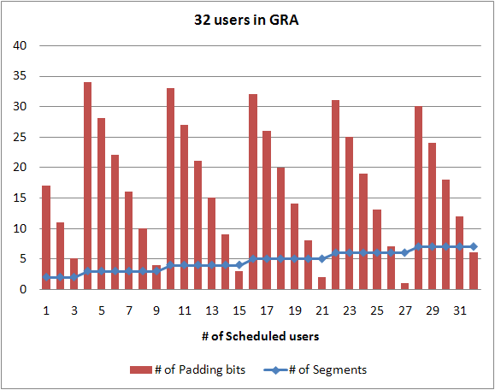
Figure 1. Padding bits overhead of GRA A-MAP IE

Considerations on M2M group resource allocation
Considering different requirements and features in 802.16p system, we have summarized the considerations on M2M group resource allocation as follows.
- To support very small burst transmission, signaling overhead shall be minimized, and M2M specific group resource allocation which requires less signaling overhead than individual resource assignment is necessary.
- Considering static user scheduling in 802.16p (i.e. Time controlled data transmission), signaling overhead for user indications in M2M group can be reduced.
- Considering static M2M traffic types and channel conditions in 802.16p, there can be
  - Fixed burst size or less number of burst sizes supported in M2M group.
  - Fixed resource size or less number of resource sizes supported in M2M group.
  - Fixed MIMO type in M2M group.
- M2M specific group resource allocation for HARQ retransmission can be considered.
- M2M specific group assignment A-MAP can be designed to prevent A-MAP segmentation which causes serious padding bit overhead.

Proposed text
------------------------------------------------- Start of proposed text -------------------------------------------------
16.x M2M Group Resource Allocation

M2M specific Group Resource Allocation (M2M GRA) mechanism allocates resources to multiple M2M devices in an M2M group in order to save control overhead.
------------------------------------------------- End of proposed text -------------------------------------------------

