Project | IEEE 802.16 Broadband Wireless Access Working Group <http://ieee802.org/16>
Title | Authenticated Integrity for M2M devices
Date Submitted | 2011-03-09
Source(s) | Eldad Zeira  Interdigital Communications LLC | E-mail:  eldad.zeira@interdigital.com
Re: | Call for Contributions for 802.16p AWD
Abstract | The contribution discusses various options to fulfill some of the security related requirements for 802.16p.
Purpose | To be discussed by TGp M2M
Notice | This document does not represent the agreed views of the IEEE 802.16 Working Group or any of its subgroups. It represents only the views of the participants listed in the “Source(s)” field above. It is offered as a basis for discussion. It is not binding on the contributor(s), who reserve(s) the right to add, amend or withdraw material contained herein.
Release | The contributor grants a free, irrevocable license to the IEEE to incorporate material contained in this contribution, and any modifications thereof, in the creation of an IEEE Standards publication; to copyright in the IEEE’s name any IEEE Standards publication even though it may include portions of this contribution; and at the IEEE’s sole discretion to permit others to reproduce in whole or in part the resulting IEEE Standards publication. The contributor also acknowledges and accepts that this contribution may be made public by IEEE 802.16.
Patent Policy | The contributor is familiar with the IEEE-SA Patent Policy and Procedures:  <http://standards.ieee.org/guides/bylaws/sect6-7.html#6> and <http://standards.ieee.org/guides/opman/sect6.html#6.3>.  Further information is located at <http://standards.ieee.org/board/pat/pat-material.html> and <http://standards.ieee.org/board/pat>.
Authenticated Integrity for M2M devices

Eldad Zeira
InterDigital

Introduction

Freed from the traditional constraint that terminals communicating wirelessly with networks should be largely ‘manned’ by humans, communication from and to M2M devices is expected to open up a large number of possibilities in terms of new use cases, services, and applications. Considering the large number of M2M devices expected to be deployed, in a highly distributed network, global enforcement of security will not be practically feasible due to the low cost of many of these devices and cost of management. Thus the conventional centralized IT network security model, protected by a firewall, becomes challenged.

M2M networks are more vulnerable to security threats than traditional networks. At the same time they are required to handle highly critical missions. In some applications of M2M network, network attacks can lead to false situational awareness, loss of privacy, denial of service attacks and even become physical attacks, all caused by devices compromised by physical or remote reconfiguration or tampering.

The main threats are summarized in table 1 below.

Common to all use cases above is the fact that recognition at the network level that an attempted attack has taken place is in itself important security related information. Due to the high value of the protected asset it is critical that the network is made aware of any attempted attack.

In order to address these threats, an M2M security solution is required such that it is not possible to illegally use M2M Devices for unintended applications or to consume network resources in an improper manner.

It is clearly understood that not all devices will require the same level of security and that HR-Network should provide the flexibility to mix devices with different security related capabilities. There is however a minimal set of requirements that we do need to standardize. If we don’t, the network will not know the difference between a device without the enhanced security capability and a compromised device (with the enhanced security capability disabled) that may masquerade as a device without the capability and pose threats to the network and service provider.

The SRD recognizes these issues and requires specific security enhancements to 802.16p system, including:

.
6.4 Security Support

The 802.16p system shall support integrity and authentication of M2M devices, as well as integrity and privacy of M2M application traffic which requires a secure connection.

6.4.1 The 802.16p system shall support a device validity check between the device and the network.
6.4.2 The 802.16p system shall enable a flexible security suite that can be adjusted per the security requirements of the M2M application

Figure 1: Some of the security related requirements in 802.16p SRD

This contribution discusses different options to fulfill these requirements.

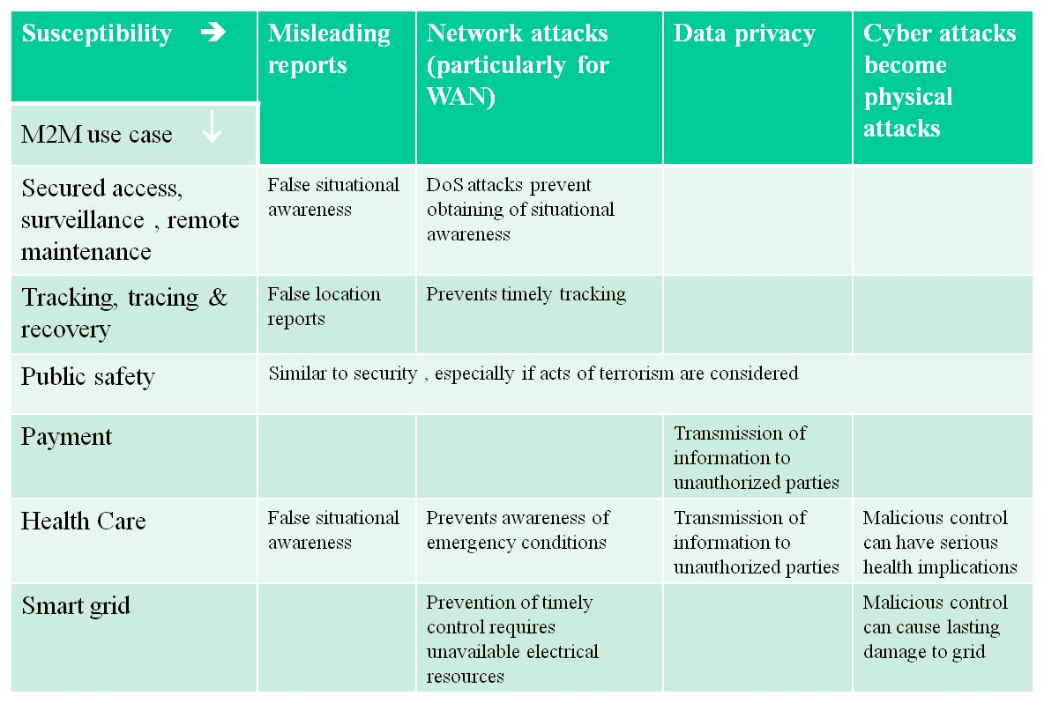
Table 1: Summary of the main threats to M2M networks

Elements of integrity validation
At the basis of device integrity validation is a trusted element (TE) on the device that has the capability to test for the integrity of the device. The TE is tamper resistant. Implementation of the TE and its interconnections to the rest of the subscriber station (SS) is out of scope for the standard. Moreover, there is no assumption that all subscribers on a network must have implemented integrity validation on the device. There is however the assumption that having such a device, where required, gives the subscriber network access that it would otherwise not receive, subject to appropriate network operator policies.

To reduce the likelihood of denial of service attacks on the network, an SS that fails integrity check must not attempt to access the network. This requirement prevents DOS performed by tampering with the application layer. Whether it prevents DOS by tampering with the access stratum depends on how it is implemented which is beyond the scope of this discussion.

To provide the network with information on compromised device function, the network must know of the security capabilities of the SS. Specifically, in case a TE is implemented the network needs to know its authenticity and capabilities. Not communicating the capabilities will allow the cover up of tampering by claiming the inability to perform the integrity validation.

Lastly, the network must know that an integrity check has passed successfully.

The following Device Integrity Information (DII) is therefore required:
- Device-Integrity Capability Info, including
  - HW description, including HW components and their integrity validation capability. The authenticity of this information must be assured. This could be provided as a certificate or a pointer to a certificate that may include such information and is out of scope for the standard.
  - SW description, including SW components and their integrity validation capability, to be similarly provided.
- Integrity Check Results Info that may include list of HW and SW components that were tested, the list of all failed tests if any and a timestamp of when the last integrity check was performed.

Note that information is sensitive in that it can expose details of the network security to an eavesdropper. In some cases this would be an issue. If unsecured devices (e.g. relays) are used to relay the information then message integrity protection may also be required. Steps should therefore be taken to protect that information.

How to provide the information to the network
There are several ways by which the information may be provided to the network.

- As part of the Security protocol
  - As part of the Authentication/Authorization Protocol
    - In a X.509 certificate used for RSA-based SS authorization message
    - As a new part of the (non-certificate portion) of the SS authorization message
  - As part of the Key (TEK) Setup Protocol

In 802.16-2009, Section 7.1.3, an SS uses the Private Key Management (PKM) protocol to obtain authorization and traffic keying material from the BS and to support periodic reauthorization and key refresh. There are two versions of PKM; PKMv1 which supports a mandated RSA-based, one-way SS authentication to BS, and PKMv2 which supports, optionally, either a RSA-based authentication or an EAP-based authentication, for both a one-way SS-to-BS authentication and mutual authentication between SS and BS. In addition to the above, the 802.16 specifications (such as the 802.16-2009 main spec, or the Draft 802.16m-v11 spec), also describe many messages sent as part of the authentication, security negotiation, and key set up procedures. Note that EAP isn't mandatory for 802.16 systems.

- In a MAC Management message
  - In a newly defined message
  - In a new field of an existing MAC management message

Discussion of the alternatives (see Fig. 2)

- Placing the DII anywhere else other than in the authorization message itself results in a two-stage process, in which the current authorization is followed by key setup before the network can fully determine the trustworthiness of the device. Network behavior should depend on the security parameters of the applications and is out of scope for the standard. For example, it could use the initial set of keys for the DII exchange only with a set expiration time. Failure to establish integrity will result in key expiration. As a result, it is desirable that the DII is provided to the network as soon as possible.
- Placing DII in the authorization or key establishment messages will not guarantee its integrity or its confidentiality unless keys have been pre-provisioned prior to initial access. It is important that the DII be protected, but in many cases pre-provisioning isn’t practical.
- WirelessMAN-OFDMA (2009) specification mandates that a very specific and tightly controlled version of the X.509, specified by the IETF RFC 3280, is used for the authorization certificate. This RFC version doesn’t allow extensions that can be used for transmission of DII, rendering the use of X.509 certificate for DII impossible.
- MAC messages are sent after key establishment and therefore can provide both integrity and confidentiality protection. As the network isn't necessarily aware that the DII is forthcoming, it is desirable that the message can be sent by the SS unsolicited.

Figure 2: DII transmission issues

Ideally a H/W based tamper resistant arrangement prevents transmission altogether if validity check failed.

