Project | IEEE 802.16 Broadband Wireless Access Working Group <http://ieee802.org/16>
Title | Change Request to SRD on the Addressing Space
Date Submitted | 2011-03-10
Source(s) | Chun-Yen Hsu, Yi-Ting Lin, Tsung-Yu Tsai, Chun-Che Chien, Chiu-wen Chen, Kanchei(Ken) Loa, Youn-Tai Lee  Institute for Information Industry  Whai-En Chen, Chuan-Yuan Tseng  National Ilan University  Yih Guang Jan, Yang-Han Lee  Tamkang University  Hsien-Wei Tseng  DLIT  Bin Chen, Erik Colban, George Calcev  Huawei Technologies  Ming-Hung-Tao  ITRI  Jaesun Cha, Soojung Jung  ETRI  Andreas Maeder, Hassan Alkanani, Nader Zein  NEC | Voice: +886-2-66000100  E-mail: hcy@nmi.iii.org.tw
Re: | 802.16p (M2M) Call for Comments on the SRD
Abstract | This contribution proposes change request to SRD
Purpose | To be discussed and adopted by the IEEE 802.16p task group.
Notice | This document does not represent the agreed views of the IEEE 802.16 Working Group or any of its subgroups. It represents only the views of the participants listed in the “Source(s)” field above. It is offered as a basis for discussion. It is not binding on the contributor(s), who reserve(s) the right to add, amend or withdraw material contained herein.
Release | The contributor grants a free, irrevocable license to the IEEE to incorporate material contained in this contribution, and any modifications thereof, in the creation of an IEEE Standards publication; to copyright in the IEEE’s name any IEEE Standards publication even though it may include portions of this contribution; and at the IEEE’s sole discretion to permit others to reproduce in whole or in part the resulting IEEE Standards publication. The contributor also acknowledges and accepts that this contribution may be made public by IEEE 802.16.
Patent Policy | The contributor is familiar with the IEEE-SA Patent Policy and Procedures:  <http://standards.ieee.org/guides/bylaws/sect6-7.html#6> and <http://standards.ieee.org/guides/opman/sect6.html#6.3>.  Further information is located at <http://standards.ieee.org/board/pat/pat-material.html> and <http://standards.ieee.org/board/pat>.
Change Request to SRD on the Addressing Space

Chun-Yen Hsu, Yi-Ting Lin, Tsung-Yu Tsai, Chun-Che Chien, Chiu-wen Chen, Kanchei(Ken) Loa, Youn-Tai Lee
Institute for Information Industry

Whai-En Chen, Chuan-Yuan Tseng
Ilan University

Yih Guang Jan, Yang-Han Lee
Tamkang University

Bin Chen, Erik Colban, George Calcev
Huawei Technologies

Ming-Hung-Tao
ITRI

Jaesun Cha, Soojung Jung
ETRI

Andreas Maeder, Hassan Alkanani, Nader Zein
NEC

Introduction
IEEE 802.16p is designed to support large number of M2M devices in connected state. However, it is not clear how “large” should be. This contribution summaries proposals for the addressing space extensions during DEV RG discussion on M2M device identification and provide suggestions to the SRD.

Addressing Space in Connected State
Considering the potential huge number of M2M devices in a 16p cell/network, during the DEV RG discussion, four proposals for addressing space extensions were reviewed.
- On the basis of the 16m feedback channel limitation, Chiwoo estimated the capacity of 16m is 13032.
- In Ming-Hung’s proposal, by means of sharing STID among M2M devices, 4096*12=49152 devices are allowable in a 16p cell [1].
- Yi-Ting proposed the STID extension and corresponding masking scheme, which gives a capacity of up to 65536 devices in a 16p cell [2, 3, 4, 5].
- With the help of new A-MAP IEs, Anshuman proposed a network-wide addressing space of 31 bits (2^31=2147483648) [6].
Figure 1 depicts the proposed addressing space. It is believed that current 12-bit STID is not sufficient for future M2M applications and hence extending the addressing space is necessary.
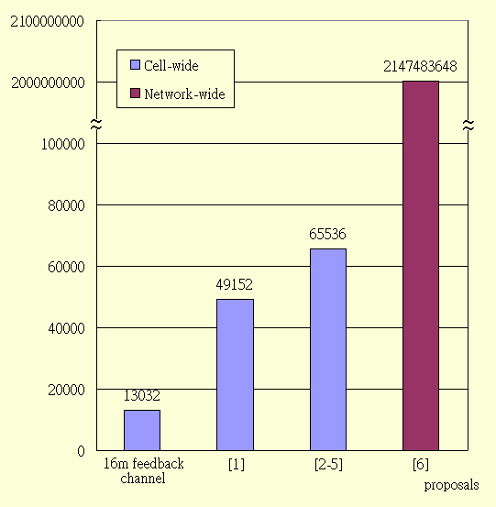
Figure 1 Extended addressing space

Reference
[1] C80216p-rg-11_0016.doc
[2] C80216p-rg-11_0022.doc
[3] C80216p-rg-11_0023.doc
[4] C80216p-rg-11_0024.doc
[5] C80216p-rg-11_0025.doc
[6] C80216p-rg-11_0043r1.doc

Proposed Text

[Insert the following text in line 3, page 7 of IEEE 802.16p-10/0004r2]

6.2.1.1 The 802.16p system shall be able to identify more devices than WirelessMAN-Advanced Air Interface does.

[End of proposed text]

