Project | IEEE 802.16 Broadband Wireless Access Working Group <http://ieee802.org/16>
Title | Network reentry from idle mode for M2M devices without mobility
Date Submitted | 2011-3-11
Source(s) | Wei-Chieh Huang, Chia-Lung Tsai,  Ping-Heng Kuo, Yu-Tao Hsieh,  Pang-An Ting  ITRI | E-mail:  aj@itri.org.tw
Re: | Call for Comments on IEEE P802.16p AWD
Abstract | This contribution proposes addressing for M2M devices
Purpose | To be discussed and adopted by Machine-to-Machine(M2M) Task Group for IEEE P802.16p AWD
Notice | This document does not represent the agreed views of the IEEE 802.16 Working Group or any of its subgroups. It represents only the views of the participants listed in the “Source(s)” field above. It is offered as a basis for discussion. It is not binding on the contributor(s), who reserve(s) the right to add, amend or withdraw material contained herein.
Release | The contributor grants a free, irrevocable license to the IEEE to incorporate material contained in this contribution, and any modifications thereof, in the creation of an IEEE Standards publication; to copyright in the IEEE’s name any IEEE Standards publication even though it may include portions of this contribution; and at the IEEE’s sole discretion to permit others to reproduce in whole or in part the resulting IEEE Standards publication. The contributor also acknowledges and accepts that this contribution may be made public by IEEE 802.16.
Patent Policy | The contributor is familiar with the IEEE-SA Patent Policy and Procedures:  <http://standards.ieee.org/guides/bylaws/sect6-7.html#6> and <http://standards.ieee.org/guides/opman/sect6.html#6.3>.  Further information is located at <http://standards.ieee.org/board/pat/pat-material.html> and <http://standards.ieee.org/board/pat>.
Network reentry from idle mode for M2M devices without mobility

Wei-Chieh Huang, Chia-Lung Tsai, Ping-Heng Kuo, Yu-Tao Hsieh, Pang-An Ting
ITRI

Introduction
In cellular network system, synchronization, including physical (PHY) layer synchronization and media access control (MAC) layer synchronization, shall be achieved before a device is allowed to access the network. For PHY synchronization, a device may achieve timing synchronization, frequency synchronization, and power control via downlink synchronization channel and uplink synchronization channel. For MAC synchronization, system information negotiation and registration are accomplished via network access (or network entry) process.

We note that the ranging channel may be labeled as two classes: non-synchronous ranging channel (NS-RCH) and synchronous ranging channel (S-RCH). Generally speaking, S-RCH has the following advantages compared to NS-RCH:
- Lower latency
- Lower power consumption
- Better performance
- Lower computational complexity
- Higher the ranging channel capacity

Since S-RCH is more efficiency than NS-RCH, it motivates us to investigate a method for fixed M2M devices performing network reentry from idle mode through S-RCH. If the M2M device has communicated with the base station previously, it may store the corresponding round trip delay (RTD) information. Therefore, devices may perform network reentry from idle mode via S-RCH if they have the knowledge about its RTD to the corresponding base station. The illustration and flowchart are depicted in Fig. 6, Fig. 7, and Fig. 8 respectively:

A simple example is given subsequently. At the first time of network access, a fixed device shall access network through NS-RCH since it does not have the information of RTD. During the initial network access, the fixed device shall obtain the information of RTD. Since RTD shall be a constant for fixed devices, the fixed device may store the information of RTD for network access afterward. Therefore, the fixed device having the information of RTD is able to achieve uplink timing synchronization with base station by using downlink channel and the information of RTD. As a result, it is allowed to perform network reentry from idle mode through S-RCH. The corresponding message flow and flowing diagram are shown in Fig. 3, Fig. 4, and Fig. 5)
Fig. 1 Procedure of network access for devices having no RTD information

Fig. 2 Procedure of network access for devices having RTD information

Fig. 3 Flowing diagram for devices performing network access

Proposed text
Red Text: delete text
Blue text: new text

---------------------------------------------------------Start of the Text 1--------------------------------------------------------
[Note to Editor – Modify the text in the current 802.16p AWD as follows]
16.2.18.X Network reentry from idle mode

For network reentry from idle mode, the fixed M2M devices shall support to initiate network reentry with the ABS by sending a ranging sequence through synchronous ranging channel.

16.3. 8.1.4 Ranging channel
16.3.8.1.4.2 Ranging channel for synchronized AMSs
The ranging preamble (RP) codes are classified into periodic ranging and reentry ranging preamble codes. The periodic RP codes shall be used for periodical synchronization between ABS and AMS. The reentry RP codes shall be used for fixed devices performing network reentry from idle mode. For a ranging code opportunity, each AMS randomly chooses one of the RP codes from the available RP codes set in a cell.
The information of RP codes are broadcasted by AAI-SCD message for periodic ranging and network reentry ranging in non-femto deployment.
Table XXX Ranging preamble code information table for the S-RCH
Field | Size (bits) | Value/Description | Condition
 | TBD | The number of reentry ranging codes | TBD
TBD | TBD | TBD | TBD

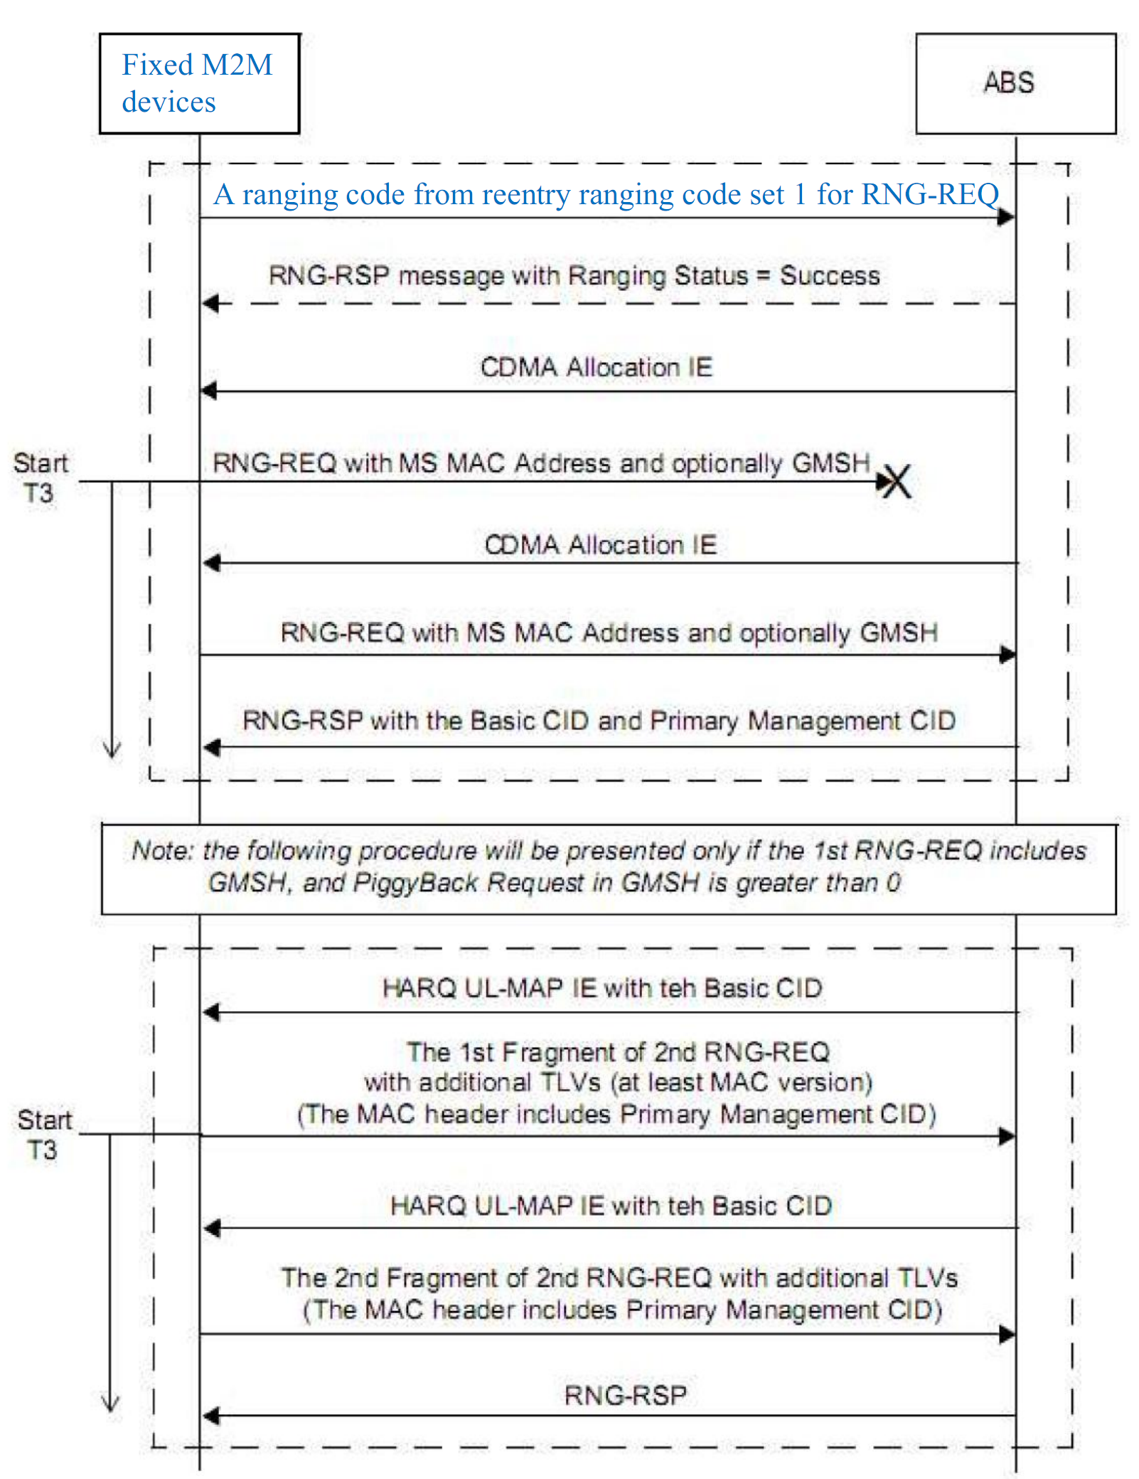
Fig. XXX The procedure of network re-entry from idle mode for fixed M2M devices.
---------------------------------------------------------End of the Text #1---------------------------------------------------------

Reference
[1] IEEE P802.16m/D12, “Part 16: Air Interface for Broadband Wireless Access Systems: Advanced Air Interface,” Feb. 2011.
[2] IEEE, “C802.16p-11/0002; IEEE 802.16p Machine to Machine (M2M): Proposed Text from Power Saving (PWR) Rapporteur Group”, Mar. 2011

