Project | IEEE 802.16 Broadband Wireless Access Working Group <http://ieee802.org/16>
Title | Ranging Optimization for Fixed devices in IEEE 802.16p
Date Submitted | 2011-03-14
Source(s) | Belal Hamzeh  Shantidev Mohanty  Yang-seok Choi  Intel Corporation | E-mail:  { Belal.Hamzeh,Yang-Seok.Choi, Shantidev.Mohanty }@intel.com
Re: | IEEE 802.16p-10/0018 (AWD for 16p)
Abstract | This contribution proposes optimization to the ranging process in support for the large number of devices in 802.16p
Purpose | To be discussed and adopted
Notice | This document does not represent the agreed views of the IEEE 802.16 Working Group or any of its subgroups. It represents only the views of the participants listed in the “Source(s)” field above. It is offered as a basis for discussion. It is not binding on the contributor(s), who reserve(s) the right to add, amend or withdraw material contained herein.
Release | The contributor grants a free, irrevocable license to the IEEE to incorporate material contained in this contribution, and any modifications thereof, in the creation of an IEEE Standards publication; to copyright in the IEEE’s name any IEEE Standards publication even though it may include portions of this contribution; and at the IEEE’s sole discretion to permit others to reproduce in whole or in part the resulting IEEE Standards publication. The contributor also acknowledges and accepts that this contribution may be made public by IEEE 802.16.
Patent Policy | The contributor is familiar with the IEEE-SA Patent Policy and Procedures:  <http://standards.ieee.org/guides/bylaws/sect6-7.html#6> and <http://standards.ieee.org/guides/opman/sect6.html#6.3>.  Further information is located at <http://standards.ieee.org/board/pat/pat-material.html> and <http://standards.ieee.org/board/pat>.

Ranging process optimization in support of large number of machine to machine devices

Belal Hamzeh, Shantidev Mohanty, Yang-seok Choi
Intel Corporation

Introduction
Due to the requirement of support of large number of machine type communication (MTC) devices in 802.16p, it is necessary to optimize the network entry/re-entry procedure; to reduce access latency, power consumption, and CQI reporting and ranging signaling overhead.

Under the envisioned deployment scenarios, many of the MTC are expected to be fixed devices, such as smart grid devices, point of sale devices, etc., where under normal operating conditions, the surrounding environment would not experience large variations and changes.

During network entry/re-entry procedure, channel quality indicator (CQI) is exchanged between the device and the base station to establish link adaptation; which under normal operating conditions for fixed devices (no drastic change to surrounding environment), the variance of the reported metrics is quite limited; thus a lot of redundancy is inherent in the process.

In a typical deployment scenario, an analysis of the channel quality indications shows that:
  - ~ 66% of fixed devices will experience a CQI variance less than ½ dB
  - ~ 82% of fixed devices will experience a CQI variance less than 1 dB
  - ~ 93% of devices will experience a CQI variance less than 2 dB
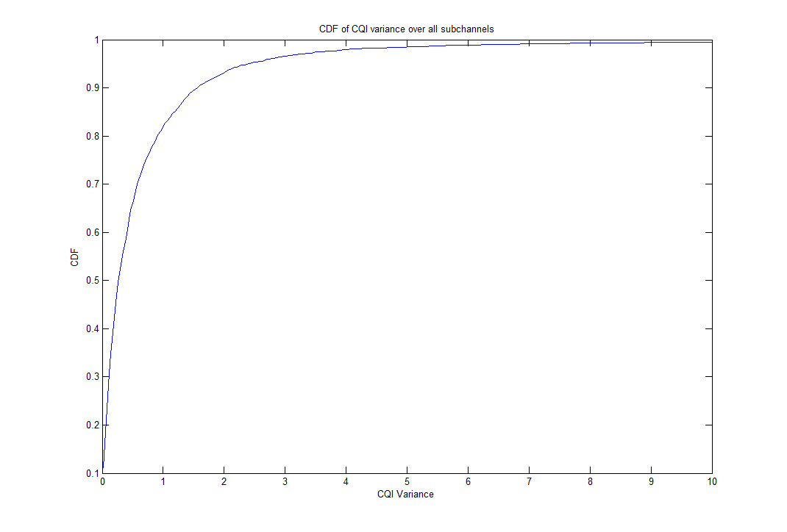
Based on the aforementioned analysis, the following solution for optimizing the ranging process.

2. Proposed Solution
In 802.16p, for fixed MTC devices, during the network entry/re-entry phase, an optimized ranging mechanism will be used where the CQI exchange process can be circumvented by reverting to historical QI values (last value, weighted average of previous values, etc.). This will speed up the ranging process; should network entry/re-entry fail; device will default to normal ranging mechanism.
This contribution proposes that during network re-entry ranging operation, the MS/AMS informs the BS/ABS about its last used MCS scheme. The BS/ABS may use this information to decide the MCS scheme for the MS/AMS without asking for CQI reports from the MS/AMS.

Proposed text with change marks
[Modify Table 678 in page 88 as follows]
[Add the following text after line 2 in page 8 of Section 6 in IEEE P802.16p AWD]

[Modify Table 678 after line 16 in page 16 of Section 16.2.3 in IEEE P802.16p AWD]
16.2.3.1 AAI-RNG-REQ

Field | Size (bits) | Value/Description | Condition
Ranging Purpose Indication | 4 | 0b0000 = Initial network entry  0b0001 = HO reentry  0b0010 = Network reentry from idle  mode  0b0011 = Idle mode location update  0b0100 = DCR mode extension  0b0101 = Emergency call setup (e.g.,  E911)  0b0110 = Location update for updating  service flow management encodings  of E-MBS flows  0b0111 = Location update for transition  to DCR mode from idle mode  0b1000 = Reentry from DCR mode,  coverage loss or detection of different  ABS restart count.  0b1001 = Network reentry from a  Legacy BS  0b1010 = Zone switch to MZONE  from LZONE  0b1011 = Location update due to  power down.  0b1100 = Interference mitigation  request to a CSG Femto ABS when  experiencing interference from the  CSG Femto ABS  0b1101 = NS/EP call setup  0b1110 - 0b1111 0b1110= reserved M2M specific ranging purpose indication  0b1111= reserved
If (Ranging purpose indication == 0b1110) {
M2M ranging purpose indication | 4 | 0b0000 = Last used MCS Indication  0b0001-0b1111 = reserved | Present if ranging purpose indication == 0b1110
}
If (M2M ranging purpose indication == 0b0000){
Last used MCS | 4
}

