Project | IEEE 802.16 Broadband Wireless Access Working Group <http://ieee802.org/16>
Title | Network reentry from idle mode for M2M devices without mobility
Date Submitted | 2011-05-08
Source(s) | Wei-Chieh Huang, Chia-Lung Tsai,  Ping-Heng Kuo, Yu-Tao Hsieh,  Pang-An Ting  ITRI  Hsi- Pin Ma, Jen-Ming Wu,  Yuan-Hao Huang, Yeong-Luh Ueng,  Shih-Yu Chang  NTHU | E-mail:  aj@itri.org.tw
Re: | Call for Comments on IEEE P802.16p AWD
Abstract | This contribution proposes a network re-entry scheme for fixed M2M devices.
Purpose | For discussion in 802.16p TG and adoption in to the 802.16p AWD
Notice | This document does not represent the agreed views of the IEEE 802.16 Working Group or any of its subgroups. It represents only the views of the participants listed in the “Source(s)” field above. It is offered as a basis for discussion. It is not binding on the contributor(s), who reserve(s) the right to add, amend or withdraw material contained herein.
Release | The contributor grants a free, irrevocable license to the IEEE to incorporate material contained in this contribution, and any modifications thereof, in the creation of an IEEE Standards publication; to copyright in the IEEE’s name any IEEE Standards publication even though it may include portions of this contribution; and at the IEEE’s sole discretion to permit others to reproduce in whole or in part the resulting IEEE Standards publication. The contributor also acknowledges and accepts that this contribution may be made public by IEEE 802.16.
Patent Policy | The contributor is familiar with the IEEE-SA Patent Policy and Procedures:  <http://standards.ieee.org/guides/bylaws/sect6-7.html#6> and <http://standards.ieee.org/guides/opman/sect6.html#6.3>.  Further information is located at <http://standards.ieee.org/board/pat/pat-material.html> and <http://standards.ieee.org/board/pat>.
Network reentry from idle mode for M2M devices without mobility
Wei-Chieh Huang, Chia-Lung Tsai, Ping-Heng Kuo, Yu-Tao Hsieh, Pang-An Ting
ITRI
Hsi- Pin Ma, Jen-Ming Wu, Yuan-Hao Huang, Yeong-Luh Ueng, Shih-Yu Chang
NTHU

Introduction
In cellular network systems synchronization, including physical (PHY) layer synchronization and media access control (MAC) layer synchronization, shall be achieved before a device is allowed to access the network. For PHY synchronization, a device may perform timing and frequency synchronization, as well as power control via downlink synchronization and uplink feedback channels. For MAC synchronization, system information negotiation and registration are accomplished via network access (or network entry) processes.
We note that the ranging channel can be classified into two classes: non-synchronous ranging channel (NS-RCH) and synchronous ranging channel (S-RCH). Generally speaking, S-RCH has performance and receiving complexity advantages over NS-RCH. Since S-RCH is more efficient than NS-RCH, it is desirable to enable fixed M2M devices perform network reentry from idle mode through S-RCH. If an M2M device already connects with the base station, it may store the corresponding round trip delay (RTD) information. The device with RTD information may perform network reentry from idle mode via S-RCH, since it can transmit the ranging code more accurately in time. Thus the ranging performance for network reentry of fixed devices through S-RCH can be sustained.
A simple example is given below. At the first time of network access, a fixed device shall access network through NS-RCH since it does not acquire the information of RTD. During the initial network access, the fixed device shall obtain the information of RTD. Since RTD shall be constant for a fixed device, the fixed device may store the information of RTD for network access afterward. Therefore, the fixed device having the information of RTD is able to achieve uplink timing synchronization using downlink channel and the information of RTD. As a result, that device can be allowed to perform network reentry from idle mode through S-RCH. The corresponding message flows and diagram are shown in Fig. 1, Fig. 2, and Fig. 3, respectively.
Fig. 1. Network access procedure without RTD information

Fig. 2. Network access procedure with RTD information

Fig. 3. Flow diagram for devices performing network access

Proposed text
Blue text: new text
Proposed Remedy #1
Modify the text in C802.16p-11/0002, page 15, line 8 as follows
---------------------------------------------------------Start of Text #1--------------------------------------------------------
[16.2.18.7.2 Network re-entry from idle mode for M2M devices
BS may assign ranging resources, including ranging code and ranging opportunity, dedicated for M2M devices. In this case, M2M devices perform ranging for network (re-)entry using dedicated ranging resources. If BS does not assign dedicated ranging resources, M2M devices perform ranging for network (re-)entry using the ranging resources defined in 6.3.10.3
For fixed M2M devices performing network reentry for from idle mode, synchronous ranging channels should be used.]
---------------------------------------------------------End of Text #1---------------------------------------------------------

Proposed Remedy #2
Modify the text in C802.16p-11/0002, page 17, line 21 as follows
---------------------------------------------------------Start of Text #2--------------------------------------------------------
16.2.18.X Ranging channel
16.2.18.X Synchronous ranging channel
The ranging preamble (RP) codes are classified into periodic and reentry RP codes. The periodic RP codes shall be used for periodic synchronization between ABS and M2M devices. The reentry RP codes shall be used for fixed M2M evices performing network reentry from idle mode. For a ranging code opportunity, each M2M device randomly chooses one of the RP codes from the available RP codes set in a cell.
The information of RP codes are broadcasted by AAI-SCD message for periodic ranging and network reentry ranging in non-femto deployment.
Table XXX. Ranging preamble code information table for the S-RCH
Field | Size (bits) | Value/Description | Condition
 | TBD | Number of reentry ranging codes | TBD
TBD | TBD | TBD | TBD

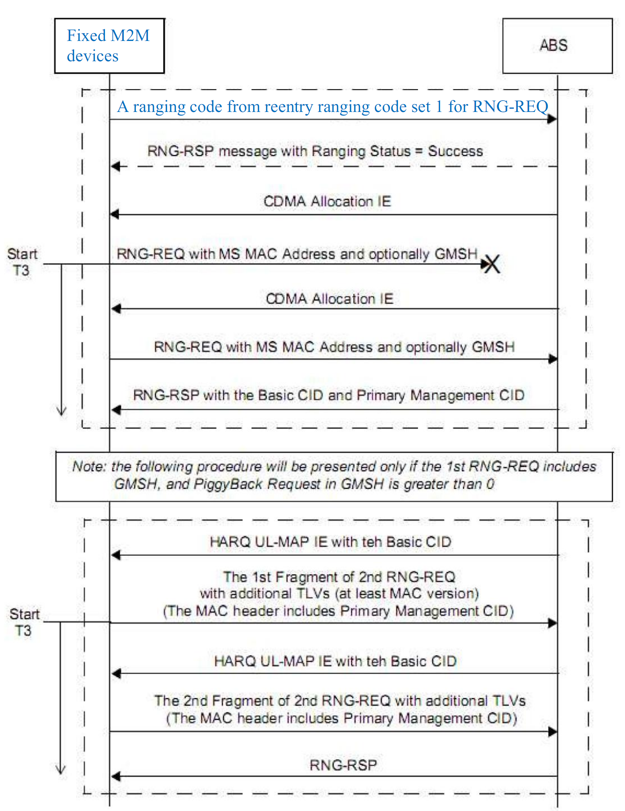
Fig. XXX The procedure of network re-entry from idle mode for fixed M2M devices.
---------------------------------------------------------End of Text #2---------------------------------------------------------

Reference
[1] IEEE P802.16m/D12, “Part 16: Air Interface for Broadband Wireless Access Systems: Advanced Air Interface,” Feb. 2011.
[2] IEEE, “C802.16p-11/0002; IEEE 802.16p Machine to Machine (M2M): Proposed Text from Power Saving (PWR) Rapporteur Group”, Mar. 2011

