Project | IEEE 802.16 Broadband Wireless Access Working Group <http://ieee802.org/16>
Title | Paging to pull M2M device with ranging parameters
Date Submitted | May 8, 2011
Source(s) | Jin Lee, Youngsoo Yuk, Jeongki Kim, Giwon Park, Kiseon Ryu , JinSam Kwak  LG Electronics | {jin1.lee, youngsoo.yuk, kiseon.ryu}@lge.com
Re: | 802.16p amendment texts
Abstract | This is to propose uniform access distribution of M2M devices for ranging access
Purpose | To be discussed and adopted by 16p TG
Notice | This document does not represent the agreed views of the IEEE 802.16 Working Group or any of its subgroups. It represents only the views of the participants listed in the “Source(s)” field above. It is offered as a basis for discussion. It is not binding on the contributor(s), who reserve(s) the right to add, amend or withdraw material contained herein.
Release | The contributor grants a free, irrevocable license to the IEEE to incorporate material contained in this contribution, and any modifications thereof, in the creation of an IEEE Standards publication; to copyright in the IEEE’s name any IEEE Standards publication even though it may include portions of this contribution; and at the IEEE’s sole discretion to permit others to reproduce in whole or in part the resulting IEEE Standards publication. The contributor also acknowledges and accepts that this contribution may be made public by IEEE 802.16.
Patent Policy | The contributor is familiar with the IEEE-SA Patent Policy and Procedures:  <http://standards.ieee.org/guides/bylaws/sect6-7.html#6> and <http://standards.ieee.org/guides/opman/sect6.html#6.3>.  Further information is located at <http://standards.ieee.org/board/pat/pat-material.html> and <http://standards.ieee.org/board/pat>.
Paging to pull M2M device with ranging parameters
Jin Lee, Youngsoo Yuk, Jeongki Kim, Giwon Park, Kiseon Ryu , JinSam Kwak

LG Electronics

Background
According to the previous PWR RG Report, scenario 3 (network reentry after paging indication) may require to handle simultaneous access, especially when the several M2M groups are paged for re-entries. One of the promising approaches is to use waiting offset time per M2M group (or M2M device) so that it is possibly distributed for M2M group (or M2M devices) to start ranging backoff window. In this contribution, we would like to include description for the waiting offset time in paging message. Also, as for backoff mechanism, we would like to show that a uniform distribution of ranging opportunity rather than the conventional random backoff mechanism can be more helpful to reduce access contention

Proposal
- Uniform access distribution
Although the waiting offset time is applied to M2M groups, we may still see the problem how to reduce access collision from M2M devices belonging to an M2M group. Since the BS may be able to predict how many M2M devices need to perform ranging, here we suggest uniform distribution of ranging opportunities, by the equation of M2M device ID mod K, K is the distinct value transmitted by a paging message. Since we assume different backoff window size for an M2M group, here K may be dependent on the number of devices required ranging.
Fig1. Uniform access distribution

Performance Evaluation
In order to investigate the performance gain of the proposed method, we evaluated the performance by simulation.
We performed traffic-level simulation without channel effect.
- The proposed method is to use uniform distribution by using modulo operation. (Uniform)
- The conventional method is to use initial back-off window with random trial (Random)

Followings are the simulation scenario we’d considered.
- 100 AMSs are trying to transmit
- The transmission probability of 0.5 or 1 per AMS (in case of 0.5, half of MSs have data to be transmitted.)
- Back-off window size : 10 ~ 35
- Target contention rate is less than 1%
- Contention when more than 4 ranging codes are received.

From the simulation results, we can learn that the proposed method shows better performance than the conventional method in the operating region (<1%).

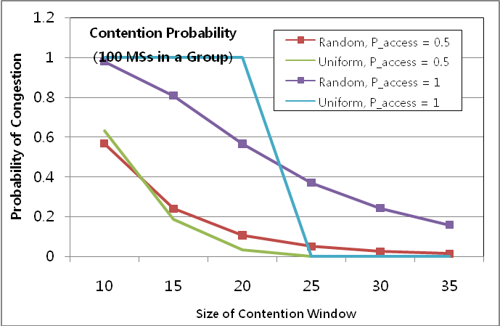

Fig2. Uniform distribution and Random distribution of ranging accesses

Text Proposal
[Remedy1: Insert the blue texts in page 7 line 16 ]

16.2.18.7 Idle mode for M2M application
16.2.18.7.2 Network re-entry from idle mode for M2M devices

For network reentry from Idle Mode, ranging parameters may be different for M2M devices or M2M groups.

BS may assign ranging resources, including ranging code and ranging opportunity, dedicated for M2M devices. In this case, M2M devices perform ranging for network (re-)entry using dedicated ranging resources. If BS does not assign dedicated ranging resources, M2M devices perform ranging for network (re-)entry using the ranging resources defined in Table 833 in 16.3.5.5.1.2.

For the network reentry indicated by a paging message that contains ranging configuration, the M2M device shall select a ranging opportunity according to the ranging configuration. Ranging configuration may include differentiated waiting offset time and backoff window size. Upon reception of the waiting offset time, the M2M devices shall wait the period of time before selecting ranging opportunities. In this case, the M2M devices determine ranging opportunities using the following equation:
Ranging opportunity offset == M2M Device ID mod K, where K is the size of initial ranging backoff window indicated by the paging message.

[Remedy2 : Insert the blue texts in page 4 line 23]

16.2.3.23 AAI-PAG-ADV (paging advertisement) Message

Table 700 – AAI-PAG-ADV Message Field Description
Field | Size (bits) | Value/Description | Condition
:
For (i=0;<i<Num_MGID; i++) {
MGID | 15 | M2M Group ID
Action Code |  | 0: Perform network reentry  1: Receiving multicast traffic
If (Action Code == 0) {
Waiting offset time |  | M2M group shall not begin ranging prior to the expiration of waiting time from the reception of paging message.
Backoff window size (K) |  | Used to indicate the size of the initial backoff window.
}
:

References
[1] IEEE P802.16m/D12
[2] IEEE P802.16p Amendment Working Document (AWD)

