Project | IEEE 802.16 Broadband Wireless Access Working Group <http://ieee802.org/16>
Title | Ranging procedure using orthogonal preamble for fixed M2M devices
Date Submitted | 2011-05-08
Source(s) | Youngsoo Yuk, Jinsoo Choi, Giwon Park, Jin Lee, Jeongki Kim, Kiseon Ryu and JinSam Kwak  LG Electronics Inc. | Email: youngsoo.yuk@lge.com, js.choi@lge.com , giwon.park@lge.com
Re: | Call for comments on the 16p AWD
Abstract | This contribution proposed the new ranging procedure for fixed M2M devices by using BR channel structure.
Purpose | For discussion in 802.16p TG
Notice | This document does not represent the agreed views of the IEEE 802.16 Working Group or any of its subgroups. It represents only the views of the participants listed in the “Source(s)” field above. It is offered as a basis for discussion. It is not binding on the contributor(s), who reserve(s) the right to add, amend or withdraw material contained herein.
Release | The contributor grants a free, irrevocable license to the IEEE to incorporate material contained in this contribution, and any modifications thereof, in the creation of an IEEE Standards publication; to copyright in the IEEE’s name any IEEE Standards publication even though it may include portions of this contribution; and at the IEEE’s sole discretion to permit others to reproduce in whole or in part the resulting IEEE Standards publication. The contributor also acknowledges and accepts that this contribution may be made public by IEEE 802.16.
Patent Policy | The contributor is familiar with the IEEE-SA Patent Policy and Procedures:  <http://standards.ieee.org/guides/bylaws/sect6-7.html#6> and <http://standards.ieee.org/guides/opman/sect6.html#6.3>.  Further information is located at <http://standards.ieee.org/board/pat/pat-material.html> and <http://standards.ieee.org/board/pat>.
Ranging procedure using orthogonal preamble for fixed M2M devices

Youngsoo Yuk, Jinsoo Choi, Giwon Park, Jin Lee, Jeongki Kim, Kiseon Ryu and JinSam Kwak

LG Electronics Inc.

Introduction
In session #72, we proposed a ranging procedure to use BR channel instead of the initial ranging channel for fixed M2M devices [1]. In this contribution, we provided the detailed proposal and the evaluation results of the proposal.
From the simulation results, the use of BR channel structure with small timing errors is shown to be acceptable, and it provides higher capacity with lower overhead.

Ranging using BR channel structure
During the network reentry from idle mode or the location update, MS starts the procedures by sending a ranging sequence on ranging channel. In case of BR procedure of connected mode MS, MS starts the BR procedure by sending a BR preamble sequence on BR channel.
In general, ranging channel is composed of 4 LRUs while BR channel has only one LRU. Thus, BR channel is more efficient than the BR channel in the perspective of radio resource.
Moreover, in the perspective of channel capacity, maximum two or four ranging codes can be used in ranging channel. On the other hand, in case of BR channel, minimum four or eight BR codes and maximum 24 BR codes can be used. Thus, BR channel is more efficient than the ranging channel in the perspective of channel capacity.

Table 1. Comparisons of various ranging code choices for fixed M2M devices
 | Pros | Cons
NS-RCH | Immunity for long timing offset | Higher Overhead (4 LRUs: 1 Subband)  Complex HW in ABS  Low capacity (upto 3 codes)
S-RCH | Higher diversity gain (repetitions)  Immunity for short timing offset | Higher Overhead (4 LRUs: 1 Subband)  Complex HW in ABS  Medium capacity
BR | Low overhead (1 LRU)  High capacity (upto 24 codes without timing offset, 6~8 codes with timing offset) | Less immune with short timing offset  Low decoding complexity
No code | No overhead  Can be used with BS-initiated access (paging etc) | No Timing offset correction  Hard to utilize for random access

With this point in view, for fixed M2M device, BR channel which is used in connected mode can be reused in network reentry from idle mode because the channel condition between fixed M2M device and BS is unchanged and always synchronized with BS if the device does not move other area.
The role of ranging preamble is to provide the adjustment of UL transmit timing and power. The initial synchronization can be done during initial entry procedures. In case of fixed M2M devices, the timing and the power level may not be changed severe, if BR channel allows certain level of variation, we can use BR channel for the ranging procedure.
From the simulation results, upto ±40samples (± 3.57us) of timing error can be acceptable. In addition, the power variation comes from the shadowing effect is not serious than the fast fading effect, we can only consider the fast fading effect for BR preamble reception.
About the timing error, various factors can be considered: Distance from BS to device, Fading effects, oscillator error etc.
- Oscillator error: Devices shall perform AFC by receiving DL signal.
- Distance from BS: It may not be changed by assuming fixed device. (small variation can be detected by tracking DL variation)
- Fading effects: By tracking DL channel, or it is difficult to determine correct timing error in this case.

In order to investigate the possible range of timing errors by fading effect, we consider the various channel environment of the WINNER II channel model [2].
Table 2 shows the delay values for various number of sample delays, and table 3 shows the 3 maximum delays and power profile of each path for various WINNER II CDL (Clustered Delay Line) channel model.
In the WINNER II model, typical delay spread is about 100ns and maximum delay is not exceed 1us except some special case (e.g. C3 (bad urban macro cell) environment).
Even though with bad urban macro cell (max 7us of -13dB), if DL/UL timing is not severely separated, it can be tracked from DL variation. In addition, most of the strong path will arrived before 600ns, it may not affect seriously. In addition, with more antennas (1x4), 3dB of gain can be achieved, and max 80 samples (7.14 us) can be received with 1% of detection error.

Table 2. Delay for each timing error (samples)
Timing Errors (samples) | Delay (ns) | Max Delay (in WINNER II channel model)
10 | 893 | A1, A2/B4, B1, B3, C1, C2LOS, D1
20 | 1786 | C2NLOS
30 | 2679 | C4
40 | 3571 | B2
50 | 4464
60 | 5357
70 | 6250
80 | 7143 | C3

Table 3. Maximum Delay for each WINNER II channel model[2].
Propagation Scenarios | Propagation type | Max Delay (ns) |  |  | Power [dB]
A1 Indoor small office | LOS | 145 | 195 | 350 | -14.2 | -21.6 | -23.4
A1 Indoor small office | NLOS | 115 | 150 | 175 | -11.8 | -20.4 | -16.6
A2/B4 (indoor to outdoor/ outdoor to indoor) | NLOS | 195 | 250 | 305 | -16.0 | -21.0 | -22.9
B1 (Urban micro-cell) | LOS | 115 | 250 | 460 | -17.8 | -19.6 | -31.4
B1 (Urban micro-cell) | NLOS | 390 | 505 | 615 | -19.6 | -25.6 | -29.9
B2 (Bad Urban micro-cell) | NLOS | 190 | 1600 | 2800 | -8.2 | -5.7 | -7.7
B3 (indoor hotspot) | LOS | 130 | 185 | 280 | -15.2 | -23.3 | -27.7
B3 (indoor hotspot) | NLOS | 190 | 290 | 405 | -11.8 | -17.0 | -24.9
C1(Urban macro-cell) | LOS | 290 | 620 | 960 | -23.2 | -28.5 | -32.6
C1(Urban macro-cell) | NLOS | 160 | 200 | 770 | -8.0 | -3.1 | -22.4
C2 (Urban micro-cell) | LOS | 150 | 160 | 220 | -18.2 | -15.3 | -23.1
C2 (Urban micro-cell) | NLOS | 725 | 1210 | 1845 | -8.5 | -17.2 | -16.7
C3 (Bad Urban macro-cell) | NLOS | 1825 | 4800 | 7100 | -25.4 | -9.7 | -13
C4 (Outdoor to indoor (urban) macro-cell) | NLOS | 815 | 1055 | 2310 | -13.6 | -17.8 | -32.2
D1 (Rural macro-cell) | LOS | 125 | 180 | 190 | -26.1 | -29.4 | -28.3
D1 (Rural macro-cell) | NLOS | 100 | 170 | 420 | -4.2 | -12.4 | -26.5

Simulation Results
Table 4 shows the simulation assumption. We investigated the performance in the point of Miss Detection (MD) given False Alarm (FA) threshold.

Table 4. Simulation Assumption
Parameters | Values | Notes
Channel structure | BR channel for 16m
Number of trials in an opportunity | 2, 4, 6, 8
Fading Channel | ITU-R Ped B, 3km/h
Antenna | 1(Tx) x 2 (Rx)
UL timing error | n samples n ~ N(0, σ²), (σ : 0, 10, 20, 30 )  n samples with uniform random between (0, ±20, ±40, ±60 samples) | - 68% of timing errors are less than σ (0, ±10, ±20, ±30 samples)  - 95% of timing errors are less than 2 σ (0, ±20, ±40, ±60 samples)
Performance target | Miss Detection rate 1%, False Alarm rate 1% | At -5dB, with 2 codes case
Number of codes (index) | 24 codes

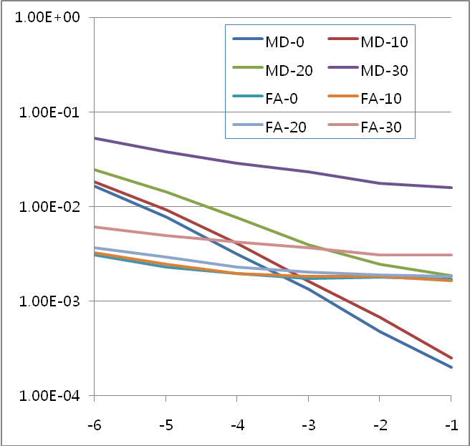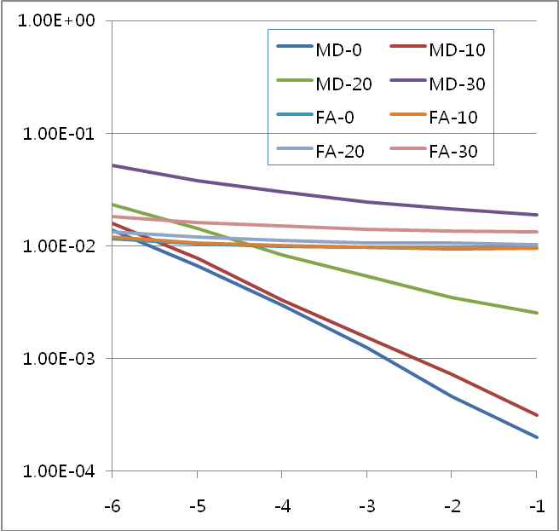
- 2 Users (b) 4 Users\

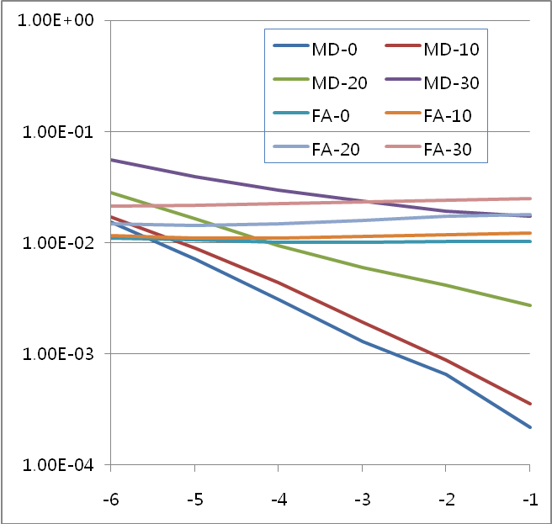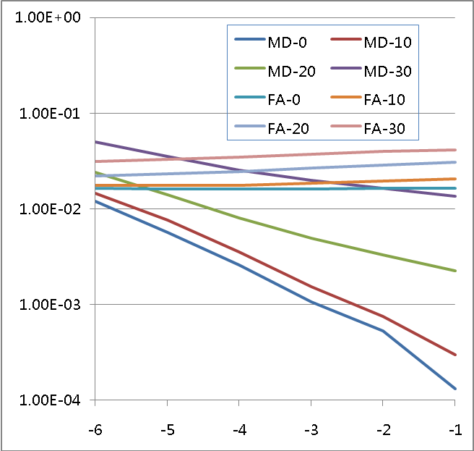
(c) 6 Users (d) 8 Users

Figure 1. Simulation results of the performance of Miss detection (MD) probability and false alarm (FA) probability using BR channels with 2, 4, 6, 8 users case (with σ of 0, 10, 20, 30 sample timing errors)

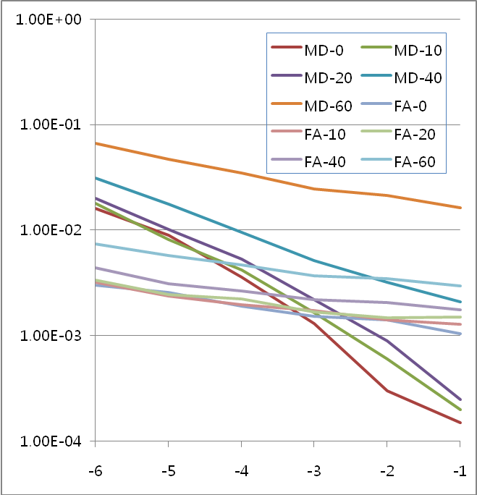

Figure 2. Simulation results of the performance of Miss detection (MD) probability and false alarm (FA) probability using BR channels with 2 users case (with uniform 0, 10, 20, 40, 60 sample timing errors)

Conclusion

In conclusion, for efficient resource usage of BS, BR channel can be used for network reentry from idle mode of fixed M2M device instead of ranging channel. For improving the efficiency of the ranging resource we propose to use BR channel for ranging procedure of fixed M2M devices.

References

[1] IEEE C802.16p-11/0018r1, Proposed text for network reentry procedure of fixed M2M device
[2] IST-4-027756 WINNER II D1.1.2.V1.2 “WINNER II Channel Models”.

Proposed Text Change
----------------------------------------------------- Start of Proposed Text -----------------------------------------------------
[Remedy 1: In line 12 of page 7 in C802.16p-10/0018r1, insert the description as following

16.2.18.7.2 Network re-entry from idle mode for M2M devices

For network reentry from Idle Mode, ranging parameters may be different for M2M devices or M2M
groups.

BS may assign ranging resources, including ranging code and ranging opportunity, dedicated for M2M
devices. In this case, M2M devices perform ranging for network (re-)entry using dedicated ranging
resources. If BS does not assign dedicated ranging resources, M2M devices perform ranging for network
(re-)entry using the ranging resources defined in Table 833 in 16.3.5.5.1.2.

Two types of M2M ranging channel may be configured. Type 0 M2M ranging channel uses the same physical structure as NS-RCH which is default configuration. Type 1 M2M ranging channel uses the same physical structure as BR channel, and it may be used for fixed M2M devices or small cell.

When type 1 M2M ranging channels are assigned, a fixed M2M device shall initiate ranging procedure by sending a BR preamble sequence on the assigned type 1 M2M ranging channel.
If the BS successfully detects a BR preamble sequence, it grants the UL resource for sending AAI-RNG-REQ MAC control message by using CDMA Allocation A-MAP IE. In this case CDMA allocation indication shall be set to ‘0’.
In order to distinguish from the CDMA Allocation A-MAP IE for normal BR sequences, Preamble index field in RA-ID shall be masked with 0b100000. Upon receiving a UL grant for AAI-RNG-REQ message, fixed M2M device sends the AAI-RNG-REQ message to the BS and the network reentry procedure proceeds as 16.2.18.5.

For the network reentry indicated by a paging message that contains ranging configuration, the M2M device
shall select a ranging opportunity according to the ranging configuration. Ranging configuration may
include differentiated waiting offset time and backoff window size.

[Remedy 2: In line 61 of page 3 in C802.16p-10/0018r1, insert the description as following

16.2.3.23 AAI_PAG-ADV (paging advertisement) Message

Table 700 - AAI-PAG-ADV Message Field Description

Field | Size (bits) | Value/Description | Condition
For (i=0;i<Num_MGID; i++){
MGID | 15 | M2M Group ID
Action Code | 1 | 0 : Perform network reentry  1 : Receiving multicast traffic
If (Action code == 0){
M2M Ranging type | 1 | 0b0: M2M Ranging type 0  (It use the same physical structure as NS-RCH)  0b1: M2M Ranging type 1  (It use the same physical structure as BR channel) | Optional,  Present when dedicated ranging channels are assigned for this M2M Group
Start frame offset of M2M ranging channel | 6 | Frames, the offset from the frame that this paging message is transmitted. | Present when dedicated ranging channels are assigned for this M2M Group
Subframe index of M2M ranging channel | 3 |  | Present when dedicated ranging channels are assigned for this M2M Group
Opportunity index | 1 | Opportunity index of the BR ranging channel.  0b0: 0b01  0b1: 0b10 | Present when dedicated ranging channels are assigned for this M2M Group
Allocation Duration | 8 | Frames, the dedicated ranging channel is allocated during the allocation duration. | Present when dedicated ranging channels are assigned for this M2M Group
LRU index of M2M ranging channel | 7/6/5 | Indicate the resource for BR ranging channel  For 20MHz, 7 bits  For 10MHz, 6 bits  For 5MHz, 5 bits | Present when M2M ranging type is type 1
}
}

[Remedy 3: In line 37 of page 4 in C802.16p-10/0018r1, insert the description as following]

16.2.3.31 AAI-System Configuration Descriptor (SCD) Message

Table 708 - AAI-SCD Message Field Description
Field | Size (bits) | Value/Description | Condition
... | ... | ...
M2M Ranging type | 1 | 0b0: M2M Ranging type 0  (It use the same physical structure as NS-RCH)  0b1: M2M Ranging type 1  (It use the same physical structure as BR channel) | Optional,  Present when M2M ranging channels are assigned.
LRU index of M2M ranging channel | 7/6/5 | Indicate the resource for M2M ranging channel  For 20MHz, 7 bits  For 10MHz, 6 bits  For 5MHz, 5 bits | Present when M2M ranging type is type 1
Subframe index of M2M ranging channel | 3
Opportunity index | 1 | Opportunity index of the BR ranging channel.  0b0: 0b01  0b1: 0b10
Periodicity of the M2M ranging | [TBD] | Indicates the periodicity of the M2M ranging. Details for the periodicity is TBD.

----------------------------------------------------- End of Proposed Text -----------------------------------------------------

