Project | IEEE 802.16 Broadband Wireless Access Working Group <http://ieee802.org/16>
Title | Handling Normal Operation Congestion in M2M Networks
Date Submitted | 2011-05-16
Source(s) | Bin Chen, George Calcev, Erik Colban, George Cummings  Huawei Technologies  Shantidev Mohanty, Joey Chou  Intel corporation | E-mail: binchen@huawei.com  George.Calcev@huawei.com  ecolban@huawei.com  gcummings@huawei.com  *<http://standards.ieee.org/faqs/affiliationFAQ.html>
Re: | Call for Comments on the 802.16p Amendment Working Document <IEEE 802.16p-10/0018r1>
Abstract | This contribution proposes discussion of M2M congestion in normal operation
Purpose | To be discussed and adopted by 802.16p TG
Notice | This document does not represent the agreed views of the IEEE 802.16 Working Group or any of its subgroups. It represents only the views of the participants listed in the “Source(s)” field above. It is offered as a basis for discussion. It is not binding on the contributor(s), who reserve(s) the right to add, amend or withdraw material contained herein.
Release | The contributor grants a free, irrevocable license to the IEEE to incorporate material contained in this contribution, and any modifications thereof, in the creation of an IEEE Standards publication; to copyright in the IEEE’s name any IEEE Standards publication even though it may include portions of this contribution; and at the IEEE’s sole discretion to permit others to reproduce in whole or in part the resulting IEEE Standards publication. The contributor also acknowledges and accepts that this contribution may be made public by IEEE 802.16.
Patent Policy | The contributor is familiar with the IEEE-SA Patent Policy and Procedures:  <http://standards.ieee.org/guides/bylaws/sect6-7.html#6> and <http://standards.ieee.org/guides/opman/sect6.html#6.3>.  Further information is located at <http://standards.ieee.org/board/pat/pat-material.html> and <http://standards.ieee.org/board/pat>.

Handling Normal Operation Congestion in M2M networks
George Calcev, Erik Colban, Bin Chen, George Cummings
Huawei Technologies
Shantidev Mohanty, Joey Chou

Introduction
One of the most important features of M2M communication is that it needs to handle a large number of devices (there may be as many as 30,000 devices in a cell). Most of the M2M devices will be programmed to upload periodic reports to the central servers or to report asynchronous events such as sudden changes in temperature, humidity, mechanical fractures, etc. Many discussions in the M2M TG were dedicated to handling congestion resulted from catastrophic events such as large power loss. However, this type of catastrophic congestion that overwhelms the wireless network is relatively rare. We think that the congestion created by the superposition of asynchronous measurements reports or by sudden changes in the environmental variables will be a very important issue to deal with on a daily or hourly basis. A rigorous forecast of this congestion might be a difficult or an impossible task due randomness and delays introduced by the contention in the ranging channel, retransmissions caused by the propagation conditions or by accidental hardware failures or by the abrupt changes in measured variables. In these conditions of congestion uncertainty is very important that the BS be able to reserve an optimum amount of resources for UL random access.

Ranging channel adaptation
In the actual implementation is very difficult to estimate the number of competing devices on ranging channel at one point in time. The BS is able to know precisely only the number of devices that were successful in their UL contention. The number of ranging collisions is hard to determine since it is not always possible to distinguish with certainty between collision and interference by simply measuring the level of energy received at BS in a particular time slot.
However there is a simple way for the BS to be aware about the congestion level by using simple reports from the MS regarding the number of retrials before a success. If the successful MS inform the BS about the most recent number of failed attempts in their transmissions, the BS would be able to estimate the number of competing devices and allocate the necessary resources.
Figure 1, top-most curve, shows the total number of slots occupied by exactly one user as a function of users ranging. Observe that this curve looks exactly as the Aloha curve, having a maximum at approximately 37% time slots usage. What it is interesting is how this total splits among successful transmissions in the first attempt, second attempt and so on. The Figure 1 shows that if one knows the total number of successes and the number of successes in the first attempt could identify the number of competing devices and from there allocate the optimum number of resources.
Figure 2, presents the probability distribution of the total number of transmissions by the number of attempts and competing devices. By measuring these curves’ distribution one can estimate the number of competing devices and adjust the number of available time slots or transmission probability such that an optimum efficiency is obtained. In Figure 2, we observe that for instance when 40 devices compete over T=60 time slots, about 50% of them are successful in the first trial, 25% are successful in the second trial, 12% are successful in the third trial, etc. Therefore, knowing this distribution one could infer the number of competing devices. The curves add up to one because they represent probability distributions of a device being in trial one, two, etc.

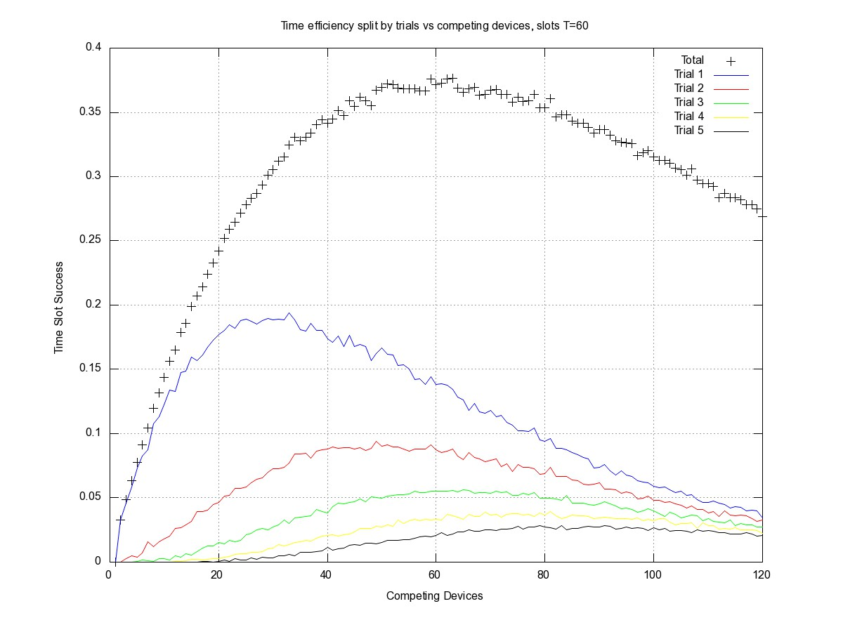
Figure 1, Time Efficiency as a fraction between successful slots and all available slots for multiple retrials
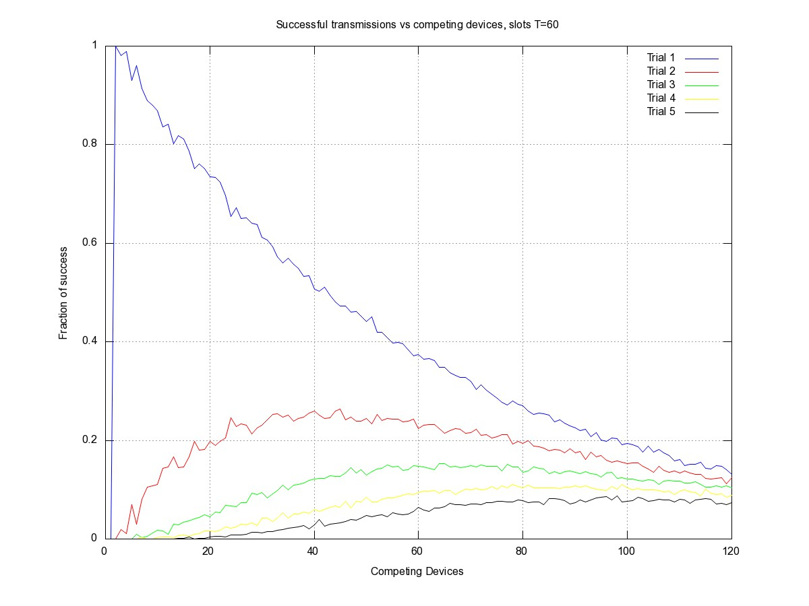
Figure 2, Fraction of successful transmissions with retrial versus number of competing devices

In order to report the failures before success the MS may use one or more bits in the RNG-REQ message dedicated to inform the BS if the last ranging transmission was a retrial or to indicate the last number of retrials. The BS collects all this information and adjusts the ranging channel accordingly in order to reach a right proportion between the successes in the first attempt and those from multiple retrials.
We think that the solution is relatively easy to implement with minor text changes in 802.16e-2009 and 802.16m/D12 specifications as suggested bellow. We would like the group to discuss the value of this solution and the proposed text changes.

References
[1] IEEE Std 802.16™-2009
[2] IEEE P802.16m/D12

In 802.16p-10/0018 insert the following text in section 6:

------------------------------------------------------ Start of Proposed Text -------------------------------------------------
[Change section 6.3.2.3.5 as follows:]

The following parameter indicates the number of ranging retries during the current ranging process performed by a M2M device. This TLV may be included by M2M devices when performing initial ranging for network entry or re-entry, periodic ranging, or HO ranging:

Ranging Retries

The following parameter shall be included in the RNG-REQ message when the MS is attempting to perform
Network Re-Entry from idle mode, Keep-Alive check in sleep mode, Secure Location Update, or HO and
the MS has a hashed message authentication code (HMAC)/cipher-based message authentication code
(CMAC) tuple necessary to expedite security authentication.

HMAC/CMAC Tuple (see 11.1.2)
The HMAC/CMAC Tuple shall be the last attribute in the message.

In 802.16p-10/0018 insert the following text in section 11:

------------------------------------------------------ Start of Proposed Text -------------------------------------------------

[Change Section 11.5 as indicated:]

Table 582- RNG-REQ message encodings
Name | Type  (l byte) | Length | Value  (variable length) | PHY scope
…
Ranging Retries | 24 | 1 | The number of ranging reties in this ranging process  Bit 0-1 – Indicates the number of retrials in the channel ranging access as follows:  - - Success in the first attempt  01 - Success in the second attempt  10 - Success in third attempt  11 –Success in the 4th or later attempt | OFDMA
…

------------------------------------------------------ End of Proposed Text -----------------------------------------------------

In 802.16p-10/0018 insert the following text in section 16.2.3:

------------------------------------------------------ Start of Proposed Text ---------------------------------------------------
[Change Section 16.2.3.1 as indicated:]

Table 678 -- AAI- RNG-REQ message field Description

Field | Size (bits) | Value/Description | Condition
…
CMAC indicator | 1 | Indicate if this message is protected by CMAC touple | Shall always be present
Retrials | 2 | The number of failed trials in this ranging process  Bit 0-1 – Indicates the number of retrials in the channel ranging access as follows:  - - Success in the first attempt  01 - Success in the second attempt  10 - Success in third attempt  11 –Success in the 4th or later attempt | May be included by M2M devices after initial ranging during network entry or re-entry, periodic ranging, or HO ranging.

------------------------------------------------------ End of Proposed Text -----------------------------------------------------

