Project | IEEE 802.16 Broadband Wireless Access Working Group <http://ieee802.org/16>
Title | Reliable multicast data transmission
Date Submitted | 2011-05-08
Source(s) | Jeongki Kim, Youngsoo Yuk, Jinsoo Choi, Jin Lee, Giwon Park, Kiseon Ryu, Jinsam Kwak  LG Electronics | Email: jeongki.kim@lge.com
Re: | Call for comments on the 16p AWD
Abstract | This contribution proposes an method of the reliable multicast transmission using MAC layer feedback
Purpose | For discussion in 802.16p TG and adoption in to the 802.16p AWD
Notice | This document does not represent the agreed views of the IEEE 802.16 Working Group or any of its subgroups. It represents only the views of the participants listed in the “Source(s)” field above. It is offered as a basis for discussion. It is not binding on the contributor(s), who reserve(s) the right to add, amend or withdraw material contained herein.
Release | The contributor grants a free, irrevocable license to the IEEE to incorporate material contained in this contribution, and any modifications thereof, in the creation of an IEEE Standards publication; to copyright in the IEEE’s name any IEEE Standards publication even though it may include portions of this contribution; and at the IEEE’s sole discretion to permit others to reproduce in whole or in part the resulting IEEE Standards publication. The contributor also acknowledges and accepts that this contribution may be made public by IEEE 802.16.
Patent Policy | The contributor is familiar with the IEEE-SA Patent Policy and Procedures:  <http://standards.ieee.org/guides/bylaws/sect6-7.html#6> and <http://standards.ieee.org/guides/opman/sect6.html#6.3>.  Further information is located at <http://standards.ieee.org/board/pat/pat-material.html> and <http://standards.ieee.org/board/pat>.
Reliable multicast data transmission

Jeongki Kim, Youngsoo Yuk, Jinsoo Choi, Jin Lee, Giwon Park, Kiseon Ryu, Jinsam Kwak
LG Electronics

Introduction
During last meeting there was a consensus that the 802.16p BS should provide the method of transmitting the multicast data for M2M application reliably [1].

For this purpose, two methods were proposed at the last meeting as follows.
- Method 1: Unsolicitedly multiple times retransmission [2]
  - BS should transmit a multicast packet multiple times
- Method 2: Retransmission based on the NACK-based MAC level feedback [3].
  - ABS retransmits the multicast data only when the request of retransmission is received from MS

Table 1 Comparison between two methods
 | Advantage | Disadvantage
Method 1 | - No feedback mechanism & management  - No resource overhead by feedback | - Residual error happens. That is, some AMS devices may miss the data.  - Fixed DL resource overhead due to fixed multiple times TX
Method 2 | - Guarantee the reliability by feedback  - Efficient resource usage (only in case there is the request of retransmission from MS) | - Need UL feedback mechanism  - Need additional resources for feedback

Details of retransmission method by NACK based MAC level feedback
The device sends the MAC level feedback only when the device finds the error of the multicast data reception as follows.
    - Burst decoding error: When an M2M device fails to decode the multicast burst, M2M device may send the MAC level feedback to BS.
    - Missing MPDUs: If multicast MPDU arrives out of sequence (e.g., when the device receives the MPDU with #SN before receiving the MPDU with #SN-1 ), then the missing MPDU is declared as missing and the device starts the multicast error detection (MED) timer (T_{MED}) for every missing MPDU
T_{MED} stops if the device receives the missing MPDU before the T_{MED} expires
If T_{MED} expires, then the device declares the missing MPDU as error and sends the MAC level feedback to BS.
    - Expiration of T_{MIA} :
Multicast inter arrival (MIA) timer (T_{MIA}) starts,
When the device in connected mode receives the first multicast data
When the device in idle mode receives the paging message indicating the multicast traffic existence for the M2M group which the device belongs to
T_{MIA} is reset whenever the device receives the multicast data
T_{MIA} stops when the device receives the MTEEH
If T_{MIA} expires, the device sends the MAC level feedback to inform BS of the error status

Regarding MAC level feedback, device in connected mode sends the M2M multicast retransmission request (AAI-MMR-REQ) message and device in idle mode sends the AAI-RNG-REQ message (i.e., location update procedure). The following information may be included in the request messages.
      - Burst decoding error: MGID, MAP transmission time (e.g., frame/subframe number)
      - Missing MPDUs (i.e., T_{MED} expiration): MGID, Sequence numbers of missed MPDUs
      - Expiration of T_{MIA} : MGID, the SN of the latest MPDU received successfully

Performance analysis
Following analysis shows the comparison result between automatic retransmission and transmission with unicast and/or multicast feedback. Table x shows the residual error rate after n-time automatic transmission. (1% of BLER for 5% of MSs in a cell for a single transmission) The required residual error shall be less than 10⁻⁶ for TCP packet. Without feedback, BS shall transmit a burst more than 4 times.

Table 2. Residual error rate after n transmission in a cell.
 | Number of transmission
Number of MSs in a cell | 1 | 2 | 3 | 4 | 5
100 | 0.05 | 0.0005 | 5.E-06 | 5.E-08 | 5.E-10
500 | 0.25 | 0.0025 | 3.E-05 | 3.E-07 | 3.E-09
1000 | 0.5 | 0.005 | 5.E-05 | 5.E-07 | 5.E-09
5000 | 1 | 0.025 | 3.E-04 | 3.E-06 | 3.E-08
10000 | 1 | 0.05 | 5.E-04 | 5.E-06 | 5.E-08
20000 | 1 | 0.1 | 1.E-03 | 1.E-05 | 1.E-07
50000 | 1 | 0.25 | 3.E-03 | 3.E-05 | 3.E-07
100000 | 1 | 0.5 | 5.E-03 | 5.E-05 | 5.E-07

We evaluate the required resource for transmitting 50 bytes of burst with various transmission options. Table x. shows the evaluation assumption, and figure xx shows the required resource according to the number of MSs in a cell. All the case, the residual error rates are the same when BS transmit the burst 4 times.

Table 3. Evaluation environment
Multicast Data Size | 50 bytes
Feedback overhead | 60 bytes
DL MCS | 1/16, QPSK
UL MCS | 1/12, QPSK (HARQ)
DL resource | 34 LRUs
UL resource | 34 LRUs
RA_code | 4 LRUs
AAI_RNG-REQ | 30 bytes
AAI_RNG-RSP | 30 bytes

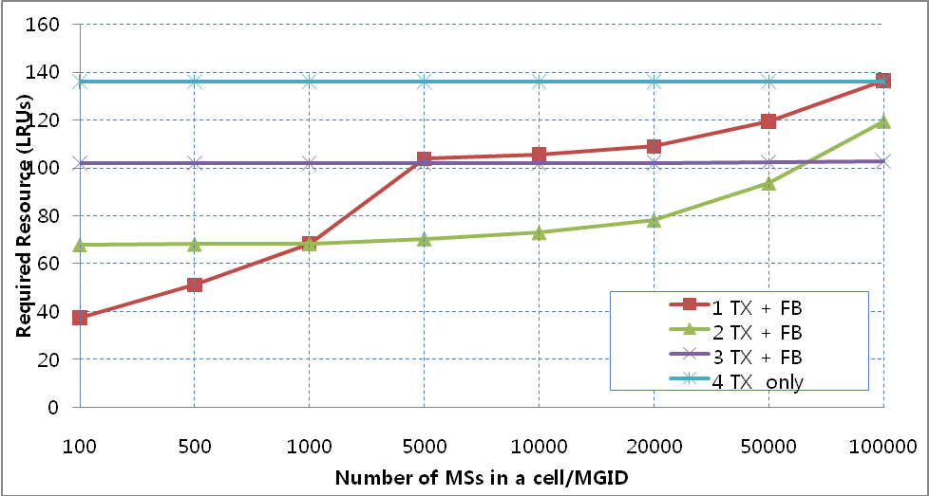

Figure 1 Required resources (LRUs) for transmitting 50 bytes of multicast data with various initial transmission times. (Residual Error Rates are the same for all cases. )

From the simulation results, we can learn that without Feedback, too large resources are required. According to the number of MSs in a cell, in order to reduce the initial error rate we can consider combining of single automatic re-transmission and feedback.

Conclusion
As we can see the result of performance analysis, in case that the number of MSs in a cell is less than 1000, one time transmission (No automatic repetition) with MAC level feedback mechanism is more efficient others. In case that the umber of MSs in a cell is larger than 1000 and less than about 70000, two time transmission (one time repetition) with MAC level feedback is more efficient than others.

Proposal
- When M2M device finds the error of multicast data reception, the device sends the MAC level feedback to BS. Upon receiving the MAC level feedback from M2M device, BS retransmits the multicast data based on the information included in the MAC level feedback message.
- BS may re-transmit the multicast data one time at the next frame.

Reference
[1] 802.16p-10_0018r1, Enhancements to Support Machine-to-Machine Applications
[2] C802.16p-11_0003r2, The reliable delivery between 802.16p BS and M2M device
[3] C802.16p-11_0032, Reliable multicast transmission using MAC layer feedback

Text proposal

---- Start of proposed text ----

[Remedy #1: Modify the Section 16.2.28.4.2 in C802.16p-10/0018r1 as follows.]
16.2.28.4.2 Reliable multicast transmission for M2M applications
An M2M BS shall provide the reliable transmission of the multicast traffic for M2M applications.

Multicast burst may be transmitted repetitively only one time. When an M2M device fails to decode the multicast burst, if the multicast burst is new burst (Burst indicator (BI) == 0) , then the M2M device waits to receive the multicast burst until next frame. Otherwise (BI ==1, the retransmitted burst), M2M device shall send the MAC level feedback to BS.

If multicast MPDU arrives out of sequence (e.g., when the device receives the MPDU with SN before receiving the MPDU with SN-1), then the device starts the multicast error detection (MED) timer (T_{MED}). T_{MED} stops if the device receives the missed MPDUs before the T_{MED} expires. If T_{MED} expires, the device sends the MAC level feedback to BS.

M2M device in connected mode starts the Multicast inter arrival (MIA) timer (T_{MIA}) when the device receives the first multicast data. M2M device in idle mode starts the Multicast inter arrival (MIA) timer (T_{MIA}) when the device receives the paging message indicating the multicast traffic existence for the M2M group which the device belongs to. T_{MIA} is reset whenever the multicast data is received. T_{MIA} stops when the device receives the MTEEH. If T_{MIA} expires, the device sends the MAC level feedback to inform BS of the error status.

For MAC level feedback M2M device shall transmit M2M multicast retransmission request (AAI-MMR-REQ) message in connected mode/ AAI-RNG-REQ message (i.e., location update procedure) in idle mode which include the MGID, MAP transmission time, Sequence numbers of missed MPDUs, the SN of the latest MPDU received successfully as described in 16.2.3.xx/16.2.3.1.
Upon receiving the AAI-MMR-REQ, BS shall re-transmit the missing multicast data to the M2M device. Upon receiving the AAI-RNG-REQ including multicast MAC level feedback information, BS shall transmit the AAI-RNG-RSP message and shall re-transmit the missing multicast data to the M2M device.

[Remedy #2: Add the following sections and texts in C802.16p-10/0018r1 as follows.]
16.3 Physical Layer
16.3.5 Downlink Control Structure
16.3.5.5 DL Control Information Elements
16.3.5.5.2.4.13 Broadcast Assignment A-MAP IE

[Modify the table 860 as indicated]
Table 860 Broadcast Assignment A-MAP IE
Syntax | Size (bit) | Notes
Broadcast_Assignment_AMAP_IE() {
A-MAP IE Type | 4 | Broadcast Assignment A-MAP IE
Function Index | 2 | 0b00: This IE carries broadcast assignment information  0b01: This IE carries handover ranging channel allocation  information  0b10: This IE carries multicast assignment information  0b11: reserved This IE carries multicast assignment information for M2M application
… | … | …
} else if {Function Index ==
0b10} {
… | … | …
}
Else {//Function Index == 0b11
MGID | 15
Burst Size | 6
Resource Index | 11
Long_TTI_Indicator | 1
Burst indicator | 1 | Burst Indicator (BI) indicates whether the multicast burst is new or not  0b0: The burst is new multicast burst  0b1: The burst is retransmitted multicast burst
}

[Insert the following texts at the end of Section 16.3.5.5.2.4.13:]

The multicast burst for M2M application may be retransmitted only once at the next frame. The SPID is set to 0 for multicast bursts for M2M application.

[Remedy #3: Add the following Section 16.2.3.xx in C802.16p-10/0018r1 as follows.]

[Insert the following Section and text:]

16.2.3.xx. AAI-MMR-REQ (multicast retransmission request) message
M2M device may send the AAI-MMR-REQ message to inform BS of the error of multicast data reception (e.g., burst decoding error, Missing MPDUs (T_{MED} expiration), T_{MIA} expiration).

Table xxx AAI-MMR-REQ (M2M multicast retransmission request) Message Field Description
Fields | Size (bit) | Value/Description | Condition
M2M group ID | 15
Action code | 2 | 0b00: Burst decoding error  0b01: Missing MPDUs (T_{MED} Expiration)  0b10: T_{MIA} Expiration  0b11: reserved
If (Action code == 0b00) {
MAP transmission time | 7 | Bit #0~#3: Least Significant 4 bits of the frame number in which the A-MAP IE corresponding to the erroneous burst was transmitted.  Bit #4~#6: The sub-frame number in which the A-MAP IE corresponding to the erroneous burst was transmitted.
} else if (Action code == 0b01) {
FID | 4 | Flow ID for the MPDU in which the out of order happens
For (i=0; i< N_MPDUs; i++) { |  | N_MPDUs: Indicates the number of MPDUs which the device missed.  1< N_MPDUs < 15
SN | 4 | The sequence number of the MPDU which the device missed
}
} else if (Action code == 0b10) {
FID | 4 | Flow ID for the MPDU related to the expired T_{MIA}
SN | 4 | The sequence number of the latest MPDU which the device received successfully
}

[Remedy #3: Add the Section 16.2.3.1 in C802.16p-10/0018r1 as follows.]

16.2.3.1 AAI-RNG-REQ
[Modify the Table 678 and text:]

Table 678—AAI-RNG-REQ Message Field Description
Field | Size  (bits) | Value/Description | Condition
Ranging purpose indication | 4 | 0b0000 = Initial network entry  0b0001 = HO reentry  0b0010 = Network reentry from idle  Mode  ……  0b1101 = NS/EP call setup  0b1110 - 0b1111 = reserved  0b1110 = M2M location update  0b1111= reserved
… | … | … | …
} else if (Ranging Purpose Indication
== 0b0011
|0b0110|0b0111| 0b1011|0b1110) {
… | … | … | …
AMS Mobility Information | 2
M2M LU purpose indication | 2 | 0b00 = LU for requesting the retransmission of multicast data  0b01 ~ 0b11 = reserved | Present when the Ranging Purpose Indication is set to 0b1110
If (M2M LU purpose indication == 0b00) {
M2M group ID | 15
Action code | 2 | 0b00: Burst decoding error  0b01: Out of order ( T_{MED} Expiration)  0b10: T_{MIA} Expiration  0b11: reserved
If (Action code == 0b00) {
MAP transmission time | 7 | Bit #0~#3: Least Significant 4 bits of the frame number in which the A-MAP IE corresponding to the erroneous burst was transmitted.  Bit #4~#6: The sub-frame number in which the A-MAP IE corresponding to the erroneous burst was transmitted.
} else if (Action code == 0b01) {
FID | 4 | Flow ID for the MPDU in which the out of order happens
For (i=0; i< N_MPDUs; i++) { |  | N_MPDUs: Indicates the number of MPDUs which the device missed.  1< N_MPDUs < 15
SN | 10 | The sequence number of the MPDU which the device missed
}
} else if (Action code == 0b10) {
FID | 4 | Flow ID for the MPDU related to the expired T_{MIA}
SN | 10 | The sequence number of the latest MPDU which the device received successfully
}
}
SMS
} else if (Ranging Purpose Indication
== 0b0100) {
… | … | … | …

---- End of proposed text ----

