Project | IEEE 802.16 Broadband Wireless Access Working Group <http://ieee802.org/16>
Title | Distribution of ranging access from M2M devices during network reentry
Date Submitted | 2011-07-10
Source(s) | Seokki Kim, Jaesun Cha, Soojung Jung, Chulsik Yoon, Kwangjae Lim  ETRI | Voice: +82-42-860-0626  E-mail: {kimsk0729}@etri.re.kr
Re: | Call for comments on IEEE 802.16p AWD
Abstract | This contribution proposes texts for distribution of ranging access from M2M devices.
Purpose | To discuss and adopt the proposed text in the 802.16p AWD.
Notice | This document does not represent the agreed views of the IEEE 802.16 Working Group or any of its subgroups. It represents only the views of the participants listed in the “Source(s)” field above. It is offered as a basis for discussion. It is not binding on the contributor(s), who reserve(s) the right to add, amend or withdraw material contained herein.
Release | The contributor grants a free, irrevocable license to the IEEE to incorporate material contained in this contribution, and any modifications thereof, in the creation of an IEEE Standards publication; to copyright in the IEEE’s name any IEEE Standards publication even though it may include portions of this contribution; and at the IEEE’s sole discretion to permit others to reproduce in whole or in part the resulting IEEE Standards publication. The contributor also acknowledges and accepts that this contribution may be made public by IEEE 802.16.
Patent Policy | The contributor is familiar with the IEEE-SA Patent Policy and Procedures:  <http://standards.ieee.org/guides/bylaws/sect6-7.html#6> and <http://standards.ieee.org/guides/opman/sect6.html#6.3>.  Further information is located at <http://standards.ieee.org/board/pat/pat-material.html> and <http://standards.ieee.org/board/pat>.
Distribution of ranging access from M2M devices during network reentry

Seokki Kim, Jaesun Cha, Soojung Jung, Chulsik Yoon, Kwangjae Lim
ETRI

Introduction

In the last meeting, it is agreed that ranging simulation is necessary for comparison of network entry solution. In this contribution, we introduce our ranging simulation results and propose the method which distributes ranging access from large number of M2M devices during network reentry

Simulation Scenario and Parameters

We have performed the ranging simulation based on ‘Scenario 1’ (fixed devices and network-initiated network entry) defined in [2] and considered individual paging. Simulation parameters for the ranging simulation are listed in Table1.

Table 1 – Simulation Parameters

Items | Value | Note
Number of M2M devices | 12000
Access Attempt/second | [10, 50, 100, 200, 500, 1200, 2000, 5000]
Initial backoff window size | [2, 4, 8, 16, 32, 64, 128, 256, 512, 1024, 2048, 4096] | in terms of frames
Final backoff window size | 65536 | in terms of frames
Arrival distribution | Poisson
T31 | 60 ms
Maximum Contention Ranging Retries | 8
Time delay for Ranging Success | 30ms | Time from the transmission of a ranging preamble code to reception of AAI-RNG-RSP/RNG-RSP message which is a response to AAI-RNG-REQ/RNG-REQ message. This parameter is applicable only when only one M2M device transmits a ranging preamble code on a ranging channel.
UL overhead | 1 ranging channel per frame
DL overhead | AAI-PAG-ADV: 5byte  AAI-RNG-ACK: 14bytes  AAI-RNG-RSP: 17bytes | Assuming each message is used once per a ranging attempt
Total number of ranging code | 1
Ranging code detection capability | 1 code per channel
Misdetection probability | 0%
False alarm | 0%
Reception of same code | No
Frame duration | 5ms

Simulation Result

According to performance metric defined in [2], ranging simulation results are represented in Figure 1-8.

We performed the simulation in case of various number of access attempt per second (10, 50, 100, 200, 500, 1200, 2000 and 5000) and initial backoff window size (2, 4, 8, 16, 32, 64, 128, 256, 512, 1024, 2048 and 4096).
When number of access attempt is small (see Figure1 or 2), it seems that there is no problem to perform the ranging access independent of initial backoff window size. Furthermore, access time delay may increase if initial backoff window size is too large. When number of access attempt is large, a lot of devices with small initial backoff window size fail to perform ranging access until maximum contention ranging retries (see Figure 3~8). Also we can find a backoff window size to satisfy a target ranging success rate while minimizing access delay.

As we can see in the figures, it is inescapable that access delay increases as number of devices grows. But we can maintain the high ranging success probability and low contention ratio by extending backoff window size. If devices type is ‘fixed’ and network entry type is ‘network-initiated’ such as ‘scenario 1’, base station can estimate the number of devices which are preparing network reentry and select appropriate backoff window size to reduce access delay and congestion.

Although this simulation is focused on the individual device access, we assume that a network can distribute M2M group accesses by assigning different paging offsets to each M2M groups based on the characteristics of M2M applications.

Because we used only one NS-RCH per a frame and didn’t deal with dedicated ranging channel allocation, overhead is not critical issue in in this simulation. To apply this proposal, we have only to insert additional 8 bits information regarding backoff window size in the paging message.

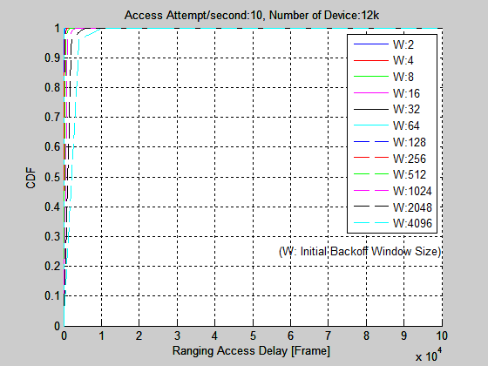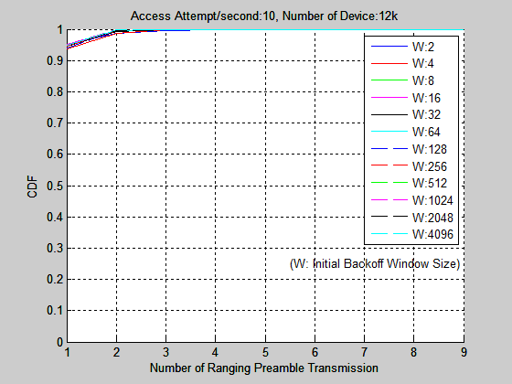
(a) Statistics of Ranging Access Delay (b) Statistics of Number of Ranging Preamble Transmission

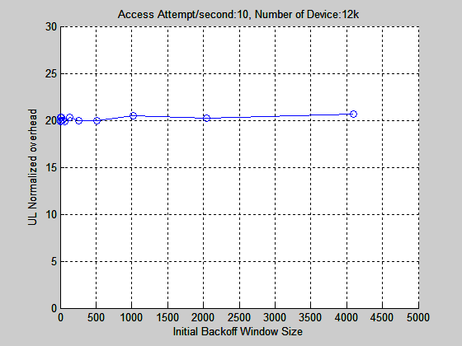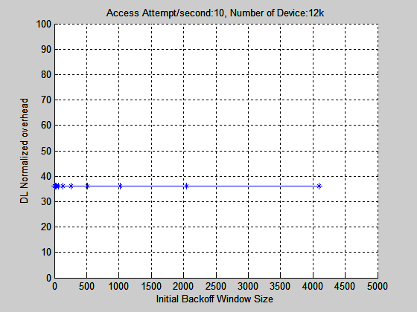
(c) UL Normalized Overhead (d) DL Normalized Overhead

Figure 1 – Simulation Result on 10 Access Attempt/second

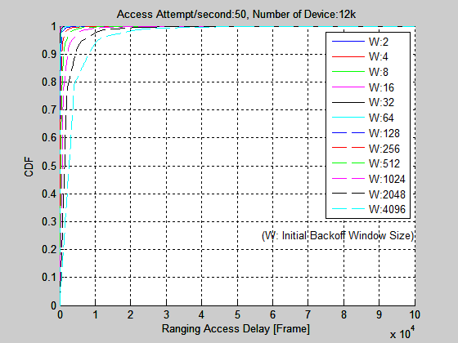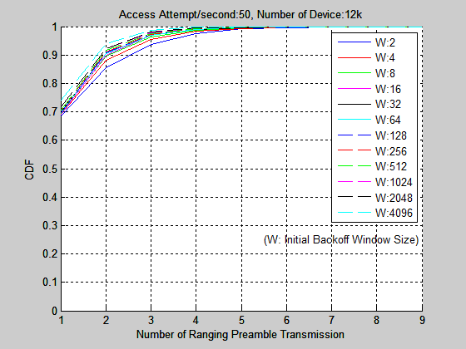

(a) Statistics of Ranging Access Delay (b) Statistics of Number of Ranging Preamble Transmission

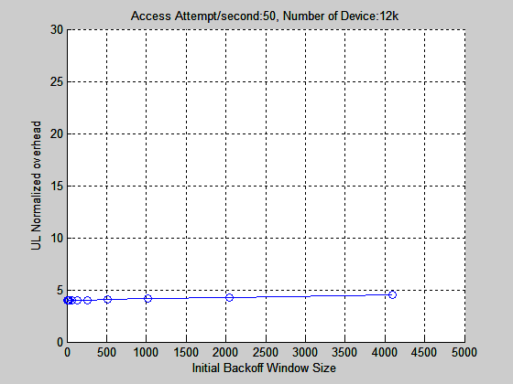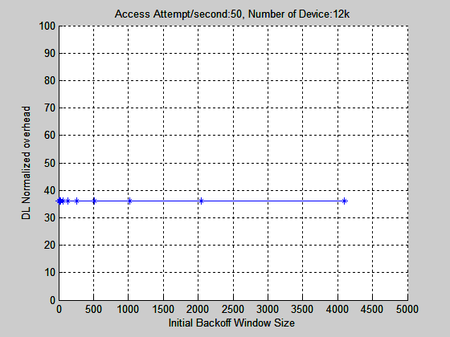
(c) UL Normalized Overhead (d) DL Normalized Overhead

Figure 2 – Simulation Result on 50 Access Attempt/second

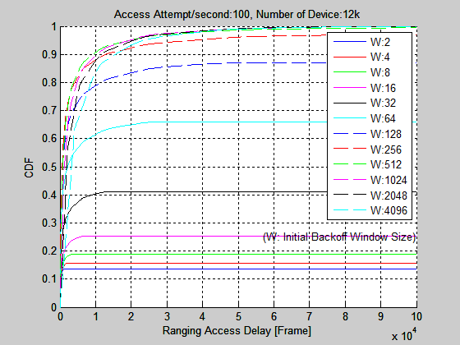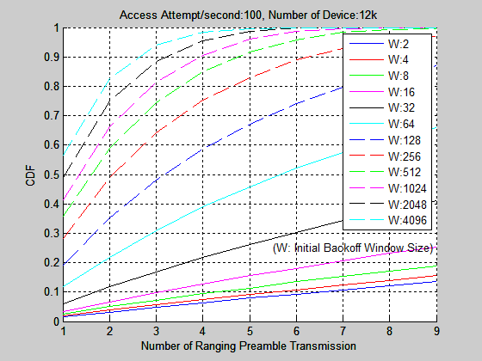

(a) Statistics of Ranging Access Delay (b) Statistics of Number of Ranging Preamble Transmission

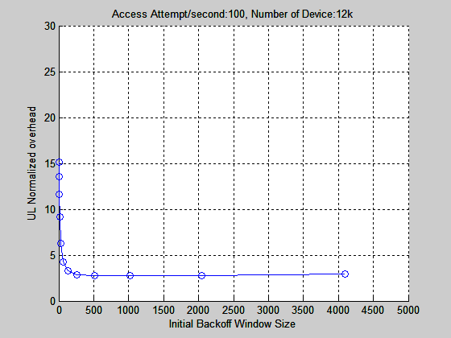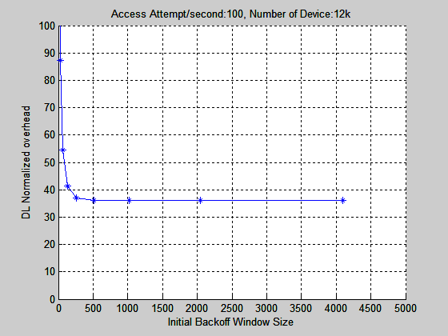
(c) UL Normalized Overhead (d) DL Normalized Overhead

Figure 3 – Simulation Result on 100 Access Attempt/second

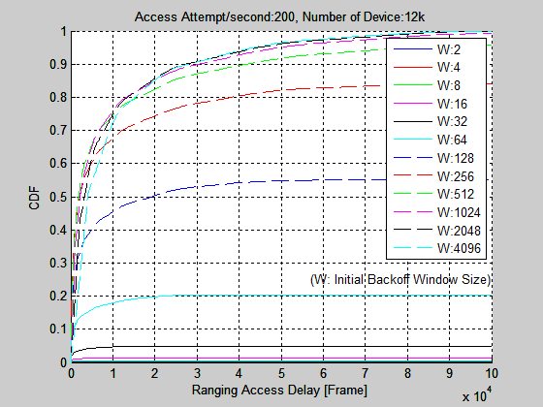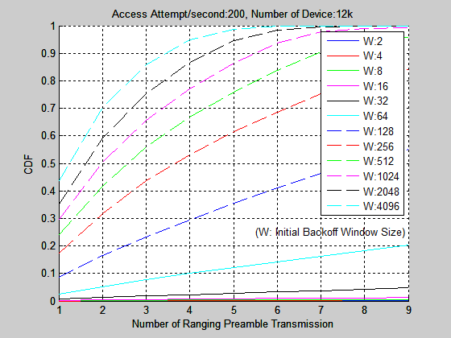

(a) Statistics of Ranging Access Delay (b) Statistics of Number of Ranging Preamble Transmission

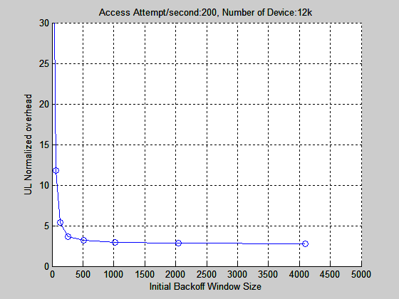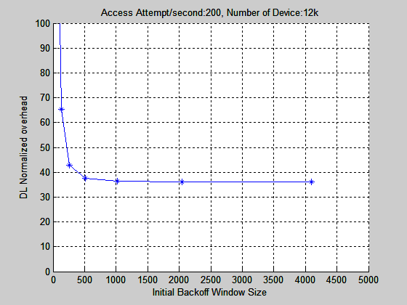
(c) UL Normalized Overhead (d) DL Normalized Overhead

Figure 4 – Simulation Result on 200 Access Attempt/second

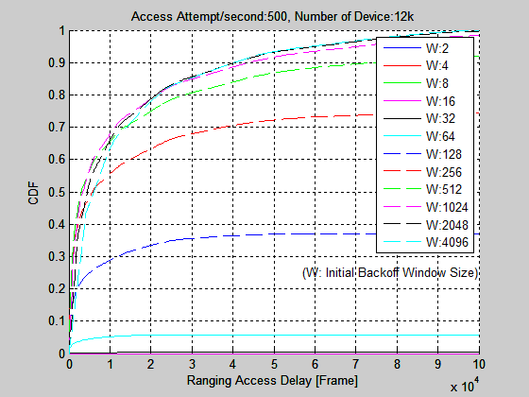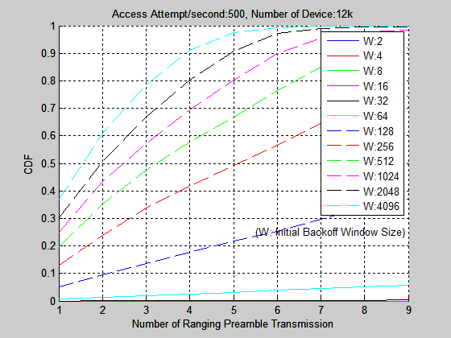
(a) Statistics of Ranging Access Delay (b) Statistics of Number of Ranging Preamble Transmission

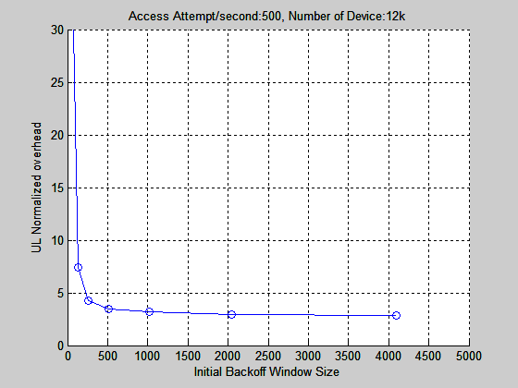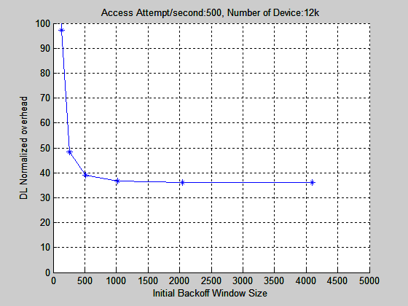
(c) UL Normalized Overhead (d) DL Normalized Overhead

Figure 5 – Simulation Result on 500 Access Attempt/second

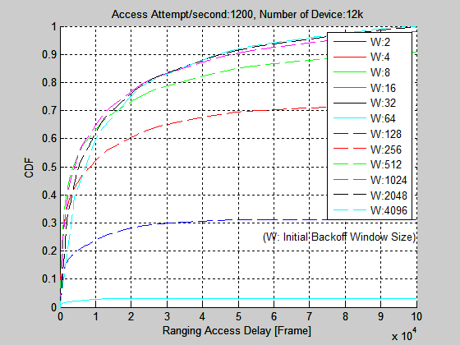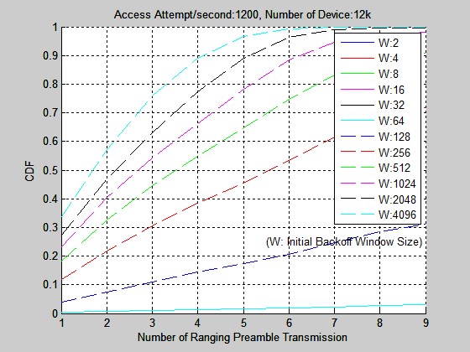
(a) Statistics of Ranging Access Delay (b) Statistics of Number of Ranging Preamble Transmission

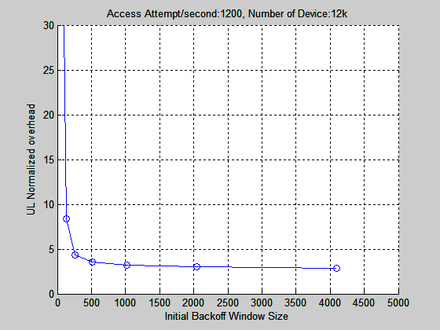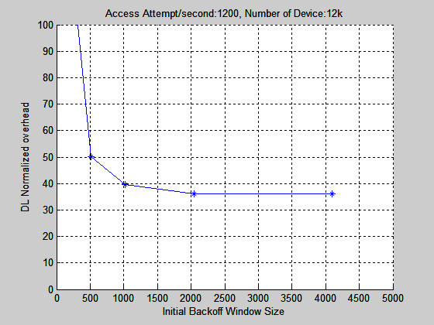
(c) UL Normalized Overhead (d) DL Normalized Overhead

Figure 6 – Simulation Result on 1200 Access Attempt/second

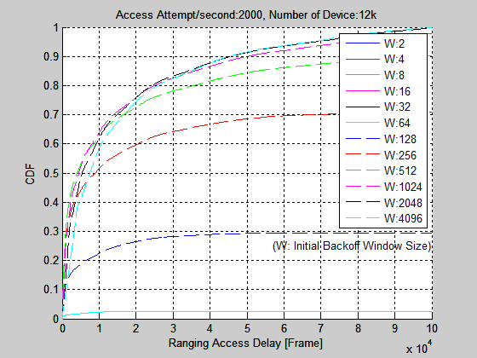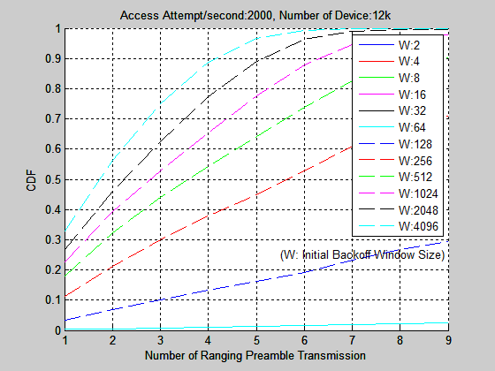
(a) Statistics of Ranging Access Delay (b) Statistics of Number of Ranging Preamble Transmission

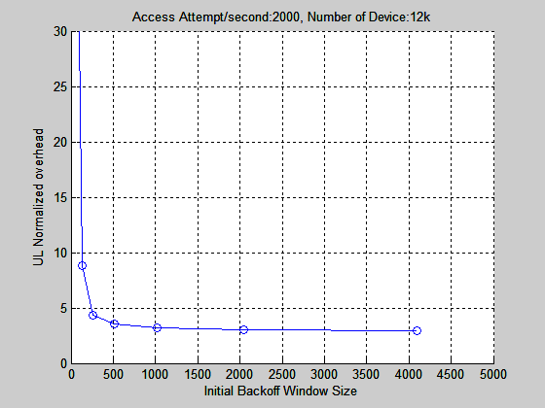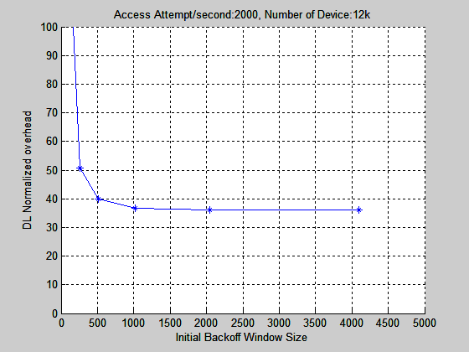
(c) UL Normalized Overhead (d) DL Normalized Overhead

Figure 7 – Simulation Result on 2000 Access Attempt/second

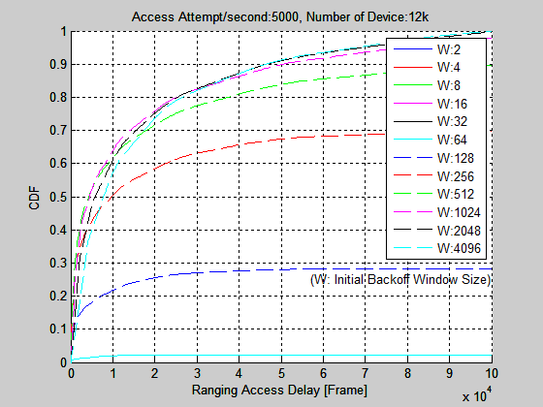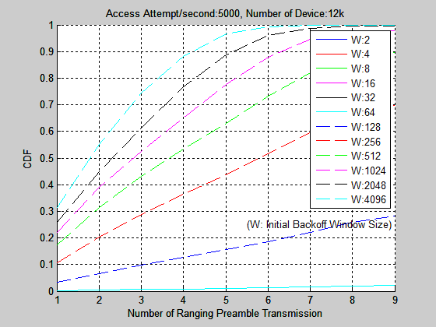
(a) Statistics of Ranging Access Delay (b) Statistics of Number of Ranging Preamble Transmission

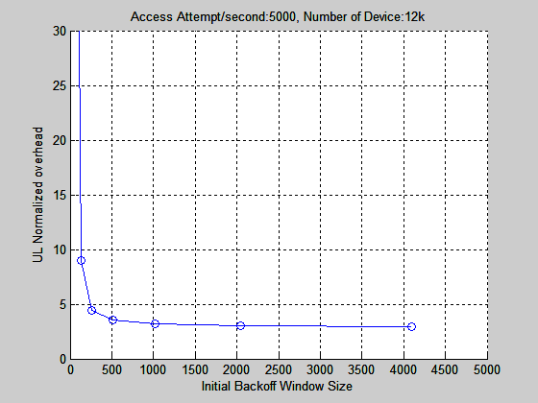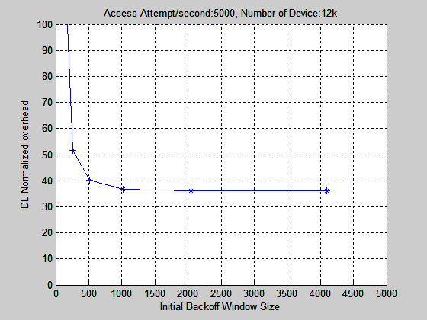
(c) UL Normalized Overhead (d) DL Normalized Overhead

Figure 8 – Simulation Result on 5000 Access Attempt/second

Proposal

This contribution proposes some texts which define ranging parameters in a paging message. Network access from large number of M2M devices can be distributed by selecting appropriate value of ‘ranging backoff start’ and ‘ranging backoff end’ in the paging message.

References

[1] IEEE 802.16p-10/0018r2, “Amendment Working Document,” May. 2011.
[2] C80216p-11-0126, “Evaluation Guideline for Comparison of Network Entry Solutions”, July. 2011.
[3] IEEE 802.16p-10_0005, “Machine to Machine (M2M) Communications Technical Report, Nov. 2010.

Proposed Text

----------------- Start of the text proposal ---------------------------------------------------------------------------------------

[Remedy 1: Modify Table 706 as follows:]

Table 706—AAI-PAG-ADV Message Field Description

Field | Size (bits) | Value/Description | Condition
…
For (i=0;i<M;i++){
For (j=0;j<Num_AMSs;j++){ |  | Num_AMSs indicates the number of paged AMSs in a corresponding paging group 1..32
Deregistration Identifier | 18 | Used to indicate Deregistration ID for  the AMS to be paged (Deregistration  Identifier and Paging Cycle are used to  identify each paged AMS)  0..218– 1 | Present if the S-SFH  Network Configuration  bit == 0b0
MAC Address Hash | 24 | Used to identify the AMS to be paged | Present if the S-SFH  Network Configuration  bit == 0b1
Paging Cycle | 4 | Used to indicate Paging cycle for the  AMS to be paged  0x00: 4 superframes  0x01: 8 superframes  0x02: 16 superframes  0x03: 32 superframes  0x04: 64 superframes  0x05: 128 superframes  0x06: 256 superframes  0x07: 512 superframes  08-0x15: reserved | Present if the S-SFH  Network Configuration  bit == 0b0.
Action code | 1 | Used to indicate the purpose of the AAI-PAG-ADV message  0b0: perform network reentry  0b1: perform ranging for location update
Ranging backoff start | 4 | Initial backoff window size for ranging contention during network reentry, expressed as a power of 2. Values of n range 0~15 | Optional
Ranging backoff end | 4 | Final backoff window size for ranging contention during network reentry, expressed as a power of 2. Values of n range 0~15 | Optional
}
}
…
For (i=0; i<Num_MGID; i++) { |  | Num_MGID indicates the number of MGIDs included in this paging message[0..63] | Shall be included if the ABS sends DL multicast data for M2M after transmission of the AAI-PAG-ADV message.
MGID | 15 | M2M Group ID
Action code | 2 | 0b00: Performing netwok re-entry  0b01: Performing location update  0b10: Receiving multicast traffic  0b11: reserved
M2M report code | 1 | Indicate the opportunity for the M2M device to send the uplink report  0b0: No action required  0b1: Send uplink report
  Present if M2M is supported
If(Action code == 0b10){
Multicast transmission start time (MTST) | TBD | Least significant TBD bits of the frame nuimber in which the ABS starts sending DL multicast data. | Shall be present when the MTST needs to be included in this message.
}
Else {
Ranging backoff start | 4 | Initial backoff window size for ranging contention during network reentry, expressed as a power of 2. Values of n range 0~15 | Optional
Ranging backoff end | 4 | Final backoff window size for ranging contention during network reentry, expressed as a power of 2. Values of n range 0~15 | Optional
}
…
}

----------------- End of the text proposal ----------------------------------------------------------------------------------------

