Project | IEEE 802.16 Broadband Wireless Access Working Group <http://ieee802.org/16>
Title | Reliable multicast data transmission
Date Submitted | 2011-07-10
Source(s) | Jeongki Kim, Youngsoo Yuk, Jin Lee, Giwon Park, Inuk Jung, Jinsam Kwak  LG Electronics | Email: jeongki.kim@lge.com
Re: | Call for comments on the 16p AWD
Abstract | This contribution proposes an method of the reliable multicast transmission using MAC layer feedback
Purpose | For discussion in 802.16p TG and adoption in to the 802.16p AWD
Notice | This document does not represent the agreed views of the IEEE 802.16 Working Group or any of its subgroups. It represents only the views of the participants listed in the “Source(s)” field above. It is offered as a basis for discussion. It is not binding on the contributor(s), who reserve(s) the right to add, amend or withdraw material contained herein.
Release | The contributor grants a free, irrevocable license to the IEEE to incorporate material contained in this contribution, and any modifications thereof, in the creation of an IEEE Standards publication; to copyright in the IEEE’s name any IEEE Standards publication even though it may include portions of this contribution; and at the IEEE’s sole discretion to permit others to reproduce in whole or in part the resulting IEEE Standards publication. The contributor also acknowledges and accepts that this contribution may be made public by IEEE 802.16.
Patent Policy | The contributor is familiar with the IEEE-SA Patent Policy and Procedures:  <http://standards.ieee.org/guides/bylaws/sect6-7.html#6> and <http://standards.ieee.org/guides/opman/sect6.html#6.3>.  Further information is located at <http://standards.ieee.org/board/pat/pat-material.html> and <http://standards.ieee.org/board/pat>.
Reliable multicast data transmission

Jeongki Kim, Youngsoo Yuk, Jin Lee, Giwon Park, Inuk Jung, Jinsam Kwak
LG Electronics

Introduction
In contrast to the legacy multicast service (e.g., MBS/E-MBS), the multicast service for M2M applications is required to more reliable data transmission because the legacy multicast service is error-tolerant (e.g., realtime traffic such as TV/Radio) but the M2M multicast service is error sensitive (e.g., application update). Therefore, the method of providing the reliability should be employed for the 16p multicast service.

Like the MBS [1] to transmit the same multicast data multiple times without any feedback may be one of the methods to provide the reliability for multicast service. However, this method is appropriate to send the error-tolerant multicast data like MBS rather than the error-sensitive multicast data like M2M software update because there is no mechanism for MS to report the error of multicast data reception in this method. That is, the reliability of the multicast data transmission cannot be provided only by this automatic multiple time transmission method.

Table 1 Comparison between legacy multicast service (MBS/E-MBS) and M2M multicast service
 | MBS/E-MBS | M2M multicast service
Main applications | Real-time traffic (e.g., TV, Radio, Streaming, etc.) | Non real-time traffic (e.g., Firmware update, softeware update, message for remotely controlling all devices in a group, etc.)
Required residual error rate | 10⁻²~10⁻³ (similar to UDP), i.e., error tolerant | 10⁻⁵~10⁻⁶ (similar to TCP), i.e., error sensitive

Proposal
To provide the reliability of multicast data transmission we propose the MAC level feedback mechanism based on NACK scheme.
- Basic procedure
M2M device sends the MAC level feedback only when the device detects the error of multicast data reception
Feedback overhead will be reduced by NACK based scheme
- Example of NACK detection
Burst decoding error: When an M2M device fails to decode the multicast burst, M2M device may send the MAC level feedback to BS.
Missing MPDUs: When the multicast MPDU arrives out of sequence, if the device does not receive the missing multicast MPDU within the specified timer, M2M device may send the MAC level feedback to BS.
- MAC level feedback
A device in connected mode sends the M2M multicast retransmission request (AAI-MMR-REQ) MAC control message
A device in idle mode sends the AAI-RNG-REQ message (i.e., location update procedure).
Upon feedback from M2M device the BS will retransmit the multicast data.

Performance analysis
Following analysis shows the comparison result between automatic retransmission and transmission with feedback. Table 2 shows the residual error rate after n-time automatic transmission. (1% of BLER for 5% of MSs in a cell for a single transmission) The required residual error shall be less than 10⁻⁶ for TCP packet. Without feedback, BS shall transmit a burst more than 4 times.

Table 2. Residual error rate after n transmission in a cell.
 | Number of transmission
Number of MSs | 1 | 2 | 3 | 4 | 5
100 | 0.05 | 0.0005 | 5.E-06 | 5.E-08 | 5.E-10
500 | 0.25 | 0.0025 | 3.E-05 | 3.E-07 | 3.E-09
1000 | 0.5 | 0.005 | 5.E-05 | 5.E-07 | 5.E-09
5000 | 1 | 0.025 | 3.E-04 | 3.E-06 | 3.E-08
10000 | 1 | 0.05 | 5.E-04 | 5.E-06 | 5.E-08
20000 | 1 | 0.1 | 1.E-03 | 1.E-05 | 1.E-07
50000 | 1 | 0.25 | 3.E-03 | 3.E-05 | 3.E-07
100000 | 1 | 0.5 | 5.E-03 | 5.E-05 | 5.E-07

We evaluate the required resource for transmitting 50 bytes of burst with various transmission options. Table 3 shows the evaluation assumption, and figure 1 shows the required resource according to the number of MSs in a cell. All the case, the residual error rates are the same when BS transmit the burst 4 times.

Table 3. Evaluation environment
Multicast Data Size | 50 bytes
Feedback overhead | 60 bytes
DL MCS | 1/16, QPSK
UL MCS | 1/12, QPSK (HARQ)
DL resource | 34 LRUs
UL resource | 34 LRUs
RA_code | 4 LRUs
AAI_RNG-REQ | 30 bytes
AAI_RNG-RSP | 30 bytes

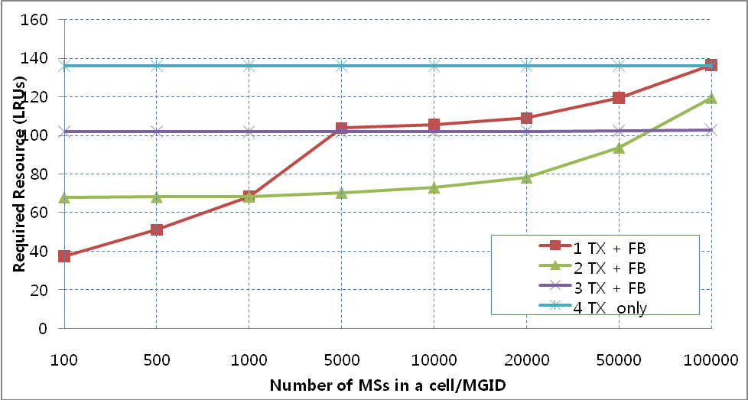

Figure 1 Required resources (LRUs) for transmitting 50 bytes of multicast data with various initial transmission times. (Residual Error Rates are the same for all cases.)

From the simulation results, we can learn that without Feedback, too large resources are required. According to the number of MSs in a cell, in order to reduce the initial error rate we can consider combining of single automatic re-transmission and feedback.

Conclusion
As we can see the result of performance analysis, in case that the number of MSs in a cell is less than 1000, one time transmission (No automatic repetition) with MAC level feedback mechanism is more efficient than others. In case that the umber of MSs in a cell is larger than 1000 and less than about 70000, two times transmission (one time repetition) with MAC level feedback is more efficient than others.

Proposal
- Generally BS sends the same multicast burst only once. However, BS may transmit the same multicast burst twice during the consecutive frames based on the number of M2M devices as shown in Figure 1.
- M2M device may request the retransmission of multicast data to BS by using NACK-based MAC level feedback.

Reference
[1] 802.16p-10_0018r1, Enhancements to Support Machine-to-Machine Applications
[2] C802.16p-11_0003r2, The reliable delivery between 802.16p BS and M2M device
[3] C802.16p-11_0032, Reliable multicast transmission using MAC layer feedback

Text proposal

---- Start of proposed text ----

[Remedy #1: Modify the Section 16.2.28.4.2 in C802.16p-10/0018r1 as follows.]
16.2.28.4.2 Reliable multicast transmission for M2M applications
An M2M BS shall provide the reliable transmission of the multicast traffic for M2M applications.

For providing the reliability to multicast service, multicast burst may be retransmitted by BS unsolicitedly one time and an M2M device may request the retransmission of multicast data to BS by using NACK-based MAC level feedback when the device finds the error of multicast data reception.

An M2M device assumes the following conditions as the error of multicast data reception.
  - Burst decoding error: When an M2M device fails to decode the multicast burst, if the multicast burst is not new burst (Burst indicator (BI) == 1 in Broadcast Assignment A-MAP IE) , M2M device shall send the MAC level feedback to BS. In this case the MAC level feedback contains the time information when the error of multicast data happens
  - Missing MPDUs: When the multicast MPDU arrives out of sequence, if the device does not receive the missing multicast MPDU within the specified timer, the device sends the Multicast retransmission request to BS. In this case the MAC level feedback contains the sequence number of the missing MPDUs or the sequence number of the latest received MPDU.

For requesting the retransmission of multicast data an M2M device in connected mode shall send the M2M multicast retransmission request (AAI-MMR-REQ) MAC control message and an M2M device in idle mode sends the AAI-RNG-REQ message (i.e., location update procedure) to the BS.

Upon receiving the request of retransmission of multicast data from a device, BS will transmit the multicast data to the device in response to the request by using unicast or multicast manner.

[Remedy #2: Modify the Section 16.3.5.5.2.4.13 in C802.16p-10/0018r1 as follows.]
16.3.5.5.2.4.13 Broadcast Assignment A-MAP IE

Modify the table 860 as indicated
Table 860 Broadcast Assignment A-MAP IE
Syntax | Size (bit) | Notes
Broadcast_Assignment_AMAP_IE() {
A-MAP IE Type | 4 | Broadcast Assignment A-MAP IE
Function Index | 2 | 0b00: This IE carries broadcast assignment information  0b01: This IE carries handover ranging channel allocation  information  0b10: This IE carries multicast assignment information  0b11: reserved This IE carries multicast assignment information for M2M application
… | … | …
} else if {Function Index ==
0b10} {
… | … | …
}
Else {//Function Index == 0b11
MGID | 15
Burst Size | 6
Resource Index | 11
Long_TTI_Indicator | 1
Reserved | 1
Burst indicator | 1 | Burst Indicator (BI) indicates whether the multicast burst is new or not  0b0: This burst is the new multicast burst  0b1: This burst is the retransmitted multicast burst
}

[Insert the following texts at the end of Section 16.3.5.5.2.4.13:]

The same multicast burst for M2M application is retransmitted only once at the next frame. The SPID is set to 0 for multicast bursts for M2M application.

[Remedy #3: Add the following Section 16.2.3.xx in C802.16p-10/0018r1 as follows.]

[Insert the following Section and text:]

16.2.3.xx. AAI-MMR-REQ (multicast retransmission request) message
M2M device may send the AAI-MMR-REQ message to inform BS of the error of multicast data reception (e.g., burst decoding error, Missing MPDUs).

Table xxx AAI-MMR-REQ (M2M multicast retransmission request) Message Field Description
Fields | Size (bit) | Value/Description | Condition
M2M group ID | 15
Action code | 2 | 0b00: Burst decoding error  0b01: Missing MPDUs  0b10~0b11: reserved
If (Action code == 0b00) {
MAP transmission time | 7 | Bit #0~#3: Least Significant 4 bits of the frame number in which the A-MAP IE corresponding to the erroneous burst was transmitted.  Bit #4~#6: The sub-frame number in which the A-MAP IE corresponding to the erroneous burst was transmitted.
} else if (Action code == 0b01) {
FID | 4 | Flow ID for the MPDU in which the out of order happens
SN type | 1
If (SN type == 0b0) {
For (i=0; i< N_MPDUs; i++) { |  | N_MPDUs: Indicates the number of MPDUs which the device missed.  1< N_MPDUs < 15
SN | 4 | 4 bits LSB of sequence number of the MPDU which the device missed
}
} else {
SN | 10 | Sequence number of the latest MPDU which the device received successfully
}
}

[Remedy #4: Modify the Section 16.2.3.1 in C802.16p-10/0018r1 as follows.]

16.2.3.1 AAI-RNG-REQ
Modify the Table 678 as indicated

Table 678—AAI-RNG-REQ Message Field Description
Field | Size  (bits) | Value/Description | Condition
Ranging purpose indication | 4 | 0b0000 = Initial network entry  0b0001 = HO reentry  0b0010 = Network reentry from idle  Mode  ……  0b1101 = NS/EP call setup  0b1110 - 0b1111 = reserved  0b1110 = M2M location update  0b1111= reserved
… | … | … | …
} else if (Ranging Purpose Indication
== 0b0011
|0b0110|0b0111| 0b1011|0b1110) {
… | … | … | …
AMS Mobility Information | 2
M2M LU purpose indication | 2 | 0b00 = LU for requesting the retransmission of multicast data  0b01 ~ 0b11 = reserved | Present when the Ranging Purpose Indication is set to 0b1110
If (M2M LU purpose indication == 0b00) {
M2M group ID | 15
Action code | 2 | 0b00: Burst decoding error  0b01: Missing MPDU  0b10 ~ 0b11: reserved
If (Action code == 0b00) {
MAP transmission time | 7 | Bit #0~#3: Least Significant 4 bits of the frame number in which the A-MAP IE corresponding to the erroneous burst was transmitted.  Bit #4~#6: The sub-frame number in which the A-MAP IE corresponding to the erroneous burst was transmitted.
} else if (Action code == 0b01) {
FID | 4 | Flow ID for the MPDU in which the out of order happens
SN type | 1
If (SN type == 0b0) {
For (i=0; i< N_MPDUs; i++) { |  | N_MPDUs: Indicates the number of MPDUs which the device missed.  1< N_MPDUs < 15
SN | 4 | 4 bits LSB of sequence number of the MPDU which the device missed
}
} else {
SN | 10 | Sequence number of the latest MPDU which the device received successfully
} // else
}
}
SMS
} else if (Ranging Purpose Indication
== 0b0100) {
… | … | … | …

---- End of proposed text ----

