Project | IEEE 802.16 Broadband Wireless Access Working Group <http://ieee802.org/16>
Title | Clarification of MGID domain
Date Submitted | 2011-09-09
Source(s) | Eunjong Lee, Youngsoo Yuk, Inuk Jung, Giwon Park and Jinsam Kwak  LG electronics | E-mail:  eunjong.lee@lge.com
Re: | Call for Comments on IEEE P802.16p AWD
Abstract | This contribution proposes to clarify MGID domain
Purpose | To be discussed and adopted by Machine-to-Machine(M2M) Task Group for IEEE P802.16p AWD
Notice | This document does not represent the agreed views of the IEEE 802.16 Working Group or any of its subgroups. It represents only the views of the participants listed in the “Source(s)” field above. It is offered as a basis for discussion. It is not binding on the contributor(s), who reserve(s) the right to add, amend or withdraw material contained herein.
Release | The contributor grants a free, irrevocable license to the IEEE to incorporate material contained in this contribution, and any modifications thereof, in the creation of an IEEE Standards publication; to copyright in the IEEE’s name any IEEE Standards publication even though it may include portions of this contribution; and at the IEEE’s sole discretion to permit others to reproduce in whole or in part the resulting IEEE Standards publication. The contributor also acknowledges and accepts that this contribution may be made public by IEEE 802.16.
Patent Policy | The contributor is familiar with the IEEE-SA Patent Policy and Procedures:  <http://standards.ieee.org/guides/bylaws/sect6-7.html#6> and <http://standards.ieee.org/guides/opman/sect6.html#6.3>.  Further information is located at <http://standards.ieee.org/board/pat/pat-material.html> and <http://standards.ieee.org/board/pat>.

Clarification of MGID domain

Eunjong Lee, Youngsoo Yuk, Inuk Jung, Giwon Park and Jinsam Kwak
LG electronics

Introduction
In the current 16p AWD, it has described that a 15 bits M2M group ID (MGID) uniquely identifies an M2M group in the domain of the network entity that assigns MGID. However, the domain of the network entity is still unclear. Therefore, we’d like to firstly discuss the possible scenarios for MGID domain and this contribution proposes to clarify the MGID domain.

Discussions
16p has already defined several procedures related to M2M grouping. 16p MGID is used for multicast data transmission and group paging. However, there are not any descriptions about what is the MGID domain and where is the network entity located. We think that MGID should be carefully assigned because it is used for not only M2M data identifier in MAC layer but also M2M service identifier in application layer. Moreover, several additional procedures related to MGID may need to be defined in 16p depending on the definition of MGID domain.
So, first of all, we introduce following 4 scenarios depending on the definition of MGID domain.
Scenario 1. MGID uniquely identifies M2M group within M2M CSN domain.
Scenario 2. MGID uniquely identifies M2M group within global network domain.
Scenario 3. MGID uniquely identifies M2M group within a paging group domain.
Scenario 4. MGID uniquely identifies M2M group within M2M ASN domain.
WiMAX forum defines two different scenarios depending on the location of M2M server, but regardless of this issue we’d like to clarify MGID domain in this contribution. That is, M2M server in our scenarios can be operated by WiMAX operator or not, as described in M2M requirements [2].
Scenario 1. MGID uniquely identifies M2M group within M2M CSN domain.
In the last meeting, we discussed MGID domain based on the contribution IEEE C802.16p-11/0130. In this document, ETRI suggested that MGID is unique within CSN. That is, the network entity that assigns MGID is located in the domain of CSN, as shown in the Figure 1. If a specific ASN belongs to only one CSN, there seems to be no problem to assign MGID. But if two different CSNs share a specific ASN, then there occurs MGID confliction within the shared ASN domain, as illustrated in Figure 2. In here, a single MGID can be assigned to M2M devices mapped to different M2M service flows within the same access network, this leads to confused M2M data transmission in MAC/PHY layer. 16p should consider this case because current ABS has been designed to be able to share one or more NSPs (Network Service Provider). To conclude, we think that this scenario seems to be unsuitable for the current 16p procedures.
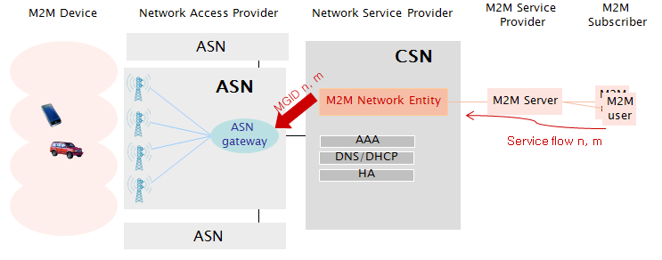
Figure 1. Example of MGID assignment in scenario 1

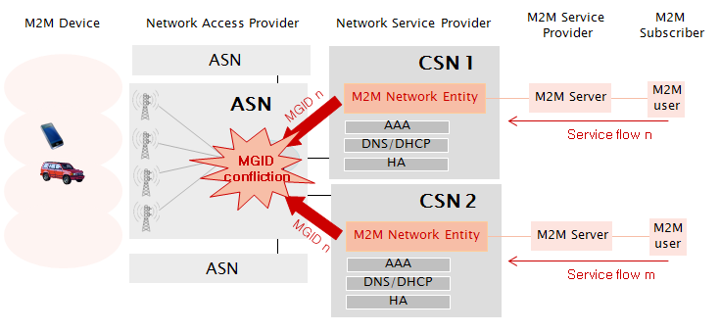
Figure 2. Example of MGID confliction in scenario 1

Scenario 2. MGID uniquely identifies M2M group within global network domain.
As shown in Figure 3, we can simply consider that MGID uniquely identifies M2M group within global network domain. Then, there is no MGID confliction problem anywhere and 16p doesn’t need to define additional procedures for MGID update, but we are worried about if 15 bits MGID is enough to globally allocate all of the service flows and who manages MGIDs. So, we think that this scenario is also difficult to adopt it as practical scenario.
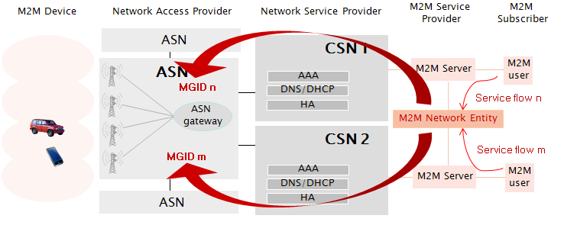
Figure 3. Example of MGID assignment in scenario 2

Scenario 3. MGID uniquely identifies M2M group within a paging group domain.
Current MGID is used for not only multicast data transmission in connected state but also group paging to wake up at once idle M2M devices belonging to the same M2M group. So, we can consider that MGID is also unique within a paging group. However, as shown in Figure 4, it can also lead to MGID confliction within the overlapped domain (i.e., ASN2 domain). In order to solve this problem, the ABS should always transmit the mapping information for MGID and Paging group ID in paging message. Since the current paging message contains Paging Group ID, there is no problem for idle mode M2M devices. However, M2M devices in connected state should also know the paging group for the assigned MGID to correctly receive the multicast M2M data within the overlapped ASN domain. It seems very difficult because this requires redesigning DL-MAP for multicast message.

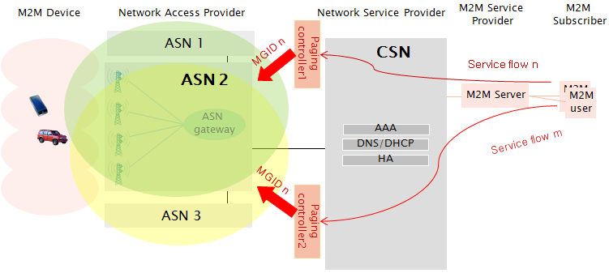
Figure 4. Example of MGID assignment in scenario 3

Scenario 4. MGID uniquely identifies M2M group within M2M ASN domain.
In this scenario, we consider that MGID uniquely identifies M2M group within ASN domain. As illustrated in Figure 5, an M2M network entity should assign MGID for service flows transmitted through M2M ASN gateways belonging to its own domain. We assume that the MGID domain can be composed of one or more M2M ASNs and an M2M ASN belongs to only one MGID domain. In addition, the MGID domain should be designed large enough considering the frequency of the MGID update that is able to occur to M2M devices with mobility. But how big is the domain or how to compose the domain is out of scope. In conclusion, we think that this is the best scenario because there is no MGID confliction and it doesn’t need to redesign DL-MAP and easy to manage MGIDs. However, we should define how to update the assigned MGID when MGID domain is changed by the mobility of M2M device.
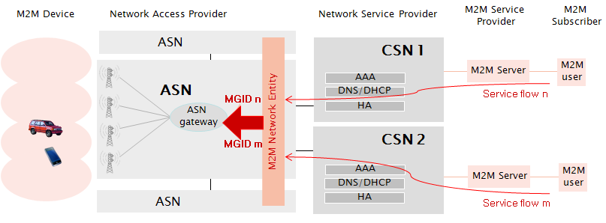
Figure 5. Example of MGID assignment in scenario 4

Conclusions
In the previous section, we discussed 4 different M2M scenarios depending on the definition of MGID domain. Table 1 summarizes our discussion results for each scenario. Scenario 1 and 3 seem to be difficult because it requires redesigning DL-MAP due to the MGID confliction. Scenario 2 and 4 seem to be proper scenario, but for scenario 2 we are okay if 16p agrees that there are no problems to manage or assign MGIDs but it is still needed to clarify the MGID domain of the current texts. Otherwise, we think that scenario 4 is practically the best solution because there is no MGID confliction and easy to manage MGIDs. The common point between scenario 2 and 4 is there are no overlapped MGID domain. Therefore, in order to clarify the domain of the network entity that assigns MGID, we propose to add the text that the MGID domain is not overlapped with other MGID domain and MGID should be updated if the MGID domain is changed.

Table 1. Comparisons of M2M scenarios depending on the definition of MGID domain
 | MGID confliction | MGID management | DL-MAP redesign | MGID update for M2M devices with mobility
Scenario 1 | yes | easy | yes | yes
Scenario 2 | no | difficult | no | no
Scenario 3 | yes | easy | yes | yes
Scenario 4 | no | easy | no | yes

References
[1] IEEE 802.16p-11/0022, “IEEE 802.16p Machine to Machine (M2M) Amendment Working Document (AWD),” August 2011.
[2] DRAFT-T31-127-R020-v01-M, “Requirements for WiMAX Machine to Machine (M2M) Communication”, WiMAX Forum

- Text proposal for inclusion in the 802.16p AWD
[Modify the following text into the 802.16p AWD]
------------------------------------------------------------------------- Text Start --------------------------------------------------------------------------
6.2.1.3 Address for machine to machine application
6.2.1.3.1 M2M Group Identifier (MGID)
A 15-bit value that uniquely identifies an M2M group in the MGID domain of the network entity that assigns MGID that one or more M2M devices belong to. The MGID domain shall be not overlapped with other MGID domain and MGID shall be updated if the MGID domain is changed.
------------------------------------------------------------------------ Text End ---------------------------------------------------------------------------

