Project | IEEE 802.16 Broadband Wireless Access Working Group <http://ieee802.org/16>
Title | S-SFH update for M2M device in idle mode
Date Submitted | 2011-09-09
Source(s) | Heejeong Cho, Youngsoo Yuk, Inuk Jung and  Jin Sam Kwak  LG Electronics  Shantidev Mohanty  Intel Corporation  Jaesun Cha  ETRI  Erik Colban  Huawei Technoloies | E-mail: heejeong.cho@lge.com
Re: | Call for comments on the 16p AWD
Abstract | This contribution provides the text for S-SFH update for M2M device in idle mode.
Purpose | For discussion in 802.16p TG
Notice | This document does not represent the agreed views of the IEEE 802.16 Working Group or any of its subgroups. It represents only the views of the participants listed in the “Source(s)” field above. It is offered as a basis for discussion. It is not binding on the contributor(s), who reserve(s) the right to add, amend or withdraw material contained herein.
Release | The contributor grants a free, irrevocable license to the IEEE to incorporate material contained in this contribution, and any modifications thereof, in the creation of an IEEE Standards publication; to copyright in the IEEE’s name any IEEE Standards publication even though it may include portions of this contribution; and at the IEEE’s sole discretion to permit others to reproduce in whole or in part the resulting IEEE Standards publication. The contributor also acknowledges and accepts that this contribution may be made public by IEEE 802.16.
Patent Policy | The contributor is familiar with the IEEE-SA Patent Policy and Procedures:  <http://standards.ieee.org/guides/bylaws/sect6-7.html#6> and <http://standards.ieee.org/guides/opman/sect6.html#6.3>.  Further information is located at <http://standards.ieee.org/board/pat/pat-material.html> and <http://standards.ieee.org/board/pat>.
S-SFH update for M2M device in idle mode

Heejeong Cho, Youngsoo Yuk, Inuk Jung and Jin Sam Kwak
LG Electronics Inc.

Shantidev Mohanty
Intel Corporation

Jaesun Cha
ETRI

Erik Colban
Huawei Technoloies

Introduction
This contribution includes the proposed text for the S-SFH update procedure for M2M device in idle mode. In WirelessMAN-Advanced Air Interface Systems [1], an ABS transmits P-SFH IE containing the S-SFH scheduling information, S-SFH change count, S-SFH SP change bitmap, and S-SFH application hold indicator. Whenever any of the values (except MSB of superframe number in S-SFH SP1 IE) in any of the S-SFH IEs change, the S-SFH change count shall be incremented by 1 modulo 16 only in the specific superframe number (SFN) that satisfies SFN modulo S-SFH change cycle = 0, where the S-SFH change cycle is indicated in S-SFH SP3 IE, as shown in Figure 1.

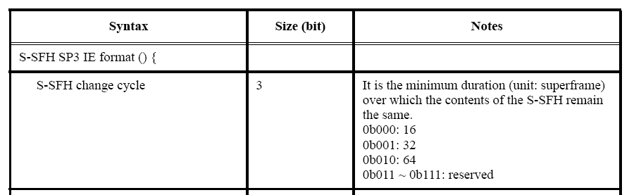

Figure 1 –S-SFH change cycle in S-SFH SP3 IE of WirelessMAN-Advanced Air Interface Systems

The modified S-SFH change count shall be maintained until the next superframe (satisfying SFN modulo S-SFH change cycle = 0) in which the S-SFH change count is incremented.
An AMS shall compare the value of S-SFH change count in the current P-SFH IE with that stored last, whenever the validity check of the last stored S-SFH SP IEs is required.
— If there is no difference between two S-SFH change counts, the AMS may not decode S-SFH IE during a certain period where S-SFH change count remains unchanged.
— Else if the difference between two S-SFH change counts is one, the AMS shall update the S-SFH SP IE(s) whose bit in the S-SFH SP change bitmap is set to 1.
— Else if the difference between two S-SFH change counts is greater than one, the AMS shall update all S-SFH SP IEs.

The AMS in idle mode performs the validity check of the last stored S-SFH SP IEs at the beginning of the paging listening interval. If the P-SFH indicates a change in SFH, then the AMS shall acquire the latest S-SFH information when the system information is broadcast by the ABS. The AMS may not perform any operations until it gets the S-SFH information from the ABS. The following problem is able to be encountered. This problem can be a critical issue to an M2M device because long paging cycle (e.g., 32768, 262144 and 4194304 superframes) may be applied to the M2M device.

- Problem <Invalid S-SFH change count>
  - If the M2M device’s paging cycle is greater than or equal to S-SFH change cycle * 2 ^{bit size of S-SFH change count}, S-SFH information can be changed more than 16 times during one paging cycle.

Therefore, we propose the S-SFH update procedure for M2M device in idle mode to solve these problems.

References
[1] IEEE P802.16.1™/D1, “WirelessMAN-Advanced Air Interface for Broadband Wireless Access Systems”
[2] IEEE 80216p-11_0022, “Enhancements to Support Machine-to-Machine Applications”

Proposed Text Change
Adopt the following Remedies in IEEE 80216p-11_0022.

[Remedy 1: Add a new subclause on page 30, line 55 as follows:]
----------------------------------------------------- Start of Proposed Text -----------------------------------------------------
6.2.18 Idle mode
6.2.18.7 Idle mode for M2M application
6.2.18.7.4 S-SFH update in idle mode

When the paging cycle of an M2M device is greater than or equal to S-SFH change cycle  2 ^{bit size of S-SFH change count}, the M2M device shall decode all the SFH SP IEs before its paging listening interval.

----------------------------------------------------- End of Proposed Text -----------------------------------------------------

